Babatype Mobile App for Barcode Reader

15 AUGUST 2020

LEADER: ROSHAN DHITAL (30361962)

MEMBERS: Kamal Pun (30371365)

Jashandeep (30362218)

Riaz Qadir (30364968)

Haque Mohammad (30379834)

PROJECT VISION DOCUMENT

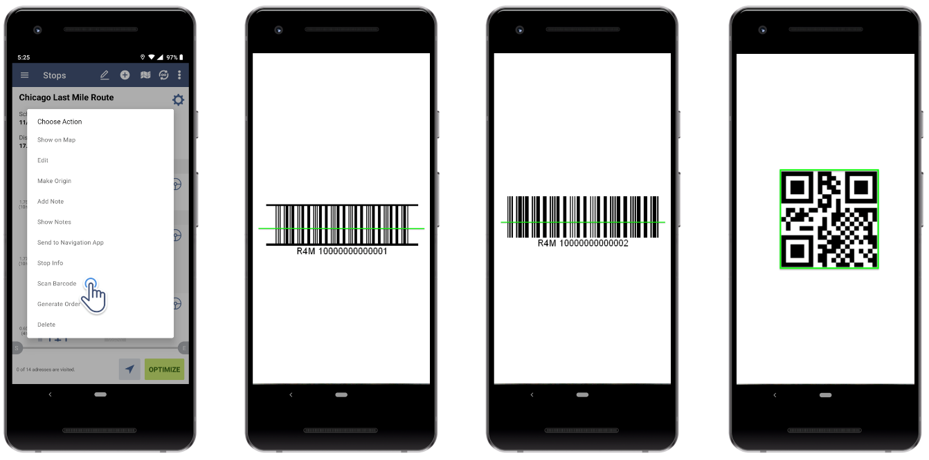

Contents

**Project Overview** 2

i. **Problem Statement:** 2

ii. **Project Position:** 2

iii. **Organisational Position:** 2

**User Description** 2

i. **Description:** 2

ii. **User Handling:** 3

iii. **Alternate System:** 3

**Application Overview** 3

i. **Access Control and Ticket Validation:** 3

ii. **Asset Tracking:** 3

iii. **Attendance:** 3

iv. **Database Builder:** 3

v. **Facility Security:** 3

vi. **Safety Returns:** 3

**vii.** **Scan to Order:** 4

**Application Features** 4

**i.** **Barcode App Process:** 4

ii. **Working of the system:** 4

iii. **Brief Explanation:** 4

**Project Deliverables** 4

**Future Development & Possibilities** 4

# **Project Overview**

1. **Problem Statement:** This part addresses the major issues which are to be solved by the project. Those major issues to be considered are:
2. Lack of barcode scanner created problem to know the details of a product and was inconvenient in buying and selling process.
3. Investors, management team, workers, suppliers of the company and the customers are having problem.
4. Influence of the problem to an organization. Investors and workers of the company in manufacturing products could not have digitalized process to calculate the type and quantity of products sold and could not manufacture products accordingly.
5. Description of plausible solutions to the problem created and key benefits of it. Barcode reader application solves the problem by storing information about product price, quantity sold, which category under the same product item was sold, and restocking information so that workers perform on the inventory part, and updates changes.
6. **Project Position:** Barcode reader is crucial in terms of determining product items and gathering its information accordingly. The scanning tool of a barcode gets more better if it’s portable so that it can be handy wherever we travel and when considering of an barcode reader application design that each of the participants in buying and selling purpose can have an access. Based on developed application, special considerations on the functionalities within will be monitored and will make changes from suppliers, customers, and management team side to reduce hassles which may arise.
7. **Organisational Position:** This project will be on behalf and assist in the management of inventory making it effective to the workers and adding value to the entire product development team through the means of barcode reader application. Also, it assists the management team to take necessary actions regarding the restock of desired products, tracking each of the products, and taking feedbacks from the customers and working accordingly.

# **User Description**

1. **Description:** This section tells about the users of the applications, those who are the users for Babatye mobile app which is used to read the barcode. So, the users will be normal persons who will be coming to the website in search of a product. The system, firstly, will create their profile if they are new users, if not they can login by using the login ID and passcode provided to them when they first came. If they have forgotten the password or user ID, they can get it back by clicking the forgot password or forgot ID tab. The user is then going to take a product app and scan the barcode of the product and then the product will be added to the basket.
2. **User Handling:** This tells about the handling of the product, for instance if the product is damaged and is supposed to not to be in the inventory then we will update the quantity of the stock by removing that particular product so user will be notified if we runs out of stock that this particular product is currently unavailable and will be available soon.
3. **Alternate System:** This looks after the system whether it is working properly or not, whether we are having any of the issues in our system or having a system failure. If we are having an alternative system, then we will divert users to that system. If we do not have an alternative system, then we will reboot the system and will let users know the estimated time which this reboot might take.

# **Application Overview**

The barcode scanner apps which we created based on mobile device support both IOS and android are mainly designed to scan the product code using the phone camera and detect the data from there using the internet and can store that in the website to further process and use.

This app can also support other accessories such as Bluetooth and NFC as well as manual input available. For the website it enables to configure the mobile apps for the product use cases for example Attendance, Access Control, Asset Tracking and so on.

This barcode app is easy to use and can find easily in the google play store and app store. The main thing is this one is free of charge which means anyone could download and use it from anywhere in the world. When we developed the app the main thing in our mind was to make it simple because all kinds of people are going to use it from teenage to 100+ so it was challenging to make something which will be usable for all.

Some of the scanning techniques and services provided by this app are:

1. **Access Control and Ticket Validation:** So, this tracking mainly makes sure anywhere in the world the app will work smoothly and can read the ticket easily.
2. **Asset Tracking:** It could track the purses as well wherever it is by tracking the last scan point and we did use google map to see the location as well.
3. **Attendance:** It also makes sure the product after purses get by the real customer, when the user gets their product by their own register app it will make sure the current user got the product safe and sound.
4. **Database Builder:** It also allows the user to input data by scanning as well as typing.
5. **Facility Security:** It always ensures the customer safety first never revolts any information of the customer and guarantees about that.
6. **Safety Returns:** Safety is always a priority for us, so we care about the product if it got burned or something like that. It can scan the other part such as name or size then detect the item and replace that with a new one.
7. **Scan to Order:** Scan to order is mainly for online customers who can pursue their item by scanning the item code from their phone. It is proven hundred percent accurate.

# **Application Features**

1. **Barcode App Process:**
2. In Chrome Browser: User will place the barcode scanner to the angle of the canvas

NOTE: Clients camera should be on capture mode

1. Then scanner will take the barcode in focus, will scan the specific type of barcode
2. Types of barcodes: .Codabar, Code39, Ean, I2of5, Upc etc

Then the output of the scanned data will be stored in the cloud database.

1. **Working of the system:** Our application will have a standard approach for the 3 tiers architecture; User tier, Server tier and Data tier.
2. **Brief Explanation:** All scanned data will be stored in a cloud database say (MYSQL database) of Bababyte and network connections will be established with the user’s application with HTTP requests of its server say (Apache)

# **Project Deliverables**

Towards the end of the project we will be handing a complete application to our client that will be able to scan any barcodes through mobile app and store those data into cloud-based data repository. With which they can keep record of their supplies from each supplier. Client will also be provided with a user manual describing every step required to use the application.

# **Future Development & Possibilities**

The history of barcode scanning goes back to the 1980s and for the last two decades companies have been utilizing these technologies as demand for storing more product information keeps rising. Mostly we see bigger companies implementing Barcode Technologies to their system as it actively eliminates any human errors and improves the company's operational performance. Like any technologies that are available Barcode technologies will also be near its lifespan in near future but with availability of more affordable and new technology in the market we can upgrade our mobile accordingly. Like we can implement new changes so 2D barcodes also can be scanned and make it future proof but still able to work with suppliers who still use 1D barcodes.