**************Most Needed Connection and Project Create*************************

Full Project Create--Full Stack Developer

File Direction Ex. C:\Users\ranak\OneDrive\Desktop\IntelliJJava\KuebikoIT\FullStackFrontend

--Back-End-Java
--Front-End- Angular (html, css, java script, bootstrap, typescript)
--Database-MySQL
--Cloud-AWS

******************************************************************************
-----------------------------------Front-End-Project------------------------------------------------------------

npm -Node Package Manager, ng—angular,
pwd -print working directory
cli - command line interface
.css-style, html-template structure, spec.ts--Testing, .ts--logic

Install and Creating Angular Files
Create from terminal/command/IntelliJ/VS code terminal
- Go to cd folder/pwd/file you want to create
- From command or vs code or intellij or any terminal
- If vs code terminal not work –run as administration and copy paste this code on terminal-
Set-ExecutionPolicy -ExecutionPolicy RemoteSigned

- Change Angular Port - ng serve --port 4565 (defult 4200)
- Create new Project-- ng new project name
Ex. ng new TicketBookingSystemFront
Would you like to add Angular routing? Yes
Which stylesheet format would you like to use? SCSS

- Open created folder from Intellij/VS Code
- Create Project - ng new AmazonEmployeeFrontEnd
- Would you like to add Angular routing? Yes
- Select-yes and choose option ---SCSS
- Create package pages under the app
- Go to the file/project directory---
PS C:\Users\ranak\OneDrive\Desktop\IntelliJ Java\KuebikoIT\FullStackFrontend\AmazonEmployeeFrontEnd\src\app\pages>

- Create Package(service, entity etc) and Create Class inside the package folder
- Go to Terminal and Directory----IntelliJ Java\KuebikoIT\FullStackFrontend\Json_Items\src\app>----create here
- Create Folder--- ng g class folder name
Ex--- ng g class Employee -Output-(employee.ts)

- Create Service Class -- ng g service file name
Ex. ng g service employee—Output(employee.service.ts)

- Create Component—ng g c component/folder name (4 component)
(Inside the component—html, scss, spec.ts and ts)
Ex. ng g c service, ng g c entity, ng g c repository

- Create Module - - ng generate module module_name (inside the pwd)
Ex. ng generate module User

- After create class—Delete spec.ts is not necessary file

- Go to file from cd or terminal
- Do npm start (Node Package Manager) on VS code or IntelliJ
- ng serve for start ng/cli

- Create Pages under the app (Right click on app-New-Director-folder name pages)
- (Create under pages different necessary commponent like login, register, list, new etc)
- Create Component under the Pages (ng g c folder name)
- ng g class and ng g service is create under the app(ts.model)
- Create Component ——ng g c———folder name( 4-components under the pages)

- Open file PWD and create class- ng g class———class name under the app(ts)
- Create service —ng g service———service file name under the app(service.ts)
- Delete spec.ts (not necessary only for testing)
- npm install -g json-server
- Clear ——ng clear
- List of version— nvm list
- Serve——ng s(next generation)
- Details——ls
- Back to pwd——cd..
- Clear ——cls clear
- npm start, ng serve
- ng v for angular version check
- Bootstrap install for beautifying pages—npm install bootstrap, npm uninstall bootstrap

For Bootstrap(Go to Angular.json and paste)
This code for Beatify the webpage
"styles": ["src/styles.scss",
"node_modules/bootstrap/dist/css/bootstrap.min.css"],

"scripts": ["node_modules/bootstrap/dist/js/bootstrap.min.js"]

Bootstrap Version
Go to Package—package.json
"bootstrap": "^5.3.0",

Important:-
Folder name ----customers.service.ts
//Database connections
url: string ='http://localhost:8080/students’--service file name (students)
constructor(private http : HttpClient){ }

Json Server
Json server port:3000 defult
Run Json-server---install
-npm install -g json-server
-
- nvm install v12.15.0 intstll version
-npm -Node Package Manager, check version node -v
-json-server --watch db.json(file name)---Go to file directory
-cd src\app\json-crud
-In the terminal---json-server --watch database.json
-Output --http://localhost:3000/database and click on the link open in browser
-We need to run to get data in the server
-http://localhost:3000/data
GET /posts: Retrieve all posts
GET /posts/1: Retrieve post with ID 1
POST /posts: Create a new post
PUT /posts/1: Update post with ID 1
DELETE /posts/1: Delete post with ID 1

******************************************************************************
-------------------------------------Back-End-Java-Project----------------------------------------------------

Create springboot app from springboot io or intellije IDE
Choose—Java-Maven-3.1.2-Project MetaDataName
Package name-Jar-Java version 20
Chose Dependency-Lombok-MySQL Driver-Spring Data JPA-Spring Web

Important:-
//Database=Connection_Details in resources file in properties
spring.datasource.url=jdbc:mysql://localhost:3306/studentdetails(database table name)
spring.datasource.username=root
spring.datasource.password=Tanuja123
#Hibernate properties
spring.jpa.properties.hibernate.dialect=org.hibernate.dialect.MySQLDialect
Type—create or update
#create-table and replace new and remove all the older data
# update/create-only update data keep older and create for first time create table
spring.jpa.hibernate.ddl-auto=update
spring.jpa.show-sql=true

In pom.xml Dependency
<dependency>
<groupId>com.mysql</groupId>
<artifactId>mysql-connector-j</artifactId>
<scope>runtime</scope>
</dependency>

For postgresql

#Database=Connection_Details
spring.datasource.url=jdbc:postgresql://localhost:5432/bank_of_america
spring.datasource.username=postgres
spring.datasource.password=Tanuja123
spring.datasource.driver-class-name=org.postgresql.Driver
spring.jpa.properties.hibernate.dialect=org.hibernate.dialect.PostgreSQLDialect
spring.flyway.baseline-on-migrate=true
spring.main.allow-bean-definition-overriding=true
Type—create or update
#create-table and replace new and remove all the older data
# update/create-only update data keep older and create for first time create table
spring.jpa.hibernate.ddl-auto=update

In pom.xml Dependency
<dependency>
<groupId>org.postgresql</groupId>
<artifactId>postgresql</artifactId>
<scope>runtime</scope>
</dependency>

Microsoft SQL Server Connections
private static final String URL = "jdbc:sqlserver://localhost:1433;databaseName=Database_Connection;encrypt=true;trustServerCertificate=true";
private static final String USER = "KamalSaru/ranak"; // your SQL Server username
//private static final String PASSWORD = "Tanuja123"; //All Database password are same

<dependency>
<groupId>com.microsoft.sqlserver</groupId>
<artifactId>mssql-jdbc</artifactId>
<version>12.6.1.jre11</version> <!-- version depends on your Java -->
</dependency>

import java.sql.Connection;
import java.sql.DriverManager;

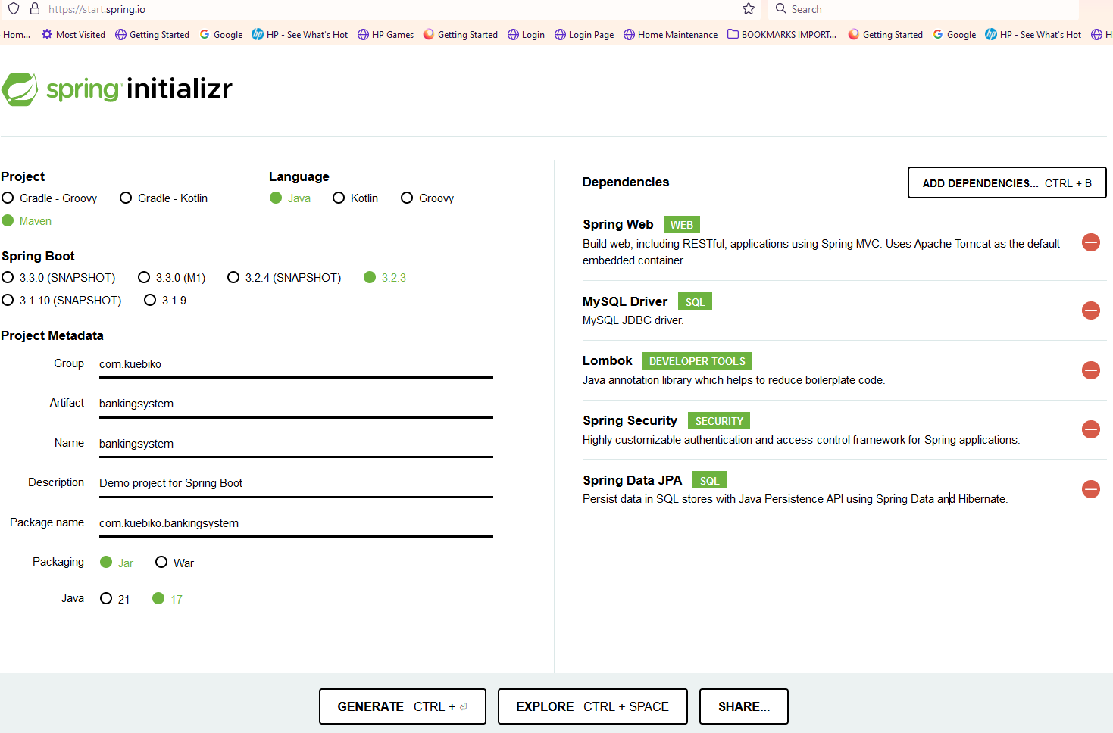
Most needed Dependency
- Lombok
- MySQL Driver
- Spring Data JPA
- Spring Web

****************************************************************

Important:-

------------------------------------------DataBase Connection-------------------------------------------------
DataBase Connection- MySQL and PostgreSQL
To Back-End and Front-End
MySQL Server Connect—Create Schemas Folder
Connection name:-KamalSaru
Port: - 3306/5432
UserName:-root/postgres
Password:-Tanuja123

Database Connection To PowerBI Postgres
- Choose Postgres Or Needed Database
- Enter Server :- 127.0.0.1 OR Localhost: (This is defult server name for Postgres-5432)
- Enter Database Name Eg. Database_Connection (Chosewhich you want)
- Enter UserName: postgres (Your)
- Password: Tanuja123 (your)

In Postgres To create Table and Import the CVS data
- Go to Database where you want to create table
- Go to Schema and Right click on Table, Right Click and Select the Query Tool
- It will open in Empty and
- Copy the all column name from the data file(CSV File)
- Create the table name using the chatgpt and copy paste the column field from CSV File
- Copy the code from ChatGPT and Paste on Query
- Run the Query and refresh the table and It will be created the table.
- For Import the data, Right click on this new created table
- Import the data

Database Connection To PowerBI Mysql
- Choose the Mysql
- Enter Server :- 127.0.0.1 OR Localhost (This is defult server name for Mysql-3306)
- Enter Database Name Eg. Udemy_data_import
- Enter UserName: root (Your)
- Password: Tanuja123 (your)

JDBC Connection on Project
- First download specific version of database connector (jar.file)
- Go to project and right click, new and click directory
- Make folder for exe.--- lib
- Copy database connector file and Paste in lib folder
- After go to the top of file menu
- Go to project structure
- Go to module and click on structure
- Click on + sign for add the database connector driver
- Click on Jar or Directories and go to lib folder and select the driver file
- Click ok and apply…

Working Steps Angular Files
Main Working Places Files
- ts, service.ts, app.module.ts, app-routing.module.ts,
- In components-html and ts only
- Check angular.json
"styles": [
"src/styles.scss",
"node_modules/bootstrap/dist/css/bootstrap.min.css"
],
"scripts": [
"node_modules/bootstrap/dist/js/bootstrap.min.js"
]

Dyanamic Web Project in Intellij
- Go to file- Project
- Choose Maven Archetype
- Choose Maven Archetype-webapp
- Run/edit Configuration
- Add tomcat apache server 9.0

Remove wsl File(Windows Subsystem Linux)
- Go to start menu and Opne turn Windows features on or off
- Remove mark on Virtual Machine Platform and Windows Subsystum for linux(wsl)
- Restart the computer

React Project (Same as Angular)
Create React File/Project from terminal/command/IntelliJ/VS code terminal
- Open VS Code or IntelliJ Idea and Open Terminal
- Make Folder in Computer where you want to save the files/project
- Go the terminal and go to inside the folder and create the files
- Npm is globally and npx is locally

Create React App/Folder/Project
- In the directory---npx create-reat-app my-first-app
- After create Go to file--- cd my-first-app
- Npm start and Project Open in---- http://localhost:3000
- Insatall the bootstrap ----- npm install react-bootstrap bootstrap
- Go the App.js and remove inside <div></div> and write something check on browser for Test.

