# Abstract

The “Rent Space ” mobile android application platform is based upon the need of people to search, lease and secure space either it be a room, office, hotels or apartments based on the location, price range, the availability of the facilities and neighborhood. The agony of finding a room in crowded and over populated major cities like Kathmandu, Biratnagar, and Pokhara and so on is real which is highly inefficient and time consuming. More so, it is highly unlikely for a single person to find a decent room or space for individual business within a day, or on a deadline. This mobile platform provides multiple opportunities for any individual to browse through several spaces to find the best one that suits their needs. This platform is not associated with any third party transactions between the users of both kind (lease and rent), which establishes a transparent connection between them. The main aim of this platform is to ensure maximum efficiency in finding any kind of space through a network of several listed spaces in a same platform without even leaving your house to search any. We expect the application reduce the agony of wandering around the city to end up in not finding a place. We further hope in continuing this platform adding several other features including finding a roommate, ratings and comments section and so on.

**Keywords**: *room finder, rent*

# Table of Contents

Abstract i

Abbreviations: iii

List of Figures: iv

Chapter 1: Introduction: 1

1.1. Background: 1

1.2. Objectives: 1

1.3. Motivation and Significance 2

Chapter 2: Related Works 3

Chapter 3: System Requirement Specification 5

3.1 System Diagrams: 5

(i) System Flow Diagram 5

(ii)Data Flow 6

(iii) Use Case Diagram 7

3.2. Software Specification 8

3. 3. Hardware Specification 8

Chapter 4:  Discussion on the Achievement 9

Chapter 5: Conclusion and Recommendation 10

5.1. Limitation 10

5.2. Future Enhancement 10

References 11

# Abbreviations:

API: Application Programming Interface

JDK: Java Development Kit

JRE: Java Runtime Environment

APK: Android Application Package

# List of Figures:

Figure 3.1: System Flow Diagram 5

Figure 3.2: Dataflow Diagram 6

Figure 3.3: Use Case Diagram 7

# 

# Chapter 1: Introduction:

“RentSpace” is an android application platform that aims in bringing ease to finding and leasing rooms for personals use, offices, restaurants, institutions, flats and more. It is a very tedious and time consuming job of searching for availability of rental space in such a densely populated society of Nepal with exponential population growth. So, in order to make searching of spaces more efficient and less time consuming this application platform provides user with multiple options to select form.

## Background:

“RentSpace” mainly focuses on establishing the platform to form a community of people who interact with each other to exchange information about rental space through various posts and advertisements on the application with an extended knowledge about the facilities of the space based on the reviews and comments of the previous owners and landlords. Drastically increasing population results in the demand for rental space and each demand comes with its own specifications. Traditional room searching procedures might just take several days to find a suitable space with a lot of time consumed. This platform aims in making that procedure as efficient as it could be.

## Objectives:

This application was built with one major purpose to provide a common platform to

* Ease with the rental space searching and ensuring the best rental space suiting for tenants.
* Lease and rent spaces based on location and price.

## Motivation and Significance

The available rental services are poorly managed, complicated to use and users feel difficulty in dealing with landlords. They were especially useful for individuals able to afford apartments or a flat and not applicable for individuals, families who could only afford to take few rooms. But Rent Space allows users of every economic status in finding and also leasing rents. From the viewpoint of consumers of space, this platform is going to reduce all the extra allocations of time, useless bargains along the search, pre planning and the unnecessary wandering of various places leading to spending a lot of time and a chunk of money in the search itself. As a landlord of space, this application will reduce the cost of setting up an advertisements in the newspaper and the tedious job of explaining the availability of room to all those who seek. With no availability of such android application for the context of Nepal, we believe it will bring ease to rental space hunting and convenience to all those who seek a perfect place to set up their office or their personal room.

# Chapter 2: Related Works

Over the years, tenants have had a problem in finding rent houses based on their income and family situations. Also landlords/property managers have had a problem in finding appropriate tenants, and thus leaving their rooms vacant for months. Based on the similar concepts of bring an ease to the problems mentioned, listed below are few projects or platforms addressing the need:

1. **Gharbheti**

Gharbheti is a web portal designed to reshape the conventional pattern of rental and real estate solution for building, flat, room, space, apartment, hostel, and land all around Nepal. This portal allows people to search and book properties from available property list via online presence. The properties are displayed in categorical lists where clients can search the property that best suits their budget range as well as location. The list is regularly updated by our marketing team; the team searches property manually as well as encourages and advocates property owners to post through online with detail information of property.

It offers clients to set preferences for location as well as budget, as per their need. Property owners can post, manage and modify properties from their free accounts.

1. **99acres**

99acres is a real estate portal in India founded in 2005. It allows people to search, buy, sell or rent property. Users can visually explore apartment, farm house, flat, house, builder floor, plot, villa, commercial office, shops, factory through rich photos and videos of society/ locality of a property. It has detailed property listings, latest information about new projects and local real estate information. It caters all kinds of properties within the real estate-from commercial to residential properties. It offers services that has made property search easier like never before. It is best known for the numerous options it provides, with listings of around 10 lakh properties across the country.

It also promises instant contact between landlords and interested tenants through phone calls, texts or e-mail.

1. **1Ropani**

1Ropani.com is a platform to disseminate Nepal real estate industry information. It provides comprehensive detail on real estate properties which are for sale or rent, including current news and information about real estate market. 1Ropani.com brings together property information - location, price, pictures, interactive maps and property features through dynamic website, mobile interface and SMS. It welcomes the participation from real estate players - sellers, renters, agents, builders, developers, investors for dissemination of information in trustworthy environment.

1Ropani.com aims to overcome the limitation of traditional method of real estate advertisement, like newspaper, brochures, leaflets or other forms of mass media, which are confined to limited time, space and audience.

# Chapter 3: System Requirement Specification

## 3.1 System Diagram:

### (I) System Flow Diagram

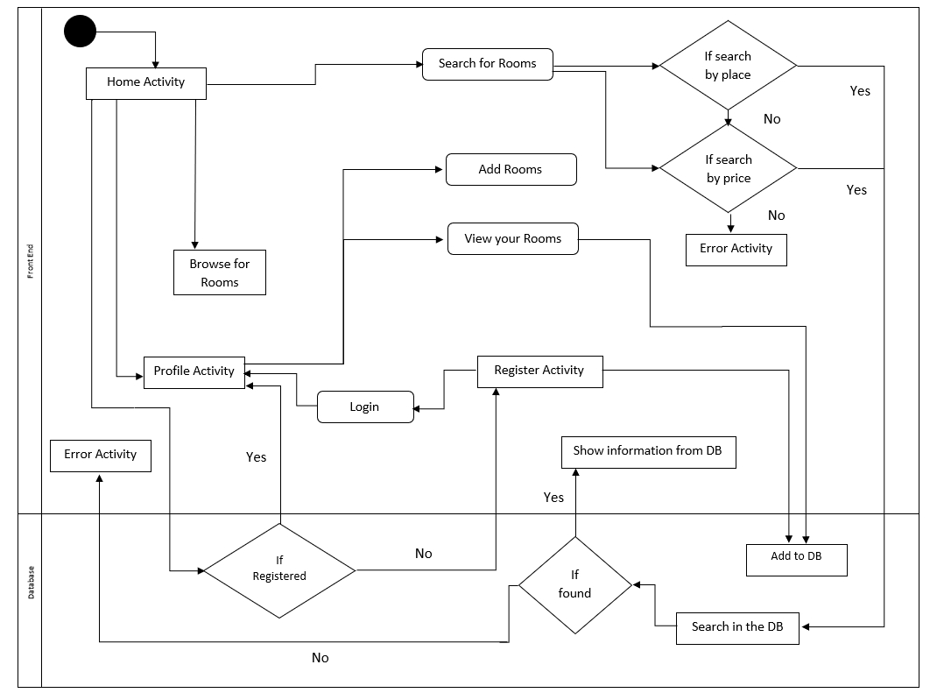

Figure 3.1: System Flow Diagram

### 

### (II)Data Flow

Figure 3.2: Dataflow Diagram

### (III) Use Case Diagram

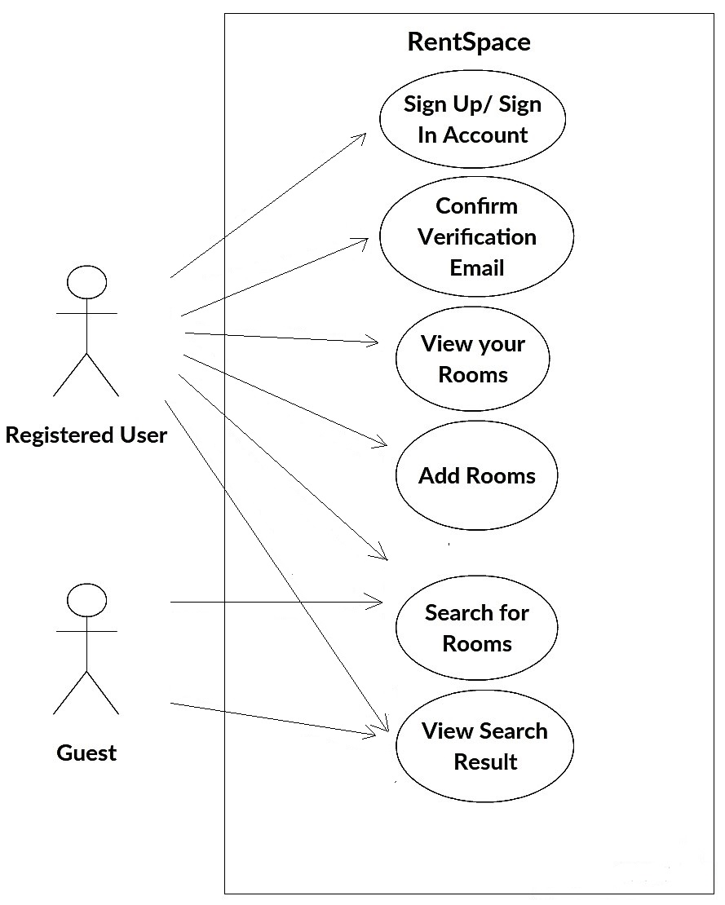

Figure 2.3: Use Case Diagram

## 3.2. Software Specifications

* For Android User

1.  OS: API level higher or Froyo version

* For Development

1.  32 or 64-bit OS

2.  Firebase Real-time Database

3.  Android Studio

4.  Web Browser

## 3. 3. Hardware Specification

* · For Android User

1.  RAM: minimum 512MB

2.  Memory: minimum 50MB space

* ·  For Development

1. RAM: 3GB minimum, 8GB Recommended

2.  Memory: 2 GB of available disk space minimum, 4 GB recommended

# Chapter 4:  Discussion on the Achievements

The group members had a great challenge in understanding and implementing the android platform because of the inexperience in the field. Despite the challenges, we made a significant progress along the way by studying and diving into the field of android development. The errors in the code took a long time to debug. The platform still may be lagging some features. Querying on the database, which was completely new to us, was a real challenge as multiple querying feature is not supported in Firebase and we had to work around it to keep up with the objectives. Regardless, the end result of the invested time is this application with most of the required features for a search based oriented platform.

When it comes to finding a rental space, decent rental space in a desired location is always the first priority. This application platform ensures us to find a rental space based on location and price. On inserting the desired location or price on the search box, the best matched rental spaces will automatically filter out. One can go through the details of the search results to find more details added by the landlords. Further selection based on decor and neighborhood, is up to the user to decide on. Thus, users as tenants can directly contact the landlords with the contact number displayed on the screen and make a deal.

# Chapter 5: Conclusion and Recommendation

The project concluded with most of its objectives fulfilled. We have made a user friendly android application where users cannot add any item without logging in the application but can also explore the application as a guest without signing in. A user can search rooms, apartments, offices, restaurants based on the location and price.  After all, the accomplished task is satisfactory but the important thing is we learned the necessary skills for android application designing and development.

## 5.1. Limitations

* The use of firebase database system as our main database restricted us to perform our main searching query only on one keyword at a time, rather than multiple keywords.
* Some dynamism to the application, including comment section, user reviews, and ratings will be added in the coming versions.

## 5.2. Future Enhancements

In the future, the android application will be updated and many features can be added according to the need of the people and from user feedbacks whenever feasible. The objectives that have not been met can be added in the upcoming days. We hope to make our application more useful and we will be working on it even after the semester because we find it very useful in the context of Kathmandu and Dhulikhel where peoples (mostly students) are finding it very hard to find a decent rental space within their price budget due to rent hike. Future version of this application will use an appropriate database system with multiple querying options to enhance the functionality of this application ensuring more dynamic searching experience

# References

* <https://developer.android.com/reference/android/app/Application> (Accessed 2018-05-15 )
* <https://developer.android.com/studio/> (Accessed 2018-06-15)
* <https://firebase.google.com/docs/database/admin/retrieve-data> (Accessed 2018-06-25)
* <https://stackoverflow.com/questions/26700924/query-based-on-multiple-where-clauses-in-firebase> (Accessed:2018-07-15)
* Ed Burnette, Hello, Android Introducing Google’s Mobile Development Platform, Fourth Edition, 2008