**Chicago Crime Analyzer Report**

**Problem Statement:**

The growing complexity of crime data challenges law enforcement in identifying patterns, high-risk areas, and trends. Limited insights hinder resource allocation, crime prediction, and safety measures. This project tackles these gaps by analysing crime data to provide actionable insights, enhancing crime prevention and public safety.

**Pandas-based Insights:**

***Insight 1***: Crime Trends Over the Year

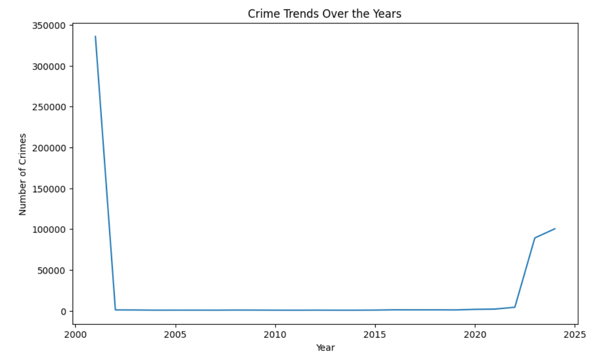

**Approach:**

* Extracted 'Year' column and counted crime occurrences.
* Sorted data in ascending order for trend analysis.
* Used a **line plot** to visualize crime trends over time.
* Set figure size (10,6) for clarity.
* Labeled axes and added a title for better interpretation.

**Visualization:** The line chart depicts the yearly trend in reported crime occurrences.

* The **y-axis** indicates the number of crimes.
* The **x-axis** represents the crime occurrence year.
* A **huge spike** appears in the early 2000s.
* Crime rates remain **low and stable** from 2005-2019.
* A **sharp increase in crime** occurs after 2020.

**Findings:**

* A significant drop in crime numbers after 2001.
* **Extended low crime rates** from 2005-2019.
* **Post-2020 surge** may indicate better reporting or new crime types.
* Further investigation needed into pandemic-era crime shifts**.**

**Actionable Insights:**

* **Verify early 2000s data** for inconsistencies or bulk entries.
* **Analyze crime categories** to identify emerging trends.
* **Check legal and reporting changes** affecting crime stats.
* **Investigate pandemic-era factors** contributing to the increase.
* **Compare crime data** with socio-economic conditions for patterns.

***Insight 2*: Crimes Reported by Time of Day**

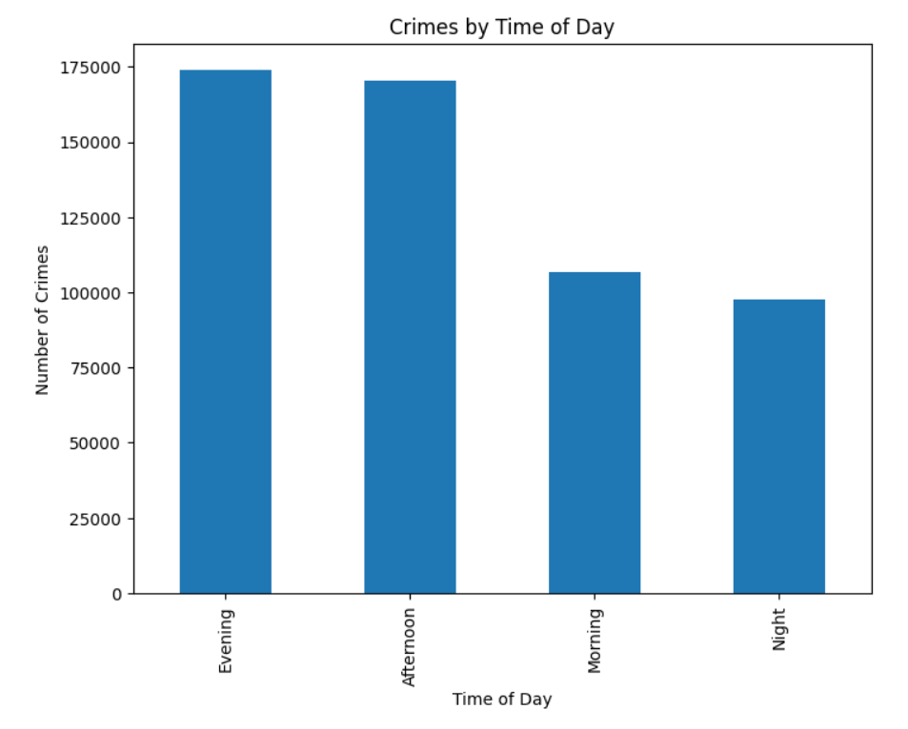

**Approach:**

* Extracted **'TimeOfDay'** column and counted occurrences.
* Used a **bar chart** to visualize crime distribution across time periods.
* Set **figure size (8,6)** for readability.
* Labeled axes and added a title for better clarity.
* Displayed trends in crime occurrences during different times of the day.

**Visualization Explanation:**

* The bar chart illustrates crime distribution across the four seasons.
* The **x-axis** denotes various seasons.
* The **y-axis** represents the total reported crime count.
* Each bar is labeled with exact crime figures for better clarity.

**Key Findings:**

* Peak crime hours occur in the Evening and Afternoon.
* Morning sees moderate crime, while Night has the least.
* Crimes align with high human activity and mobility.
* Possible reasons: work hours, social gatherings, and public exposure.
* Nighttime reduction may indicate stricter surveillance or lower activity.

**Actionable Insights:**

* **Increase security presence** during **Evening and Afternoon.**
* **Monitor hotspots** in high-crime periods for preventive actions.
* **Improve street lighting and surveillance** to deter crimes.
* **Implement public awareness campaigns** during peak crime hours.
* **Analyze crime types** in each time period for targeted prevention.

***Insight 3*: Crime Distribution – Domestic vs. Non-Domestic**

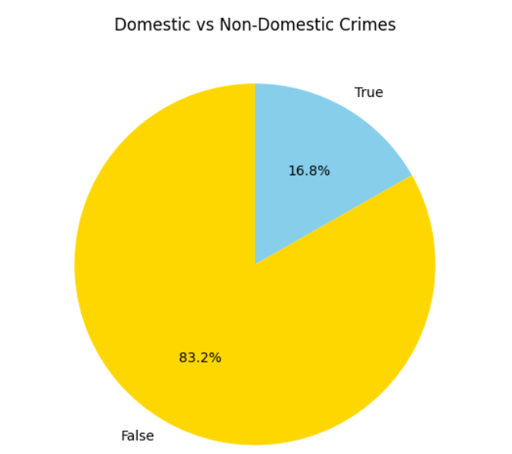

**Approach:**

* Extracted 'Domestic' crime column and counted occurrences.
* Created a pie chart to show the ratio of domestic vs. non-domestic crimes.
* Used gold and sky blue colors for clear differentiation.
* Set start angle to 90° for better visual alignment.
* Displayed percentage labels on each slice for clarity.

**Visualization Explanation:**

* The **pie chart** represents the proportion of domestic vs. non-domestic crimes.
* **83.2%** of crimes are non-domestic, while 16.8% are domestic.
* **Gold (Non-Domestic)** dominates the chart, highlighting external crimes.
* **Sky blue (Domestic)** represents a smaller share of total crimes.
* No **y-axis label** is needed since the chart uses percentages.

**Key Findings:**

* Non-domestic crimes are significantly higher than domestic crimes.
* Domestic crimes make up only 16.8% of total incidents.
* This suggests crime prevention should focus more on public spaces.
* Domestic crime, though lower, still requires targeted intervention.
* Further analysis can explore trends, locations, and patterns.

**Actionable Insights:**

* **Increase law enforcement** efforts in high-crime public areas.
* **Implement awareness programs** to address domestic violence cases.
* **Encourage victims** to report domestic crimes through secure channels.
* **Analyze crime hotspots** to allocate law enforcement resources efficiently.
* **Examine repeat offenders** in both domestic and non-domestic crime categories.

***Insight 4*: Crimes Reported by Primary Type**

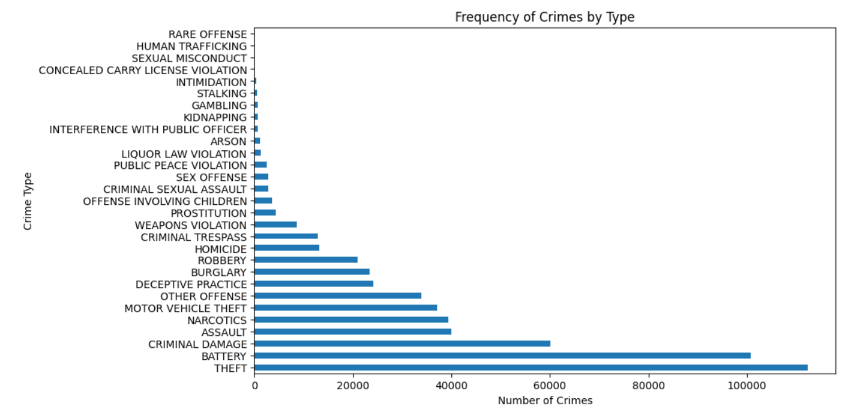

**Approach:**

* Extracted **'Primary_Type'** column and counted occurrences.
* Used a **horizontal bar chart** for better readability.
* Set **figure size (10,6)** for clear visualization.
* Labeled axes and added a title for context.
* Displayed crime types in descending order of frequency.

**Visualization Explanation:**

* The **bar chart** represents the frequency of different crime types.
* **Theft, Battery, and Criminal Damage** are the most common crimes.
* **Rare offenses, Human Trafficking, and Sexual Misconduct** have the least occurrences.

Crimes vary significantly in frequency, reflecting different risk levels.

* **Higher crime categories** indicate areas needing focused law enforcement.

**Key Findings:**

* **Theft is the most frequent crime**, followed by Battery and Criminal Damage.
* **Narcotics, Assault,** and **Motor Vehicle Theft** are also highly reported.
* **Crimes like Human Trafficking** and **Kidnapping** are rare but serious.
* Property-related crimes dominate, indicating security challenges.
* Crime prevention efforts should prioritize high-frequency offenses.

**Actionable Insights:**

* **Enhance theft prevention** with surveillance and security measures.
* **Strengthen law enforcement** in high-crime areas.
* **Increase awareness programs** for violent crimes like assault.
* **Monitor and control drug-related offenses** through targeted interventions.
* **Focus on emerging crime trends** to prevent future spikes..

***Insight 5*: Crimes Severity Distribution**

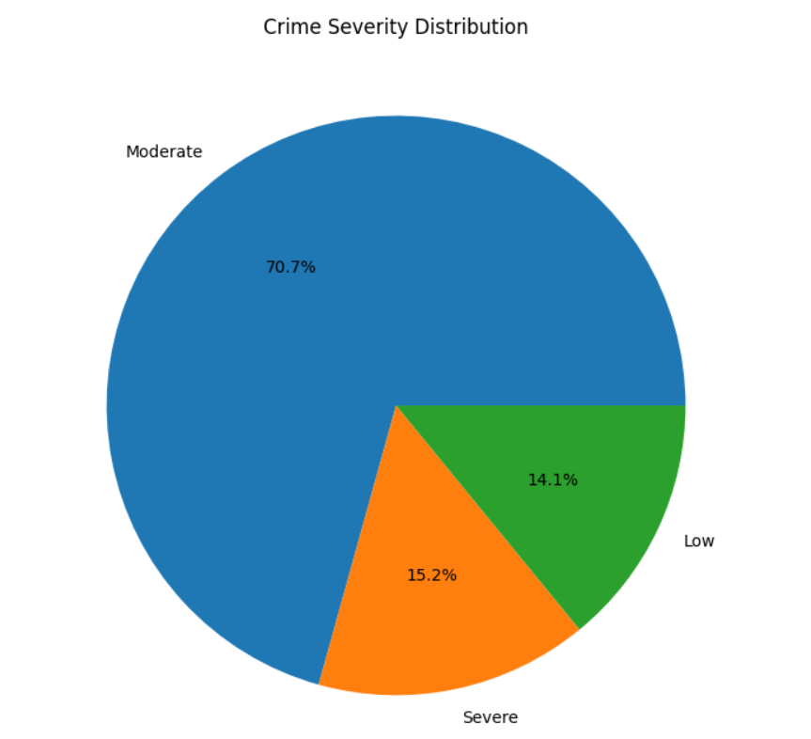

**Approach:**

* Extracted **'Severity'** column and counted occurrences.
* Created a **pie chart** to visualize the proportion of severity levels.
* Used **percentage labels** for clear representation.
* Set **figure size (8,8)** for better visibility.
* Removed y-axis label since it's unnecessary for a pie chart..

**Visualization Explanation:**

* The pie chart **categorizes crimes** into Low, Moderate, and Severe.
* **Moderate crimes dominate (70.7%)**, followed by **Severe (15.2%)** and **Low (14.1%)**.
* Most crimes are **moderately serious**, requiring focused interventions.
* **Severe crimes**, though fewer, demand **higher law enforcement attention.**
* **Low-severity crimes** suggest minor infractions or non-violent offenses

**Key Findings:**

* **Moderate crimes form the majority**, needing structured control measures.
* **Severe crimes are significant**, requiring strict legal actions.
* **Low-severity crimes** might include administrative or petty offenses.
* Law enforcement should **prioritize severe and high-impact crimes.**
* Crime prevention strategies should **address trends in severity.**

**Actionable Insights:**

* **Strengthen law enforcement** against severe crimes for public safety.
* **Implement targeted interventions** for moderate crime control.
* **Monitor trends in low-severity crimes** to prevent escalation.
* **Allocate more resources** to areas with higher severe crime rates.
* **Encourage community programs** to reduce moderate crime occurrences.

***Insight 6*: Crime And Arrest by Police over District**

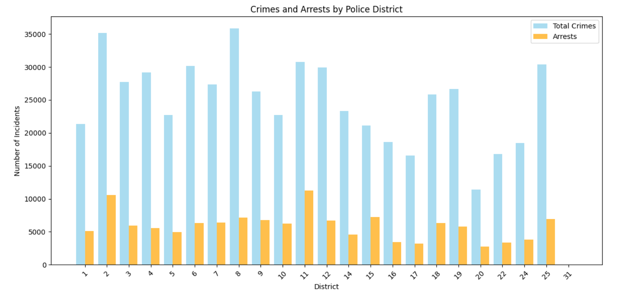

**Approach:**

* Extracted **total crimes and arrests** per police district.
* Used a **grouped bar chart** to compare crimes vs. arrests.
* Set **sky blue for total crimes** and **orange for arrests** for distinction.
* Adjusted **bar width** for clarity and better visualization.
* Rotated district labels for readability

**Visualization Explanation:**

* The bar chart compares **total crimes and arrests** across districts.
* **Total crimes (sky blue)** are significantly higher than **arrests (orange)** in all districts.
* Some districts have **higher crime rates** but **lower arrest counts.**
* Arrest rates vary, indicating **law enforcement efficiency differences.**
* The chart highlights **districts needing better crime control.**

**Key Findings:**

* Crime rates are much higher than arrests in most districts.
* Some districts show better arrest-to-crime ratios than others.
* High-crime districts need more police intervention and resources.
* Low-arrest areas may indicate inefficient law enforcement.
* Further analysis can explore why some areas have fewer arrests.

**Actionable Insights:**

* **Increase law enforcement presence** in high-crime districts.
* **Improve police efficiency** in low-arrest areas.
* **Enhance community engagement** for crime prevention.
* **Analyze arrest policies** to ensure effective legal action.
* **Allocate more resources** to districts with rising crime rates.

***Insight 7*: Crime Severity By Primary Type**

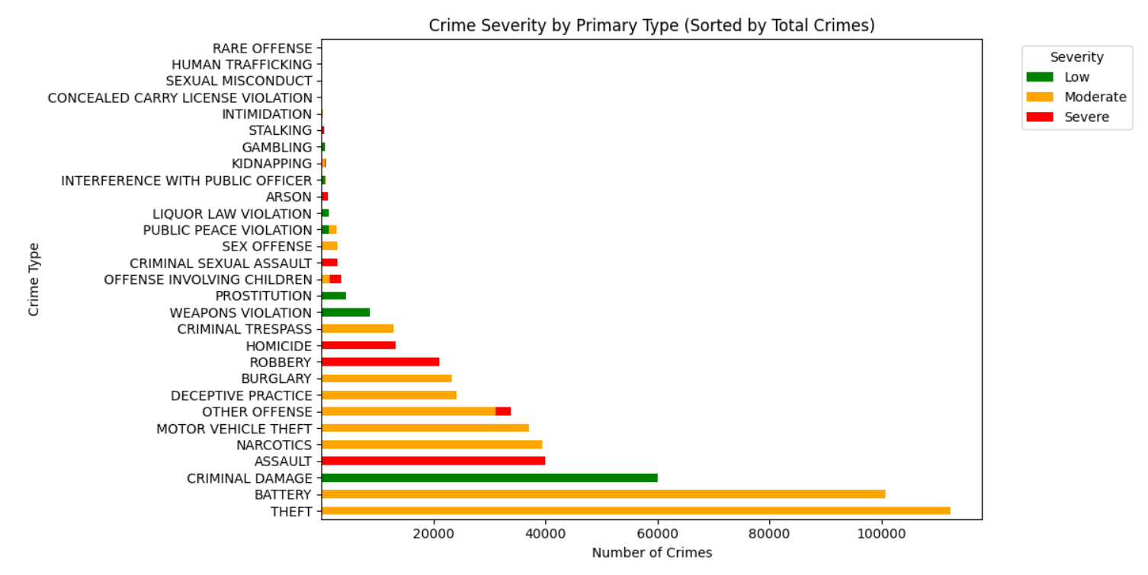

**Approach:**

* Grouped crimes by **Primary Type and Severity** using value counts.
* Summed total crimes per type and sorted them in **descending order**.
* Used **stacked horizontal bar chart** for better comparison.
* Assigned **colors (red, orange, green)** to severity levels.
* Adjusted legend position and layout for clarity.

**Visualization Explanation:**

* The **stacked bar chart** shows crime severity across different types.
* **Theft, Battery, and Criminal Damage** have the highest cases.
* **Severe crimes (red)** include **Homicide, Assault, and Sexual Assault**.
* **Moderate crimes (orange)** dominate most categories.
* **Low-severity crimes (green)** are fewer but still present.

**Key Findings:**

* **Theft is the most frequent crime**, mainly of **moderate severity**.
* **Violent crimes like Assault and Homicide** are mostly **severe**.
* **Property-related crimes** like **Burglary and Damage** are common.
* **Weapon violations have mixed severities**, requiring specific interventions.
* **Severe crimes need higher law enforcement attention.**

**Actionable Insights:**

* **Strengthen law enforcement** for severe crimes (homicide, assault).
* **Enhance security measures** in high-theft areas.
* **Implement rehabilitation programs** for repeat offenders.
* **Increase surveillance and patrolling** in crime hotspots.
* **Analyze crime trends** to prevent escalation to severe offenses.

***Insight 8*: Crime Severity by District**

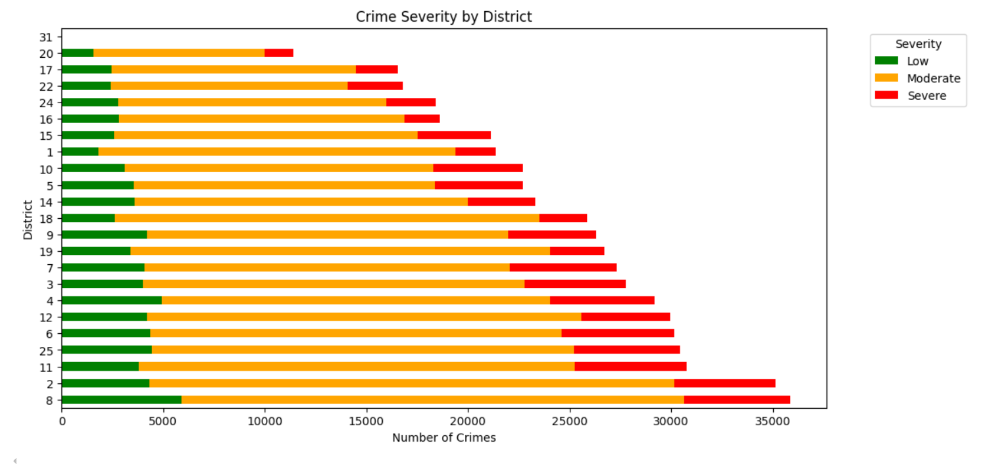

**Approach:**

* Grouped **crime severity by district** using value counts.
* Summed total crimes per district and **sorted in descending order**.
* Used a **stacked horizontal bar chart** for better comparison.
* Assigned **red (Severe), orange (Moderate), and green (Low)** colors.
* Adjusted **legend position** for clear interpretation.

**Visualization Explanation:**

* The **stacked bar chart** shows crime severity levels across districts.
* **Moderate severity crimes (orange) dominate most districts.**
* **Severe crimes (red) are high in certain districts,** requiring attention.
* **Low-severity crimes (green) appear consistently across all districts.**
* **Some districts show disproportionately high severe crime rates.**

**Key Findings:**

* High-crime districts also have higher severe crimes.
* Moderate crimes contribute most to overall crime rates.
* Some districts have an alarming proportion of severe crimes.
* Low-severity crimes are more evenly distributed.
* Law enforcement efforts should target high-severity districts.

**Actionable Insights:**

* **Increase police patrols** in high-severity crime districts.
* **Implement targeted interventions** for moderate-severity crimes.
* **Enhance crime prevention programs** in high-crime areas.
* **Allocate more resources** to districts with rising severe crimes.
* **Monitor low-severity crimes** to prevent escalation.

***Insight 9*: Top 10 Crime Hotspots by Block**

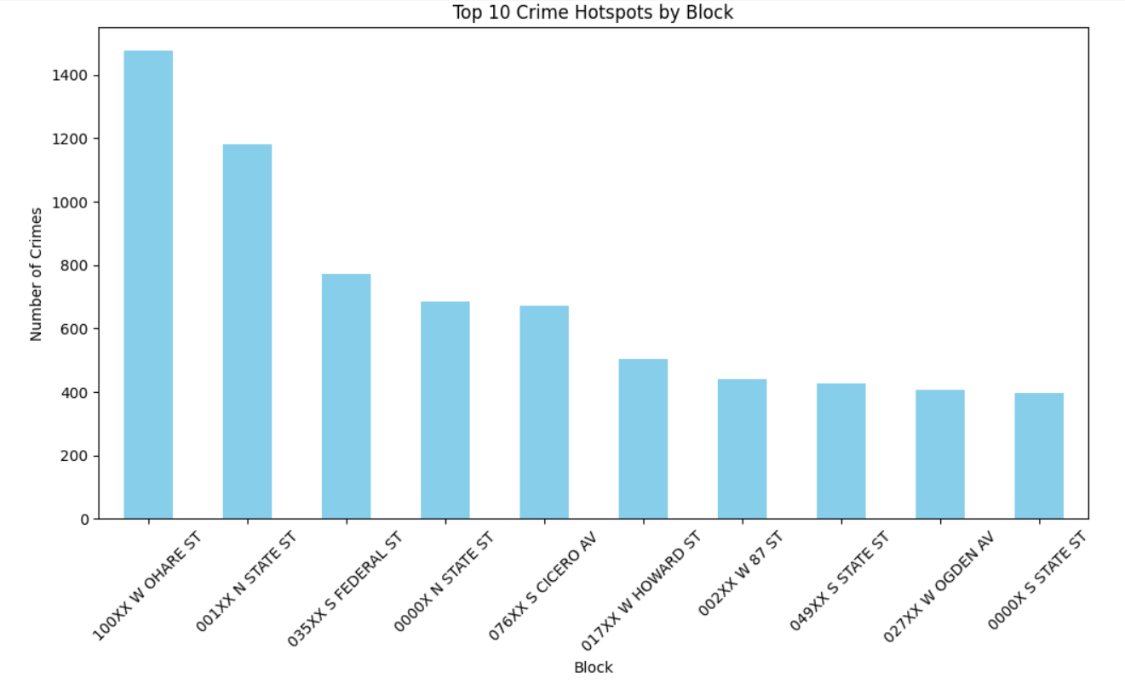

**Approach:**

* Extracted **crime occurrences by block** using value counts.
* Selected the **top 10 blocks with the highest crime rates.**
* Used a **bar chart** for clear comparison.
* Colored bars **sky blue** for visual distinction.

**Visualization Explanation:**

* The **bar chart highlights crime hotspots** across different blocks.
* **100XX W O'HARE ST** has the **highest crime count.**
* **Other blocks show varying but significant crime rates.**
* Certain areas have consistently **higher crime occurrences.**
* **Crime distribution varies** across different urban locations.

**Key Findings:**

* **Certain blocks experience significantly higher crime rates.**
* **High-crime areas may need targeted security interventions.**
* **Urban hotspots attract more criminal activities.**
* **Crime prevention measures should focus on these locations.**
* **Analyzing crime types in these blocks can guide policy actions.**

**Actionable Insights:**

* **Increase police patrols** in high-crime blocks.
* **Implement surveillance systems** in these hotspots.
* **Enhance community policing** to improve security.
* **Conduct in-depth analysis** of crime trends in these locations.
* **Improve street lighting and public safety measures.**

***Insight 10*: Crime Trends : Arrests vs Non-Arrest**

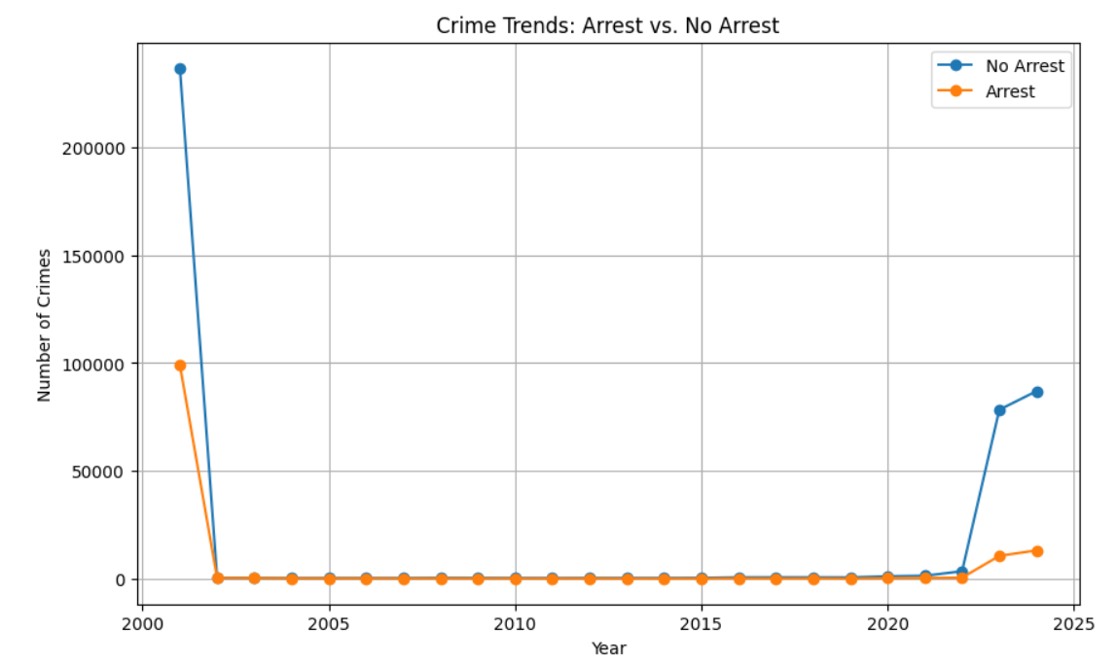

**Approach:**

* Grouped crime data by **Year** and **Arrest status**.
* Counted occurrences and **unstacked data** for separate trend lines.
* Used a **line chart** with markers for visibility.
* Differentiated **'No Arrest' (blue) and 'Arrest' (orange)** trends.
* Added gridlines and a **legend** for better readability.

**Visualization Explanation:**

* The **line chart** compares crime trends with and without arrests.
* **Crimes without arrests** are consistently higher.
* **Early 2000s show an extreme peak**, followed by a **flat period**.
* A **sudden rise in crime from 2020 onwards** is evident.
* **Arrests also increased post-2020** but remain significantly lower.

**Key Findings:**

* Crime data in early 2000s shows unusual spikes.
* Crimes with no arrests dominate throughout the years.
* Post-2020 crime surge aligns with global disruptions.
* Arrest rates do not match rising crime trends.
* Possible data gaps exist between 2005–2019.

**Actionable Insights:**

* **Investigate early 2000s crime spikes for anomalies.**
* **Improve law enforcement efficiency** to close arrest gaps.
* **Analyze post-2020 crime trends** for emerging patterns.
* **Enhance legal reforms** to boost conviction rates.
* **Address possible underreporting issues (2005-2019).**

***Insight 11*: Crime Trends Hour of the Day**

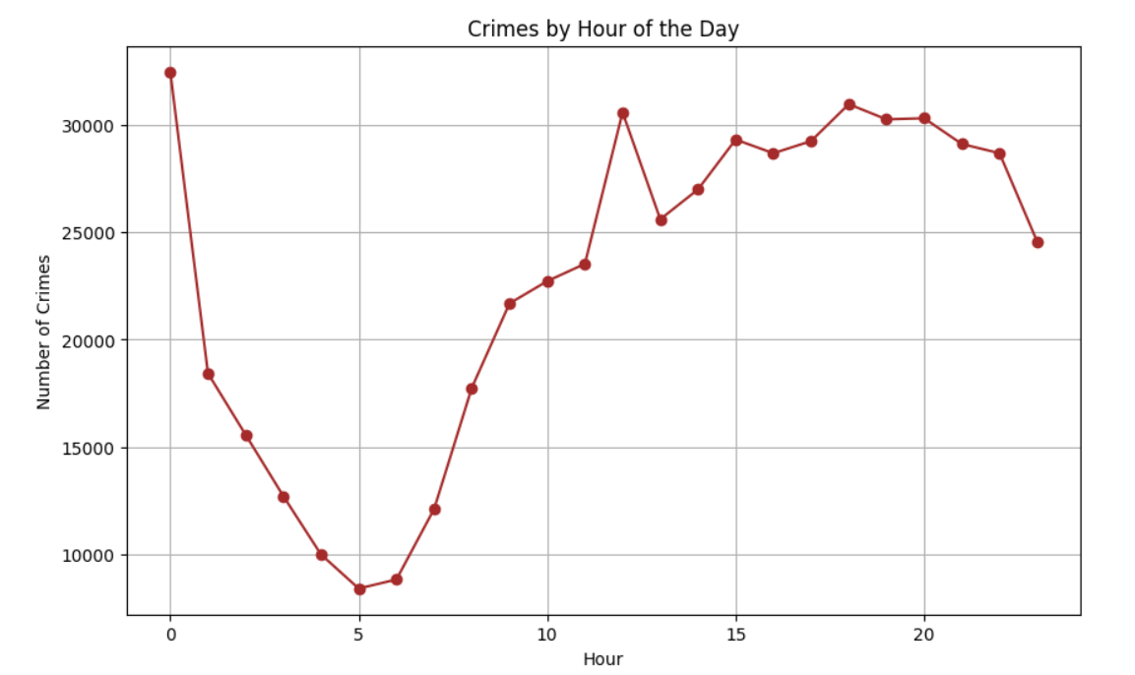

**Approach:**

* Grouped crime data by **Year** and **Arrest status**.
* Counted occurrences and **unstacked data** for separate trend lines.
* Used a **line chart** with markers for visibility.
* Differentiated **'No Arrest' (blue) and 'Arrest' (orange)** trends.
* Added gridlines and a **legend** for better readability.

**Visualization Explanation:**

* The **line chart** compares crime trends with and without arrests.
* **Crimes without arrests** are consistently higher.
* **Early 2000s show an extreme peak**, followed by a **flat period**.
* A **sudden rise in crime from 2020 onwards** is evident.
* **Arrests also increased post-2020** but remain significantly lower.

**Key Findings:**

* Crime data in early 2000s shows unusual spikes.
* Crimes with no arrests dominate throughout the years.
* Post-2020 crime surge aligns with global disruptions.
* Arrest rates do not match rising crime trends.
* Possible data gaps exist between 2005–2019.

**Actionable Insights:**

* **Investigate early 2000s crime spikes for anomalies.**
* **Improve law enforcement efficiency** to close arrest gaps.
* **Analyze post-2020 crime trends** for emerging patterns.
* **Enhance legal reforms** to boost conviction rates.

**Address possible underreporting issues (2005-2019).**

***Insight 11*: Crime Count By Location Type**

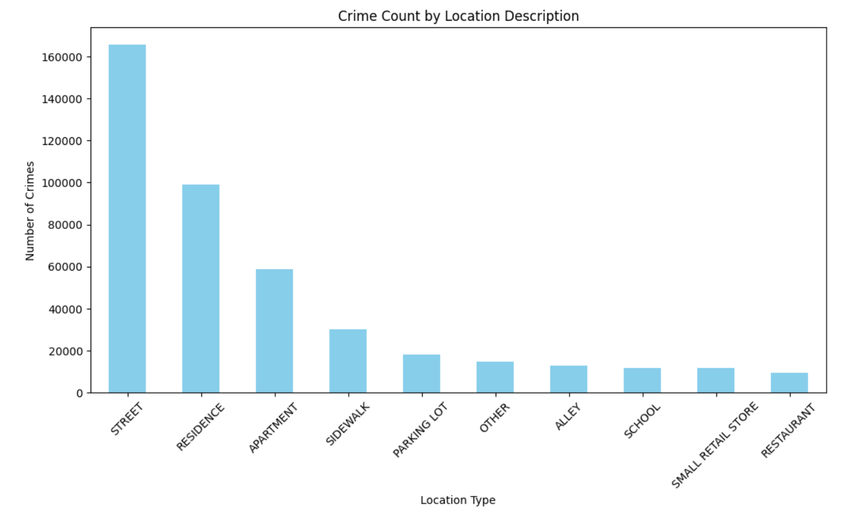

**Approach:**

* Grouped crimes by **location type** and counted occurrences.
* Sorted values in **descending order** to highlight top crime locations.
* Used a **bar chart** with **sky blue** for visual clarity.
* Rotated x-axis labels **(45°) for better readability.**
* Limited results to **top 10 high-crime locations.**

**Visualization Explanation:**

* The **bar chart** shows crime frequency across locations.
* **Streets have the highest crime rates,** followed by **residences.**
* **Public places (sidewalks, parking lots) have moderate crime.**
* **Retail stores, restaurants, and schools have lower crime rates.**
* Crime distribution highlights **risks in outdoor vs. indoor locations.**

**Key Findings:**

* Streets and residences are major crime hotspots.
* Apartments also face significant crime rates.
* Public spaces (sidewalks, parking lots) are vulnerable.
* Schools and restaurants report fewer crimes.
* Security should focus on high-risk locations.

**Actionable Insights:**

* **Increase street patrols** in high-crime areas.
* **Enhance residential security** with community policing.
* **Install surveillance cameras** in public spaces.
* **Improve safety measures** in apartments.
* **Analyze crime types per location for prevention.**