AN AI-POWERED VOICE RECEPTIONIST FRAMEWORK FOR SMART CAMPUS COMMUNICATION AND INFORMATION ACCESS

PHASE I PROJECT REPORT

Submitted by

KAMALESH S P | 2116230701138
AKASH N | 2116230701019
SUBRAMANI A | 2116230701347
GURU RAJA T | 2116230701502

in partial fulfillment for the award of the degree of
BACHELOR OF ENGINEERING

IN

COMPUTER SCIENCE AND ENGINEERING



RAJALAKSHMI ENGINEERING COLLEGE, CHENNAI

ANNA UNIVERSITY, CHENNAI – 600 025

DECEMBER 2026

RAJALAKSHMI ENGINEERING COLLEGE, CHENNAI ANNA UNIVERSITY, CHENNAI - 600 025
BONAFIDE CERTIFICATE

Certified that this Report titled “AN AI-POWERED VOICE RECEPTIONIST FRAMEWORK FOR SMART CAMPUS COMMUNICATION AND INFORMATION ACCESS” is the bonafide work of KAMALESH S P (230701138), AKASH N (230701019), SUBRAMANI A (230701347), and GURU RAJA T (230701502) who carried
out the work under my supervision. Certified further that to the best of my knowledge the work reported herein does not form part of any other thesis or dissertation on the basis of which a degree or award was conferred on an earlier occasion on this or any other candidates.

“This project directly aligns with UN Sustainable Development Goals 4, 9, and 16 by enhancing access to educational information, promoting AI-driven innovation, and supporting secure, reliable, and accountable institutional communication.”

SIGNATURE
Dr. J. Manoranjini, Professor and Head,
Department of Computer Science and Engineering,
Rajalakshmi Engineering College, Chennai – 602 105.

SIGNATURE

Mr. B. BHUVANESWARAN, SUPERVISOR,
Assistant Professor (SG),
Department of Computer Science and Engineering,
Rajalakshmi Engineering College, Chennai – 602 105.

Submitted to Project Viva-Voce Examination held on .

Internal Examiner External Examiner

ABSTRACT

Educational institutions get a large number of telephone calls regarding admissions, academic programs, departments, fee structure, hostel facilities, placements, examinations and student services. Doing this manually increases the receptionist’s workload, the waiting time, and the chances of delivering inconsistent information. To address these issues, this project presents an AI-Powered Voice Receptionist Framework for Smart Campus Communication and Information Access by integrating Speech-to-Text (STT), Retrieval-Augmented Generation (RAG), Large Language Models (LLMs), and Text-to-Speech (TTS) for automated telephone communication. The system receives the calls through a telephony interface and converts the speech into text by a STT module. The query is processed through a RAG pipeline, which retrieves relevant information from an institutional knowledge base consisting of official college website content, PDF documents, circulars, handbooks, academic information, facilities, placements and events. The retrieved context is fed to an LLM to generate an accurate and grounded response. The response is synthesized to speech using TTS and played back to the caller. Conversation history enables multi-turn interactions and contributes to consistent responses.

ACKNOWLEDGMENT

Initially we thank the Almighty for being with us through every walk of our life and showering his blessings through the endeavor to put forth this report. Our sincere thanks to our Chairman Mr. S. MEGANATHAN, B.E, F.I.E., our Vice Chairman Mr. ABHAY SHANKAR MEGANATHAN, B.E., M.S., and
our respected Chairperson Dr. (Mrs.) THANGAM MEGANATHAN, Ph.D., for providing us with the requisite infrastructure and sincere endeavoring in educating us in their premier institution.

Our sincere thanks to Dr. S.N. MURUGESAN, M.E., Ph.D., our beloved Principal for his kind support and facilities provided to complete our work in time. We express our sincere thanks to Dr. J. Manoranjini, Ph.D., Professor and Head of the Department of Computer Science and Engineering for his guidance and encouragement throughout the project work. We convey our sincere and deepest gratitude to our internal guide, Mr. B. BHUVANESWARAN, M.E., Assistant Professor (SG), Department of Computer Science and Engineering for his valuable guidance throughout the course of the project. We thank our Project Coordinator, Dr.
S. Madhusudhanan, Ph.D., Associate Professor, Department of Computer Science and Engineering for his useful tips during our review to build our project.

KAMALESH S P | 2116230701138
AKASH N | 2116230701019
SUBRAMANI A | 2116230701347
GURU RAJA T | 2116230701502

TABLE OF CONTENTS

CHAPTER NO. | TITLE |  |  |  | PAGE NO.
 | ABSTRACT |  |  |  | iii
 | ACKNOWLEDGMENT |  |  |  | iv
 | LIST OF TABLES |  |  |  | vii
 | LIST OF FIGURES |  |  |  | viii
 | LIST OF ABBREVIATIONS |  |  |  | ix
1. | INTRODUCTION |  |  |  | 1
 |  | 1.1 GENERAL |  |  | 1
 |  | 1.2 OBJECTIVES |  |  | 2
 |  | 1.3 EXISTING SYSTEM |  |  | 2
 |  | 1.4 PROPOSED SYSTEM |  |  | 3
2. | RELATED WORKS |  |  |  | 6
 |  |  | 2.1 LITERATURE SURVEY |  | 6
 |  |  | 2.2 COMPARISON AND DISCUSSION |  | 12
 |  |  | 2.3 CONCLUSION |  | 13
3. | PROPOSED SYSTEM |  |  |  | 14
 |  | 3.1 SYSTEM ARCHITECTURE |  |  | 14
 |  | 3.2 SYSTEM REQUIREMENTS |  |  | 16
 |  |  |  | 3.2.1 SOFTWARE REQUIREMENTS | 16
 |  |  |  | 3.2.2 HARDWARE REQUIREMENTS | 19
 |  |  |  | 3.2.3 DATASET REQUIREMENTS | 21
 |  | 3.3 SYSTEM DESIGN |  |  | 21
 |  |  |  | 3.3.1 ACTIVITY DIAGRAM | 22
 |  |  |  | 3.3.2 DATA FLOW DIAGRAM | 23
4. | MODULE DESCRIPTION |  |  |  | 26
 |  | 4.1 METHODOLOGIES |  |  | 26
 |  | 4.2 MODULES |  |  | 26
 |  |  |  | 4.2.1 TELEPHONY GATEWAY MODULE | 27
 |  |  |  | 4.2.2 SPEECH PROCESSING MODULE | 27
 |  |  |  | 4.2.3 KNOWLEDGE BASE AND RAG MODULE | 29
 |  |  |  | 4.2.4 LLM AND CONVERSATION MODULE | 30
 |  |  |  | 4.2.5 RESPONSE AND HUMAN ESCALATION MODULE | 31
5. | IMPLEMENTATION AND RESULTS DISCUSSION |  |  |  | 33
 |  | 5.1 IMPLEMENTATION RESULTS |  |  | 33
 |  |  |  | 5.1.1 DIRECT RAG EVALUATION | 33
 |  |  |  | 5.1.2 RAGAS EVALUATION | 34
 |  |  |  | 5.1.3 ARES-INSPIRED EVALUATION | 35
 |  |  |  | 5.1.4 OVERALL EVALUATION DISCUSSION | 36
6. | CONCLUSION AND FUTURE WORKS |  |  |  | 38
 |  | 6.1 CONCLUSION |  |  | 38
 |  | 6.2 FUTURE WORKS |  |  | 38
7. | REFERENCES |  |  |  | 40
8. | PUBLICATION STATUS |  |  |  | 42
 |  | 8.1 AI SCORE REPORT |  |  | 42
 |  | 8.2 PLAGIARISM REPORT |  |  | 42
 |  | 8.3 CONFERENCE PAPER |  |  | 43
 |  | 8.4 ACCEPTANCE LETTER |  |  | 50
 |  | 8.5 PAYMENT PROOFS |  |  | 51

LIST OF TABLES

TABLE NO. | TITLE | PAGE NO.
3.1 | SOFTWARE REQUIREMENTS | 17
3.2 | HARDWARE REQUIREMENTS | 19

LIST OF FIGURES

FIGURE NO. | TITLE | PAGE NO.
1.1 | Overview of the Proposed System Architecture | 4
3.1 | Architecture Diagram for the Entire System | 15
3.2 | Activity Diagram of the System | 22
3.3 | Data Flow Diagram of the System | 24
5.1 | Direct RAG Evaluation Performance | 34
5.2 | RAGAS Evaluation Performance | 35
5.3 | ARES-Inspired Evaluation Performance | 36
8.1 | AI Score Report | 42
8.2 | Plagiarism Report | 42
8.3 | Payment Proofs | 52

LIST OF ABBREVIATIONS

SL. NO. | ACRONYM | EXPANSION
1 | AI | Artificial Intelligence
2 | API | Application Programming Interface
3 | LLM | Large Language Model
4 | VOIP | Voice over Internet Protocol
5 | SIP | Session Initiation Protocol
6 | STT | Speech-to-Text
7 | VAD | Voice Activity Detection
8 | RAG | Retrieval-Augmented Generation
9 | ML | Machine Learning
10 | WER | Word Error Rate
11 | PDF | Portable Document Format
12 | Top-K | Top K Retrieved Results
13 | TTS | Text-to-Speech
14 | DTMF | Dual-Tone Multi-Frequency
15 | PCM | Pulse Code Modulation
16 | PBX | Private Branch Exchange
17 | ONNX | Open Neural Network Exchange
18 | WSL | Windows Subsystem for Linux
19 | CSV | Comma Separated Values

CHAPTER 1 INTRODUCTION
  - GENERAL
Educational institutions receive a large number of telephone queries from students, parents and other callers regarding admissions, courses, departments, fee structures, hostel facilities, placements, examinations, academic activities and campus services. Such repeated queries are dealt with manually by the reception staff resulting in increased waiting time and inconsistent delivery of institutional information. Access to important college information is also affected by limited availability outside of regular business hours. These challenges lead to a requirement for an intelligent and automated communication system that can provide a reliable information in a natural voice interaction.

To address these issues, this paper proposes an AI-Powered Voice Receptionist Framework for Smart Campus Communication and Information Access using Speech-to-Text (STT), Retrieval-Augmented Generation (RAG), Large Language Models (LLMs) and Text-to-Speech (TTS). The query is then processed through the RAG pipeline which pulls relevant information from an institutional knowledge base which includes content from the official college website, PDF documents, circulars, handbooks, academic information, facilities, placements, events and notices. The retrieved context is given to the LLM to generate a grounded response, which is then converted to natural speech using TTS and delivered to the caller. This method provides consistent and readily available college communication, reduces the burden of repetitious receptionist queries and increases timely access to important institutional information by the callers.

OBJECTIVE

The main aim of this project is to develop a Voice Based AI Receptionist Agent to automate College Telephone communication and to provide correct information of the institution through natural voice interaction. The system is designed to convert the speech of the caller to text using Speech to text (STT), retrieve relevant information from the college knowledge base using Retrieval Augmented Generation (RAG) and generate responses based on context using Large Language Models (LLMs).
The other goal of the project is to convert the generated responses to natural speech using Text to Speech (TTS) and support multi-turn conversations to provide better caller experience. It is designed to provide instant and consistent answers to frequently asked questions, relieving pressure on reception staff, reducing waiting times, improving access to information about the college and providing reliable communication when the college is closed.

EXISTING SYSTEM

At present the college communication system relies heavily on human reception staff to answer the calls of prospective students, parents and current students. The receptionists attend to queries concerning admission, courses, departments, fee structure, hostel facilities, placement, academic calendar, examination and other student services. These are queries handled manually so the reception staff have to repeatedly provide similar information to different callers. The number of calls may be high during busy periods such as admissions, examinations and placement drives leading to increase workload and longer time for callers to wait.
Another major disadvantage is the lack of 24×7 phone support. Reception services are available during normal working hours. Calls received outside of normal working hours (including evenings, weekends and holidays) may not be answered. One of the problems with the current approach is that it can lead to information being standard

because it is inconsistent, as different staff members may give different answers, depending on their knowledge and access to updated institutional documents. There is no automated voice system that can understand natural language telephone queries and retrieve relevant information directly from the college’s institutional resources.

The college website already has an entry point for an AI assistant, “Ask Aadhi”, which is an example of the use of AI for institutional interaction. However the telephone communication channel is not covered by the current system. So routine queries still require a lot of manual help and Not having an intelligent voice system means that information cannot be automatically accessible and more work is put on reception staff. These constraints demand a voice solution, which can understand the caller’s questions, provide consistent information about the institution, and create a more efficient and accessible communication channel with the college.

PROPOSED SYSTEM

The proposed system is a Voice-Based AI Receptionist Agent to automate the college telephone communication using Speech to Text (STT), Retrieval Augmented Generation (RAG), Large Language Models (LLMs) and Text to Speech (TTS). It provides a medium for the callers to communicate with the college through voice and get information about ad-missions, academics, departments, facilities, placements, events and other institutional information that is available to the public. The system takes the voice query from the caller, transcribes the speech into text, searches the institutional knowledge base for related information, and then uses a large language model (LLM) to generate a contextually grounded response. The response is then synthesised to speech and provided to the caller. Multi-turn conversations keep conversation history. If the information is lacking, or the AI is unable to answer confidently, the call is sent to a human receptionist. Phase 1: Public institutional information only Phase 1 has no personalised student data or authentication.

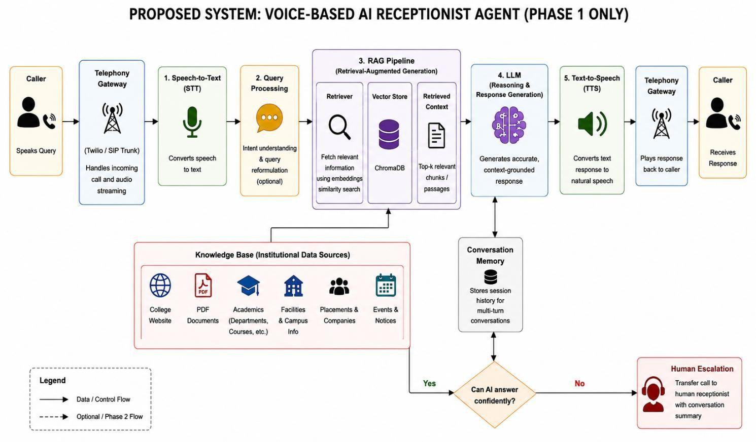

Figure 1.1: Overview of the Proposed System Architecture

The proposed system is an end to end voice processing pipeline for automating college telephone communications. The first step is with the Caller.The Caller initiates the conversation by uttering a query. The Telephony Gateway receives the incoming call and facilitates the audio stream between the caller and the AI system. The Speech-to-Text (STT) module then transcribes the caller's speech to text. The converted query is processed to understand the intent of the caller and if needed to reframe the query for efficient retrieval.

The processed query is sent to the Retrieval-Augmented Generation (RAG) Pipeline that performs similarity-based retrieval to extract relevant information from the institutional knowledge base. The RAG pipeline includes a Retriever, Vector Store, and Retrieved Context. The knowledge base has information collected from college

website, PDF documents, academic information, facilities and campus information, placements and companies, events and notices. The retrieved relevant context is then fed to the large Language Model.
The retrieved context is used by the Large Language Model (LLM) to generate an accurate, context-grounded response. The system also has Conversation Memory to keep session history, and offer multi-turn, context-aware interactions. This allows the system to take into account previous conversations when responding to follow-up questions. The generated response is then sent to the Text-to-Speech (TTS) module, which converts the text response into natural speech.
Finally the generated voice response is returned to the caller by the Telephony Gateway. If the AI is not confident enough to provide an answer to the query, the system does a Human Escalation and transfers the call to a human receptionist with the summary of the conversation. Thus, the entire pipeline allows for automated voice communication, with humans ready to help out whenever the AI is not confident enough to deal with the query.

CHAPTER 2 RELATED WORKS

This section of the paper, provides an all-round review about multiple existing systems that holds similar objective and problem statements as that of the proposed project. The study of these existing papers will produce valuable insights for the construction of the proposed system.

LITERATURE SURVEY
- Voice Assistant vs. Chatbot – In the paper, Rzepka, Berger and Hess discuss the suitability of voice assistants and chatbots for information-search tasks. This work presents a user experiment with 116 participants comparing speech- and text-based conversational agents. Results show that voice interaction offers better perceived efficiency, lower cognitive effort, more enjoyment and higher service satisfaction than touch interaction for several information-search tasks. The study also demonstrates that the success of speech interaction is dependent on the task type. The research is mainly focused on comparing voice and text interaction modalities and not on developing a domain specific voice receptionist. The system does not use Retrieval-Augmented Generation (RAG), institutional knowledge retrieval, or college communication via telephone.
- Robust Speech Recognition via Large-Scale Weak Supervision – In their paper, Radford et al. introduce Whisper, a robust automatic speech recognition system trained with large-scale weakly supervised data. The model is trained on approximately 680k hours of multilingual and multitask audio data scraped from the web. The system demonstrates strong generalisation for various speech recognition datasets and works reliably without dataset-specific fine-tuning. The approach is very useful in converting spoken queries to text in voice based applications. The paper, however, focuses mainly on speech recognition and does not provide information retrieval, LLM-based response generation, or telephone-based conversational communication. So you need additional RAG, LLM and telephony stuff to create a complete AI receptionist.

- SpeechT5: Unified-Modal Encoder-Decoder Pre-Training – The Paper By Ao et al. introduce SpeechT5, a unified encoder-decoder framework for spoken language processing. The system learns common representations between speech and text by using a shared encoder-decoder network coupled with modality-specific components. We use cross-modal vector quantisation to relate speech and text in a common representation space. The framework is evaluated on several tasks, including automatic speech recognition, speech synthesis, speech translation, voice conversion, and speech enhancement. Our results show the effectiveness of unifying speech and text modelling for various spoken-language applications. However, the proposed framework mainly focuses on speech processing and does not provide institutional information retrieval, RAG-based generation, or telephone receptionist functionality.
- FastSpeech 2: Fast and High-Quality End-to-End Text to Speech – In this paper, Ren et al. propose a fast and high quality text-to-speech synthesis system, FastSpeech 2. The model employs a non-autoregressive architecture for efficient speech generation, which solves the problems of the previous FastSpeech model. This approach models the information related to speech directly. It improves the quality and efficiency of the speech synthesized. The potential usefulness of fast speech generation for real-time voice-response applications was demonstrated in studies. However, this paper only considers the text-to-speech part without involvement of speech recognition, information retrieval or conversational question answering. FastSpeech 2 only produces speech generation component so you need to combine it with other technologies to build feature rich voice based receptionist.
- YourTTS: Zero-Shot Multi-Speaker TTS – In This Paper, Casanova et al., present YourTTS, a multilingual zero-shot text-to-speech and voice-conversion system based on the VITS architecture. This system is able to perform multi-speaker speech synthesis and synthesizing speech for unseen speakers. The results are also promising for low-resource languages and show effective zero-shot multi-speaker TTS and voice conversion performance. Research suggests

that it is possible to make natural flexible synthetic voices for voice-based applications. However, the proposed system focuses on speech synthesis and does not address caller queries, institutional knowledge retrieval, or LLM-based response generation. Thus, TTS technology must be combined with STT, RAG and LLM components to construct a complete AI receptionist.
- Improving Language Models by Retrieving from Trillions of Tokens – In This Paper, Borgeaud et al., introduce the Retrieval-Enhanced Transformer (RETRO), which improves language-model performance by retrieving chunks of relevant documents from a large external database during generation. The system combines a retriever with a language model to retrieve more information from an external knowledge source rather than relying solely on the model’s parameters. Research shows retrieval can improve performance on knowledge-heavy language tasks without the need for very large language models. This work points out the importance of utilizing external information when generating language. However, the system is based on a very large general purpose database and is not aimed at small institution-specific knowledge base or voice-based communication.
- Improving the Domain Adaptation of RAG Models – In This Paper, Siriwardhana et al. . Domain adaptation of Retrieval-Augmented Generation models for open domain question answering. The authors point out that conventional RAG systems are typically evaluated on general knowledge sources and may not perform well when adapted to domain-specific applications. We propose RAG-end2end, which adapts both the retrieval and the generation parts for domain-specific knowledge bases. Experiments in different domains show that our approach improves upon the original RAG approach. The proposed system is relevant to this work as college information is a specialized institutional domain and such domains need specialized retrieval. But the research doesn't cover voice communication, telephone integration or an automated college receptionist.

Retrieval-Augmented Generation for Large Language Models: A Survey –

In this paper, Gao et al. [Gao et al., 2023] give detailed surveys on Retrieval-Augmented Generation for Large Language Models. The paper discusses RAG for linking language models with external knowledge bases for the purpose of addressing hallucination, stale knowledge, and limited model knowledge problems. In the paper the main stages of RAG are described: retrieval, augmentation and generation. It also classifies RAG approaches into three categories: Naive RAG, Advanced RAG, and Modular RAG. They also talk about evaluation methods and main challenges of RAG based systems. The work provides a good foundation for developing knowledge-based applications. However, this is a survey of RAG techniques, and not a specific implementation for voice based communication or telephone receptionist systems.
- In-Context Retrieval-Augmented Language Models – In this paper, Ram et al. (2021) propose an in-context retrieval augmented language modelling method. In this method, relevant documents from an external knowledge source are retrieved and given to the language model at the time of generation. This work shows how to use retrieved information in the model context to improve performance on knowledge-intensive language tasks. The proposed system is related to this approach, as the institutional information retrieved from the knowledge base can be provided to the LLM before generating the final answer. This enables the language model to make use of external information and not depend solely on its internal knowledge. But the research is mainly on language modelling and retrieval and does not include telephone communication, speech-to-text or text-to-speech components.
- RAGTruth: A Hallucination Corpus for Trustworthy RAG – In This Paper, Niu et al., RAGTruth: A Hallucination Corpus for Studying and Developing Trustworthy Retrieval-Augmented Generation Systems. The authors say RAG can help reduce hallucinations, but responses generated by it could still contain information that is not supported by or contradicts the data. The corpus is a large collection of naturally generated RAG responses with case-level and word-level annotations for studying hallucination

behavior. The dataset is useful for analyzing and improving the reliability of RAG-generated responses. This work is important for the proposed AI receptionist; the answers should be based on official institutional information and should not be unsupported answers. However, the research is mostly about hallucination analysis, not voice interaction and telephone automation.
- Self-RAG: Learning to Retrieve, Generate, and Critique – In This Paper, Asai et al. propose a framework called Self-RAG, which combines retrieval, generation and self-reflection to improve the factuality and quality of the responses generated by language models in the paper. The system retrieves information on demand and uses reflection mechanisms to evaluate retrieved segments and generated answers. The experiments demonstrate improvements on tasks including open-domain question answering, reasoning, fact checking and citation accuracy. The approach stresses the importance of evaluating both the retrieved information and the generated responses to improve grounded generation. However, the Self-RAG architecture is more complex than the standard RAG pipeline needed for the proposed Phase 1 system. It does not specifically address telephone based college communication or speech interaction.
- Adaptive-RAG: Learning to Adapt RAG through Question Complexity – In the paper by Jeong et al., they propose Adaptive-RAG, which chooses a suitable retrieval strategy according to the complexity of the incoming question. Question complexity is detected using a classifier, and can be used to dynamically choose between no retrieval, single-step retrieval and more advanced retrieval strategies. Experiments on open-domain question answering datasets demonstrate efficiency and accuracy improvements over fixed retrieval approaches. The work is relevant to query processing because different questions of the caller may demand different levels of information retrieval. However, the proposed method emphasizes on adaptive question answering and not on speech processing, telephone integration or college-specific institutional knowledge base.

- RAGAs: Automated Evaluation of Retrieval-Augmented Generation – In This Paper,Es et al., propose RAGAs, an automated and reference-free framework to evaluate Retrieval-Augmented Generation systems. The framework evaluates several aspects of a RAG pipeline including the relevance of the retrieved context, the fidelity of the generated response to the retrieved information, and the quality of the final answer. This approach enables the evaluation of RAG systems without the need of a large set of human-written reference answers. The study shows that automated evaluation is useful for assessing retrieval and generation quality. This work is related to the proposed system since the quality of retrieved institutional information and generated answers should be evaluated. However, RAGAs is designed to evaluate RAG pipelines, not speech recognition, speech synthesis or telephone communication.
- ARES: An Automated Evaluation Framework for RAG Systems – In This Paper,Saad-Falcon et al. ARES: A framework for automatic evaluation of Retrieval-Augmented Generation systems. The framework uses lightweight language-model judges and synthetic training data to assess RAG important properties such as context relevance, answer faithfulness and answer relevance. The reliability of the evaluation is also taken into account by injecting a small amount of human annotated information. The experimental results show that the proposed framework can effectively evaluate RAG systems on knowledge-intensive tasks and domains. This is helpful in measuring reliability and quality of responses generated from the retrieved institutional information. But ARES is about automated evaluation of RAG and does not cover the full speech-to-speech workflow required for a voice-enabled receptionist.
- User Interaction Patterns and Breakdowns in LLM-Powered Voice Assistants – In this paper, Mahmood et al. examine user interactions and conversational failures in large language model-powered voice assistants. They built an LLM-based voice assistant and tracked users’ interactions with

it over a range of conversational situations. In this study we examine issues such as intent recognition, interaction behaviour and conversational breakdowns and show the significance of contextual understanding for LLM-based voice interaction. Results show that LLMs can enable more natural conversations compared to traditional techniques for voice assistants. The study focuses on user interactions and conversational breakdowns, and does not include a RAG knowledge base specific to an institution. However it does not deal specifically with automated college telephone reception and institutional information retrieval.

COMPARISON AND DISCUSSION
The reviewed papers show that recent research has made great progress in voice-based interaction, speech processing, Retrieval-Augmented Generation (RAG), Large Language Models (LLMs), and automated evaluation. Voice assistant studies show that speech-based interaction is an effective and convenient way for information access, and Whisper and SpeechT5 provide effective methods for speech recognition and spoken-language processing. FastSpeech 2 and YourTTS emphasise the importance of fast, high-quality and natural speech synthesis for voice applications. RETRO, domain-adapted RAG and in-context RAG show that external information can improve language-model responses in knowledge retrieval. RAGTruth, Self-RAG, and Adaptive-RAG also tackle hallucination, factuality, retrieval quality, and query complexity. RAGAs and ARES give us handy approaches for assessment of retrieval quality, relevance of context, faithfulness and generated responses.

However, the majority of the studies reviewed are on individual technologies or general-purpose conversational systems and not on institution-specific communication. These technologies are integrated in the proposed system in a single voice based college receptionist architecture. It processes caller questions using Speech-to-Text (STT), retrieves relevant official institutional information

using RAG with ChromaDB, generates grounded responses using an LLM, and delivers responses through the voice using Text-to-Speech (TTS). Conversation memory allows multi-turn interaction and confidence checking helps to identify unreliable answers. When information is not available, the system can escalate the call to a human receptionist. The result is a more complete and reliable college communication solution for students, parents and other institutional callers.

CONCLUSION
The literature review presents the significant progress made in the domains of voice assistants, speech recognition, text-to-speech, Retrieval-Augmented Generation (RAG), and Large Language Models (LLMs). Survey studies are useful for spoken query processing, relevant information retrieval, grounded response generation and evaluation of RAG-based systems. Most of the existing works focus on individual technologies or generic conversational applications that are not integrated with college communication systems. In this paper, we propose a unified architecture for a voice-based receptionist by combining Speech-to-Text (STT), Retrieval-Augmented Generation, ChromaDB, LLM-based response generation, conversation memory, and Text-to-Speech (TTS) to bridge this gap. It aims to provide reliable answers based on public data of the institutions. It also supports multi-turn interaction and can handle unanswered queries with confidence. Therefore, the reviewed work provides a strong technological foundation for the development of the proposed an AI-Powered Voice Receptionist Framework for Smart Campus Communication and Information Access and emphasises the importance of an integrated solution for automated access to institutional information.

CHAPTER 3 PROPOSED SYSTEM

This chapter of the paper, briefly discusses about the design of the proposed system with the help of Model diagrams. The requirements of the system and deployment are also extensively studied. This chapter also covers the overall architecture of the proposed system along with the overview of modules involved.

SYSTEM ARCHITECTURE
Overall, the architecture integrates telephony, voice processing, intelligent retrieval, institutional knowledge, and voice response generation into a single AI receptionist system. The voice of the caller is captured through SIP/VoIP, Asterisk PBX and AudioSocket which is then transcribed into text using Faster-Whisper. The query is processed and converted into embedding to retrieve relevant information from ChromaDB. The retrieved institutional context is used to generate an accurate and grounded response from the Gemma 3:4B LLM. The response gets formatted, converted to speech with Piper/ONNX TTS, processed and streamed back to the caller via AudioSocket and Asterisk. This architecture guarantees that callers can efficiently obtain information, interact in a natural voice manner, get consistent responses, and reliably access publicly available college information.

Caller and Telephony Layer
The Caller and Telephony Layer is the first point of contact between the caller and the AI receptionist. The caller may be a parent, student, visitor or member of the public contacting the college by voice. Call is made over SIP/VoIP with a softphone like MicroSIP. Asterisk PBX offers call routing, DTMF, call transfer and optional voice mail. AudioSocket creates a bi-directional audio stream between Asterisk and the AI app. This allows the AI application to receive audio from the caller and respond with voice.

Voice Processing and Gateway Layer
The Voice Processing and Gateway Layer converts the caller’s voice into text that

the AI system can understand. The Audio Gateway, written in Python, receives 8 kHz PCM audio and performs Voice Activity Detection (VAD) and frame or buffer management. The Speech-to-Text (STT) module is used to transcribe the speech of the caller, detect the language and return the recognised text. We use Faster-Whisper. After passing through text cleaning, intent classification, greeting or farewell detection and out of scope checking, the transcribed text is then passed to the next layer.
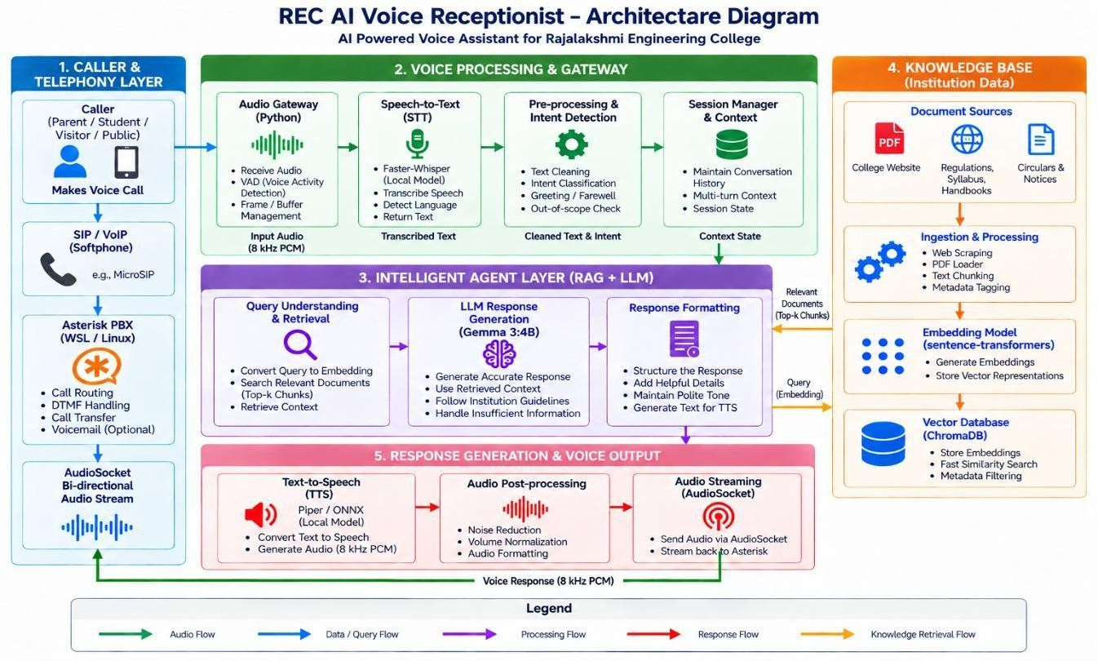

Figure 3.1: System Architecture of Entire System
- Intelligent Agent Layer (RAG + LLM)
The Intelligent Agent Layer is responsible for understanding queries, retrieving information, generating responses and formatting responses the processed caller query is transformed to an embedding and used to search the institutional knowledge base for relevant information. The retrieved Top-K document chunks are used as the context for the Gemma 3:4B Large Language Model. The LLM uses the retrieved information to generate an accurate response and handles insufficient information. The answer is then formatted into a clear and polite conversational form suitable for conversion into speech

Knowledge Base (Institution Data)
The Knowledge Base includes the institutional information required to respond to callers’ questions. The architecture is based on document sources like college website contents, regulations, syllabus, handbooks, circulars and notices. Processing Resources: Loading pdf, Web scraping, Chunking texts, tagging metadata. The processed data converted into embeddings and vector representations with the help of sentence transformers. ChromaDB is the vector database that stores the embeddings and does the similarity searches. It also adds metadata filtering to bring back the most relevant institutional information to individual caller queries.

Response Generation and Voice Output Layer
The Response Generation and Voice Output Layer converts the generated textual response into speech and delivers it back to the caller. The formatted response from the LLM is provided to the Piper/ONNX Text-to-Speech (TTS) module, which converts the text into 8 kHz PCM audio. The generated audio is then processed through noise reduction, volume normalization, and audio formatting. Finally, the processed audio is sent through AudioSocket to Asterisk and streamed back through the SIP/VoIP connection. This completes the voice-based response cycle between the AI receptionist and the caller.

SYSTEM REQUIREMENTS
This section describes the requirements of the proposed system. Various aspects of the system like the hardware and software compatibility, the data requirements, dependencies and other ethical requirements are discussed in detail.

SOFTWARE REQUIREMENTS

The proposed Voice Based AI Receptionist Agent is developed in Python as a major development language. The software environment includes libraries and frameworks for speech processing, Retrieval-Augmented Generation (RAG), document processing, vector storage, language model integration and voice communication.

The selected components support the implementation of the Phase 1 system which is providing.

Software Component | Version / Model Used | Purpose
Python | 3.13 | Primary programming language for system development and integration
Asterisk | 22.10.1 | Provides SIP telephony and handles caller audio communication
MicroSIP | 3.22.16 | Softphone used for placing and testing telephone calls
AudioSocket | Asterisk AudioSocket | Transfers bidirectional 8 kHz PCM audio between Asterisk and Python
WebRTC VAD | Mode 3 | Detects speech activity and identifies utterance boundaries
Faster-Whisper | Small, CUDA, Float16 | Converts caller speech into text
Sentence Transformers | all-MiniLM-L6-v2 | Generates embeddings for institutional documents and queries
ChromaDB | 1.5.9 | Stores embeddings and retrieves

Software Component | Version / Model Used | Purpose
 |  | relevant knowledge chunks
Ollama | 0.6.2 | Runs the local language model
Gemma 3 | Gemma 3:4B | Generates context-grounded responses using retrieved information
Piper TTS | en_US-lessac-medium(1.7.0) | Converts generated responses into speech
PyMuPDF | 1.24.2 | Extracts text from PDF documents
Tesseract OCR | 5.5.3.20260724 | Extracts text from scanned/image-based PDF documents
BeautifulSoup4 | 4.15.0 | Extracts relevant content from official college webpages
Requests | 2.34.2 | Retrieves webpage content during knowledge-base construction
Pandas | 3.0.5 | Processes evaluation results
Pillow | 12.3.0 | Handles image files/data needed during

Software Component | Version / Model Used | Purpose
 |  | the OCR process.
Matplotlib | 3.11.1 | Generates evaluation and latency graphs
Table 3.1: Software Requirements

HARDWARE REQUIREMENTS

The proposed Voice-Based AI Receptionist Agent requires a computer system with adequate processing and memory capacity to run the backend, speech processing, RAG pipeline and voice communication modules. You’ll need at least a Core i5 processor (or equivalent) to run the system efficiently. At least 8 GB RAM is needed to run the application and supporting services smoothly. A 256 GB SSD or more should be adequate to store the application, institutional documents and vector database. Voice input is made with a microphone and voice output is played through a speaker or headset. Stable Internet connection is required to use telephony, STT, TTS and LLM services. The system can be developed and deployed on Windows or Linux based computer.

Hardware Component | Minimum Requirement | Purpose
Processor | Intel Core i5 / AMD Ryzen 5 or higher | Used for running the application, RAG pipeline, and supporting system services.

Hardware Component | Minimum Requirement | Purpose
RAM | 8 GB or higher | Required for Python, vector database, speech-processing models, and other system components.
GPU | NVIDIA GPU with CUDA  support, preferably 4 GB VRAM or higher | Used to accelerate Faster-Whisper speech recognition and local LLM inference.
Storage | 256 GB SSD or higher | Used for storing the application, institutional documents, models, vector database, and required software.
Microphone | Standard USB / Built-in microphone | Used for capturing caller voice during system testing.
Speaker / Headset | Standard speaker or headset | Used for receiving the generated voice responses.
Network | Local network / SIP connectivity | Required for communication between MicroSIP, Asterisk, and the Python AudioSocket gateway.
Table 3.2: Hardware Requirements

DATASET REQUIREMENTS
The system requires the following entities to create a knowledge base that extracts the relevant institutional information from the college website and official documents. The data sources are analysed and arranged in a manner that the system will be able to provide precise answers to the callers’ questions.

Requirements,
      - Information on institutional and academic issues available at college website
      - Syllabus, Rules, Handbooks, Academic Material (pdf files)
      - Circulars and notices of general information concerning the college.
      - Information Retrieval for the improvement of data processing, cleaning and chunking
      - Text Vector Representation (Sentence Transformer Embeddings)
      - ChromaDB vector database for storing the embeddings and retrieving by similarity.
      - For institutional A content, retain metadata information for categorisation and filtering.

SYSTEM DESIGN
The following section is dedicated to the preparation of UML diagrams to represent the design and development process of the proposed Voice-Based AI Receptionist Agent, and to clearly illustrate the system workflow and the communication between its components. These diagrams use different shapes and notations to represent processes, activities, data, decisions and system flows. Different diagrams are used to explain the working of the proposed system from different angles. The system workflow is shown with activity diagrams. The data flow diagram shows the flow of information between the caller, voice processing, RAG, ChromaDB, LLM, and response components.

ACTIVITY DIAGRAM
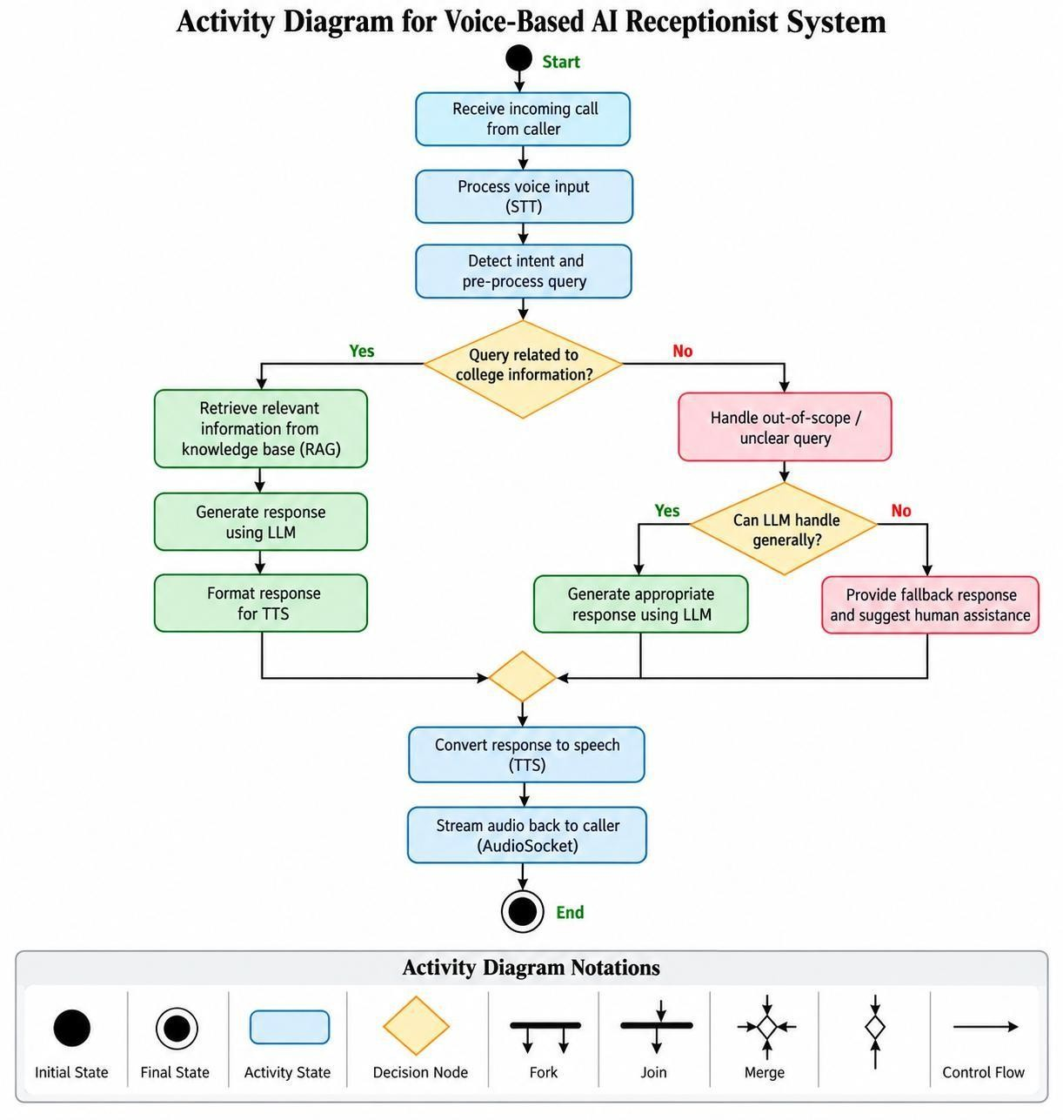

Figure 3.2: Activity Diagram of the System

The activity diagram represents the complete process flow of the Voice Based AI Receptionist System from the reception of the voice query of the caller to the delivery of the voice generated response. The process starts when the system receives an incoming call from the caller. Speech-to-Text (STT) processes the voice input and pre-processing of the query to find out the intent of the caller. Then the system checks for query related to the college information. This first decision allows the system to decide on the correct route for processing. This ensures the query is processed according to the identified purpose.

If the question is regarding the college, the relevant data is fetched from the institutional knowledge base using the RAG process. The retrieved information is then fed to the LLM for generating an appropriate response which is then converted to Text-to-Speech (TTS) If the query does not relate to college it is treated as an out of scope or ambiguous query by the system. The system verifies if the LLM can answer the query in general. If it’s something that’s answerable, the LLM will provide an appropriate answer. The branching mechanism allows the system to respond appropriately to different types of requests of the caller.

If the query is not a generally handled one, the system provides a fallback response and suggests a human agent. Then, the different response paths are combined and provided to the TTS module to convert the response to speech. Finally, the generated audio is streamed back to the caller over AudioSocket. Then the activity flow ends and the voice interaction between the caller and the AI receptionist system is completed. This workflow describes a systematic order of the process of information processing, retrieval, generation and delivery through voice communication.

DATA FLOW DIAGRAM
The Data Flow Diagram (DFD) illustrates the data flow among the caller, the processing components, the knowledge base, and the voice output components of the proposed Voice-Based AI Receptionist System. It covers the processing of the caller's voice query, converting it to text, retrieving information and converting it back to a final voice response. The diagram is given at different levels, to provide a clear insight into the whole system and its processes inside.

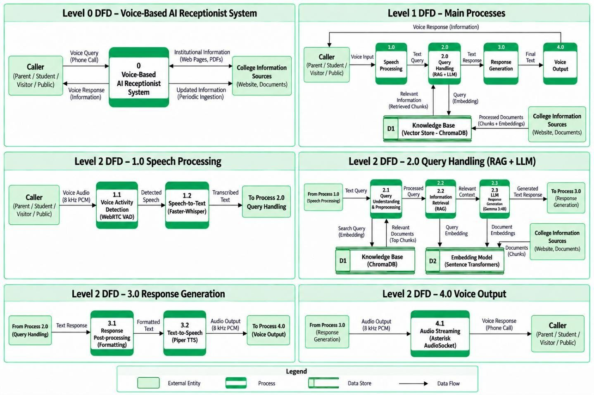

Figure 3.3: Data Flow Diagram of the System

Level 0 DFD has a high level view of the whole system. The caller asks a question using voice via a phone call to the Voice-Based AI Receptionist System. The system processes the query and responds with a voice having the required information. The system also gathers institutional information from college information sources such as the college website and documents. Periodic updates can be provided so that the knowledge base is kept up to date.
Level 1 DFD shows 4 main processes of the system: 1.0 Processing of Speech 1.1
2.0 Query Processing (RAG + LLM) 3.0 Response Generation 4.0 Voice Output 4.1 The first step is to give the voice input from the caller to the Speech Processing process where voice activity detection is done and the speech is converted to text using Faster-Whisper. The generated query text is fed to Query Handling for further processing. 1.1 Voice Activity Detection. Level 2 DFD - Speech Processing WebRTC VAD processes incoming 8 kHz PCM voice audio. Then the detected speech is processed in 1.2 Speech to Text with Faster-Whisper. This generates the

transcribed text and hands it over to the Query Handling process.
The text query is fed into the Level 2 DFD – Query Handling at 2.1 Query Understanding and Preprocessing. The query is processed and transformed into a search query embedding. The embedding is then used to query the D1 ChromaDB Knowledge Base for relevant document chunks. The institutional information from the college website and documents has been processed by the knowledge base. The system also employs the D2 Sentence Transformers Embedding Model to generate document and query embeddings. The retrieved relevant context is sent to 2.3 LLM Response Generation using Gemma 3:4B which provides the desired response. In Level 2 DFD - Response Generation, the text response generated from Query Handling is sent to 3.1 Response Post-processing (Formatting). The formatted response is then sent to 3.2 Text-to-Speech with Piper TTS where the text is converted to 8 kHz PCM audio. The 4.1 Audio Streaming in the Level 2 DFD – Voice Output gets the audio output from the Response Generation via the Asterisk AudioSocket and streams it back to the caller as a voice response through the telephone connection. Thus the DFD shows the complete data flow from the voice input of the caller, speech processing, RAG-based retrieval, LLM response generation, and text-to-speech conversion to the final voice output.

CHAPTER 4 MODULE DESCRIPTION

  - METHODOLOGIES
This section gives an in-depth description about the modules involved in the proposed Voice-Based AI Receptionist Agent, the processes inside the system, and the interaction between the modules. The system uses telephony, Speech-to-Text (STT), query processing, Retrieval-Augmented Generation (RAG), Large Language Model (LLM), and Text-to-Speech (TTS) to process caller voice queries. The system architecture is deeply investigated in below sub section.

The structure of the system is divided into major modules. The first, Each module contains several components, each performing a specific function. The components are interlinked and pass the necessary data from one stage to another. The institutional information is collected from college website content, PDF documents, circulars, handbooks, academic information, facilities, placements, events and notices available in public domain. The complete system takes the caller query and processes it to generate a voice response using the institution information that it has retrieved.

MODULES
The proposed system is partitioned in different functional modules and collectively they perform the entire voice based communication process. These modules are interconnected to support the workflow from getting the voice query of the caller to generating and delivering the final response. Each module carries out a specific function and plays a role in the overall operation of the AI receptionist system.
- Telephony Gateway Module (TGM)
- Speech Processing Module
- Knowledge Base and RAG Module
- Conversation Module & LLM
- Response and Human Escalation Module

In each of the above modules several components are present which contribute to the different functions of the proposed system. Each module communicates with the other modules through the necessary data and processing flow.

TELEPHONY GATEWAY MODULE
This module manages the initialization and control of the communication between the caller and the Voice-Based AI Receptionist System. Incoming telephone calls are received via SIP / VoIP interface. The call is run with Asterisk PBX. The two-way audio communication between Asterisk and the AI application is provided by AudioSocket. The module also provides call routing, DTMF, call transfer and session establishment. The main purpose of this module is to establish a robust communication channel through which the caller can send voice queries and get the generated voice response.
The modules are:

- SIP/VoIP Module: This module provides the telephone link between caller and system using a soft phone like MicroSIP.
- Asterisk PBX Module: This module handles the incoming calls, call routing, DTMF handling and transfer of calls between the caller and AI receptionist.
- Audio Socket Module: This module handles a two-way audio stream between the Python application and Asterisk. It takes the audio from the caller and returns generated voice to the telephony system.
- Call Session Module: It is responsible for the active call session, and monitors the communication status during the interaction.

SPEECH PROCESSING MODULE
The module processes the voice input received from the caller and converts it to text for further analysis. Audio Gateway receives incoming audio as 8 kHz PCM. Voice Activity Detection is employed to detect the speech portion of the audio and reduce the needless processing of silent portions. Then, the detected speech is fed to the

Faster-Whisper Speech-to-Text model and it transcribes the caller's voice into text. The processed text is passed to the Query Handling module for further processing.

The modules comprise:

- Audio Gateway Module: This module receives the incoming audio stream and handles audio frames and buffers before speech recognition.
- Voice Activity Detection Module: The WebRTC VAD module is used to detect human speech in the incoming audio and determine the segments of active speech.
- Speech-to-Text Module: Faster-Whisper transcribes the detected speech to text format and recognizes the spoken language if necessary.
- Text Pre-processing Module: This module does basic cleaning and preparation of the transcribed text before feeding it into the query processing.

Evaluation Metrics:

  - Word Error Rate (WER): WER is a metric that measures the accuracy of the speech recognition system. It compares the transcribed text to the reference text.

WER =
S + D + I N

Where,
S represents substitutions,
D represents deletions,
I represents insertions, and
N represents the total number of words in the reference transcription.

KNOWLEDGE BASE AND RAG MODULE
The module handles the institutional information that the AI receptionist needs to respond to the caller’s questions. The information is collected from the publicly available content on college websites, PDF documents, regulations, syllabus, handbooks, circulars and notices. The collected content is then processed with text extraction, cleaning, chunking and Meta tagging. Sentence Transformers are used to generate vector embeddings and stored in ChromaDB. When a caller interacts with it, the query is converted into an embedding and compared to stored embeddings, to retrieve the most relevant chunks of a document for the response generation.

Modules cover:
- Data Collection Module: It gathers the institutional data from the college website and official documents like pdfs, circulars, notices, handbooks etc.
- Document Processing Module: The gathered information is cleaned and processed, split into relevant text chunks and annotated with relevant meta-data.
- Embedding Module: The Sentence transformers convert the processed document chunks and the user queries to the vector representations.
- ChromaDB Module: Stores the generated embeddings and does similarity based retrieval to get relevant Top-K document chunks.
- RAG Retrieval Module: This module retrieves the most relevant institutional context given caller’s query and provides it to LLM.

Evaluation Metrics,

Retrieval Hit@5: Measures whether the relevant information is successfully retrieved within the top five retrieved document chunks. In the implemented evaluation, the system achieved 100% accuracy with 18 test queries.

𝐻𝑖𝑡@5 =
No. of queries with relevant result in Top − 5
Total no. of. Queries × 100

Answer Accuracy: This metric measures the percentage of queries for which the generated answer correctly provides the expected institutional information. The implemented system achieved 100.00% accuracy for 18 test queries.

Answer Accuracy =
No. of Correct Answers
Total Answerable Queries × 100

Refusal Accuracy: This metric measures whether the system correctly refuses or provides appropriate handling for queries that should not be answered using the available institutional knowledge. The implemented system achieved 100% accuracy for 2 test queries.

Refusal Accuracy =
Number of Correctly Refused Queries Total Unsupported Queries
× 100

LLM AND CONVERSATION MODULE
This module is responsible for understanding the retrieved institutional context and generating an appropriate response for the caller. The processed query and the relevant document chunks retrieved from ChromaDB are fed into the Gemma 3:4B Large Language Model. The LLM uses the retrieved information to generate a response and follows the required institutional communication standards. The module also keeps conversation history and multi-turn context so that subsequent queries may be interpreted in relation to the current conversation.

The modules are:
      - Query Understanding Module: This module understands the processed caller query and identifies the information needed to generate a suitable response.
      - LLM Response Generation Module Gemma 3:4B generates a relevant and grounded response based on the caller query and retrieved institutional context

      - Conversation Memory Module: This module stores the conversation history to help maintain the context needed for multi-turn interactions.
      - Response Formatting Module: It formats the output of the generated response in a clear, concise and polite format, which is suitable for voice communication and TTS.

Evaluation Metrics,

Answer Relevancy: How relevant is the generated response to the caller’s question and how much information relevant to it is provided.

Answer Relevancy =
Total number of Answers Evaluated Total Answer Evaluated
× 100

Faithfulness: Checks the extent to which the generated response is based on the information retrieved from the institutional knowledge base.

Faithfulness =
Number of Faithful Answers
Total Answer Evaluated × 100

Response Latency: Time taken by the system to process the query and generate the final textual response.

Response Latency = Tresponse ready − Tquery start

RESPONSE AND HUMAN ESCALATION MODULE
This module takes the generated text response and converts it to speech and returns it to the caller. The formatting output is fed to the Piper TTS module to produce 8 kHz PCM audio. The generated audio is then subjected to audio post-processing techniques such as noise reduction, volume normalisation and audio formatting.

Then Asterisk AudioSocket sends the processed audio back to the caller. If the necessary information cannot be reliably given, the system can provide a fallback response and suggest human assistance.

Among the modules are:

- Text-to-Speech Module: Piper TTS converts the formatted textual response created by the LLM into natural speech audio.
- Audio Post-processing Module: This module applies noise reduction, volume normalization and audio formatting to prepare the generated audio for telephone communication.
- Audio Streaming Module The processed voice response is streamed back to the caller over the telephone connection using the Asterisk AudioSocket.
- Fallback and Human Assistance Module: This module deals with situations when the required information is not available or the system is unable to provide a suitable response and directs the caller to human assistance.

Evaluation Metrics,

Response Latency: The time it takes to convert the generated response into playable audio and send it to the caller.
Speech Quality: Evaluates the naturalness and clarity of the synthesized voice response.
Overall System Accuracy: Percentage of test queries for which the system returns correct institution information.

CHAPTER 5 IMPLEMENTATION AND RESULT DISCUSSION

  - IMPLEMENTAION RESULTS
In this chapter, the implementation results of the proposed Voice-Based AI Receptionist Agent are presented along with the evaluation of its retrieval and response-generation performance. The implemented system integrates voice communication, speech processing, Retrieval-Augmented Generation (RAG), institutional knowledge retrieval, local Large Language Model (LLM) response generation, and text-to-speech processing. The system was evaluated using publicly available institutional information to examine its ability to retrieve relevant knowledge, generate correct responses, and handle unsupported queries appropriately. Three complementary evaluation approaches, namely Direct RAG Evaluation, RAGAS Evaluation, and ARES-Inspired Evaluation, were used to assess the overall performance of the implemented system.

DIRECT RAG EVALUATION
The Direct RAG evaluation was conducted using 20 test queries, consisting of 18 answerable institutional queries and 2 unsupported queries. The evaluation considered Retrieval Hit@5, Answer Accuracy, and Negative Refusal Accuracy. As shown in Figure 5.1, the system achieved 100.00% Retrieval Hit@5, indicating that relevant institutional information was retrieved within the top five document chunks for all 18 answerable queries. The system also achieved 100.00% Answer Accuracy, showing that the generated responses correctly provided the expected institutional information for all answerable queries. For the two unsupported queries, the system achieved 100.00% Negative Refusal Accuracy, demonstrating that it correctly avoided generating unsupported institutional information.

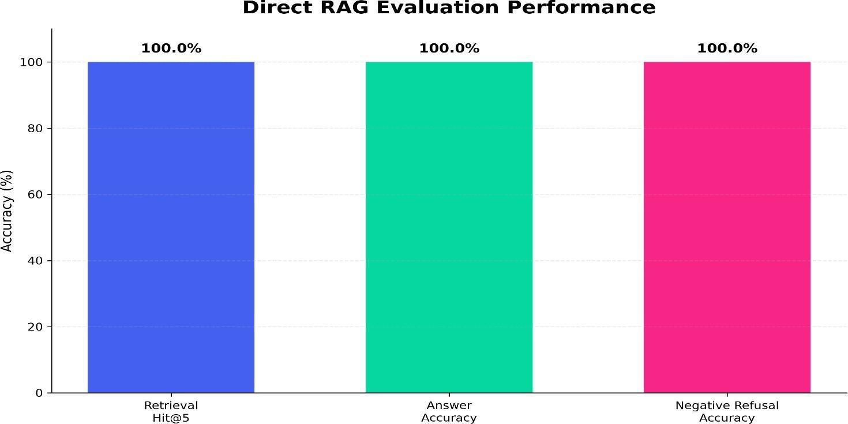

Figure 5.1 Direct RAG Evaluation Performance

Result:
The Direct RAG evaluation demonstrates that the implemented system successfully retrieves relevant institutional information and generates correct responses for the evaluated queries. The 100.00% Retrieval Hit@5 indicates consistent retrieval of relevant knowledge, while the 100.00% Answer Accuracy shows that the retrieved context was effectively used for response generation. The 100.00% Negative Refusal Accuracy further demonstrates the system's ability to appropriately handle queries for which the required information is not available in the knowledge base.

RAGAS EVALUATION
RAGAS evaluation was performed to further assess the quality of the Retrieval-Augmented Generation pipeline. The evaluation considered Faithfulness, Answer Relevancy, Context Precision, and Context Recall. As presented in Figure 5.2, the system obtained a 95.37% Faithfulness score, indicating that the generated responses were largely supported by the retrieved institutional context. The Answer Relevancy score was 54.33%, measuring the relevance of the generated responses to the corresponding questions. The system achieved 92.31% Context Precision, indicating that a high proportion of the retrieved context was relevant to the queries.

The Context Recall reached 100.00%, showing that the information required for the evaluated answers was present in the retrieved context.
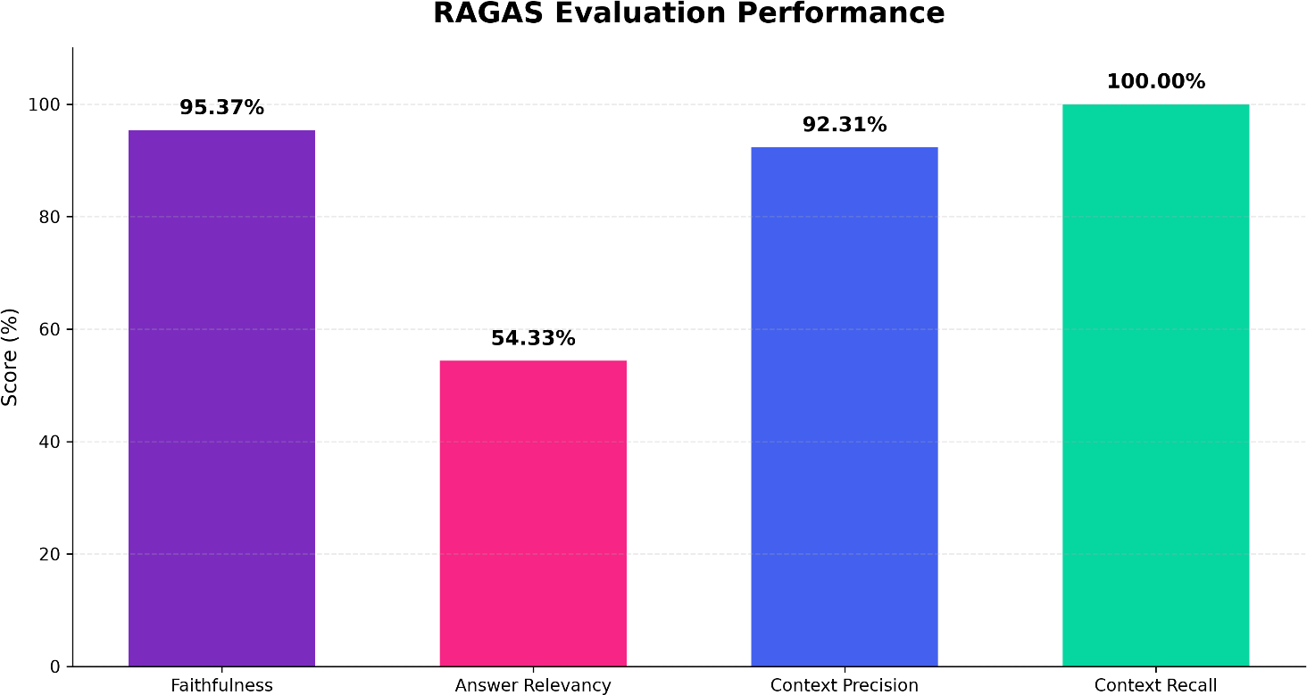

Figure 5.2 RAGAS Evaluation Performance

Result:
The RAGAS results indicate that the proposed RAG pipeline provides strongly grounded responses based on the retrieved institutional information. The high faithfulness, context precision, and context recall scores demonstrate effective retrieval and contextual grounding. The comparatively lower answer relevancy score indicates that there is still scope for improving the directness and formulation of generated responses while maintaining their factual grounding.

ARES-INSPIRED EVALUATION
An additional evaluation inspired by the ARES framework was performed to provide further assessment of retrieval and response quality. The evaluation considered Context Relevance, Answer Faithfulness, and Answer Relevance. As shown in Figure 5.3, the system achieved 89.44% Context Relevance, indicating that the retrieved information was largely relevant to the user queries. The Answer Faithfulness score was 95.83%, showing that the generated responses were strongly

supported by the retrieved context. The system achieved 82.22% Answer Relevance, indicating that the generated responses generally addressed the corresponding user questions.
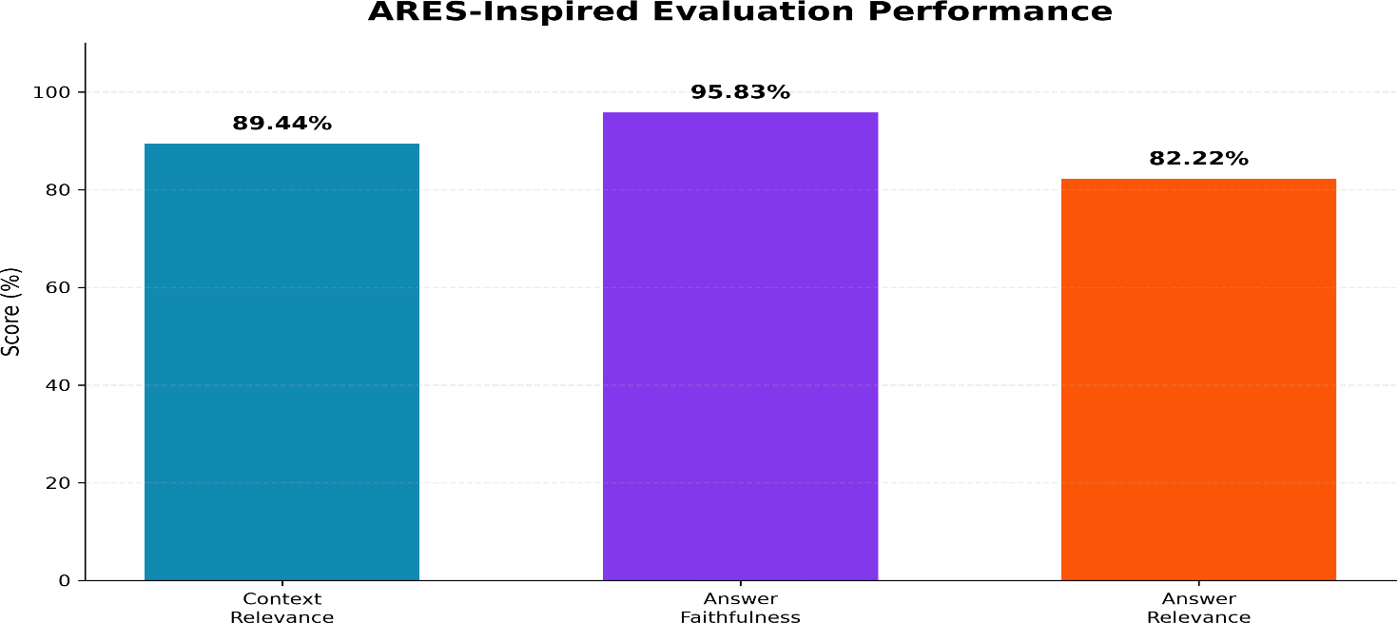

Figure 5.3 ARES-Inspired Evaluation Performance

Result:
The ARES-inspired evaluation provides additional evidence of the quality of the retrieval and response-generation process. The high Context Relevance and Answer Faithfulness scores indicate that the system maintains a strong connection between the user query, retrieved institutional information, and generated response. The Answer Relevance result further shows that the responses generally address the intended questions, while leaving scope for further improvement in response formulation.

OVERALL EVALUATION DISCUSSION
The results obtained from the three evaluation approaches demonstrate the performance of the implemented Voice-Based AI Receptionist Agent from different perspectives. The Direct RAG evaluation achieved 100.00% Retrieval Hit@5, 100.00% Answer Accuracy, and 100.00% Negative Refusal Accuracy on the defined test set. The RAGAS evaluation produced 95.37% Faithfulness, 54.33% Answer Relevancy, 92.31% Context Precision, and 100.00% Context Recall.

The ARES-inspired evaluation further obtained 89.44% Context Relevance, 95.83% Answer Faithfulness, and 82.22% Answer Relevance.

Taken together, these results show that the implemented system is able to retrieve institution-specific information effectively and generate responses that remain largely grounded in the available knowledge base. The direct evaluation confirms correct retrieval, answer generation, and refusal behavior on the selected test queries, while the RAGAS and ARES-inspired evaluations provide additional assessment of contextual grounding and response quality. The evaluation results therefore demonstrate the effectiveness of the implemented Phase 1 system for handling the tested college-related information queries through a voice-based interaction.

CHAPTER 6 CONCLUSION AND FUTURE WORKS

  - CONCLUSION
The proposed AI-Powered Voice Receptionist Framework for Smart Campus Communication and Information Access provides a practical solution for handling routine institutional enquiries through voice interaction. The implemented Phase 1 system integrates SIP/VoIP, Asterisk PBX, AudioSocket, WebRTC VAD, Faster-Whisper, Retrieval-Augmented Generation (RAG), ChromaDB, Gemma 3:4B LLM, and Piper TTS to create a complete voice-based communication pipeline. The system uses publicly available institutional information to retrieve relevant content and generate grounded responses for callers. The Direct RAG evaluation achieved 100.00% Retrieval Hit@5, 100.00% Answer Accuracy, and 100.00% Negative Refusal Accuracy on the defined evaluation dataset. Additional RAGAS and ARES-inspired evaluations were performed to assess contextual grounding, faithfulness, and response relevance. Overall, the implemented system demonstrates the potential of combining voice technologies, RAG, and local LLM-based response generation to provide accessible, consistent, and reliable institutional communication.

FUTURE WORKS
Future work for the proposed an AI-Powered Voice Receptionist Framework for Smart Campus Communication and Information Access can focus on improving the speed, accuracy, and naturalness of the existing voice interaction. Since LLM processing contributes the highest portion of the current pipeline latency, lightweight language models and optimized inference techniques can be explored to reduce response time. The Speech-to-Text and Text-to-Speech components can also be improved to handle different accents, speaking styles, background noise, and real-world telephone conditions more effectively. Support for multiple languages can further improve accessibility and allow a wider range of callers to interact with the system comfortably.

The institutional knowledge base can also be improved through automatic updating of newly published college website content, circulars, notices, regulations, and academic documents. This can help maintain up-to-date information without requiring frequent manual processing. Advanced retrieval and document-ranking techniques can be explored to improve the relevance of retrieved information. A larger and more diverse evaluation dataset can also be developed to test the system across different categories of institutional queries and user interactions. Continuous evaluation can help identify areas where retrieval or response generation needs improvement.

Future phases can extend the system with authenticated and personalized services for authorized users. Student-specific information and controlled access to institutional services can be introduced using suitable authentication mechanisms. Agentic capabilities can also be added to perform authorized tasks through integration with college systems. Improved conversation memory, fallback handling, and smoother transfer to human reception staff can make interactions more reliable. Finally, real-world deployment with continuous monitoring can be conducted to evaluate usability, scalability, response quality, and reliability. These improvements can help transform the current Phase 1 system into a more comprehensive and intelligent college communication platform.

CHAPTER 7 REFERENCES

- Rzepka, C., Berger, B. and Hess, T. (2022) ‘Voice Assistant vs. Chatbot – Examining the Fit Between Conversational Agents’ Interaction Modalities and Information Search Tasks’, Information Systems Frontiers, Vol. 24, No. 3, pp. 839-856.
- Radford, A., Kim, J. W., Xu, T., Brockman, G., McLeavey, C. and Sutskever,
I. (2023) ‘Robust Speech Recognition via Large-Scale Weak Supervision’, Proceedings of the 40th International Conference on Machine Learning, pp. 28492-28518.
- Ao, J., Wang, R., Zhou, L., Wang, C., Ren, S., Wu, Y., et al. (2022)
‘SpeechT5: Unified-Modal Encoder-Decoder Pre-Training for Spoken Language Processing’, Proceedings of the 60th Annual Meeting of the Association for Computational Linguistics, Vol. 1, pp. 5723-5738.
- Ren, Y., Hu, C., Tan, X., Qin, T., Zhao, S., Zhao, Z. and Liu, T. Y. (2020)
‘FastSpeech 2: Fast and High-Quality End-to-End Text to Speech’, arXiv preprint arXiv:2006.04558.
- Casanova, E., Weber, J., Shulby, C. D., Junior, A. C., Gölge, E. and Ponti, M.
A. (2022) ‘YourTTS: Towards Zero-Shot Multi-Speaker TTS and Zero-Shot Voice Conversion for Everyone’, Proceedings of the 39th International Conference on Machine Learning, Vol. 162, pp. 2709-2720.
- Borgeaud, S., Mensch, A., Hoffmann, J., Cai, T., Rutherford, E., Millican, K., et al. (2022) ‘Improving Language Models by Retrieving from Trillions of Tokens’, Proceedings of the 39th International Conference on Machine Learning, Vol. 162, pp. 2206-2240.
- Siriwardhana, S., Weerasekera, R., Wen, E., Kaluarachchi, T., Rana, R. and Nanayakkara, S. (2023) ‘Improving the Domain Adaptation of Retrieval Augmented Generation (RAG) Models for Open Domain Question Answering’, Transactions of the Association for Computational Linguistics, Vol. 11, pp. 1-17.
- Gao, Y., Xiong, Y., Gao, X., Jia, K., Pan, J., Bi, Y., et al. (2023) ‘Retrieval-Augmented Generation for Large Language Models: A Survey’, arXiv preprint arXiv:2312.10997.
- Ram, O., Levine, Y., Dalmedigos, I., Muhlgay, D., Shashua, A., Leyton-Brown, K. and Shoham, Y. (2023) ‘In-Context Retrieval-Augmented Language Models’, Transactions of the Association for Computational Linguistics, Vol. 11, pp. 1316-1331.
- Niu, C., Wu, Y., Zhu, J., Xu, S., Shum, K., Zhong, R., et al. (2024)
‘RAGTruth: A Hallucination Corpus for Developing Trustworthy Retrieval-Augmented Language Models’, Proceedings of the 62nd Annual Meeting of the Association for Computational Linguistics, Vol. 1, pp. 10862-10878.

- Asai, A., Wu, Z., Wang, Y., Sil, A. and Hajishirzi, H. (2024) ‘Self-RAG: Learning to Retrieve, Generate, and Critique through Self-Reflection’, International Conference on Learning Representations (ICLR), pp. 9112-9141.
- Jeong, S., Baek, J., Cho, S., Hwang, S. J. and Park, J. C. (2024) ‘Adaptive-RAG: Learning to Adapt Retrieval-Augmented Large Language Models through Question Complexity’, Proceedings of the 2024 Conference of the North American Chapter of the Association for Computational Linguistics: Human Language Technologies, Vol. 1, pp. 7036-7050.
- Es, S., James, J., Espinosa Anke, L. and Schockaert, S. (2024) ‘RAGAs: Automated Evaluation of Retrieval Augmented Generation’, Proceedings of the 18th Conference of the European Chapter of the Association for Computational Linguistics: System Demonstrations, pp. 150-158.
- Saad-Falcon, J., Khattab, O., Potts, C. and Zaharia, M. (2024) ‘ARES: An Automated Evaluation Framework for Retrieval-Augmented Generation Systems’, Proceedings of the 2024 Conference of the North American Chapter of the Association for Computational Linguistics: Human Language Technologies, Vol. 1, pp. 338-354.
- Mahmood, A., Wang, J., Yao, B., Wang, D. and Huang, C.-M. (2025) ‘User Interaction Patterns and Breakdowns in Conversing with LLM-Powered Voice Assistants’, International Journal of Human-Computer Studies, Vol. 195, Article 103406.

AI SCORE REPORT
CHAPTER 8 PUBLICATION STATUS

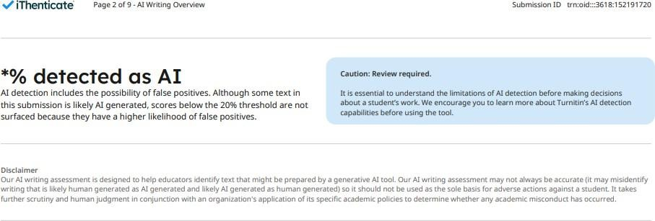

Figure 8.1: AI Score Report

PLAGIARISM REPORT
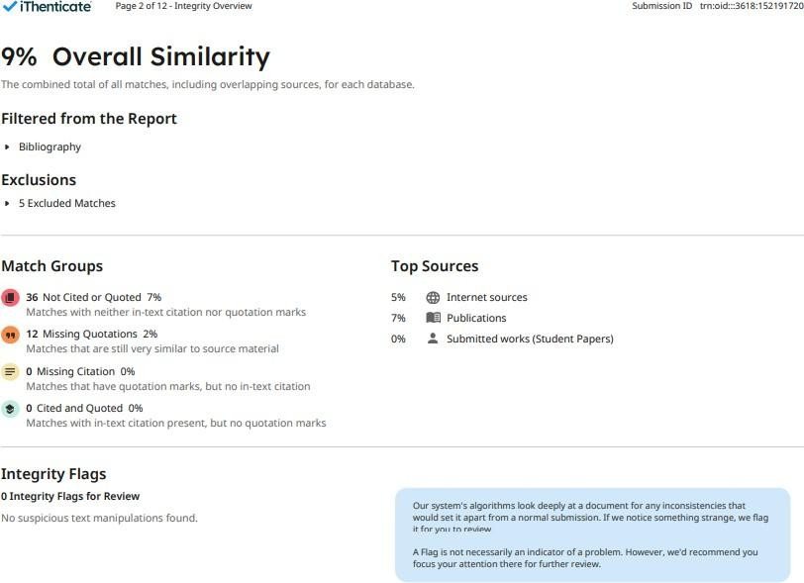
Figure 8.2: Plagiarism Report

  - CONFERENCE PAPER

An AI-Powered Voice Receptionist Framework for Smart Campus Communication and Information
Access

1Bhuvaneswaran B
Department of Computer Science and Engineering Rajalakshmi Engineering College (Autonomous)
Chennai, India bhuvaneswaran@rajalakshmi.edu.in
2Kamalesh S P
Department of Computer Science and Engineering Rajalakshmi Engineering College (Autonomous) Chennai, India
230701138@rajalakshmi.edu.in

3Akash N
Department of Computer Science and Engineering
Rajalakshmi Engineering College (Autonomous)
Chennai, India 230701019@rajalakshmi.edu.in
4Guru Raja T
Department of Computer Science and Engineering
Rajalakshmi Engineering College (Autonomous)
Chennai, India 230701502@rajalakshmi.edu.in
5Subramani A
Department of Computer Science and Engineering
Rajalakshmi Engineering College (Autonomous)
Chennai, India 230701347@rajalakshmi.edu.in

Abstract—Educational institutions receive many phone calls regarding admissions, departments, academic programs, courses, fees, placements, facilities, events, and other institutional in-formation. Such repeat calls can increase the work load for receptionists, increase the waiting time for callers and lead to inconsistency in the information given. Traditional systems for information access are based on websites or document-based interfaces and do not provide a natural voice-based interaction mechanism for telephone users. To address these issues, this paper proposes an AI voice-based receptionist system for smart college communication, by integrating real-time telephony, speech recognition, Retrieval-Augmented Generation (RAG) and a local Large Language Model (LLM). Real-time voice communication is pro-vided by the Asterisk telephony server, AudioSocket-based audio gateway and softphone-based caller interface. Incoming speech is processed and converted to text using Voice Activity Detection and Faster-Whisper. The identified query is then provided to a RAG pipeline to retrieve relevant institutional information using Sentence Transformers embeddings from a ChromaDB vector store. We pass the retrieved context to a Gemma 3:4B model, hosted locally via Ollama, to generate grounded and context-aware responses. This resulting response is then converted to natural speech using Piper TTS and sent back to the caller over the telephony pipeline. Direct RAG evaluation, RAGAS metrics and evaluation based on ARES were used to evaluate the system. The direct evaluation achieved 100.00% retrieval hit@5, 100.00% answer accuracy, and 100.00% negative refusal accuracy, and the RAGAS evaluation achieved 95.37% faithfulness, 92.31% context precision, and 100.00% context recall. The system offers a unified voice interaction framework for automated, consistent and knowledge grounded college information services.

Keywords—AI Voice Receptionist, Speech-to-Text (STT), Text-to-Speech (TTS), Retrieval-Augmented Generation (RAG), Large Language Model (LLM), Conversational AI, Voice Interaction.
I. Introduction
Students, parents, visitors, and other stakeholders commonly place calls to educational organizations with regards to admissions, academic courses, departments,
charges, placements, facilities, events, rules, and student services, with most of these inquiries being repetitive, which leads to the increased work of receptionists, creates the possibility of inconsistent answers, and restricts help beyond normal work hours. The following solution can solve the existing limitations in the form of the development of an automated voice-based system, which would allow users to interact naturally via voice communication. Due to recent developments in the sphere of conversational artificial intelligence, voice-based systems became capable of recognizing the human speech and responding naturally due to Speech-to-Text (STT) models and Large Language Models (LLMs). However, the reliance on the LLM in terms of providing responses to voice-based interactions can result in the lack of grounding of these responses with the correct institution information, especially when it comes to academic policies, descriptions of courses, prices, and procedures. In order to overcome this problem, Retrieval-Augmented Generation (RAG) should be used. Unlike web-based/text-based chatbots, a voice receptionist needs to take into account the full communication process, which includes call receipt, audio processing, voice activity detection, speech recognition, knowledge retrieval, response generation, TTS synthesis, and delivering the answer back to the caller, as well as dealing with audio processing, latency problems, and reliable interactions between telephony and AI components. To meet these needs, in this paper we present an AI voice receptionist system for smart college communication by leveraging telephony automation capabilities with speech and language intelligence based on the Asterisk-based telephony architecture, a softphone interface, and AudioSocket for audio processing from the caller side. Incoming speech is processed through the audio gateway and voice activity detection, then transcribed using a Faster-Whisper model running locally, and sent to a RAG pipeline where Sentence Transformers are used for generating embeddings and ChromaDB is used as the vector store for institutional knowledge retrieval. The context retrieved in this manner is then fed to a locally deployed Gemma 3:4B model via Ollama in order to produce grounded responses that are subsequently translated into speech with the help of a TTS module and delivered back to the user through

the telephony pipeline. The proposed system has been developed in such a way as to offer an automatic and consistent response to common college questions with minimum involvement of a live receptionist and formation of an integrated architecture encompassing telephony, speech recognition, semantic retrieval, local language model inference, and speech synthesis.

- Literature Survey
The appropriateness of voice-based AI frameworks and chatbots for different information search tasks was investigated by Rzepka, Berger and Hess [1]. In a laboratory experiment, the authors compared speech-based and text-based conversational agents using 116 participants. Results showed that voice assistants increased perceived efficiency, decreased cognitive effort, in-creased enjoyment, and increased service satisfaction for information search tasks. Also, the effectiveness of the interaction modality depends on the characteristics and goals of the in-formation search task. The authors concluded that voice-based and text-based conversational agents have different strengths per task at hand.

Radford et al., in [2], introduced a speech recognition model called Whisper which uses large-scale weak supervision during the training process. These models were trained using 680,000 hours of multilingual and multitasking audio data extracted from the web. In this work, these models are tested on several speech recognition and translation datasets. As a result, it is demonstrated that the obtained models have high robustness and generalization ability for different languages, accents, and speech settings. Also, it was shown that these models achieve human-level performance on a number of speech recognition benchmarks.

The authors of [3], Ao et al., have introduced a unified-modal encoder-decoder pre-training approach for spoken language processing tasks known as SpeechT5. It is based on using an encoder-decoder model where modality-specific pre-network and post-network are used for dealing with the speech and text. In order to create a common representation of speech and text, the authors suggested cross-modal vector quantization. We have tested SpeechT5 on automatic speech recognition, speech synthesis, speech translation, voice conversion, and speech enhancement and speaker identification tasks.

Ren et al. proposed FastSpeech 2 [4], a non-autoregressive text-to-speech model, to overcome the limitations of the original FastSpeech model. The proposed method uses ground-truth speech information directly in training, as opposed to teacher-student distillation. Duration, pitch and energy information are added as conditional inputs in an effort to better represent the variations displayed in speech. The authors also proposed FastSpeech 2s which directly generates speech waveforms from text in parallel. The experiments show that FastSpeech 2 can speed up the training process by 3× compared with FastSpeech, and generate higher voice quality. The study showed that information of speech variation can be used to improve the quality and efficiency of synthesis.
In [5], Casanova et al. introduced YourTTS, which is an approach for multilingual zero-shot multi-speaker TTS and voice conversion. The approach relied on the VITS architecture adapted to multilingual and multi-speaker speech synthesis. The system obtained state-of-the-art performance in zero-shot multi-speaker TTS. Competitive results were also obtained for zero-shot voice conversion in terms of performance on the VCTK dataset. In addition, it was shown that the model can be fine-tuned using less than a minute of speech to obtain high voice similarity with decent speech quality.

Borgeaud et al. [6] proposed the Retrieval-Enhanced Trans-former (RETRO), a language model architecture that retrieves from a large external database at generation time. The model fetches relevant document chunks based on the previous input and merges the fetched information using cross-attention. It was trained on a data base of some two trillion tokens. RETRO matches the performance of much larger language models on a range of language modeling benchmarks while using far fewer model parameters. The study also showed improvements on knowledge intensive tasks after fine-tuning, showing external retrieval can provide useful knowledge to language models during generation.

In the research paper, Siriwardhana et al. [7], studied the application of the adaptation of the Retrieval-Augmented Generation model for open-domain question answering. The researchers have described the previous RAG models, which were trained on external knowledge mainly derived from Wikipedia and were not fine-tuned for any specific domain. They introduced RAG-end2end, an extension of the RAG model, for the joint training of the retriever and generator for the purpose of domain adaptation. We introduce another training signal that enables the model to retrieve sentences from a domain-specific external knowledge source and recreate those sentences.
[8] Gao et al. have done an extensive review of Retrieval-Augmented Generation in Large Language Models. In this review, the authors classified the development of RAG models into three main categories, namely Naive RAG, Advanced RAG, and Modular RAG. It discussed how to improve each part. It discussed challenges like hallucination, outdated knowledge, retrieval quality and evaluation. The authors also mention the capacity of RAG systems to combine external domain-specific and constantly updated knowledge with the internal knowledge of language models. This paper offers an in-depth survey of existing RAG techniques and future directions of research.

The paper Ram et al. [9] analyzed In-Context Retrieval-Augmented Language Models, whereby language models are conditioned on retrieved documents from an external corpus of grounding documents during the time of generation. The paper focused on studying retrieval augmented language modeling and how information retrieved can augment context of a language model. They use external documents as additional context, rather than forcing all the information to be contained within the parameters of the model. The study showed the efficacy of providing relevant retrieved information during generation, and that retrieval augmentation

can lead to substantial gains in language modelling performance.
RAGTruth: Niu et al. [10] introduced a corpus for halluci-nation study of Retrieval-Augmented Generation systems. The authors observed that RAG models can produce unsupported or conflicting statements despite retrieving relevant information. RAGTruth contains nearly 18,000 naturally-generated responses from various large language models under RAG frameworks. Responses were manually annotated at the case and word level with information on the intensity of hallucination. The authors evaluated the hallucination rates of various language models and surveyed existing techniques for detecting hallucinations. The results showed that a relatively small fine-tuned language model could achieve competitive hallucination detection performance, and could also help re-duce hallucinations in generated responses.

Asai et al. [11] introduce the idea of Self-RAG, which incorporates the concepts of retrieval, generation, and self-reflection into one system, in order to enhance the factuality and quality of responses provided by the language model. The authors noted that in the traditional RAG setting, a set of certain number of passages is retrieved, which was unnecessary or irrelevant. Self-RAG enables the language model to conduct adaptive retrieval when necessary, and self-inspect the retrieved passages and generated responses through the use of reflective tokens. Experimental results for 7B and 13B models prove that Self-RAG is more effective than other language models and retrieval-augmented techniques in answering open domain questions, reasoning and fact verification tasks.
In [12], Jeong et al. proposed Adaptive-RAG, a framework that selects an appropriate retrieval strategy based on the complexity of the input question. They note that today’s retrieval-augmented language models may retrieve unnecessarily for simple questions, or may fail to properly handle complex multi-step questions. Adaptive-RAG addresses this problem by dynamically choosing between different strategies, from simple language-model answering to retrieval-based approaches and more sophisticated multi-step retrieval. “The framework was built to understand the complexity of a question and choose a correct method. Experimental evaluation showed that adaptive retrieval strategies are effective to deal with questions with different levels of complexity.

In [13], Es et al. introduced RAGAs (Retrieval Augmented Generation Assessment), which is an assessment methodology for the evaluation of the performance of Retrieval-Augmented Generation pipeline, using a reference-free method. Three significant factors of the evaluation process are identified by the authors: the ability of the retrieval system to retrieve the relevant context, the ability of the language model to faithfully utilize the retrieved context and the generation performance of the response. RAGA provides a collection of evaluation metrics, which measure these factors without the necessity of manual preparation of the reference answers.
ARES, which stands for Automated RAG Evaluation System, was introduced by Saad-Falcon et al. in [14] for evaluating retrieval-augmented generation systems. This framework considers three dimensions in the evaluation: context relevance, answer faithfulness, and answer relevance. ARES creates synthetic training data for training language model judges that evaluate the components of RAGs. In order to make sure that ARES works more reliably in its evaluation, some human-annotated examples have been used for this purpose by prediction-based inference. ARES has been evaluated on eight knowledge-intensive tasks of KILT, SuperGLUE, and AIS.

In [15], Mahmood et al. investigated voice-based LLM models. The researchers developed a ChatGPT-powered Alexa skill and examined interactions across different scenarios. The study analyzed the different ways users interact with LLM-powered voice assistants and identified several types of conversational breakdowns. The findings showed that integrating ChatGPT improved intent recognition and enabled the voice assistant to proactively address some conversational breakdowns. The authors also discussed the benefits and challenges associated with using large language models in voice assistants and provided design considerations for developing future LLM-powered conversational voice assistants.

The studies reviewed show the effectiveness of voice inter-action, speech processing, retrieval-augmented generation and automated RAG evaluation. However, these technologies are often studied in isolation or in non-telephonic conversational settings. This leads to the requirement for a system that integrates real-time telephone communication, speech processing, retrieval of institutional knowledge, generation of grounded responses, and voice output for college information services.

- Proposed Method
The proposed system is the implementation of a voice-based AI receptionist to handle routine institutional information inquiries through a telephone interface. It uses speech processing, retrieval-augmented generation, a local large language model, and text-to-speech synthesis to produce voice responses. The telephony layer captures the speaker’s speech and then applies Voice Activity Detection and Faster-Whisper to convert speech to text. The transcribed query is processed and relevant institutional information is retrieved from the ChromaDB knowledge base using embeddings from sentence-transformers. The retrieved context is fed into the Gemma 3:4B language model to generate a context-aware response. The response is then converted to speech with Piper TTS and streamed back to the caller over Asterisk and AudioSocket. The overall workflow is oriented to support multi-turn conversation while restricting the answers to the knowledge that the institution has at disposal.

Pseudo Code of the Proposed Method
Input: Caller voice query Output: Voice response Begin
- Initialize Asterisk, AudioSocket, VAD, Faster-Whisper, ChromaDB, embedding model, Gemma 3:4B, and Piper TTS.
- Receive incoming call from the caller.
- Establish bidirectional audio communication through AudioSocket.
- while call is active do
- Capture incoming 8 kHz PCM audio.
- Detect speech using WebRTC VAD.
- if speech is detected then
- Identify the complete user utterance.
- Convert speech to text using Faster-Whisper.
- Pre-process the transcribed query.
- Generate query embedding using Sentence-Transformers.
- Retrieve relevant document chunks from ChromaDB.
- if relevant institutional information is available
then
- Provide retrieved context to Gemma 3:4B.
- Generate a context-grounded response.
- else
- Generate a suitable refusal response.
- end if
- Convert the response into speech using Piper TTS.
- Stream generated 8 kHz PCM audio through AudioSocket.
- Return the voice response to the caller.
- end if
- end while
- Terminate the call.
End
- Architecture Diagram
Fig. 1 illustrates the workflow of the proposed framework which is voice-based AI receptionist system. The architecture includes a caller and telephony layer, a voice processing and gateway layer, an intelligent agent layer, a knowledge base, and a response generation and voice output layer. These modules work together to receive a spoken query, retrieve relevant institutional information, generate a grounded response, and return the response to the caller in the form of speech.
The telephony layer captures the caller’s voice and passes it to the voice processing components. Speech-to-text converts the caller’s speech into text, which is then pre-processed for query handling. The knowledge base stores institutional information and retrieves relevant content using ChromaDB. The retrieved context is provided to the Gemma 3:4B LLM through the RAG module to generate a suitable response. The generated response is converted into speech using Piper TTS. Finally, the processed audio is streamed back through Asterisk and AudioSocket to complete the interaction.

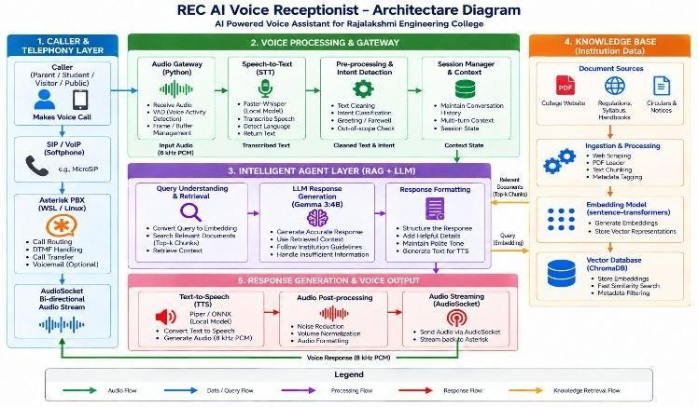

Fig. 1. Architecture of the proposed voice-based AI receptionist system

- Data Flow Diagram
The Data Flow Diagram (DFD) shown in Fig. 2 illustrates the flow of information between the major processing stages of the proposed system. It represents the transformation of the caller’s voice query into a voice response through speech processing, query handling, response generation, and voice output processes.
Voice Activity Detection and Faster-Whisper are used to detect and process the caller’s voice query. The resulting transcribed text is passed to the Query Handling module for pre-processing and retrieval. Sentence-Transformers embed-dings are used to retrieve relevant institutional information from the ChromaDB knowledge base. The response is then post-processed and converted into speech using Piper TTS. Finally, AudioSocket streams the generated voice response through Asterisk to the caller.
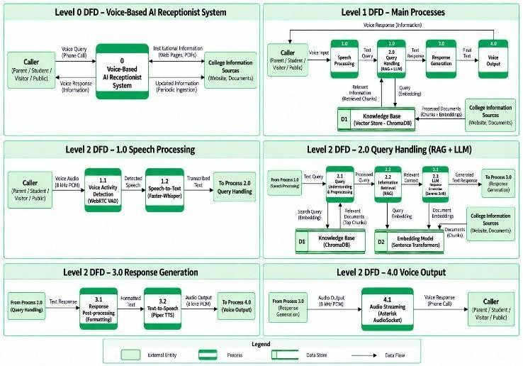
Fig. 2. Data Flow Diagram of the proposed voice-based AI receptionist system

- Methodology
- Institutional Data Collection and Knowledge Base Preparation
The first step is to gather institutional information needed to answer routine college-related questions. The information has been gathered from publicly available sources of college like institution’s website, academic regulations, syllabus documents, circulars, notices and other relevant documents. The collected PDF and web content is extracted and transformed into text for proceeding further. The extracted information is di-vided into smaller pieces of text to increase

retrieval accuracy and to reduce irrelevant information during query processing. Each chunk is embedded using Sentence Transformers embedding model so that it can be represented as a number in relation to its semantic content. The embeddings are generated and stored along with the text and metadata in a ChromaDB vector database. This is used as the institutional knowledge base of the proposed system to retrieve relevant information during a caller interaction.

- Voice Query Processing
The voice input is acquired when a caller makes a telephone call, through the Asterisk telephony server and AudioSocket-based audio gateway. The incoming audio is interpreted as 8 kHz PCM audio and processed with WebRTC Voice Activity Detection (VAD) to detect the start and end of speech segments. The detected speech is then fed into the speech recognition model Faster-Whisper for speech to text conversion. Thus, the transcription produced is the question of the caller and is passed to the query processing stage. The transcribed query is cleaned and prepared for semantic retrieval by performing basic text pre-processing. This process allows the system to convert natural telephone speech into a text-based query that is acceptable for the RAG pipeline.

- Query Retrieval and Response Generation
The transcribed query is embedded using the Sentence Transformers model and compared to the vector representations stored in ChromaDB. The system gets back the significant relevant chunks of documents based on the semantic similarity. We select the top five chunks as the candidates for retrieval. The retrieved institutional context is then sent to a locally hosted Large Language Model, Gemma 3:4B, via Ollama. The model generates a response with the retrieved information while respecting the institutional knowledge constraints. The response generation process is designed to avoid unsupported information, and to provide an appropriate refusal when the requested information is not present in the knowledge base. This response is then formatted into text and passed on to the text-to-speech stage.

- Voice Response Generation
The textual response generated is transformed into oral using the Piper text-to-speech model with a locally hosted ONNX voice model. The synthesized output is converted to 8 kHz PCM format, as required for telephone communication. This audio stream is then sent back to the Asterisk server via AudioSocket and delivered to the caller through the softphone interface. This completes the cycle of voice interaction, from the caller’s speech to an AI generated spoken response.

- System Evaluation
The efficiency of the proposed framework is evaluated by three complementary approaches: direct RAG evaluation, RA-GAS evaluation and ARES-based evaluation. Direct evaluation measures success in retrieval, correctness of answers, and the potential of the system to correctly refuse unsupported queries. The retrieved context and generated responses are evaluated by RAGAS in terms of performance metrics such as answer relevancy, context recall, faithfulness, and context precision to assess their quality. We also conduct an ARES-based evaluation based on context relevance,
answer faithfulness and answer relevance which acts as extra evaluation of retrieval and response quality.
Retrieval Hit@5: Retrieval Hit@5 is defined as whether the relevant institutional information is among the top five document chunks returned by the RAG pipeline. We used 18 answerable test queries for evaluation.
  - i → is the score achieved for the i^{th} query and,
  - N → is the total number of evaluated queries.
Faithfulness: Verifies that the generated response is sup-ported by the retrieved institutional context and does not contain unsupported claims.
Answer Relevancy: Measures how appropriate and relevant the generated answer is to the caller’s question.
Context Precision: Quantifies the amount of relevant in-formation in the retrieved context for answering the given question.
Context Recall: Measures whether the retrieved context has the information to support the expected answer.
- ARES Evaluation: An additional evaluation is performed inspired by ARES to give more assessment of the quality of retrieval and response. Similar to the RAGAS evaluation, for each metric, we report average scores across all queries evaluated.
- Answer Accuracy: Answer Accuracy Percentage of answerable queries for which the generated response correctly provides the expected institutional information.
Context Relevance: The relevance of the retrieved context to the user query. The evaluation was conducted on 18 answerable test queries.
- Negative Refusal Accuracy: Negative Refusal Accuracy is a metric that quantifies the system’s capability to accurately deny queries when the information requested is not found within the institutional knowledge base. This assessment was conducted with two unsupported queries. Number of correctly refused queries
Answer Faithfulness: Evaluates the faithfulness of the generated answer with respect to the retrieved context.
Answer Relevance: Evaluates how well the response answers the user’s question.
- AGAS Evaluation: RAGAS evaluates the performance of a Retrieval Augmented Generation system with a suite of complementary metrics. Each metric yields a score between 0 and 1 for each test case. The overall score for each metric is the average of the scores obtained for all evaluated queries answer correctness, contextual grounding, and response qual-ity. The direct RAG evaluation used 18 answerable queries and 2 unsupported queries, while the RAGAS and ARES-inspired evaluations further evaluated the retrieval and generation stages.
- Results And Discussions
The proposed voice-based AI receptionist system was assessed by three complementary methods: direct RAG evaluation, RAGAS evaluation and ARES-inspired evaluation. These evaluations were conducted to evaluate retrieval effectiveness.

- Direct RAG Evaluation
We present the outcomes of the direct RAG evaluation in Fig.
3. The Retrieval Hit@5 of the system was 100.00%, indicating that the relevant institutional information was retrieved in the top five document chunks for all the 18 answerable queries. The answer accuracy was also 100.00%, meaning that the generated responses correctly delivered the expected institutional information for all answerable queries tested. For the two unsupported queries the system achieved 100.00% negative refusal accuracy, demonstrating that it correctly re-fused to provide the information which was not available in the institutional knowledge base.
TABLE I.Direct RAG Evaluation Results

Evaluation Metric | Score (%)
Retrieval Hit@5 | 100.00
Answer Accuracy | 100.00
Negative Refusal Accuracy | 100.00
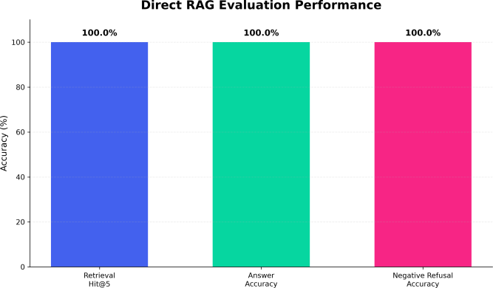

Fig. 3. Direct RAG evaluation performance

- RAGAS Evaluation

Fig. 4 shows the promising outputs of RAGAS of our proposed system. The system explicitly shows that 95.37% generated responses were mostly supported by the retrieved institutional context. The con-text precision was 92.31%, which indicates that majority of the information retrieved was relevant to the corresponding queries. Context recall was 100.00%, meaning the information needed to answer the evaluated answers was in the retrieved context. The answer relevancy score was 54.33% which is relatively lower than the other RAGAS metrics and shows room for improvement of the directness and formulation of the generated responses.
TABLE II RAGAS Evaluation Results

RAGAS Metric | Score (%)
Faithfulness | 95.37
Answer Relevancy | 54.33
Context Precision | 92.31
Context Recall | 100.00

Fig.4. RAGAS Evaluation Performance

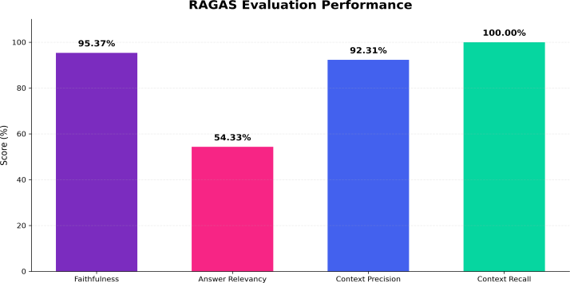
- ARES-Inspired Evaluation

The findings based on the ARES evaluation are illustrated in Fig. 5. The obtained value for context relevance is 89.44%, meaning that most of the retrieved context is relevant to the user queries. As for answer faithfulness, its value is 95.83%, meaning that most of the generated answers are faithful to the context. The relevance score was 82.22%, which means that the answers were mostly relevant to the questions. These results provide further evidence that the proposed system preserves good alignment of user query, retrieved institutional context and generated response.
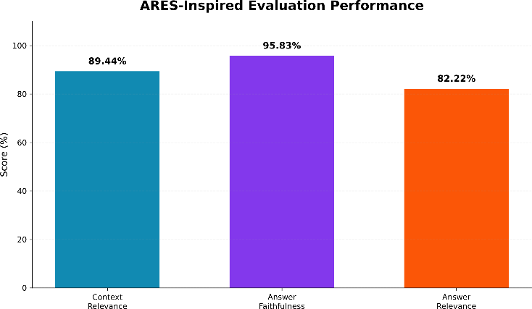
TABLE III ARES-Inspired Evaluation Results

Evaluation Metric | Score (%)
Context Relevance | 89.44
Answer Faithfulness | 95.83
Answer Relevance | 82.22

Fig. 5. ARES-inspired evaluation performance

- Overall Discussion
The results of the three evaluation approaches consistently proving its efficiency in retrieving and generating institution-specific information from the prepared knowledge base. The 100.00% Retrieval Hit@5 and answer accuracy obtained in the direct evaluation indicate reliable performance on the chosen test queries. The RAGAS evaluation also shows high faithfulness, context precision and context recall, confirming that the produced outputs are significant base for institutional information. The results motivated by ARES also achieve high context relevance and answer faithfulness. Although the RAGAS answer relevancy score is relatively lower, the results of the complementary evaluations indicate that the system

provides useful and knowledge-grounded responses for the tested college-related queries.

- Conclusion

We propose a Voice-Based AI Receptionist Agent that offers an intelligent and efficient solution to common college-related questions through natural voice interaction. The system uses a real-time telephony pipeline along with Speech-to-Text, Retrieval-Augmented Generation, ChromaDB, Sentence Transformers, Gemma 3:4B, and Text-to-Speech technologies. We processed institutional information obtained from publicly available college sources into a knowledge base for similarity-based retrieval. The evaluation on 18 answerable questions got 100.00% Retrieval Hit@5 and 100.00% answer accuracy and negative queries got 100.00% refusal accuracy. RAGAS evaluation results showed 95.37% faithfulness, 54.33% answer relevancy, 92.31% context precision, and 100.00% context recall. The ARES-based evaluation achieved 89.44% context relevance, 95.83% answer faithfulness and 82.22% answer relevance. These results prove that the proposed system is robust for knowledge-grounded voice-based college communication. The system reduces the need for manual handling of repetitive inquiries and provides a practical basis for an automated AI receptionist.

- Future Works
In future work, the current system will be developed into a full AI receptionist with personalized and automated services. A major enhancement would be to connect the college ERP system with secure APIs to provide personalized data like attendance, internal marks, exam results, fee status and placement eligibility. Sensitive information will be protected by student verification via OTP or PIN based authentication and secure API communication. We will add support for Indian accents, multilingual and Tamil-English code-mixed queries, conversation history and faster response generation, making voice interaction more natural and responsive. Further development will be done to improve these aspects. Confidence based escalation can be used to pass complex queries to a human receptionist along with the conversation summary. Future evaluations could include larger sets of real-world queries, user satisfaction and longer voice interaction testing to evaluate the system in practical conditions of use. These improvements can develop the system into a scalable 24x7 voice-based college receptionist for general and personalized institutional communication.

References

- Rzepka, C., Berger, B., & Hess, T. (2022). Voice assistant vs. Chat-bot–examining the fit between conversational agents’ interaction modal-ities and information search tasks. Information systems frontiers, 24(3), 839-856.
- Casanova, E., Weber, J., Shulby, C. D., Junior, A. C., Go¨lge, E., & Ponti, M. A. (2022, June). Yourtts: Towards zero-shot multi-speaker tts and zero-shot voice conversion for everyone. In International conference on machine learning (pp. 2709-2720). PMLR.
- Borgeaud, S., Mensch, A., Hoffmann, J., Cai, T., Rutherford, E., Millican, K., ... & Sifre, L. (2022, June). Improving language models by retrieving from trillions of tokens. In International conference on machine learning (pp. 2206-2240). PMLR.
- Siriwardhana, S., Weerasekera, R., Wen, E., Kaluarachchi, T., Rana, R., & Nanayakkara, S. (2023). Improving the domain adaptation of retrieval augmented generation (RAG) models for open domain question answer-ing. Transactions of the Association for Computational Linguistics, 11, 1-17.
- Gao, Y., Xiong, Y., Gao, X., Jia, K., Pan, J., Bi, Y., ... & Wang, H.(2023). Retrieval-augmented generation for large language models: A survey. arXiv preprint arXiv:2312.10997.
- Ram, O., Levine, Y., Dalmedigos, I., Muhlgay, D., Shashua, A., Leyton-Brown, K., & Shoham, Y. (2023). In-context retrieval-augmented language models. Transactions of the Association for Computational Linguistics, 11, 1316-1331.
- Niu, C., Wu, Y., Zhu, J., Xu, S., Shum, K., Zhong, R., ... & Zhang,
T. (2024, August). Ragtruth: A hallucination corpus for developing trustworthy retrieval-augmented language models. In Proceedings of the 62nd Annual Meeting of the Association for Computational Linguistics (Volume 1: Long Papers) (pp. 10862-10878).
- sai, A., Wu, Z., Wang, Y., Sil, A., & Hajishirzi, H. (2024, May). Self-rag: Learning to retrieve, generate, and critique through self-reflection. In International conference on learning representations (Vol. 2024, pp. 9112-9141).
- Jeong, S., Baek, J., Cho, S., Hwang, S. J., & Park, J. C. (2024, June). Adaptive-rag: Learning to adapt retrieval-augmented large language models through question complexity. In Proceedings of the 2024 confer-ence of the north american chapter of the association for computational linguistics: Human language technologies (volume 1: Long papers) (pp. 7036-7050).
- Es, S., James, J., Anke, L. E., & Schockaert, S. (2024, March). Ragas: Automated evaluation of retrieval augmented generation. In Proceedings of the 18th conference of the european chapter of the association for computational linguistics: system demonstrations (pp. 150-158).
- Saad-Falcon, J., Khattab, O., Potts, C., & Zaharia, M. (2024, June). Ares: An automated evaluation framework for retrieval-augmented generation systems. In Proceedings of the 2024 Conference of the North Ameri-can Chapter of the Association for Computational Linguistics: Human Language Technologies (Volume 1: Long Papers) (pp. 338-354).
- Mahmood, A., Wang, J., Yao, B., Wang, D., & Huang, C. M. (2025). User interaction patterns and breakdowns in conversing with LLM-powered voice assistants. International Journal of Human-Computer Studies, 195, 103406.

ACCEPTANCE LETTER

- Radford, A., Kim, J. W., Xu, T., Brockman, G., McLeavey, C., & Sutskever, I. (2023, July). Robust speech recognition via large-scale weak supervision. In International conference on machine learning (pp. 28492-28518). PMLR.
- Ao, J., Wang, R., Zhou, L., Wang, C., Ren, S., Wu, Y., ... & Wei,
F.(2022, May). Speecht5: Unified-modal encoder-decoder pre-training for spoken language processing. In Proceedings of the 60th annual meeting of the association for computational linguistics (volume 1: Long papers) (pp. 5723-5738).
- Ren, Y., Hu, C., Tan, X., Qin, T., Zhao, S., Zhao, Z., & Liu, T.
Y. (2020). Fastspeech 2: Fast and high-quality end-to-end text to speech. arXiv preprint arXiv:2006.04558.


9/24/26, 9:39 AM Rajalakshmi Engineering College Mail - ICSCDS 2026-Acceptance Notification

Kamalesh Suresh Kumar <230701138@rajalakshmi.edu.in>

ICSCDS 2026-Acceptance Notification

icscds conf <icscds.conference@gmail.com> Mon, Sep 21, 2026 at 11:13 AM To: 230701138@rajalakshmi.edu.in
Dear Author (s)
Greetings from the organizing committee of the 4th International Conference of Sustainable Computing and Data Communication Systems (ICSCDS 2026). We are pleased to inform you that your paper has been accepted for presentation and recommended for publication in the conference proceedings. Please refer to the attached acceptance letter and reviewer comments. Kindly submit the final paper after incorporating all review comments and ensuring proper formatting, references, figures, and tables.
Important Dates:
Conference Dates: 15-17, December 2026
Registration Deadline: 9 October, 2026 Registration Details:
Conference Registration Page - https://icscds.com/2026/participant-registration.html
Payment Link -https://www.paypal.com/ncp/payment/ZJBV7PCNE297J
In case of payment error, please send a mail, we will provide alternate payment options
Registration Confirmation:
Authors are requested to submit the IEEE E-Copyright given below (Paper ID given in acceptance letter) and send the following details and documents to the Conference Email ID: icscds.conference@gmail.com,with the subject line "ICSCDS 2026 Registration Documents".
The email body should include:
- Paper ID:
- Paper Title:
- Author Name(s):
- Corresponding Author Name:
- Mode of Presentation:
- Payment Transaction ID:
- Contact Number:
The following documents must be attached:
- Camera-ready paper (Word / LaTex)
- IEEE E-Copyright (Submit at https://icscds.com/2026/participant-registration.html)
- Proof of payment (Snapshot of mail received from Razorpay / Payment done screenshot with payment ID “Pay_XXX”)
Please note that modifications to author information will not be permitted after acceptance. Best Regards,
Conference Chair - ICSCDS 2026.

9/24/26, 9:39 AM Rajalakshmi Engineering College Mail - ICSCDS 2026-Acceptance Notification
Acceptance letter- ICSCDS-0201.pdf
405K

  - PAYMENT PROOFS
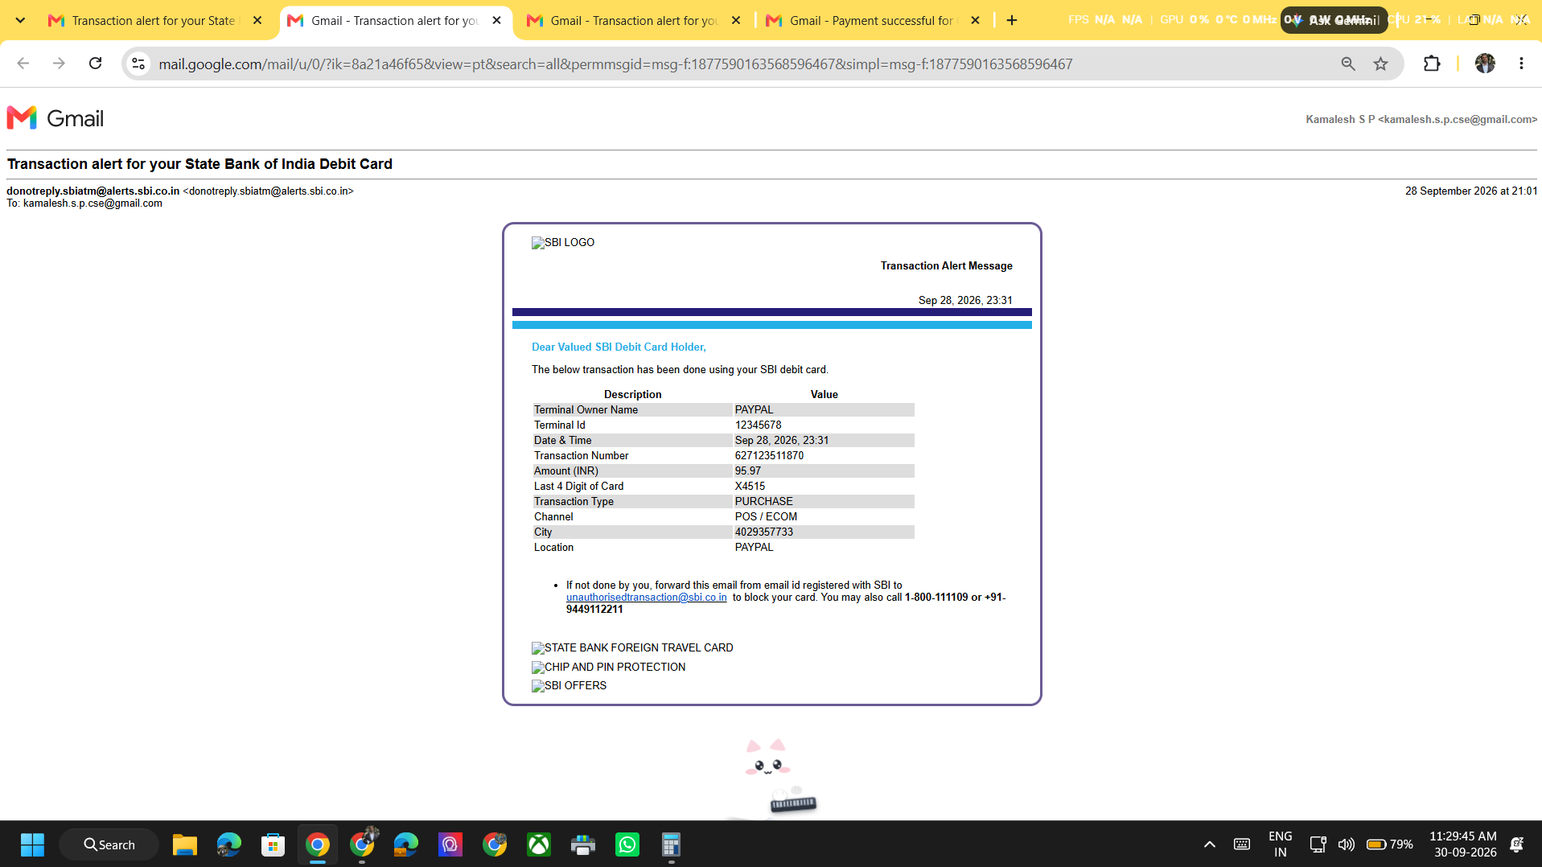
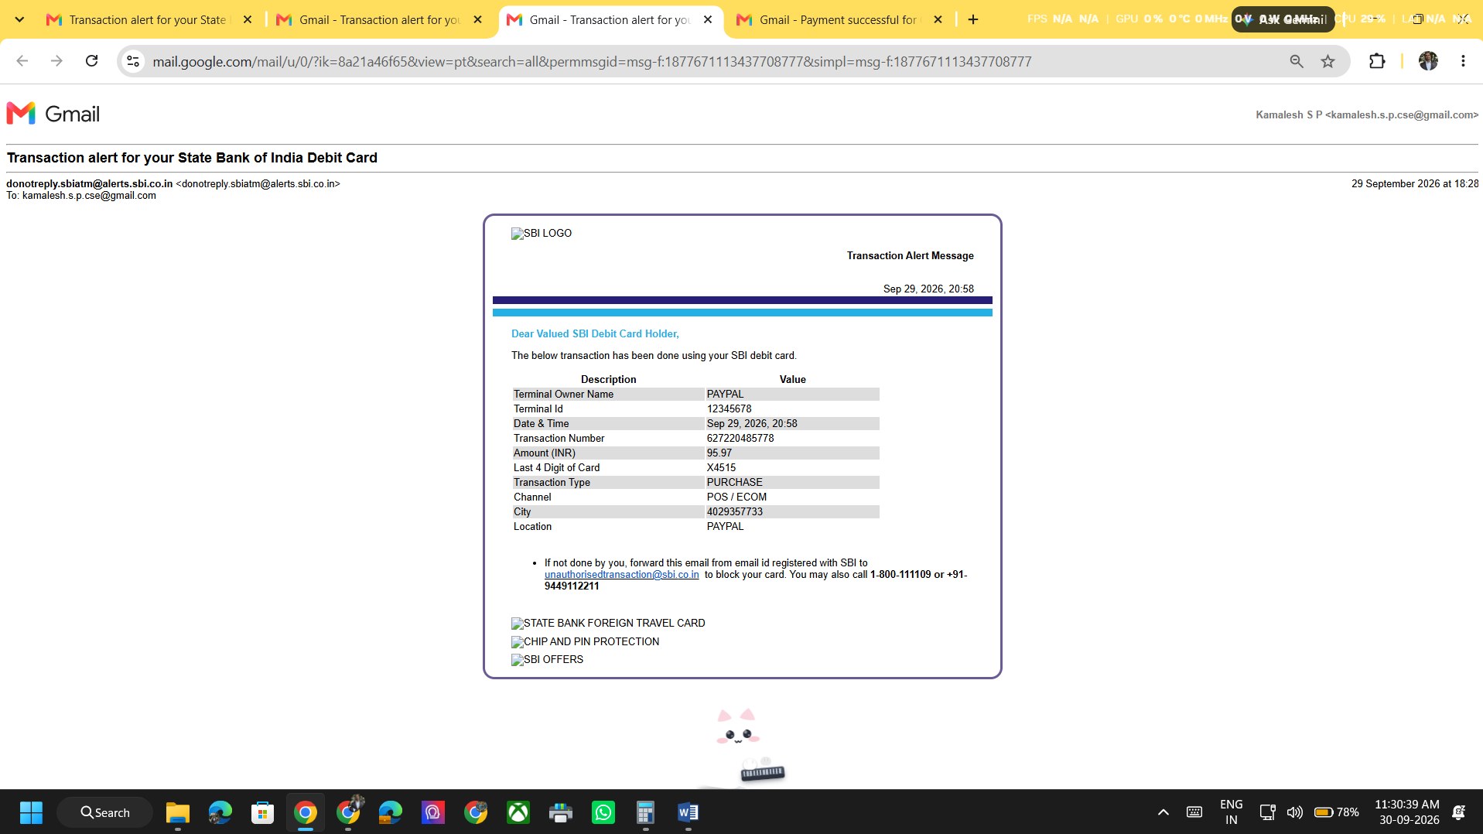



Figure 8.3: Payment Proofs

