WEBSITE: Kaggle <https://www.kaggle.com/johnsmith88/heart-disease-dataset>

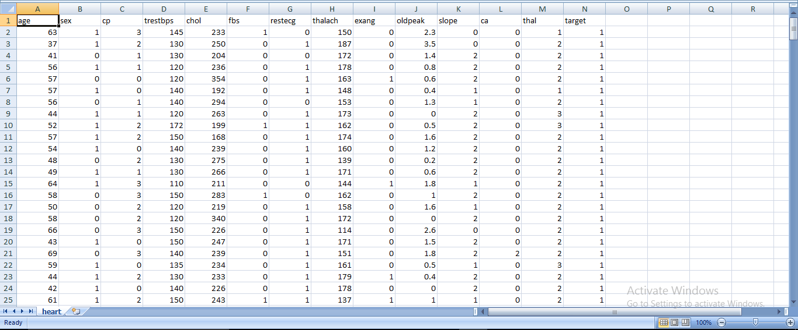

This data set dates consists of four databases: Cleveland, Hungary, Switzerland, and Long Beach V. It contains 76 attributes, including the predicted attribute, but all published experiments refer to using a subset of 14 of them. The "target" field refers to the presence of heart disease in the patient. It is integer valued 0 = no disease and 1 = disease.

Attribute Information:

> 1. age

> 2. sex - (1 = male; 0 = female)

> 3. Cp - chest pain type (4 values)

> 4. Trestbps - resting blood pressure

> 5. Chol - serum cholestoral in mg/dl

> 6. Fbs - fasting blood sugar > 120 mg/dl ((fasting blood sugar > 120 mg/dl) (1 = true; 0 = false))

> 7. Restecg- resting electrocardiographic results (values 0,1,2)

> 8. Thalach - maximum heart rate achieved

> 9. Exang - exercise induced angina ( (1 = yes; 0 = no))

> 10. oldpeak = ST depression induced by exercise relative to rest

> 11. slope - the slope of the peak exercise ST segment

> 12. ca - number of major vessels (0-3) colored by flourosopy

> 13. thal: 0 = normal; 1 = fixed defect; 2 = reversable defect

>14.Target: 0 = no disease and 1 = disease.

The names and social security numbers of the patients were recently removed from the database, replaced with dummy values.