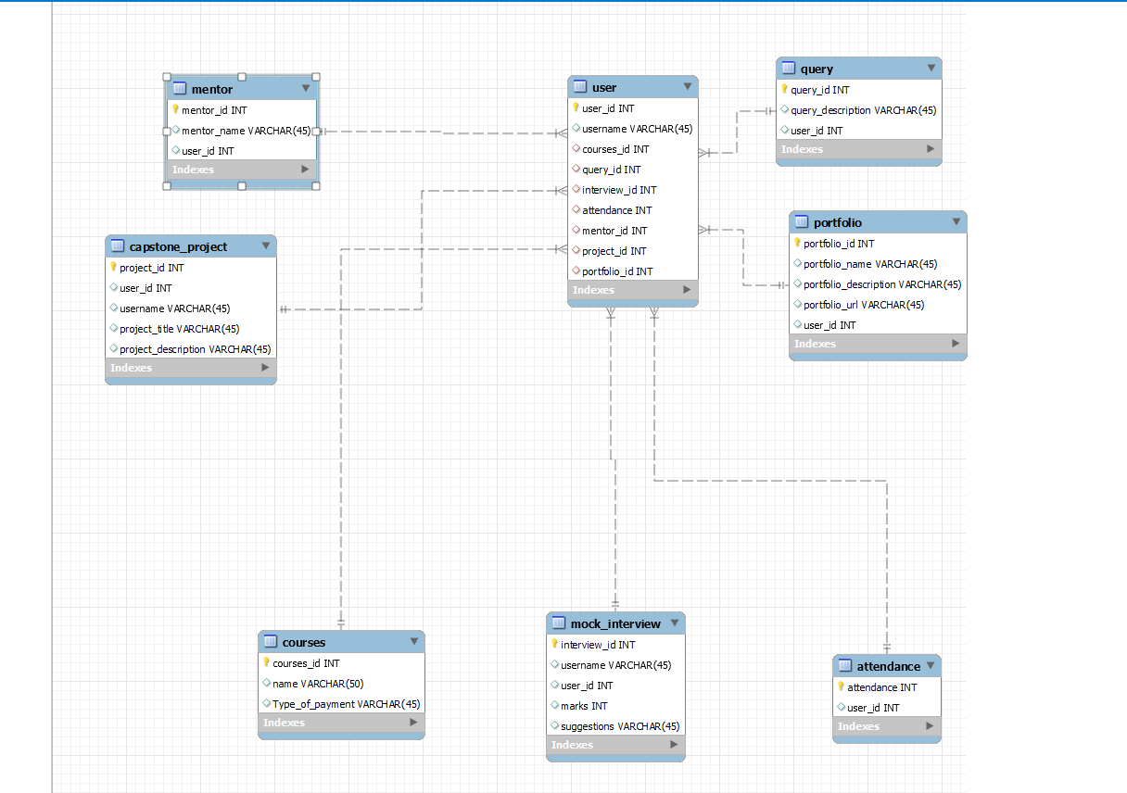

use guvidb;

select * from courses;

insert into courses (courses_id, name, Type_of_payment) values (8, 'Full Stack Development', Paid);

select * from courses;

insert into courses (courses_id, name, Type_of_payment) values (9, 'Data Science', 'Paid'), (10, 'UI/Ux Program', 'Paid');

create table user (user_id int Primary key, username varchar(45), courses_id int, query_id int,interview_id int,

attendance int, mentor_id int, project_id int, portfolio_id int,

foreign key (courses_id) references courses(courses_id),

foreign key (interview_id) references mock_interview(interview_id),

foreign key (project_id) references capstone_project(project_id),

foreign key (attendance) references attendance (attendance),

foreign key (mentor_id) references mentor(mentor_id),

foreign key (query_id) references query (query_id),

foreign key (portfolio_id) references portfolio (portfolio_id));

select * from user;

create table query (query_id int primary key, query_description varchar(45), user_id int);

describe user;

select * from mentor;

create table mock_interview (interview_id int primary key, username varchar(45), user_id int,

marks int, suggestions varchar(45));

create table capstone_project (project_id int primary key, user_id int, username varchar(45),

project_title varchar(45), project_description varchar(45));

create table attendance (attendance int primary key, user_id int);

create table mentor (mentor_id int primary key, mentor_name varchar(45), user_id int, foreign key (user_id) references user (user_id));

create table portfolio (portfolio_id int primary key, portfolio_name varchar(45), portfolio_description varchar(45),

portfolio_url varchar(45), user_id int);