**Exercise using grep, sed , awk**

1. You are given a text file that will be piped into your command through STDIN. Use grep to display all the lines that contain the word **the** in them.
2. The search should be sensitive to case. Display only those lines of the input file that contain the word 'the'.

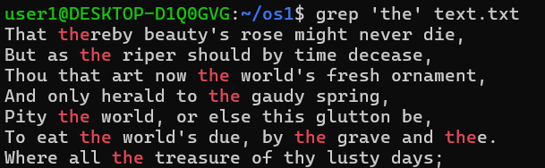

1. The search should NOT be sensitive to case. Display only those lines of the input file that contain the word 'the'.

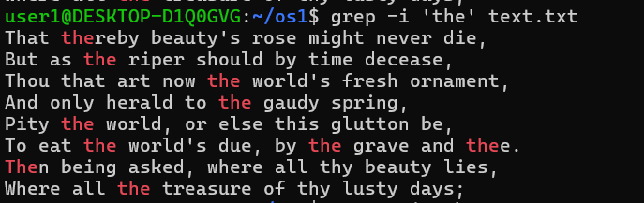

1. Use grep to **remove** all those lines that contain the word 'that'. The search should NOT be sensitive to case.

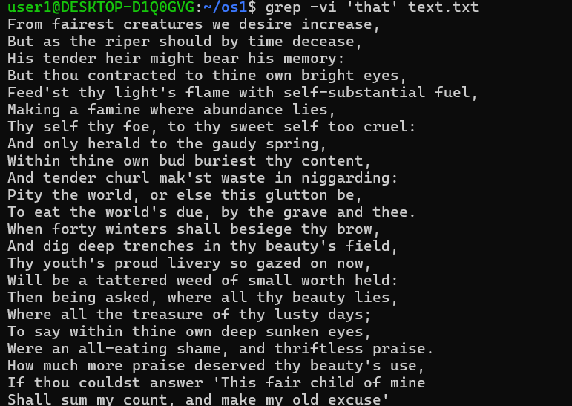

1. use grep to display all those lines which contain any of the following words in them: **the , that, then, those.** The search should not be sensitive to case. Display only those lines of an input file, which contain the required words.

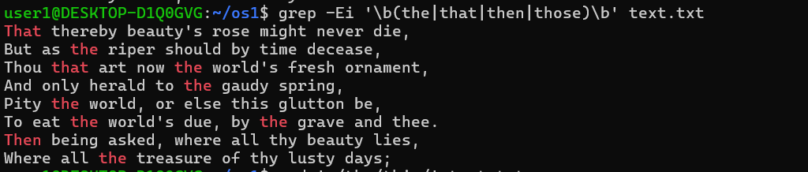

1. use SED , For each line in a given input file, transform the **first** occurrence of the word 'the' with 'this'. The search and transformation should be strictly case sensitive.

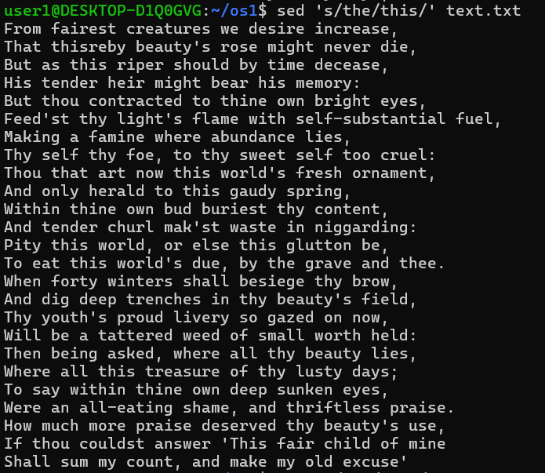

1. Use SED,For each line in a given input file, transform all the occurrences of the word 'thy' with 'your'. The search should be **case insensitive**, i.e. 'thy', 'Thy', 'tHy' etc. should be transformed to 'your'.

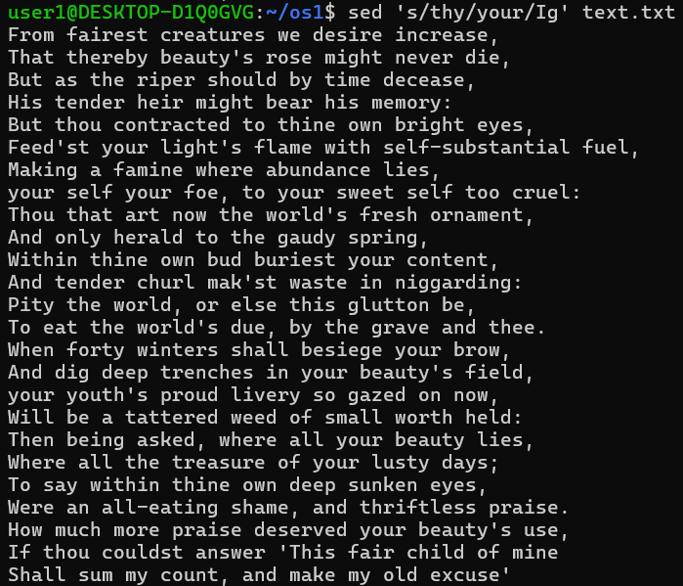

1. Use SED,Given an input file, in each line, highlight all the occurrences of 'thy' by wrapping them up in brace brackets. The search should be case-insensitive.

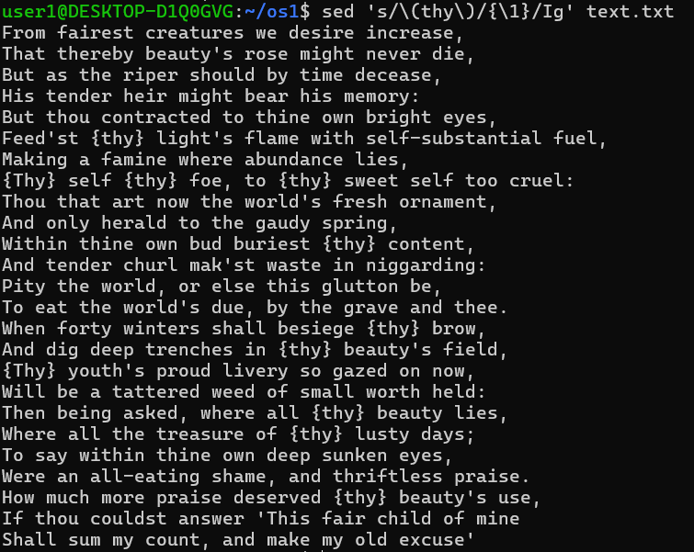

**Sample Input**

From fairest creatures we desire increase,

That thereby beauty's rose might never die,

But as the riper should by time decease,

His tender heir might bear his memory:

But thou contracted to thine own bright eyes,

Feed'st thy light's flame with self-substantial fuel,

Making a famine where abundance lies,

Thy self thy foe, to thy sweet self too cruel:

Thou that art now the world's fresh ornament,

And only herald to the gaudy spring,

Within thine own bud buriest thy content,

And tender churl mak'st waste in niggarding:

Pity the world, or else this glutton be,

To eat the world's due, by the grave and thee.

When forty winters shall besiege thy brow,

And dig deep trenches in thy beauty's field,

Thy youth's proud livery so gazed on now,

Will be a tattered weed of small worth held:

Then being asked, where all thy beauty lies,

Where all the treasure of thy lusty days;

To say within thine own deep sunken eyes,

Were an all-eating shame, and thriftless praise.

How much more praise deserved thy beauty's use,

If thou couldst answer 'This fair child of mine

Shall sum my count, and make my old excuse'

**Sample Output**

But as the riper should by time decease,

Thou that art now the world's fresh ornament,

And only herald to the gaudy spring,

Pity the world, or else this glutton be,

To eat the world's due, by the grave and thee.

Where all the treasure of thy lusty days;

**2) Do the following Using AWK**

a) You are given a file with four space separated columns containing the scores of students in three subjects. The first column contains a single character (), the student identifier. The next three columns have three numbers each. The numbers are between  and , both inclusive. These numbers denote the scores of the students in English, Mathematics, and Science, respectively.

Your task is to identify those lines that do not contain all three scores for students.

**Sample Input**

A 25 27 50

B 35 75

C 75 78

D 99 88 76

**Sample Output**

Not all scores are available for B

Not all scores are available for C

b)  identify whether each of the students has passed or failed.  
A student is considered to have passed if (s)he has a score  or more in each of the three subjects.

**Sample Input**

A 25 27 50

B 35 37 75

C 75 78 80

D 99 88 76

**Sample Output**

A : Fail

B : Fail

C : Pass

D : Pass

c)  identify the performance grade for each student. If the average of the three scores is 80 or more, the grade is 'A'. If the average is 60 or above, but less than 80, the grade is 'B'. If the average is 50 or above, but less than 60, the grade is 'C'. Otherwise the grade is 'FAIL'.

**Sample Input**

A 25 27 50

B 35 37 75

C 75 78 80

D 99 88 76

**Sample Output**

A 25 27 50 : FAIL

B 35 37 75 : FAIL

C 75 78 80 : B

D 99 88 76 : A

d) Concatenate every 2 lines of input with a semi-colon.

**Sample Input**

A 25 27 50

B 35 37 75

C 75 78 80

D 99 88 76

**Sample Output**

A 25 27 50;B 35 37 75

C 75 78 80;D 99 88 76

Output for above 4 question

