

K. Vishnuwaran
ESOFT METRO CAMPUS
E-Space Solutions (Pvt.) Ltd
Technical Document
|

Table of Contents
Technical Documentation for E-Space Solution 3
Overview 3
System Requirements 3
User Access Levels 3
Database Operations 4
Error Handling 4
Use case Diagram for E Space Solution 5
Flow Chart for Database Functionalities 6
Dataflow Diagram for E Space Solution 8
System Interface with code 9
Other Functionalities interfaces with code 10
Design view of tables 13
Database data tables 13

Technical Documentation for E-Space Solution

Overview
The E-Space Solution is a database management system developed to assist E-Space Solutions (Pvt.) Ltd. in their Mars colonization project, starting in 2040. The system manages critical data related to colonists, their dependents, E-Jets, trips, housing, and job assignments on Mars. The solution ensures data consistency, accuracy, and ease of retrieval for decision-making purposes, and will be expanded to include reporting features in future development phases.

System Requirements
- Database Management System (DBMS): Microsoft SQL Server
- Operating System: Windows 10 or higher
- Hardware Requirements: Minimum 8 GB RAM, 500 GB storage
- Software Requirements:
  - SQL Server Management Studio (SSMS)
  - NET Framework (for additional tools and integration, if needed)
  - Visual Studio (for integration with the E-Space system application)

User Access Levels
- System Administrator: Manages the overall system, data integrity, and security, and generates critical reports.
- Data Entry Operators: Input new data (e.g., colonists, trips, dependents) and update existing records.
- Pilots: Access trip-related data and passenger details.
- Colony Superintendent: Reviews reports on housing, job allocations, and colonist details.

Database Operations
- Data Input: Data entry operators use input forms to add colonist details, dependent data, and E-Jet trip information.
- Search and Retrieval: System users can search for colonists, trips, or E-Jets using the system’s search functionalities, which utilize indexed fields such as Mars_Coloni_id, Jet unique Code, or Trip id.
- Data Validation: The system implements validation constraints, such as unique Mars_Coloni_id, and ensures referential integrity across all tables (e.g., linking colonists to dependents).
- Reports: Future implementation of reporting will include detailed colonist reports, trip schedules, and housing assignments.

Error Handling
- User Errors: Detailed error messages guide users when invalid data is entered, such as duplicate Mars Colonization ID or missing required fields.
- System Errors: All system-level errors, such as database connection failures, are logged and displayed to administrators with relevant debug information.
- Transaction Rollback: In case of database errors, transactions are rolled back to ensure data integrity is maintained.

Use case Diagram for E Space Solution

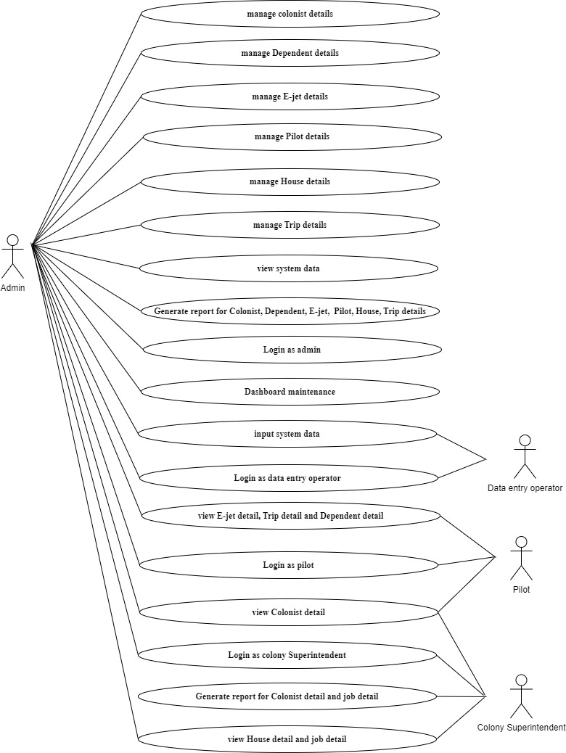

Flow Chart for Database Functionalities
- Login
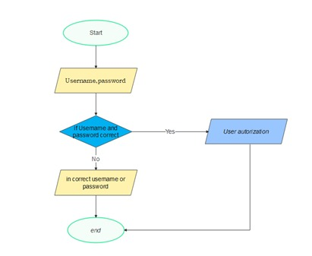
- Insert
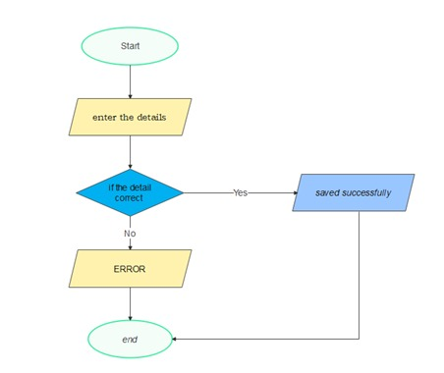
- Update
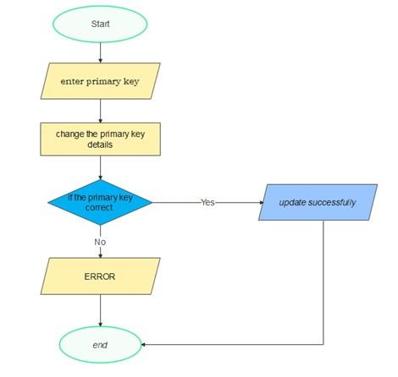
- Delete
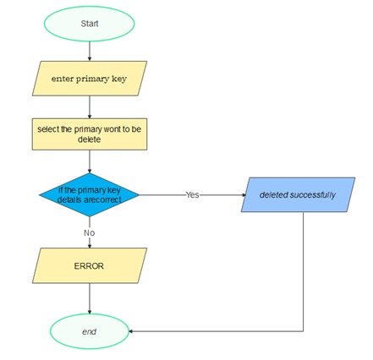

Dataflow Diagram for E Space Solution

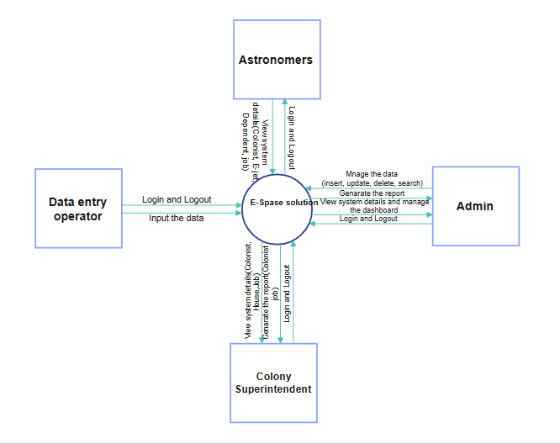

System Interface with code
- Login interface
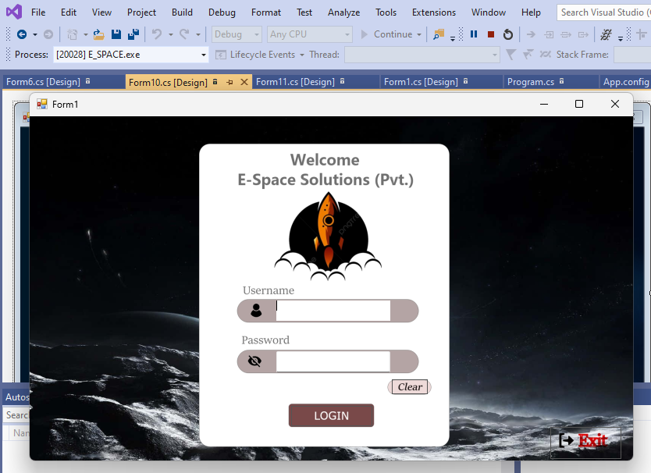

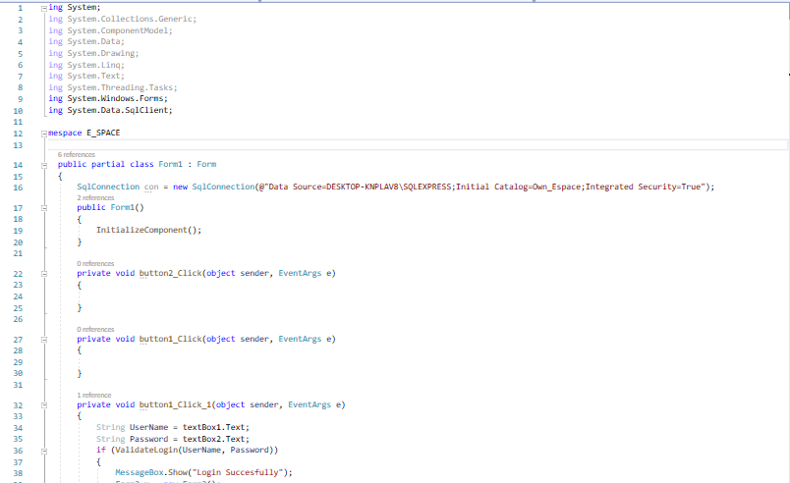
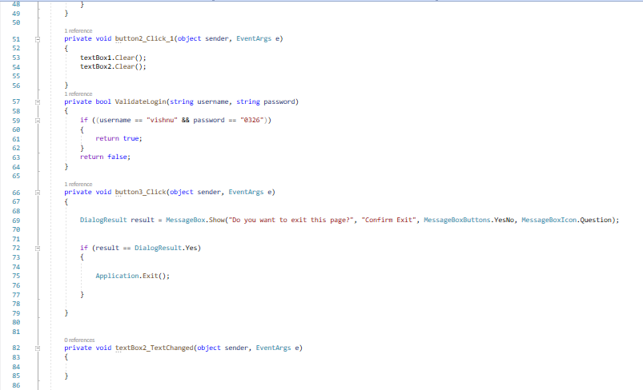

Other Functionalities interfaces with code
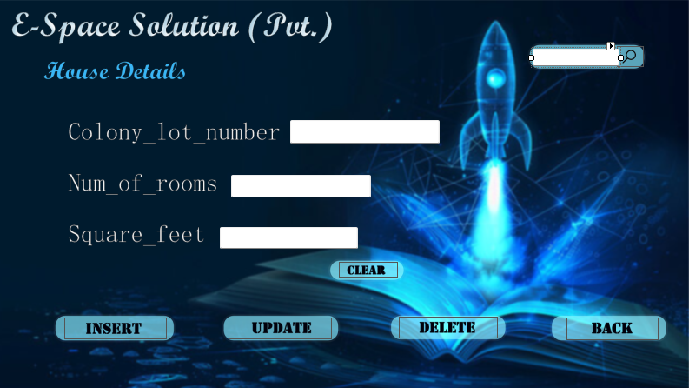

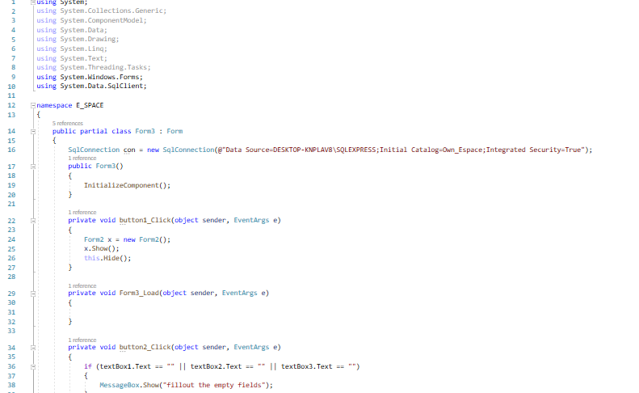

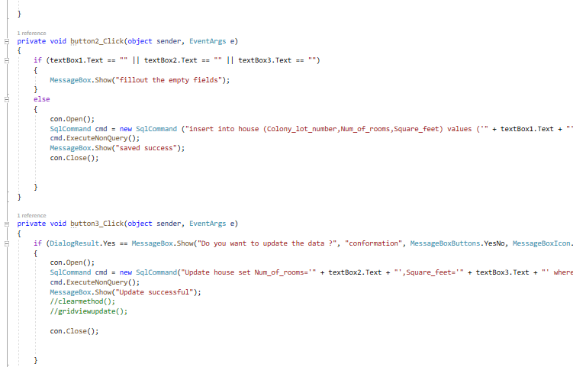
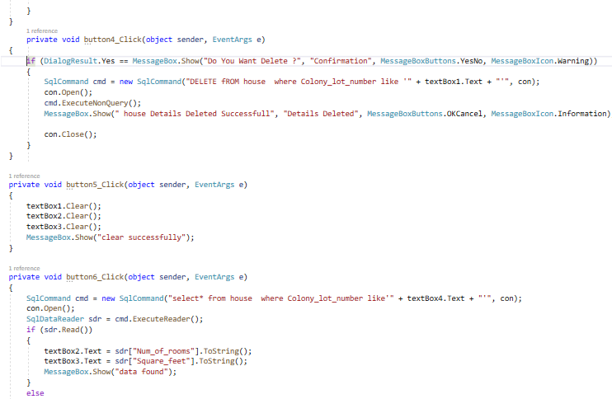

Design view of tables
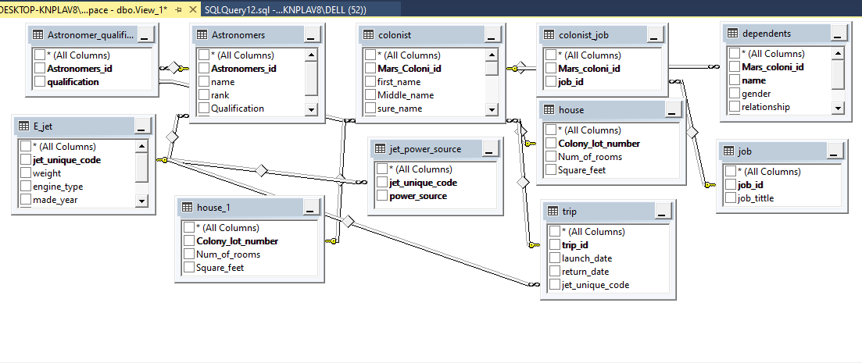

Database data tables
