Ex no: 02

Register no: 240701225 Name: R J Kamali

Zoho Creator Setup and Platform Exploration

Setting Up a Zoho Creator Account and Exploring the Platform Architecture and Interface
1. Aim
To create and configure a Zoho Creator account, develop a sample application using forms, reports, and dashboards, and explore the Develop, Deploy, and Manage sections of the Zoho Creator platform.
2. Setting Up Zoho Creator
I) Creating the Sample Application
Procedure
1. Open the Zoho Creator website and sign in using a Zoho account.
2. Select Create Application from the Zoho Creator home page.
3. Choose Create from Scratch or select a suitable application template.
4. Enter the application name, for example Student Management System.
5. Create the application.
6. Add the required forms, reports, and dashboards to the application.
7. Save and test the application. 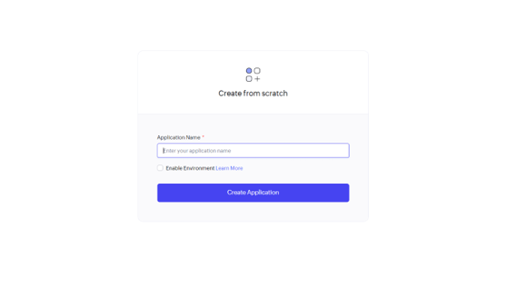

II) Creating a Form
A Form is used to collect and store data in the Zoho Creator application.
1. Open the application.
2. Go to Develop.
3. Select Create → Form.
4. Enter the form name as Student Form.
5. Drag and drop the required fields.
6. Configure the field properties.
7. Click Done/Save.
8. Add sample student records. 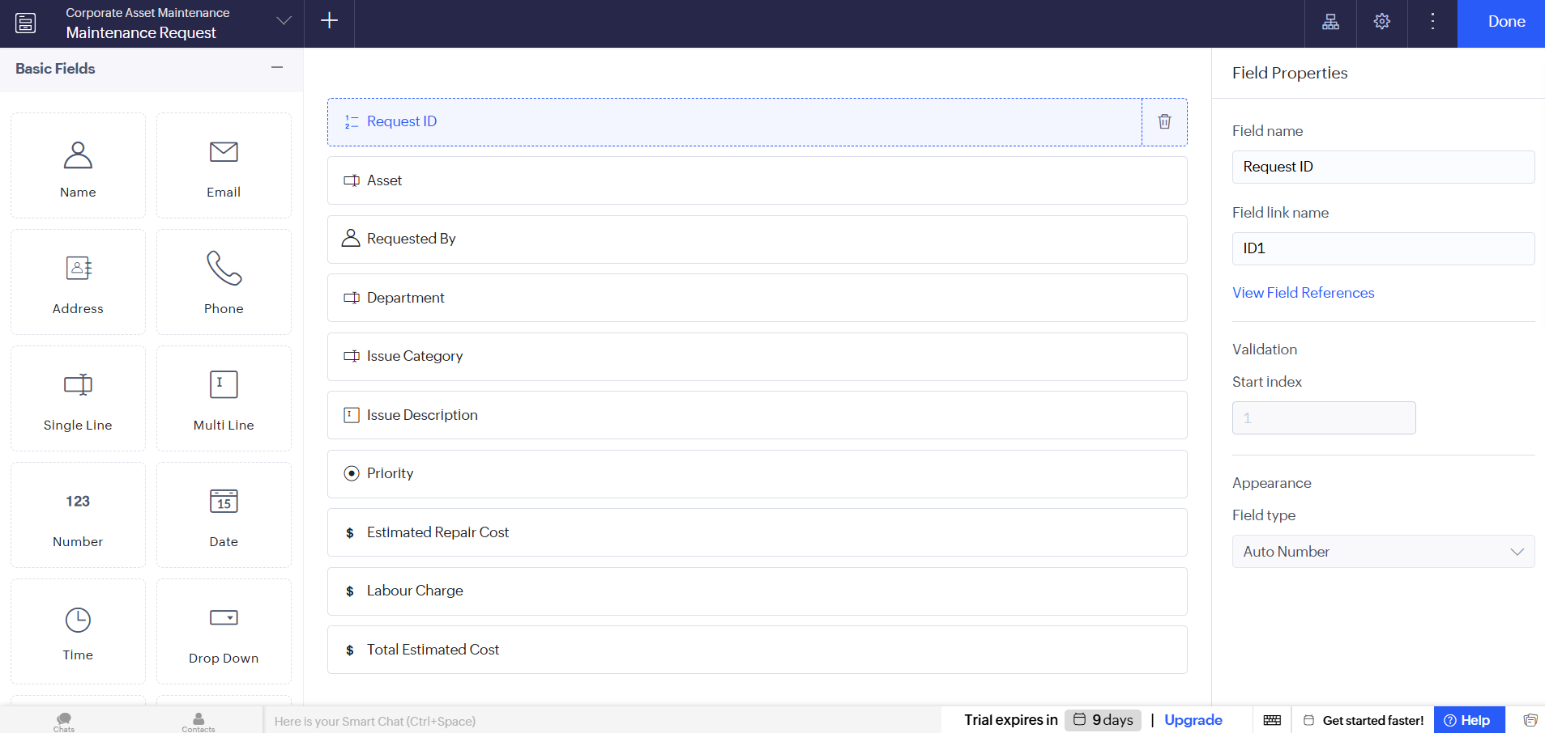

III) Creating a Report
A Report is used to view, organize, filter, and analyze the data collected through forms.
Procedure
1. Go to the Develop section.
2. Select Create → Report.
3. Choose Student Form as the data source.
4. Select a report type such as List Report or Table Report.
5. Select the required fields.
6. Save the report.
7. Add or modify records to observe the report. 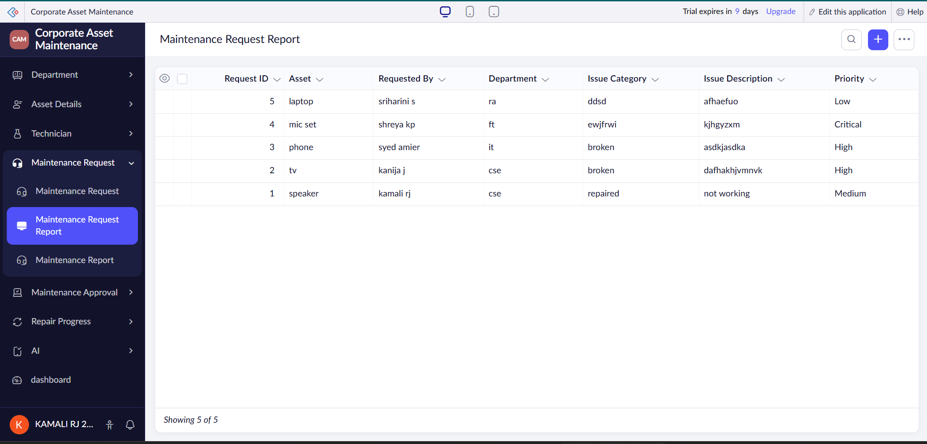

IV) Creating a Dashboard
A Dashboard provides a visual representation of application data using charts, panels, and summaries.
Procedure
1. Open the application.
2. Go to Create → Dashboard.
3. Enter the dashboard name as Student Dashboard.
4. Add charts and panels.
5. Select the Student Report as the data source.
6. Configure the required chart type.
7. Save and preview the dashboard. 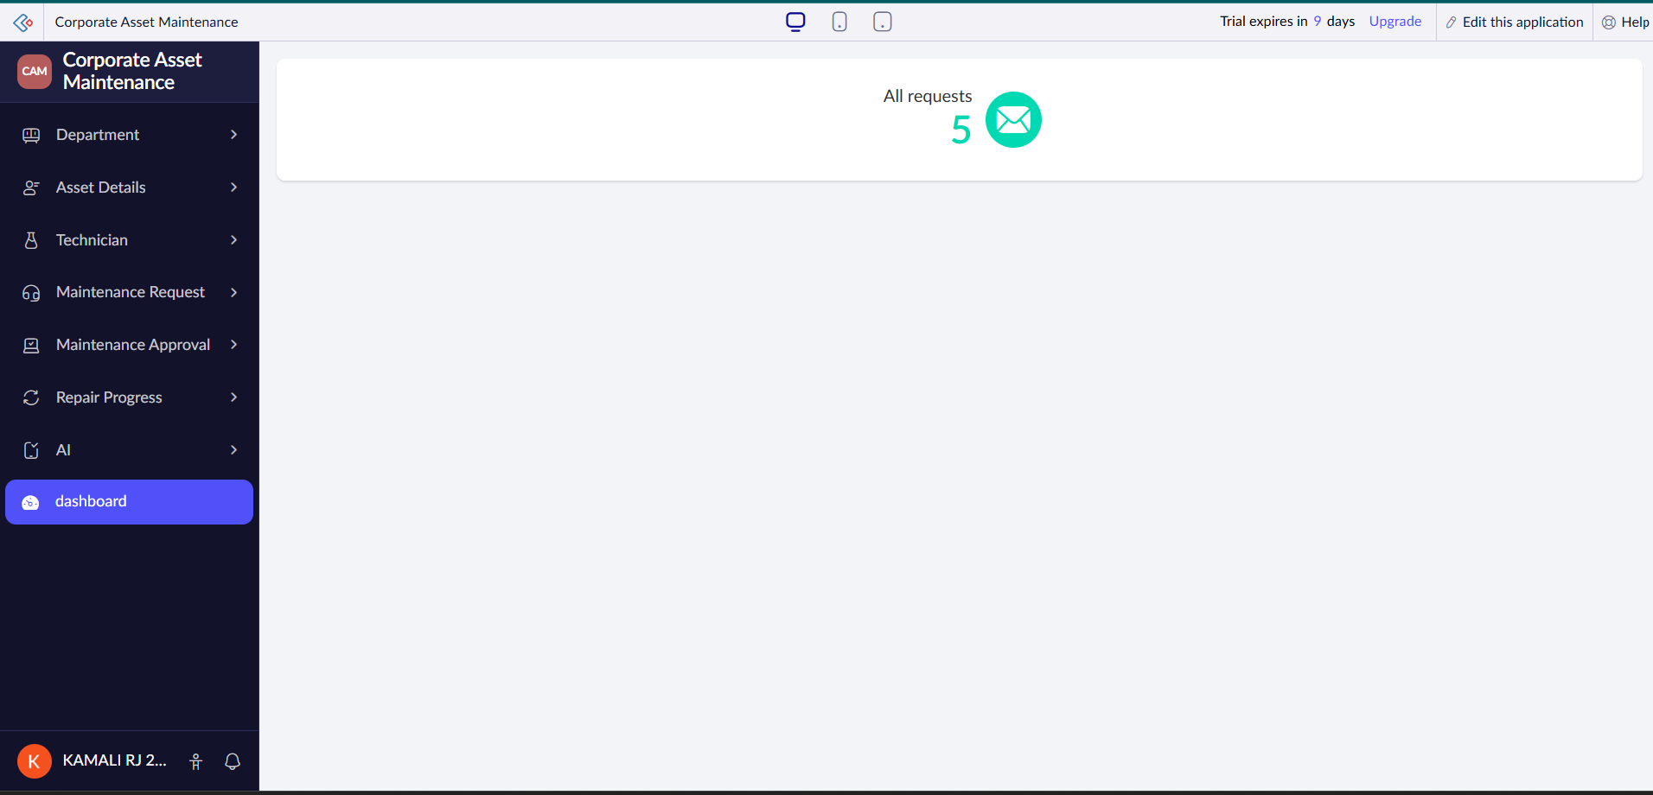

8. Exploring the Zoho Creator Platform Architecture and Interface
A) Develop
1. The Develop section is used to create and customize applications in Zoho Creator.
2. It allows users to create forms, reports, pages, workflows, and dashboards.
3. Developers can also use Deluge scripting to add automation and custom functionality.
B) Deploy
1. The Deploy section is used to publish and make applications available to users.
2. Applications can be accessed through web browsers and supported devices after deployment.
3. It provides options to control application access, permissions, and user availability.
C) Manage
1. The Manage section is used to manage application settings, users, permissions, and data.
2. Administrators can monitor the application and control user access and security settings.
3. It helps maintain the application and manage its overall configuration.
Result
Thus, a Zoho Creator account was successfully set up and a sample Student Management System application was created using forms, reports, and dashboards. The Develop, Deploy, and Manage sections of the Zoho Creator platform architecture and interface were also explored successfully.

