

**DEDAN KIMATHI UNIVERSITY OF TECHNOLOGY**

**SCHOOL OF COMPUTER SCIENCE AND INFORMATION TECHNOLOGY**

**DEPARTMENT OF INFORMATION TECHNOLOGY**

**PROJECT DOCUMENTATION**

**TITLE: DRIVER STATE MONITORING SYSTEM**

**JOSEPHAT KAMALI KINUTHIA**

**REG NO: C025-01-0639/2020**

**SUPERVISOR: DR. PATRICK GIKUNDA**

**Project documentation submitted to the Department of Information Technology in the school of Computer Science and Information Technology in partial fulfillment of the requirements for the award of the degree of BSc in Information Technology at Dedan Kimathi University of Technology**

**AUGUST 2024.**

# 

# DECLARATION

I declare that this is my original work and has not been presented in any University for a degree or for any consideration of any certification.

Name: ………………………………………………………………

Signature ……………………………….. Date………………………………………..

This documentation has been submitted for examination with my approval as the University

Supervisor.

Dr. Patrick Gikunda Sign…………………. Date……………………

Department of Information Technology.

# ABSTRACT

The Driver Monitoring System (DMS) designed to significantly improve road safety (Hashemi et al., 2020), it comprises of three key components, data acquisition, feature extraction and state classification: The camera collects real-time video stream of the driver and surrounding, the stream undergo preprocessing to enhance clarity and eliminate noise to ensure optimal input for analysis [5].The system Integrates Dlib for facial landmark detection, Haar cascade classifier for face detection, CNNs for facial expression recognition, Optical Flow Analysis for eye movement tracking, and SVM for driver state classification in a driver state monitoring system using real-time video from a dashboard camera offers a comprehensive approach to analyzing driver behavior. This system leverages the efficiency of the selected algorithms, ensuring a balance between accuracy and computational efficiency crucial for real-time processing. The robustness of Dlib and Haar cascade provides reliable facial landmark detection and face tracking capabilities, while CNNs excel in recognizing complex patterns like facial expressions. Optical Flow Analysis and SVM enhance the system's versatility by accurately tracking eye movements and classifying driver states.The classifier analyzes extracted features, enabling prompt intervention through auditory and visual alerts upon detection of unsafe behaviors effectively aiding to mitigate potential risks in real-time(Ghoddoosian et al., 2019).

Table of Contents

DECLARATION i

ABSTRACT ii

TABLE OF FIGURES vi

CHAPTER ONE : INTRODUCTION 1

1.1 Background of study 1

1.2 Statement of the problem 3

1.3 Objectives 3

General Objective. 3

Specific Objectives. 3

1.4 Research Questions. 4

1.5 Justification 4

1.6 Scope 5

CHAPTER TWO : LITERATURE REVIEW 6

2.1 INTRODUCTION 6

2.2. CASE STUDIES 6

2.2.1 CASE STUDY 1: Driver State Monitoring System Using AI 6

2.2.2 CASE STUDY 2: Real-Time Driver Drowsiness Detection System Based on Convolutional Neural Network. 7

2.2.3: CASE STUDY 3: Real-Time Machine Learning-Based Driver Drowsiness Detection Using Visual Features. 7

2.3 Summary 8

2.4 Research Gap 9

2.5 Proposed methodology 9

CHAPTER THREE : METHODOLOGY 10

3.1: Introduction 10

3.2: Fact finding techniques 10

3.3: Machine learning models and architecture 10

3.4: Tools and Technologies 11

3.5: Implementation Steps 11

3.5.1: Data Collection and Preparation 11

3.5.2: Model Training 11

3.5.3: Real-Time Eye Detection 11

3.5.4: Drowsiness Detection Logic 11

3.5.5: Head tilt Angle Logic 12

3.5.6: System Deployment 12

3.6: Testing and Validation 12

3.7: Results and Analysis 12

CHAPTER FOUR: SYSTEM ANALYSIS AND DESIGN 13

4.1: INTRODUCTION 13

4.2:REQUIREMENT ANALYSIS 13

4.2.1: FEASIBILITY STUDY 13

4.2.2:FUNCTIONAL REQUIREMENTS 14

4.2.3: NON-FUNCTIONAL REQUIREMENTS 15

4.3: UML DIAGRAMS 15

4.3.1:ACTIVITY DIAGRAM 15

4.3.2:SEQUENCE DIAGRAM 17

4.3.3:CLASS DIAGRAM 17

4.3.4: USE CASE DIAGRAM 18

4.3.5: FLOWCHART 19

CHAPTER FIVE: 21

REFERENCES 22

# TABLE OF FIGURES

Figure 1: sample dataset, closed open eyes, head pose 11

Figure 2: Activity diagram 16

Figure 3:sequence diagram 17

Figure 4:class diagram 18

Figure 5:usecase diagram 19

Figure 6:flowchart 20

Figure 7: sleepy driver 21

Figure 8: driver with tilted head beyond threshold angle 22

Figure 9: driver in a normal position 22

Figure 10: interface 24

Figure 11: budget table 30

Figure 12: resources table 30

Figure 13:Ganhtchart 30

Figure 14: block code for training drowsiness model 31

Figure 15: block of code for training head pose model 31

Figure 16: Block of code for the system 31

# CHAPTER ONE : INTRODUCTION

## 1.1 Background of study

Drowsiness detection systems are commonly classified into three categories based on the measures used to detect signs of drowsiness: biological-based, vehicle-based, and image-based systems. **Biological-Based Systems**: These systems rely on monitoring the body's physiological signals, including ElectroEncephaloGraphy (EEG), Electrocardiography (ECG), Electromyography (EMG), Electro-Oculography (EOG) signals, and blood pressure. Drowsiness is determined by detecting deviations in these signals from their standard characteristics and analyzing whether the new signal indicates drowsiness. **Vehicle-Based Systems**: This category depends on monitoring variations in the car's movement patterns through various sensors installed to measure vehicle and street parameters. Vehicle-based systems analyze changes or abnormal behaviors of the car, such as steering wheel angle, speed, or deviation from the lane, to infer the driver's drowsiness level. **Image-Based Systems**: [13] Image-based measures focus on drowsiness signs appearing on the driver's face and head. These systems detect drowsiness by monitoring head movements and facial parameters, including the eyes, mouth, facial expressions, eyebrows, or respiration. (Sun et al. 2011)

With the recent advancement in Artificial Intelligence technology, DMS has benefitted with revolutionized capabilities. The integration of AI enables DMS to provide real-time alerts to drivers when signs of distraction are detected. This technology addresses the limitations of traditional DMS, significantly improving driver alertness and attentiveness and overall road safety (Khadraoui et al., 2024).

In recent years, the automotive industry has witnessed remarkable advancements in vehicle safety technologies that aim at reducing the incidences of accidents and improving overall road safety. Among these innovations, Driver State Monitoring Systems (DMS) have emerged as critical components designed to assess the driver's cognitive and physical state in real-time during driving. The system that works by constantly monitoring factors such as drowsiness and distraction inattentiveness, the DMS aim to mitigate the risk of accidents that is caused by human error, which remains a significant contributor to road fatalities worldwide (Khan & Lee, 2019).

The genesis of the problem lies in the recognition of the profound impact of human factors on road safety. Despite significant progress in vehicle design and infrastructure, human error continues to be a primary cause of accidents, accounting for a substantial percentage of road traffic fatalities worldwide. According to the World Health Organization (WHO), an estimated 1.35 million people die each year due to road traffic injuries, with human error playing a significant role in many of these incidents. Addressing this issue requires a multifaceted approach that encompasses both technological innovations and behavioral interventions .

The imperative to enhance road safety has stimulated the adoption of driver monitoring systems as a standard feature in modern vehicles. Regulatory bodies and safety organizations around the globe have recognized the potential of DMS to mitigate the risks associated with driver impairment and distraction. For instance, the European-Union (EU), a political union located in Europe, has mandated the inclusion of DMS in all new vehicle models starting in 2024, underscoring the increasing acknowledgment of these systems as integral elements of automotive safety, highlighting their importance and significance. In addition to regulatory mandates, organizations such as the European New Car Assessment Program (Euro NCAP), an organization that conducts safety tests and provides safety ratings for all new vehicles sold in Europe have incorporated driver monitoring systems into their safety assessment criteria, incentivizing automakers to prioritize the integration of these technologies into their vehicles. This global trend reflects a collective effort to leverage technology to address the persistent challenge of road traffic injuries and fatalities.

According to National Transport and Safety Authority (NTSA), the body in charge of transport in Kenya, the country recorded 3572 fatalities, 6938 serious injuries and 5186 slight injuries as at December 2019. Despite ongoing efforts to improve road infrastructure and enforce traffic regulations, the prevalence of road traffic injuries remains a pressing concern. Previous research has identified various transportation and traffic situation as identifiers for accident prevalence. Such identifiers include but not limited to, traffic congestion, human factors and behaviors, road types and sections.

Within this local context, the implementation of driver monitoring systems holds significant promise for enhancing road safety and reducing the incidence of accidents caused by human error. By providing real-time assessment of driver state and alerting drivers to potential risks, a DMS have the potential to mitigate the impact of human factors on road safety and save lives.

## 1.2 Statement of the problem

Based on the data released by the National Transport and Safety Authority (NTSA) of Kenya, the nation's road transport sector confronts a significant and persistent challenge marked by alarmingly high rates of road traffic incidents. As of December 2019, the recorded figures are stark and emblematic of the profound challenges facing Kenya's road transport sector.: Kenya reported a total of 3,572 fatalities, 6,938 serious injuries, and 5,186 slight injuries. These statistics reflect not just numbers but also lives lost, families shattered, and communities deeply affected by the aftermath of road accidents.

Against this backdrop, the implementation of a Driver State Monitoring System emerges as a critical strategy to mitigate the risks associated with driver impairment and distraction on Kenyan roads. By leveraging advanced technologies, such as real-time monitoring of driver behavior and alerting mechanisms, a Driver State Monitoring System holds the potential to proactively identify and address factors contributing to road accidents, thereby saving lives and reducing the socio-economic impact of road traffic incidents.

## 1.3 Objectives

### General Objective.

Develop a driver state monitoring system that analyzes and classifies driver behavior and issues auditory and visual warnings to enhance driver safety.

### Specific Objectives.

1. Data collection: eye classification dataset will be gathered from Kaggle datasets to facilitate model training. <https://www.kaggle.com/datasets/serenaraju/yawn-eye-dataset-new>.
2. Head pose dataset: http://crowley-coutaz.fr/Head%20Pose%20Image%20Database.html
3. Data processing: Help the model to get consistent, normalized, and clean input data.
4. Train and test two machine learning models, one that analyzes and classifies driver state into two categories namely, drowsy, distracted, two a model that analyzes the tilt angle of the driver and classifies it as attentive or not.
5. Evaluate the performance and efficacy of the developed driver state monitoring system.

## 1.4 Research Questions.

1. What are the most relevant features and attributes for accurately identifying and classifying different driver states, such as alertness, distraction and impairment?
2. What auditory and visual warning mechanisms are most effective for alerting drivers to potential hazards or signs of impairment, distraction, or fatigue without causing distraction or confusion?
3. What metrics and criteria should be used to assess the performance and efficacy of the developed driver state monitoring system in real-world driving scenarios?

## 1.5 Justification

The implementation of a Driver State Monitoring System (DMS) in Kenya is a critical strategy to mitigate the risks associated with driver impairment and distraction on the nation's roads. The alarming rates of road traffic incidents, as evidenced by the recorded figures of 3,572 fatalities, 6,938 serious injuries, and 5,186 slight injuries in December 2019, underscore the urgent need for such a system. This research is conducted to address the profound challenges facing Kenya's road transport sector and to ultimately save lives and reduce the socio-economic impact of road traffic incidents.

The research will benefit various stakeholders, including the government, road safety authorities, transport companies, drivers, and the general public. For the government and road safety authorities, the implementation of a DSMS can lead to a reduction in the number of road traffic incidents, thereby easing the burden on the healthcare system and minimizing the socio-economic impact of such incidents. Transport companies and drivers stand to benefit from improved safety, reduced accident-related costs, and enhanced public trust. The general public will benefit from increased road safety, leading to fewer lives lost, fewer families shattered, and fewer communities affected by the aftermath of road accidents.

The justification for conducting this research is clear: the high rates of road traffic incidents in Kenya demand urgent and effective measures to enhance road safety. The implementation of a DMS, as supported by the research, holds the potential to proactively identify and address factors contributing to road accidents, thereby saving lives and reducing the socio-economic impact of road traffic incidents.

## 1.6 Scope

The scope of this study is to focus on the potential benefits of implementing a Driver State Monitoring System (DMS) in the context of Kenya's road transport sector. The study will specifically examine the potential impact of DMS on road safety, reduction of road traffic incidents caused by human error, and the socio-economic implications of such incidents in Kenya. The geographical area of focus for this study is the nation of Kenya, with an emphasis on its road transport sector, transport companies, drivers, and the general public.

# CHAPTER TWO : LITERATURE REVIEW

## 2.1 INTRODUCTION

Driver drowsiness poses a significant risk to road safety, contributing to numerous accidents and fatalities worldwide(Khan & Lee, 2019). In response to this challenge, researchers and engineers have developed innovative driver state monitoring systems aimed at detecting signs of distraction or drowsiness in real-time. These systems utilize advanced technologies such as artificial intelligence (AI), convolutional neural networks (CNNs), and machine learning algorithms to analyze various physiological and behavioral signals of drivers.

This introduction provides an overview of three compelling case studies that exemplify the advancements in driver drowsiness detection systems:

These case studies underscore the critical role of technology in mitigating the risks associated with driver drowsiness and emphasize the importance of continuous innovation in developing robust and reliable driver state monitoring systems. As road safety remains a global concern, these advancements hold promise in reducing accidents and saving lives on the roadways.

## 2.2. CASE STUDIES

### 2.2.1 CASE STUDY 1: Driver State Monitoring System Using AI

The driver state monitoring system presented herein is designed to analyze a driver's eye movements in real-time to detect signs of distraction or drowsiness. This report outlines the methodology and key features of the proposed system, along with its potential benefits in enhancing driver safety. The system utilizes various techniques to detect and alert drivers to potential hazards. The system employs camera input to track the driver's eye movements, which are then analyzed to determine levels of distraction or drowsiness. The system employs Histogram of Oriented Gradients (HOG) feature extraction with Support Vector Machine (SVM) and Hue-Saturation-Value (HSV) algorithms to aid drivers, particularly those with color blindness, in identifying traffic lights. Using the Haar cascade technique, the system monitors the driver's blink rate and eye condition to alert the driver when signs of drowsiness are detected. Modules for detecting distracted driving and mobile phone usage are incorporated, which analyze the driver's head position and presence of a phone in proximity. An alarm system alerts the driver when distraction is detected. The driver state monitoring system has been evaluated using a dataset of 150 photographs of various individuals to ensure precision in its detection capabilities. Results indicate that the system effectively identifies signs of weariness and distraction, providing timely alerts to drivers to mitigate potential accidents.

The effectiveness of the system relies on drivers accepting and responding to the alerts issued by the system. Some drivers may find the alerts intrusive or annoying, leading to non-compliance or even disabling of the system.

To classify drowsy and non-drowsy database

images, we trained three different deep convolutional networks. Our model outperformed the others by utilize-

in ResNet50V2, a modiﬁed pyramid network, and the designed architecture. We used the trained networks to

run the fully automated identiﬁcation system after training. Our model achieved an overall accuracy of 98.17%

for single image classiﬁcation (the ﬁrst method of evaluation). In the driver state identiﬁcation step (sequence

of images or video), our model performed better than the other systems; correctly identifying approximately

463 images out of 502 images as drowsy. We also used the webcam, which continuously captures and observes

the driver’s eyes, to test the classiﬁcation’s accuracy

To classify drowsy and non-drowsy database

images, we trained three different deep convolutional networks. Our model outperformed the others by utiliz-

ing ResNet50V2, a modiﬁed pyramid network, and the designed architecture. We used the trained networks to

run the fully automated identiﬁcation system after training. Our model achieved an overall accuracy of 98.17%

for single image classiﬁcation (the ﬁrst method of evaluation). In the driver state identiﬁcation step (sequence

of images or video), our model performed better than the other systems; correctly identifying approximately

463 images out of 502 images as drowsy. We also used the webcam, which continuously captures and observes

the driver’s eyes, to test the classiﬁcation’s accuracy

To classify drowsy and non-drowsy database

images, we trained three different deep convolutional networks. Our model outperformed the others by utiliz-

ing ResNet50V2, a modiﬁed pyramid network, and the designed architecture. We used the trained networks to

run the fully automated identiﬁcation system after training. Our model achieved an overall accuracy of 98.17%

for single image classiﬁcation (the ﬁrst method of evaluation). In the driver state identiﬁcation step (sequence

of images or video), our model performed better than the other systems; correctly identifying approximately

463 images out of 502 images as drowsy. We also used the webcam, which continuously captures and observes

the driver’s eyes, to test the classiﬁcation’s accuracy

To classify drowsy and non-drowsy database

images, we trained three different deep convolutional networks. Our model outperformed the others by utiliz-

ing ResNet50V2, a modiﬁed pyramid network, and the designed architecture. We used the trained networks to

run the fully automated identiﬁcation system after training. Our model achieved an overall accuracy of 98.17%

for single image classiﬁcation (the ﬁrst method of evaluation). In the driver state identiﬁcation step (sequence

of images or video), our model performed better than the other systems; correctly identifying approximately

463 images out of 502 images as drowsy. We also used the webcam, which continuously captures and observes

the driver’s eyes, to test the classiﬁcation’s accura

### **2.2.2 CASE STUDY 2:** Real-Time Driver Drowsiness Detection System Based on Convolutional Neural Network.

In this system by Maryam Hashemi, Alireza Mirrashid, Aliasghar Beheshti Shirazi, to detect the falling sleep state of the driver as the sign of drowsiness, Convolutional Neural Networks (CNN) are used with regarding the two goals of real-time application, including high accuracy and fastness [2]. Three networks introduced as a potential network for eye status classification in which one of them is a Fully Designed Neural Network (FD-NN), and others use Transfer Learning in VGG16 and VGG19 with extra designed layers (TL-VGG) [2].

The system captures a stream of frames, and in the preprocessing unit, landmark points applied to access Region of Interest (ROI) [2]. The eye region is selected, and the preprocessing unit selects the eye front of the camera. The image is converted to gray image, and contrast of eye equalizes. Finally, the image is resized 24×24 pixels [2]. The authors use the output of this step as input to the network to eye state classification. If the network detects the eye is closed for more than 12 successive images, an alarm will be sent for the driver. Otherwise, it considers it as blinking.

The experimental results show the high accuracy and low computational complexity of the eye closure estimation and the ability of the proposed framework on drowsiness detection[2].

### 2.2.3: CASE STUDY 3: Real-Time Machine Learning-Based Driver Drowsiness Detection Using Visual Features.

In this work conducted by Albadawi, Y.; AlRedhaei, A.; Takruri, they presented an image based DDD system. It uses a unique combination of features derived from the driver’s facial parameters to test and train three classifiers. Random Forest (RF), Sequential Neural Networks (NN), Support Vector Machine (SVM). The features used in this system are Eye Aspect Ratio (EAR), Mouth Aspect Ratio (MAR) and head pose estimation. The system does not require any sensors to be attached to the driver’s body. When evaluated against the Tsing Hua University DDD(NTHDDD) video dataset it achieved an accuracy score of 99%.

The system starts by capturing a video that monitors the driver’s head and extracts frames from it. The RGB frames are converted to grayscale for preprocessing. For eyes and mouth region, face detection is applied by utilizing the Dlib Histogram of Oriented Gradients (HOG) face detector. This step involved calculating for each frame a feature vector containing the EAR, MAR and the nose X-Y coordinates, and storing them in a different list. This was repeated to populate a matrix with feature vectors corresponding to 15 consecutive frames. The Dlib facial landmarks detector is the applied to extract the eyes and mouth regions. Lastly, in the preprocessing step, to capture the head region, media pipe face mesh is used to obtain a 3D map of the face and extract the 3D nose coordinates to use as a reference to estimate the driver’s head position.

Once the system has the first 15 feature vectors stored, it feeds them to the trained classification model which results in initial drowsy/alert labels. The final decision of whether the driver is drowsy is taken if the drowsy label is produced 15 consecutive times and an alarm will sound to alert the driver, Albadawi, Y et al.

## 2.3 Summary

These systems harness the power of technologies such as machine learning and computer vision to achieve unparalleled accuracy and efficiency in detecting driver drowsiness. By leveraging sophisticated algorithms and neural networks, they can analyze complex patterns in real-time, enabling swift identification of potential hazards on the road. The integration of machine learning allows these systems to continuously adapt and improve their performance based on diverse datasets and real-world scenarios. Moreover, the utilization of computer vision techniques enables precise monitoring of driver behavior, including eye movements, facial expressions, and head poses, providing a comprehensive understanding of the driver's state. Through the seamless integration of these advanced methodologies, these systems not only enhance driver safety but also pave the way for the development of intelligent and proactive automotive safety solutions.

## 2.4 Research Gap

Most drowsiness detection systems monitoring the driver’s state requires complex computation and expensive wearable equipment’s which are uncomfortable to wear while driving. Some of the equipment like Electroencephalography(EEG) and Electrocardiography that detect and measure the frequency of the brain and the rhythm of the heart.

For physical signs that indicate the condition (drowsy and distracted) of the driver, a drowsiness detection system which use a camera is more suitable to be used.

## 2.5 Proposed methodology

The proposed methodology for implementing the drowsiness detection system involves several key steps. We plan to start by collecting and preparing a diverse dataset of images depicting open and closed eyes, capturing various lighting conditions and angles to ensure robustness. These images will be preprocessed by converting them to grayscale, resizing them to 24x24 pixels, and normalizing pixel values. We will then train a Convolutional Neural Network (CNN) using Keras, which will be designed with three convolutional layers and two fully connected layers, optimized for accuracy and loss metrics. For real-time application, we will integrate OpenCV to capture video from a webcam, utilizing Haar cascades for face and eye detection. Detected eye regions will be preprocessed similarly to the training data and fed into the trained CNN to classify eye states as open or closed. If both eyes are detected as closed for a predefined number of frames, an alert will be triggered using Pygame to play an alarm sound. Finally, the system will be deployed on a Raspberry Pi, with optimizations to ensure efficient performance despite limited computational resources, thereby providing a robust real-time drowsiness detection solution.

# CHAPTER THREE : METHODOLOGY

## 3.1: Introduction

The methodology chapter of the driver state monitoring system aims to provide a comprehensive overview of the research approach, techniques, and processes employed in developing a system that analyzes a driver's eye movements in real-time to detect signs of distraction or drowsiness. This chapter outlines the key features and methodologies utilized in the proposed system, emphasizing its potential benefits in enhancing driver safety.

## 3.2: Fact finding techniques

Fact-finding strategies are ways to obtain knowledge, facts, and information on a certain subject, issue, or area of interest. Many different professions, including business analysis, project management, research, and problem-solving, regularly use these strategies. In developing my proposed system, I will use the following fact-finding techniques:

1. Literature reviews- this will help me understand the existing knowledge and research in the field of machine learning-based driver state monitoring system. I will review academic journals, conference papers, and reputable sources to identify key features, methodologies, and challenges faced by current systems.
2. Data collection and analysis- the purpose is to gather relevant data sets for training machine learning models. I will identify, collect and analyze datasets used in existing driver state drowsiness system research to understand their characteristics.

## 3.3: Machine learning models and architecture

The model we employed is constructed using Keras and utilizes Convolutional Neural Networks (CNNs).

All layers except for the output layer that utilizes Softmax activation function, uses ReLU activation function. The final layer is fully connected layer with 2 nodes.

The architecture of our CNN model includes the following layers:

* Convolutional layer: 32 nodes, kernel size of 3
* Convolutional layer: 32 nodes, kernel size of 3
* Convolutional layer: 64 nodes, kernel size of 3
* Fully connected layer: 128 nodes

## 3.4: Tools and Technologies

* Programming Language: Python
* Libraries: OpenCV, TensorFlow, Keras, Pygame,dlib
* Hardware: Webcam

## 3.5: Implementation Steps

### 3.5.1: Data Collection and Preparation

* Data Collection: Gathered images of open and closed eyes under various conditions.
* Data Preprocessing: Resized images to 24x24 pixels, normalized pixel values, and split the dataset into training and testing sets.

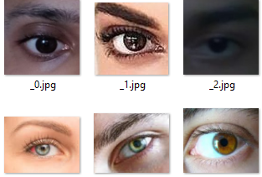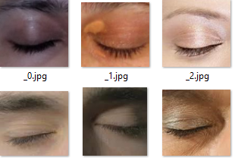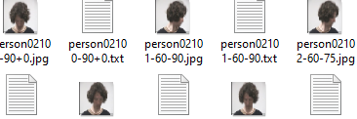

Figure 1: sample dataset, closed open eyes, head pose

### 3.5.2: Model Training

* Model Selection: Used a Convolutional Neural Network (CNN).
* Architecture Design: Designed a CNN with convolutional, pooling, and fully connected layers.
* Training: Trained the model on the dataset using Keras and TensorFlow.
* Evaluation: Evaluated the model on a testing set for generalization.

### 3.5.3: Real-Time Eye Detection

* Face and Eye Detection: Utilized OpenCV Haar cascades to detect faces and eyes from the webcam feed.
* Eye State Classification: Processed and classified eye regions using the trained CNN model.

### 3.5.4: Drowsiness Detection Logic

* State Monitoring: Monitored eye states; triggered an alert if eyes are closed for consecutive frames.
* Alert Mechanism: Played an alarm sound using Pygame when drowsiness(detect eye closed for 6 consecutive frames/seconds) is detected.

### 3.5.5: Head tilt Angle Logic

* The system detects the angle the driver has tilted their head. If it goes below or beyond the set threshold the driver is classified as inattentive and the alarm goes off until they return their head to the desired angle.

### 3.5.6: System Deployment

## 3.6: Testing and Validation

* Functional Testing: Verified system accuracy under various conditions.
* User Testing: Collected user feedback to validate reliability and usability.

## 3.7: Results and Analysis

* System Responsiveness: Measured detection speed and alert latency.
* Limitations: Due to different lighting conditions, a normal camera can fail to feed a clear video to the system resulting to false/no detection.

# CHAPTER FOUR: SYSTEM ANALYSIS AND DESIGN

## 4.1: INTRODUCTION

Chapter Four delves into the practical implementation of the project. This section provides a detailed account of the project's requirements analysis, covering both functional and non-functional aspects. The chapter is structured to ensure a comprehensive understanding of the system's necessities and feasibility, thereby laying the groundwork for a robust and scalable application.

## 4.2:REQUIREMENT ANALYSIS

This section discusses the feasibility of the project, the functional requirements that define the core functionalities, and the non-functional requirements that set the standards for system performance and usability.

### 4.2.1: FEASIBILITY STUDY

The feasibility study is conducted to assess the project's viability by examining its practicality, identifying potential risks, and determining if the project can be successfully executed within the specified constraints. This evaluation encompasses an analysis of technical feasibility, economic feasibility, and operational feasibility.

#### 4.2.1.1:Technical:

assesses whether the project is technically possible and the capability to execute it.

Hardware Requirements:

* Webcam: Required for real-time video capture.
* External Speaker (optional): For audible alerts.

Software Requirements:

* Python programming language
* OpenCV: For image processing and video capture.
* TensorFlow & Keras: For building and deploying the CNN model.
* Pygame: For playing alert/alarm sounds.

Overall, the project is technically feasible with the current technology and tools available.

#### 4.2.1.2:Economic :

evaluates the cost-effectiveness of the project and its financial benefits.

* **Cost of Components**:
  + Webcam: Approximately 3-5k.
  + Miscellaneous : 1k.
* **Software Costs**:
  + Open source software and libraries

The project is economically feasible.

#### 4.2.1.3:Functional :

examines whether the proposed system will fulfill the intended functions and requirements.

* **Functionality**:
  + Real-time video capture.
  + Face and eye detection.
  + Classification of eye state (open/closed).
  + Driver head angle detection
  + Triggering an alert when drowsiness/inattentiveness is detected.
* **Reliability**:
  + Real-time performance to provide timely alerts.

The system meets all the functional requirements, making it functionally feasible.

### 4.2.2:FUNCTIONAL REQUIREMENTS

**Real-Time Video Capture**: The system must capture video input from a webcam in real-time.

**Face and Eye Detection**: The system must detect the face and eyes of the user from the captured video.

**Eye State Classification**: The system must classify the detected eyes as open or closed using a CNN model.

**Drowsiness Detection**: The system must monitor the eye state and detect drowsiness if both eyes are closed for a certain period(fifteen consecutive frames).

**Driver head tilt angle detection**: The system checks the angle he driver tilts his head and declares him inattentive if the angle goes beyond or below the threshold.

**Alert Mechanism**: The system must trigger an audible alarm when drowsiness is detected.

**Data Preprocessing**: The system must preprocess the input images (grayscale conversion, resizing, normalization) before classification.

### 4.2.3: NON-FUNCTIONAL REQUIREMENTS

**Performance**: The CNN model should classify eye states with high accuracy.

**Usability**: The system should be easy to set up and use, with minimal user intervention required. The alarm should be noticeable and prompt the user to act.

**Reliability**: The system should minimize false positives and false negatives.

**Maintainability**: The system should be easy to maintain and update, with clear documentation provided.

**Portability**: The system should be portable and lightweight, suitable for use in a vehicle environment.

**Security**: The system should ensure that the captured video data is processed securely and not stored unnecessarily.

## 4.3: UML DIAGRAMS

### 4.3.1:ACTIVITY DIAGRAM

This activity diagram outlines the steps involved in the drowsiness detection system:

1. Initialize System: The system starts and initializes necessary components.

2. Capture Frames: Frames are captured from the video input (e.g., webcam).

3. Detect Face: The system detects faces within the captured frames.

4. Detect Eyes: Eyes are detected within the detected face regions.

5. Predict State: The system predicts the state of the eyes (e.g., open or closed).

6. Update Score: The system updates a drowsiness score based on the prediction.

7. Check Score: If the score exceeds a threshold (e.g., 5), the alarm is triggered.

8. Play Alarm: An alarm is played to alert the driver if drowsiness is detected.

9. Loop Back: The process loops back to capture frames continuously.

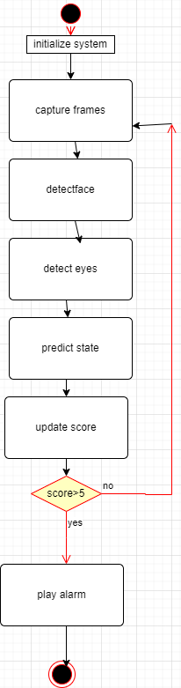

Figure 2: Activity diagram

### 4.3.2:SEQUENCE DIAGRAM

This sequence diagram illustrates the interactions between various components in the system:

1. Driver: Initiates the video input.

2. Video Input: Captures frames and sends them for face and eye detection.

3. Face and Eye Detection: Extracts relevant data points (e.g., face and eye regions) from the frames.

4. Drowsiness Detection: Analyzes the extracted data points to detect drowsiness.

5. Gaze Tracking: Tracks the gaze direction as part of drowsiness detection.

6. Alarm System: Activates the alarm if drowsiness is detected.

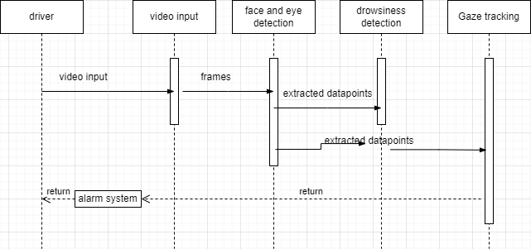

Figure 3:sequence diagram

### 4.3.3:CLASS DIAGRAM

This class diagram shows the structure of the drowsiness detection system, including its main classes and their interactions:

- DrowsinessDetectionSystem: The core system class, which includes attributes like `alarm_active`, `alarm_start_time`, `score`, and `No_face_start_time`. It has methods for capturing frames, detecting faces and eyes, predicting eye state, and playing an alarm.

- Webcam: Manages video input with methods to start and stop capture.

- Dlib: Provides facial detection and shape prediction functionalities.

- Haarcascades: Handles face and eye detection using pre-trained cascades.

- TensorflowModel: Manages the neural network model for predicting eye state.

- Pygame: Handles audio functionalities for the alarm sound.

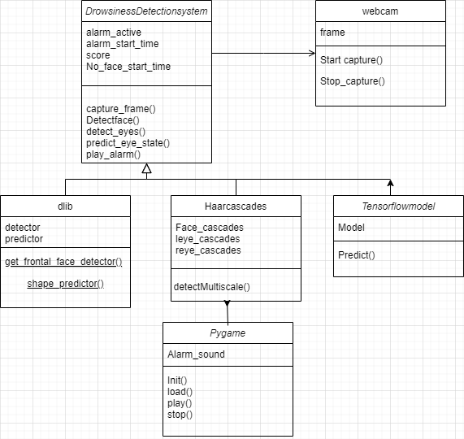

Figure 4:class diagram

### 4.3.4: USE CASE DIAGRAM

This use case diagram shows the interactions between the driver and the drowsiness detection system:

- Driver: The actor who interacts with the system.

- Start/Stop Camera: The driver can start or stop the camera.

- Realtime Video Capture: The system captures video in real-time.

- Face and Eye Detection: The system detects the driver's face and eyes.

- Eye Status Analysis: Analyzes the status of the eyes (open or closed).

- Head Tilt Angle Detection: Detects the angle of the driver's head.

- Drowsy Status Detection: Determines if the driver is drowsy based on the eye status and head tilt.

- Alarm Running: Activates the alarm if drowsiness is detected.

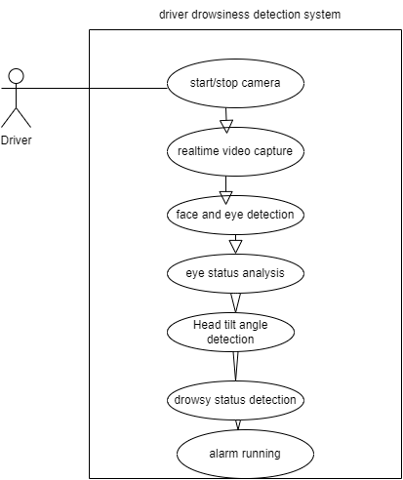

Figure 5:usecase diagram

### 4.3.5: FLOWCHART

This flowchart depicts the step-by-step logic of the drowsiness detection process:

1. Start: Begin the process.

2. Initialize System: Set up the system components.

3. Capture Frame from Webcam: Continuously capture video frames.

4. Detect Face using Dlib: Detect faces within each frame.

5. Face Detected?: Check if a face is detected. If not, loop back to capture frames.

6. Detect Eyes using Haar Cascade: Detect eyes within the detected face.

7. Predict Eye State using CNN Model: Use a neural network model to predict whether eyes are open or closed.

8. Update Drowsiness Score: Adjust the score based on the eye state prediction.

9. Score > 5?: Check if the drowsiness score exceeds the threshold.

10. Play Alarm: If the score is high, play an alarm.

11. Capture Drowsy Frame: Optionally, capture and save the frame when drowsiness is detected.

12. Stop: End the process if needed.

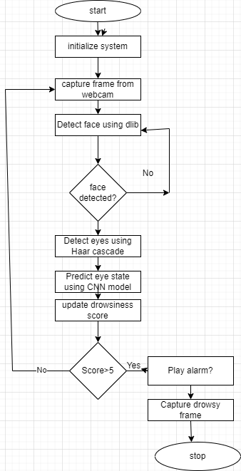

Figure 6:flowchart

# CHAPTER FIVE: TESTING AND RESULTS

## 5.1:Functional Testing

Functional testing ensures that the system functions correctly according to the specified requirements. It involves verifying the system's features, ensuring they work as expected, and identifying any defects.

### 5.1.2: Test Cases:

#### 5.1.2.1: Eye State Detection:

Verify that the system accurately detects whether the user's eyes are open or closed.

Expected Result: The system should correctly identify and display the eye state.

Actual Result: fulfilled:

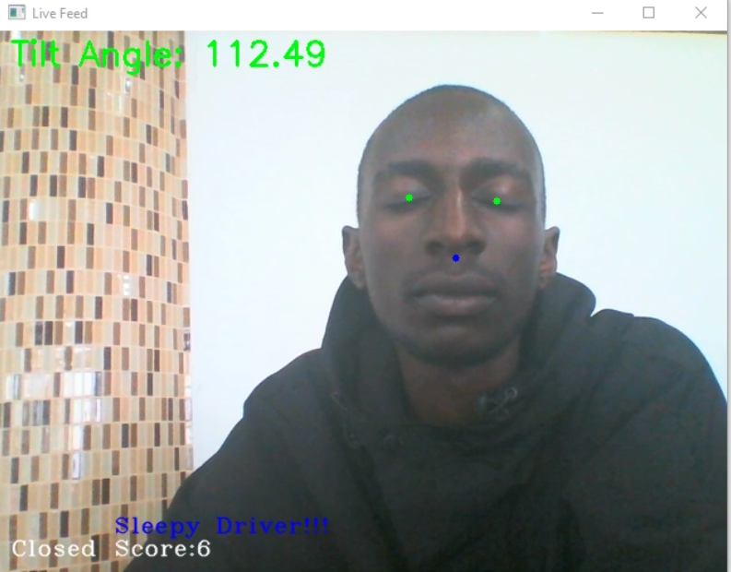

Figure 7: sleepy driver

#### 5.1.2.2:Head Pose Detection:

Verify that the system accurately detects the user's head pose and identifies inattentiveness.

- Expected Result: The system should correctly identify head tilt angles and trigger an alarm if the tilt exceeds the threshold.

- Actual Result: fulfilled.

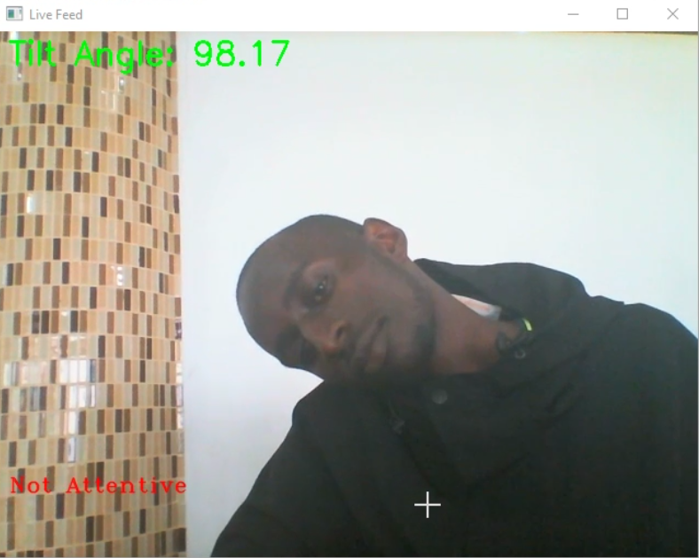

Figure 8: driver with tilted head beyond threshold angle

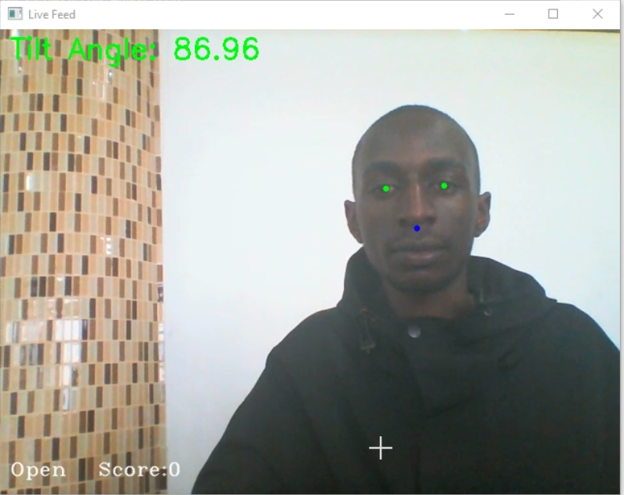

Figure 9: driver in a normal position

#### 5.1.2.3:Alarm Functionality:

Verify that the alarm sounds correctly when drowsiness or inattentiveness is detected.

- Expected Result: The alarm should sound and continue until the user is attentive again.

- Actual Result: The system triggers when driver is drowsy or have tilted head beyond threshold angle.

## 5.2: Performance Testing

Performance testing ensures that the system performs efficiently under various conditions. It evaluates the system's responsiveness, stability, and resource usage.

### 5.2.1:Response Time:

Measure the time taken to detect drowsiness and head pose.

Expected Result: The system should detect and respond within 1 second.

Actual Result: The system responds within 1 second.

## 5.3: Usability Testing

Usability testing ensures that the system is user-friendly and meets user expectations. It involves evaluating the user interface and overall user experience.

### 5.3.1: Ease of Use:

Verify that the system is easy to operate for users with minimal technical knowledge.

Expected Result: Users should be able to operate the system without difficulty.

Actual Result: Users operates the system with ease

## 5.3.2:User Interface:

Verify that the user interface is intuitive and easy to navigate.

Expected Result: The interface should be clear and straightforward.

Actual Result: simple user interface



Figure 10: interface

## 5.4: Acceptance Testing

A phase in software development where the software is tested to ensure it meets the requirements and expectations

### 5.4.1: Acceptance Criteria

Acceptance testing ensures that the system meets the defined acceptance criteria and is ready for deployment.

**Criteria:**

* **Functionality:** The system should accurately detect drowsiness and inattentiveness(head position).
* **Performance:** The system should respond quickly and operate efficiently.
* **Usability:** The system should be user-friendly and easy to operate.

# CHAPTER SIX: CONCLUSION AND RECOMMENDATION

## 6.1: INTRODUCTION

This chapter summarizes the results of the system testing and provides recommendations based on the findings. It highlights the challenges encountered during the development and testing phases and offers concluding remarks.

## 6.2: CHALLENGES

### 6.2.1: Cognitive Disengagement:

The situation where a person has open eyes but their brain is not focusing on the moment is commonly referred to as "microsleep" or "zoning out."

**Microsleep:** Microsleep refers to brief episodes of sleep that last for a few seconds. These episodes often occur without the person being aware of them. During microsleep, a person can appear to be awake with their eyes open, but their brain briefly enters a sleep state. This can happen during monotonous tasks, such as driving, where sustained attention is required.

**Zoning Out :**Zoning out, while not a scientific term per se, describes a state of inattentiveness or daydreaming where a person's mind wanders away from the task at hand. During this state, even though the person may seem awake and alert, they are not actively processing the external environment.

**Cognitive Disengagement:** Cognitive disengagement is a more formal term that can describe a similar phenomenon. It refers to a state where a person's cognitive focus shifts away from the primary task, resulting in a lapse in attention and potentially performance.

**Limitations of Image Based Systems in Detecting These States**

**Explanation of the Situation**

Microsleep and cognitive disengagement represent significant challenges in maintaining safety and performance in activities requiring continuous attention, such as driving. These states can occur unexpectedly, with the person’s eyes remaining open, giving the false appearance of alertness. The brain, however, temporarily shuts down, leading to a lack of response to external stimuli.

**Accuru7ate Methods to Detect the Situation**

1. **Electroencephalography (EEG) Monitoring:**

**Description:** EEG monitors brain wave patterns to detect sleep states and cognitive engagement. Specific patterns, such as the presence of theta waves, can indicate drowsiness or microsleep.

**Accuracy**: Highly accurate as it provides direct insights into brain activity.

**Limitations of Image.Based Systems.**

1. **Lack of Direct Brain Activity Monitoring:**. Limitation: Image.based systems cannot capture brain wave patterns. EEG is essential for directly assessing brain states related to microsleep.
2. **Inability to Measure Physiological Indicators:**. Limitation: Image.based systems cannot measure heart rate variability, which is crucial for detecting physiological signs of reduced alertness.

### 6.2.2: Variable Lighting Conditions:

Inconsistent lighting can hinder the accuracy of eye state and head pose detection, making the system less reliable under certain conditions

## 6.3: RECOMMENDATIONS

**Infrared (IR) Cameras:** Use IR cameras that can capture clear images in low-light or no-light conditions. Infrared cameras are less affected by changes in visible light and can provide consistent image quality regardless of lighting conditions. This ensures more reliable detection of eye states and head poses.

**User Training**: Provide users with detailed instructions and training to ensure they can operate the system effectively.

**Continuous Monitoring and Updates:** Regularly update the system to fix bugs, improve performance, and address emerging security threats.

## 6.4: CONCLUSION

The drowsiness detection system has been thoroughly tested and meets the defined acceptance criteria. Despite the challenges encountered, including those posed by variable lighting conditions, the system successfully detects drowsiness and inattentiveness of the driver, triggering alarm to alert the driver. By adopting the recommended solutions to address the lighting conditions, the system can provide better performance contributing to a safer and more attentive driving experience.

# REFERENCES

Albadawi, Y.; AlRedhaei, A.; Takruri, M. Real-Time Machine Learning-Based Driver Drowsiness Detection Using Visual Features. J. Imaging **2023**, 9, 91. <https://doi.org/10.3390/jimaging9050091>

Bamidele, A. A., Kamardin, K., Abd Aziz, N. S. N., Sam, S. M., Ahmed, I. S., Azizan, A., ... & Kaidi, H. M. (2019). Non-intrusive driver drowsiness detection based on face and eye tracking. *International Journal of Advanced Computer Science and Applications*, *10*(7).

Ghoddoosian, Reza & Galib, Marnim & Athitsos, Vassilis. (2019). A Realistic Dataset and Baseline Temporal Model for Early Drowsiness Detection. 178-187. 10.1109/CVPRW.2019.00027.

Hashemi, Maryam & Mirrashid, Alireza & Shirazi, Aliasghar. (2020). Driver Safety Development: Real-Time Driver Drowsiness Detection System Based on Convolutional Neural Network. SN Computer Science. 1. 10.1007/s42979-020-00306-9.

<https://pyimagesearch.com/2021/04/12/opencv-haar-cascades/>

<https://www.jdpower.com/cars/shopping-guides/what-is-a-driver-monitoring-system>

<https://www.labellerr.com/blog/hands-on-with-driver-activity-monitoring-system-for-autonomous-driving/>

<https://www.researchgate.net/publication/374979117_Real-time_driver_monitoring_system_with_facial_landmark-based_eye_closure_detection_and_head_pose_recognition>

Khadraoui, Abdelhak & Zemmouri, EL Moukhtar & Taki, Youssef & Douimi, Mohammed. (2023). Towards a system for real-time prevention of drowsiness-related accidents. IAES International Journal of Artificial Intelligence (IJ-AI). 13. 153-161. 10.11591/ijai.v13.i1.pp153-161.

Khan MQ, Lee S. A Comprehensive Survey of Driving Monitoring and Assistance Systems. *Sensors*. 2019; 19(11):2574. https://doi.org/10.3390/s19112574

M. Karchani, A. Mazloumi, G. N. Saraji, A. Nahvi, K. S. Haghighi,B. M. Abadi, A. R. Foroshani, A. Niknezhad, The Steps of Proposed Drowsiness Detection System Design based on Image Processing in Simulator Driving, International Research Journal of Applied and Basic Sciences, vol. 9(6), pp 878-887, 2015.

Sun, Y.; Yu, X.; Berilla, J.; Liu, Z.; Wu, G. An in-vehicle physiological signal monitoring system for driver fatigue detection. In Proceedings of the 3rd International Conference on Road Safety and Simulation Purdue University Transportation Research Board, West Lafayette, IN, USA, 14–16 September 2011.

Vicente, J., Laguna, P., Bartra, A., & Bailón, R. (2011, September). Detection of driver's drowsiness by means of HRV analysis. In *2011 Computing in Cardiology* (pp. 89-92). IEEE.

# APPENDIX

|  |  |
| --- | --- |
| **Item** | **Cost(Ksh)** |
| Laptop | 34,000 |
| Internet | 4,000 |
| Documentation | 1,200 |
| Total Project Cost | 39,200 |

Figure 11: budget table

Resources:

|  |  |
| --- | --- |
| Hardware | Software |
| 1. Processor: Intel Corei 7 2. RAM: 8GB 3. System memory 256GB | 1. Google Colab 2. Anaconda 3. Windows |

Figure 12: resources table

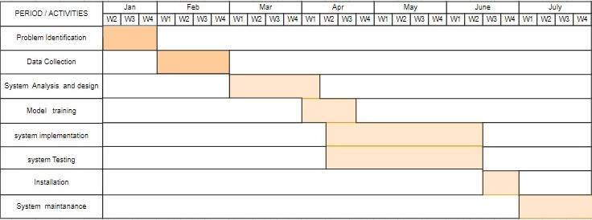

Figure 13:Ganhtchart

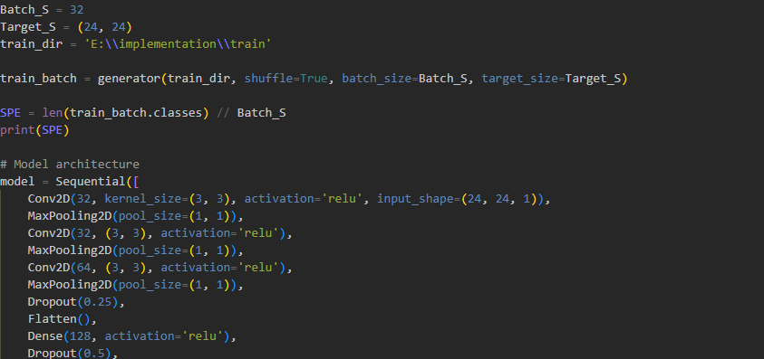

Figure 14: block code for training drowsiness model

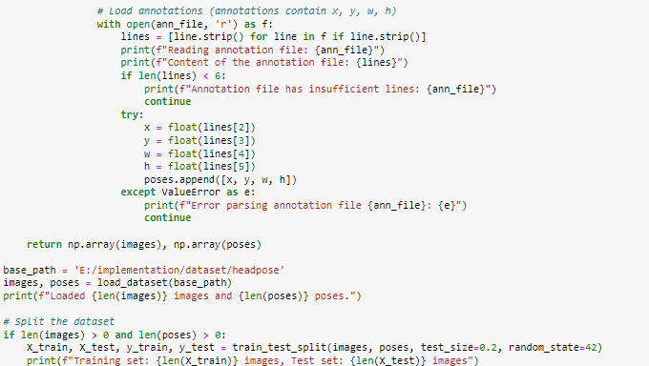

Figure 15: block of code for training head pose model

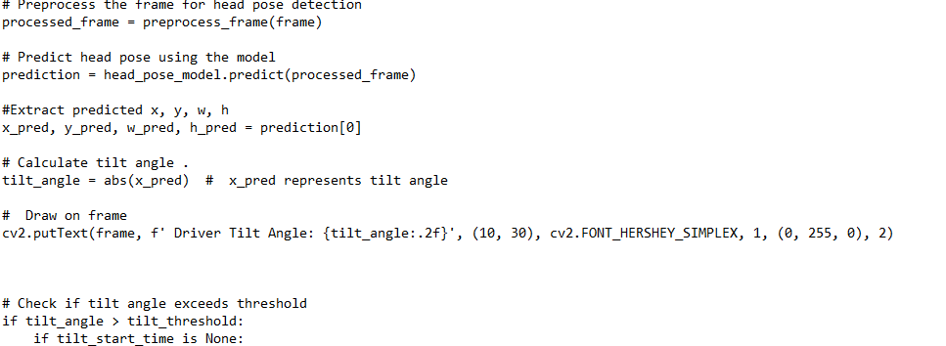

Figure 16: Block of code for the system