**Cordova-project 2APPAI – 2WT - 3IoT**

**Brief description of the app**

I want to create a calendar/task scheduler with notification system. How is it going to work?

User must fill in his data. Then he will be have an option to create (schedule) a new task. He can choose whether it’s one-off or constantly repeating task. Then , he will be warned by the system beforehand, so a day before the event, he will be notified in advance that he has planned an event for the next day. Of course, user will be able to turn off or configure notification system. It would be also good to store this data on a server, so you would be able to schedule task from other devices.

**Screenshots**

A screen capture of each tab in your app

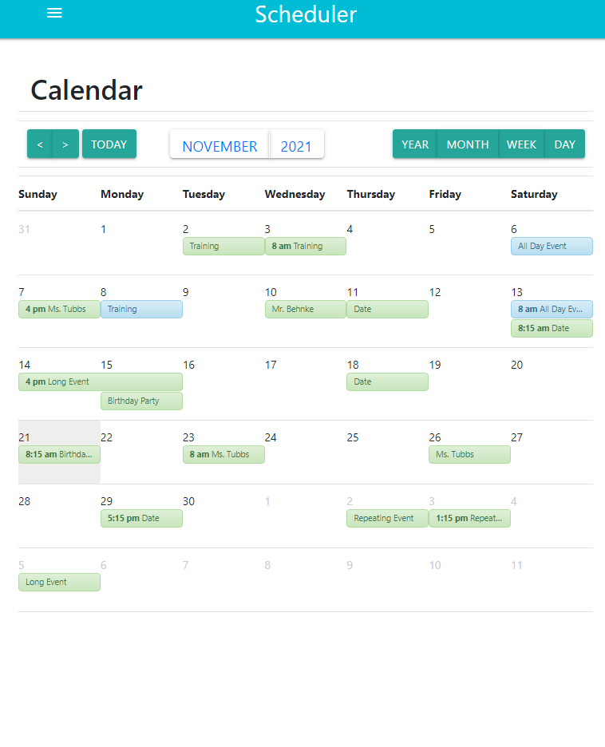

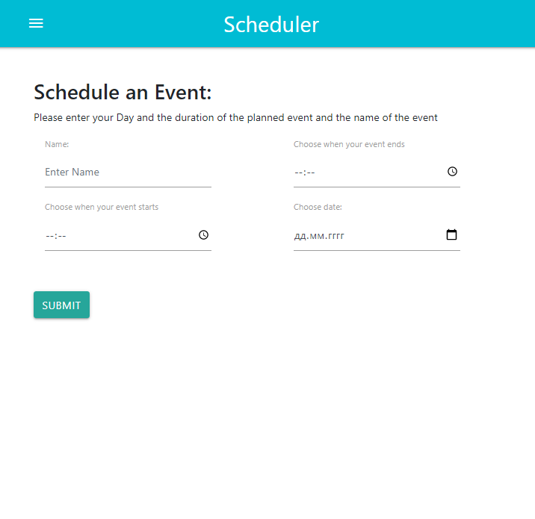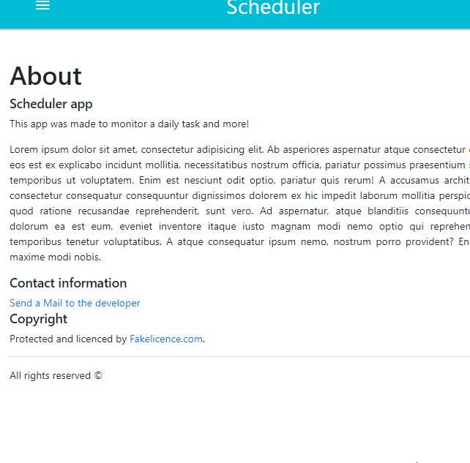

**Used Cordova plug-ins**

Cordova-calendar - for creating events

**Infopage about the app**

URL where you can download the app (apk-file).

**Source code**

My files are too big to be displayed in the document. Please check my GitHub:

https://github.com/itfactory-tm/2021_2022_2acs_cordova-KamalidenovRustem