DA2

library("magrittr") # for piping %>%  
head(iris, 3)

## Sepal.Length Sepal.Width Petal.Length Petal.Width Species  
## 1 5.1 3.5 1.4 0.2 setosa  
## 2 4.9 3.0 1.4 0.2 setosa  
## 3 4.7 3.2 1.3 0.2 setosa

library(scatterplot3d)  
scatterplot3d(  
 iris[,1:3], pch = 19, color = "steelblue",  
 grid = TRUE, box = FALSE,  
 mar = c(3, 3, 0.5, 3)   
 )  
library(GGally)

## Warning: package 'GGally' was built under R version 4.1.3

## Loading required package: ggplot2

## Registered S3 method overwritten by 'GGally':  
## method from   
## +.gg ggplot2

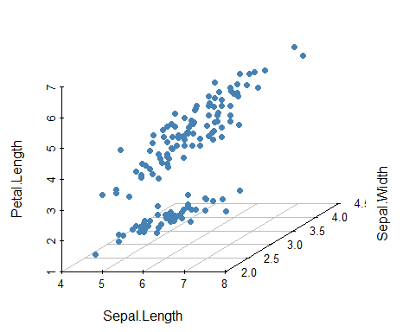

library(ggplot2)  
ggpairs(iris[,-5])+ theme_bw()

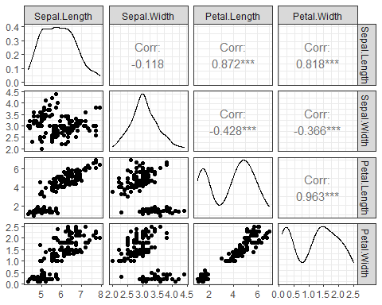

p <- ggpairs(iris, aes(color = Species))+ theme_bw()  
# Change color manually.  
# Loop through each plot changing relevant scales  
for(i in 1:p$nrow) {  
 for(j in 1:p$ncol){  
 p[i,j] <- p[i,j] +   
 scale_fill_manual(values=c("#00AFBB", "#E7B800", "#FC4E07")) +  
 scale_color_manual(values=c("#00AFBB", "#E7B800", "#FC4E07"))   
 }  
}  
p

## `stat_bin()` using `bins = 30`. Pick better value with `binwidth`.

## `stat_bin()` using `bins = 30`. Pick better value with `binwidth`.  
## `stat_bin()` using `bins = 30`. Pick better value with `binwidth`.  
## `stat_bin()` using `bins = 30`. Pick better value with `binwidth`.

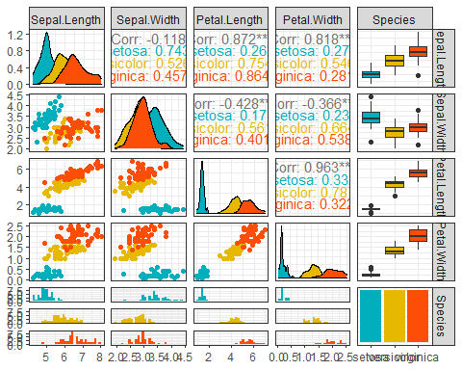

# install.packages("PerformanceAnalytics")  
library("PerformanceAnalytics")

## Warning: package 'PerformanceAnalytics' was built under R version 4.1.3

## Loading required package: xts

## Loading required package: zoo

##   
## Attaching package: 'zoo'

## The following objects are masked from 'package:base':  
##   
## as.Date, as.Date.numeric

##   
## Attaching package: 'PerformanceAnalytics'

## The following object is masked from 'package:graphics':  
##   
## legend

my_data <- mtcars[, c(1,3,4,5,6,7)]  
chart.Correlation(my_data, histogram=TRUE, pch=19)

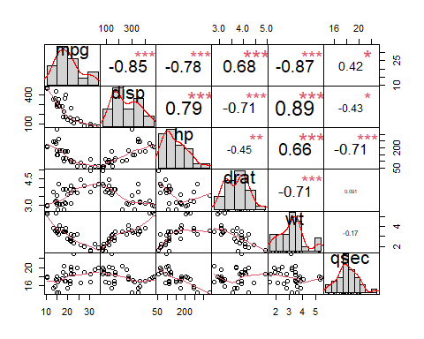

library("ggcorrplot")  
# Compute a correlation matrix  
my_data <- mtcars[, c(1,3,4,5,6,7)]  
corr <- round(cor(my_data), 1)  
# Visualize  
ggcorrplot(corr, p.mat = cor_pmat(my_data),  
 hc.order = TRUE, type = "lower",  
 color = c("#FC4E07", "white", "#00AFBB"),  
 outline.col = "white", lab = TRUE)

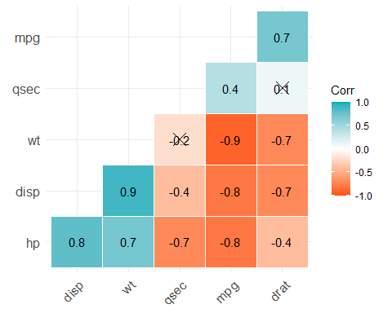

library("factoextra")

## Warning: package 'factoextra' was built under R version 4.1.3

## Welcome! Want to learn more? See two factoextra-related books at https://goo.gl/ve3WBa

my_data <- iris[, -5] # Remove the grouping variable  
res.pca <- prcomp(my_data, scale = TRUE)  
fviz_pca_biplot(res.pca, col.ind = iris$Species,  
 palette = "jco", geom = "point")

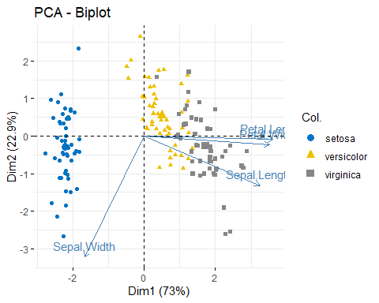

library(factoextra)  
USArrests %>%  
 scale() %>% # Scale the data  
 dist() %>% # Compute distance matrix  
 hclust(method = "ward.D2") %>% # Hierarchical clustering  
 fviz_dend(cex = 0.5, k = 4, palette = "jco") # Visualize and cut

## Warning: `guides(<scale> = FALSE)` is deprecated. Please use `guides(<scale> =  
## "none")` instead.

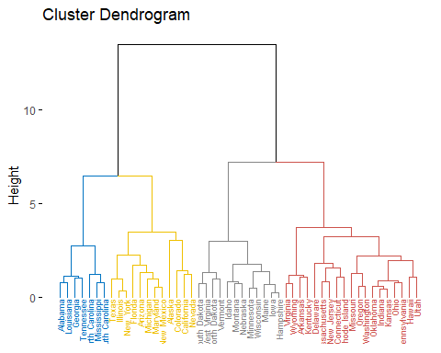

# into 4 groups  
library(pheatmap)

## Warning: package 'pheatmap' was built under R version 4.1.3

USArrests %>%  
 scale() %>% # Scale variables  
 t() %>% # Transpose   
 pheatmap(cutree_cols = 4) # Create the heatmap

