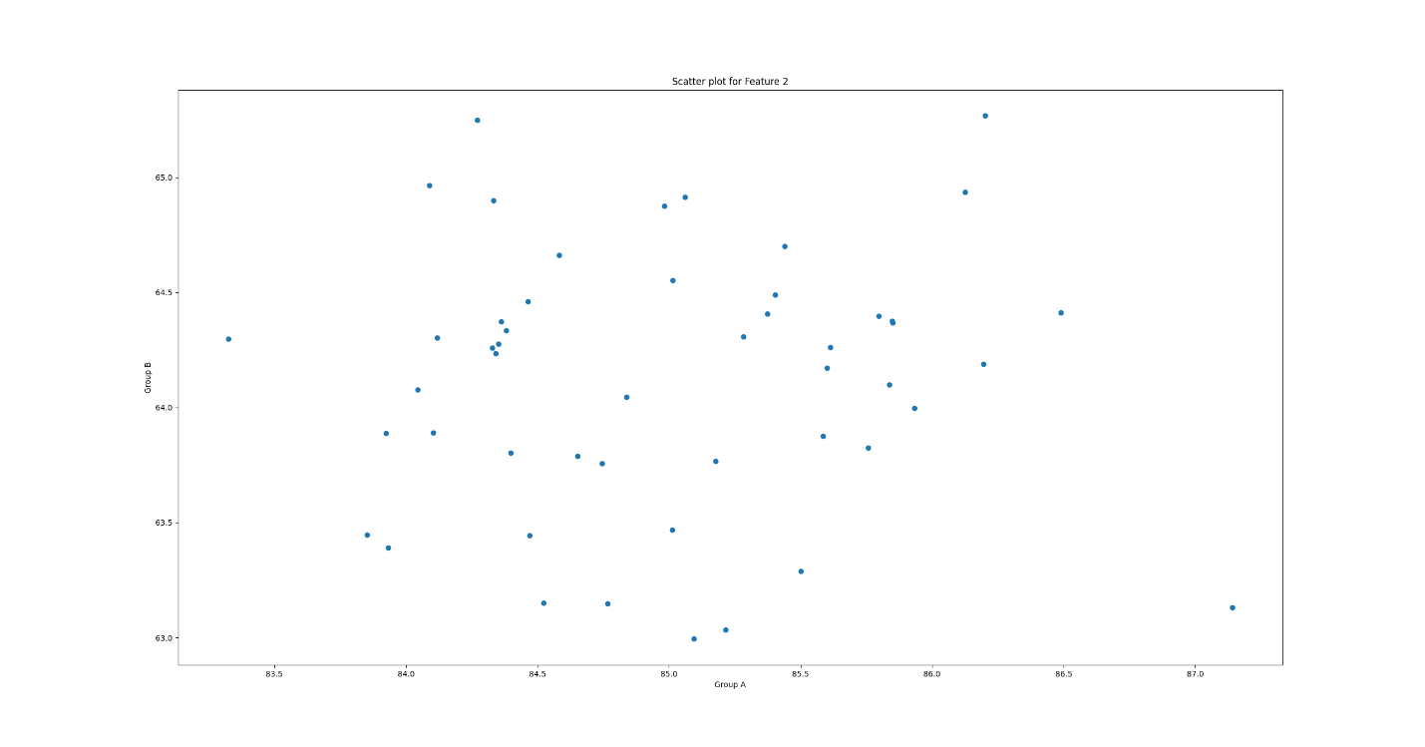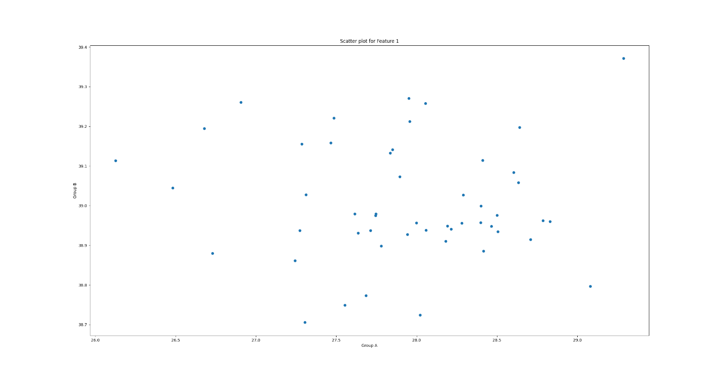

**The scatter plots compare each feature values for Group A and group B data. This can be patient data where feature 1 and 2 follow normal distribution eg: height and weight and feature 3 follows binomial distribution eg: side effects of a medication.**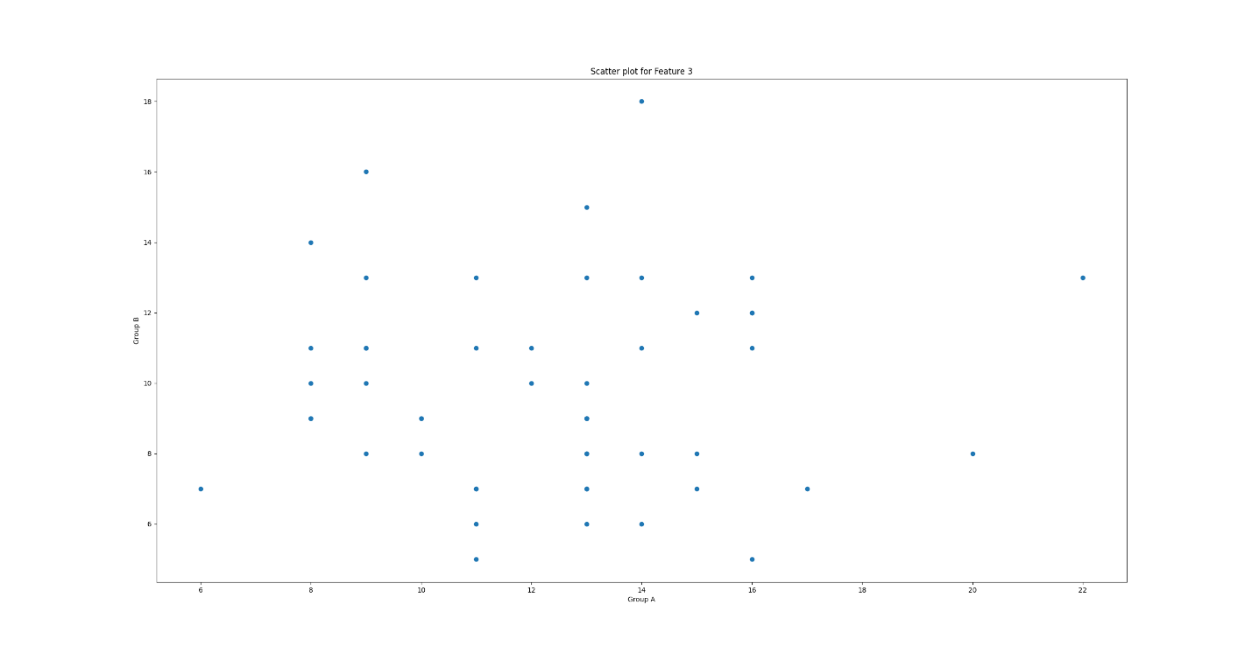

**Statistical Test Results for group A and group B:**

Feature 1 t-test results:   
statistic=1496.5760724156376, pvalue=2.0639202977690738e-215

Feature 2 t-test results:

statistic=-497.6809193266381, pvalue=1.4647576531196389e-168

Feature 3 t-test results:

statistic=4.851761013762491, pvalue=4.6137906398451765e-06