**FSD – Assignment 1**

By: Kamaljeeth Anand (1MS24SCS12)

**Exercise 1: Basic HTML5 Structure**

Code:

<!DOCTYPE HTML>

<html lang="en">

<head>

<title>My First HTML Page</title>

</head>

<body>

<h1>Kamaljeeth Anand</h1>

<p>I enjoy playing video-games, playing badminton, coding, and learning new technologies in my free time.</p>

<p>I also like to read books and watch videos related to finance and stock market.</p>

<hr>

<br>

</body>

</html> OUTPUT: 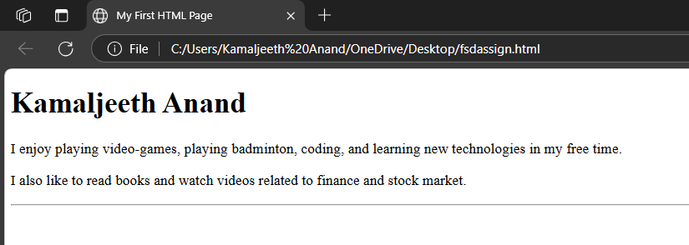

**Exercise 2: Use of Lists and Links**

Code:

<!DOCTYPE HTML>

<html lang="en">

<head>

<title>My Favorites</title>

</head>

<body>

<h1 style="text-align: center;">My Favorites</h1>

<h2>My Favorite Fruits</h2>

<ul>

<li>Mango</li>

<li>Watermelon</li>

<li>Guava</li>

<li>Custard Apple</li>

</ul>

<hr>

<br>

<h2>My Top 3 Movies</h2>

<ol>

<li>Interstellar</li>

<li>Inception</li>

<li>The Prestige</li>

</ol>

<hr>

<br>

<h2>My Favorite Website</h2>

<p>

Visit my favorite website:

<a href="https://roadmap.sh" target="_blank">Roadmap AI</a>

</p>

</body>

</html>

OUTPUT:

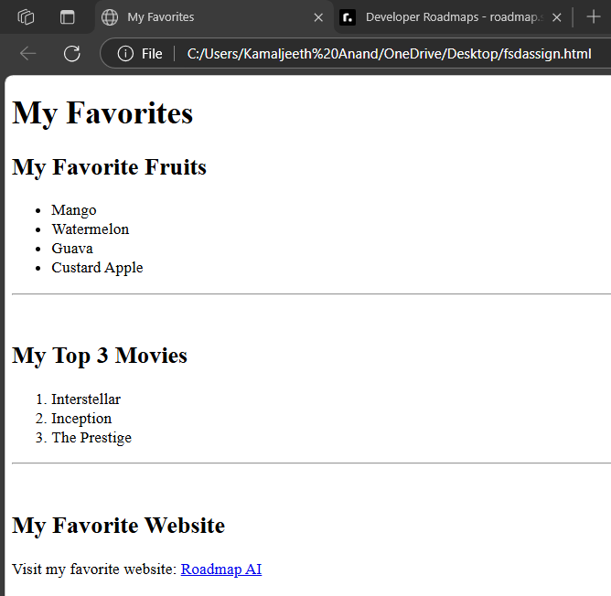

**Exercise 3: Adding Images and Tables**

Code:

<!DOCTYPE HTML>

<html lang="en">

<head>

<title>Image & Table insertion</title>

</head>

<body>

<h1>Image</h1>

<img src="https://www.chronicle.ng/wp-content/uploads/2022/12/Argentinas-Lionel-Messi-celebrates-winning-the-World-Cup-with-the-trophy-in-Qatar.jpg" alt="Placeholder Image">

<h2>Student Table</h2>

<table border="1" cellpadding="10">

<tr>

<th>Student Name</th>

<th>Age</th>

<th>Favorite Subject</th>

</tr>

<tr>

<td>Kamaljeeth Anand</td>

<td>23</td>

<td>Mathematics</td>

</tr>

<tr>

<td>Jai Vishal</td>

<td>22</td>

<td>FSD</td>

</tr>

<tr>

<td>C S Darshan</td>

<td>23</td>

<td>Virtual Reality</td>

</tr>

</table>

</body>

</html>

OUTPUT:

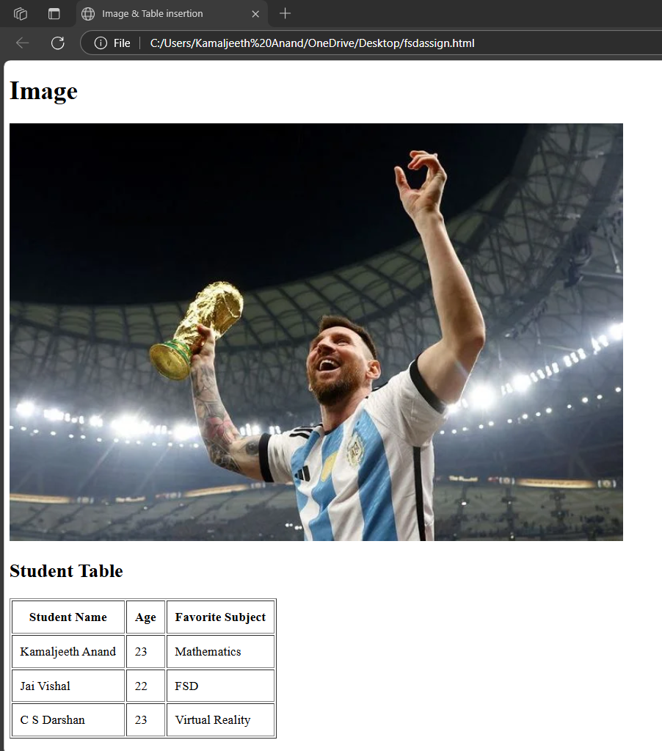

**Exercise 4: Introduction to CSS (Internal CSS)**

Code:

<!DOCTYPE HTML>

<html lang="en">

<head>

<title>Intro to CSS</title>

<style>

h1 {

background-color: lightblue;

color: darkblue;

font-size: 30px;

padding: 10px;

}

p {

font-family: Arial, sans-serif;

text-align: justify;

}

</style>

</head>

<body>

<h1>Welcome to My Page on Career of Lionel Messi</h1>

<p>

Lionel Messi is an Argentine professional footballer who plays as a forward for and captains both Major League Soccer club Inter Miami and the Argentina national team. His individual achievements include eight Ballon d'Or awards, the most for any footballer. Having won 45 team trophies,he is the most decorated player in the history of professional football. Messi is often hailed as a genius, with his prolific goalscoring ability and high level dribbling, passing and playmaking earning him recognition as one of the greatest and most iconic players in football history. In 2024, US-based sports company ESPN named Messi the greatest player of the 21st-century.

</p>

<p>

Messi's club career began with Barcelona, where he rose through the youth ranks, making his first-team debut in 2004. Over the next years, Messi became the club's all-time top scorer, amassing numerous domestic and international accolades. During his tenure, Barcelona secured ten La Liga titles, seven Copa del Reys, four UEFA Champions Leagues, seven Supercopa de Españas, three UEFA Super Cups, and three FIFA Club World Cups. In August 2021, due to financial constraints faced by Barcelona, Messi signed for Paris Saint-Germain (PSG). Joining forces with fellow superstars Neymar and Kylian Mbappé, he won two Ligue 1 titles and one Trophée des Champions. In July 2023, Messi joined Inter Miami, leading the team to win their first-ever trophies with the Leagues Cup and the Supporters' Shield.

</p>

<p>

On the international stage, Messi made his debut with Argentina's senior national football team in 2005, and would represent the country in five FIFA World Cups, seven Copa Américas, and one Finalissima. Initially facing criticism for not winning major tournaments with the senior national team, Messi broke Argentina's 28-year international trophy drought by captaining the team to victory in the 2021 Copa América, the 2022 Finalissima, the 2022 FIFA World Cup, and the 2024 Copa América.

</p>

<hr>

<br>

</body>

</html>

OUTPUT: 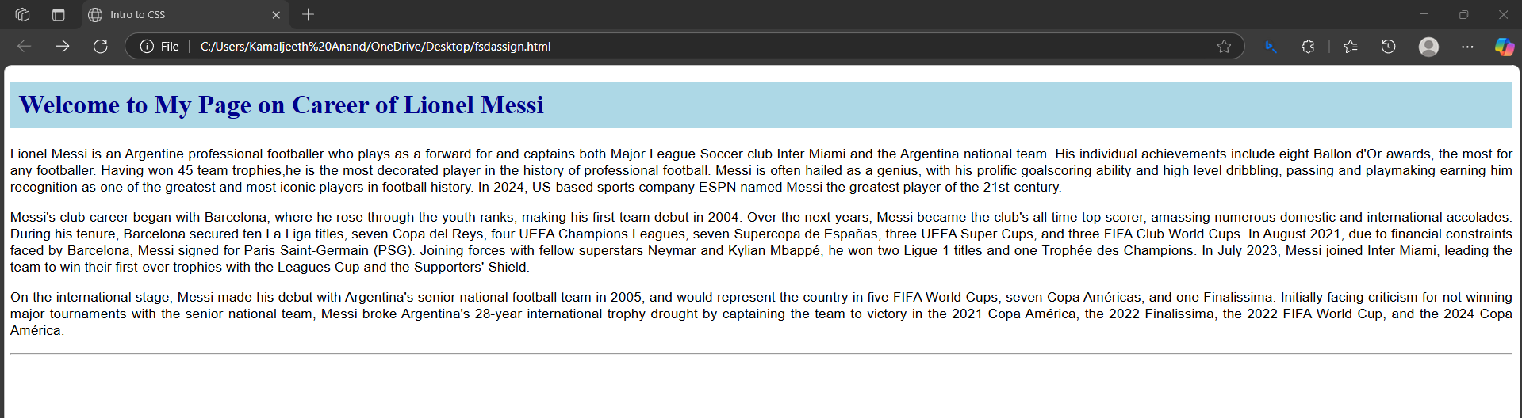

**Exercise 5: CSS Classes and IDs**

Code:

<!DOCTYPE HTML>

<html lang="en">

<head>

<title>Div Block Styling</title>

<style>

#intro {

border: 2px solid black;

padding: 15px;

}

.highlight {

background-color: yellow;

padding: 10px;

}

</style>

</head>

<body>

<div id="intro">

<p> This is Div block with 2px solid black border and padding of 15px. </p>

</div>

<br>

<hr>

<br>

<div class="highlight">

<p>This is another Div block with yellow background and padding of 10px.</p>

</div>

</body>

</html>

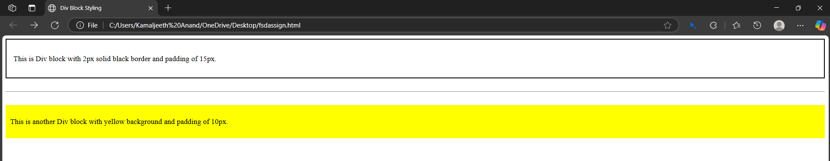OUTPUT: