Backtracking in Data Structures and Algorithms
Backtracking is an algorithmic technique used to solve problems by trying different choices, exploring possible solutions, and undoing choices when they lead to an invalid solution.
It is based on the idea:
"Choose → Explore → Undo → Try another choice"
Backtracking is commonly used for problems where we need to find all possible solutions or the best solution among many possibilities.

Real-Life Example: Maze Problem
Imagine you are solving a maze.
- You choose a path.
- You continue walking.
- If you reach a dead end:
  - You go back to the previous point.
  - Try another path.
This going back and trying another option is backtracking.
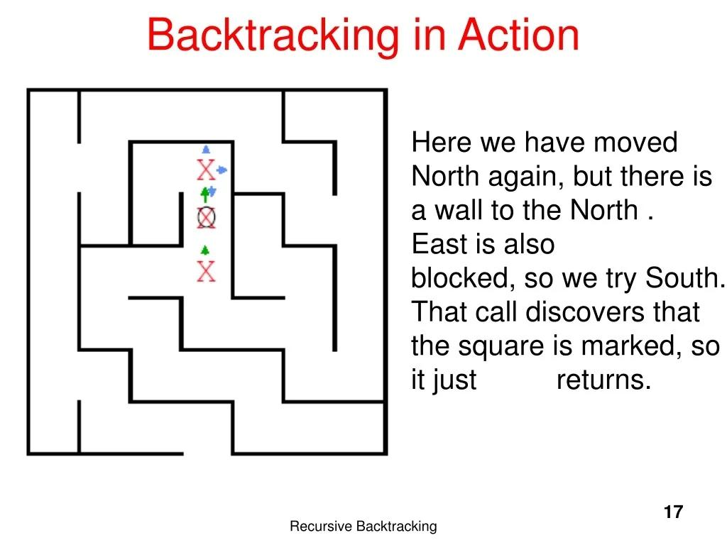
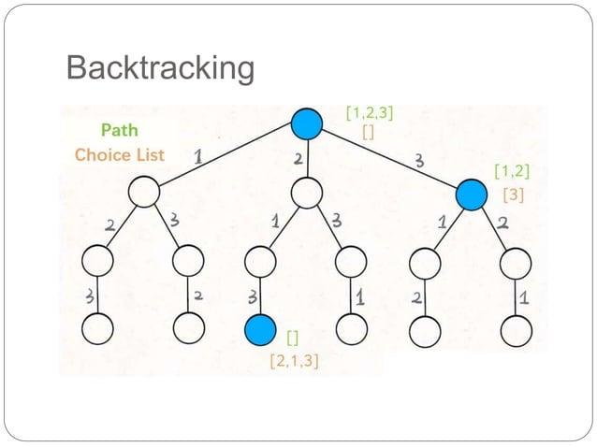
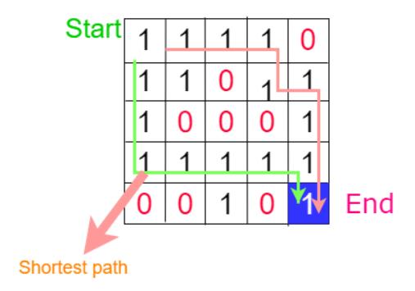
4

How Backtracking Works
Backtracking usually uses recursion.
The general pattern:
function backtrack(choice):

if solution_found:
save solution
return

for each possible choice:

make choice

if choice is valid:
backtrack(next step)

undo choice
The important operation is:
undo choice
This allows us to return to the previous state and try another possibility.

Example 1: Generate All Permutations
Given:
Input: [1,2,3]
Possible arrangements:
123
132
213
231
312
321
We can solve this using backtracking.

Decision Tree:
[]
/ | \
1 2 3
/ \ / \ / \
12 13 21 23 31 32
| | | | | |
123 132 213 231 312 321
Algorithm:
Start with empty result

Pick 1
Pick 2
Pick 3
Found 123
Remove 3
Remove 2

Remove 1

Pick 2
Pick 1
Pick 3
Found 213
The removal step is backtracking.

Example 2: N-Queens Problem
Problem:
Place N queens on an N×N chess board so that no two queens attack each other.
For 4 queens:
. Q . .
. . . Q
Q . . .
. . Q .
A queen attacks:
- Same row
- Same column
- Diagonal
Approach:
- Put queen in first row.
- Move to next row.
- If placement is invalid:
  - Remove queen.
  - Try next position.

Example 3: Sudoku Solver
A Sudoku has empty cells.
Algorithm:
Find empty cell

Try number 1-9

If valid:
place number

solve remaining board

If failed:
remove number

Try next number
Example:
Cell = ?

Try 5

Invalid ❌

Remove 5

Try 7

Valid ✅

Continue

Backtracking vs Brute Force
Both explore possibilities, but backtracking is smarter.

Brute Force
Try everything:
A
B
C
D
E
F
...
Even invalid paths are explored.

Backtracking
Stops invalid paths early:
Start
/ \
A B
/
Invalid ❌
No need to explore further.
This is called:
Pruning

Backtracking Components
A backtracking solution usually has:

1. State
Current situation.
Example:
Current chess board
Current Sudoku board
Current path in maze

2. Choices
Possible options.
Example:
Queen positions:
Column 1
Column 2
Column 3
Column 4

3. Constraint
Rules that decide if choice is valid.
Example:
Two queens cannot attack each other

4. Goal
When solution is complete.
Example:
All queens placed

Common Backtracking Problems
Problem | Technique
N-Queens | Place items with constraints
Sudoku Solver | Constraint satisfaction
Maze Path | Explore paths
Word Search | Search grid
Permutations | Generate arrangements
Combinations | Select elements
Subsets | Generate subsets
Rat in Maze | Path finding
Graph Coloring | Assign colors

Backtracking Complexity
Usually exponential because it explores many possibilities.
Example:
For permutations:
n elements

Number of possibilities = n!
Time complexity:
O(n!)
For subsets:
2^n possibilities

Time complexity:
O(2^n)

Backtracking vs Recursion
They are related but different.

Recursion
A function calls itself.
Example:
factorial(5)

5 * factorial(4)

Backtracking
Uses recursion plus undoing decisions.
Example:
Choose path
recurse
Undo path
Try another path

Backtracking vs Dynamic Programming
Backtracking | Dynamic Programming
Explores choices | Stores previous results
Usually exponential | Usually optimized
Finds all solutions | Finds optimal solution
Uses recursion | Uses memoization/tabulation
Example: Sudoku | Example: Fibonacci optimization

Simple C# Example: Generate Subsets
Given:
[1,2,3]
Output:
[]
[1]
[2]
[3]
[1,2]
[1,3]
[2,3]
[1,2,3]
void Backtrack(int index, List<int> current)
{
Console.WriteLine(string.Join(",", current));

for(int i=index; i<nums.Length; i++)
{
// choose
current.Add(nums[i]);

// explore
Backtrack(i + 1, current);

// undo
current.RemoveAt(current.Count - 1);
}
}
The important line:
current.RemoveAt(current.Count - 1);
is the backtracking step.

When Should You Think About Backtracking?
Use backtracking when the problem contains words like:
- "Find all possible..."
- "Generate all..."
- "Arrange..."
- "Combination..."
- "Permutation..."
- "Choose from..."
- "Can we place..."
- "Find a path..."

Interview Tip (Senior Developer)
A good way to explain backtracking:
"Backtracking is a depth-first search approach where we build a solution incrementally. If a partial solution violates constraints, we abandon that branch and revert the state to explore other possibilities. It uses recursion and pruning to reduce unnecessary exploration."
This explanation is suitable for DSA interviews for senior developers.

