IQR – Interquartile Range
Formula:
IQR = Q3 – Q2
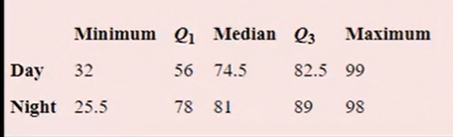
- Day_IQR = 82.5 – 56 = 26.5
- Lower outlier Day
= Q1 – (1.5*IQR) = 56 – (1.5*26.5)
= 16.25
- Higher outlier Day
= Q3 + (1.5*IQR) = 82.5 + (1.5*26.5)
= 122.25
- Night_IQR = 89 – 78 = 11
- Lower outlier Night
= 78 – (1.5*11) = 61.5
- Higher outlier Night
= 89 + (1.5*11) = 105.5
INFERENCE:
- For Day column Minimum and Maximum are within the limits of Lower outlier Day and Higher outlier Day, so there is no outlier in this column
- For Night column Minimum (25.5) is lesser than Lower outlier Night (61.5) and Maximum is lesser than Higher outlier Night. So Lower outliers are present in this Column.

