FREQUENCY
- Frequency is simply the count of occurrences of each value (or category) in the dataset
- Relative frequency is the proportion or percentage of times a value occurs
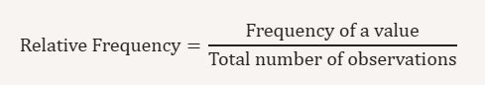
Normalizes the data, making it easier to compare across datasets of different sizes

- Cumulative relative frequency is the running total of relative frequencies up to a certain value.

Shows how data accumulates across categories or values. It’s especially useful in ordered data (like ages, income ranges) to understand percentiles and thresholds.

- Frequency → Raw counts for direct observation.
- Relative frequency → Standardized comparison across datasets.
- Cumulative relative frequency → Understanding distribution buildup, percentiles, and probability thresholds.
POINTS:
- raw frequency counts are less informative for continuous numerical data, because every distinct value could appear only once (e.g., exact heights, weights, or sensor readings).
- usually group continuous data into intervals (bins) before calculating frequencies. Define Ranges

