ACTIONS
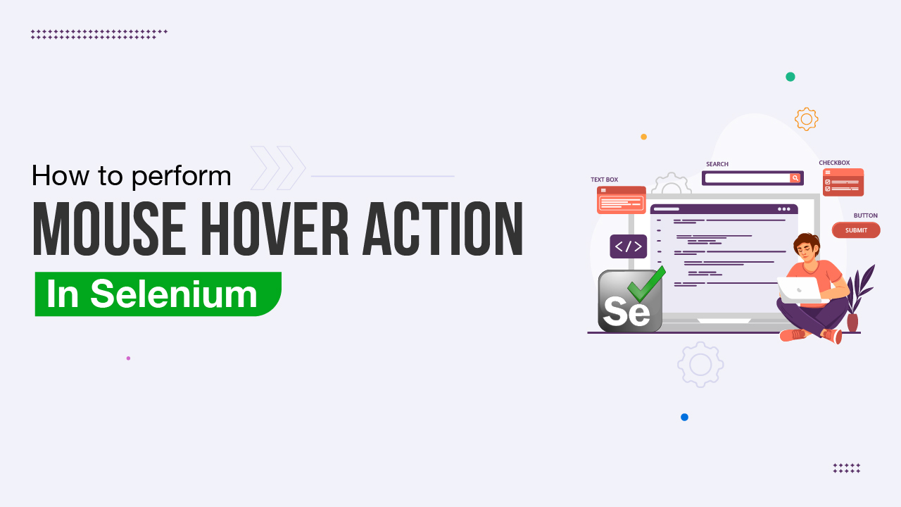
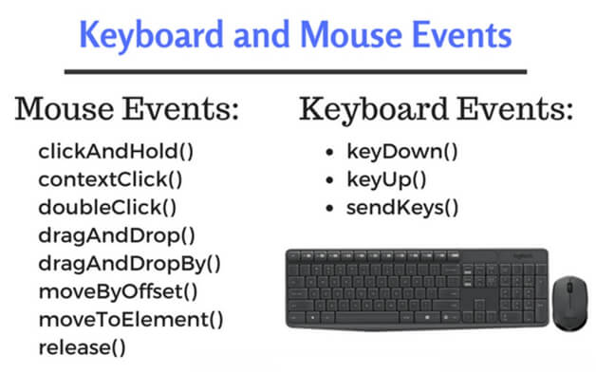

🧩 What is the Actions Class?
The Actions class in Selenium is used to perform advanced user interactions that cannot be handled using normal WebElement methods.
📌 It simulates real user behavior like:
- Mouse hover
- Right click
- Double click
- Drag and drop
- Keyboard combinations (CTRL, SHIFT, ALT)

📦 Actions Class Basics
Package
org.openqa.selenium.interactions.Actions
Initialization
Actions actions = new Actions(driver);

🏗️ How Actions Class Works (Internals)
Actions class uses the W3C Actions API.
Internal Flow
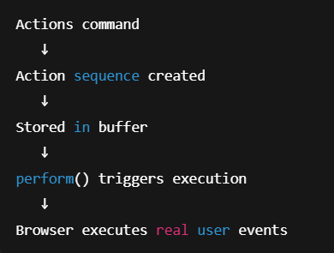
📌 Until you call perform(), nothing happens.

🧠 Two Ways to Execute Actions

1️⃣ perform() (most common)
actions.moveToElement(element).perform();

2️⃣ build().perform() (for multiple actions)
actions.moveToElement(menu)
.click(subMenu)
.build()
.perform();

🖱️ MOUSE EVENTS (Very Important)

🔥 1️⃣ Mouse Hover (moveToElement)
Use case
- Hover menus
- Tooltips
- Hidden dropdowns
actions.moveToElement(menu).perform();
📌 Hover is mandatory before clicking hidden elements.

🔥 2️⃣ Click & Hold
actions.clickAndHold(element).perform();
Used for:
- Sliders
- Drag start
- Long press

🔥 3️⃣ Release
actions.release().perform();
Usually used after clickAndHold().

🔥 4️⃣ Right Click (Context Click)
actions.contextClick(element).perform();
Use cases:
- Context menu
- Admin options
- Browser-like menus

🔥 5️⃣ Double Click
actions.doubleClick(element).perform();
Used for:
- Editable grids
- File explorers
- Special UI widgets

🔥 6️⃣ Drag and Drop
Basic Drag & Drop
actions.dragAndDrop(source, target).perform();
Advanced (More Reliable)
actions.clickAndHold(source)
.moveToElement(target)
.release()
.perform();
📌 Interview fact
dragAndDrop() often fails in HTML5; click-and-hold is more reliable.

🔥 7️⃣ Move By Offset
actions.moveByOffset(100, 50).click().perform();
Used for:
- Canvas
- Charts
- Games
- Signature pads

⌨️ KEYBOARD EVENTS (Very Important)

🔥 8️⃣ sendKeys (Keyboard Simulation)
actions.sendKeys("Hello").perform();
Works without focusing on an element.

🔥 9️⃣ Key Down & Key Up
Used for keyboard combinations.
Example: CTRL + A
actions.keyDown(Keys.CONTROL)
.sendKeys("a")
.keyUp(Keys.CONTROL)
.perform();

🔥 🔟 Common Keyboard Shortcuts
Action | Code
Copy | CTRL + C
Paste | CTRL + V
Cut | CTRL + X
Select All | CTRL + A
Shift Select | SHIFT + Click

🔥 11️⃣ Keyboard + Mouse Combination
Example: SHIFT + Click
actions.keyDown(Keys.SHIFT)
.click(element)
.keyUp(Keys.SHIFT)
.perform();
Used in:
- Multi-select lists
- Range selection

🧠 Actions vs WebElement Commands
Feature | WebElement | Actions
Simple click | ✅ | ✅
Hover | ❌ | ✅
Right click | ❌ | ✅
Drag & drop | ❌ | ✅
Keyboard combos | ❌ | ✅
Real user simulation | ❌ | ✅

⚠ Common Actions Pitfalls (INTERVIEW GOLD)
❌ Forgetting perform()
❌ Not hovering before clicking submenu
❌ Using Actions for simple clicks
❌ Drag & drop failing in HTML5
❌ Element not visible before action

✅ Best Practices (Senior-Level)
✔ Always wait before performing actions
✔ Prefer moveToElement() before click
✔ Use click-and-hold for drag/drop
✔ Keep actions small and readable
✔ Wrap complex actions in utility methods

🧱 Reusable Actions Utility (Framework Style)
public class ActionUtil {
public static void hover(WebDriver driver, WebElement element) {
new Actions(driver).moveToElement(element).perform();
}
public static void rightClick(WebDriver driver, WebElement element) {
new Actions(driver).contextClick(element).perform();
}
public static void dragAndDrop(WebDriver driver, WebElement src, WebElement dest) {
new Actions(driver).clickAndHold(src).moveToElement(dest).release().perform();
}
}

🧠 Actions Class & Waits (IMPORTANT)
❌ Wrong
actions.click(element).perform();
✅ Correct
wait.until(ExpectedConditions.elementToBeClickable(element));
actions.click(element).perform();

🎯 Interview-Ready Definition
The Selenium Actions class is used to perform advanced mouse and keyboard interactions by simulating real user behavior using the W3C Actions API. It supports operations such as hover, right click, drag and drop, and keyboard combinations.

🧠 Ultra-Strong Final Takeaway
Actions class should be used only when normal WebElement methods are insufficient. It enables real user-like mouse and keyboard interactions but requires proper waits and careful sequencing to avoid flakiness.

✔ 1️⃣ Why is Actions needed when click() exists?
Answer (Interview-ready):
click() works only for simple, visible, directly clickable elements, whereas the Actions class simulates real user interactions like mouse hover, right-click, drag-and-drop, and keyboard combinations that click() cannot handle.
Why click() fails:
- Element appears only after hover
- Element is overlapped
- Element requires mouse movement
- Complex UI widgets (menus, sliders, canvas)
Example:
actions.moveToElement(menu).click(subMenu).perform();
📌 Key line:
Use click() for simple interactions, Actions for advanced user behavior.

✔ 2️⃣ Difference between build() and perform()
🔹 perform()
- Executes the action immediately
- Used for single actions
actions.moveToElement(element).perform();

🔹 build().perform()
- Builds a sequence of actions
- Executes them together
- Used for multiple chained actions
actions.moveToElement(menu)
.click(subMenu)
.build()
.perform();

🆚 Interview Table
Aspect | perform() | build().perform()
Single action | ✅ | ❌
Multiple actions | ❌ | ✅
Action buffering | ❌ | ✅
Real-world usage | Common | Advanced

📌 Interview line:
build() is used to combine multiple actions into a single composite user interaction.

✔ 3️⃣ Why does dragAndDrop() fail sometimes?
Answer (Interview-ready):
dragAndDrop() fails mainly with HTML5-based UIs because the browser handles drag events using JavaScript APIs that Selenium’s default implementation cannot always simulate correctly.
Common reasons:
- HTML5 drag-and-drop
- React / Angular UI
- Canvas-based elements
- Element not visible
- Timing issues

✅ Reliable Alternative (Recommended)
actions.clickAndHold(source)
.moveToElement(target)
.release()
.perform();
📌 Key line:
For stability, prefer clickAndHold → moveToElement → release over dragAndDrop().

✔ 4️⃣ Actions vs JavaScriptExecutor
🆚 Comparison Table
Feature | Actions | JavaScriptExecutor
Simulates real user | ✅ | ❌
Bypasses UI | ❌ | ✅
Hover / drag | ✅ | ❌
Click hidden elements | ❌ | ✅
Browser-native | Yes | Direct DOM

When to use Actions
- Hover menus
- Drag & drop
- Keyboard shortcuts
- User-behavior testing
When to use JavaScriptExecutor
- Element not clickable
- Overlapping elements
- Scroll issues
- Framework bugs
js.executeScript("arguments[0].click();", element);
📌 Interview line:
Actions simulate user behavior, JavaScriptExecutor bypasses the UI.

✔ 5️⃣ When should you NOT use Actions?
Answer (Interview-ready):
Actions should not be used for simple interactions where WebElement methods are sufficient, as they add unnecessary complexity and execution overhead.
❌ Avoid Actions when:
- Simple click() works
- Just entering text
- Selecting <select> dropdowns
- No hover or gesture required
- Tests need speed over realism
✔ Use Actions only when:
- UI demands real mouse/keyboard behavior
- Element appears on hover
- Drag/slider/canvas involved
📌 Golden rule:
Prefer WebElement methods first; use Actions only when required.

🧠 Ultra-Strong Final Summary (Say This Confidently)
WebElement click() is sufficient for simple interactions, while the Actions class is required for advanced mouse and keyboard operations. perform() executes a single action immediately, whereas build().perform() executes multiple actions as a sequence. dragAndDrop() may fail with HTML5 UIs, so click-and-hold is more reliable. Actions simulate real user behavior, while JavaScriptExecutor bypasses the UI. Actions should be avoided when simple WebElement methods can achieve the same result.

