SELENIUM LOCATORS
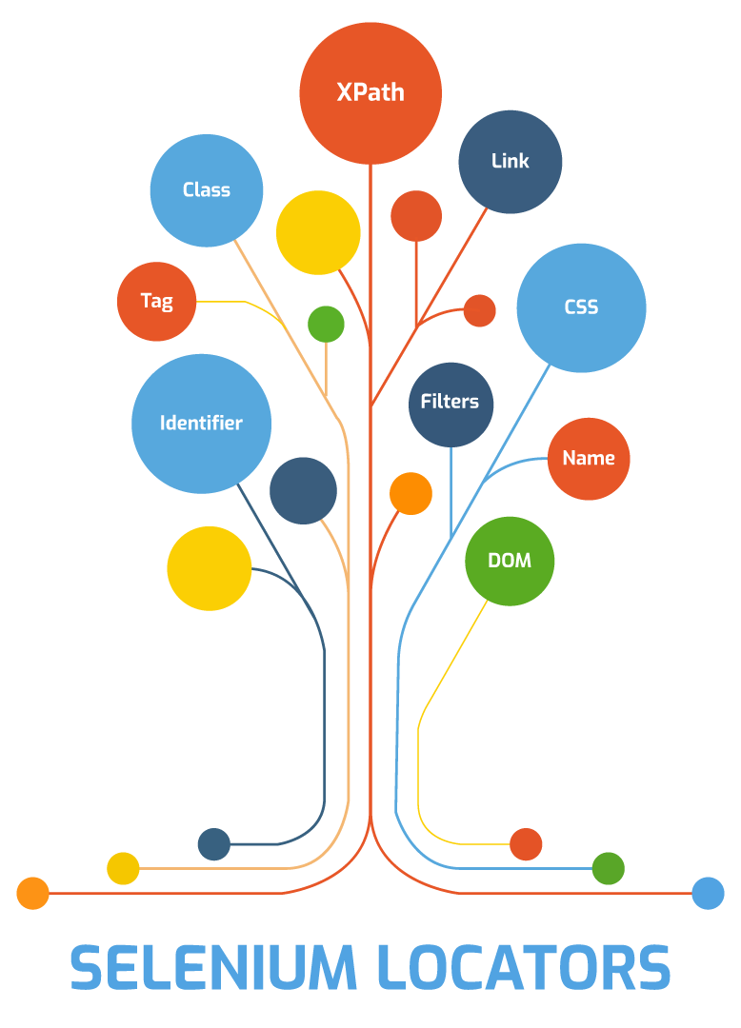

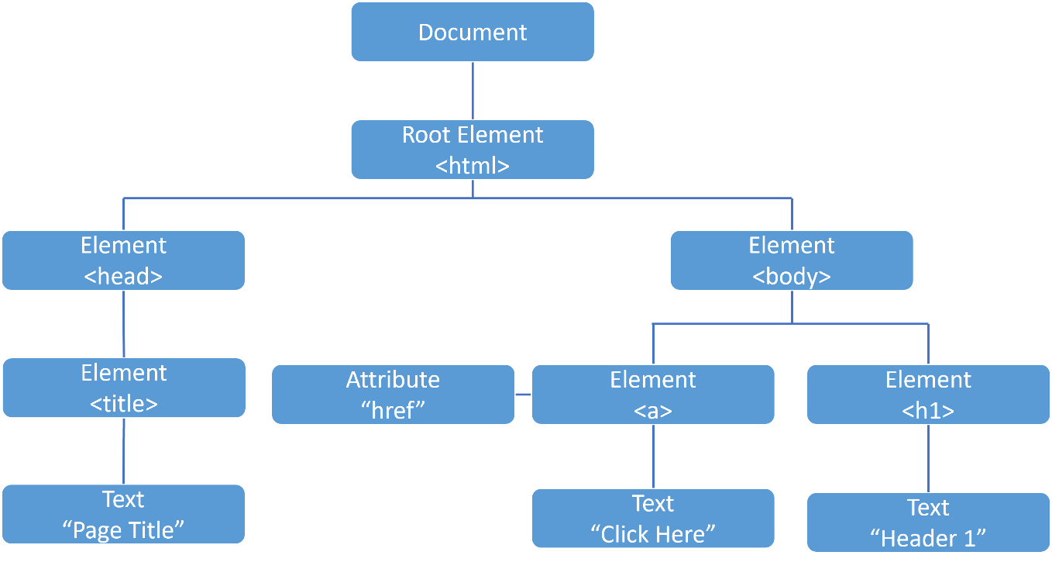

✅ What are Selenium Locators?
Locators are strategies used to identify and find web elements in the DOM so Selenium can interact with them.
📌 Without locators → Selenium cannot perform actions like click, type, or validate.
Example:
driver.findElement(By.id("username")).sendKeys("admin");

🧩 Why Locators Are Important
- ✔ Identify elements uniquely
- ✔ Core of Selenium automation
- ✔ Poor locators = flaky tests
- ✔ Good locators = stable framework

🏗️ Types of Selenium Locators
Selenium supports 8 locator strategies:
Locators
├── ID
├── Name
├── ClassName
├── TagName
├── LinkText
├── PartialLinkText
├── CSS Selector
└── Xpath

🔥 1️⃣ ID Locator (Best & Fastest)
Syntax:
By.id("elementId")
Example:
<input id="email">
driver.findElement(By.id("email"));
✅ Pros
- Fastest
- Unique
- Reliable
❌ Cons
- Not always available
📌 First preference in real projects

🔥 2️⃣ Name Locator
Syntax:
By.name("username")
Example:
<input name="username">
❌ Cons
- Can be duplicated
- Less reliable than ID

🔥 3️⃣ ClassName Locator
Syntax:
By.className("btn-primary")
Example:
<button class="btn btn-primary">
⚠ Important rule
❌ Cannot use multiple classes:
By.className("btn btn-primary"); // ❌ wrong

🔥 4️⃣ TagName Locator
Syntax:
By.tagName("input")
Use case:
- Counting elements
- Generic lists
Example:
List<WebElement> inputs = driver.findElements(By.tagName("input"));

🔥 5️⃣ LinkText Locator
Used only for anchor (<a>) tags
Syntax:
By.linkText("Forgot Password?")
Example:
<a href="/reset">Forgot Password?</a>
❌ Fails if text changes

🔥 6️⃣ PartialLinkText Locator
Matches partial visible text
Syntax:
By.partialLinkText("Forgot")
⚠ Avoid when multiple links contain same text

🔥 7️⃣ CSS Selector (Most Powerful & Fast)
Syntax:
By.cssSelector("cssPattern")
🔹 Common CSS Patterns

ID
#loginBtn

Class
.login-button

Attribute
input[type='password']

Child
form > input

Descendant
form input

Contains
input[id*='user']

Starts with
input[id^='user']

Ends with
input[id$='name']
Example:
driver.findElement(By.cssSelector("input[type='email']"));
✅ Pros
- Faster than XPath
- Clean syntax
❌ Cons
- Cannot move upward in DOM

🔥 8️⃣ XPath (Most Flexible)
Syntax:
By.xpath("xpathExpression")

🔹 Absolute XPath ❌ (Avoid)
/html/body/div/form/input

🔹 Relative XPath ✅ (Preferred)
//input[@id='username']

🔹 XPath Using Text
//button[text()='Login']

🔹 XPath Using Contains
//input[contains(@id,'user')]

🔹 XPath Using Starts-with
//input[starts-with(@id,'user')]

🔹 XPath Axes (Advanced)
Axis | Example
parent | //input/parent::div
child | //div/child::input
ancestor | //input/ancestor::form
following-sibling | //label/following-sibling::input
preceding-sibling | //input/preceding-sibling::label

🆚 CSS Selector vs XPath (Interview Table)
Feature | CSS | XPath
Speed | Faster | Slightly slower
Readability | Cleaner | Complex
Upward traversal | ❌ | ✅
Text matching | ❌ | ✅
Browser support | Excellent | Excellent

🧠 Locator Priority (Real Projects)
1️⃣ ID
2️⃣ Name
3️⃣ CSS Selector
4️⃣ XPath
5️⃣ LinkText / Partial
6️⃣ ClassName / TagName
--

⚠ Common Locator Mistakes
❌ Using absolute XPath
❌ Using index-based XPath (//input)[3]
❌ Using dynamic auto-generated IDs
❌ Overusing XPath when CSS is enough
❌ Hardcoding text without stability

Best Practices (Interview Gold)
✔ Prefer ID
✔ Use relative XPath / CSS
✔ Avoid dynamic attributes
✔ Use data-test or data-testid
✔ Centralize locators (Page Object Model)
✔ One locator per element

🧠 Interview-Ready Definition
Selenium locators are strategies used to identify web elements in the DOM. Selenium supports eight locator types including ID, Name, ClassName, CSS Selector, and XPath. Choosing stable and unique locators is critical for reliable automation.
If you want next, I can explain:
- 🔹 Dynamic XPath handling
- 🔹 Locator strategy in Page Object Model
- 🔹 Interview XPath challenges
- 🔹 Shadow DOM locators
- 🔹 Selenium 4 relative locators (above(), near())

REAL WORLD KNOWLEDGE

✅ 1️⃣ Locator Strategy (How Seniors Think)
Instead of “which locator works”, think:
Which locator will survive UI changes?
🧠 Priority Order (Real Projects)
1️⃣ data-test / data-testid
2️⃣ ID
3️⃣ CSS Selector
4️⃣ XPath
5️⃣ Name / LinkText
6️⃣ Index-based (last option)
📌 If your app team agrees to add:
<button data-testid="login-btn">
→ your tests become 10× more stable.

✅ 2️⃣ CSS Selector – Advanced Things You MUST Know

🔹 Multiple Attributes
input[type='text'][name='username']

🔹 :nth-child() vs :nth-of-type()
li:nth-child(2) /* counts all children */
li:nth-of-type(2) /* counts only <li> */

🔹 :not() selector
input:not([disabled])

🔹 Attribute case-insensitive (modern browsers)
input[type='TEXT' i]

🔹 Direct child vs descendant (very important)
form > input /* direct child */
form input /* any depth */

⚠ CSS Limitations (Must Know)
❌ Cannot move upward
❌ Cannot locate by text
❌ Limited for complex DOM traversal
👉 That’s why XPath still matters.

✅ 3️⃣ XPath – Advanced & Professional-Level Knowledge

🔹 normalize-space() (very underrated)
//button[normalize-space()='Login']

🔹 Multiple conditions
//input[@type='text' and @name='email']

🔹 Grouping with parentheses
(//input[contains(@id,'user')])[1]

🔹 Using . vs text()
//button[.='Login']
Better when text has nested tags.

🧠 XPath Axes You Should ACTUALLY Use
Axis | Real Use
ancestor | Form-based locators
following-sibling | Label → input
preceding-sibling | Reverse lookup
parent | Climb one level
descendant | Scoped search

⚠ XPath Performance Myths (Truth)
❌ “XPath is slow” → myth
✔ Bad XPath is slow
✔ Absolute XPath is slow
✔ Overusing // is slow
👉 Good relative XPath performs well.

✅ 4️⃣ Selenium 4 Relative Locators (VERY IMPORTANT)
Selenium 4 introduced human-like locators.

🔹 Types
- above()
- below()
- toLeftOf()
- toRightOf()
- near()

🔹 Example
WebElement password = driver.findElement(RelativeLocator.with(By.tagName("input"))
.below(By.id("username")));
📌 Use when:
- No unique attributes
- Layout is stable
⚠ Avoid in highly dynamic layouts.

✅ 5️⃣ Shadow DOM Locators (Modern Apps)
Traditional locators ❌ don’t work.
🔹 Correct way
SearchContext shadowRoot =
driver.findElement(By.cssSelector("app-root"))
.getShadowRoot();
WebElement input =
shadowRoot.findElement(By.cssSelector("input"));
📌 XPath ❌ inside shadow DOM
📌 CSS ✅ only

✅ 6️⃣ Iframes & Locators (Hidden Trap)
Locators fail if element is inside iframe.
🔹 Correct flow
driver.switchTo().frame("loginFrame");
driver.findElement(By.id("email"));
driver.switchTo().defaultContent();
📌 80% “element not found” issues come from iframes.

✅ 7️⃣ StaleElementReferenceException (Locator Related)

Occurs when:
- DOM refreshes
- Page reloads
- AJAX updates

🔹 Best practices
✔ Re-locate element
✔ Use waits
✔ Avoid storing WebElement globally

✅ 8️⃣ Page Object Model (Locator Design Rule)
❌ Bad
driver.findElement(By.id("login")).click();
✅ Good
@FindBy(id = "login")
WebElement loginBtn;
📌 Centralized locators = low maintenance.

✅ 9️⃣ Locator Validation & Debugging Skills
✔ Validate XPath/CSS in DevTools
✔ Use $x("xpath") in console
✔ Use $$("css") for CSS
✔ Check uniqueness (1 match only)

🎯 Final Senior-Level Takeaway
A good automation engineer doesn’t just “find elements”, they design locators that are stable, readable, and resilient to UI change.

