🧩 What is a Maven Project?
A Maven project is a standardized Java project managed by Apache Maven, where:
- Dependencies, build steps, and plugins are defined in a single file: pom.xml
- Maven handles download of libraries, build, test, and packaging automatically
In short: Maven = build tool + dependency manager

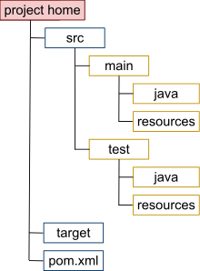
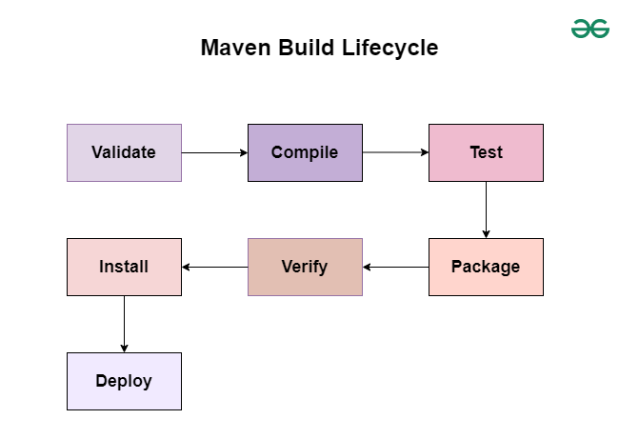
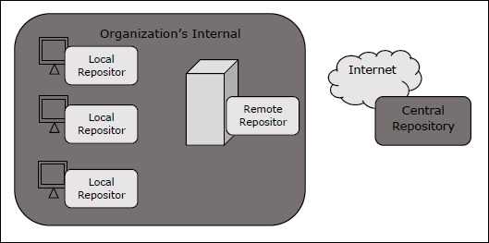\

📁 Standard Maven Project Structure
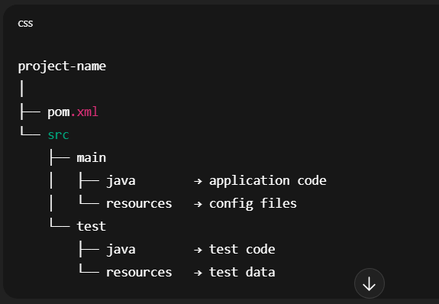

Why this matters?
- Consistency across teams
- Tools (IDE, CI) understand it automatically
- Clean separation of prod vs test code

📄 pom.xml (Project Object Model)
This is the heart of a Maven project.
Key sections:
Xml

<project>
<groupId>com.company</groupId>
<artifactId>automation</artifactId>
<version>1.0-SNAPSHOT</version>

<dependencies>
<!-- Selenium, TestNG, etc. -->
</dependencies>

<build>
<plugins>
<!-- Surefire, Compiler, etc. -->
</plugins>
</build>
</project>

Coordinates meaning:
Field | Meaning
groupId | Company / organization
artifactId | Project name
version | Project version

🔄 Maven Build Lifecycle (Quick View)
Phase | Purpose
clean | Remove old build
compile | Compile source code
test | Run unit tests
package | Create JAR/WAR
install | Install into local repo
deploy | Push to remote repo
Example:
mvn clean test

🗄️ Types of Maven Repositories
A repository is where Maven stores and fetches dependencies (JARs).
There are 3 main types 👇

1️⃣ Local Repository
📍 Location (default):
~/.m2/repository
What it does:
- Stores dependencies on your machine
- First place Maven looks for a dependency
Flow:
Project → Local Repo → (if not found) → Remote Repo
✅ Faster builds
❌ Only available on that machine

2️⃣ Central Repository
🌍 Public repository maintained by Maven
- URL: https://repo.maven.apache.org
- Contains most open-source libraries
- Default remote repo (no config needed)
Example dependency from Central:
Xml
<dependency>
<groupId>org.seleniumhq.selenium</groupId>
<artifactId>selenium-java</artifactId>
<version>4.20.0</version>
</dependency>

✅ Free
✅ Reliable
❌ No private/company libraries

3️⃣ Remote Repository (Private / Custom)
Used by companies to store:
Internal libraries
Approved versions only
Custom artifacts
Examples:
Nexus
Artifactory
GitHub Packages
GitLab Maven Registry

Configured in pom.xml or settings.xml:
<repositories>
<repository>
<id>company-repo</id>
<url>https://repo.company.com/maven2</url>
</repository>
</repositories>

✅ Secure
✅ Team-wide sharing
✅ Version control

🔁 Dependency Resolution Order
When Maven needs a dependency, it checks in this order:
1. Local Repository
2. Central Repository
3. Remote Repository

🧠 Interview-Ready Summary
Maven Project
A Maven project is a Java project structured and managed using Maven, where dependencies, build lifecycle, and plugins are defined in the pom.xml file.
Maven Repository Types
Maven uses three types of repositories:
Local (on developer machine),
Central (public Maven repository), and
Remote (private/company repositories).

⚡ Common Interview Questions (Quick)
Q: Why Maven?
✔ Dependency management
✔ Consistent build
✔ CI/CD friendly
Q: What happens if dependency not found locally?
➡ Maven downloads it from Central/Remote and stores it locally
Q: Can we skip tests in Maven?
mvn clean install -DskipTests

