SELECT COMMANDS
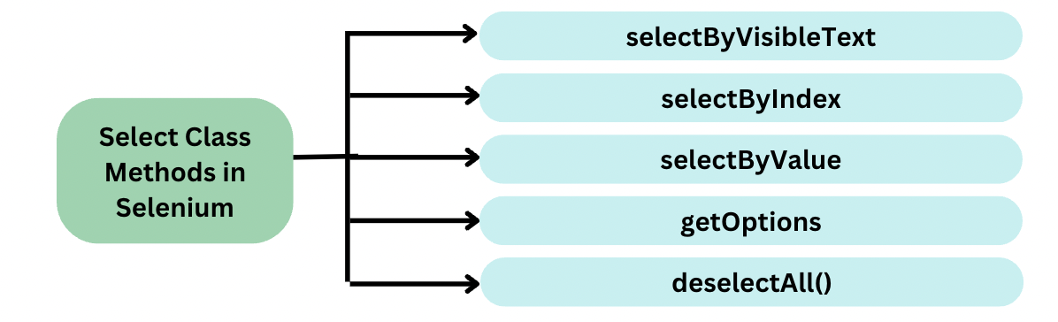
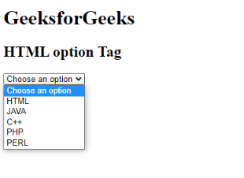
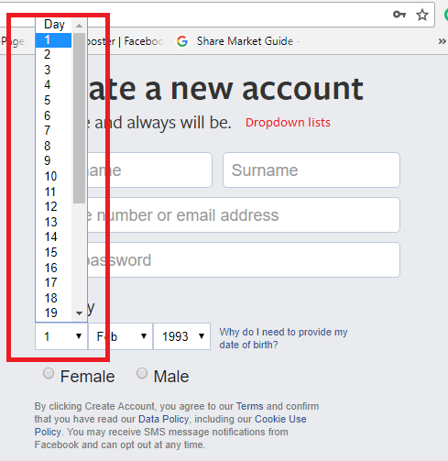

🧩 What are Select Commands?
Select commands are methods of the Select class in Selenium used to interact with HTML <select> dropdowns (single-select or multi-select).
📌 The Select class works only if the dropdown tag is:
<select> ... </select>

📦 Select Class Basics
Package
org.openqa.selenium.support.ui.Select
Initialization
WebElement dropdown = driver.findElement(By.id("country"));
Select select = new Select(dropdown);

🏗️ Types of <select> Dropdowns

1️⃣ Single-Select Dropdown
- Only one option can be selected

2️⃣ Multi-Select Dropdown
- Multiple options can be selected (has multiple attribute)
<select multiple>

✅ Core Select Commands

🔥 1️⃣ selectByVisibleText()
Selects option based on displayed text.
select.selectByVisibleText("India");
✔ Most readable
❌ Fails if text changes

🔥 2️⃣ selectByValue()
Selects using the value attribute.
<option value="IN">India</option>
select.selectByValue("IN");
✔ Stable if value is fixed

🔥 3️⃣ selectByIndex()
Selects option by position (0-based).
select.selectByIndex(2);
⚠ Risky if order changes
📌 Use only as last option

🔁 Deselect Commands (Multi-Select Only)

🔥 4️⃣ deselectByVisibleText()
select.deselectByVisibleText("India");

🔥 5️⃣ deselectByValue()
select.deselectByValue("IN");

🔥 6️⃣ deselectByIndex()
select.deselectByIndex(1);

🔥 7️⃣ deselectAll()
select.deselectAll();
📌 Throws exception if dropdown is not multi-select.

🔍 Information / Validation Commands

🔥 8️⃣ getFirstSelectedOption()
Returns the currently selected option.
WebElement selected = select.getFirstSelectedOption();
System.out.println(selected.getText());

🔥 9️⃣ getAllSelectedOptions()
Returns all selected options (multi-select).
List<WebElement> selectedOptions = select.getAllSelectedOptions();

🔥 🔟 getOptions()
Returns all dropdown options.
List<WebElement> options = select.getOptions();
Used for:
- Validation
- Counting options
- Printing values

🔥 11️⃣ isMultiple()
Checks if dropdown allows multiple selections.
if (select.isMultiple()) {
select.selectByVisibleText("India");
}

🧠 Common Real-World Examples

✔ Validate Dropdown Values
List<WebElement> options = select.getOptions();
for (WebElement option : options) {
System.out.println(option.getText());
}

✔ Select Multiple Values Safely
if (select.isMultiple()) {
select.selectByValue("IN");
select.selectByValue("US");
}

✔ Assert Selected Value
Assert.assertEquals(
select.getFirstSelectedOption().getText(),
"India"
);

⚠ Common Mistakes (VERY IMPORTANT)
❌ Using Select on non-<select> dropdown
❌ Using selectByIndex() blindly
❌ Calling deselectAll() on single-select
❌ Not waiting for dropdown to load
👉 Custom dropdowns (React, Angular) ❌ don’t work with Select class.

🧠 Select vs Custom Dropdowns
Feature | <select> | Custom Dropdown
Select class | ✅ | ❌
Tag name | <select> | <div>, <li>
Handling | Select methods | Click + XPath/CSS
Common in | Legacy apps | Modern apps

🧠 Best Practices (Interview Gold)
✔ Always check tag name before using Select
✔ Prefer selectByValue() or selectByVisibleText()
✔ Avoid selectByIndex()
✔ Validate options before selection
✔ Use waits if options load dynamically

🎯 Interview-Ready Definition
The Selenium Select class is used to interact with HTML <select> dropdowns and provides methods to select, deselect, and validate dropdown options using visible text, value, or index.

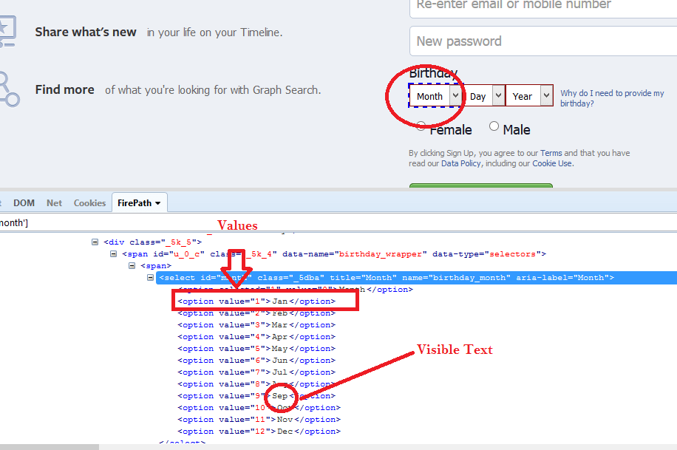
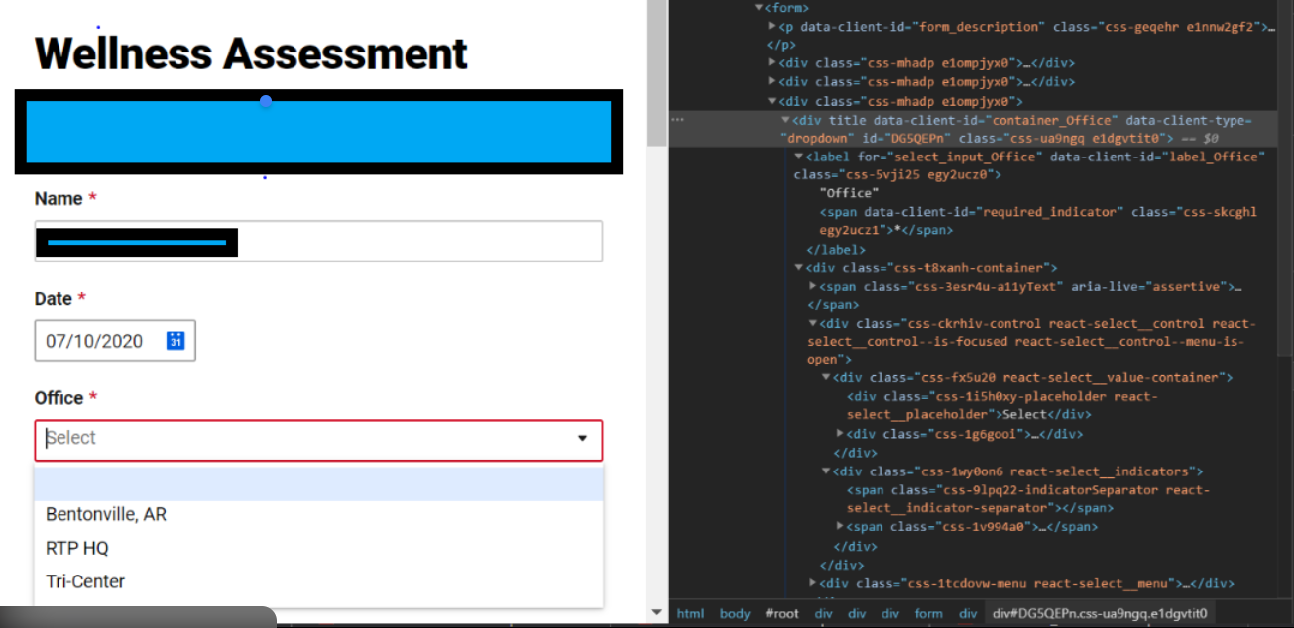
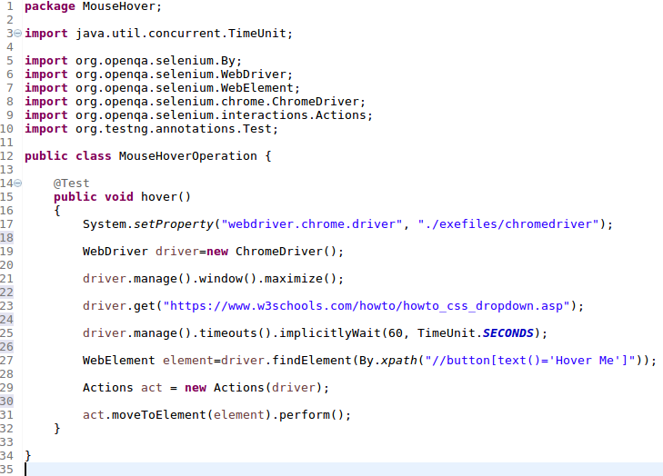



🔹 1️⃣ Handling Non-Select (Custom) Dropdowns

❓ What is a Non-Select Dropdown?
Modern apps (React, Angular, Vue) often use:
<div> <ul> <li> </li> </ul> </div>
❌ No <select> tag
❌ Select class will NOT work

✅ General Strategy (4 Steps)
1️⃣ Click dropdown to open
2️⃣ Capture all options
3️⃣ Loop & match text
4️⃣ Click required option

🧪 Example: Custom Dropdown (UL / LI)

HTML
<div id="countryDropdown">Select Country</div>
<ul class="options">
<li>India</li>
<li>USA</li>
<li>UK</li>
</ul>

Selenium Code
driver.findElement(By.id("countryDropdown")).click();

List<WebElement> options =
driver.findElements(By.cssSelector(".options li"));

for (WebElement option : options) {
if (option.getText().equals("India")) {
option.click();
break;
}
}

🧠 Pro Tips
✔ Use normalize-space() for text
✔ Add explicit waits
✔ Avoid index-based clicks
✔ Prefer contains(text()) if text is dynamic

🔹 2️⃣ Dropdown Interview Challenges (VERY COMMON)

❓ Q1: How do you handle dropdown without <select>?
Answer:
Click the dropdown, locate options using XPath/CSS, iterate through them, and click the required option.

❓ Q2: How do you handle dropdown with search input?
Example: React Select
dropdown.click();
searchBox.sendKeys("Ind");
option.click();

❓ Q3: How do you validate dropdown values?
List<String> actual = options.stream()
.map(WebElement::getText)
.collect(Collectors.toList());

❓ Q4: Dropdown loads via AJAX — what to do?
✔ Explicit wait
✔ Wait for options count
✔ Wait for visibility
wait.until(ExpectedConditions
.visibilityOfAllElements(options));

❓ Q5: Multi-select custom dropdown?
✔ Track selected items
✔ Click again to deselect
✔ Validate selected list

🔹 3️⃣ Reusable Dropdown Utility Class (Framework-Level)

✅ Universal Utility (Select + Non-Select)
public class DropdownUtil {

// For <select> dropdowns
public static void selectByText(WebElement element, String text) {
Select select = new Select(element);
select.selectByVisibleText(text);
}

// For custom dropdowns
public static void selectFromCustomDropdown(
WebDriver driver,
By optionsLocator,
String value) {

List<WebElement> options =
driver.findElements(optionsLocator);

for (WebElement option : options) {
if (option.getText().trim().equals(value)) {
option.click();
break;
}
}
}
}

🧪 Usage Example
DropdownUtil.selectByText(countrySelect, "India");

DropdownUtil.selectFromCustomDropdown(
driver,
By.cssSelector(".options li"),
"India"
);
📌 This is framework-quality code — interview gold.

🔹 4️⃣ Select Class vs Actions Class
🆚 Comparison Table
Feature | Select Class | Actions Class
Works on <select> | ✅ Yes | ❌ No
Custom dropdown | ❌ No | ✅ Yes
Mouse hover | ❌ No | ✅ Yes
Keyboard actions | ❌ No | ✅ Yes
Complexity | Simple | Advanced
Usage | Traditional dropdown | Modern UI

🧪 Actions Class Example (Hover Dropdown)
Actions actions = new Actions(driver);
actions.moveToElement(menu).perform();
submenu.click();

🧠 When to Use What?
✔ Use Select class → <select> tag
✔ Use Actions → hover-based dropdowns
✔ Use Custom logic → React / Angular dropdowns

🔥 Bonus: Keyboard-Based Dropdown Handling
dropdown.sendKeys(Keys.ARROW_DOWN);
dropdown.sendKeys(Keys.ENTER);
Useful when:
- No clickable options
- Accessibility-focused apps

🎯 Interview-Ready Final Summary
The Selenium Select class works only with HTML <select> elements. Modern applications use custom dropdowns built with divs and lists, which require clicking the dropdown, locating options, and selecting values manually or using the Actions class. A reusable dropdown utility helps maintain clean and scalable automation frameworks.

