SWITCHING WINDOWS AND FRAMES

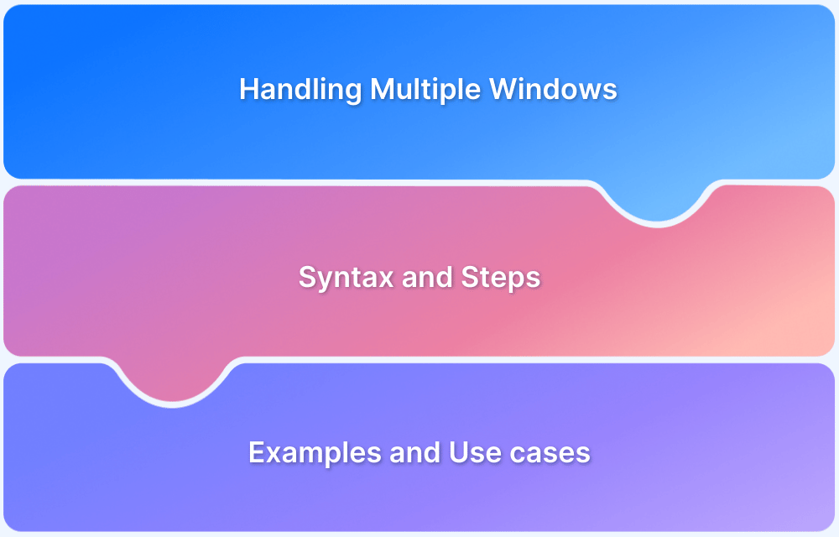
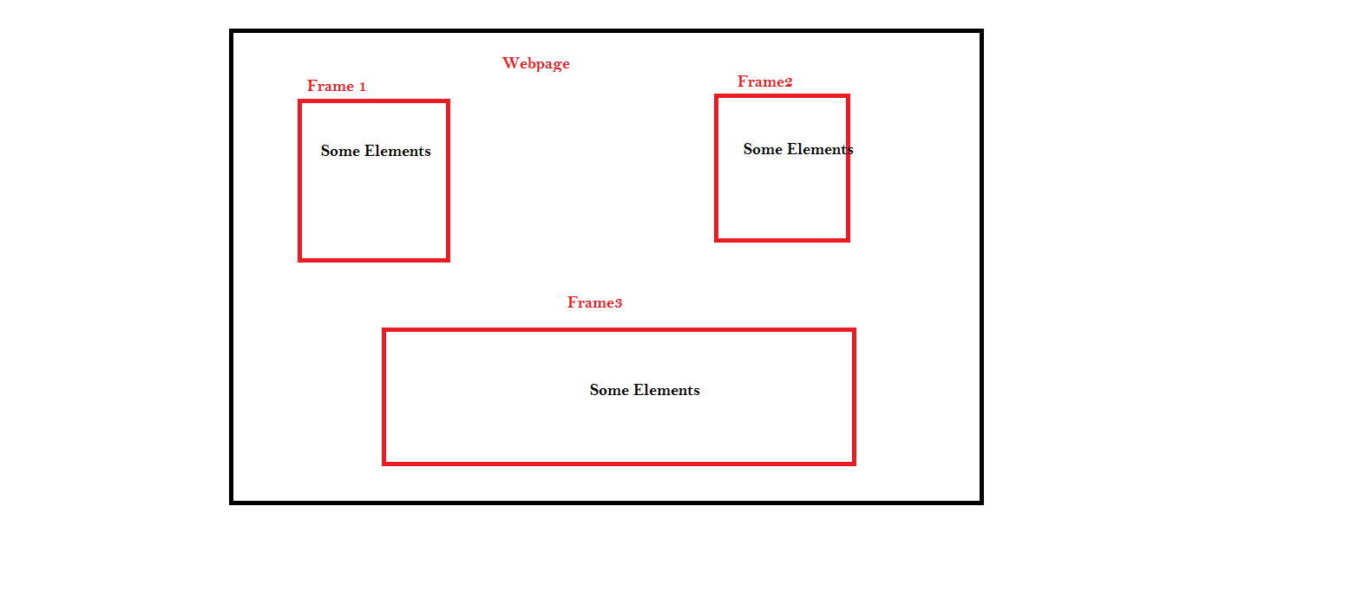

🔁 PART 1: Switching Windows & Tabs

🧩 What is a Window / Tab in Selenium?
In Selenium, every browser window or tab has a unique ID, called a Window Handle.
- Parent Window → the original browser window
- Child Window → any new tab/window opened from parent
Selenium can control only one window at a time, so you must switch.

🔑 Important Window Commands
Command | Purpose
getWindowHandle() | Get current window ID
getWindowHandles() | Get all window IDs
switchTo().window(id) | Switch to a window
close() | Close current window
quit() | Close all windows

🔄 Basic Window Switching Workflow
Step-by-step flow:
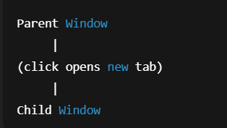

✅ Example: Switch to Child Window
String parent = driver.getWindowHandle();
driver.findElement(By.id("openTab")).click();
Set<String> windows = driver.getWindowHandles();
for (String win : windows) {
if (!win.equals(parent)) {
driver.switchTo().window(win);
break;
}
}

📌 Interview line
Selenium switches windows using window handles, not titles.

🔍 Switching by Window Title (More Readable)
for (String win : driver.getWindowHandles()) {
driver.switchTo().window(win);
if (driver.getTitle().equals("Dashboard")) {
break;
}
}

✔ More readable
❌ Slower (loads page titles)

🔁 Switch Back to Parent Window
driver.switchTo().window(parent);
❌ Common Window Mistakes
❌ Forgetting to store parent handle
❌ Using close() instead of switching
❌ Assuming new window is always second
❌ Not waiting for window to appear

⏳ Wait for New Window (IMPORTANT)
WebDriverWait wait = new WebDriverWait(driver, Duration.ofSeconds(10));
wait.until(ExpectedConditions.numberOfWindowsToBe(2));
📌 Prevents flaky window switching.

🧠 Window Handling – Best Practices
✔ Always store parent window
✔ Wait for number of windows
✔ Switch back after child work
✔ Close only child windows
✔ Never hardcode index

🔁 PART 2: Switching Frames (iframe)

🧩 What is a Frame / iFrame?
An iframe is a webpage inside another webpage.
📌 Selenium cannot access elements inside a frame unless it switches into it.

🔑 Frame Switching Commands
Command | Purpose
switchTo().frame(index) | Switch by index
switchTo().frame(name/id) | Switch by name or id
switchTo().frame(WebElement) | Switch by element
switchTo().defaultContent() | Exit all frames
switchTo().parentFrame() | Exit one level

🏆 Best Way to Switch Frames (Recommended)

Switch using WebElement
WebElement frame =
driver.findElement(By.id("loginFrame"));
driver.switchTo().frame(frame);
✔ Most stable
❌ Index-based is fragile

❌ Worst Way (Avoid)
driver.switchTo().frame(0); // ❌ breaks if frame order changes

🔁 Nested Frames (Very Important)

DOM Example
Main Page
└── Frame A
└── Frame B
Correct Flow
driver.switchTo().frame("frameA");
driver.switchTo().frame("frameB");
// work inside frameB
driver.switchTo().parentFrame(); // back to frameA
driver.switchTo().defaultContent(); // back to main page

⏳ Wait for Frame to Load (BEST PRACTICE)
wait.until(
ExpectedConditions.frameToBeAvailableAndSwitchToIt(
By.id("loginFrame")
));
📌 Prevents NoSuchFrameException.

❌ Common Frame Errors
Error | Cause | Fix
NoSuchElementException | Not switched to frame | Switch to frame
NoSuchFrameException | Frame not loaded | Use wait
StaleElementReference | Frame refreshed | Re-locate & switch
ElementNotInteractable | Wrong frame | Check hierarchy

🧠 Frame Debugging Tips (INTERVIEW GOLD)
✔ Check iframe in DevTools
✔ Highlight iframe borders
✔ Verify nesting
✔ Always exit frame after use

🧱 PART 3: Framework-Level Utilities

🔧 Window Utility
public static void switchToWindowByTitle(WebDriver driver, String title) {
for (String win : driver.getWindowHandles()) {
driver.switchTo().window(win);
if (driver.getTitle().equals(title)) {
break;
}
}
}

🔧 Frame Utility
public static void switchToFrame(WebDriver driver, By locator) {
new WebDriverWait(driver, Duration.ofSeconds(10))
.until(ExpectedConditions.frameToBeAvailableAndSwitchToIt(locator));
}

🧠 Windows vs Frames (Interview Table)
Aspect | Windows | Frames
Level | Browser | Page
Identification | Window Handle | Index / Name / Element
Switch required | ✅ | ✅
Default context | Main window | Main page
Common error | Wrong handle | Not switched

🎯 Interview-Ready One-Liners

✔ Window:
Selenium uses window handles to switch between multiple browser windows or tabs.

✔ Frame:
Selenium must switch to an iframe before interacting with elements inside it.

✔ Best Practice:
Always use explicit waits when switching windows or frames.

🧠 Ultra-Strong Final Summary (Say This Confidently)
Selenium can interact with only one window and one frame at a time. Window switching is done using window handles, while frame switching is done using index, name, or WebElement. Explicit waits should be used to ensure windows and frames are available before switching. Index-based switching should be avoided, and context must always be restored after switching.

