TEST NG FRAMEWORK
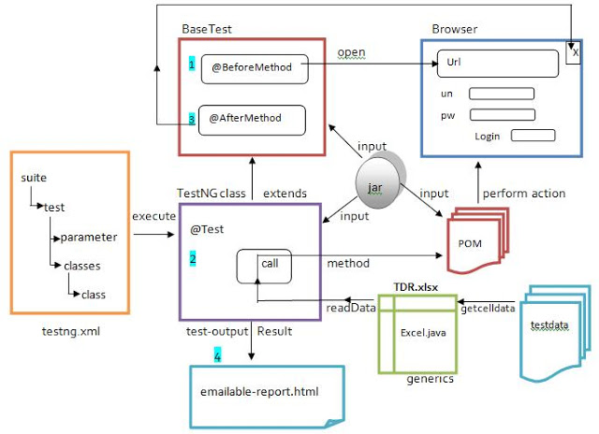

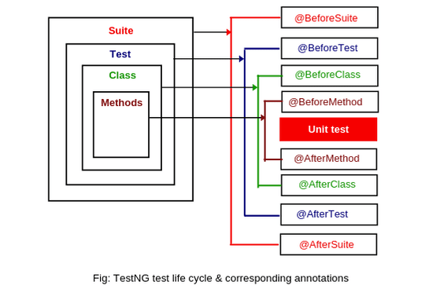
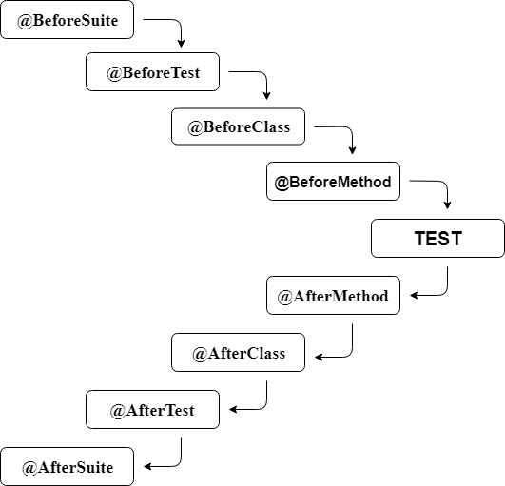
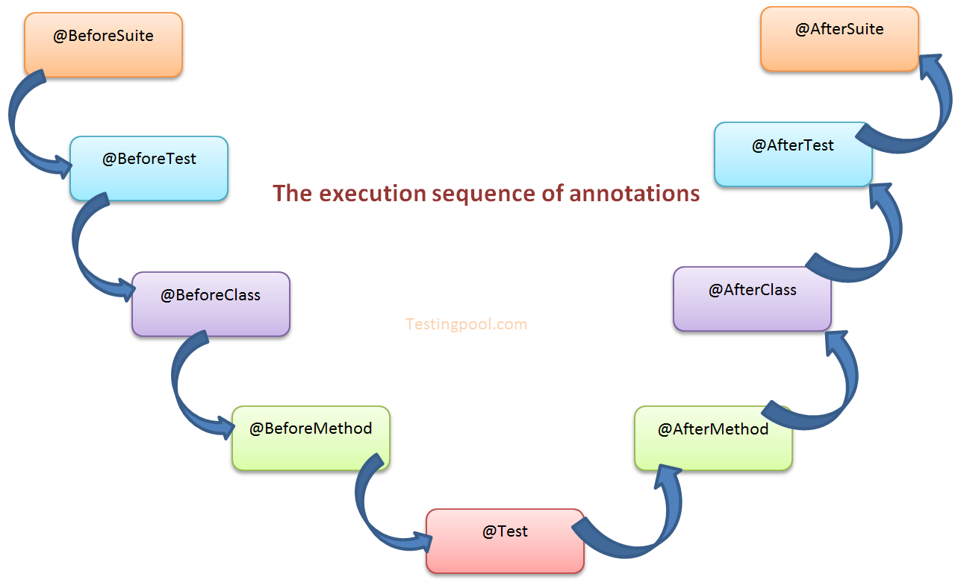

🧩 What is TestNG?
TestNG (Test Next Generation) is a testing framework for Java inspired by JUnit and NUnit, designed to make testing more powerful and flexible—especially for automation testing.
It works seamlessly with Selenium and is widely used in real projects.

🎯 Why Use TestNG?
- ✅ Easy test configuration with annotations
- 🔁 Parallel execution (faster runs)
- 🧪 Grouping & priorities
- 🔄 Data-driven testing
- 📊 Built-in HTML reports
- ❌ Control failures with retry & dependency
- 🔌 Strong Maven / CI-CD integration

🏗️ TestNG Framework Architecture (Conceptual)
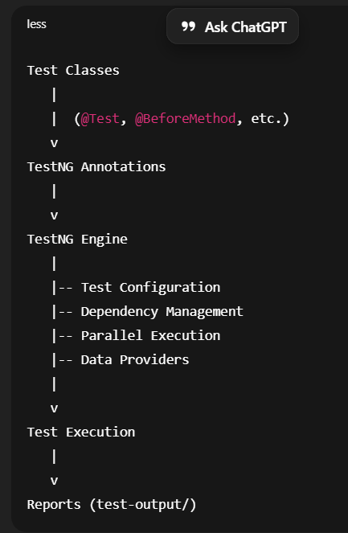

🧠 Core Concept: Annotations
Annotations control when and how methods run.
🔹 Most-Used Annotations
Annotation | Runs
@BeforeSuite | Once before entire suite
@BeforeTest | Before <test> in XML
@BeforeClass | Before first method in class
@BeforeMethod | Before each @Test
@Test | Test case
@AfterMethod | After each @Test
@AfterClass | After all methods in class
@AfterTest | After <test>
@AfterSuite | After entire suite

EXAMPLE:
@BeforeMethod
public void setup() {
System.out.println("Browser setup");
}

@Test
public void loginTest() {
System.out.println("Login test");
}

@AfterMethod
public void tearDown() {
System.out.println("Close browser");
}

🔄 TestNG Execution Flow
@BeforeSuite
@BeforeTest
@BeforeClass
@BeforeMethod
@Test
@AfterMethod
@AfterClass
@AfterTest
@AfterSuite

⚙️ Key TestNG Features (with Examples)

1️⃣ Priority
Controls order of execution.
@Test(priority = 1)
public void login() {}

@Test(priority = 2)
public void logout() {}

2️⃣ Depends On
Run a test only if another passes.

@Test
public void login() {}

@Test(dependsOnMethods = "login")
public void dashboard() {}

3️⃣ Grouping
Run selective tests.
@Test(groups = "smoke")
public void smokeTest() {}

@Test(groups = "regression")
public void regressionTest() {}

4️⃣ DataProvider (Data-Driven Testing)
@DataProvider(name = "loginData")
public Object[][] data() {
return new Object[][] {
{"user1", "pass1"},
{"user2", "pass2"}
};
}

@Test(dataProvider = "loginData")
public void loginTest(String user, String pass) {}

5️⃣ Parallel Execution
Configured via testng.xml.
<suite name="Suite" parallel="methods" thread-count="3">
<test name="Tests">
<classes>
<class name="tests.LoginTest"/>
</classes>
</test>
</suite>

6️⃣ Assertions
Validate expected vs actual results.
Assert.assertEquals(actualTitle, expectedTitle);
Assert.assertTrue(isDisplayed);

7️⃣ Listeners
Hook into test execution events.
Use cases:
- Screenshot on failure
- Custom reports
- Retry failed tests
@Listeners(TestListener.class)
public class LoginTest {}

📄 testng.xml (Control Center)
- Decide what to run
- Control parallelism
- Include/exclude groups
<suite name="AutomationSuite">
<test name="SmokeTests">
<groups>
<run>
<include name="smoke"/>
</run>
</groups>
<classes>
<class name="tests.LoginTest"/>
</classes>
</test>
</suite>

📊 Reports Generated by TestNG
After execution:
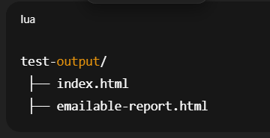
Open index.html to view:
- Passed / Failed tests
- Execution time
- Stack traces

🆚 TestNG vs JUnit (Quick)
Feature | TestNG | JUnit
Annotations | Rich | Limited
Parallel execution | ✅ | ❌
Data-driven | Built-in | External
XML control | Yes | No
Selenium friendly | ⭐⭐⭐⭐⭐ | ⭐⭐⭐

🎯 Interview-Ready Definition
TestNG is a Java testing framework that uses annotations to manage test execution, supports grouping, dependency, parallel execution, data-driven testing, and generates detailed reports—making it ideal for Selenium automation.

