TEST NG REPORTS AND LISTENERS

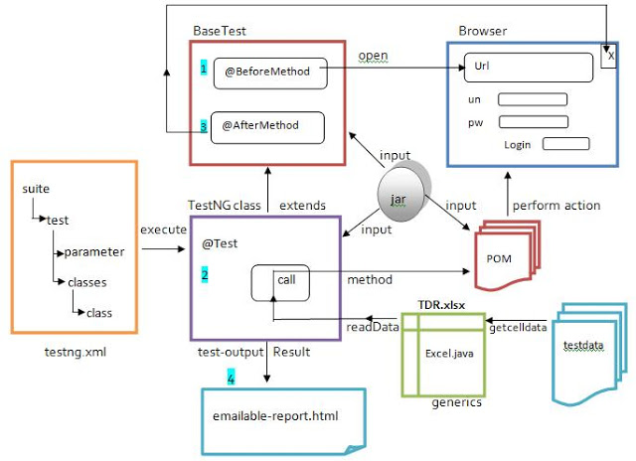
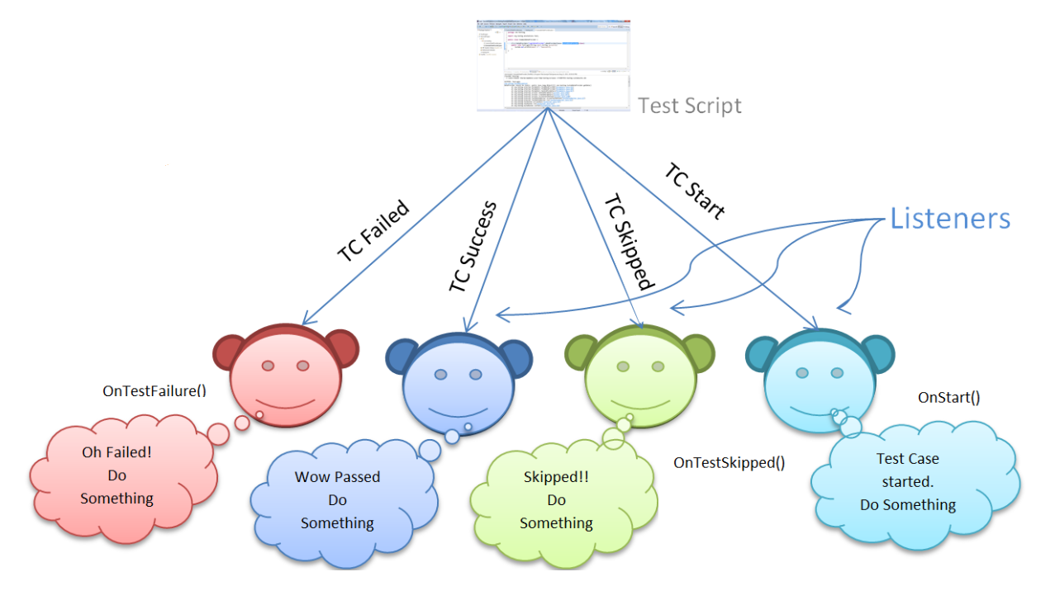

TestNG Listeners and Reporters both observe test execution, but they serve different purposes.
Listeners = react to events
Reporters = log & report results

✅ TestNG Listeners
🔹 What are Listeners?
Listeners are event-driven hooks that execute code when a test lifecycle event occurs.
They let you take action automatically during execution.
📌 Example events:
- Test started
- Test passed
- Test failed
- Suite started/finished

🔹 Common Listener Interfaces
Listener | Purpose
ITestListener | Test-level events
ISuiteListener | Suite start/end
IInvokedMethodListener | Before/after every method
IRetryAnalyzer | Retry failed tests
IExecutionListener | JVM-level execution
IAnnotationTransformer | Modify annotations at runtime

🔹 ITestListener (Most Used)
public class TestListener implements ITestListener {

public void onTestFailure(ITestResult result) {
System.out.println("Test Failed: " + result.getName());
// takeScreenshot();
}

public void onTestSuccess(ITestResult result) {
System.out.println("Test Passed: " + result.getName());
}
}

🔹 How to Attach a Listener
Option 1: Annotation
@Listeners(TestListener.class)
public class LoginTest {}

Option 2: testng.xml
<listeners>
<listener class-name="listeners.TestListener"/>
</listeners>
--

🔹 Real-Time Uses of Listeners
✅ Take screenshot on failure
✅ Retry failed tests
✅ Capture logs
✅ Attach screenshots to reports
✅ Track execution time
✅ Trigger alerts (Slack / Email)

✅ TestNG Reporters

🔹 What are Reporters?
Reporters are used to log information into TestNG HTML reports.
They do not control execution — only record data.
📌 Core class:
org.testng.Reporter
🔹 Reporter Example
Reporter.log("Login test started", true);
Reporter.log("User logged in successfully", true);
This text appears in:
- reporter-output.html
- index.html
🔹 Reporter Output Location
test-output/
├── index.html
├── emailable-report.html
└── reporter-output.html

🔹 What Reporters Are Used For
✅ Logging steps
✅ Debug messages
✅ Execution notes
✅ Simple audit trails
❌ Cannot take actions
❌ No event control

🆚 Listeners vs Reporters (Interview Table)
Feature | Listeners | Reporters
Nature | Event-driven | Logging
Control execution | ✅ Yes | ❌ No
Capture failures | ✅ Yes | ❌ No
Screenshot on failure | ✅ Yes | ❌ No
Used for reporting | Indirect | Direct
Complexity | Medium | Simple

🧠 Execution Flow (Simplified)
Test Execution
|
|---> Listener triggered (onTestStart, onTestFailure)
|
|---> Test Logic
|
|---> Reporter.log() writes messages
|
v
TestNG Report Generated

🎯 When to Use What?
✔ Use Listeners when:
- You need to react to test events
- You want automation actions
- You are building a framework
- You need retry logic or screenshots
✔ Use Reporters when:
- You want to log messages
- You need simple reporting
- You want debug info in HTML report
👉 In real projects, we use BOTH together

🧠 Interview-Ready Definitions
TestNG Listener
A TestNG Listener is an interface that listens to test execution events and allows us to perform actions like taking screenshots, retrying failed tests, or logging results when those events occur.
TestNG Reporter
A TestNG Reporter is used to log custom messages into TestNG reports for debugging and execution tracking purposes.
⭐ Pro Tip (Framework Design)
Most professional frameworks use:
- Listeners → screenshots, retries, extent report hooks
- Reporters → step-level logging

