WEBDRIVER COMMANDS
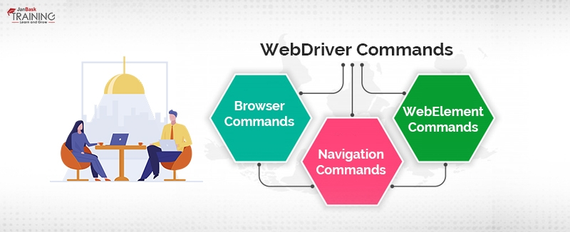
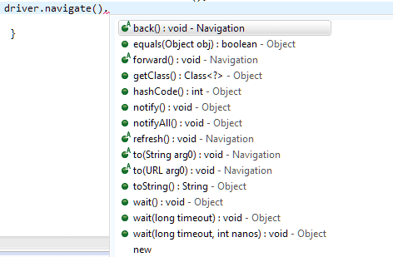
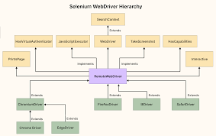

🧩 What are WebDriver Commands?
WebDriver commands are methods provided by Selenium to:
- Control the browser
- Interact with web elements
- Handle windows, frames, alerts
- Manage timeouts, cookies
- Perform navigation and waits
They are executed via the WebDriver interface.

🏗️ Classification of WebDriver Commands
WebDriver Commands
├── Browser Commands
├── Navigation Commands
├── WebElement Commands
├── Conditional Commands
├── Wait Commands
├── SwitchTo Commands
├── Manage Commands
├── Window Commands
└── Screenshot & Utility Commands

✅ 1️⃣ Browser Commands
Used to launch, close, and quit the browser.
Command | Purpose
get(url) | Open URL
getTitle() | Get page title
getCurrentUrl() | Get current URL
getPageSource() | Get page HTML
close() | Close current tab
quit() | Close all tabs & end session

driver.get("https://google.com");
driver.getTitle();
driver.quit();

✅ 2️⃣ Navigation Commands
Used to move within browser history.
Command | Purpose
navigate().to() | Go to URL
navigate().back() | Back
navigate().forward() | Forward
navigate().refresh() | Refresh

driver.navigate().to("https://example.com");
driver.navigate().refresh();

✅ 3️⃣ WebElement (Action) Commands
Used to interact with elements.
Command | Purpose
click() | Click element
sendKeys() | Enter text
clear() | Clear text
submit() | Submit form
getText() | Get visible text
getAttribute() | Get attribute value

driver.findElement(By.id("email")).sendKeys("test@gmail.com");

✅ 4️⃣ Conditional Commands
Used to check element state.
Command | Purpose
isDisplayed() | Visible or not
isEnabled() | Enabled or not
isSelected() | Selected or not
loginBtn.isDisplayed();

✅ 5️⃣ Wait Commands (Very Important)

🔹 Implicit Wait
driver.manage().timeouts()
.implicitlyWait(Duration.ofSeconds(10));

🔹 Explicit Wait
WebDriverWait wait = new WebDriverWait(driver, Duration.ofSeconds(10));
wait.until(ExpectedConditions.elementToBeClickable(btn));

🔹 Fluent Wait
Wait<WebDriver> wait = new FluentWait<>(driver)
.withTimeout(Duration.ofSeconds(10))
.pollingEvery(Duration.ofSeconds(2))
.ignoring(NoSuchElementException.class);

✅ 6️⃣ switchTo() Commands
Used for alerts, frames, windows.

🔹 Alerts
driver.switchTo().alert().accept();
driver.switchTo().alert().getText();

🔹 Frames
driver.switchTo().frame("frameName");
driver.switchTo().defaultContent();

🔹 Windows/Tabs
driver.switchTo().window(windowHandle);

✅ 7️⃣ manage() Commands
Used to manage browser settings.

🔹 Cookies
driver.manage().getCookies();
driver.manage().deleteAllCookies();

🔹 Timeouts
driver.manage().timeouts()
.pageLoadTimeout(Duration.ofSeconds(20));

✅ 8️⃣ Window Commands
Used to control browser window size & position.
Command | Purpose
maximize() | Maximize
minimize() | Minimize
fullscreen() | Fullscreen
setSize() | Custom size
setPosition() | Move window

✅ 9️⃣ Screenshot Commands
Used for failure debugging & reporting.
File src = ((TakesScreenshot)driver)
.getScreenshotAs(OutputType.FILE);

✅ 🔟 Utility Commands (Advanced)
Command | Purpose
executeScript() | Run JavaScript
executeAsyncScript() | Async JS
getWindowHandles() | All tabs
getWindowHandle() | Current tab

JavascriptExecutor js = (JavascriptExecutor) driver;
js.executeScript("window.scrollBy(0,500)");

🧠 Execution Flow (How Commands Work Internally)
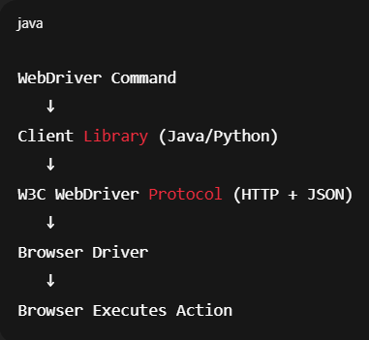

⚠ Common Mistakes (Avoid These)
❌ Using Thread.sleep() instead of waits
❌ Forgetting switchTo() for alerts/frames
❌ Using close() instead of quit()
❌ Storing WebElement too long (stale element)

🎯 Interview-Ready Summary
WebDriver commands are methods used to control the browser, interact with elements, manage waits, handle alerts, frames, windows, cookies, and navigation. They work through a client–server model using the W3C WebDriver protocol.

