WEBELEMENT COMMANDS

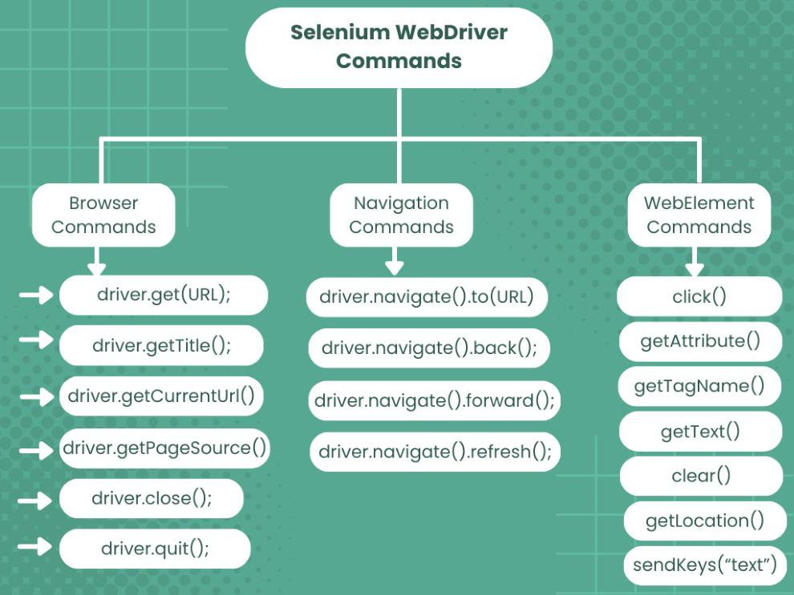
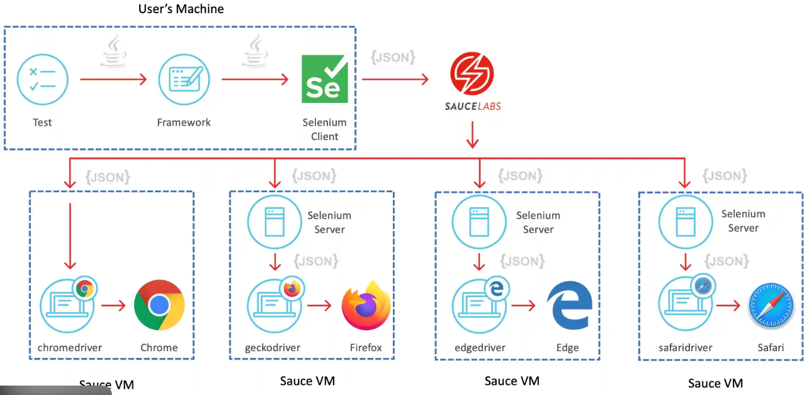
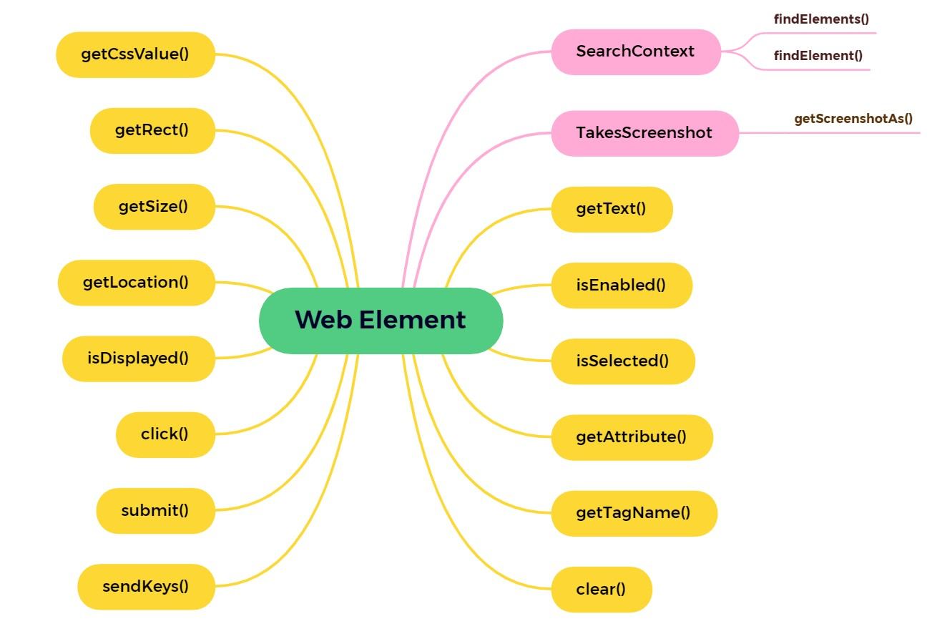

🧩 What are WebElement Commands?
WebElement commands are methods used to interact with and inspect a specific HTML element (input, button, link, checkbox, etc.) after it’s located using a locator.
WebElement element = driver.findElement(By.id("username"));
From here on, everything you do with element is a WebElement command.

🏗️ Classification of WebElement Commands
WebElement Commands
├── Interaction Commands
├── State (Conditional) Commands
├── Information Commands
├── Attribute & CSS Commands
├── Find Child Elements
├── Accessibility & DOM Commands (Selenium 4)

✅ 1️⃣ Interaction Commands (Most Used)
Used to perform actions on elements.
Command | Purpose
click() | Clicks the element
sendKeys() | Types text
clear() | Clears input
submit() | Submits form
Example:
element.clear();
element.sendKeys("kamal");
element.click();
📌 Notes
- submit() works only inside <form>
- Use waits before click() if element loads dynamically

✅ 2️⃣ State / Conditional Commands
Used to check the current state of the element.
Command | Purpose
isDisplayed() | Visible on UI
isEnabled() | Enabled or disabled
isSelected() | Checked/selected (checkbox, radio)
Example:
if (loginBtn.isEnabled()) {
loginBtn.click();
}
📌 Common in assertions and conditional flows.

✅ 3️⃣ Information Commands
Used to fetch information about the element.
Command | Purpose
getText() | Visible text
getTagName() | HTML tag name
getRect() | Position + size
getLocation() | X, Y position
getSize() | Width & height

Example:
String text = element.getText();
String tag = element.getTagName();
📌 getText() returns only visible text, not hidden values

✅ 4️⃣ Attribute & CSS Commands
Used to read attributes and styles.
Command | Purpose
getAttribute("attr") | Attribute value
getCssValue("property") | CSS value
getDomAttribute() | Live DOM attribute
getDomProperty() | DOM property

Example:
String value = element.getAttribute("value");
String color = element.getCssValue("color");
📌 Use getDomProperty() when getAttribute() returns null (modern apps).

✅ 5️⃣ Finding Child Elements (Scoped Search)
A WebElement can search inside itself — very powerful for tables, forms, cards.
Command | Purpose
findElement(By) | Find single child
findElements(By) | Find multiple children

Example:
WebElement form = driver.findElement(By.id("loginForm"));
List<WebElement> inputs = form.findElements(By.tagName("input"));
📌 Reduces flaky locators by scoping the DOM.

✅ 6️⃣ Accessibility & DOM Commands (Selenium 4)
Used for accessibility testing and modern DOM handling.
Command | Purpose
getAriaRole() | ARIA role
getAccessibleName() | Screen-reader name
getShadowRoot() | Access shadow DOM
Example
String role = element.getAriaRole();
String name = element.getAccessibleName();
📌 XPath ❌ inside shadow DOM;
CSS ✅ via getShadowRoot().

🧠 WebElement Command Flow (Internals)
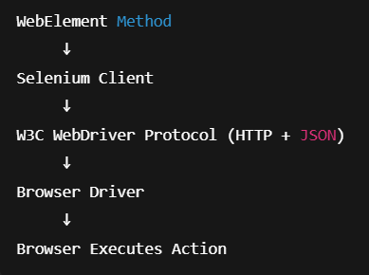

⚠ Common WebElement Pitfalls (Very Important)
❌ StaleElementReferenceException
→ DOM refreshed; re-locate the element
❌ Clicking before element is clickable
→ Use explicit waits
❌ Storing WebElement as global/static
→ Avoid; locate fresh when needed
❌ Using getText() for input value
→ Use getAttribute("value")

✅ Best Practices (Senior-Level)
✔ Always wait before interacting
✔ Use scoped searches (parent.findElement)
✔ Prefer attributes over indexes
✔ Centralize elements (Page Object Model)
✔ Re-locate after page refresh / AJAX
✔ Use SoftAssert for UI validations

🆚 WebDriver vs WebElement (Quick Contrast)
Aspect | WebDriver | WebElement
Controls | Browser | Element
Examples | get(), quit() | click(), sendKeys()
Scope | Global | Local

🎯 Interview-Ready Definition
WebElement commands are methods provided by Selenium to interact with, inspect, and validate individual web elements, such as clicking, typing, checking state, reading attributes, and locating child elements.

