WEB DRIVER IMPLEMENTATIONS

✅ What Are WebDriver Implementations?
WebDriver is an interface.
Each browser has a class that implements this interface.
These classes are called WebDriver implementations.
Example:
WebDriver driver = new ChromeDriver();
Here:
- WebDriver → interface
- ChromeDriver → implementation class

🧩 List of All Major WebDriver Implementations
Below are all the official Selenium WebDriver implementation classes.

🔥 1️⃣ ChromeDriver
- Package: org.openqa.selenium.chrome.ChromeDriver
- Controls Google Chrome
Example:
WebDriver driver = new ChromeDriver();
Uses chromedriver.exe internally.

🔥 2️⃣ FirefoxDriver
- Package: org.openqa.selenium.firefox.FirefoxDriver
- Controls Mozilla Firefox
Example:
WebDriver driver = new FirefoxDriver();
Uses geckodriver.exe internally.

🔥 3️⃣ EdgeDriver
- Package: org.openqa.selenium.edge.EdgeDriver
- Controls Microsoft Edge
Example:
WebDriver driver = new EdgeDriver();
Uses msedgedriver.exe.

🔥 4️⃣ SafariDriver (Mac Only)
- Package: org.openqa.selenium.safari.SafariDriver
- Controls Safari Browser (only on macOS)
Example:
WebDriver driver = new SafariDriver();
No driver executable needed on macOS.

🔥 5️⃣ OperaDriver (Deprecated)
- OperaDriver was earlier used for Opera Browser
- Now Opera supports WebDriver via ChromeDriver (since Opera is Chromium-based)
Not used anymore.

🔥 6️⃣ RemoteWebDriver
- Package: org.openqa.selenium.remote.RemoteWebDriver
- Used for running tests on:
  - Selenium Grid
  - Cloud platforms (BrowserStack, Sauce Labs, LambdaTest)
  - Docker Selenium
Example:
WebDriver driver = new RemoteWebDriver(new URL("http://localhost:4444"), capabilities);
This is the parent class of all drivers.

🔥 7️⃣ HtmlUnitDriver (Headless — Deprecated)
- A lightweight, headless browser for very fast execution
- No UI
- Deprecated in Selenium 4
Example:
WebDriver driver = new HtmlUnitDriver();

🔥 8️⃣ ChromiumDriver (Underlying Class)
- Base class for Chrome/Edge/WebView drivers
- Mostly used internally
Example (rarely used):
ChromiumDriver driver = new ChromeDriver();

🔥 9️⃣ OperaChromiumDriver (Deprecated)
- Chromium-based implementation for Opera
- No longer maintained

🔥 🔟 WebView2Driver (For Desktop Applications — New)
- Used for automating Windows applications that use WebView2 (Edge-based)
- Introduced in Selenium 4
Example:
WebDriver driver = new WebView2Driver();

🧠 Hierarchy Diagram
WebDriver (Interface)
|
+-- ChromeDriver
+-- FirefoxDriver
+-- EdgeDriver
+-- SafariDriver
+-- InternetExplorerDriver (deprecated)
+-- OperaDriver (deprecated)
+-- RemoteWebDriver (Parent for all)
+-- ChromiumDriver (Internal)
+-- WebView2Driver

🎯 Short Interview Summary
All browsers have their own WebDriver implementation class that implements the WebDriver interface.
ChromeDriver controls Chrome, FirefoxDriver controls Firefox, EdgeDriver controls Edge, SafariDriver controls Safari.
RemoteWebDriver is used for Grid and Cloud execution.

⚡ Bonus: Old/Deprecated Drivers
Driver | Status
InternetExplorerDriver | Deprecated
OperaDriver | Deprecated
HtmlUnitDriver | Deprecated
PhantomJSDriver | Discontinued
MarionetteDriver | Merged into FirefoxDriver
--

BLUE PRINT:
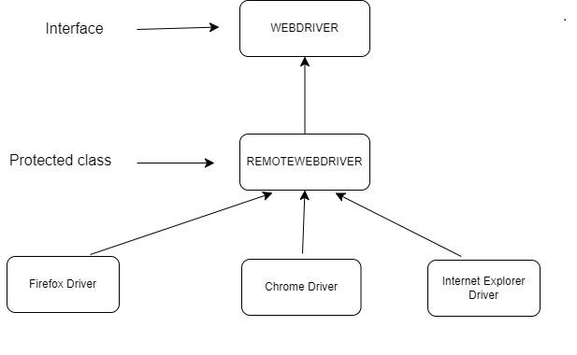
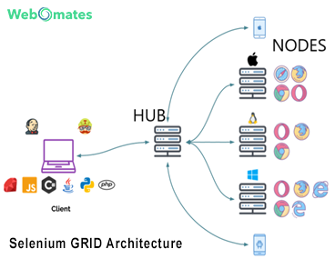
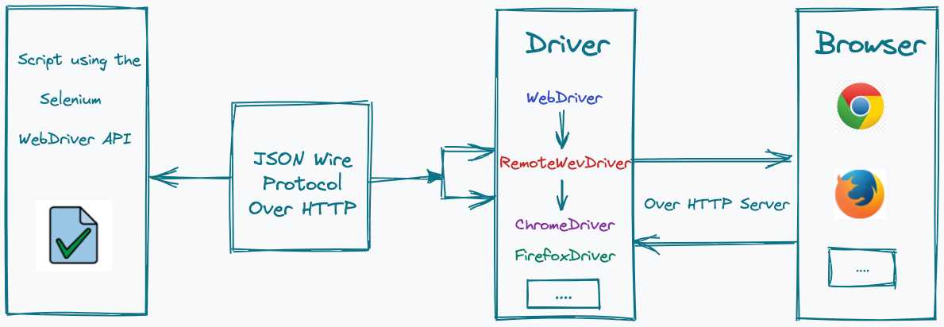
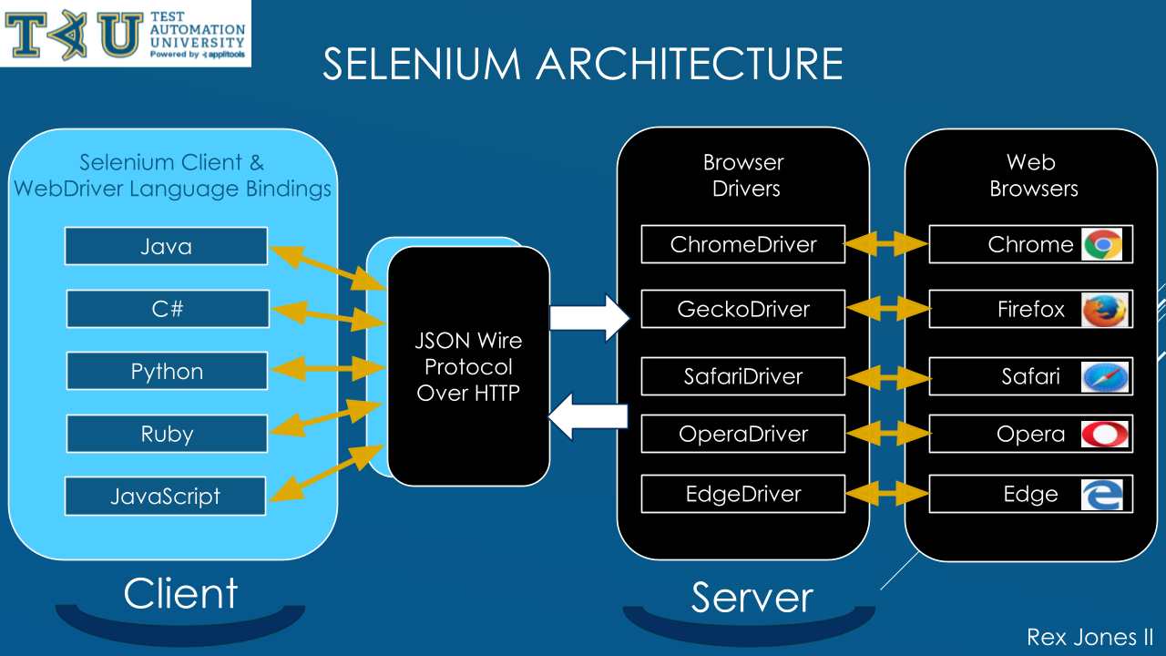

✅ 1️⃣ Difference: WebDriver vs RemoteWebDriver
🔹 WebDriver
- Interface
- Used for local browser execution
- Implemented by browser-specific drivers
Example:
WebDriver driver = new ChromeDriver();
📌 Runs:
- On same machine
- Directly controls the browser

🔹 RemoteWebDriver
- Concrete class
- Used for remote execution
- Communicates with browsers over HTTP
Example:
WebDriver driver = new RemoteWebDriver(
new URL("http://localhost:4444"),
capabilities
);
📌 Runs:
- On different machine / container / cloud
- Used with Selenium Grid / Cloud platforms

🆚 WebDriver vs RemoteWebDriver (Interview Table)
Feature | WebDriver | RemoteWebDriver
Type | Interface | Class
Execution | Local | Remote
Browser control | Direct | Via HTTP
Grid support | ❌ | ✅
Cloud execution | ❌ | ✅
Speed | Faster (local) | Network dependent
Use case | Local testing | Parallel & distributed

🎯 Interview One-Liner
WebDriver is an interface for local browser automation, while RemoteWebDriver is a concrete implementation used to execute tests remotely using Selenium Grid or cloud platforms via HTTP.

✅ 2️⃣ Selenium Grid Driver Workflow
🔹 What is Selenium Grid?
Selenium Grid allows you to:
- Run tests in parallel
- Execute tests on multiple browsers
- Run tests on multiple machines

🏗️ Selenium Grid Architecture
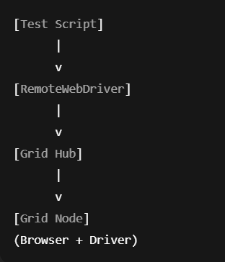

🔄 Step-by-Step Workflow

🔹 Step 1: Test Script Starts
RemoteWebDriver driver = new RemoteWebDriver(hubURL, capabilities);

🔹 Step 2: Request Sent to Hub

Capabilities include:
- Browser name
- Version
- Platform
Example:
browserName = chrome
platform = WINDOWS

🔹 Step 3: Hub Finds Matching Node
- Hub checks all registered nodes
- Finds node that matches capabilities

🔹 Step 4: Hub Forwards Request
- Request forwarded to selected node

🔹 Step 5: Node Launches Browser
- Node starts:
  - Browser driver (chromedriver)
  - Browser (Chrome)

🔹 Step 6: Test Executes
- Commands flow:
Test → Hub → Node → Browser

🔹 Step 7: Response Sent Back
- Browser → Node → Hub → Test Script

🧠 Why Grid Uses RemoteWebDriver?
- Communication is network-based
- Uses HTTP + JSON
- Enables distributed execution

✅ 3️⃣ How Browser Driver Communicates Using W3C WebDriver Protocol

🔹 What is W3C WebDriver Protocol?
It is a standard specification that defines:
- How automation commands are sent
- How browsers respond
- A common language for all browsers
📌 Selenium 4 uses only W3C protocol.

🧩 Communication Architecture
[Test Script]
|
v
[Selenium Client Library]
(Java / Python / JS)
|
v
[HTTP + JSON]
(W3C Protocol)
|
v
[Browser Driver]
(chromedriver / geckodriver)
|
v
[Browser Native APIs]

🔄 Example: click() Command Flow
Selenium code:
element.click();
Converted to HTTP request:
POST /session/{sessionId}/element/{elementId}/click
JSON payload:
{}

🔹 Driver Side Actions
- Driver receives HTTP request
- Converts command into native browser action
- Browser executes click
- Driver sends HTTP response

🔁 Response Example:
{
"value": null
}

🧠 Why W3C Protocol Is Important
✅ Cross-browser compatibility
✅ Standardized behavior
✅ Less flakiness
✅ No browser-specific hacks
✅ One protocol for all browsers

🧠 End-to-End Command Flow (Combined View)
Test Script
|
v
WebDriver API
|
v
RemoteWebDriver
|
v
Grid Hub
|
v
Grid Node
|
v
Browser Driver
|
v
Browser

🎯 Final Interview Summary (Perfect Answer)
Selenium uses a client–server architecture. WebDriver is an interface for local execution, while RemoteWebDriver enables remote and distributed execution via Selenium Grid. All browser interactions are performed through browser drivers that communicate using the W3C WebDriver protocol over HTTP and JSON.

