SELENIUM WAITS
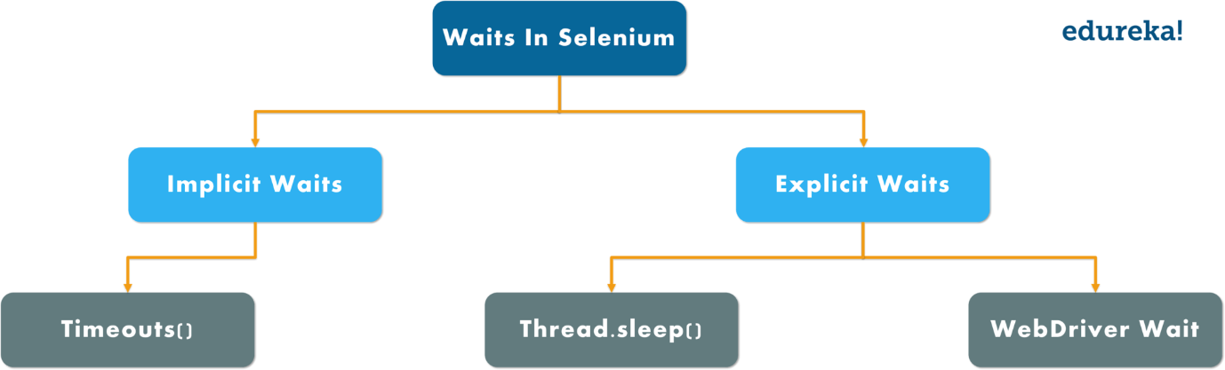
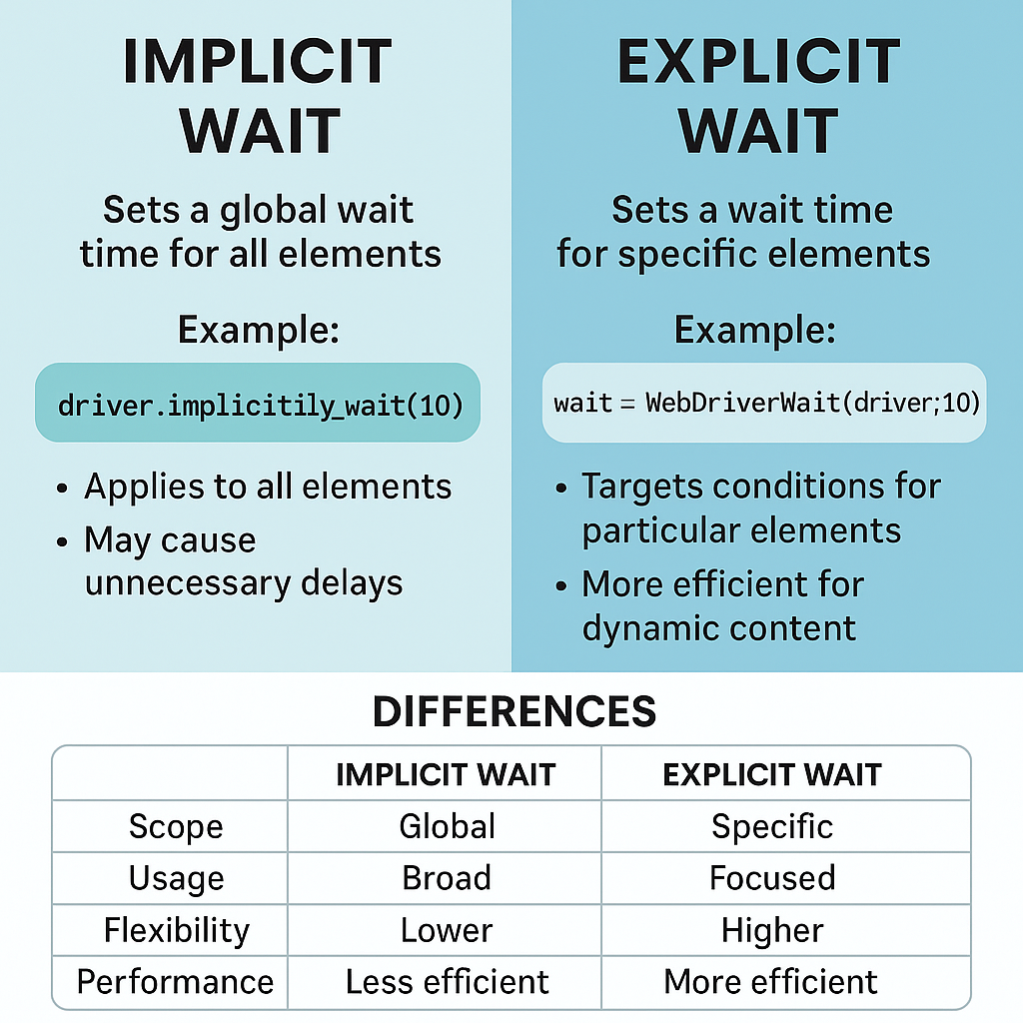

⏳ What are Selenium Waits?
Waits tell Selenium how long to wait for a condition to occur before throwing an exception.
Selenium is faster than the UI
Waits synchronize Selenium with the application
Without waits → flaky tests.

🎯 Why Waits Are Mandatory
- Modern apps are dynamic (AJAX, SPA)
- Elements load after page load
- DOM updates asynchronously
- Network speed varies
👉 Waits = stability + reliability

🧩 Types of Selenium Waits
Selenium Waits
├── Static Wait (Thread.sleep) ❌
├── Implicit Wait
├── Explicit Wait
└── Fluent Wait

❌ 1️⃣ Static Wait (Thread.sleep) – AVOID
Thread.sleep(5000);
Why it’s bad
❌ Always waits full time
❌ Slows execution
❌ No condition check
❌ Blocks thread

📌 Interview line
Thread.sleep is a Java wait, not a Selenium wait, and should be avoided.

✅ 2️⃣ Implicit Wait
🔹 What It Does
- Sets a global wait
- Applied to all findElement calls
- Selenium polls DOM until timeout
driver.manage().timeouts()
.implicitlyWait(Duration.ofSeconds(10));

🔹 How It Works Internally
findElement()
|
|-- retry every 500ms
|
|-- until element found or timeout

✅ Pros
✔ Easy to use
✔ Less code

❌ Cons
❌ Global (hard to control)
❌ Cannot wait for specific conditions
❌ Causes delay even when not needed
❌ Interferes with Explicit Wait

📌 Rule
Never mix Implicit and Explicit waits in the same framework.

✅ 3️⃣ Explicit Wait (MOST IMPORTANT)

🔹 What It Does
- Waits for a specific condition
- Applied to specific element
- Most reliable wait

🔹 Syntax
WebDriverWait wait =
new WebDriverWait(driver, Duration.ofSeconds(10));

wait.until(ExpectedConditions.visibilityOf(element));

🔥 Common ExpectedConditions
Condition | Use
visibilityOfElementLocated | Element visible
elementToBeClickable | Clickable
presenceOfElementLocated | Present in DOM
invisibilityOfElementLocated | Disappear
titleIs | Page title
urlContains | URL change
alertIsPresent | Alert popup
frameToBeAvailableAndSwitchToIt | Frame load

🔹 Example (Best Practice)
By loginBtn = By.id("login");

WebDriverWait wait = new WebDriverWait(driver, Duration.ofSeconds(10));
wait.until(ExpectedConditions.elementToBeClickable(loginBtn)).click();

✔ Locator-based wait
✔ Prevents stale element issues

✅ Pros
✔ Precise
✔ Fast (waits only when needed)
✔ Most stable

❌ Cons
❌ Slightly more code

✅ 4️⃣ Fluent Wait (Advanced Explicit Wait)

🔹 What It Adds
- Custom polling interval
- Ignore specific exceptions

🔹 Syntax
Wait<WebDriver> wait = new FluentWait<>(driver)
.withTimeout(Duration.ofSeconds(15))
.pollingEvery(Duration.ofSeconds(2))
.ignoring(NoSuchElementException.class);

wait.until(ExpectedConditions.visibilityOfElementLocated(locator));

When to Use
✔ Highly dynamic UI
✔ Slow network
✔ Repeated DOM refresh
📌 Explicit Wait is internally a special case of Fluent Wait.

🧠 Implicit vs Explicit vs Fluent (Interview Table)
Feature | Implicit | Explicit | Fluent
Scope | Global | Element-specific | Element-specific
Condition | ❌ | ✅ | ✅
Polling | Fixed | Fixed | Custom
Exception handling | ❌ | ❌ | ✅
Recommended | ❌ | ✅ | Advanced

⚠ Most Common Wait-Related Failures

❌ NoSuchElementException
➡ Element not yet in DOM
✔ Use presenceOfElementLocated

❌ ElementNotInteractableException
➡ Element present but not clickable
✔ Use elementToBeClickable

❌ StaleElementReferenceException
➡ DOM refreshed
✔ Re-locate element + wait

❌ TimeoutException
➡ Condition not met within wait time
✔ Check locator or increase wait

🧠 Best Practices (Senior-Level)
✔ Use Explicit Wait as default
✔ Use locator-based waits, not WebElement
✔ Centralize waits in utility class
✔ Avoid Thread.sleep
✔ Never mix implicit & explicit waits
✔ Add wait only where needed

🧱 Framework-Level Wait Utility (Very Important)
public class WaitUtil {
private static WebDriverWait wait(WebDriver driver) {
return new WebDriverWait(driver, Duration.ofSeconds(10));
}

public static WebElement waitForVisible(WebDriver driver, By locator) {
return wait(driver)
.until(ExpectedConditions.visibilityOfElementLocated(locator));
}

public static void waitForClickable(WebDriver driver, By locator) {
wait(driver)
.until(ExpectedConditions.elementToBeClickable(locator));
}
}
📌 This is real project code.

🧠 Waits vs Sleep (Interview Killer Question)
Aspect | Wait | Sleep
Condition based | ✅ | ❌
Smart polling | ✅ | ❌
Performance | Fast | Slow
Selenium aware | ✅ | ❌

🎯 Interview-Ready Definition
Selenium waits are synchronization mechanisms that pause execution until a specified condition is met or a timeout occurs. Selenium supports Implicit Wait, Explicit Wait, and Fluent Wait, with Explicit Wait being the most recommended for stable automation.

🔥 1️⃣ Why is Explicit Wait preferred?
Answer (Interview-ready):
Explicit wait is preferred because it waits for a specific condition on a specific element, making tests faster, more reliable, and less flaky than global waits.
Why (bullet proof points):
- ✔ Condition-based (visibility, clickability, alert, etc.)
- ✔ Element-level control (not global)
- ✔ Stops waiting as soon as condition is met
- ✔ Best for dynamic and AJAX-driven apps
Example:
wait.until(ExpectedConditions.elementToBeClickable(loginBtn)).click();

🔥 2️⃣ Why should we not mix Implicit and Explicit waits?
Answer (Interview-ready):
Mixing implicit and explicit waits causes unpredictable wait times because implicit wait is applied globally and gets added to every explicit wait polling cycle.
What goes wrong internally:
- Explicit wait polls every 500ms
- Each poll is delayed by implicit wait
- Total wait time becomes implicit + explicit × polling
📌 Result: slow tests, timeouts, flakiness
Rule to remember:
Use only Explicit Wait in frameworks.

🔥 3️⃣ Which wait handles AJAX best and why?
Answer (Interview-ready):
Explicit wait handles AJAX best because it waits for specific conditions like element visibility or clickability after asynchronous DOM updates.
Why not implicit wait?
- Implicit wait only checks element presence
- AJAX elements may exist but not be visible or clickable
Best conditions for AJAX:
visibilityOfElementLocated()
elementToBeClickable()
invisibilityOfElementLocated()

🔥 4️⃣ Difference between presence and visibility

📌 presenceOfElementLocated
- Element exists in DOM
- May be hidden
- May not be interactable
presenceOfElementLocated(By.id("msg"))

📌 visibilityOfElementLocated
- Element exists in DOM
- Element is visible on UI
- Has height & width > 0
visibilityOfElementLocated(By.id("msg"))

🆚 Interview Table
Aspect | Presence | Visibility
DOM | ✅ Yes | ✅ Yes
Visible | ❌ No | ✅ Yes
Clickable | ❌ No | Possibly
Use case | Background load | UI interaction

🔥 5️⃣ How do you handle StaleElementReferenceException using waits?

❓ Why stale element occurs?
- DOM refresh
- AJAX reload
- Page navigation
- Element re-rendered

✅ Correct Approach (Interview-Approved)
✔ Do not store WebElement long-term
✔ Use locator-based explicit wait
✔ Re-locate element after refresh
Correct Pattern:
By loginBtn = By.id("login");

wait.until(ExpectedConditions.elementToBeClickable(loginBtn)).click();

❌ Wrong Pattern
WebElement btn = driver.findElement(By.id("login"));
wait.until(ExpectedConditions.elementToBeClickable(btn)); // stale risk

🔁 Retry Strategy (Advanced)
for (int i = 0; i < 2; i++) {
try {
wait.until(ExpectedConditions.elementToBeClickable(locator)).click();
break;
} catch (StaleElementReferenceException e) {
// re-try
}
}
📌 Key line for interview:
Always wait using By locator, not WebElement, to avoid stale element issues.

🧠 Ultra-Strong Final Summary (Say This Confidently)
Explicit wait is preferred because it provides condition-based, element-level synchronization. Implicit and explicit waits should not be mixed due to unpredictable wait times. Explicit wait handles AJAX best by waiting for visibility or clickability. Presence checks only DOM existence, while visibility ensures UI readiness. Stale elements are handled by re-locating elements using locator-based explicit waits.

🔹 1️⃣ Custom ExpectedConditions
❓ Why Custom ExpectedConditions?
Selenium’s built-in ExpectedConditions are not enough for:
- Complex UI logic
- Custom JS states
- Loader + element combo waits
- Text + attribute validations

✅ How Custom ExpectedCondition Works
You create a function that returns true or WebElement.

✅ Example: Wait until element text changes
public static ExpectedCondition<Boolean> textToChange(
By locator, String oldText) {
return driver -> {
String newText = driver.findElement(locator).getText();
return !newText.equals(oldText);
};
}

🔹 Usage
wait.until(textToChange(By.id("status"), "Loading"));

📌 Interview line
Custom ExpectedConditions allow us to handle application-specific wait scenarios not covered by Selenium defaults.

🔹 2️⃣ Wait Handling for Shadow DOM

❓ Why Shadow DOM Needs Special Handling?
- XPath ❌ does not work
- DOM is encapsulated
- Elements load asynchronously

✅ Correct Strategy
1️⃣ Wait for shadow host
2️⃣ Get shadow root
3️⃣ Locate inner element
4️⃣ Apply explicit wait

✅ Example
WebElement host = wait.until(
ExpectedConditions.presenceOfElementLocated(
By.cssSelector("app-root")
)
);

SearchContext shadowRoot = host.getShadowRoot();

WebElement input = shadowRoot.findElement(
By.cssSelector("input")
);

📌 Key rule
Shadow DOM requires CSS selectors + explicit waits, never XPath.

🔹 3️⃣ Selenium 4 Relative Locators (Relative Waits)

❓ What Are Relative Locators?
They locate elements based on visual position, not attributes.
🔹 Types
- above()
- below()
- toLeftOf()
- toRightOf()
- near()

✅ Example
WebElement password =
driver.findElement(
RelativeLocator.with(By.tagName("input"))
.below(By.id("username"))
);

🔹 When to Use
✔ No unique attributes
✔ Stable layout
✔ Form-based UIs
⚠ Avoid for dynamic layouts.

📌 Interview line
Selenium 4 relative locators improve readability but should be used only when DOM layout is stable.

🔹 4️⃣ Debugging Flaky Tests Using Waits

❓ Why Tests Become Flaky?
- AJAX delays
- DOM re-render
- Hard sleeps
- Incorrect wait condition
- Stale elements

✅ Debugging Checklist (Real-World)
✔ Replace Thread.sleep() with explicit wait
✔ Use locator-based waits
✔ Check condition (presence vs visibility)
✔ Handle stale element properly
✔ Log wait failures

❌ Common Mistake
wait.until(ExpectedConditions.presenceOfElementLocated(locator)).click();

✅ Correct Fix
wait.until(ExpectedConditions.elementToBeClickable(locator)).click();
📌 Interview line
Most flaky tests are caused by wrong wait conditions, not locator issues.

🔹 5️⃣ Wait Strategy in Page Object Model (POM)

❓ Where Should Waits Be Placed?
❌ Inside test methods
❌ Repeated everywhere
✅ Inside page actions or utility layer

✅ Correct POM Wait Strategy

Wait Utility
public class WaitUtil {

public static WebElement waitForVisible(
WebDriver driver, By locator) {

return new WebDriverWait(driver, Duration.ofSeconds(10))
.until(ExpectedConditions.visibilityOfElementLocated(locator));
}
}

Page Class
public void clickLogin() {
WaitUtil.waitForVisible(driver, loginBtn).click();
}

🧠 Benefits
✔ Clean tests
✔ Centralized wait logic
✔ Easy maintenance
✔ CI-stable execution
📌 Interview line
In POM, waits should be abstracted into page methods or utilities, never scattered in test classes.

🎯 Ultra-Strong Final Summary (Say This Confidently)
Custom ExpectedConditions handle application-specific wait logic. Shadow DOM elements require CSS selectors with explicit waits. Selenium 4 relative locators help when attributes are missing but layouts are stable. Flaky tests are usually caused by incorrect waits rather than locators. In Page Object Model, waits must be centralized in page actions or utility layers for maintainability and stability.

