PAGE OBJECT MODEL

📘 Page Object Model (POM) – Concept First

What is POM?
Page Object Model is a design pattern in Selenium where:
- Each web page = one Java class
- Page class contains:
  - Web elements (locators)
  - Page actions (methods)
👉 Test scripts never directly interact with locators

🎯 Why POM?
Problem | Solution
Code duplication | Centralized locators
Maintenance nightmare | Change once, reflect everywhere
Poor readability | Business-level methods
Tight coupling | Loose & clean structure

🧱 POM WITHOUT PageFactory (Classic POM)
📌 Idea
- Use By locators
- Use driver.findElement() inside methods
- No annotations

📂 Folder Structure
src/test/java
├── pages
│ └── LoginPage.java
├── tests
│ └── LoginTest.java
└── base
└── BaseTest.java

🔹 LoginPage.java (Without PageFactory)
public class LoginPage {
WebDriver driver;
// Locators
By username = By.id("username");
By password = By.id("password");
By loginBtn = By.id("login");
// Constructor
public LoginPage(WebDriver driver) {
this.driver = driver;
}
// Actions
public void enterUsername(String user) {
driver.findElement(username).sendKeys(user);
}
public void enterPassword(String pass) {
driver.findElement(password).sendKeys(pass);
}
public void clickLogin() {
driver.findElement(loginBtn).click();
}
}

🔹 LoginTest.java
LoginPage login = new LoginPage(driver);
login.enterUsername("admin");
login.enterPassword("1234");
login.clickLogin();

✅ Advantages (Without PageFactory)
✔ Simple & beginner-friendly
✔ Full control over element finding
✔ Better for dynamic elements
✔ Easier debugging

❌ Disadvantages
❌ Repeated findElement() calls
❌ Slightly more boilerplate
❌ Less elegant

🧱 POM WITH PageFactory
📌 Idea
- Use @FindBy annotations
- Elements initialized once
- Uses lazy loading

🔹 LoginPage.java (With PageFactory)
import org.openqa.selenium.support.FindBy;
import org.openqa.selenium.support.PageFactory;
public class LoginPage {
WebDriver driver;

@FindBy(id = "username")
WebElement username;

@FindBy(id = "password")
WebElement password;

@FindBy(id = "login")
WebElement loginBtn;

// Constructor
public LoginPage(WebDriver driver) {
this.driver = driver;
PageFactory.initElements(driver, this);
}

// Actions
public void login(String user, String pass) {
username.sendKeys(user);
password.sendKeys(pass);
loginBtn.click();
}
}

🔹 LoginTest.java
LoginPage login = new LoginPage(driver);
login.login("admin", "1234");

🧠 How PageFactory Works (Internally)
- WebElements are NOT located immediately
- Selenium creates a proxy
- Actual findElement() happens only when used
This is called Lazy Initialization.

✅ Advantages (With PageFactory)
✔ Cleaner & readable code
✔ Less boilerplate
✔ Better abstraction
✔ Industry-standard pattern

❌ Disadvantages
❌ Less flexible for dynamic locators
❌ StaleElement issues more common
❌ Debugging is harder
❌ Deprecated-style usage (not recommended by Selenium team for future-heavy frameworks)

⚔️ Comparison Table (Interview Favorite)
Feature | Without PageFactory | With PageFactory
Locators | By | @FindBy
Initialization | Manual | Automatic
Readability | Medium | High
Dynamic elements | Excellent | Weak
Performance | Slightly slower | Faster
Debugging | Easy | Hard
Modern usage | ✅ Preferred | ⚠️ Declining

🧩 Real-World Best Practice (IMPORTANT)

⭐ Hybrid POM (Most Used in Companies)
public class LoginPage {
WebDriver driver;
By username = By.id("username");
By password = By.id("password");
public LoginPage(WebDriver driver) {
this.driver = driver;
}
public void login(String user, String pass) {
driver.findElement(username).sendKeys(user);
driver.findElement(password).sendKeys(pass);
}
}
✔ No PageFactory
✔ Uses waits & utilities
✔ Works well with Selenium 4
✔ Best for scalable frameworks

🧪 When to Use What?
✅ Use PageFactory when:
- Small to medium projects
- Mostly static pages
- Team prefers annotations
- Quick development
✅ Avoid PageFactory when:
- Heavy dynamic DOM
- Angular / React apps
- Shadow DOM usage
- Complex waits needed

🗣️ Interview-Ready Answer (Short)
Page Object Model is a design pattern that separates page logic from test logic.
With PageFactory, elements are initialized using annotations and lazy loading.
Without PageFactory, elements are located using By locators, offering better flexibility and control.
In modern Selenium frameworks, non-PageFactory POM or hybrid approaches are preferred.

✅ Final Cheat Sheet
Topic | Key Takeaway
POM | Separation of concerns
PageFactory | Lazy-loaded WebElements
Without PF | More control
Best Practice | Hybrid / Non-PF
Selenium 4 | PF not recommended

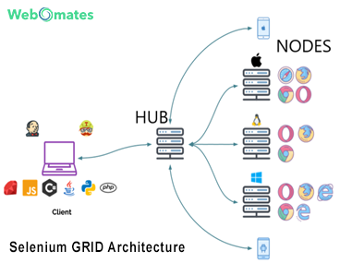

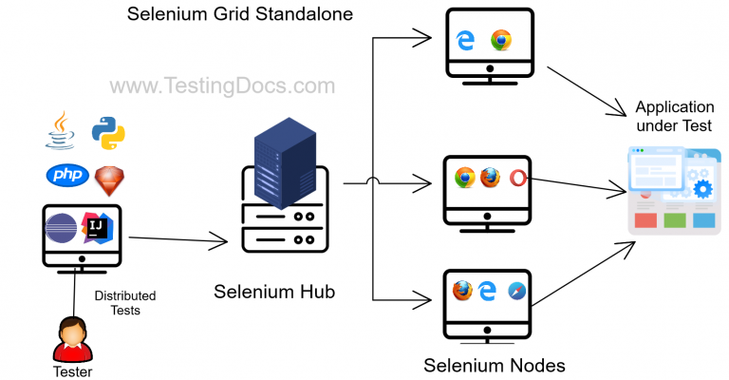

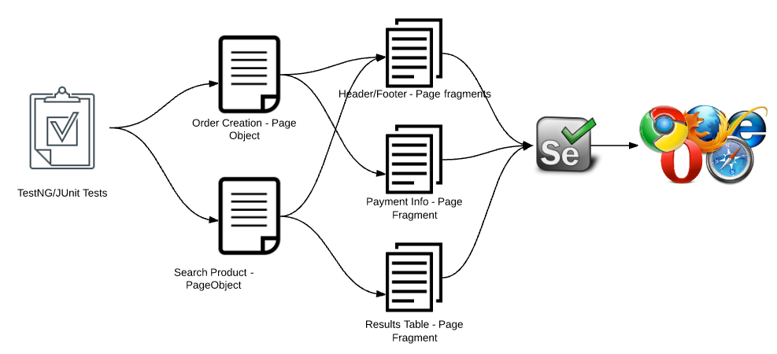
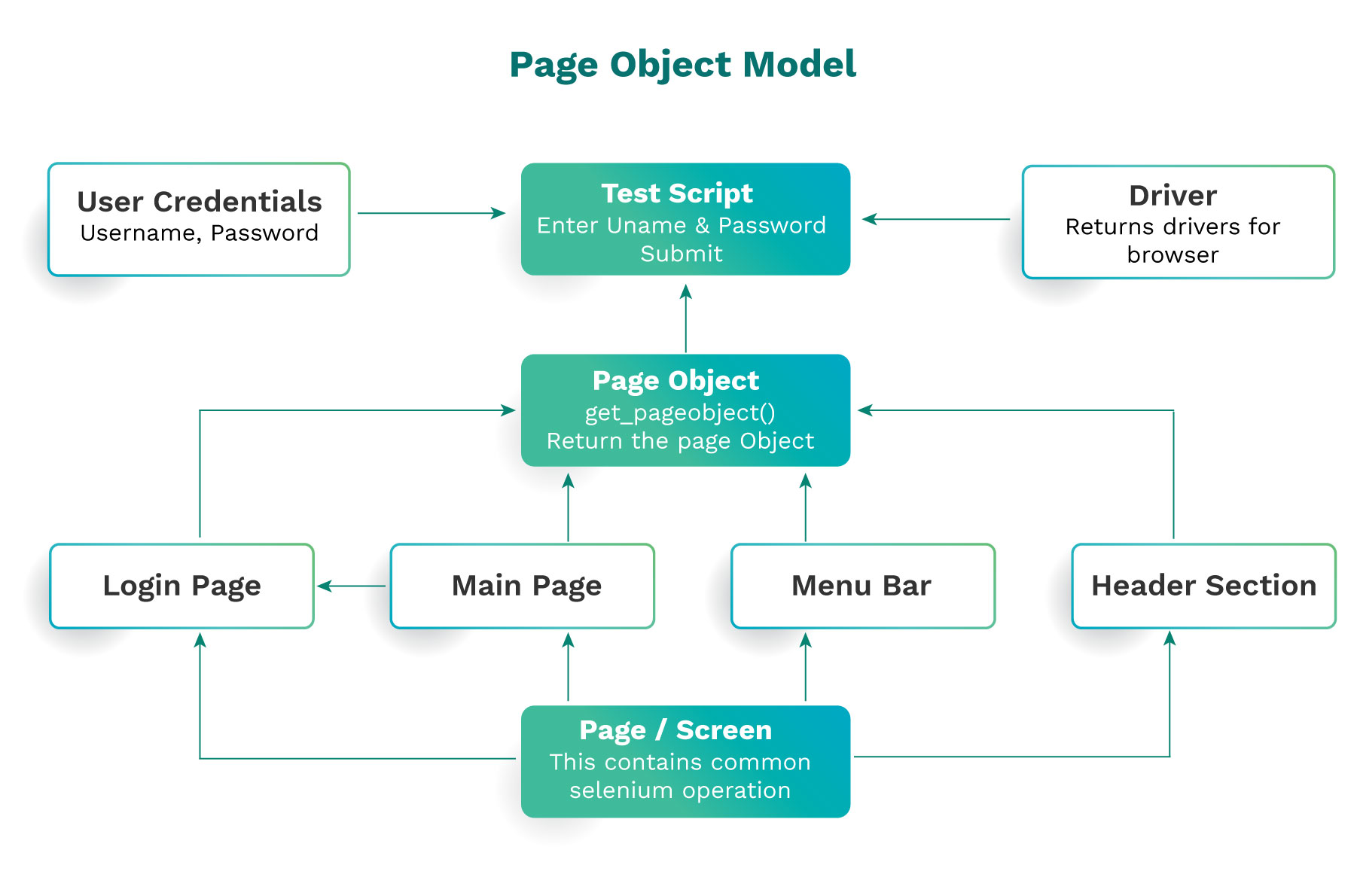

🧩 What changes when you use POM with Selenium Grid?
POM stays the same.
WebDriver creation changes.

👉 With Grid:
- Tests run on remote machines / browsers
- You use RemoteWebDriver
- Driver is created per thread
- Parallel execution is common

🎯 Why combine POM + Selenium Grid?
Problem | Solved by
Slow execution | Parallel runs
Browser coverage | Chrome, Firefox, Edge
OS coverage | Windows, Linux
Maintainability | POM
Scalability | Grid

🏗️ High-Level Architecture
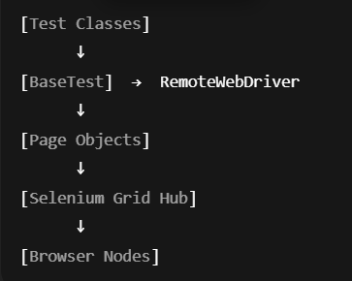

📁 Recommended Framework Structure
src/test/java
├── base
│ ├── BaseTest.java
│ └── DriverFactory.java
├── pages
│ └── LoginPage.java
├── tests
│ └── LoginTest.java
└── utils
└── ConfigReader.java

🔑 Key Rule (VERY IMPORTANT)
Never create WebDriver inside Page classes
WebDriver must be created in BaseTest / DriverFactory

🧱 DriverFactory (Grid-aware, Thread-safe)
public class DriverFactory {
private static ThreadLocal<WebDriver> tlDriver = new ThreadLocal<>();
public static void setDriver(String browser) throws MalformedURLException {
DesiredCapabilities caps = new DesiredCapabilities();
if (browser.equalsIgnoreCase("chrome")) {
caps.setBrowserName("chrome");
} else if (browser.equalsIgnoreCase("firefox")) {
caps.setBrowserName("firefox");
}
WebDriver driver = new RemoteWebDriver(
new URL("http://localhost:4444/wd/hub"),
caps
);

tlDriver.set(driver);
}
public static WebDriver getDriver() {
return tlDriver.get();
}
public static void quitDriver() {
tlDriver.get().quit();
tlDriver.remove();
}
}
✅ Thread-safe
✅ Parallel-ready
✅ Grid-compatible

🧱 BaseTest (Test lifecycle control)
public class BaseTest {
@Parameters("browser")
@BeforeMethod
public void setup(String browser) throws MalformedURLException {
DriverFactory.setDriver(browser);
DriverFactory.getDriver().manage().window().maximize();
DriverFactory.getDriver().get("https://example.com/login");
}
@AfterMethod
public void tearDown() {
DriverFactory.quitDriver();
}
}

📄 Page Object (POM – NO Grid code here)
public class LoginPage {
WebDriver driver;
By username = By.id("username");
By password = By.id("password");
By loginBtn = By.id("login");
public LoginPage(WebDriver driver) {
this.driver = driver;
}

public void login(String user, String pass) {
driver.findElement(username).sendKeys(user);
driver.findElement(password).sendKeys(pass);
driver.findElement(loginBtn).click();
}
}

✔ Clean
✔ Reusable
✔ Grid-agnostic

🧪 Test Class (Parallel Execution)
public class LoginTest extends BaseTest {
@Test
public void loginTest() {
LoginPage loginPage =
new LoginPage(DriverFactory.getDriver());
loginPage.login("admin", "admin123");
}
}

⚙️ testng.xml (Parallel Browsers)
<!DOCTYPE suite SYSTEM "https://testng.org/testng-1.0.dtd">
<suite name="Grid Suite" parallel="tests" thread-count="2">
<test name="Chrome Test">
<parameter name="browser" value="chrome"/>
<classes>
<class name="tests.LoginTest"/>
</classes>
</test>
<test name="Firefox Test">
<parameter name="browser" value="firefox"/>
<classes>
<class name="tests.LoginTest"/>
</classes>
</test>
</suite>
✔ Runs same test on multiple browsers simultaneously

▶️ How to Start Selenium Grid (Quick)
Selenium 4 (Single command)
java -jar selenium-server-4.x.x.jar standalone
Grid URL:
http://localhost:4444

⚠️ Common Mistakes (Avoid These)
❌ Creating WebDriver inside Page class
❌ Using static WebDriver without ThreadLocal
❌ Using PageFactory heavily with dynamic pages
❌ Hardcoding browser logic in tests

🧠 Best Practices (Real-World)
✅ Use ThreadLocal WebDriver
✅ Keep Grid logic outside Page Objects
✅ Use explicit waits in pages
✅ Prefer By locators over PageFactory
✅ Add browser & env via config files

🗣️ Interview-Ready Answer
In POM with Selenium Grid, Page Objects remain unchanged while WebDriver creation is handled using RemoteWebDriver in a centralized factory. Tests run in parallel using ThreadLocal WebDriver to ensure thread safety, enabling cross-browser and distributed execution.

📌 One-Look Summary
Layer | Responsibility
DriverFactory | RemoteWebDriver creation
BaseTest | Setup / teardown
Page Objects | UI actions
Tests | Business flows
Grid | Distributed execution

