Shadow DOM
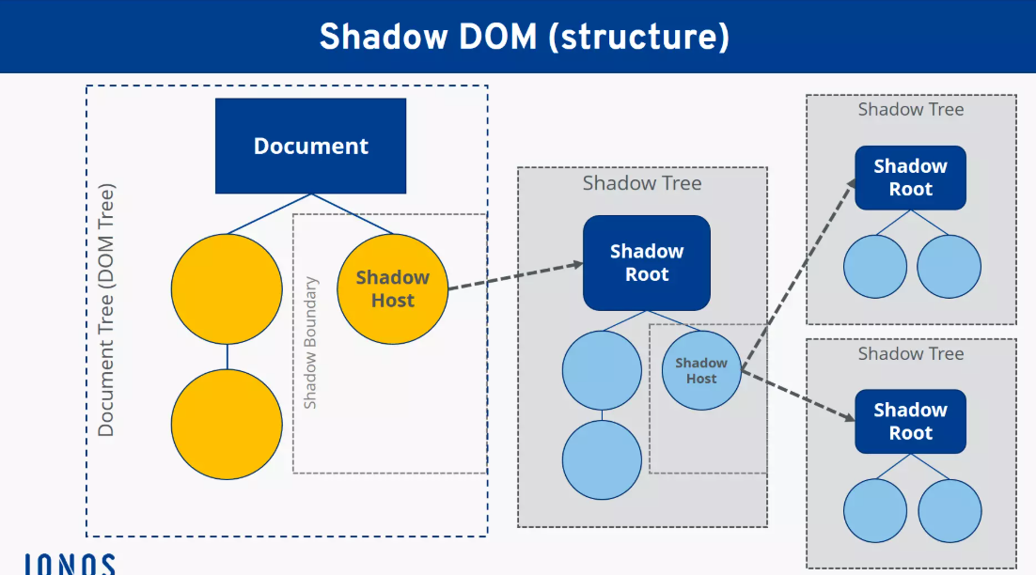

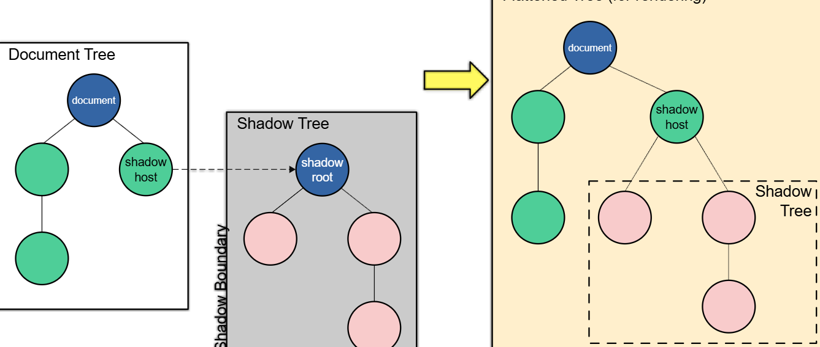
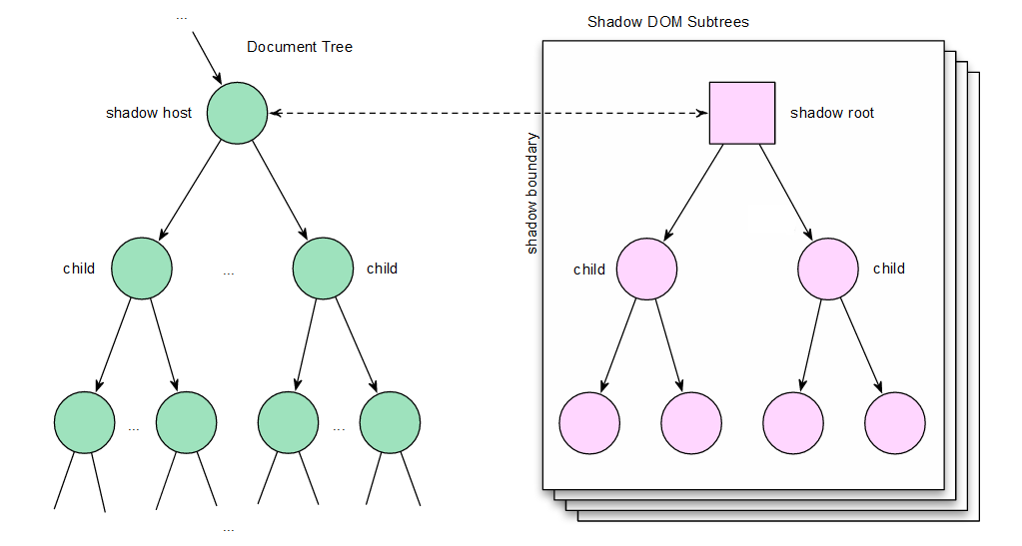

🌑 Shadow DOM — Detailed Notes

1️⃣ What is Shadow DOM? (Core Idea)
Shadow DOM is a web standard that allows a component to have its own private DOM tree, separate from the main document DOM.
👉 This enables:
- Encapsulation
- Reusable UI components
- Style isolation
- Cleaner, conflict-free HTML
Think of it as:
“A DOM inside another DOM, hidden from the outside world.”

2️⃣ Why Shadow DOM exists (The Problem It Solves)
❌ Problems in normal DOM (Light DOM)
- CSS conflicts (button {} affects everything)
- JS selectors accidentally match wrong elements
- Large apps become fragile
- Hard to build reusable components
✅ Shadow DOM Solution
- Styles are scoped
- Markup is encapsulated
- JavaScript access is controlled
- Components behave like black boxes

3️⃣ Key Terminology (Very Important)

🔹 Light DOM
The regular DOM written in HTML.
<my-button>
Click me
</my-button>

🔹 Shadow Host
The custom element that owns the Shadow DOM.
<my-button></my-button>

🔹 Shadow Root
The root node of the Shadow DOM tree.
element.attachShadow({ mode: "open" });

🔹 Shadow Tree
The DOM structure inside the shadow root.

4️⃣ Shadow DOM Structure (Visualization)
<my-button> ← Shadow Host
#shadow-root ← Shadow Root
<button>OK</button>
</my-button>
⚠️ The <button> does not exist in document.querySelector()

5️⃣ Open vs Closed Shadow DOM (CRITICAL)
🔓 Open Shadow DOM
this.attachShadow({ mode: "open" });
✅ Accessible via JavaScript
✅ Testable in Selenium & Cypress
element.shadowRoot.querySelector("button");

🔒 Closed Shadow DOM
this.attachShadow({ mode: "closed" });
❌ shadowRoot returns null
❌ Hard / impossible to test directly
element.shadowRoot // null
👉 Frameworks sometimes use closed mode for security

6️⃣ How Shadow DOM is Created (Code Example)
class MyButton extends HTMLElement {
constructor() {
super();
const shadow = this.attachShadow({ mode: "open" });
shadow.innerHTML = `
<style>
button {
background: red;
color: white;
}
</style>
<button>Click Me</button>
`;
}
}

customElements.define("my-button", MyButton);

7️⃣ CSS Behavior in Shadow DOM
✅ What works
- Styles inside Shadow DOM apply only inside
- External CSS cannot leak in
- Shadow CSS cannot leak out
button {
background: red;
}
✔ Only affects shadow button

❌ What does NOT work
my-button button {
color: blue;
}
❌ Cannot style inside Shadow DOM from outside

8️⃣ Styling Hooks (Advanced)
🔹 :host
Styles the shadow host itself
:host {
display: inline-block;
}

🔹 ::slotted()
Styles content passed from Light DOM
<my-card>
<p slot="content">Hello</p>
</my-card>
::slotted(p) {
color: blue;
}

9️⃣ Slots (Content Projection)
Shadow DOM Template
<slot name="content"></slot>
Light DOM
<my-card>
<p slot="content">Hello World</p>
</my-card>
✔ Allows flexibility
✔ Keeps structure hidden

🔟 Shadow DOM & JavaScript Access
❌ Normal selector fails
document.querySelector("button"); // null
✅ Correct way
document
.querySelector("my-button")
.shadowRoot
.querySelector("button");

1️⃣1️⃣ Shadow DOM in Selenium (Automation Focus)
❌ This fails
driver.findElement(By.cssSelector("button"));

✅ Correct Selenium 4 approach
WebElement host = driver.findElement(By.cssSelector("my-button"));
SearchContext shadowRoot = host.getShadowRoot();
WebElement button = shadowRoot.findElement(By.cssSelector("button"));
button.click();
✔ Works only for open Shadow DOM

1️⃣2️⃣ Shadow DOM in Cypress
Native support (Cypress 10+)
cy.get('my-button')
.shadow()
.find('button')
.click();

1️⃣3️⃣ Nested Shadow DOM (Real-World Case)
<parent-comp>
#shadow-root
<child-comp>
#shadow-root
<button>Save</button>

Selenium access
WebElement parent = driver.findElement(By.cssSelector("parent-comp"));
SearchContext parentShadow = parent.getShadowRoot();

WebElement child = parentShadow.findElement(By.cssSelector("child-comp"));
SearchContext childShadow = child.getShadowRoot();

childShadow.findElement(By.cssSelector("button")).click();

1️⃣4️⃣ Limitations & Gotchas
❌ XPath does NOT work across Shadow DOM
❌ document.querySelectorAll() can’t cross boundary
❌ Closed shadow DOM is mostly untestable
❌ Browser DevTools hides shadow nodes by default

1️⃣5️⃣ Where Shadow DOM is Commonly Used
- Modern design systems
- Web Components
- Chrome internal UI
- Salesforce Lightning
- Material UI Web Components
- Polymer / Lit

1️⃣6️⃣ Interview-Ready Summary (One Shot)
Shadow DOM is a web standard that provides DOM and CSS encapsulation for custom elements.
It isolates structure, style, and behavior from the main DOM, preventing conflicts and enabling reusable components.
Shadow DOM can be open or closed, affecting test automation accessibility.

1️⃣7️⃣ When NOT to use Shadow DOM
❌ Simple static pages
❌ Apps needing heavy global styling
❌ Teams unfamiliar with encapsulation concepts

✅ Final Cheat Sheet
Topic | Key Point
Purpose | Encapsulation
CSS | Scoped
JS access | Via shadowRoot
Testable | Only open mode
Selenium | getShadowRoot()
Cypress | .shadow()

