1. Alert on receiving message

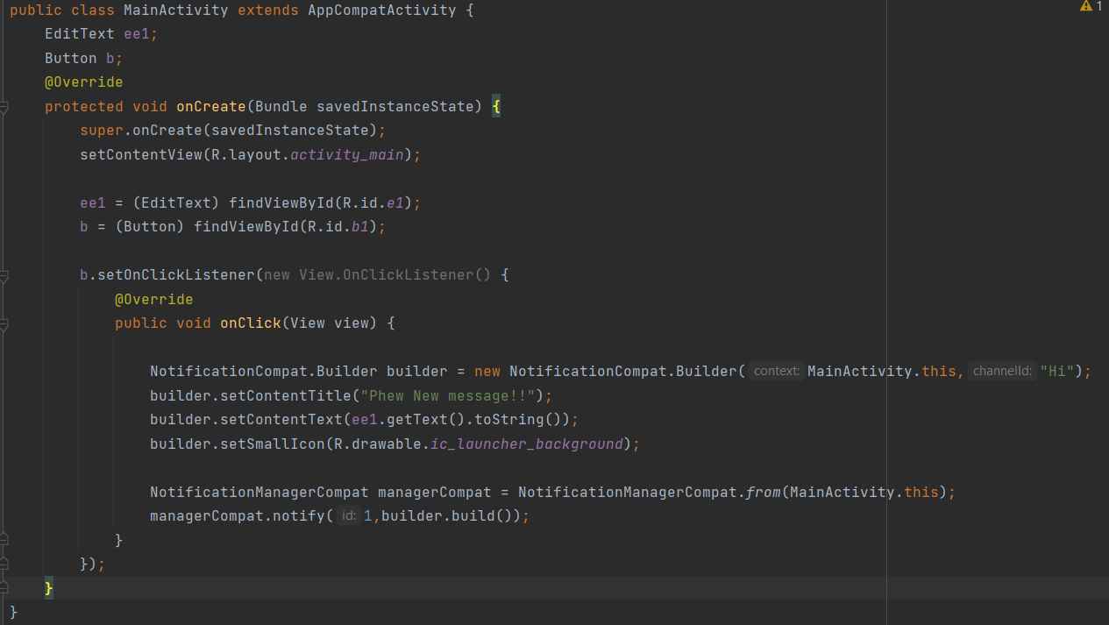

https://youtu.be/4BuRMScaaI4

1. Calculator

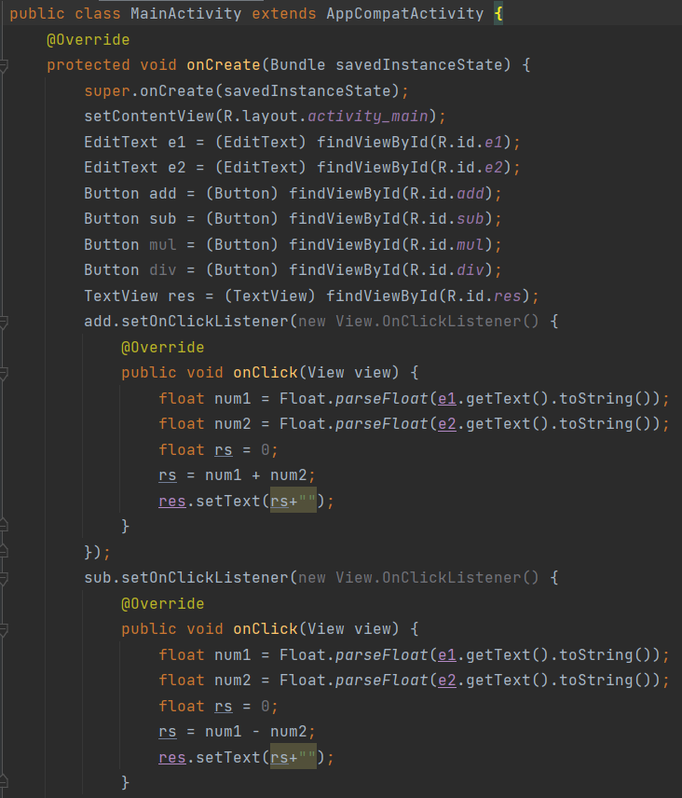

1. Layout and event listener

Mainactivity.java

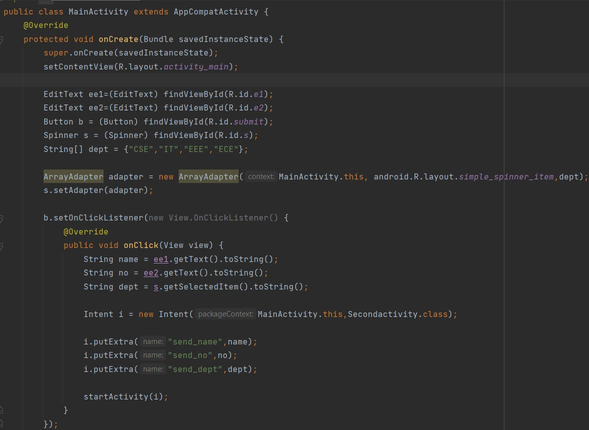

**Secondactivity.java**

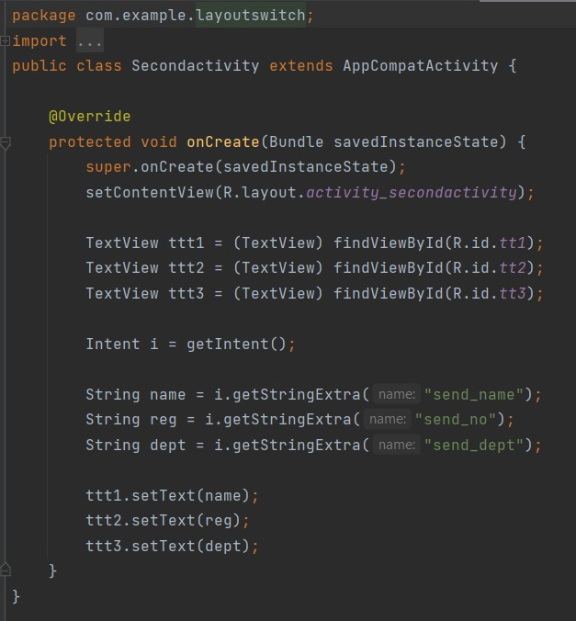

1. Database

Activitymain.xml

<?xml version="1.0" encoding="utf-8"?>  
<androidx.constraintlayout.widget.ConstraintLayout xmlns:android="http://schemas.android.com/apk/res/android"  
 xmlns:app="http://schemas.android.com/apk/res-auto"  
 xmlns:tools="http://schemas.android.com/tools"  
 android:layout_width="match_parent"  
 android:layout_height="match_parent"  
 tools:context=".MainActivity"  
 tools:layout_editor_absoluteX="0dp"  
 tools:layout_editor_absoluteY="-16dp">  
  
 <EditText  
 android:id="@+id/name"  
 android:layout_width="151dp"  
 android:layout_height="49dp"  
 app:layout_constraintBottom_toBottomOf="parent"  
 app:layout_constraintEnd_toEndOf="parent"  
 app:layout_constraintHorizontal_bias="0.892"  
 app:layout_constraintStart_toStartOf="parent"  
 app:layout_constraintTop_toTopOf="parent"  
 app:layout_constraintVertical_bias="0.326" />  
  
 <EditText  
 android:id="@+id/mark"  
 android:layout_width="159dp"  
 android:layout_height="57dp"  
 app:layout_constraintBottom_toBottomOf="parent"  
 app:layout_constraintEnd_toEndOf="parent"  
 app:layout_constraintHorizontal_bias="0.935"  
 app:layout_constraintStart_toStartOf="parent"  
 app:layout_constraintTop_toTopOf="parent"  
 app:layout_constraintVertical_bias="0.435" />  
  
 <EditText  
 android:id="@+id/roll"  
 android:layout_width="149dp"  
 android:layout_height="50dp"  
 app:layout_constraintBottom_toBottomOf="parent"  
 app:layout_constraintEnd_toEndOf="parent"  
 app:layout_constraintHorizontal_bias="0.885"  
 app:layout_constraintStart_toStartOf="parent"  
 app:layout_constraintTop_toTopOf="parent"  
 app:layout_constraintVertical_bias="0.236" />  
  
 <Button  
 android:id="@+id/viewall"  
 android:layout_width="wrap_content"  
 android:layout_height="wrap_content"  
 android:text="View All"  
 app:layout_constraintBottom_toBottomOf="parent"  
 app:layout_constraintEnd_toEndOf="parent"  
 app:layout_constraintHorizontal_bias="0.498"  
 app:layout_constraintStart_toStartOf="parent"  
 app:layout_constraintTop_toTopOf="parent"  
 app:layout_constraintVertical_bias="0.814" />  
  
 <Button  
 android:id="@+id/View"  
 android:layout_width="wrap_content"  
 android:layout_height="wrap_content"  
 android:text="View"  
 app:layout_constraintBottom_toBottomOf="parent"  
 app:layout_constraintEnd_toEndOf="parent"  
 app:layout_constraintHorizontal_bias="0.684"  
 app:layout_constraintStart_toStartOf="parent"  
 app:layout_constraintTop_toTopOf="parent"  
 app:layout_constraintVertical_bias="0.695" />  
  
 <Button  
 android:id="@+id/Insert"  
 android:layout_width="wrap_content"  
 android:layout_height="wrap_content"  
 android:text="Insert"  
 app:layout_constraintBottom_toBottomOf="parent"  
 app:layout_constraintEnd_toEndOf="parent"  
 app:layout_constraintHorizontal_bias="0.266"  
 app:layout_constraintStart_toStartOf="parent"  
 app:layout_constraintTop_toTopOf="parent"  
 app:layout_constraintVertical_bias="0.581" />  
  
 <Button  
 android:id="@+id/update"  
 android:layout_width="wrap_content"  
 android:layout_height="wrap_content"  
 android:text="Update"  
 app:layout_constraintBottom_toBottomOf="parent"  
 app:layout_constraintEnd_toEndOf="parent"  
 app:layout_constraintHorizontal_bias="0.27"  
 app:layout_constraintStart_toStartOf="parent"  
 app:layout_constraintTop_toTopOf="parent"  
 app:layout_constraintVertical_bias="0.695" />  
  
 <TextView  
 android:id="@+id/namee"  
 android:layout_width="182dp"  
 android:layout_height="59dp"  
 android:gravity="center"  
 android:text="Enter the Name: "  
 android:textSize="20dp"  
 app:layout_constraintBottom_toBottomOf="parent"  
 app:layout_constraintEnd_toEndOf="parent"  
 app:layout_constraintHorizontal_bias="0.215"  
 app:layout_constraintStart_toStartOf="parent"  
 app:layout_constraintTop_toTopOf="parent"  
 app:layout_constraintVertical_bias="0.332" />  
  
 <TextView  
 android:id="@+id/t"  
 android:layout_width="271dp"  
 android:layout_height="60dp"  
 android:text="Enter the student data"  
 android:textSize="25dp"  
 android:gravity="center"  
 app:layout_constraintBottom_toBottomOf="parent"  
 app:layout_constraintEnd_toEndOf="parent"  
 app:layout_constraintStart_toStartOf="parent"  
 app:layout_constraintTop_toTopOf="parent"  
 app:layout_constraintVertical_bias="0.128" />  
  
 <TextView  
 android:id="@+id/rollno"  
 android:layout_width="182dp"  
 android:layout_height="42dp"  
 android:gravity="center"  
 android:text="Enter the rollno: "  
 android:textSize="20dp"  
 app:layout_constraintBottom_toBottomOf="parent"  
 app:layout_constraintEnd_toEndOf="parent"  
 app:layout_constraintHorizontal_bias="0.215"  
 app:layout_constraintStart_toStartOf="parent"  
 app:layout_constraintTop_toTopOf="parent"  
 app:layout_constraintVertical_bias="0.245" />  
  
 <TextView  
 android:id="@+id/Marks"  
 android:layout_width="183dp"  
 android:layout_height="45dp"  
 android:gravity="center"  
 android:text="Enter the marks: "  
 android:textSize="20dp"  
 app:layout_constraintBottom_toBottomOf="parent"  
 app:layout_constraintEnd_toEndOf="parent"  
 app:layout_constraintHorizontal_bias="0.215"  
 app:layout_constraintStart_toStartOf="parent"  
 app:layout_constraintTop_toTopOf="parent"  
 app:layout_constraintVertical_bias="0.442" />  
  
 <Button  
 android:id="@+id/Delete"  
 android:layout_width="wrap_content"  
 android:layout_height="wrap_content"  
 android:text="Delete"  
 app:layout_constraintBottom_toBottomOf="parent"  
 app:layout_constraintEnd_toEndOf="parent"  
 app:layout_constraintHorizontal_bias="0.679"  
 app:layout_constraintStart_toStartOf="parent"  
 app:layout_constraintTop_toTopOf="parent"  
 app:layout_constraintVertical_bias="0.581" />  
</androidx.constraintlayout.widget.ConstraintLayout>

Mainactivity.java

package com.example.database;  
  
import androidx.appcompat.app.AppCompatActivity;  
  
import android.app.AlertDialog;  
import android.content.Context;  
import android.database.Cursor;  
import android.database.sqlite.SQLiteDatabase;  
import android.os.Bundle;  
import android.view.View.OnClickListener;  
import android.widget.Button;  
import android.widget.EditText;  
  
public class MainActivity extends AppCompatActivity implements OnClickListener {  
  
 EditText e1,e2,e3;  
 Button insert,delete,update,View,viewall;  
 SQLiteDatabase db;  
  
 @Override  
 protected void onCreate(Bundle savedInstanceState) {  
 super.onCreate(savedInstanceState);  
 setContentView(R.layout.*activity_main*);  
  
 e1 = (EditText) findViewById(R.id.*roll*);  
 e2 = (EditText) findViewById(R.id.*name*);  
 e3 = (EditText) findViewById(R.id.*mark*);  
  
 insert = (Button) findViewById(R.id.*Insert*);  
 delete = (Button) findViewById(R.id.*Delete*);  
 update = (Button) findViewById(R.id.*update*);  
 View = (Button) findViewById(R.id.*View*);  
 viewall = (Button) findViewById(R.id.*viewall*);  
  
 insert.setOnClickListener(this);  
 delete.setOnClickListener(this);  
 update.setOnClickListener(this);  
 View.setOnClickListener(this);  
 viewall.setOnClickListener(this);  
  
 db=openOrCreateDatabase("StudentDB", Context.*MODE_PRIVATE*,null);  
 db.execSQL("CREATE TABLE IF NOT EXISTS student(rollno VARCHAR,Name VARCHAR,Marks VARCHAR);");  
 }  
  
 public void onClick(android.view.View view){  
  
 if(view == insert)  
 {  
 if(e1.getText().toString().trim().length()==0||e2.getText().toString().trim().length()==0||e3.getText().toString().trim().length()==0)  
 {  
 showMessage("Error","Enter all the values!!!");  
 return;  
 }  
  
 db.execSQL("Insert into student values ('"+e1.getText()+"','"+e2.getText()+"','"+e3.getText()+"')");  
 showMessage("SUCCESS!!","Record added successfully");  
 cleartext();  
 }  
  
 if(view == delete)  
 {  
 if(e1.getText().toString().trim().length()==0)  
 {  
 showMessage("Error","Record not found");  
 return;  
 }  
  
 Cursor c = db.rawQuery("Select * from student where rollno ='"+e1.getText()+"'",null);  
  
 if(c.moveToFirst())  
 {  
 db.execSQL("delete from student where rollno = '"+e1.getText()+"'");  
 showMessage("SUCCESS","Record deleted!!");  
 }  
  
 cleartext();  
 }  
  
 if(view == update)  
 {  
 if(e1.getText().toString().trim().length()==0)  
 {  
 showMessage("Error","Please enter roll no:");  
 return;  
 }  
  
 Cursor c = db.rawQuery("Select * from student where rollno ='"+e1.getText()+"'",null);  
 if(c.moveToFirst())  
 {  
 db.execSQL("update student set Name = '"+e2.getText()+"',Marks = '"+e3.getText()+"' where rollno = '"+e1.getText()+"'");  
 showMessage("SUCCESS","Record updated!!");  
 }  
  
 cleartext();  
 }  
  
 if(view == View)  
 {  
 if(e1.getText().toString().trim().length()==0)  
 {  
 showMessage("Error", "Please enter Rollno");  
 return;  
 }  
 Cursor c=db.rawQuery("SELECT * FROM student WHERE rollno='"+e1.getText()+"'", null);  
  
 if(c.moveToFirst())  
 {  
 e2.setText(c.getString(1));  
 e3.setText(c.getString(2));  
 }  
 else  
 {  
 showMessage("Error", "Invalid Rollno");  
 cleartext();  
 }  
 }  
  
 if(view == viewall)  
 {  
 Cursor c=db.rawQuery("SELECT * FROM student", null);  
  
 if(c.getCount()==0)  
 {  
 showMessage("Error", "No records found"); return;  
 }  
 StringBuffer buffer=new StringBuffer();  
  
 while(c.moveToNext())  
 {  
 buffer.append("Rollno: "+c.getString(0)+"\n");  
 buffer.append("Name: "+c.getString(1)+"\n");  
 buffer.append("Marks: "+c.getString(2)+"\n\n");  
 }  
 showMessage("Student Details", buffer.toString());  
 }  
 }  
  
 public void showMessage(String title,String message)  
 {  
 AlertDialog.Builder builder = new AlertDialog.Builder(this);  
 builder.setCancelable(true);  
 builder.setTitle(title);  
 builder.setMessage(message);  
 builder.show();  
 }  
  
 public void cleartext()  
 {  
 e1.setText("");  
 e2.setText("");  
 e3.setText("");  
 e1.requestFocus();  
 }  
  
}

1. SD CARD

Activity_main.xml

<?xml version="1.0" encoding="utf-8"?>  
<androidx.constraintlayout.widget.ConstraintLayout xmlns:android="http://schemas.android.com/apk/res/android"  
 xmlns:app="http://schemas.android.com/apk/res-auto"  
 xmlns:tools="http://schemas.android.com/tools"  
 android:layout_width="match_parent"  
 android:layout_height="match_parent"  
 tools:context=".MainActivity">  
  
 <EditText  
 android:id="@+id/e1"  
 android:layout_width="338dp"  
 android:layout_height="73dp"  
 app:layout_constraintBottom_toBottomOf="parent"  
 app:layout_constraintEnd_toEndOf="parent"  
 app:layout_constraintHorizontal_bias="0.493"  
 app:layout_constraintStart_toStartOf="parent"  
 app:layout_constraintTop_toTopOf="parent"  
 app:layout_constraintVertical_bias="0.185" />  
  
 <Button  
 android:id="@+id/button"  
 android:layout_width="320dp"  
 android:layout_height="61dp"  
 android:text="Write to SD card"  
 android:textSize="20dp"  
 app:layout_constraintBottom_toBottomOf="parent"  
 app:layout_constraintEnd_toEndOf="parent"  
 app:layout_constraintHorizontal_bias="0.472"  
 app:layout_constraintStart_toStartOf="parent"  
 app:layout_constraintTop_toTopOf="parent"  
 app:layout_constraintVertical_bias="0.325" />  
  
 <Button  
 android:id="@+id/button2"  
 android:layout_width="317dp"  
 android:layout_height="61dp"  
 android:text="Read from SD Card"  
 android:textSize="20dp"  
 app:layout_constraintBottom_toBottomOf="parent"  
 app:layout_constraintEnd_toEndOf="parent"  
 app:layout_constraintHorizontal_bias="0.457"  
 app:layout_constraintStart_toStartOf="parent"  
 app:layout_constraintTop_toTopOf="parent"  
 app:layout_constraintVertical_bias="0.431" />  
  
 <Button  
 android:id="@+id/button3"  
 android:layout_width="320dp"  
 android:layout_height="59dp"  
 android:text="Clear"  
 android:textSize="20dp"  
 app:layout_constraintBottom_toBottomOf="parent"  
 app:layout_constraintEnd_toEndOf="parent"  
 app:layout_constraintHorizontal_bias="0.494"  
 app:layout_constraintStart_toStartOf="parent"  
 app:layout_constraintTop_toTopOf="parent"  
 app:layout_constraintVertical_bias="0.541" />  
  
</androidx.constraintlayout.widget.ConstraintLayout>

Mainactivity.java

package com.example.sdcard;  
  
import androidx.appcompat.app.AppCompatActivity;  
  
import android.os.Bundle;  
import android.os.Environment;  
import android.view.View;  
import android.widget.Button;  
import android.widget.EditText;  
import android.widget.Toast;  
  
import java.io.BufferedInputStream;  
import java.io.BufferedReader;  
import java.io.File;  
import java.io.FileInputStream;  
import java.io.FileOutputStream;  
import java.io.InputStreamReader;  
import java.nio.charset.StandardCharsets;  
  
public class MainActivity extends AppCompatActivity {  
  
 @Override  
 protected void onCreate(Bundle savedInstanceState) {  
 super.onCreate(savedInstanceState);  
 setContentView(R.layout.*activity_main*);  
  
 String state = Environment.*getExternalStorageState*();  
  
 EditText e1 = (EditText) findViewById(R.id.*e1*);  
 Button write = (Button) findViewById(R.id.*button*);  
 Button read = (Button) findViewById(R.id.*button2*);  
 Button clear = (Button) findViewById(R.id.*button3*);  
  
 write.setOnClickListener(new View.OnClickListener() {  
 @Override  
 public void onClick(View view) {  
 String message = e1.getText().toString();  
 try {  
 File f = new File("/sdcard/test.txt");  
 f.createNewFile();  
 FileOutputStream fout = new FileOutputStream(f);  
 fout.write(message.getBytes());  
 fout.close();  
 Toast.*makeText*(getBaseContext(),"Data written in SD card",Toast.*LENGTH_LONG*).show();  
 }  
 catch (Exception e)  
 {  
 Toast.*makeText*(getBaseContext(),e.getMessage(),Toast.*LENGTH_LONG*).show();  
 }  
 }  
 });  
  
 read.setOnClickListener(new View.OnClickListener() {  
 @Override  
 public void onClick(View view) {  
 String message;  
 String buf = "";  
 try {  
 File f = new File("/sdcard/test.txt");  
 FileInputStream fin = new FileInputStream(f);  
 BufferedReader br = new BufferedReader(new InputStreamReader(fin));  
 while ((message = br.readLine()) != null) {  
 buf += message;  
 }  
 e1.setText(buf);  
 br.close();  
 fin.close();  
 Toast.*makeText*(getBaseContext(), "Data Recived from SDCARD", Toast.*LENGTH_LONG*).show();  
 } catch (Exception e) {  
 Toast.*makeText*(getBaseContext(), e.getMessage(), Toast.*LENGTH_LONG*).show();  
 }  
 }  
 });  
  
 clear.setOnClickListener(new View.OnClickListener()  
 {  
 @Override  
 public void onClick(View v)  
 {  
 e1.setText("");  
 }  
 });  
  
 }  
}

Manifest.xml

<?xml version="1.0" encoding="utf-8"?>  
<manifest xmlns:android="http://schemas.android.com/apk/res/android"  
 xmlns:tools="http://schemas.android.com/tools">  
  
 <uses-permission android:name="android.permission.WRITE_EXTERNAL_STORAGE" />  
 <uses-permission android:name="android.permission.READ_EXTERNAL_STORAGE"/>  
  
 <application  
 android:allowBackup="true"  
 android:requestLegacyExternalStorage="true"  
 android:dataExtractionRules="@xml/data_extraction_rules"  
 android:fullBackupContent="@xml/backup_rules"  
 android:icon="@mipmap/ic_launcher"  
 android:label="@string/app_name"  
 android:roundIcon="@mipmap/ic_launcher_round"  
 android:supportsRtl="true"  
 android:theme="@style/Theme.SDcard"  
 tools:targetApi="31">  
 <activity  
 android:name=".MainActivity"  
 android:exported="true">  
 <intent-filter>  
 <action android:name="android.intent.action.MAIN" />  
  
 <category android:name="android.intent.category.LAUNCHER" />  
 </intent-filter>  
  
 <meta-data  
 android:name="android.app.lib_name"  
 android:value="" />  
 </activity>  
 </application>  
  
</manifest>

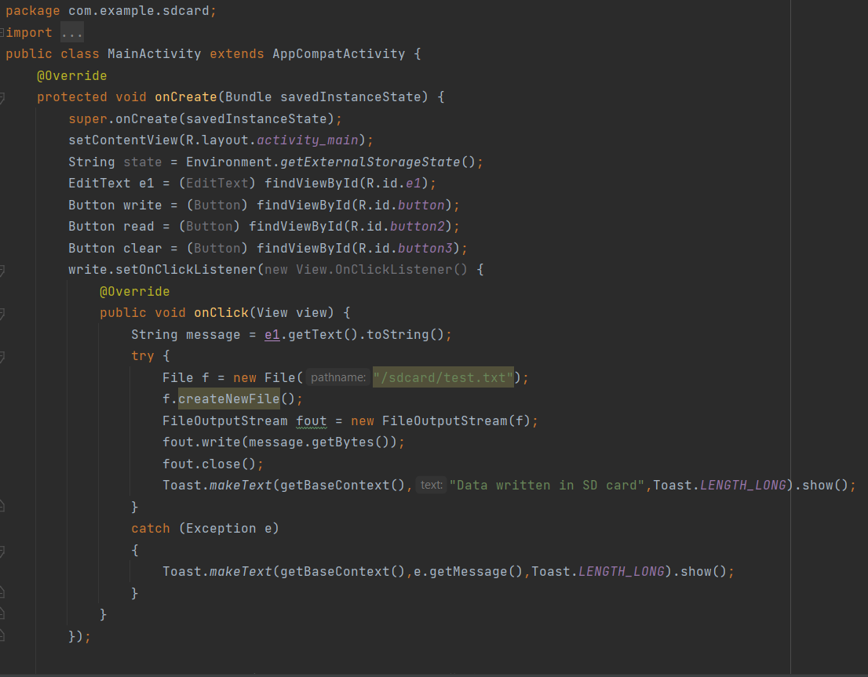

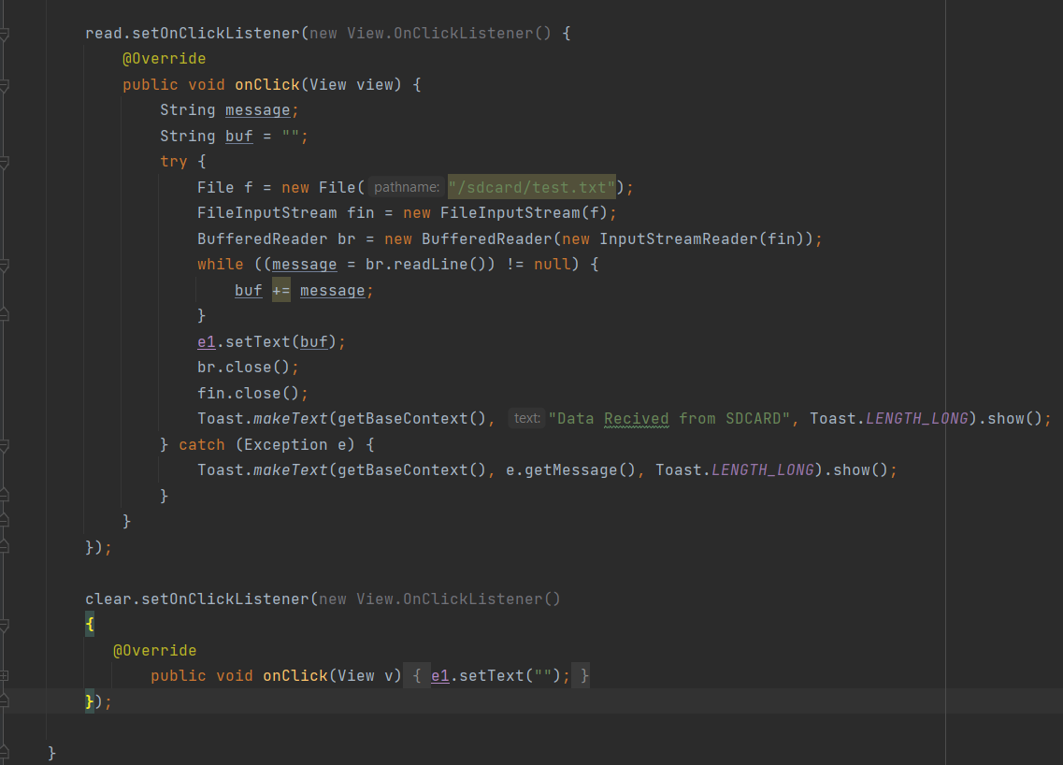

1. Multithread

Activitymain.xml

<?xml version="1.0" encoding="utf-8"?>  
<androidx.constraintlayout.widget.ConstraintLayout xmlns:android="http://schemas.android.com/apk/res/android"  
 xmlns:app="http://schemas.android.com/apk/res-auto"  
 xmlns:tools="http://schemas.android.com/tools"  
 android:layout_width="match_parent"  
 android:layout_height="match_parent"  
 tools:context=".MainActivity">  
  
 <ImageView  
 android:id="@+id/imageView"  
 android:layout_width="348dp"  
 android:layout_height="462dp"  
 app:layout_constraintBottom_toBottomOf="parent"  
 app:layout_constraintEnd_toEndOf="parent"  
 app:layout_constraintStart_toStartOf="parent"  
 app:layout_constraintTop_toTopOf="parent"  
 app:layout_constraintVertical_bias="0.315"  
 />  
  
 <Button  
 android:id="@+id/button"  
 android:layout_width="124dp"  
 android:layout_height="58dp"  
 android:text="Button1"  
 app:layout_constraintBottom_toBottomOf="parent"  
 app:layout_constraintEnd_toEndOf="parent"  
 app:layout_constraintHorizontal_bias="0.243"  
 app:layout_constraintStart_toStartOf="parent"  
 app:layout_constraintTop_toTopOf="parent"  
 app:layout_constraintVertical_bias="0.882" />  
  
 <Button  
 android:id="@+id/button2"  
 android:layout_width="131dp"  
 android:layout_height="58dp"  
 android:text="Button2"  
 app:layout_constraintBottom_toBottomOf="parent"  
 app:layout_constraintEnd_toEndOf="parent"  
 app:layout_constraintHorizontal_bias="0.803"  
 app:layout_constraintStart_toStartOf="parent"  
 app:layout_constraintTop_toTopOf="parent"  
 app:layout_constraintVertical_bias="0.882" />  
</androidx.constraintlayout.widget.ConstraintLayout>

Main activity.java

package com.example.multithread;  
import androidx.appcompat.app.AppCompatActivity;  
import android.os.Bundle;  
import android.view.View;  
import android.widget.Button;  
import android.widget.ImageView;  
  
public class MainActivity extends AppCompatActivity {  
  
 ImageView img;  
 Button b1,b2;  
 @Override  
 protected void onCreate(Bundle savedInstanceState) {  
 super.onCreate(savedInstanceState);  
 setContentView(R.layout.*activity_main*);  
  
 img = (ImageView) findViewById(R.id.*imageView*);  
 b1 = (Button) findViewById(R.id.*button*);  
 b2 = (Button) findViewById(R.id.*button2*);  
  
 b1.setOnClickListener(new View.OnClickListener() {  
 @Override  
 public void onClick(View view) {  
 new Thread(new Runnable() {  
 @Override  
 public void run() {  
 img.post(new Runnable() {  
 @Override  
 public void run() {  
 img.setImageResource(R.drawable.*img*);  
 }  
 });  
 }  
 }).start();  
 }  
 });  
  
 b2.setOnClickListener(new View.OnClickListener() {  
 @Override  
 public void onClick(View view) {  
 new Thread(new Runnable() {  
 @Override  
 public void run() {  
 img.post(new Runnable() {  
 @Override  
 public void run() {  
 img.setImageResource(R.drawable.*img_1*);  
 }  
 });  
 }  
 }).start();  
 }  
 });  
 }  
}

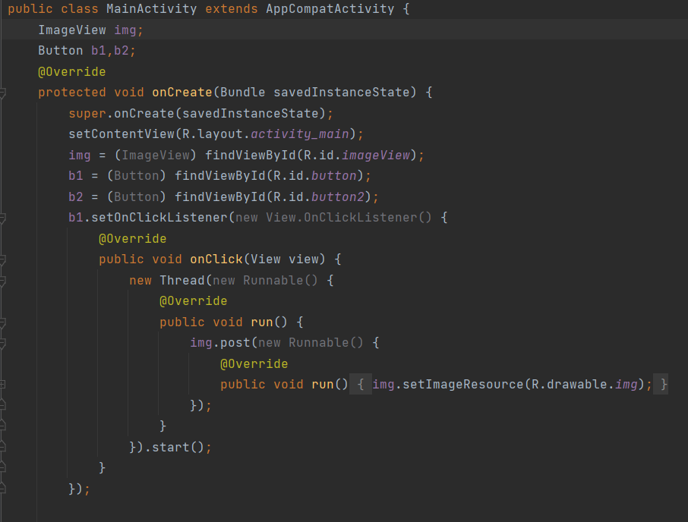

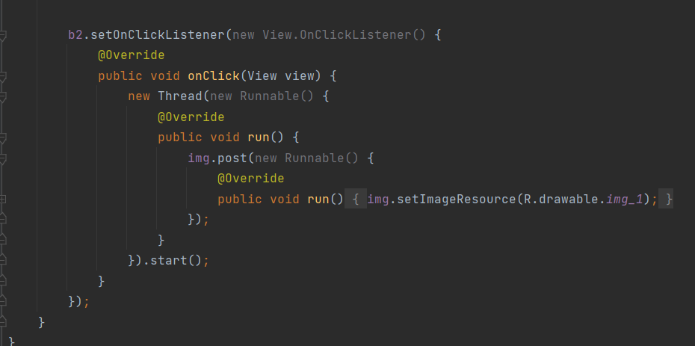

1. Gmail

Main activity.java

package com.example.email;  
import android.content.Intent;  
import android.os.Bundle;  
import android.view.View;  
import android.widget.Button;  
import android.widget.EditText;  
import androidx.appcompat.app.AppCompatActivity;  
public class MainActivity extends AppCompatActivity {  
 private EditText eTo;  
 private EditText eSubject;  
 private EditText eMsg;  
 private Button btn;  
 @Override  
 protected void onCreate(Bundle savedInstanceState) {  
 super.onCreate(savedInstanceState);  
 setContentView(R.layout.*activity_main*);  
 eTo = (EditText)findViewById(R.id.*txtTo*);  
 eSubject = (EditText)findViewById(R.id.*txtSub*);  
 eMsg = (EditText)findViewById(R.id.*txtMsg*);  
 btn = (Button)findViewById(R.id.*btnSend*);  
 btn.setOnClickListener(new View.OnClickListener() {  
 @Override  
 public void onClick(View v) {  
 Intent it = new Intent(Intent.*ACTION_SEND*);  
 it.putExtra(Intent.*EXTRA_EMAIL*, new String[]{eTo.getText().toString()});  
 it.putExtra(Intent.*EXTRA_SUBJECT*,eSubject.getText().toString());  
 it.putExtra(Intent.*EXTRA_TEXT*,eMsg.getText());  
 it.setType("message/rfc822");  
 startActivity(Intent.*createChooser*(it,"Choose Mail App"));  
 }  
 });  
 }  
}

activitymain.xml

<?xml version="1.0" encoding="utf-8"?>  
<LinearLayout xmlns:android="http://schemas.android.com/apk/res/android"  
 android:layout_width="match_parent"  
 android:layout_height="match_parent"  
 android:paddingLeft="20dp"  
 android:paddingRight="20dp"  
 android:orientation="vertical" >  
 <EditText  
 android:id="@+id/txtTo"  
 android:layout_width="match_parent"  
 android:layout_height="wrap_content"  
 android:hint="To"/>  
 <EditText  
 android:id="@+id/txtSub"  
 android:layout_width="match_parent"  
 android:layout_height="wrap_content"  
 android:hint="Subject"/>  
 <EditText  
 android:id="@+id/txtMsg"  
 android:layout_width="match_parent"  
 android:layout_height="0dp"  
 android:layout_weight="1"  
 android:gravity="top"  
 android:hint="Message"/>  
 <Button  
 android:layout_width="100dp"  
 android:layout_height="wrap_content"  
 android:layout_gravity="right"  
 android:text="Send"  
 android:id="@+id/btnSend"/>  
</LinearLayout>

Android manifest

<?xml version="1.0" encoding="utf-8"?>  
<manifest xmlns:android="http://schemas.android.com/apk/res/android"  
 xmlns:tools="http://schemas.android.com/tools">  
  
 <application  
 android:allowBackup="true"  
 android:dataExtractionRules="@xml/data_extraction_rules"  
 android:fullBackupContent="@xml/backup_rules"  
 android:icon="@mipmap/ic_launcher"  
 android:label="@string/app_name"  
 android:roundIcon="@mipmap/ic_launcher_round"  
 android:supportsRtl="true"  
 android:theme="@style/Theme.Email"  
 tools:targetApi="31">  
 <activity  
 android:name=".MainActivity"  
 android:exported="true">  
 <intent-filter>  
 <action android:name="android.intent.action.MAIN" />  
 <category android:name="android.intent.category.LAUNCHER" />  
 <action android:name="android.intent.action.SEND"/>  
 <category android:name="android.intent.category.DEFAULT"/>  
 <data android:mimeType="message/rfc822"/>  
 </intent-filter>  
  
 <meta-data  
 android:name="android.app.lib_name"  
 android:value="" />  
 </activity>  
 </application>  
  
</manifest>

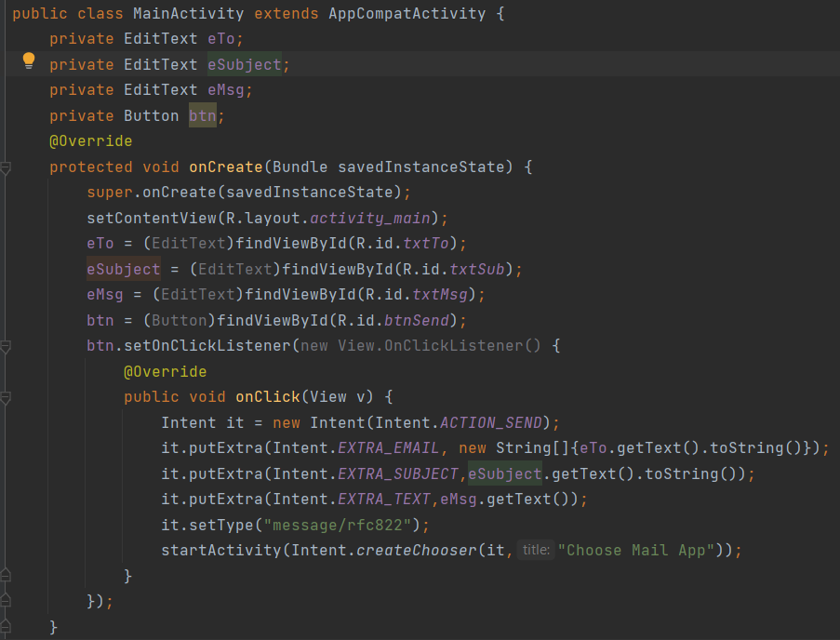

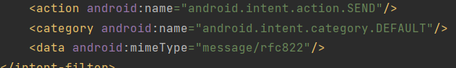

1. Read from RSS Feed

Activity main.xml

<?xml version="1.0" encoding="utf-8"?>  
<LinearLayout xmlns:android="http://schemas.android.com/apk/res/android"  
 android:layout_width="fill_parent"  
 android:layout_height="fill_parent"  
 android:orientation="vertical" >  
  
 <ListView  
 android:id="@+id/listView"  
 android:layout_width="match_parent"  
 android:layout_height="wrap_content" />  
  
</LinearLayout>

Main activity.java

package com.example.rssfeed;  
import android.app.ListActivity;  
import android.content.Intent;  
import android.net.Uri;  
import android.os.AsyncTask;  
import android.os.Bundle;  
import android.view.View;  
import android.widget.ArrayAdapter;  
  
import android.widget.ListView;  
import org.xmlpull.v1.XmlPullParser;  
import org.xmlpull.v1.XmlPullParserException;  
import org.xmlpull.v1.XmlPullParserFactory;  
import java.io.IOException;  
import java.io.InputStream;  
import java.net.MalformedURLException;  
import java.net.URL;  
import java.util.ArrayList;  
import java.util.List;  
public class MainActivity extends ListActivity  
{  
 List headlines;  
 List links;  
 @Override  
 protected void onCreate(Bundle savedInstanceState)  
 {  
 super.onCreate(savedInstanceState);  
 new MyAsyncTask().execute();  
 }  
 class MyAsyncTask extends AsyncTask<Object,Void,ArrayAdapter>  
 {  
 @Override  
 protected ArrayAdapter doInBackground(Object[] params)  
 {  
 headlines = new ArrayList();  
 links = new ArrayList();  
 try  
 {  
 URL url = new URL("https://timesofindia.indiatimes.com/rssfeedmostrecent.cms");  
 XmlPullParserFactory factory = XmlPullParserFactory.*newInstance*();  
 factory.setNamespaceAware(false);  
 XmlPullParser xpp = factory.newPullParser();  
 // We will get the XML from an input stream  
 xpp.setInput(getInputStream(url), "UTF_8");  
 boolean insideItem = false;  
 // Returns the type of current event: START_TAG, END_TAG, etc..  
 int eventType = xpp.getEventType();  
 while (eventType != XmlPullParser.*END_DOCUMENT*)  
 {  
 if (eventType == XmlPullParser.*START_TAG*)  
 {  
 if (xpp.getName().equalsIgnoreCase("item"))  
 {  
 insideItem = true;  
 }  
 else if (xpp.getName().equalsIgnoreCase("title"))  
 {  
 if (insideItem)  
 headlines.add(xpp.nextText()); //extract the headline  
 }  
 else if (xpp.getName().equalsIgnoreCase("link"))  
 {  
 if (insideItem)  
 links.add(xpp.nextText()); //extract the link of article  
 }  
 }  
 else if(eventType==XmlPullParser.*END_TAG* && xpp.getName().equalsIgnoreCase("item"))  
 {  
 insideItem=false;  
 }  
 eventType = xpp.next(); //move to next element  
 }  
  
 }  
 catch (MalformedURLException e)  
 {  
 e.printStackTrace();  
 }  
 catch (XmlPullParserException e)  
 {  
 e.printStackTrace();  
 }  
 catch (IOException e)  
 {  
  
 e.printStackTrace();  
 }  
 return null;  
 }  
 protected void onPostExecute(ArrayAdapter adapter)  
 {  
 adapter = new ArrayAdapter(MainActivity.this, android.R.layout.*simple_list_item_1*, headlines);  
 setListAdapter(adapter);  
 }  
 }  
  
  
 @Override  
 protected void onListItemClick(ListView l, View v, int position, long id)  
 {  
 Uri uri = Uri.*parse*((links.get(position)).toString()); Intent intent = new Intent(Intent.*ACTION_VIEW*, uri);  
 startActivity(intent);  
 }  
  
 public InputStream getInputStream(URL url)  
 {  
 try  
 {  
 return url.openConnection().getInputStream();  
 }  
 catch (IOException e)  
 {  
 return null;  
 }  
 }  
}

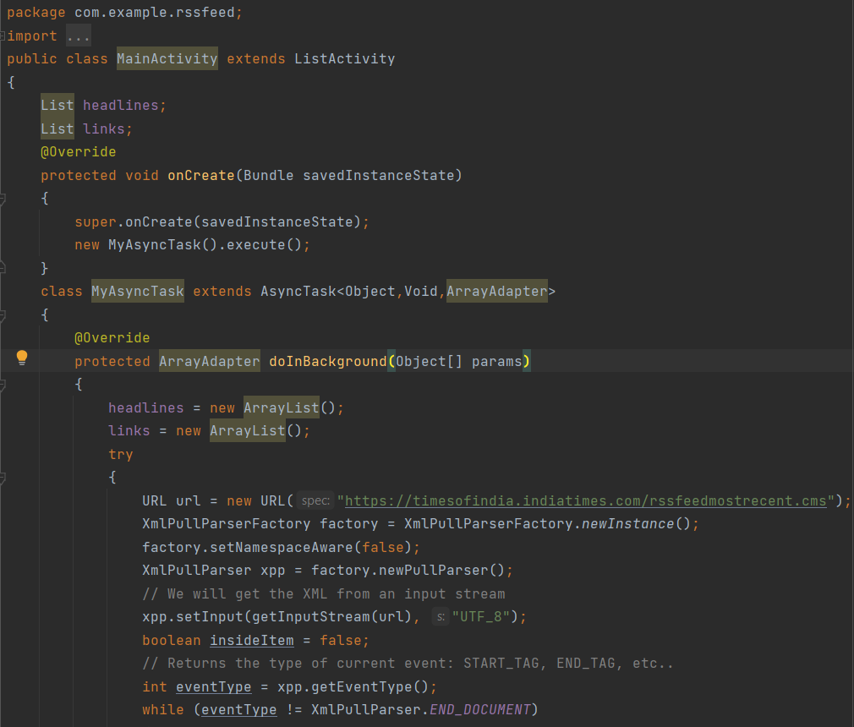

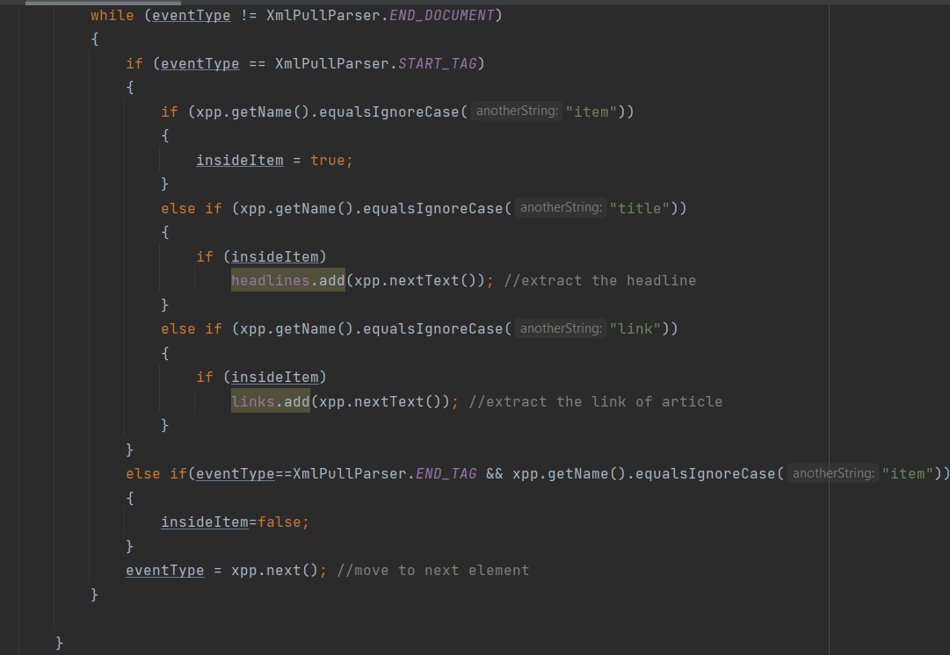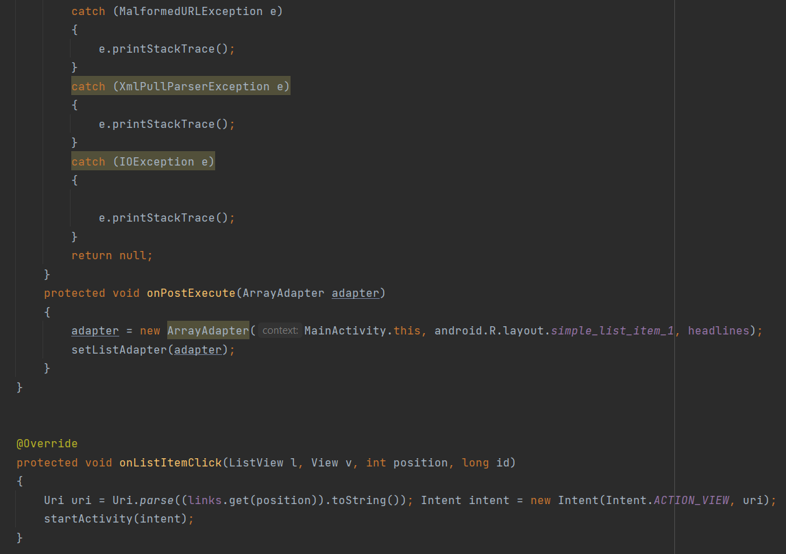

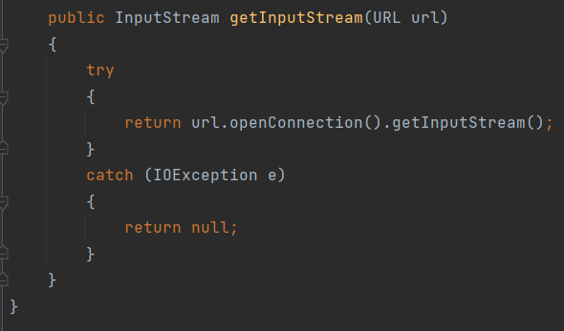

1. Alarm clock
2. GPS

Activity_main.xml

<?xml version = "1.0" encoding = "utf-8"?>  
<LinearLayout xmlns:android = "http://schemas.android.com/apk/res/android"  
 android:layout_width = "fill_parent"  
 android:layout_height = "fill_parent"  
 android:orientation = "vertical" >  
  
 <Button  
 android:id = "@+id/button"  
 android:layout_width = "fill_parent"  
 android:layout_height = "wrap_content"  
 android:text = "getlocation"/>  
  
</LinearLayout>

Activity_gpstracker.xml

<?xml version="1.0" encoding="utf-8"?>  
<androidx.constraintlayout.widget.ConstraintLayout xmlns:android="http://schemas.android.com/apk/res/android"  
 xmlns:app="http://schemas.android.com/apk/res-auto"  
 xmlns:tools="http://schemas.android.com/tools"  
 android:layout_width="match_parent"  
 android:layout_height="match_parent"  
 tools:context=".GPSTracker">  
  
</androidx.constraintlayout.widget.ConstraintLayout>

Mainactivity.java

package com.example.gps;  
import android.Manifest;  
import android.app.Activity;  
import android.os.Bundle;  
import android.content.pm.PackageManager;  
import android.view.View;  
import android.widget.Button;  
import android.widget.Toast;  
import androidx.core.app.ActivityCompat;  
public class MainActivity extends Activity {  
 Button btnShowLocation;  
 private static final int *REQUEST_CODE_PERMISSION* = 2;  
 String mPermission = Manifest.permission.*ACCESS_FINE_LOCATION*;  
  
 GPSTracker gps;  
 @Override  
 public void onCreate(Bundle savedInstanceState) {  
 super.onCreate(savedInstanceState);  
 setContentView(R.layout.*activity_main*);  
 try {  
 if (ActivityCompat.*checkSelfPermission*(this, mPermission)  
 != PackageManager.*PERMISSION_GRANTED*) {  
 ActivityCompat.*requestPermissions*(this, new String[]{mPermission},  
 *REQUEST_CODE_PERMISSION*);  
 }  
 } catch (Exception e) {  
 e.printStackTrace();  
 }  
 btnShowLocation = (Button) findViewById(R.id.*button*);  
 btnShowLocation.setOnClickListener(new View.OnClickListener() {  
 @Override  
 public void onClick(View arg0) {  
 gps = new GPSTracker(MainActivity.this);  
 if(gps.canGetLocation()){  
 double latitude = gps.getLatitude();  
 double longitude = gps.getLongitude();  
 Toast.*makeText*(getApplicationContext(), "Your Location is - \nLat: "+ latitude + "\nLong: " + longitude, Toast.*LENGTH_LONG*).show();  
 }else{  
 gps.showSettingsAlert();  
 }  
 }  
 });  
 }  
}

GPSTracker.java

package com.example.gps;  
  
import android.annotation.SuppressLint;  
import android.app.AlertDialog;  
import android.app.Service;  
import android.content.Context;  
import android.content.DialogInterface;  
import android.content.Intent;  
import android.location.Location;  
import android.location.LocationListener;  
import android.location.LocationManager;  
import android.os.Bundle;  
import android.os.IBinder;  
import android.provider.Settings;  
import android.util.Log;  
  
public class GPSTracker extends Service implements LocationListener {  
 private final Context mContext;  
 boolean isGPSEnabled = false;  
 boolean isNetworkEnabled = false;  
 boolean canGetLocation = false;  
 Location location;  
 double latitude;  
 double longitude;  
 private static final long *MIN_DISTANCE_CHANGE_FOR_UPDATES* = 10;  
 private static final long *MIN_TIME_BW_UPDATES* = 1000 * 60 * 1;  
 protected LocationManager locationManager;  
 public GPSTracker(Context context) {  
 this.mContext = context;  
 getLocation();  
 }  
 @SuppressLint("MissingPermission")  
  
 public Location getLocation() {  
 try {  
 locationManager = (LocationManager) mContext.getSystemService(*LOCATION_SERVICE*);  
 isGPSEnabled = locationManager.isProviderEnabled(LocationManager.*GPS_PROVIDER*);  
 isNetworkEnabled = locationManager.isProviderEnabled(LocationManager.*NETWORK_PROVIDER*);  
 if (!isGPSEnabled && !isNetworkEnabled) {  
 } else {  
 this.canGetLocation = true;  
 if (isNetworkEnabled) {  
 locationManager.requestLocationUpdates(LocationManager.*NETWORK_PROVIDER*, *MIN_TIME_BW_UPDATES*, *MIN_DISTANCE_CHANGE_FOR_UPDATES*, this);  
 Log.*d*("Network", "Network");  
 if (locationManager != null) {  
 location = locationManager.getLastKnownLocation(LocationManager.*NETWORK_PROVIDER*);  
 if (location != null) {  
 latitude = location.getLatitude();  
 longitude = location.getLongitude();  
 }  
 }  
 }  
 if (isGPSEnabled) {  
 if (location == null) {  
 locationManager.requestLocationUpdates(LocationManager.*GPS_PROVIDER*, *MIN_TIME_BW_UPDATES*, *MIN_DISTANCE_CHANGE_FOR_UPDATES*, this);  
 Log.*d*("GPS Enabled", "GPS Enabled");  
 if (locationManager != null) {  
 location = locationManager.getLastKnownLocation(LocationManager.*GPS_PROVIDER*);  
 if (location != null) {  
 latitude = location.getLatitude();  
 longitude = location.getLongitude();  
 }  
 }  
 }  
 }  
 }  
 } catch (Exception e) {  
 e.printStackTrace();  
 }  
 return location;  
 }  
 public void stopUsingGPS(){  
 if(locationManager != null){  
 locationManager.removeUpdates(GPSTracker.this);  
 }  
 }  
 public double getLatitude(){  
 if(location != null){  
 latitude = location.getLatitude();  
 }  
 // return latitude  
 return latitude;  
 }  
 public double getLongitude(){  
 if(location != null){  
 longitude = location.getLongitude();  
 }  
 // return longitude  
 return longitude;  
 }  
 public boolean canGetLocation() {  
 return this.canGetLocation;  
 }  
  
 public void showSettingsAlert(){  
 AlertDialog.Builder alertDialog = new AlertDialog.Builder(mContext);  
 alertDialog.setTitle("GPS is settings");  
 alertDialog.setMessage("GPS is not enabled. Do you want to go to settings menu?");  
 alertDialog.setPositiveButton("Settings", new DialogInterface.OnClickListener() {  
 public void onClick(DialogInterface dialog,int which) {  
 Intent intent = new Intent(Settings.*ACTION_LOCATION_SOURCE_SETTINGS*);  
 mContext.startActivity(intent);  
 }  
 });  
  
 alertDialog.setNegativeButton("Cancel", new DialogInterface.OnClickListener() {  
 public void onClick(DialogInterface dialog, int which) {  
 dialog.cancel();  
 }  
 });  
  
 alertDialog.show();  
 }  
 @Override  
 public void onLocationChanged(Location location) { }  
 @Override  
 public void onProviderDisabled(String provider) { }  
 @Override  
 public void onProviderEnabled(String provider) { }  
 @Override  
 public void onStatusChanged(String provider, int status, Bundle extras) { }  
 @Override  
 public IBinder onBind(Intent arg0) {  
 return null;  
 }  
}