|  |
| --- |
| TradeNest |
| High Level Requirements Document |
| **Version 1.0** |
| **18/09/2024** |

**Project Identification**

|  |  |
| --- | --- |
| **Project:** | TradeNest |
| **Prepared By:** | Kaman Wong |
| **Document Version:** | 1.0 |
| **Published Date:** | 18/09/2024 |

**Contributors**

The following individuals contributed to this document.

| **Name** | **Title** |
| --- | --- |
| Naomi Teklu | *UX Designer* |
| Diego Tsukayama | *Project Manager / Business Analyst* |
| Kaman Wong | *Lead Developer* |
| Shalom Aideyan | *Security Architect / Penetration Tester* |

**Distribution**

This document is distributed to all the following people.

| **Name** | **Title** |
| --- | --- |
| Anjana Shah | Teacher |
|  |  |

**Referenced Documents**

This document refers to the following materials

|  |  |  |  |  |
| --- | --- | --- | --- | --- |
| **Version number** | **Title** | **Author** | **Date** | **Source / Location** |
|  |  |  |  |  |
|  |  |  |  |  |
|  |  |  |  |  |

**Revision History**

|  |  |  |  |
| --- | --- | --- | --- |
| **Version Number** | **Revision Date** | **Summary of Changes** | **Modified by** |
|  |  |  |  |
|  |  |  |  |
|  |  |  |  |

[Note: It is recommended that drafts be numbered 0.1 to 0.9, and that the first approved version be numbered 1.0. Thereafter, new version numbers will depend upon changes: 1.01, 1.1, etc for minor updates, 2.0, 3.0 etc for major changes.]

TABLE OF CONTENTS

1. Business Context Diagram 3

2. REquirements Scope Statements 4

3. High Level Business Requirements Sign-Off 5

1. Business Context Diagram

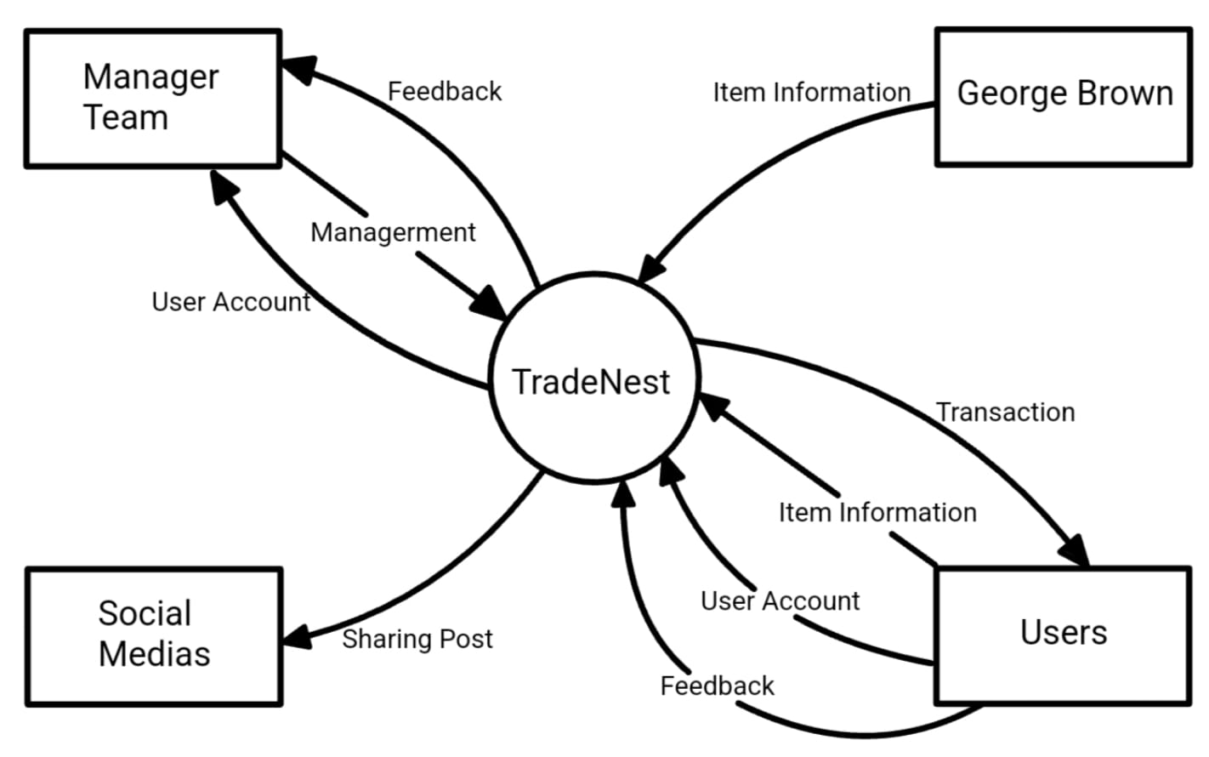

|  |  |
| --- | --- |
| **Requirement Scope Area** | **Description** |
| TradeNest | This trading platform has been developed with the specific needs of college students in mind. It offers a range of features designed to facilitate the trading, buying and selling of items, help users locate misplaced items, provide a lending service, and enable users to share lists and event information on social media. |

|  |  |
| --- | --- |
| **External Entity** | **Description** |
| Users | College students who can buy, sell, trade, lend, recover lost items, and share posts on social media. |
| George Brown | Responsible for ensuring that the platform complies with campus regulations and promotes a safe trading environment. |
| Manager Team | Oversee user activity, manage disputes, and enforce platform rules. |
| Social Medias | External platforms (e.g., Facebook, Instagram) where students can share. |

| **Information Flows** | **Description** |
| --- | --- |
| User Account | Student registration is conducted via the school's email address, with personalized messages appended. |
| Item information | The item details are to be imported, modified, and updated. |
| Transaction | Peer-to-peer transaction and lending information and real-time tracking of transaction progress. |
| Feedback | Upon the conclusion of a transaction, users may opt to comments, rate and share their experience |
| Sharing Post | Posts are compatible with a range of social media platforms. |
| Management | The management of users and platform items. |

1. Requirements Scope Statements

|  |  |  |
| --- | --- | --- |
| **HLR#** | **Description** | **Priority**  **(H, M, L)** |
|  | Users must be able to register and verify their accounts with their college credentials. | H |
|  | Users must be able to upload items, including item descriptions and pictures. | H |
|  | Users must be able to search for and request to borrow or trade items from other users. | H |
|  | Users must be able to contact other users to track transactions. | M |
| HLR05 | Users must be able to share their items or activities directly on social media platforms. | M |
| HLR06 | Users must be able to view and manage their list of items and transaction records to manage items easily. | M |
| HLR07 | Users must be able to provide feedback and comment on the transactions they complete. | M |
| HLR08 | Users must receive the transaction/borrowing request immediately. | M |
| HLR09 | Users should be able to customize their user profiles, including profile pictures and bios | L |
| HLR10 | Users should be able to save favorite items or follow certain users to track new items or update | L |
| HLR11 | Users should be able to use filters to search for specific items. | L |

1. High Level Business Requirements Sign-Off

The undersigned acknowledge their agreement with the contents of Version <1.0> of the High-Level Requirements document for <TradeNest >.

Following approval of this document, requirements changes will be governed by the project’s change management process, including impact analysis and appropriate reviews and approvals, under the general control of the Project Plan and according to company policy. Approved Change Request Documents, if present, will be attached to this Requirements Document as updates.

|  |  |  |
| --- | --- | --- |
| **Name** | **Project Role and**  **Functional Area** | **Date Signed** |
| Diego Tsukayama | *Project Manager / Business Analyst* | 20/09/2024 |
| Naomi Teklu | *UX Designer* | 20/09/2024 |
| Kaman Wong | *Lead Developer* | 20/09/2024 |
| Shalom Aideyan | *Security Architect / Penetration Tester* | 20/09/2024 |

* Note: physical signatures are not required. Email approvals are acceptable and should be appended to project documents.