COMP3104 DevOps

Group Assignment

Student ID: 101424041

Student Name: Kaman Wong

Repository Link: <https://github.com/DiegoHidenori/COMP3104_Group41_Assignment>

Screenshots:

▪ Git commit history

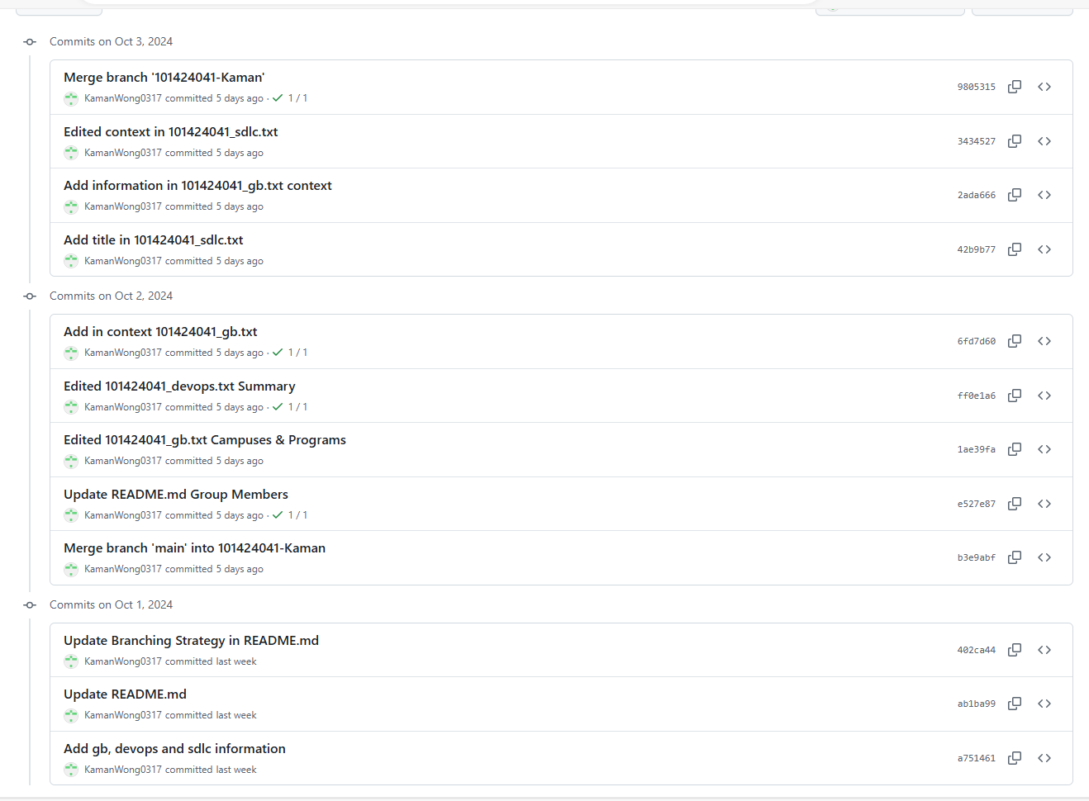

▪ Branch structure.

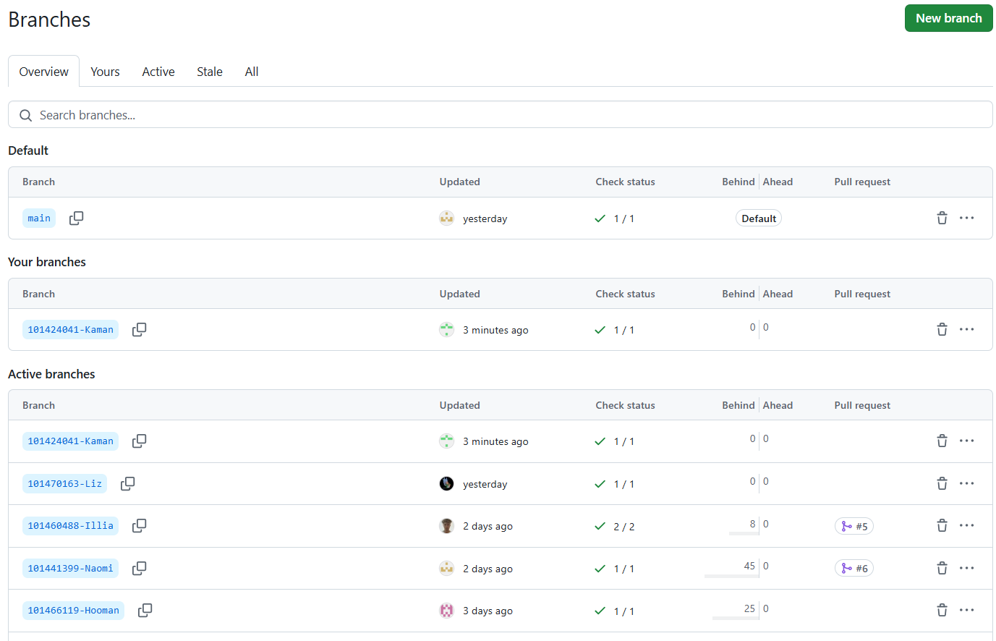

▪ CI pipeline status

