

TRIBHUVAN UNIVERSITY
Faculty of Computer Science and Information Technology

NET Centric Computing REPORT ON Smart Inventory and Low Stock Prediction System

Submitted By: Submitted To:
Name: - Kamana Shrestha Yuva Raj Devkota
Roll No: 12 National College of Computer Studies
TU Reg.No:5-2-551-20-2023 ………………………..
Year/Semester:6th Sem/3rd Year Signature
Acknowledgement

I would like to express my sincere gratitude to my teacher for their guidance and support during the preparation of this project report. Their feedback helped me understand the requirements, structure, implementation, and documentation standards needed to develop and present an organized academic project.
I am also thankful to everyone who supported the development and testing of this Smart Inventory and Low Stock Prediction System. This project helped me apply concepts of C# programming, ASP.NET Core MVC, database management, Entity Framework Core, inventory management, and rule-based stock prediction in a practical software development environment.
Abstract
Smart Inventory and Low Stock Prediction System is a web-based inventory management application developed using ASP.NET Core MVC, C#, .NET 10, Entity Framework Core, and SQL Server/LocalDB. The system allows an inventory manager or user to manage products, record sales, view sales history, and monitor stock levels. Stock quantities are automatically updated whenever sales are recorded, edited, or deleted.
The system also provides a dashboard for monitoring overall inventory status and a prediction module that calculates average daily sales, estimated days of stock remaining, and expected stockout dates based on recorded sales history. Products are classified into different stock statuses and appropriate restocking recommendations are provided using rule-based logic. This documentation presents the analysis, design, feasibility, and implementation of the system. It describes the problem statement, objectives, feasibility study, system design, module-wise implementation, and result analysis of the project. The report also includes the Use Case Diagram as the required visual model for representing user interaction with the system.

Table of Contents
1. Introduction 2
1.1 Purpose 2
1.2 Project Scope 2
1.3 Document Convention 2
1.4 Tools and Technologies Used 2
2. Problem Statement 4
3. Objectives 5
4. Feasibility Study 6
4.1 Technical Feasibility 6
4.2 Economic Feasibility 6
4.3 Operational Feasibility 6
4.4 Schedule Feasibility 7
5. System Analysis & Design 8
5.1 System Modules 8
5.2 Use Case Diagram 9
5.3 Database Design 10
6. Implementation 11
6.1 Dashboard Module 11
6.2 Product Management Module 12
6.3 Sales Management Module 13
6.4 Sales Edit and Delete 14
6.5 Prediction Module 16
7. Result Analysis 18
8. Non-Functional Requirements 19
9. Conclusion 20
10. Recommendations 21
11. Future Scope 22

1. Introduction
Smart Inventory and Low Stock Prediction System is a web-based inventory management application developed as an academic project using ASP.NET Core MVC and C#. The system allows an inventory manager or user to manage products, record sales, monitor stock levels, and view sales history. It also provides a dashboard for monitoring inventory status and a prediction module that uses sales history to estimate average daily sales, remaining stock days, and expected stockout dates.

Purpose
The purpose of this project is to design and develop a simple but effective inventory management system that helps users maintain accurate stock records and identify products that require restocking. The project demonstrates the practical application of object-oriented programming, web application development, database management, Entity Framework Core, and rule-based stock prediction within a realistic academic project scope.

Project Scope
The scope of the project includes product management, sales management, sales history, stock monitoring, dashboard-based inventory analysis, and stock prediction. The system allows users to add, edit, view, and delete products, record sales, and edit or delete sales records while automatically adjusting stock quantities. The system also identifies low-stock and out-of-stock products and provides restocking recommendations based on reorder levels and estimated days of stock remaining.

Document Convention
This document follows a standard academic project report format. The main text uses numbered headings and sub-headings, with important source code presented in monospace code blocks and screenshots or output figures captioned below each image. The report presents the analysis, design, implementation, and results of the Smart Inventory and Low Stock Prediction System.

Tools and Technologies Used
- Programming Language: C#
- Framework: ASP.NET Core MVC (.NET 10)
- Database: SQL Server / LocalDB
- ORM: Entity Framework Core
- IDE: Visual Studio
- Frontend: HTML, CSS, Bootstrap, and Razor Views
- Database Management: Entity Framework Core Migrations
- Version Control / Backup: Git and GitHub.

2. Problem Statement
Managing inventory manually can lead to several problems such as incorrect stock records, difficulty tracking sales, delayed restocking, and products becoming out of stock unexpectedly.
In a traditional inventory system, employees may need to manually calculate available stock and determine which products need to be reordered. This can be time-consuming and may result in human errors.
Therefore, there is a need for a computerized inventory system that can:
- Maintain accurate product records.
- Automatically update stock after sales.
- Prevent sales when sufficient stock is unavailable.
- Identify low-stock and out-of-stock products.
- Analyze sales history.
- Estimate when existing stock may run out.
The Smart Inventory and Low Stock Prediction System was developed to address these problems through automated inventory management and simple sales-based prediction

3. Objectives

- To develop a web-based inventory management system for adding, updating, viewing, and managing product information using ASP.NET Core MVC and C#.
- To implement automated stock management by recording sales, reducing stock automatically, validating available quantities, and restoring stock when sales are edited or deleted.
- To develop a rule-based low-stock prediction system that uses sales history and average daily sales to identify products that may require restocking.

4. Feasibility Study

4.1 Technical Feasibility
The project is technically feasible because the required technologies are available and suitable for developing the application. C#, ASP.NET Core MVC, Entity Framework Core, SQL Server/LocalDB, HTML/CSS/Bootstrap, and Visual Studio provide the required tools for application development, database management, and user interface design.

4.2 Economic Feasibility
The project is economically feasible because it can be developed using commonly available development tools such as Visual Studio and SQL Server LocalDB. No expensive specialized hardware is required.

4.3 Operational Feasibility
The system is easy to operate because users can manage products and sales through simple web pages. The dashboard provides a quick overview of inventory conditions, making it easier to identify products that require attention.

4.4 Schedule Feasibility

Activity | Work
Requirement Analysis | Identified inventory and prediction requirements
System Design | Designed modules and database structure
Database Development | Created Product and Sale tables
Product Module | Implemented product CRUD operations
Sales Module | Implemented sales and stock management
Dashboard | Implemented inventory statistics
Prediction Module | Implemented sales-based prediction
Testing | Tested validation, stock updates, and deletion
Documentation | Prepared project report

5. System Analysis & Design

5.1 System Modules
Dashboard Module: Provides total products, low-stock products, out-of-stock products, restock-soon count, and restock alerts.
Product Management Module: Allows users to add, view, edit, and delete products and manage stock and reorder levels.
Sales Management Module: Records sales, updates stock automatically, validates quantities, and maintains stock consistency during edit/delete operations.
Prediction Module: Uses sales history to calculate average daily sales, estimate remaining stock days, estimate possible stock-out dates, and provide recommendations.

5.2 Use Case Diagram
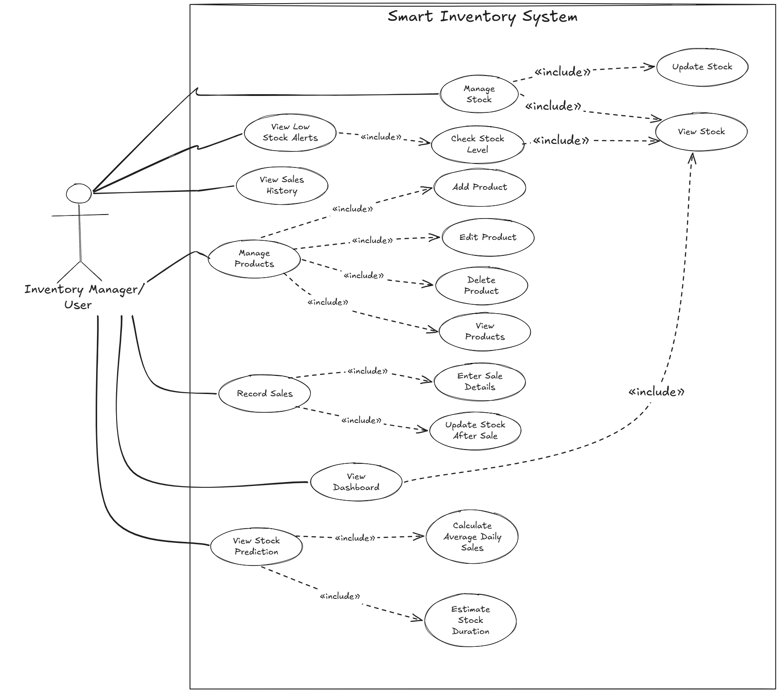
Here is the Use Case Diagram of Smart Inventory and low stock prediction system:
Figure 1: Use Case Diagram of Smart Inventory and Low Stock Prediction System
The diagram shows a single User actor interacting with the system's core functions. Managing Products and Managing Sales each include their respective Add, Edit, Delete, and View operations, while all sale-related actions (Record, Edit, Delete Sale) include the Update Stock Quantity use case, since every sale action affects stock. This reflects how the system keeps product and sales data synchronized at all times.

5.3 Database Design
The main entities used in the system are Product and Sale.
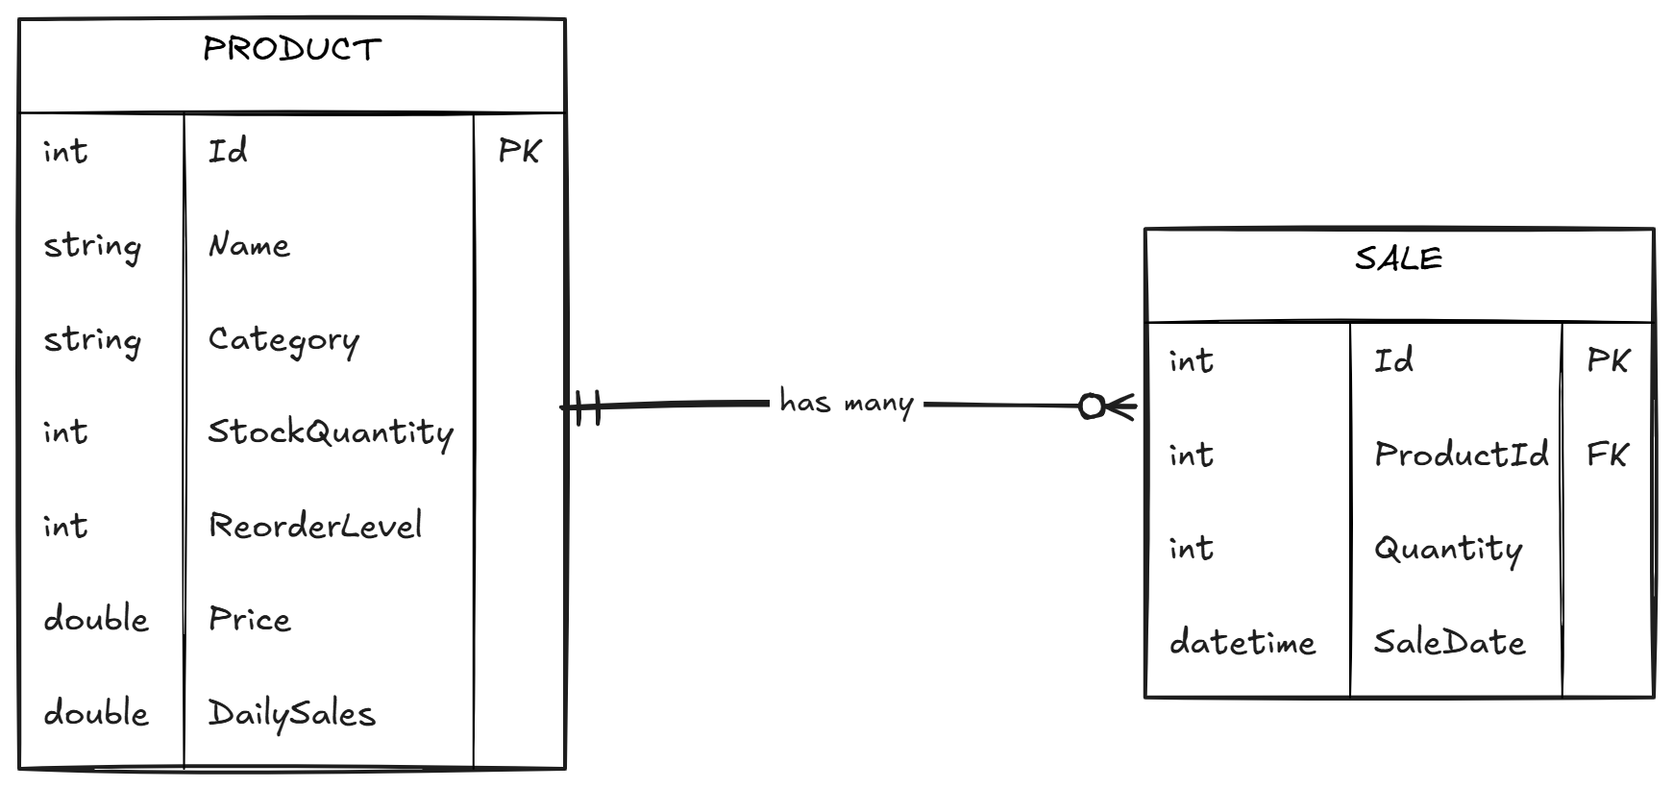
Figure 2: Database Design

The ProductId in the Sale entity connects sales with their corresponding product. This forms a one-to-many relationship: one Product can have multiple associated Sale records, but each Sale belongs to exactly one Product.

6. Implementation

6.1 Dashboard Module
The Dashboard provides an overall summary of the inventory. It displays the total number of products, low-stock products, out-of-stock products, and products that should be restocked soon. It also displays restock alerts. 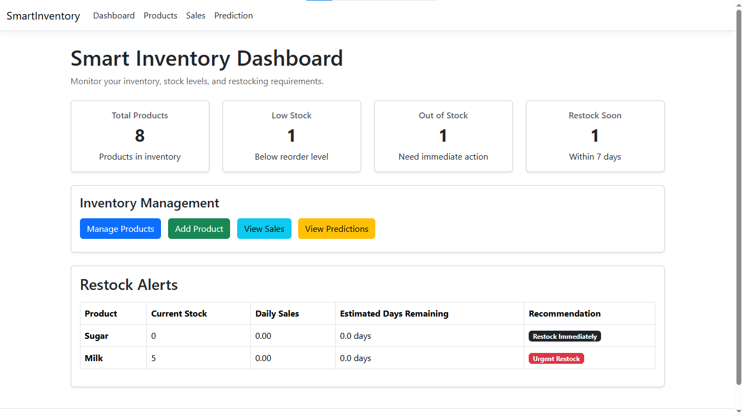
Figure 3: Dashboard of Smart Inventory

Daily Sales Calculation:
foreach (var product in products)
{
var productSales = sales
.Where(s => s.ProductId == product.Id)
.ToList();
if (productSales.Any())
{
var totalSales = productSales.Sum(s => s.Quantity);
var firstSaleDate = productSales
.Min(s => s.SaleDate)
.Date;
var days = (DateTime.Today - firstSaleDate).Days + 1;
if (days > 0)
{
product.DailySales = (double)totalSales / days;
}
}
else
{
product.DailySales = 0;
}
}

Inventory Status Calculation:
ViewBag.RestockSoon = products.Count(p =>
p.StockQuantity > 0 &&
(
p.StockQuantity <= p.ReorderLevel ||
(p.DailySales > 0 &&
(p.StockQuantity / p.DailySales) <= 7)
));

6.2 Product Management Module
The Product Management module allows the user to manage product information. Users can add new products, edit existing products, view details, and delete products. The system also validates product information.
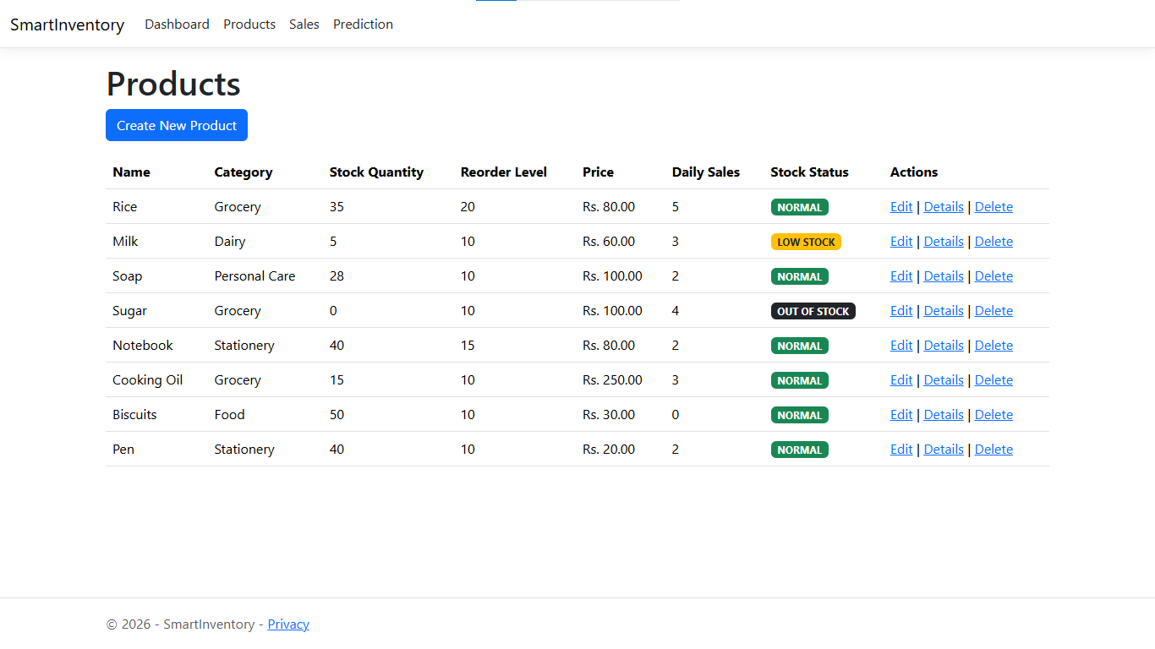
Figure 4: Products module of Smart Inventory
Product Module:
[Required(ErrorMessage = "Product name is required.")]
[StringLength(100, ErrorMessage = "Product name cannot exceed 100 characters.")]
public string Name { get; set; } = string.Empty;
[Range(0, int.MaxValue, ErrorMessage = "Stock quantity cannot be negative.")]
public int StockQuantity { get; set; }

Adding a Product:
if (ModelState.IsValid)
{
_context.Add(product);
await _context.SaveChangesAsync();
TempData["SuccessMessage"] = "Product added successfully.";
return RedirectToAction(nameof(Index));
}

6.3 Sales Management Module
The Sales module records sales transactions and automatically updates product stock. The system prevents the user from selling more products than are currently available.
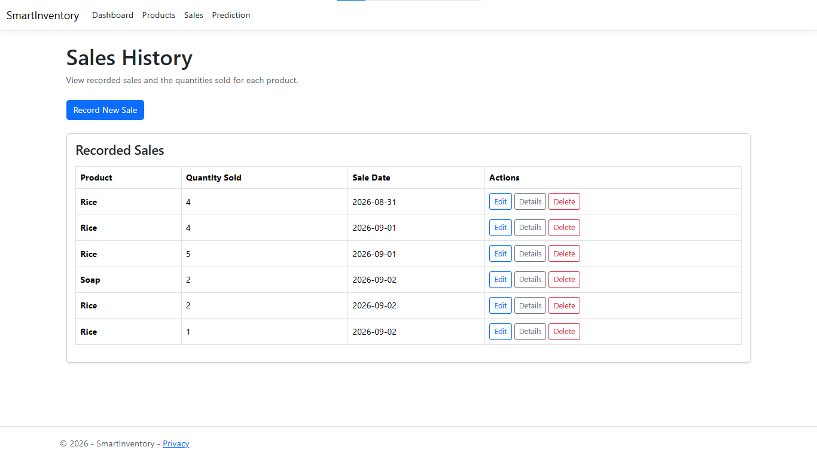
Figure 5: Sales record of Smart Inventory
Recording a Sale:

if (sale.Quantity > product.StockQuantity)
{
ModelState.AddModelError("Quantity", "Not enough stock available.");
}
product.StockQuantity -= sale.Quantity;
_context.Sales.Add(sale);
await _context.SaveChangesAsync();
}

6.4 Sales Edit and Delete
The system maintains stock consistency when sales are edited or deleted. When a sale is edited, the previous quantity is returned to stock before applying the new quantity. When a sale is deleted, its quantity is restored.

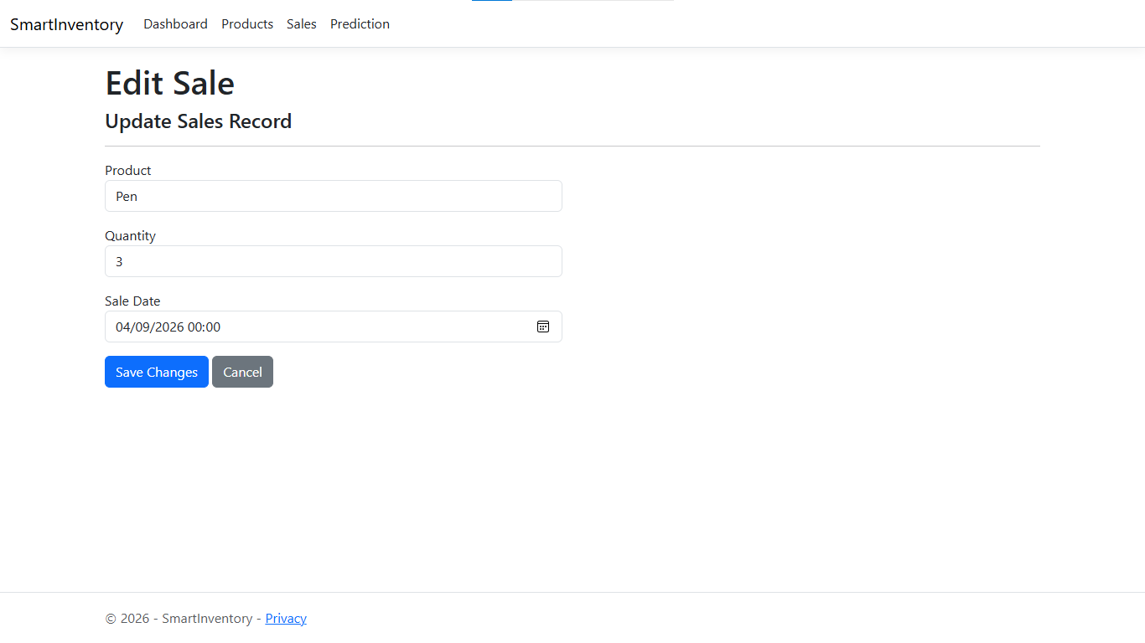
Figure 6: Editing Sale record

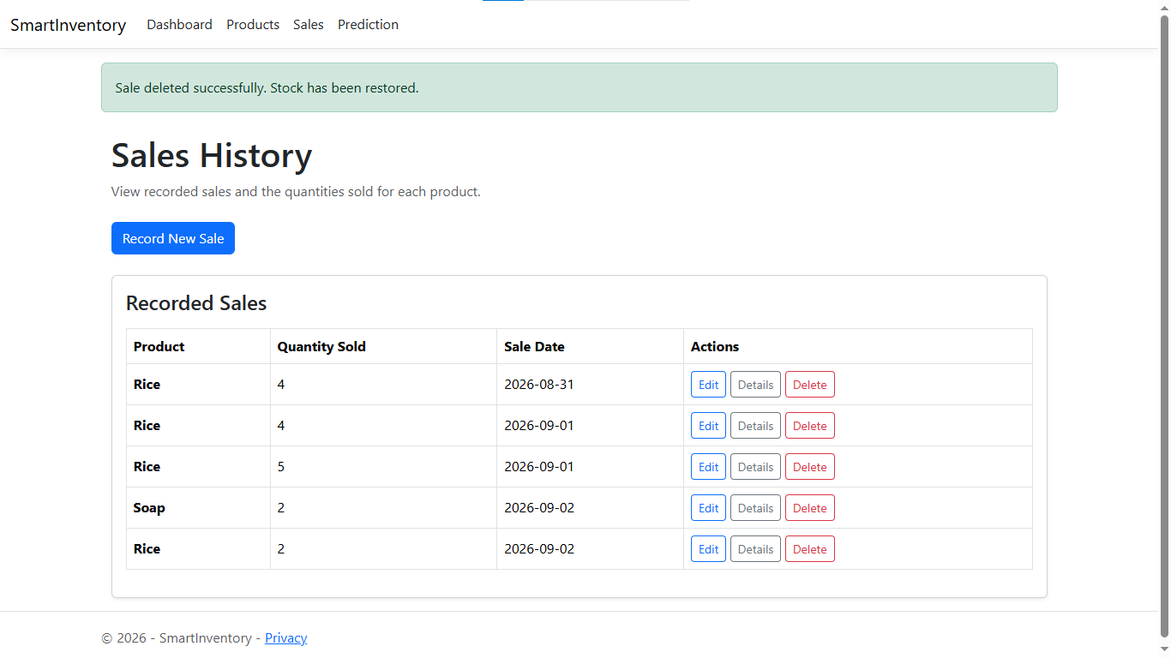
Figure 7: Deletion of sale record
Editing a Sales Record:
product.StockQuantity += existingSale.Quantity;
product.StockQuantity -= sale.Quantity;
existingSale.Quantity = sale.Quantity;
existingSale.SaleDate = sale.SaleDate;
await _context.SaveChangesAsync();

Deleting a Sales Record:
product.StockQuantity += sale.Quantity;
_context.Sales.Remove(sale);
await _context.SaveChangesAsync();

6.5 Prediction Module
The Prediction module analyzes sales history and calculates average daily sales. It then uses current stock and average daily sales to estimate how many days the remaining stock may last.
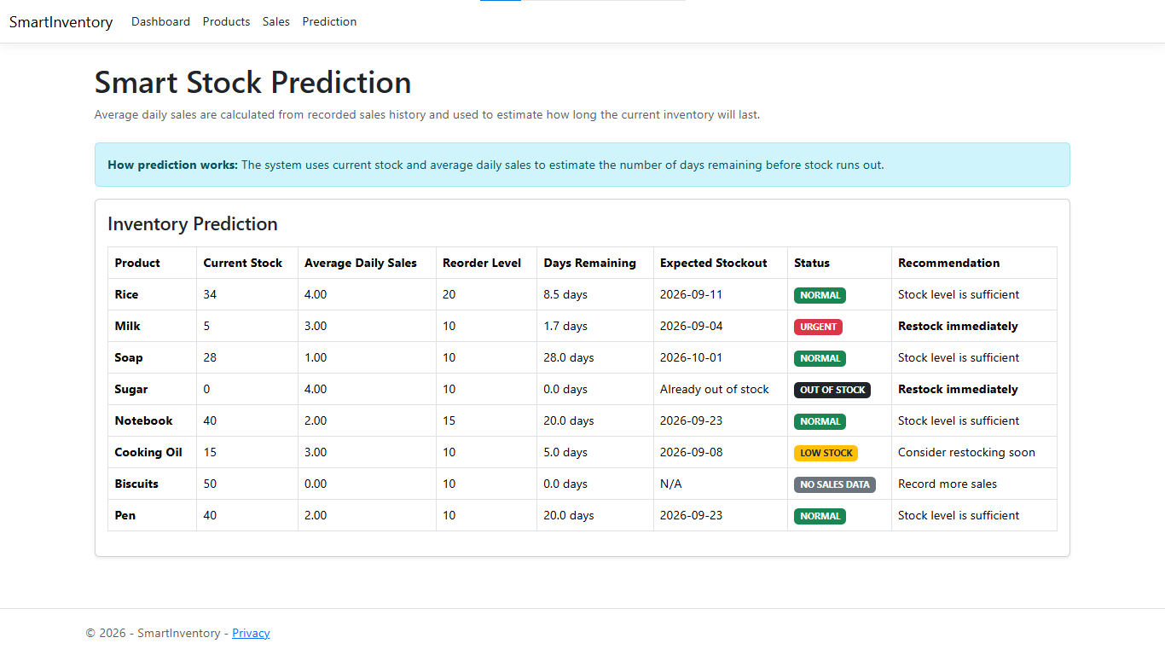
Figure 8: Prediction module of Smart Inventory
Average Daily Sales Calculation:
if (days > 0)
{
product.DailySales = (double)totalSales / days;
}

Estimated Days Remaining:
daysRemaining = product.StockQuantity /product.DailySales;

Prediction Status and Recommendation:
if (daysRemaining <= 3)
{
status = "URGENT";
}
else if (daysRemaining <= 7 || product.StockQuantity <= product.ReorderLevel)
{
status = "LOW STOCK";
}
else
{
status = "NORMAL";
}

The system estimates the remaining number of days by dividing the current stock quantity by the average daily sales. It also uses this value to calculate the expected stockout date. Based on the estimated remaining days and reorder level, the system classifies the product as Urgent, Low Stock, or Normal and provides an appropriate restocking recommendation

7. Result Analysis
The completed Smart Inventory and Low Stock Prediction System was tested by performing the major operations of the system, including product management, sales recording, stock monitoring, dashboard analysis, and stock prediction. The table below summarizes the outcome of testing for each major module.
Module | Expected Result | Status
Product Management | Products can be added, viewed, edited, and deleted successfully. | Working
Product Validation | Required fields are validated and invalid values such as negative stock, price, or reorder level are prevented. | Working
Sales Management | Sales can be recorded successfully and the selected product's stock is automatically reduced. | Working
Sales Editing | Editing a sale correctly adjusts the stock according to the new quantity. | Working
Sales Deletion | Deleting a sale removes the sales record and restores the sold quantity to stock. | Working
Stock Monitoring | Products are identified as normal, low stock, or out of stock based on their current stock and reorder level. | Working
Dashboard | Total products, low-stock products, out-of-stock products, and restock-soon products are displayed correctly. | Working
Sales History | Recorded sales are displayed with product, quantity, sale date, and available actions. | Working
Stock Prediction | Average daily sales, estimated days remaining, expected stockout date, and stock status are calculated correctly. | Working
Restock Recommendation | The system provides appropriate recommendations such as restock immediately, restock soon, or stock level is sufficient. | Working

8. Non-Functional Requirements
- Performance: Dashboard and prediction calculations run efficiently for the expected data volume of an academic project, using LINQ queries against the database rather than repeated manual recalculation.
- Usability: Forms and pages use simple Bootstrap layouts with clear validation messages, so a new user can add products and record sales without training or a manual.
- Reliability / Data Integrity: Stock quantity remains accurate at all times because every sale operation — create, edit, and delete — updates the related product's stock within the same request, preventing the two from drifting out of sync.
- Maintainability: The project follows the ASP.NET Core MVC pattern with a clear separation between Models, Views, and Controllers, making it straightforward to extend with new modules (such as authentication or reporting) without restructuring existing code.
- Portability: The system runs on any machine with the .NET 10 runtime and SQL Server/LocalDB installed, and can be deployed to standard ASP.NET Core hosting environments such as IIS.
- Constraint: The current version does not include user authentication or role-based access control — it assumes a single trusted user, which is acceptable for the academic scope of this project but would need to be addressed before real-world deployment.

9. Conclusion
The Smart Inventory and Low Stock Prediction System was successfully developed using ASP.NET Core MVC, C#, Entity Framework Core, and SQL Server/LocalDB.
The system provides an efficient way to manage products, record sales, monitor inventory, and identify products requiring restocking.
The automatic stock update mechanism reduces manual calculation and helps maintain accurate inventory records. The sales-based prediction feature provides useful information about expected stock availability and helps users identify products that may require attention.
The project successfully achieved its three main objectives: inventory management, automated stock handling, and low-stock prediction.

10. Recommendations
- Add basic user authentication so that only authorized staff can access and modify inventory and sales data.
- Introduce an audit log for stock changes (who changed what, and when) to improve traceability and accountability.
- Add clearer inline feedback (e.g., a live stock-remaining warning) on the sales form before a sale is submitted, rather than only after validation fails.

11. Future Scope
Future versions of this system could include machine-learning-based demand forecasting to replace the current average-rate calculation, automated email or SMS restock alerts, role-based access separating staff and admin permissions, supplier management with automatic purchase-order generation, graphical sales-trend reports, and barcode scanning for faster stock entry.

