**SUBMISSION REPORT**

**CHALLENGE-1**

Added name and roll number to PARTICIPANTS.md

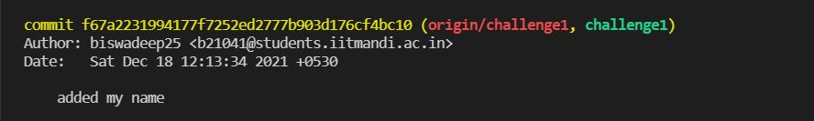

**CHALLENGE-2**

Merged version1 from upstream to challenge2 branch

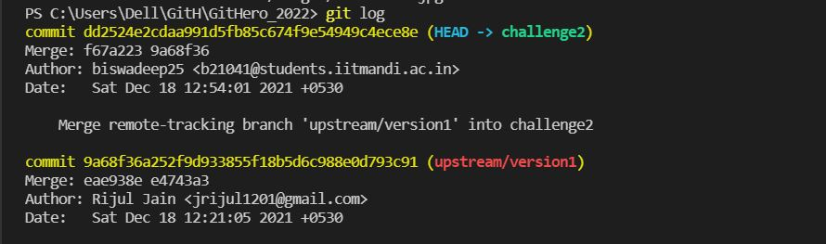

**CHALLENGE-3**

Changed score from 1000 to 0

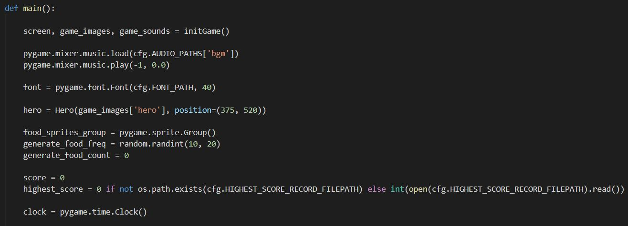

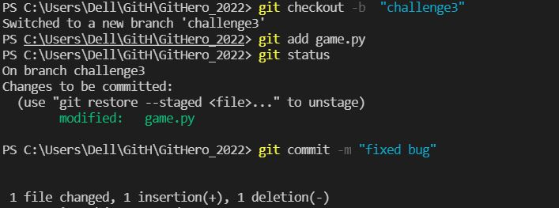

**CHALLENGE-4**

Reset Repository one commit back



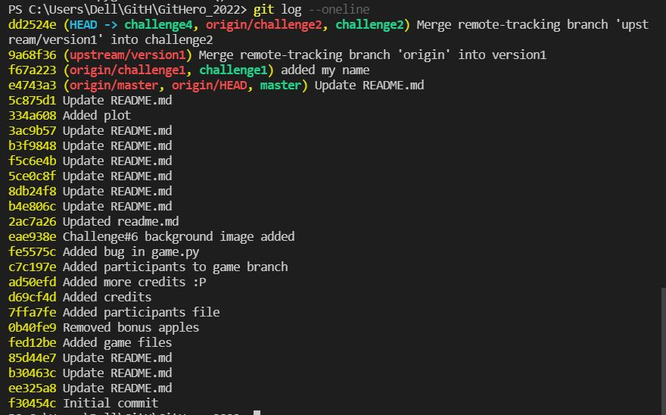

Changes since Challenge 3

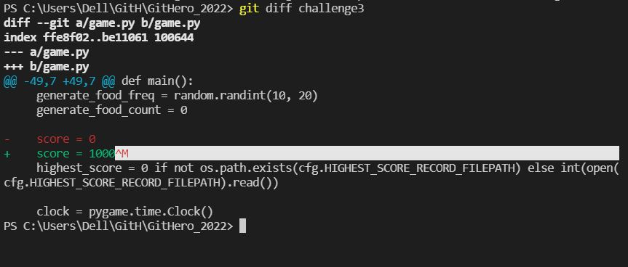

Reset using commithash

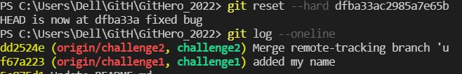

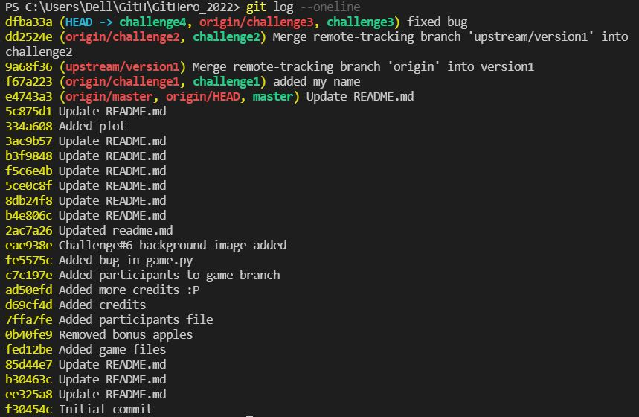

**CHALLENGE-5**

Creating Vicku.txt and adding required text and committing

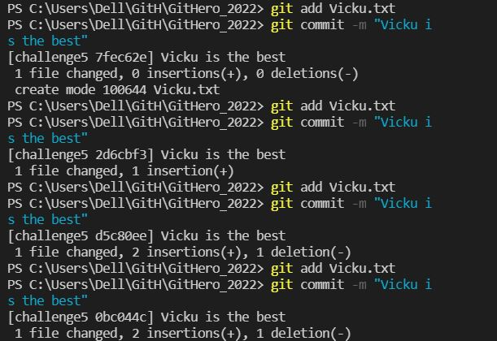

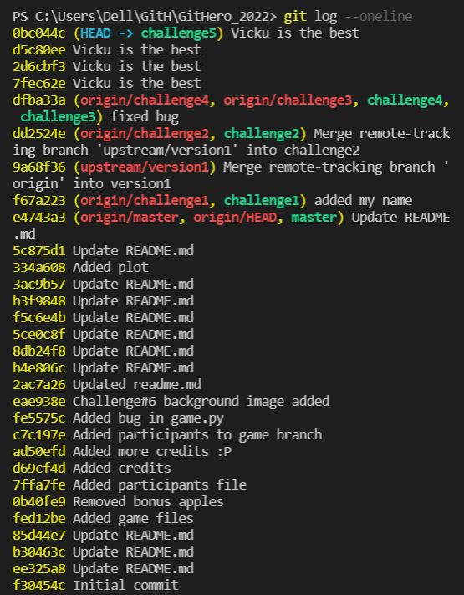

Using Git Rebase commands

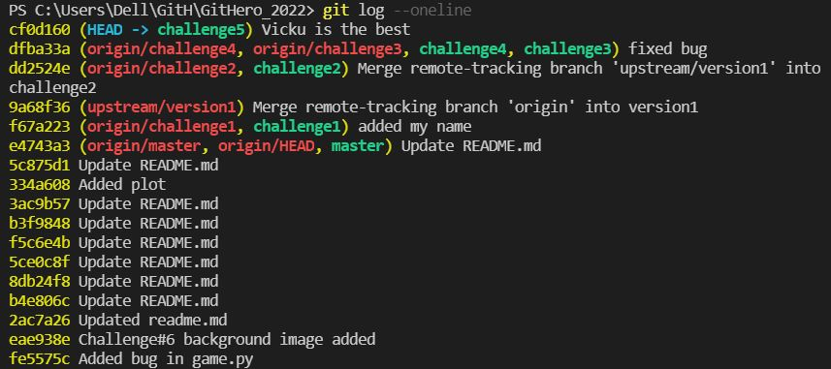

Pushing challenge5

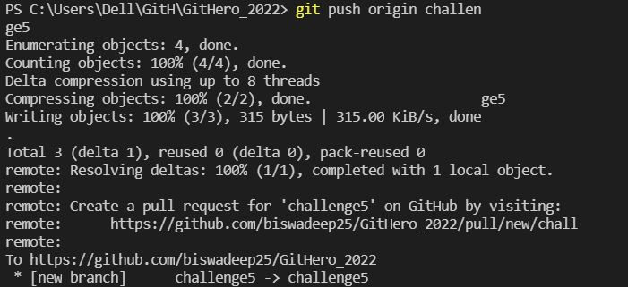

**CHALLENGE-6**

Difference in challenge5 before using git stash

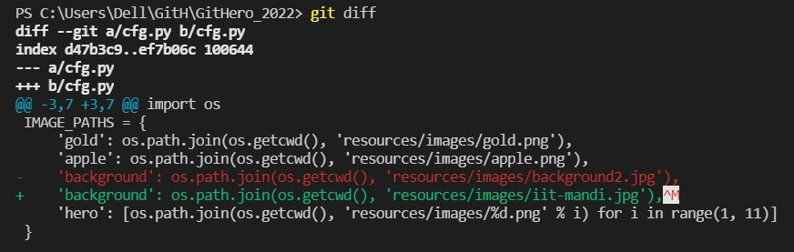

Applying changes in branch challenge6 from stash

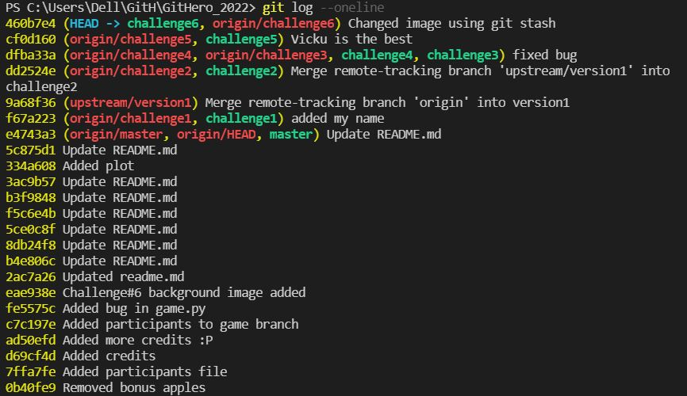

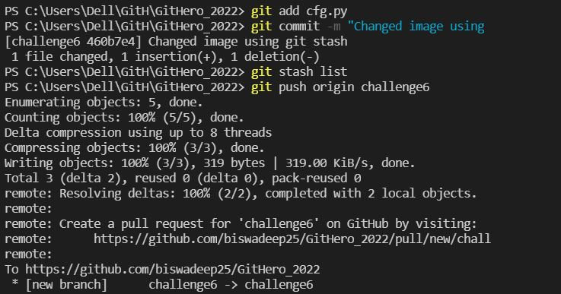

**CHALLENGE-7**

Fetching challenge-7 from upstream

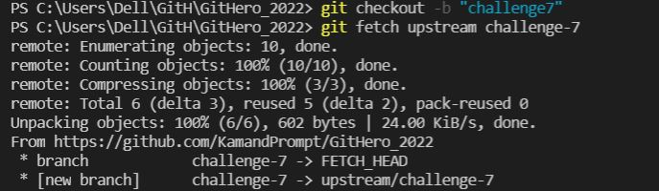

Changes implemented while merging conflicts

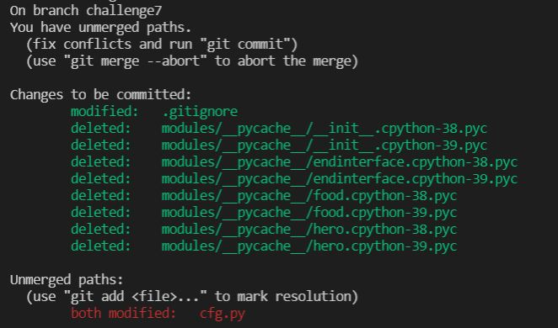

Committing after resolution of conflicts



Pushing branch challenge7

