Problem:1

1. **Forked** the repo in the given situation
2. Copy the path given after **“CODE”** is pressed
3. Cloned the repo using -> **git clone “PATH”**
4. New Branch Using -> **git checkout -b “Challenge1”**
5. Commited the changes using **-> git commit -m “Challenge1solved”**
6. Push the changes using ->**“git push origin Challenge1”**
7. Made a pull request.

PROBLEM 2:

1. New branch as🡪 **git checkout -b “Challenge2”**
2. Add a new remote upstream using-> **git remote add upstream(Jo bhi location ho daal do)**
3. Fetch the Version1 using -> **git fetch upstream/version1**(for some reason it worked as **git fetch upstream version1** also)
4. Type : **git merge** to merge version1 and your own branch
5. **Git log** is used to know the history of everything
6. Now use : **git push origin “Challenge2hogaya”**

PROBLEM 3:

1.New Branch as: **git checkout -b “Challenge3”**

2.Opened-(as soon as I clicked VS a light beam with approximated wavelength of 450nm went into my eye contacted my retina and the neurons started firing new brain bridges were created) Visual Studio opened

3.Change value of score=0 from score=1000

4.commit changes and make pull request (**PR**) **again**!

Problem 4:

1. Create a new Branch
2. Used **git log**  and noted last two commit hash
3. Reset kara repository ko by : **git reset –hard<commithash>**
4. Now to see difference in the situation/code before and after reseting repository type: **git diff challenge4 when on challenge3**
5. Reset the repo using 3rd step
6. Used : **git log --oneline**
7. Pull request

PROBLEM 5:

* 1. Created a new branch
  2. Created a file VICKU.txt
  3. Added 4 commits and commited 4 commits
  4. Removed last commit
  5. Then squashed using : **git rebase -i HEAD~3**
  6. Preplaced pick by squash using **“ctrlX”**
  7. PR

PROBLEM 6:

1. Changed “cfg.py” by replacing the “background2”to “iit-mandi”
2. Used Git diff
3. Then : **git stash**
4. Then:**Git stash list**
5. Then made a branch :  **git stash branch “challenge6”**
6. Add and commit
7. **Git stash list**
8. **Push and PR**
9. [https://git-scm.com/book/en/v2/Git-Tools-Stashing-and-Cleaning (iska](https://git-scm.com/book/en/v2/Git-Tools-Stashing-and-Cleaning%20(iska) istemaal kiya gaya tha )

PROBLEM 7:

1.Made branch

2. fetched branch

3. merge kiya and error was presented

4.Saw the challenge video

5.Open the VS

6. PROBLEM KYA AAYI THI**: Accept incoming changes**

7. Thik kaise kara: “**Accept current change**”(Iss process mai branch ka naam “chalenge” rakha tha)

8.Merge

9. ADD and Commit

10.PUSH AND PR

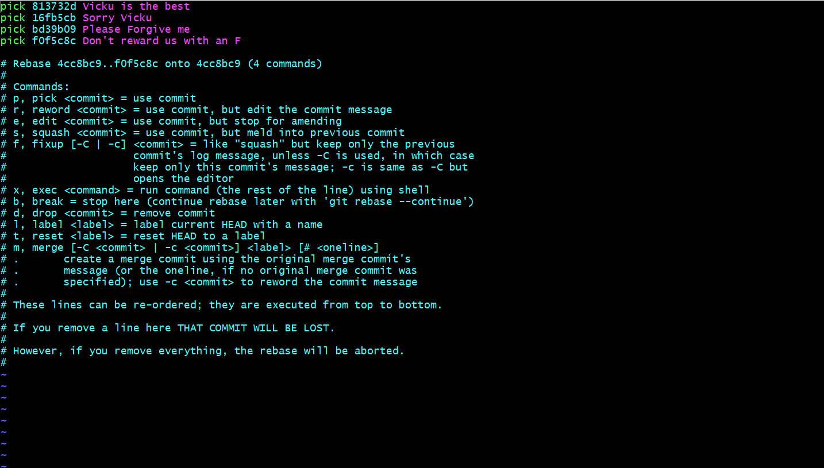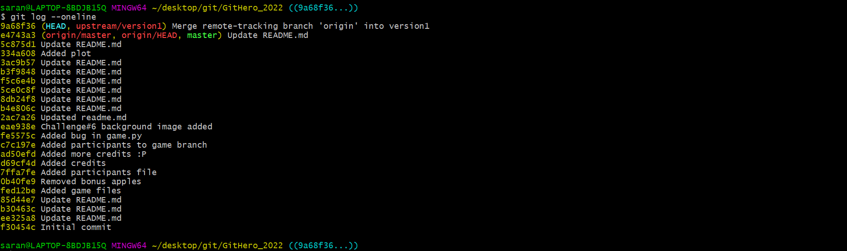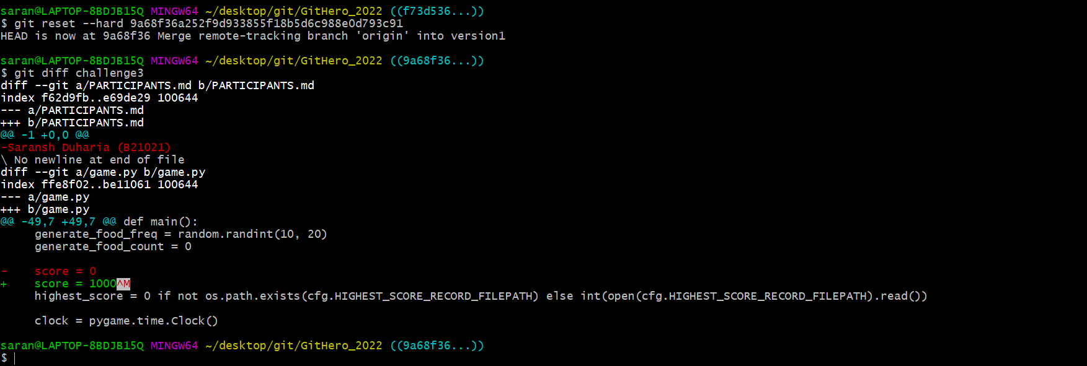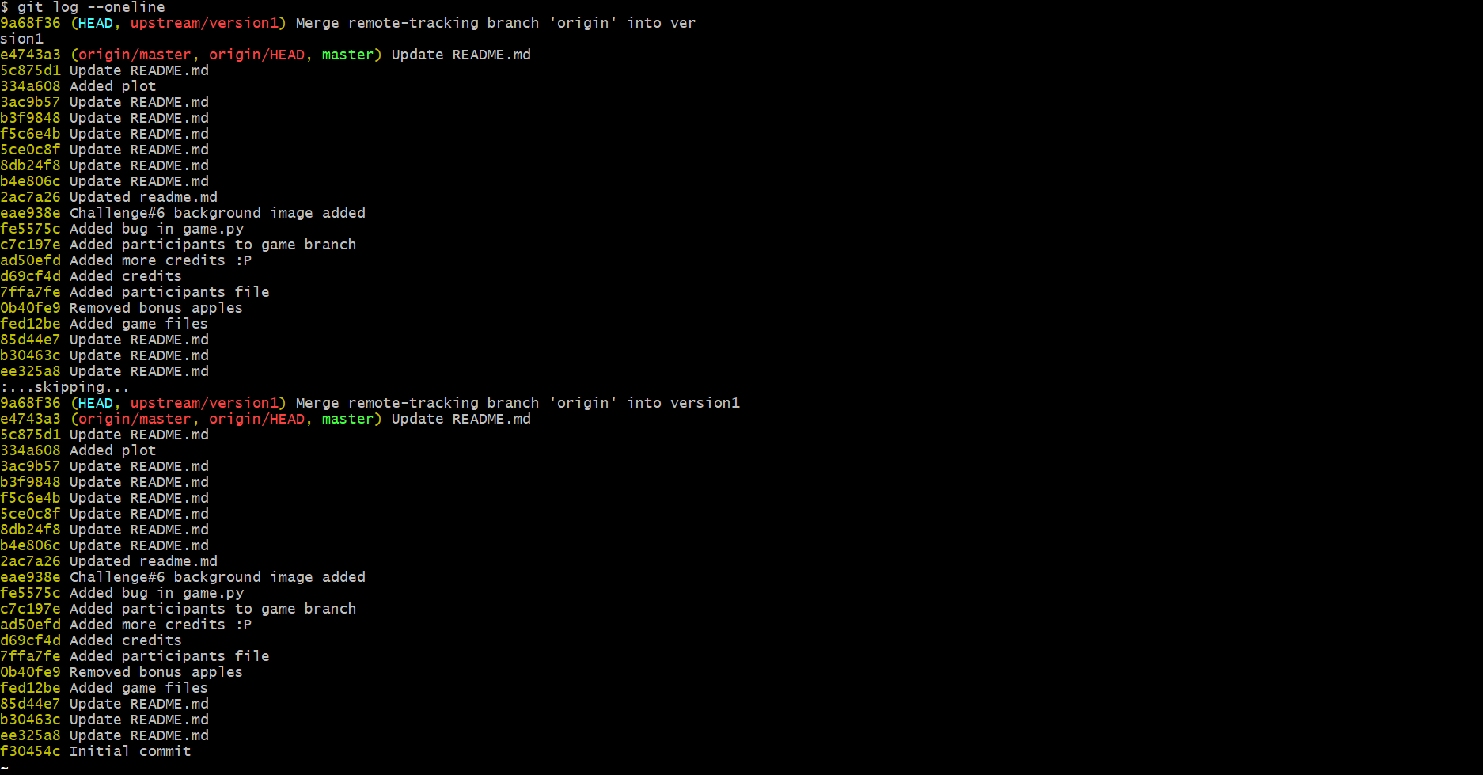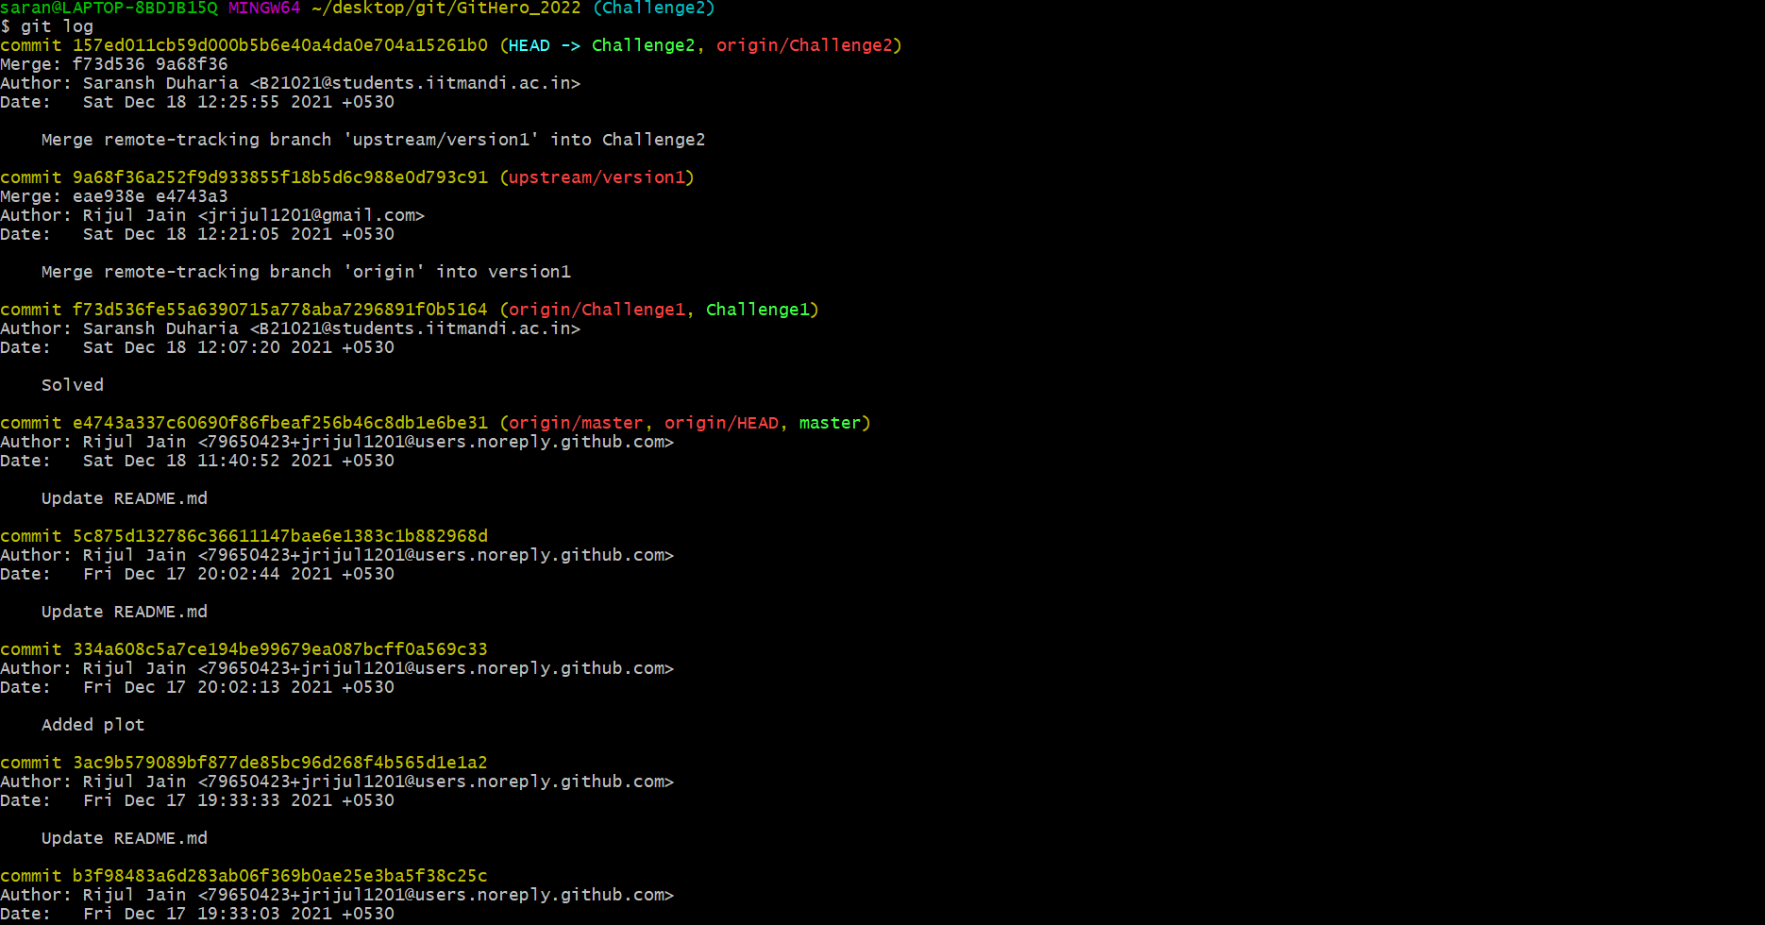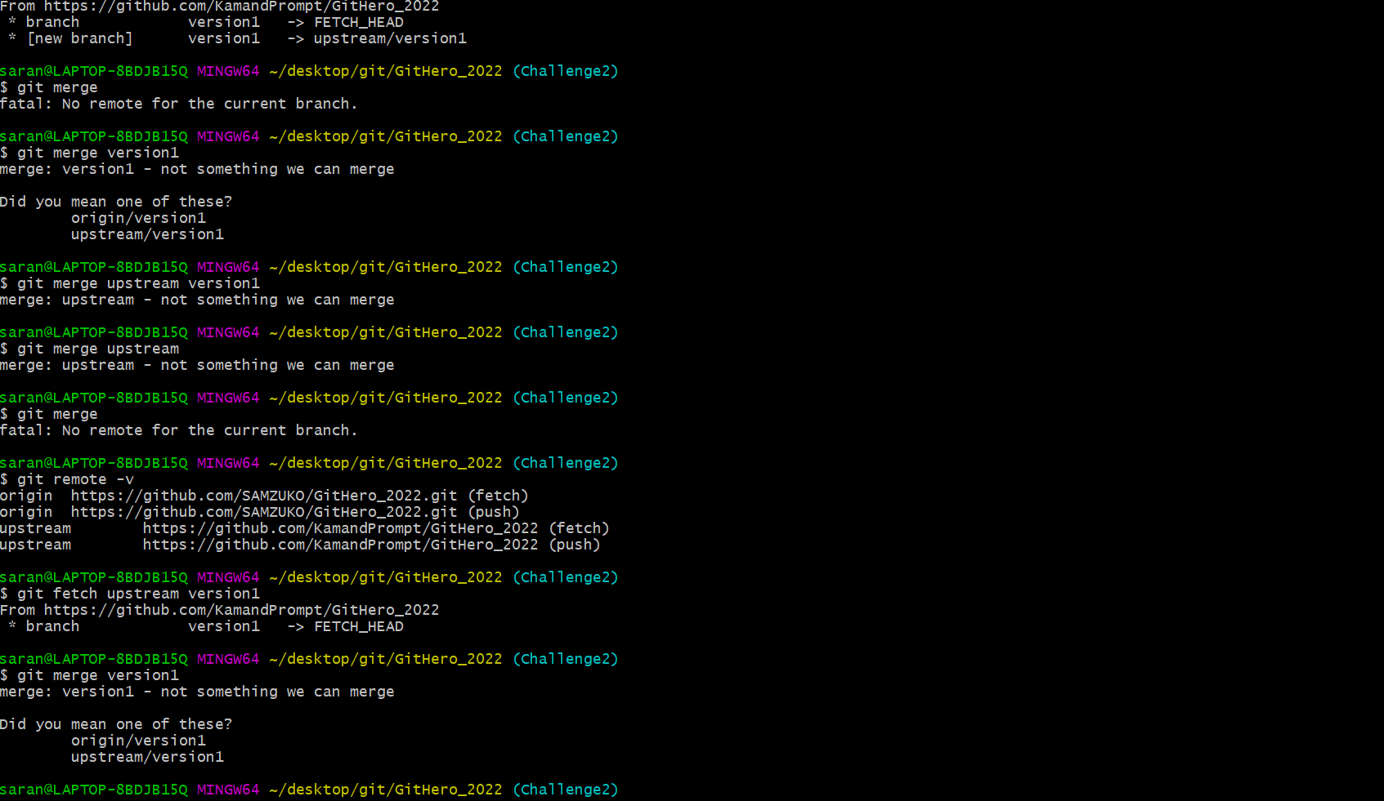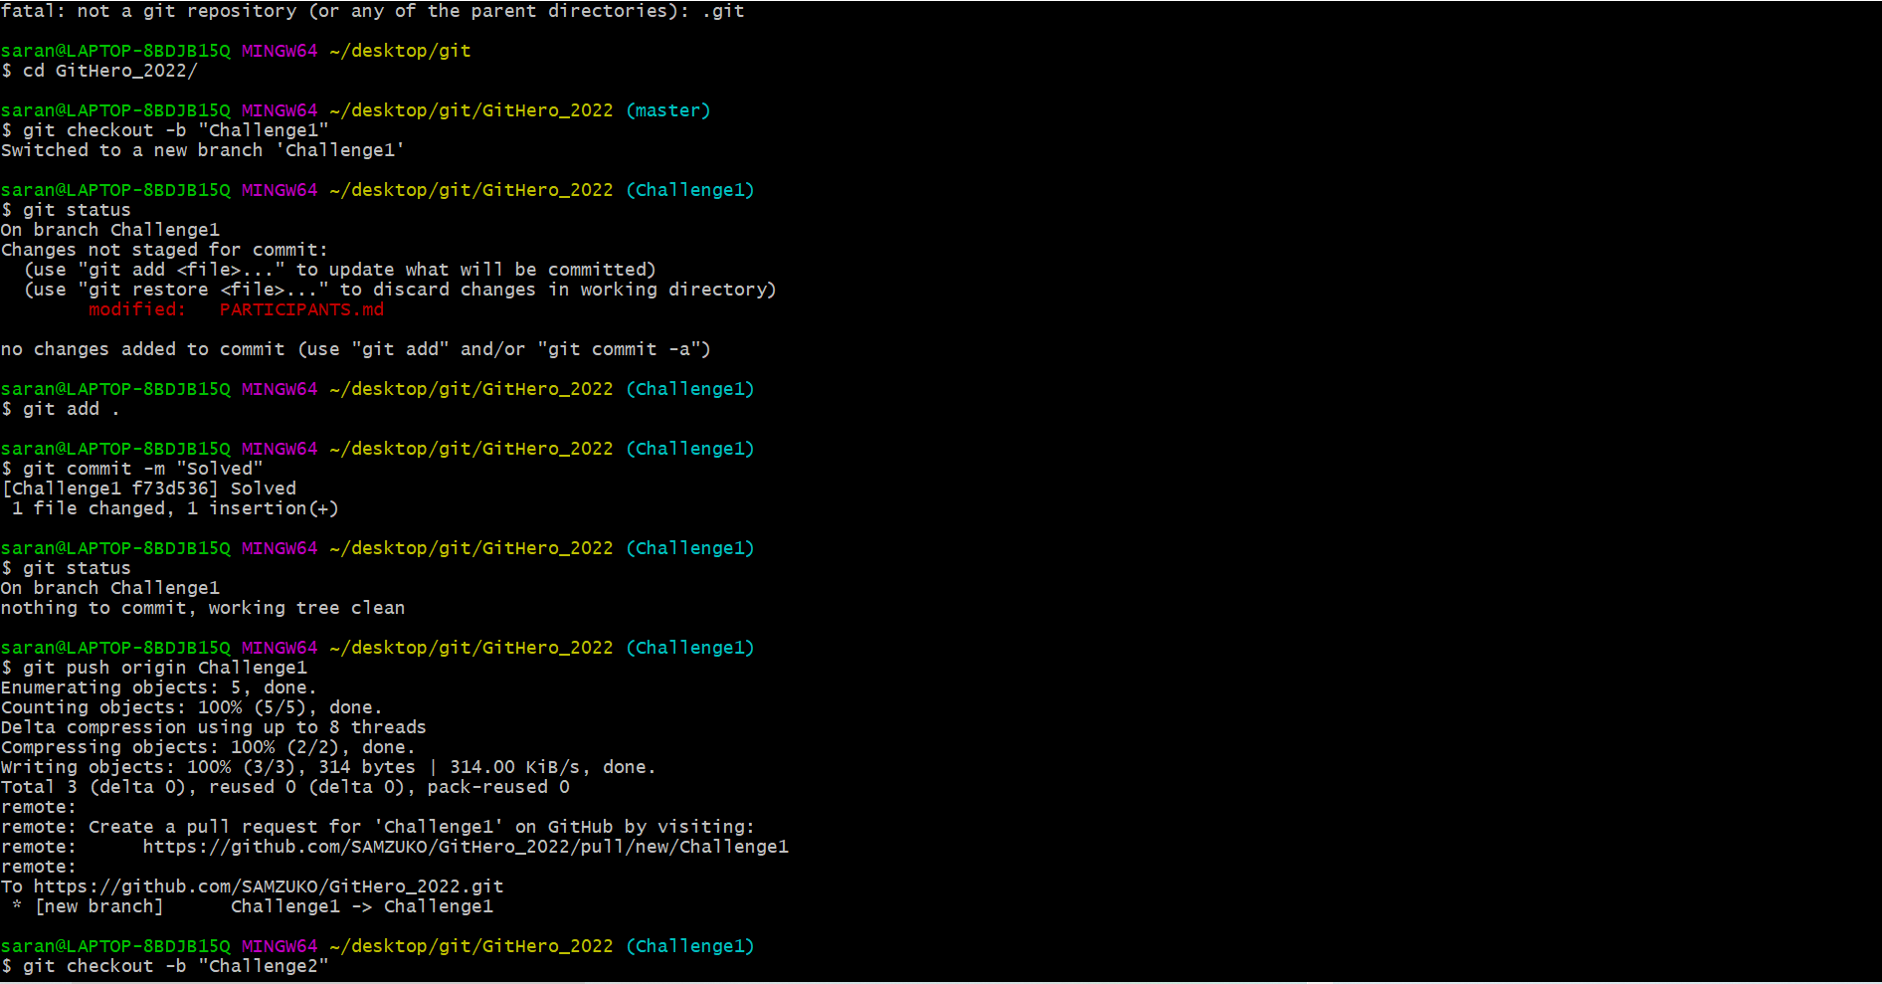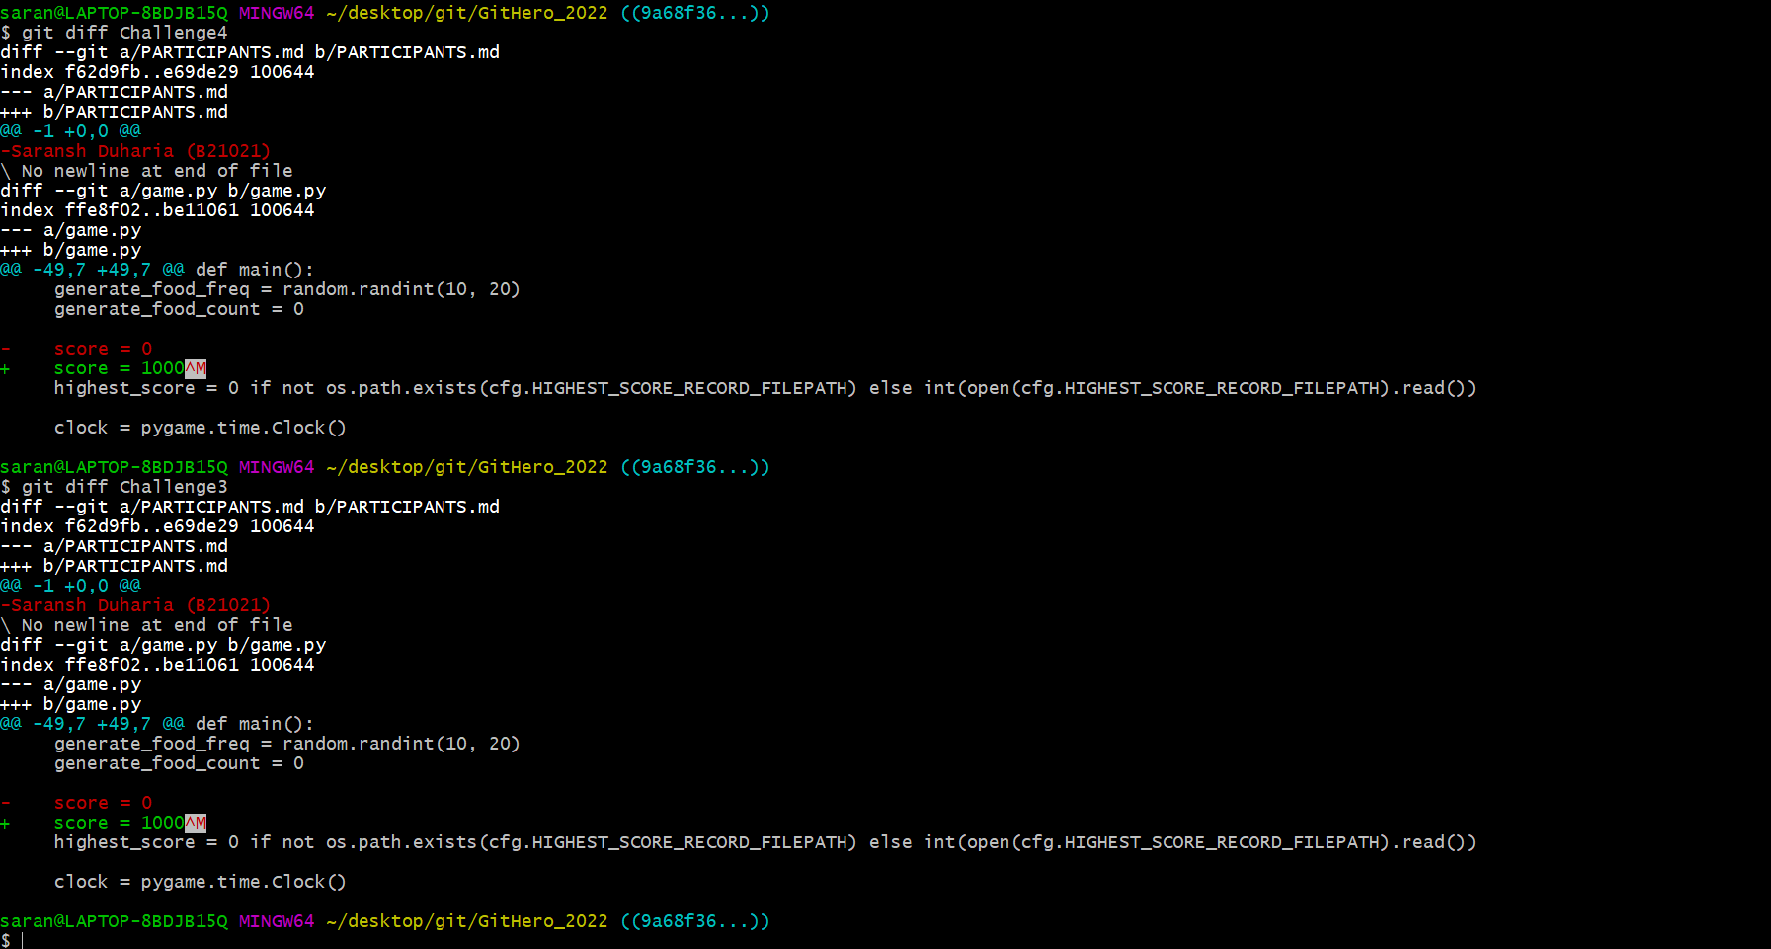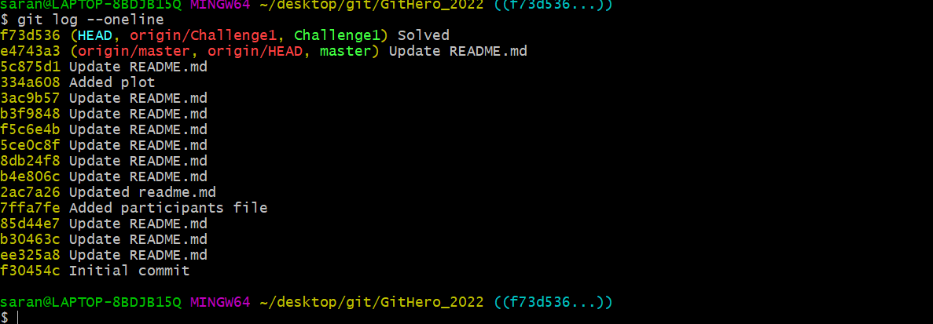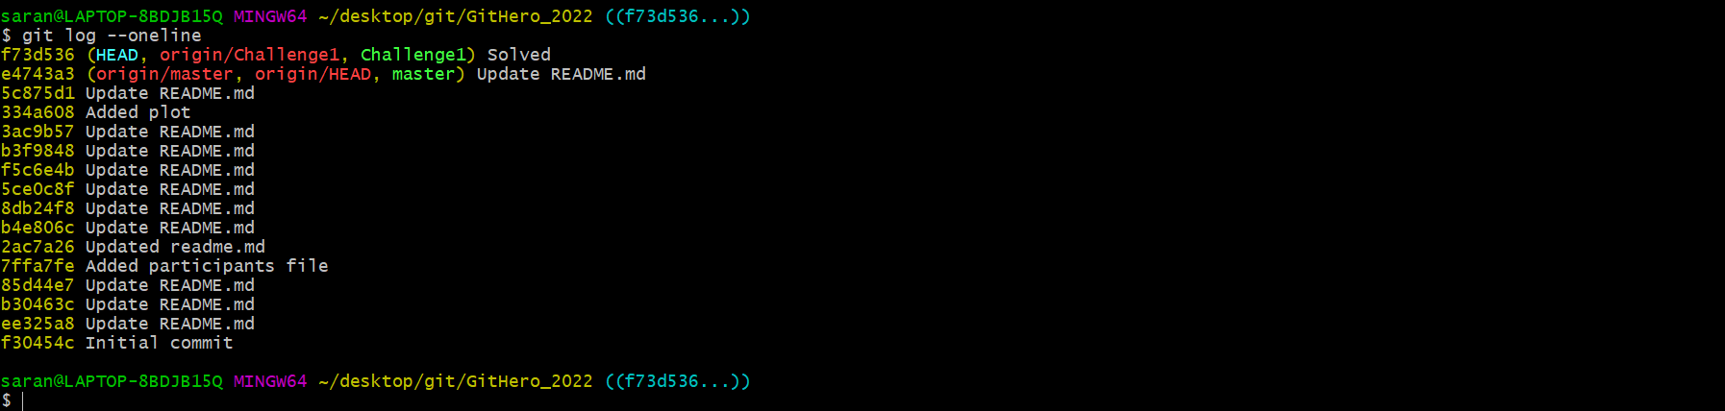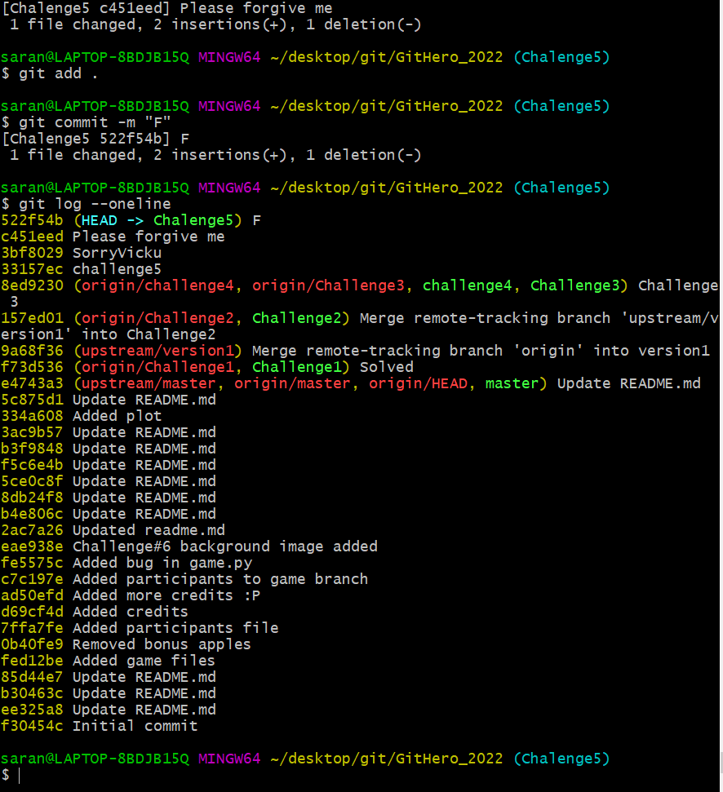Ch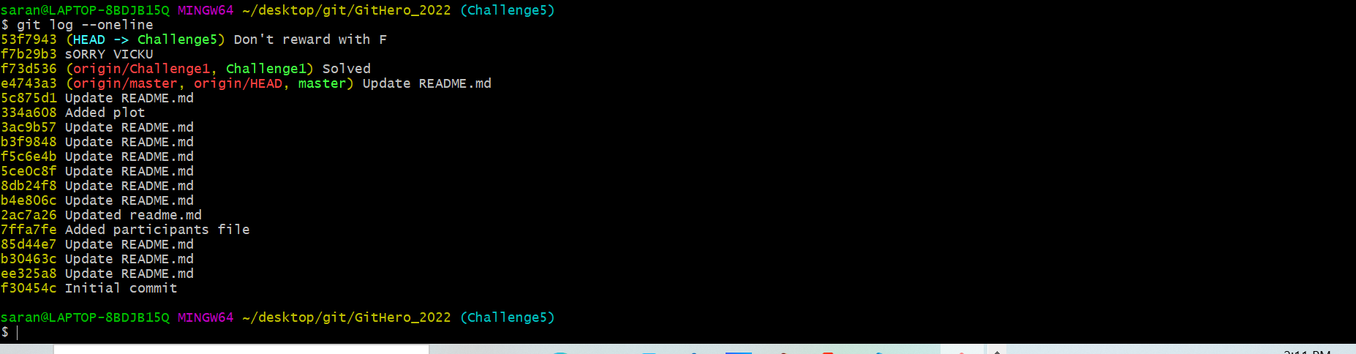

Challenge 5 ki proper slides