Challenge #1:
Forked and cloned repo.
Made and checkout to branch challenge1
modified,added and commited participants.md
pushed changes and made PR
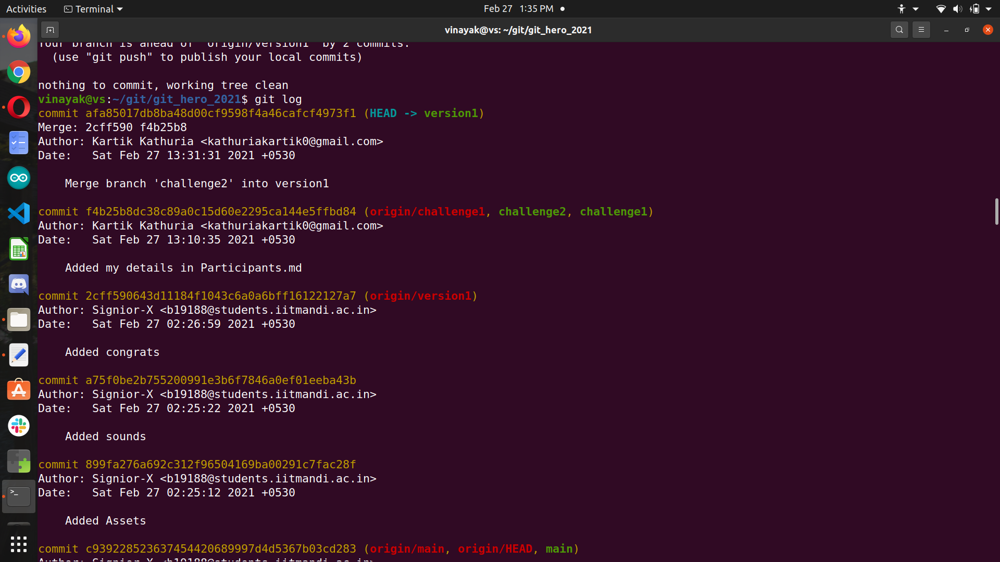
Challenge #2:
made branch challenge2
fetched version1 and merged it to challenge2
then pushed and made PR.(did it wrong first time,came to know after doing Challenge #4)
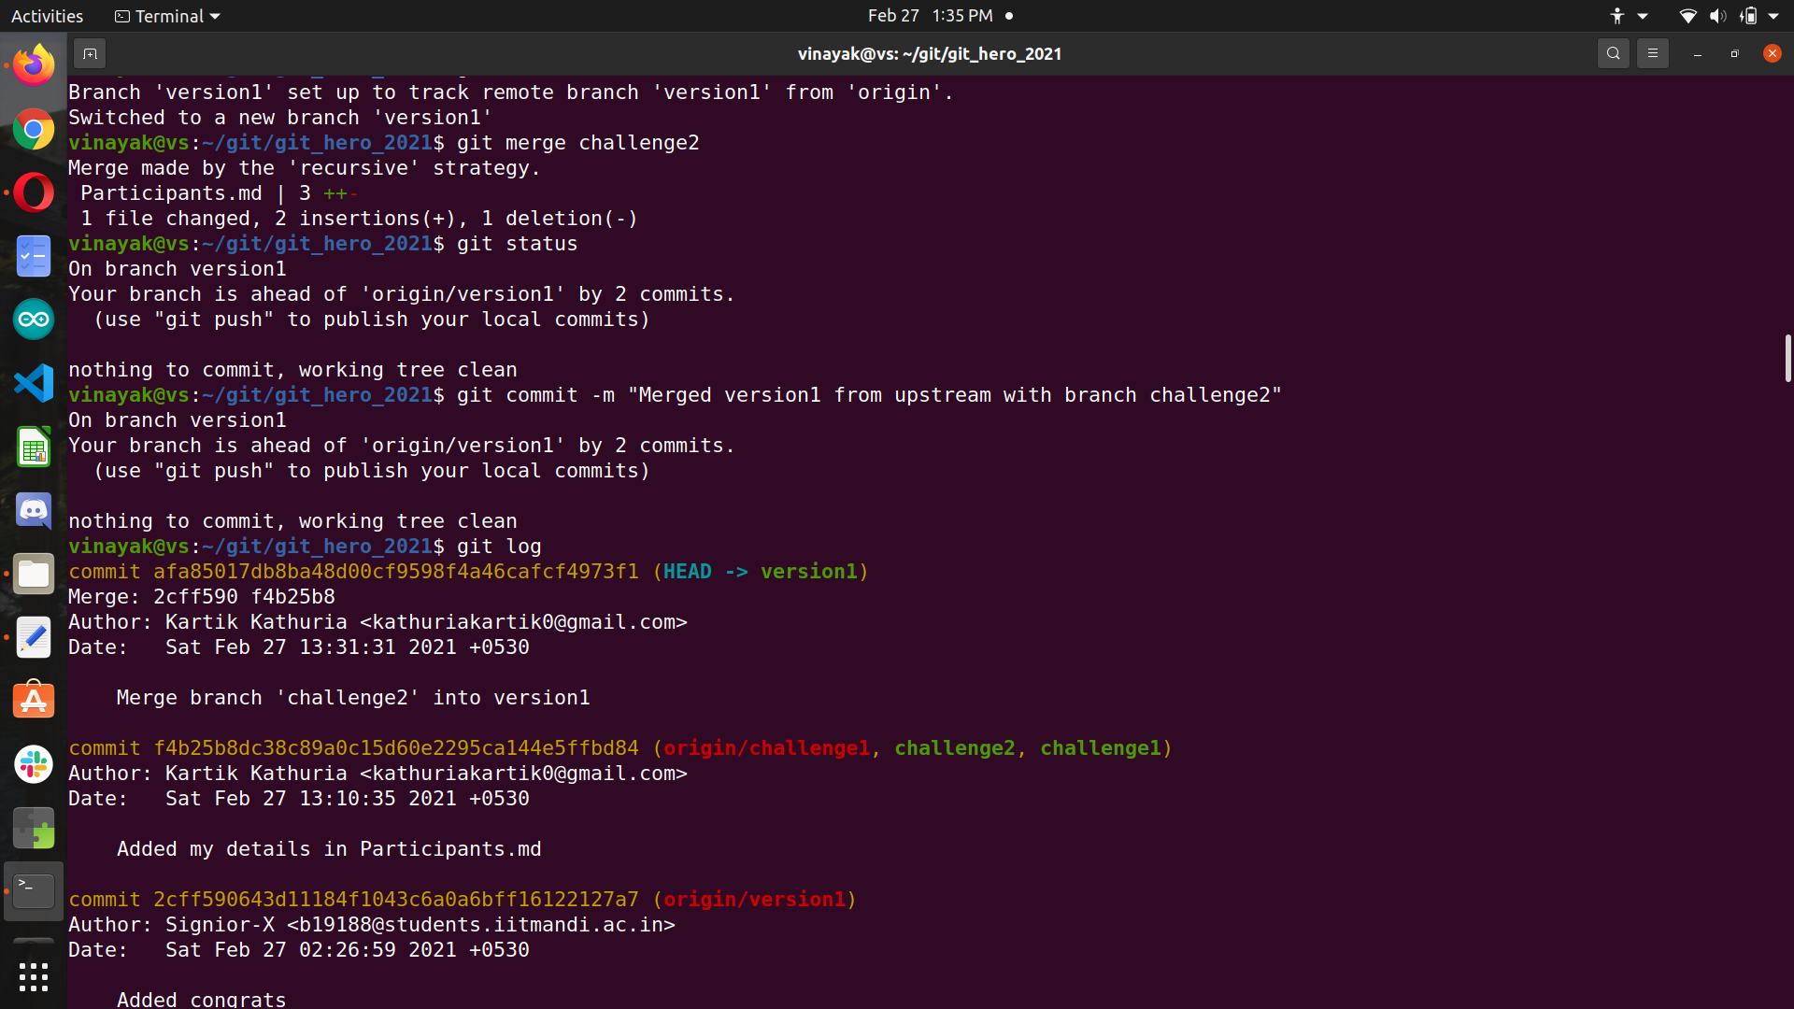
Challenge #3:
created challenge3 branch
squashed last 5 commits by mistake(Changed 4 picks to squash instead of 3) :’)
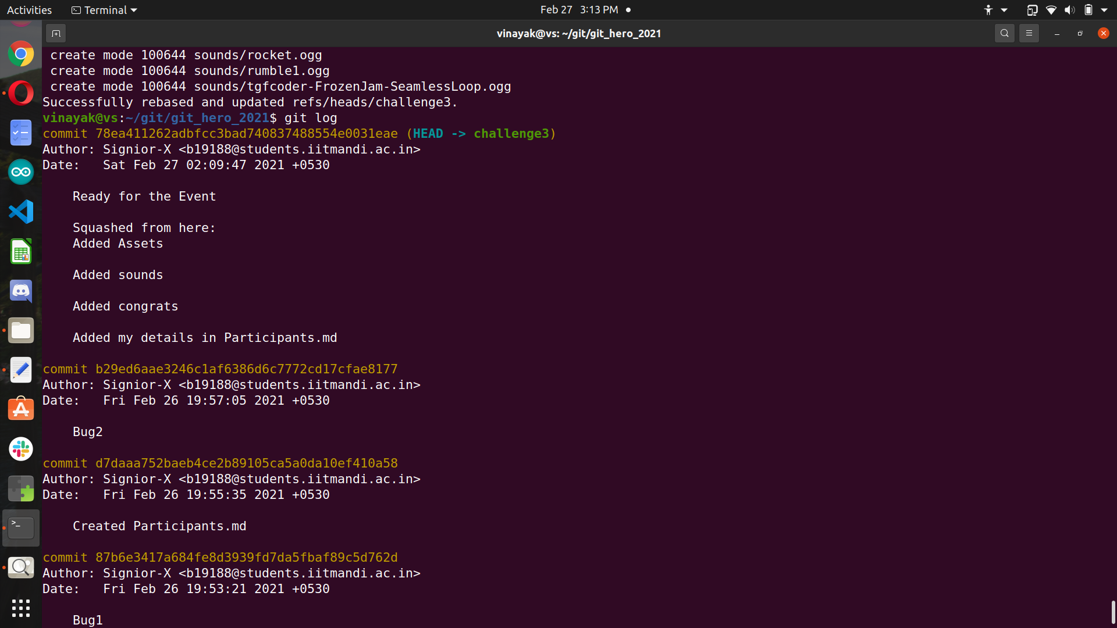

Challenge #4
Before attempting challenge#2 second time:
Did the stashing properly.
Edited line 24,25
popped the stashed changes.
But since Challenge #2 was wrong,version1 files were absent during pushing.
PR was already done before realizing files missing when playing the game.(Realized when running game during challenge #6 :’) )
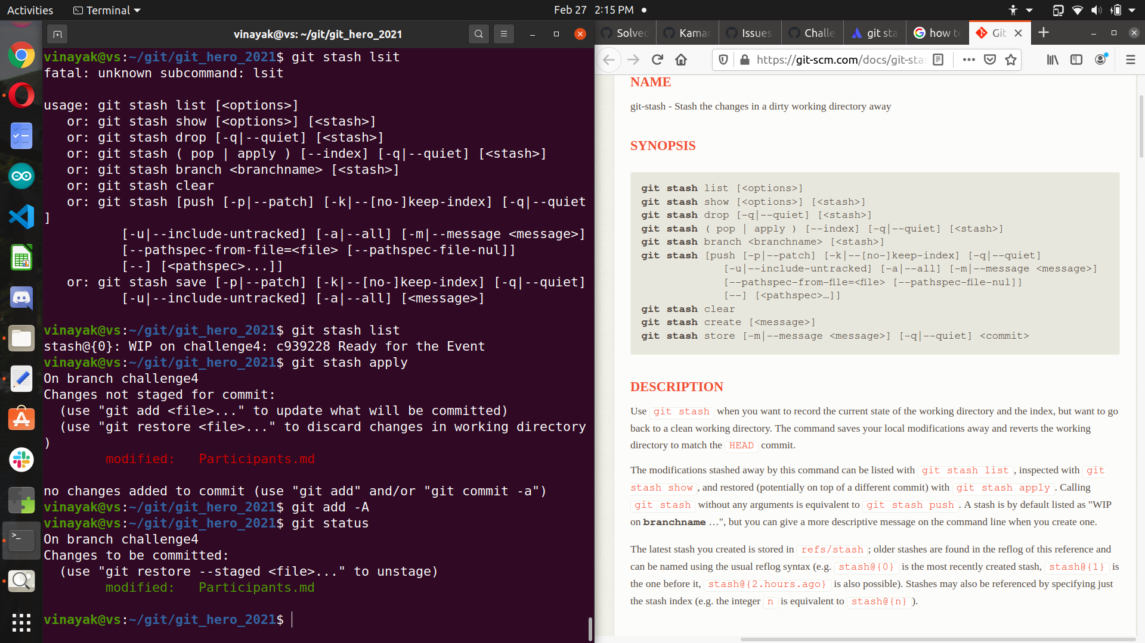
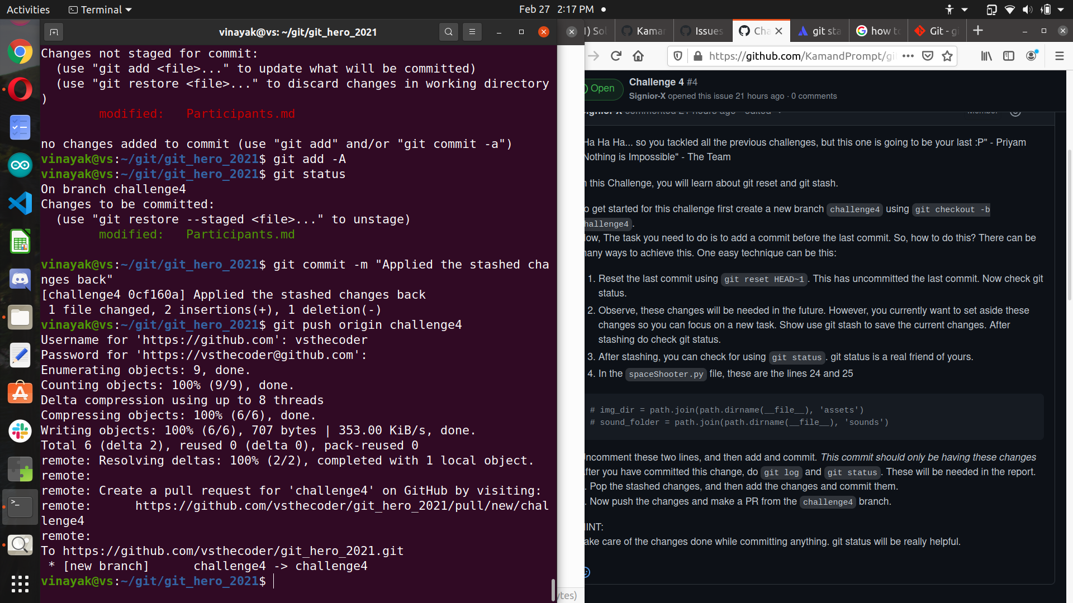
Challenge #5
Without files from version1,
cherry picked commits from part 1,2 and 3
in branch challenge5
using “git cherry-pick <hash>”
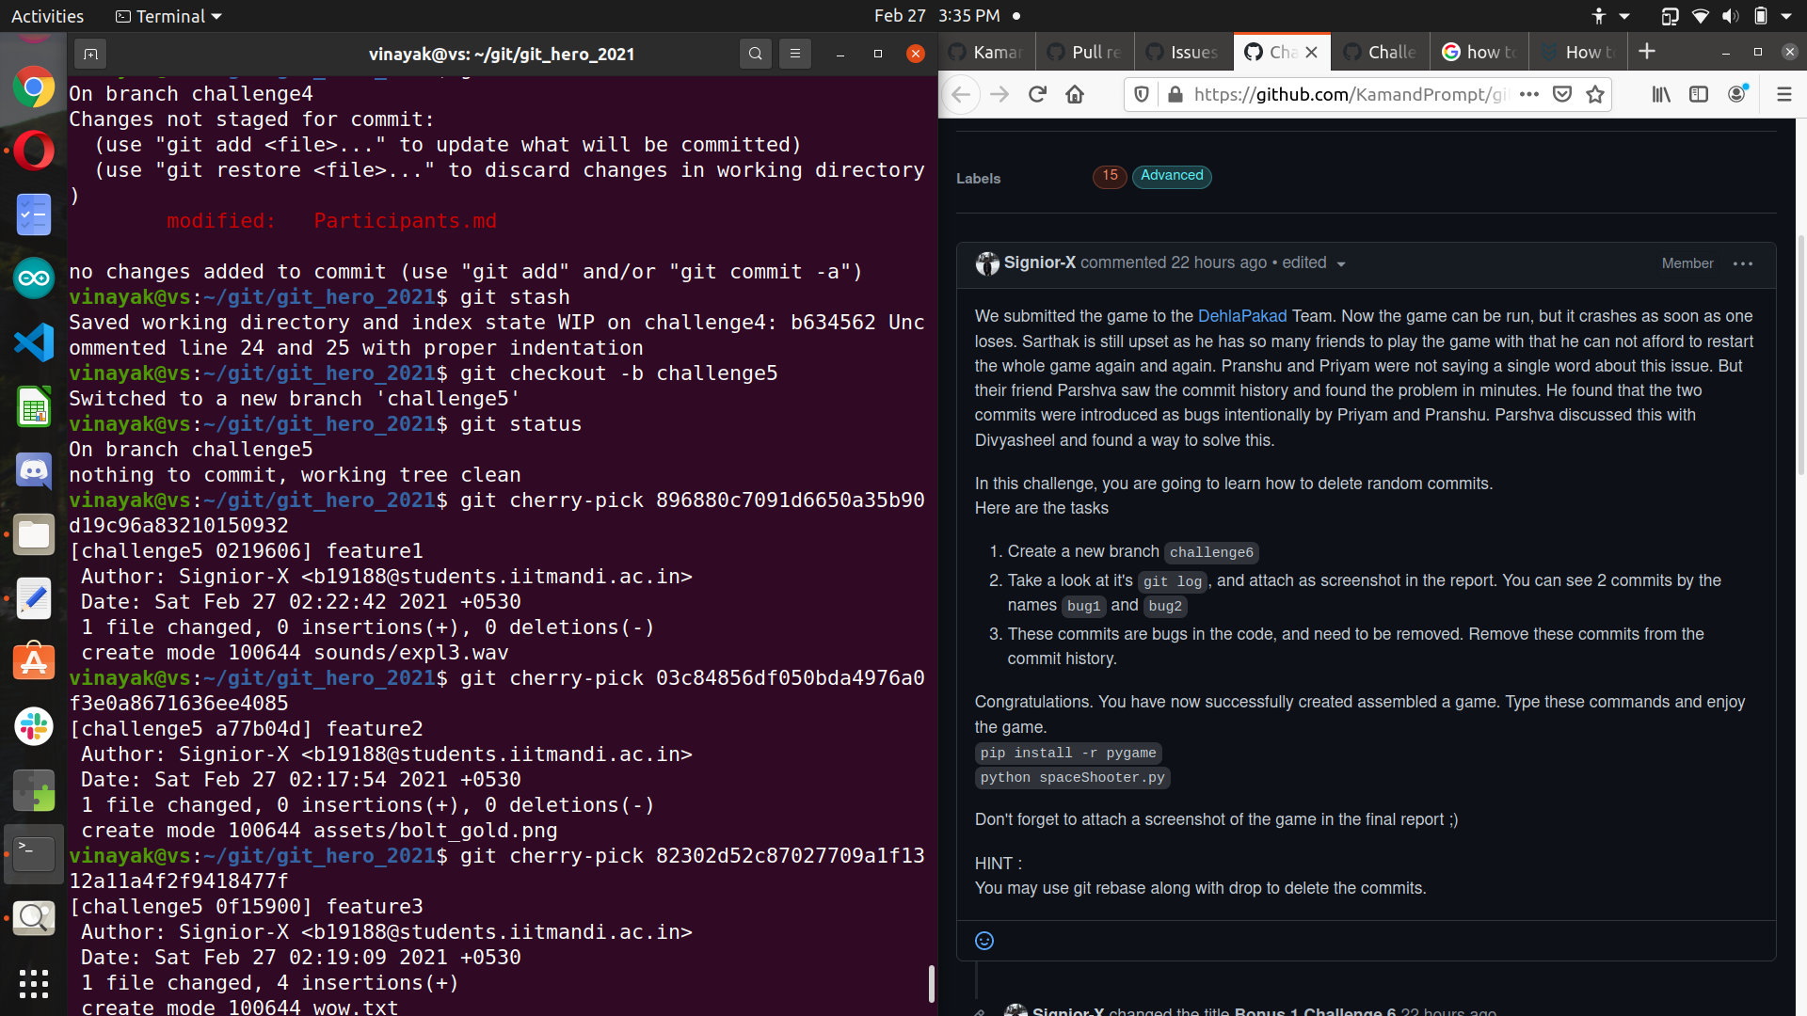
Did it successfully and made PR

Challenge #6
in branch challenge6
used
“git rebase -i 87b6e3417a684fe8d3939fd7da5fbaf89c5d762d~”
and
“git rebase -i b29ed6aae3246c1af6386d6c7772cd17cfae8177~”
and edited the commits history by changing
pick to drop and removed bug1 and bug2 commits
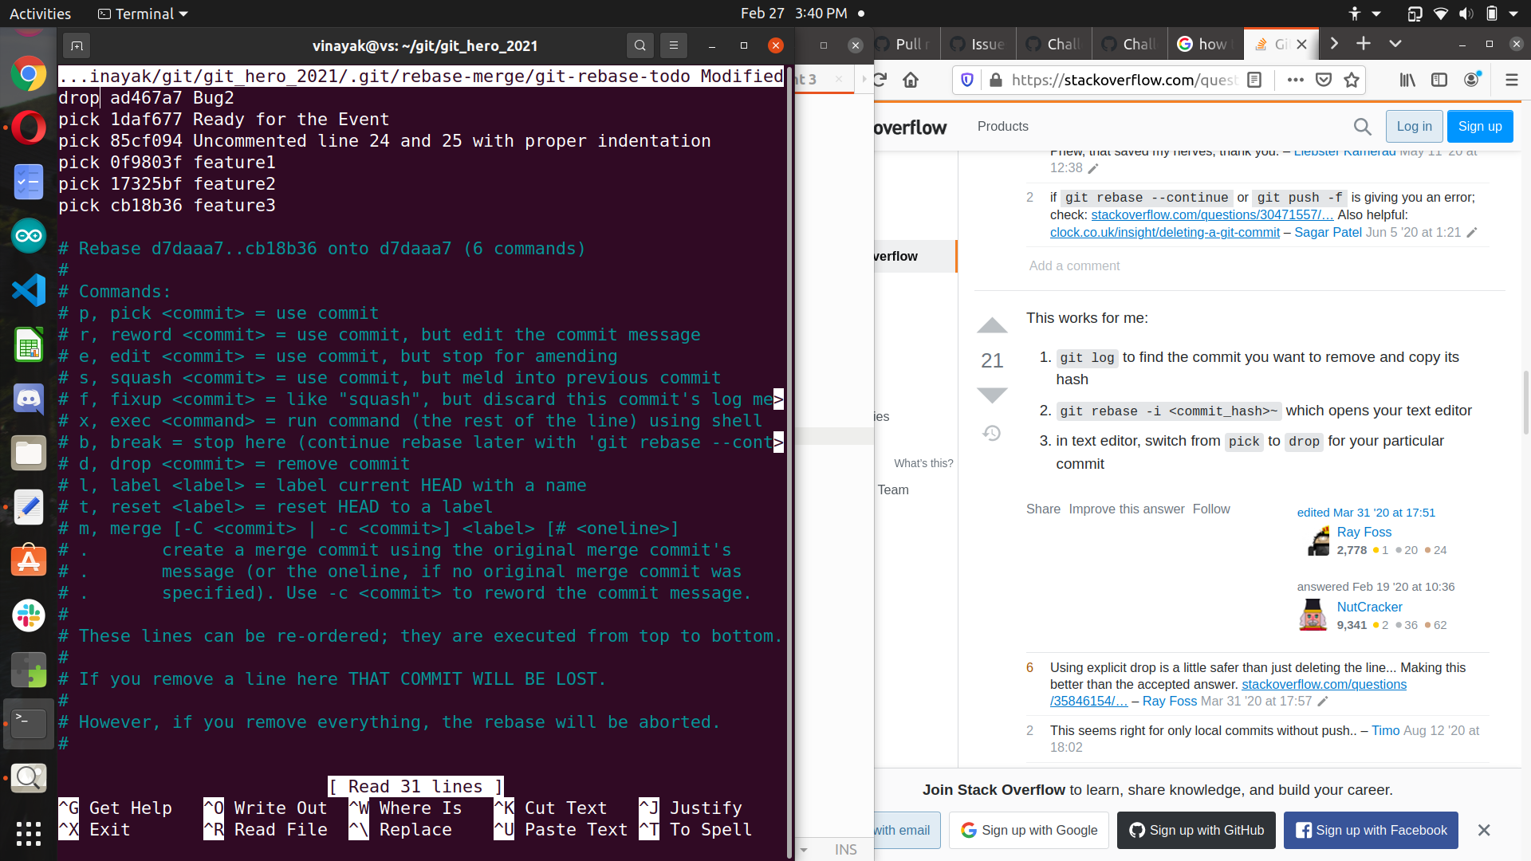
installed pip and pygame
and when running the spaceShooter.py
it showed file missing errors due wrong merging in challenge2(version 1 files not present)

So manually gathered files from version1 to challenge6 branch.
Now the game executed successfully.

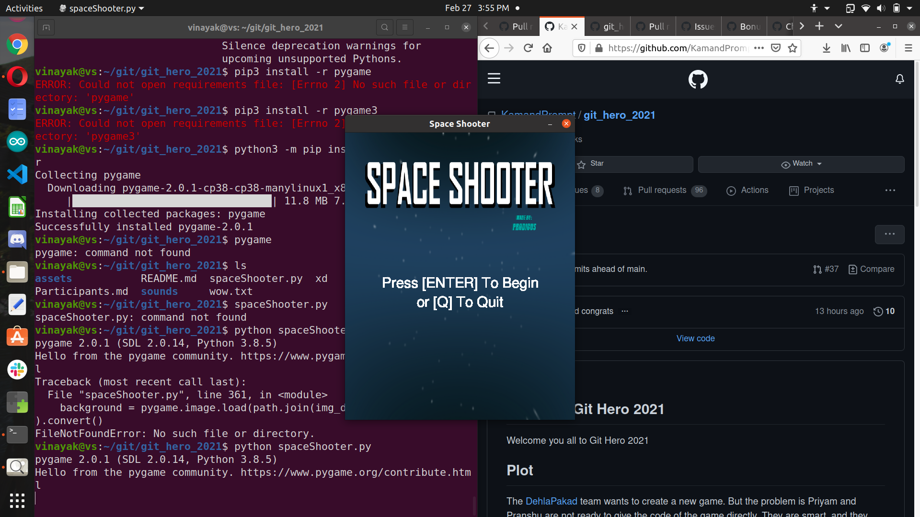
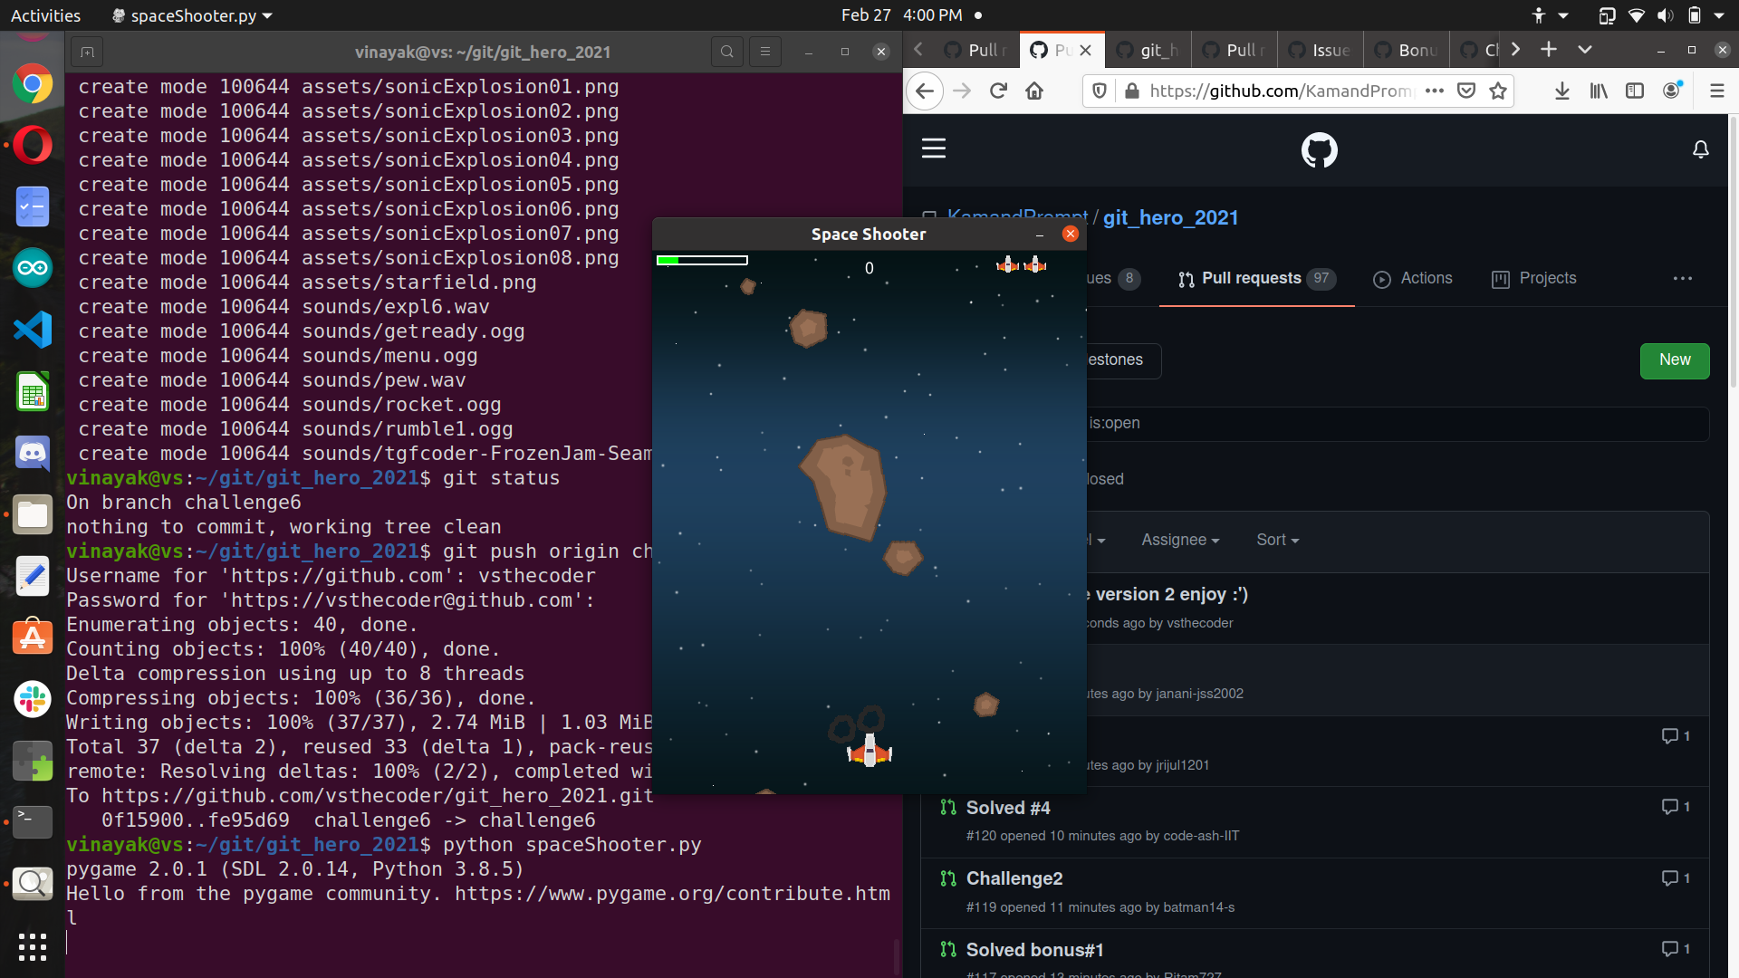
:)

Nice event,Thanks

