Welcome to the Recipe Application! This application provides a convenient way to manage and interact with your recipes directly from the command line.

**GitHub Repository**

Explore the source code and project files on GitHub: [Recipe_App Repository](https://github.com/Kamapholoba/Recipe_App)

**Compiling and Running the Software:**

To compile and run the Recipe Application, follow these steps:

1. Open the solution file (`Recipe_App.sln`) in Visual Studio.

2. Build the solution by navigating to **Build > Build Solution** from the menu.

3. Once the build is successful, run the program by pressing **F5** or selecting **Debug > Start Debugging**.

**Usage:**

1. Upon launching the program, you'll be presented with a menu of options.

2. Select an option by entering the corresponding number and pressing **Enter**.

3. Follow the on-screen prompts to enter recipe details, view recipes, scale recipes, reset quantities, clear all data, or exit the program.

4. Enjoy managing your recipes seamlessly with Recipe Application!

**Screenshots**

The application sorts and displays all entered recipes in alphabetical order by their names. This is implemented by sorting the list of recipes before displaying them. When the user picks 2 from the menu it displays recipes in alphabetical order.

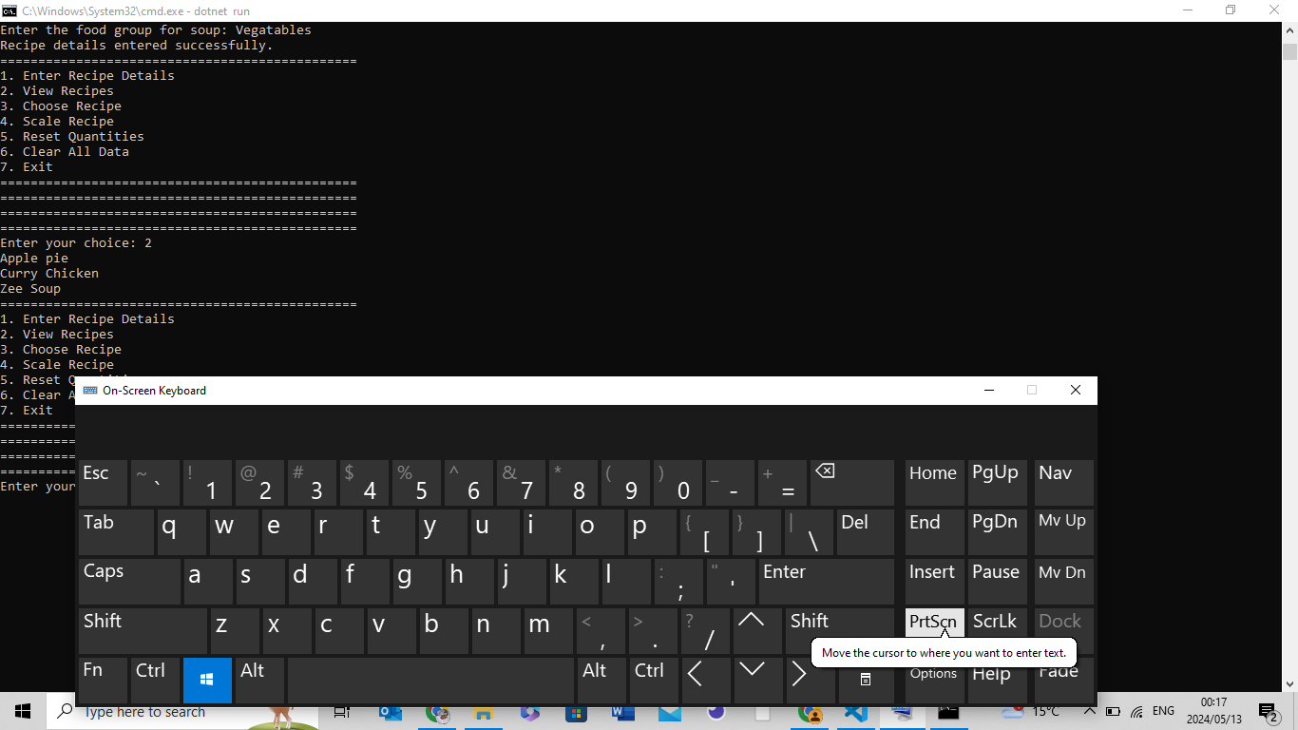

Users can select which recipe they want to view from the list of displayed recipes. This is done by entering the number corresponding to the recipe's position in the list. Choose numbers starting from 0 and upwards depending on the collection.

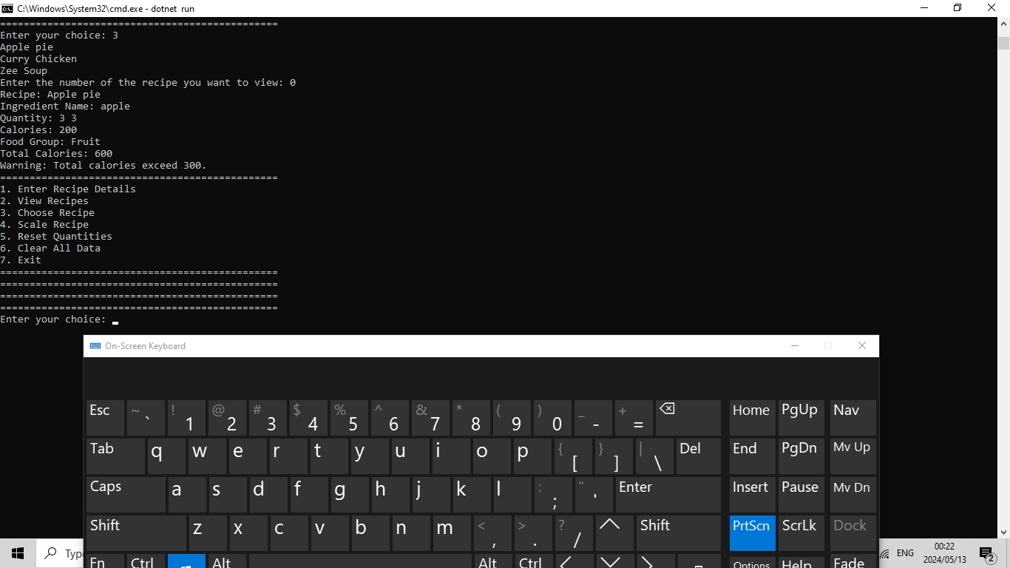

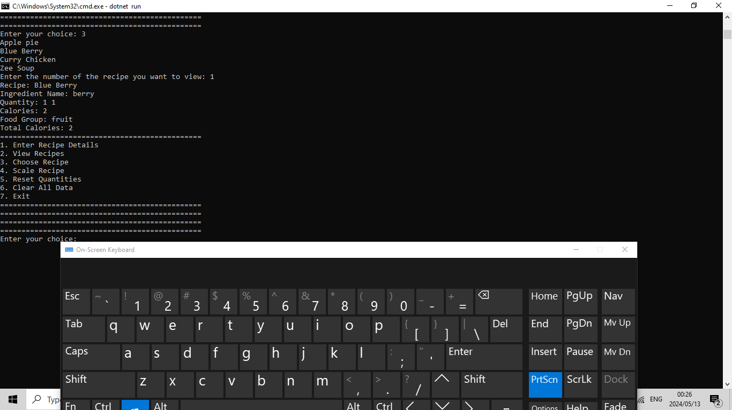

The application calculates the total calories of all ingredients in a selected recipe and displays this information. If the total calories of a recipe exceed 300, the application notifies the user with a warning message. As seen in the screenshot:

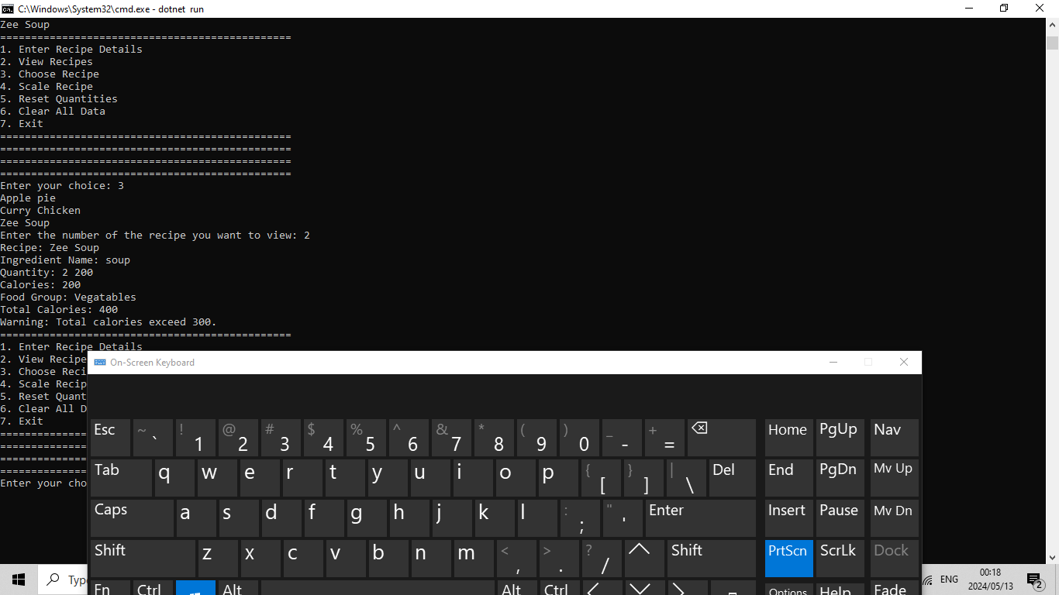

The app allows users to enter an unlimited number of recipes. This is achieved by using a list to store recipes, also added more inputs on ‘Entering Ingredient Details’: food group and calories. As seen below:

