**Route ZSR 191-193 for Microsoft train simulator and Open rails**

Before installation please, read this document

**Content**

**Introduction 3**

**Using in Microsoft train simulator and Open rails 9**

**License terms 15**

**Acknowledges 17**

**Introduction**

I am very happy, that you get Route ZSR 191-193 for Microsoft train simulator 1.4 and for Open rails.

This project in current version contains sections ZSR 191 Michalany – Medzilaborce mesto.

This route has finished section between Michalany – Humenne mesto with completely scenery and only finished route without scenery or with partially scenery to Medzilaborce mesto with original buildings of stations and stops. You can enjoy all section from Michalany to Medzilaborce mesto. The next section is ZSR 193, which is builded to Vranov nad Toplou. This section is not good for any activities or driving. It is builded only with track, without any scenery or track`s signals. The next completely finished section is ZSR 195 Banovce nad Ondavou – Matovce borders with Ukraine. This route is completely finished and you can full enjoy it. Very specific section is SRT 500 route with bigger spread than other routes in my project. This route is SRT 500 from Haniska pri Kosiciach to Matovce-border with Ukraine. This route is completely finished. The local route ZSR 192 Trebisov – Vranov nad Toplou is finished only Trebisov –Secovce. From Secovce to Vranov nad Toplou are only tracks without any signals. Very important section is ZSR 190 Kosice –Cierna nad Tisou, which is completely finished to Biel and partially finished to Ukrainan borders. The next sections are ZSR 169 Barca – Cana, ZSR 160 Barca – Velka Ida, ZSR 180 Kosice –Kysak and ZSR 189 Kysak-Presov. These sections are not completely finished and in future will get under improvement process.

More information you can see on figure 1.

Figure 1

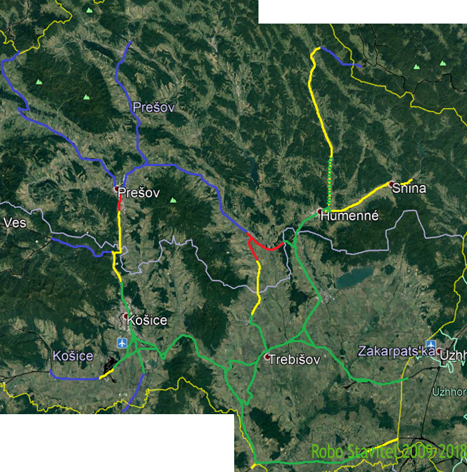

Green line is completely finished sections

Green and yellow is completely finished sections with partially scenery

Yellow completely finished sections without scenery

Red is only tracks, without signals scenery and necessary accessories

Blue color means routes, with will be builded in future

Whole project is developed with using real documents like videos, scheme, information about tracks and photos.

This project is a collection of routes, which have electricity and which do not have any electricity. These routes belongs to different categories like a corridor, regional or local.

Route ZSR 190 is very important route in Slovakia. This route is a corridor V. It connects Kosice with Cierna nad Tisou, Ukrainian borders Chop. The size is 1435 mm electricity 3kv. The route was opened in 1872. During years 1951-1952 it got second track and in 1961-1962 it got an electricity. In year 1985 was builded 16 km long route with connect Trebisov with Slivnik.

List of stations and stops

Čierna nad Tisou  
• Čierna nad Tisou zastávka  
• Biel  
• Dobrá  
• Pribeník  
• Veľký Horeš  
• Somotor  
• Streda nad Bodrogom  
• Borša  
• Slovenské Nové Mesto – odbočka do maďarského mesta Nové Mesto pod Šiatrom (Sátoraljaújhely)  
• Čerhov  
• Michaľany – križovatka s traťou 191 (Michaľany – Lupków)  
• Kuzmice  
• výhybňa Slivník odbočka Kalša – Trebišov  
• Kalša  
• Slanec  
• Ruskov  
• Bohdanovce  
• Vyšná Myšľa  
• Nižná Myšľa  
• Krásna nad Hornádom  
• Košice predmestie  
• Košice (hl. stanica) – križovatka s traťou 160 (Zvolen – Košice), 169 (Košice – Hidasnémeti) and 180 (Žilina – Košice)

(Source: http://vovlaku.teraz.sk/trat-zsr-190-cierna-nad-tisou-kosice/)

This project includes also Trat ZSR 191. This route is regional and connects Michalany, Trebisov, Banovce nad Ondavou, Strazske, Humenne, Medzilaborce, and Lupkow. This route has very reach history. It has an electricity in section Michlany – Banovce nad Ondavou. The spread is 1436mm. It`s task was connect Halic to another regions in Austria Hungary monarchy. During the highest developing of Monarchy the route got a second track. Between word wars was second track destroyed.

List of stations and stops

* Michaľany – crossing with route  190 (Košice – Čierna nad Tisou)
* Lastovce
* Veľaty
* Stanča
* Úpor
* Trebišov – crossing with route192 (Trebišov – Vranov nad Topľou)
* Bánovce nad Ondavou – crossing with route 195 (Bánovce nad Ondavou – Veľké Kapušany)
* Laškovce
* Michalovce zastávka
* Michalovce
* Petrovce nad Laborcom
* Nacina Ves
* Pusté Čemerné
* Strážske – crossing with route 193 (Prešov – Humenné)
* Brekov
* Humenné – crossing with route 196 (Humenné – Stakčín) a 193 (Prešov – Humenné)
* Humenné mesto
* Kochanovce
* Udavské
* Ľubiša
* Hankovce
* Koškovce
* Zbudské Dlhé
* Hrabovec nad Laborcom
* Radvaň nad Laborcom
* Volica
* Nižné Čabiny
* Vyšné Čabiny
* Sukov
* Monastier
* Krásny Brod
* Medzilaborce
* Medzilaborce mesto

(source: http://vovlaku.teraz.sk/trat-zsr-191-michalany-medzilaborce-mesto/)

This project contains also two local routes. These routes are ZSR 195 and ZSR 196. The route ZSR 195 Banovce nad Ondavou Matovce was builded, because it was very important to connect Uzhorod with Slovakia. Before was one old routes between Uzhorod and Vojany. This route has in currently electricity and its spread is 1435mm. The public transport was cancelled in 2012.

Route ZSR 196 does not have any electricity and gauge is 1435mm. It was builder in 1909.

The list of stations and stops

* Humenné
* Humenné mesto
* Hažín nad Cirochou
* Kamenica nad Cirochou
* Kamenica nad Cirochou dvor
* Modrá nad Cirochou
* Dlhé nad Cirochou
* Dlhé nad Cirochou obec
* Bela nad Cirochou
* Snina predmestie
* Snina mesto
* Snina
* Stakčín

Unique route is a route with special gauge 1520 mm. It connects from US steel in Kosice to Matovce and Uzhorod. This route never had a public transport. The route was opened in 1966.

List of switch stations:

* Matovce
* Výhybňa Vojany
* Výhybňa Budkovce
* Výhybňa Trebišov
* Výhybňa Trebišov vagónka ŠRT
* Výhybňa Slivník
* Výhybňa Slančík
* Výhybňa Hornád
* Matovce ŠRT

**Using in Microsoft train simulator and Open rails**

This project is an add-on for Microsoft train simulator and it is possible to use it for Open rails. The instructions you can find in Czech language here: <https://www.semora.cz/msts/desatero.htm> or here: <https://midrafon-msts.webnode.cz/navod-na-instalaci-msts/>, but I try to describe these e instructions

1. First I put CD disk number 1 in to drive or I mount Iso image, first I open the cd and I find the file “ setup.exe” . With right button on mouse I click and choose “run as administrator”
2. Secondly we run Microsoft train simulator(MSTS) how it has installed. It is necessary for probing hardware on which it will run.
3. We need install an MSTS update to version 1.4
4. In case if you have any problem with keyboard is very important to delete a file”startup.mpg”
5. Make save of global and Sound . You can rename these folders or move them.
6. We need install MSTS BIN from here <http://mstsbin.uktrainsim.com/eng/download.htm> and here you can find also MS update to version 1.4
7. After installation we get a new shortcut on our desktop. So we click with right button on mouse properties and in target we add "C:\Program Files\Microsoft Games\Train Simulator\train.exe" -toolset -mem:512 Attention: "C:\Program Files\Microsoft Games\Train Simulator\train.exe" can be different it depends from your installation. It is recommended to install MSTS to different partition, than is your system.

The users who use Windows 10 may have a problem with small fps. In this case you can solve this problem here: <http://dege.freeweb.hu/dgVoodoo2/dgVoodoo2.html> . You have to download the file [dgVoodoo v2.55.2](http://dege.freeweb.hu/dgVoodoo2/dgVoodoo2_55_2.zip) . After download you need to extract his file and copy in MSTS folder like on figure 2

Figure 2

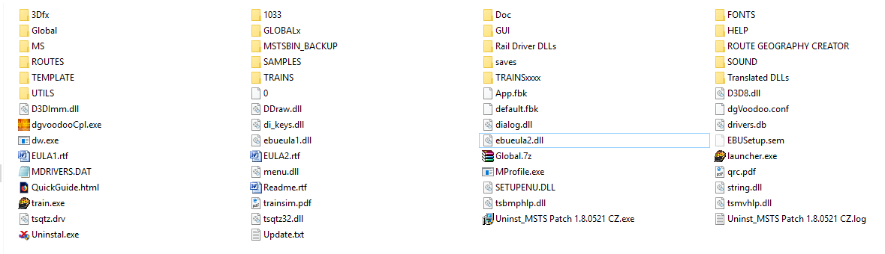

After extraction we need to run an exe file “dgwoodooCpl.exe” You get something like on figure 3.

Figure 3

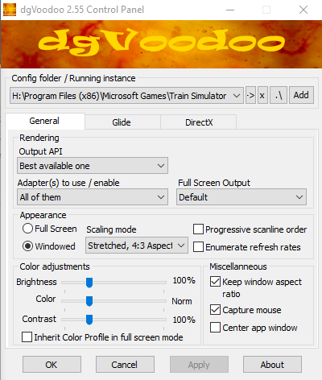

After you have to click on Glide how is on figure 4.Every thing you set according figure 4. On the top you have to choose your path to MSTS.

Figure 4

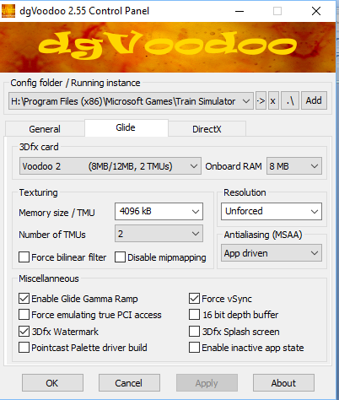

The last task is to click on DirextX how is on figure 5 and we need to set according figure 5. After running MSTS we will have in bottom right a small water mark dgWoodoo. If you want to remove it you need in DirectX unmark dgWoodoo watermark. The main task of this software is to run older games on new operating systems. It translates older version of Direct to new.

Figure 5

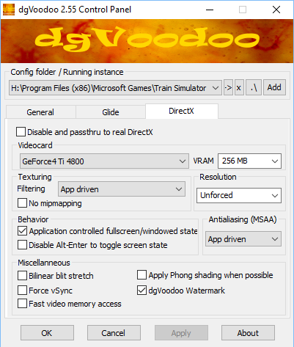

After all procedures I recommend to try MSTS. If you have experiences or advice for improvement do not hesitate to post on <https://forum.msts.cz/> in section Trat ZSR 191-193.

Now we have MSTS to be ready. Now we need to install the route in to MSTS. For users who have another routes, which use different global , these routes must be move out. So the folder with our route we move in folder “ROUTES” like on figure 6

Figure 6

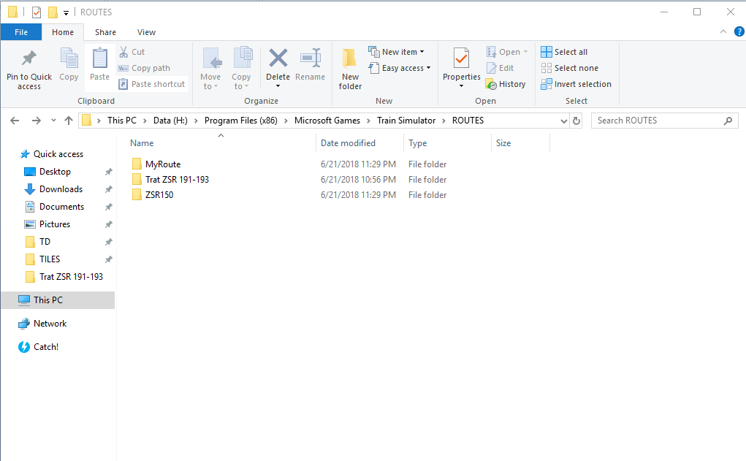

The next step is the folder global move in root folder of MSTS like figure 7

Figure 7

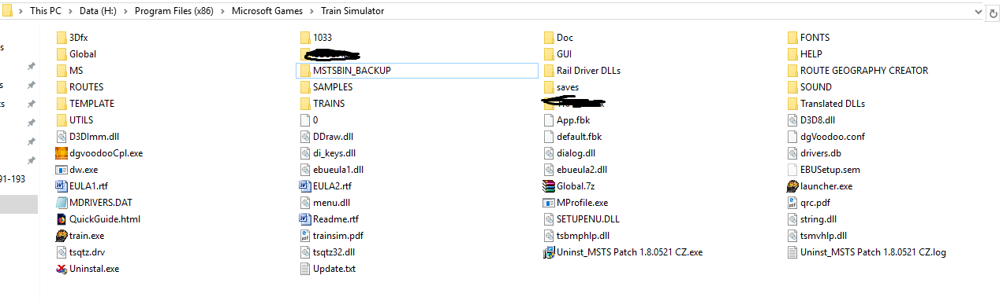

If you want to use a real models of trains you can download them from here:

<http://demmsts.eu/novinky.htm> <http://trainset.simtrains.eu/dod_vozidla.php> , <http://trainset.simtrains.eu/>, <https://modely-msts.cz/>, <https://pikku.msts.cz/>, <http://eldar.cz/kank/>, <https://skura.msts.cz/>, <http://xtrain.alsat.sk/msts/msts.htm>

The route uses a global with XTRACT 3.20, UZK and New Roads 4.0 + animated turntable.

How to install Open rails you can find here: <https://www.youtube.com/watch?v=EQ8yH3U4XDg>

**License terms**

The Project is an Intellectual property of author. The used objects are Intellectual properties of authors.

Sources:

* <https://www.semora.cz/msts/>
* <http://www.trat321.cz/zakl_verze.php>
* <http://simtrains.eu/trate/srt/>
* <http://www.railman.motorhorse.net/viewpage.php?page_id=1>
* <http://demmsts.eu/zsr130.htm>
* <https://msts.virel.eu/route_info/14>
* <http://mstshungary.hu/>
* **ČD 090 (author Tygy)**
* **ČD 120 ( author VaclavS)**
* **ČD 341 a 346 Luhačovice-Újezdec**
* **Objects from Mates**
* **Objects from Mikulda**
* **Traction line from Paw with using his source code to adapt.**
* **Objects from Somatko**
* **Objects from** [**https://modely-msts.cz/index.html**](https://modely-msts.cz/index.html)
* **Objects from Tax**
* **Special Objects from Somatko, Augustus , Reluk , zssk**
* **Traction line from Ned with modifications**
* **Objects from Nebulus**
* **Objects from Michal, Martin, Deterio, Jiří Polák**

**Vegetation from Tundra,** [**http://www.thetrain.de/de/downloadarea/**](http://www.thetrain.de/de/downloadarea/)

* **Another objects from Routes BMO, ODESA, Hungarian signal system from  Alfold 7**
* **Sound regions from Route Mr.Šemora Praha Bratislava, Staviteľ xxx CD 321 and ALfold 7**
* **Small objects from another routes and servers, z defaultných trati MSTS a podobne**
* **My own objects**
* **Textures from  Google street view and  Google earth maps.**
* Tracks from <http://msts-tiefbau.de/>
* Unique repaints and models from John Railmana ( part of package )
* Vegetation from PepeQ-2

**The route is free to use and can be stored on another server with the name of author with links:** <https://forum.msts.cz/>

The projects cannot be a part of payee add-on or with non zero price add-on. The exception is possible by author. In case of installation I accept the license terms..

**Acknowledgment**

Many thanks to GOD with help patience during developing this project

ASP for high quality video and photo documentation

Tomas Ondusko, Augustus, KuroSV for video documentation

Bubko for documentation

Stefan Ftan Danko for video documentation

Somatko, Reluk, ZSSK for original objects

PAW, Nebulus for source codes

NED for unique track lines

Deterio, Mikulda for consultation and switches

For cooperation I thank very much to Perinax – author of Route SRT500+ZSR 169

Photo documentation, track documentation from <https://www.vlaky.net/>,

Video documentation from: <http://vovlaku.teraz.sk/> <https://tv.teraz.sk/>

For comments advices Tax, Zbynek Semora and Stavitel XXX

For installation of animated runtable Martin Mouka

For documentation Michal Plihal

Photo documentation and video Tomas Smigalla

**Attention:**

The author does not have any responsibility if your software will not work or you will get a damage of your system if you will not follow rules during installation. Before Installation it is recommended to save your folder MSTS Routes, Global and Sound

Author does not have any responsibility for losing your data and damaging your system.

I wish you a lot of kilometers without any accident and fails

More information: you can joint to facebook group Trat ZSR 191-193

<https://forum.msts.cz/subdom/forum/index.php?threads/2796/> in Slovak Czech language

<https://forum.msts.cz/subdom/forum/index.php?threads/5367/> in Slovak Czech language

<http://modely-msts.cz/forum/showthread.php?tid=119> Slovak Czech language

if you have any questions, doubts you can type a private message here: <https://forum.msts.cz>

Robo Stavitel 2009-2018