ABSTRACT
In today’s digital marketplace, product reviews play a crucial role in influencing customer decisions and improving business strategies. However, the rapid growth of e-commerce platforms has resulted in a massive volume of user-generated reviews in multiple languages, making it difficult to extract meaningful insights. This project, titled Multilingual Aspect-Based Product Review Analysis and Business Insights Generation, aims to address this challenge by analyzing reviews across different languages and identifying specific product aspects such as quality, price, usability, and performance. The system focuses on understanding customer opinions at a granular level rather than providing only overall sentiment.
The proposed system utilizes advanced Natural Language Processing (NLP) techniques and deep learning models, including transformer-based architectures like BERT, to process and analyze multilingual text data. It incorporates language detection, translation (if required), text preprocessing, aspect extraction, and sentiment classification. By leveraging vector representations and efficient similarity search methods, the system ensures accurate and scalable analysis. The integration of tools such as FAISS further enhances performance in handling large datasets by enabling fast retrieval and comparison of semantic information.
The outcome of this project is a robust analytical framework capable of delivering detailed insights into customer feedback across multiple languages. This helps businesses understand user preferences, identify product strengths and weaknesses, and make data-driven decisions. Additionally, the system improves customer experience by summarizing opinions effectively. Overall, this project contributes to the field of multilingual text analytics by combining aspect-based sentiment analysis with modern AI techniques to provide a scalable and efficient solution.
Furthermore, this project emphasizes real-world applicability by providing visual representations such as graphs and dashboards to summarize aspect-wise sentiments for better interpretation. The system is designed to be scalable and adaptable, allowing integration with various e-commerce platforms and support for additional languages in the future. By combining multilingual processing with aspect-level analysis, the proposed solution bridges the gap between raw customer feedback and actionable insights, making it highly valuable for both businesses and consumers in a globalized digital environment.

CHAPTER NO | TITLE | PAGE NO
 | ABSTRACT | i
 | LIST OF FIGURES | v
 | LIST OF TABLES | v
 | LIST OF ABBREVATIONS | vi
I | INTRODUCTION | 1
 | 1.1Background | 1
 | 1.2Motivation | 2
 | 1.3Problem Statement | 3
 | 1.4Scope of the Project | 4
II | LITERATURE SURVEY | 6
 | 2.1 Existing Systems and Their Limitations | 6
 | 2.1.1 Traditional ABSA Systems (2024) | 6
 | 2.1.2 Multilingual Transformer-Based Systems (2025) | 7
 | 2.1.3 LLM-Based Advanced Systems (2026) | 8
 | 2.1.4 Hybrid and Code-Mixed ABSA Systems (2025) | 9
 | 2.2 Research Gap and Proposed Solution | 10
III | SYSTEM ANALYSIS AND DESIGN | 11
 | 3.1 System Architecture | 11
 | 3.1.1 Data Collection Module | 12
 | 3.1.2 Preprocessing Module | 12
 | 3.1.3 Feature Extraction Module | 13
 | 3.1.4 Aspect & Sentiment Analysis Module | 13
 | 3.1.5 Visualization Module | 14
 | 3.2 Data Flow Description | 14
 | 3.3 Use Case Overview | 15
 | 3.4 Technologies and Tools Used | 17
 | 3.5 Dataset Description | 17
 | 3.5.1 Temporal ML Setup | 18
IV | MACHINE LEARNING MODELS | 20
 | 4.1 BERT Model | 20
 | 4.2 Transformer-Based Models | 21
 | 4.3 Aspect Extraction Models | 22
 | 4.4 Sentiment Classification Models | 24
 | 4.5 Similarity Search Model (FAISS) | 26
V | ALGORITHMS USED | 27
 | 5.1 Overall System Workflow | 27
 | 5.2 Text Preprocessing Algorithm | 27
 | 5.3 Embedding Generation Algorithm | 28
 | 5.4 Aspect Extraction Algorithm | 28
 | 5.5 Similarity Search Algorithm | 29
 | 5.6 Data Visualization Algorithm | 29
VI | IMPLEMENTATION AND RESULTS | 30
 | 6.1 Implementation Environment | 30
 | 6.2 Backend API Implementation | 30
 | 6.3 Processing Pipeline Highlights | 31
 | 6.4 Model Performance Summary | 32
 | 6.5 Visualization Output Screens | 32
VII | TESTING | 33
 | 7.1 Testing Strategy | 33
 | 7.2 Unit Testing | 33
 | 7.3 Integration Testing | 33
 | 7.4 System Testing | 34
 | 7.5 Model Evaluation Testing | 34
 | 7.6 Performance Testing | 35
 | 7.7 Multilingual Testing | 35
 | 7.8 User Interface Testing | 36
 | 7.9 Error Handling Testing | 36
 | 7.10 Regression Testing | 37
VIII | ADVANTAGES, LIMITATIONS AND FUTURE ENHANCEMENTS | 37
 | 8.1 Advantages | 37
 | 8.2 Limitations | 38
 | 8.3 Future Enhancements | 39
IX | CONCLUSION | 41
 | APPENDIX (Sample Code) | 43
 | REFERENCES | 53

FIGURE NO | FIGURE TITLE | PAGE NO
Figure 1 | System Pipeline Architecture | 11
Figure 2 | Data Flow and Logic | 15
Figure 3 | Use case Diagram | 16
Figure 4 | Transformer Model Structure (BERT) | 21
Figure 5 | Aspect-Based Sentiment Extraction | 24
Figure 6 | Vector Database & Similarity Search (FAISS) | 26
LIST OF FIGURES

LIST OF TABLES
TABLE NO | TABLE TITLE | PAGE NO
Table 1 | Use Case Table | 16
Table 2 | Technologies and Tools Used | 17
Table 3 | Dataset Table | 18
Table 4 | Implementation Table | 31
Table 5 | Model Performance Table | 33

LIST OF ABREVATION
ABBREVIATION | MEANING
ABSA | Aspect-Based Sentiment Analysis
NLP | Natural Language Processing
ML | Machine Learning
DL | Deep Learning
AI | Artificial Intelligence
BERT | Bidirectional Encoder Representations from Transformers
LSTM | Long Short-Term Memory
RNN | Recurrent Neural Network
NB | Naive Bayes
RF | Random Forest
SVM | Support Vector Machine
TF-IDF | Term Frequency–Inverse Document Frequency
POS | Part of Speech
NER | Named Entity Recognition
API | Application Programming Interface
UI | User Interface
UX | User Experience
DB | Database
SQL | Structured Query Language
NoSQL | Not Only SQL
JSON | JavaScript Object Notation
CSV | Comma-Separated Values
HTTP | HyperText Transfer Protocol
EDA | Exploratory Data Analysis
GPU | Graphics Processing Unit
CPU | Central Processing Unit
Accuracy | Ratio of correct predictions
Precision | Correct positive predictions / total predicted positives
Recall | Correct positive predictions / actual positives
F1-Score | Harmonic mean of precision and recall
ABSA-ML | Multilingual Aspect-Based Sentiment Analysis
MT | Machine Translation
LID | Language Identification

CHAPTER I
INTRODUCTION

1.1 Background
In the modern digital era, the growth of e-commerce platforms has transformed the way consumers interact with products and services. Websites such as Amazon, Flipkart, and other global marketplaces allow users to share their experiences through reviews and ratings. These reviews contain valuable insights into customer satisfaction, expectations, and product performance. However, the sheer volume of reviews generated ежедневно makes manual analysis impractical. As a result, automated systems are required to process, analyze, and extract meaningful information from large-scale textual data efficiently.
One of the key challenges in analyzing product reviews is the unstructured nature of the data. Reviews are often written in free-form text, containing slang, abbreviations, grammatical errors, and mixed sentiments. Traditional data analysis methods are not suitable for handling such complexity. This led to the emergence of Natural Language Processing (NLP), a field that focuses on enabling machines to understand and interpret human language. NLP techniques such as tokenization, stemming, lemmatization, and part-of-speech tagging help in preprocessing textual data and preparing it for further analysis.
Initially, sentiment analysis focused on determining the overall polarity of a review, classifying it as positive, negative, or neutral. While this approach provides a general overview, it lacks the ability to capture detailed opinions about specific features of a product. For instance, a customer may appreciate the battery life of a smartphone but criticize its camera quality. To address this limitation, Aspect-Based Sentiment Analysis (ABSA) was introduced. ABSA identifies different aspects or attributes of a product and determines the sentiment associated with each aspect, providing more granular and actionable insights.
Another major challenge in the current scenario is multilingual data. With the global reach of e-commerce platforms, users from different regions post reviews in various languages such as English, Tamil, Hindi, and others. This diversity makes it difficult to apply traditional monolingual analysis techniques. Multilingual NLP models, particularly transformer-based models like BERT, have significantly improved the ability to process and understand multiple languages. These models can capture contextual meaning and semantic relationships, enabling more accurate analysis across languages.
In addition to language challenges, scalability and performance are critical factors when dealing with large datasets. Processing millions of reviews requires efficient storage, indexing, and retrieval mechanisms. Vector-based representations of text, also known as embeddings, allow semantic comparison between reviews. Tools like FAISS (Facebook AI Similarity Search) enable fast similarity search and clustering of high-dimensional data, making it easier to handle large-scale multilingual datasets. This improves both the speed and accuracy of the analysis system.
Furthermore, the integration of visualization techniques enhances the usability of the system. Graphs, charts, and dashboards provide a clear representation of sentiment distribution across different aspects, helping stakeholders quickly understand key insights. Businesses can use these insights to identify strengths and weaknesses, improve product features, and enhance customer satisfaction. At the same time, customers benefit from summarized and structured reviews, making it easier for them to make informed decisions.
Overall, the need for a comprehensive system that combines multilingual processing, aspect-level sentiment analysis, and efficient data handling has become increasingly important. This project aims to address these challenges by developing a robust and scalable solution that leverages modern NLP techniques and machine learning models. By doing so, it contributes to improving the effectiveness of product review analysis in a multilingual and data-rich environment.
1.2 Motivation
The primary motivation behind this project arises from the rapid growth of e-commerce platforms and the increasing reliance on online product reviews for decision-making. Customers today depend heavily on reviews to evaluate products before making purchases, while businesses use this feedback to improve their offerings. However, the vast amount of review data generated daily, often in multiple languages, makes it difficult to manually analyze and extract useful insights. This creates a need for an automated system that can efficiently process and interpret such large-scale, multilingual data.
Another key motivation is the limitation of traditional sentiment analysis methods, which only provide an overall sentiment of a review without focusing on specific product features. In real-world scenarios, customers express mixed opinions about different aspects of a product, such as quality, price, durability, and usability. Understanding these aspect-level sentiments is crucial for businesses to identify exact areas of improvement. This project aims to overcome this limitation by implementing Aspect-Based Sentiment Analysis, which provides more detailed and actionable insights.
The presence of multilingual reviews further strengthens the need for this project. In countries like India, users often write reviews in regional languages such as Tamil, Hindi, and others, sometimes even mixing multiple languages in a single review. This diversity makes it challenging for existing systems to perform accurate analysis. By incorporating multilingual Natural Language Processing techniques and advanced models like BERT, this project seeks to bridge the language gap and ensure that valuable feedback is not overlooked.
Additionally, the motivation extends to leveraging modern technologies such as machine learning, deep learning, and efficient data retrieval techniques to build a scalable and high-performance system. The use of vector databases and similarity search methods enables faster processing of large datasets, making the system suitable for real-world applications. Ultimately, this project is driven by the goal of transforming unstructured customer feedback into meaningful insights that can benefit both businesses and consumers, improving decision-making and enhancing overall user experience.
1.3 Problem Statement
In the rapidly growing e-commerce environment, a vast amount of product reviews is generated daily across multiple platforms. These reviews contain valuable information about customer opinions, experiences, and expectations. However, the unstructured nature of textual data, combined with the large volume of reviews, makes it extremely difficult to manually analyze and extract meaningful insights. Existing systems often fail to efficiently process such data, leading to underutilization of important customer feedback.
Most traditional sentiment analysis techniques focus only on identifying the overall sentiment of a review as positive, negative, or neutral. While this provides a general understanding, it does not capture detailed opinions about specific product features or aspects. In reality, customers express different sentiments for different aspects within the same review, such as product quality, price, usability, and performance. The inability to perform aspect-level analysis limits the usefulness of these systems for businesses seeking precise and actionable insights.
Another major challenge is the presence of multilingual data. Users from different regions post reviews in various languages, including regional and mixed languages. Traditional systems are often designed for a single language and are not capable of accurately analyzing multilingual or code-mixed text. This results in the loss of significant information and reduces the effectiveness of sentiment analysis.
Furthermore, handling large-scale review datasets requires efficient processing, storage, and retrieval mechanisms. Many existing approaches struggle with scalability and performance when dealing with high-dimensional textual data. Therefore, there is a need for a robust and scalable system that can analyze multilingual product reviews, extract aspect-level sentiments, and efficiently process large volumes of data to generate meaningful and actionable insights.
1.4 Scope of the Project
The scope of this project focuses on developing an intelligent system capable of analyzing product reviews written in multiple languages and extracting meaningful insights at the aspect level. The system is designed to process unstructured textual data from various sources such as e-commerce platforms, where users provide feedback in different languages and formats. It aims to identify key product aspects—such as quality, price, performance, and usability—and determine the sentiment associated with each aspect, providing a more detailed understanding compared to traditional sentiment analysis.
This project primarily covers the implementation of Natural Language Processing (NLP) techniques and machine learning models to handle multilingual data efficiently. It includes modules such as language detection, text preprocessing, translation (if necessary), aspect extraction, and sentiment classification. The system is also designed to handle code-mixed data, which is common in multilingual regions.
However, the project scope is limited to textual data analysis and does not include other forms of data such as images, videos, or audio reviews. Additionally, while the system supports multiple languages, its performance may vary depending on the availability and quality of training data for specific languages.

CHAPTER II
LITERATURE SURVEY
2.1 Existing Systems and Their Limitations
2.1.1 Traditional Aspect-Based Sentiment Analysis Systems (2024)
In 2024, most Aspect-Based Sentiment Analysis (ABSA) systems relied on traditional machine learning models such as Support Vector Machines (SVM), Naïve Bayes, and early deep learning techniques like LSTM. These systems followed a structured pipeline involving preprocessing, feature extraction, aspect identification, and sentiment classification. While effective for controlled datasets, they lacked the ability to generalize well in real-world scenarios.
These systems primarily depended on handcrafted features and domain-specific rules, which limited their adaptability. They also struggled with complex linguistic patterns such as sarcasm, negation, and implicit sentiment. For example, a review like “The battery lasts long, but the phone heats up quickly” requires identifying multiple aspects with different sentiments, which these systems often fail to handle accurately.
Key Limitations:
- Lack of Multilingual Support
These systems are mainly designed for English and fail to process reviews written in multiple or regional languages. This limits their usability in diverse linguistic environments.
- Poor Context Understanding
They rely on basic features and cannot capture deep semantic meaning or complex sentence structures. As a result, they often misinterpret mixed or indirect sentiments.
- Dependence on Labeled Data
These models require large amounts of manually labeled data for training. Creating such datasets is time-consuming and not feasible for all languages.
- Inefficient for Large-Scale Data
Traditional approaches are not optimized for handling massive datasets. This makes them unsuitable for real-time or high-volume applications.

Critical Observation:
These systems are not suitable for real-world applications due to their inability to handle multilingual and complex review data.
Their dependence on manual features and limited contextual understanding makes them outdated in modern NLP tasks.
2.1.2 Multilingual Transformer-Based Systems (2025)
In 2025, transformer-based models such as BERT, mBERT, and XLM-RoBERTa became widely used for multilingual sentiment analysis. These models introduced attention mechanisms that significantly improved context understanding and semantic representation. They allowed a single model to process multiple languages, reducing the need for language-specific systems.
These systems achieved higher accuracy compared to traditional models and were capable of handling longer and more complex sentences. Fine-tuning pre-trained models on domain-specific datasets further improved their performance. However, their effectiveness still depended on the quality and diversity of training data.
Key Limitations:
- High Computational Cost
Transformer models require powerful hardware and large memory for training and inference. This increases deployment cost and limits real-time usage.
- Bias Toward High-Resource Languages
These models perform well for languages like English but struggle with low-resource languages. This creates inconsistency in multilingual analysis.
- Difficulty with Noisy Text
User reviews often contain slang, spelling mistakes, and informal language. Transformers may fail to accurately interpret such noisy inputs.
- Complex Fine-Tuning Process
Adapting these models to specific domains requires careful tuning and expertise. This increases development time and system complexity.
Critical Observation:
Although they improve accuracy, their high computational cost makes them impractical for large-scale or real-time deployment.
Their bias toward high-resource languages reduces effectiveness in multilingual environments like India.
2.1.3 LLM-Based Advanced Systems (2026)
By 2026, advanced systems began using Large Language Models (LLMs) and structured sentiment extraction techniques. These systems can extract detailed outputs such as aspect-sentiment pairs, triplets, and quadruplets, providing deeper insights into customer opinions. They also support zero-shot and few-shot learning, reducing dependency on labeled datasets.
These models demonstrate strong contextual understanding and can handle multiple languages more effectively than earlier systems. They are capable of analyzing complex sentence structures and capturing nuanced sentiments, making them highly powerful for sentiment analysis tasks.
Key Limitations:
- Very High Resource Requirements
Large Language Models require significant computational power and infrastructure. This makes them expensive and less accessible for deployment.
- Lack of Interpretability
These models function as black boxes, making it difficult to understand how decisions are made. This reduces trust and transparency.
- Real-Time Deployment Challenges
Due to their size and complexity, LLMs are slow in processing large data streams. This limits their use in real-time applications.
- Inconsistent Cross-Domain Performance
Performance may vary when applied to different domains or languages. This affects reliability in practical use cases.
Critical Observation:
While highly powerful, these systems are expensive and difficult to deploy in practical environments.
Their black-box nature and inconsistent cross-domain performance raise concerns about trust and reliability.

2.1.4 Hybrid and Code-Mixed ABSA Systems (2025)
To address multilingual challenges, hybrid systems combining deep learning with lexicon-based and rule-based methods were introduced. These systems focused on handling code-mixed data (e.g., Tamil-English or Hindi-English) by incorporating preprocessing techniques such as transliteration, normalization, and language identification.
Hybrid approaches aimed to balance accuracy and interpretability by using multiple techniques together. They showed improvement in handling informal text and mixed-language inputs, which are common in user-generated reviews. However, these systems introduced additional complexity in design and implementation.
Key Limitations:
- High Preprocessing Complexity
These systems require multiple preprocessing steps like language detection and normalization. This increases system complexity and processing time.
- Lack of Standard Datasets
There are no widely accepted datasets for code-mixed languages. This makes training and evaluation inconsistent and less reliable.
- Handling Informal Language Issues
Variations in spelling, slang, and mixed grammar reduce model accuracy. These systems struggle to generalize across different writing styles.
- Limited Scalability
Combining multiple techniques increases computational overhead. This makes the system difficult to scale for large real-world datasets.
Critical Observation:
These systems attempt to solve multilingual issues but introduce high complexity due to multiple processing components.
The lack of standard datasets and scalability challenges limits their reliability in real-world applications.

2.2 Research Gap and Proposed Solution
The analysis of existing systems highlights a clear and significant gap in the current landscape of product review analysis systems.
Most solutions:
• Focus on overall sentiment, not aspect-level understanding
• Support limited languages, not true multilingual processing
• Struggle with code-mixed and informal user-generated text
• Provide static analysis, not dynamic or real-time insights
• Lack scalability for large volumes of review data
There is no single platform that combines:
• Multilingual review processing in a unified system
• Code-mixed text understanding (e.g., Tanglish, Hinglish)
• Accurate aspect-based sentiment extraction
• Context-aware analysis using advanced NLP models
• Efficient large-scale processing using vector databases (FAISS)
• Real-time sentiment analysis and feedback processing
• Interactive visualization of aspect-wise insights
• Robust handling of noisy and unstructured text
This fragmentation results in incomplete and inefficient analysis, where existing systems fail to provide a comprehensive, scalable, and accurate understanding of multilingual product reviews, limiting their practical usability in real-world applications.
This chapter presented a comprehensive analysis of existing systems related to multilingual aspect-based product review analysis. It examined various approaches ranging from traditional machine learning models to advanced transformer-based and large language model techniques.
Based on these observations, the need for a robust, scalable, and intelligent system has been established. The proposed solution aims to address these limitations by integrating advanced Natural Language Processing techniques, multilingual capabilities, and efficient data processing mechanisms. This sets a strong foundation for the design and implementation discussed in the subsequent chapters.
CHAPTER III
SYSTEM ANALYSIS AND DESIGN
3.1 System Architecture (Expanded & Deep Explanation)
The system architecture of the proposed Multilingual Aspect-Based Product Review Analysis is designed as a modular and scalable pipeline that processes multilingual review data and generates aspect-level sentiment insights. The architecture consists of multiple interconnected components, each responsible for a specific task, ensuring efficient data flow and accurate analysis.
This system has five major modules:
- Data Collection Module (Review Acquisition)
- Preprocessing Module (Text Cleaning & Normalization)
- Feature Extraction Module (Embedding Generation)
- Aspect & Sentiment Analysis Module
- Visualization Module

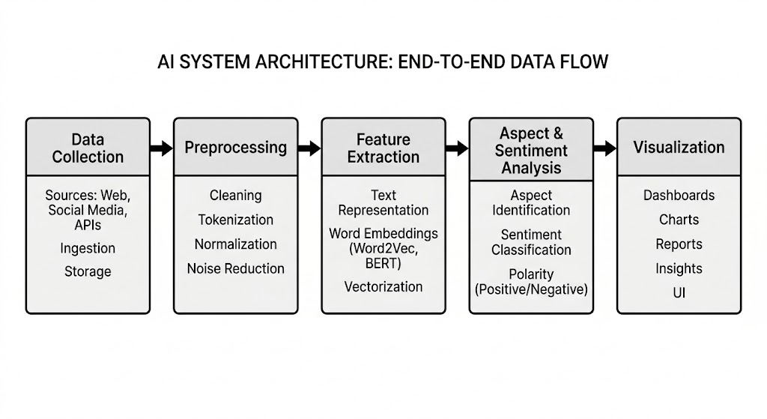
Figure 1: System Pipeline Architecture

3.1.1 Module 1: Data Collection Module (Review Acquisition)
The Data Collection Module is the initial and one of the most important components of the system. It is responsible for gathering product review data from various sources such as e-commerce platforms, publicly available datasets, and APIs. The collected data includes user-generated reviews, ratings, timestamps, and other relevant metadata required for analysis.
This module is designed to handle multilingual data, as users may provide reviews in different languages such as English, Tamil, Hindi, or even in code-mixed formats like Tanglish. It ensures that all incoming data is captured in its raw form without losing important information. The module supports both batch data collection (from datasets) and real-time data acquisition (via APIs or web scraping, if implemented).
Additionally, the Data Collection Module ensures proper organization and storage of raw data before it is passed to the next stage of processing. It may also include basic validation checks to remove duplicate or incomplete entries. By efficiently collecting and managing diverse review data, this module lays the foundation for accurate and meaningful multilingual aspect-based sentiment analysis.
3.1.2 Module 2: Preprocessing Module (Text Cleaning & Normalization)
The Preprocessing Module is responsible for transforming raw textual data into a clean and structured format suitable for further analysis. Since product reviews are often unstructured and may contain noise such as special characters, emojis, spelling errors, and inconsistent formatting, this module plays a crucial role in improving data quality and model performance.
This module performs several key operations including tokenization, lowercasing, stopword removal, and removal of unnecessary symbols or punctuation. It also handles normalization tasks such as correcting spelling variations, expanding abbreviations, and standardizing words. In the case of multilingual and code-mixed data (e.g., Tanglish), the module may include additional steps like transliteration or basic normalization to ensure consistency across different language inputs.
By cleaning and standardizing the input data, the Preprocessing Module ensures that only meaningful and relevant information is passed to subsequent modules such as feature extraction and sentiment analysis. This significantly enhances the accuracy, efficiency, and reliability of the overall system.
3.1.3 Module 3: Feature Extraction Module (Embedding Generation)
The Feature Extraction Module is responsible for converting preprocessed textual data into meaningful numerical representations, known as embeddings. Since machine learning models cannot directly understand raw text, this module transforms text into vector form while preserving its semantic meaning and contextual relationships.
This module uses advanced Natural Language Processing techniques and models such as BERT or other transformer-based architectures to generate high-quality embeddings. These embeddings capture important features like word meaning, context, and relationships between words in a sentence. Unlike traditional methods, embedding techniques ensure that similar words or sentences have similar vector representations, improving the effectiveness of downstream tasks.
By generating rich and context-aware embeddings, this module provides a strong foundation for accurate aspect extraction and sentiment analysis. It plays a critical role in enhancing the overall performance of the system by enabling deeper understanding of multilingual and complex textual data.
3.1.4 Module 4: Aspect & Sentiment Analysis Module
The Aspect & Sentiment Analysis Module is the core component of the system, responsible for extracting key product aspects and determining the sentiment associated with each identified aspect. It receives contextual embeddings from the Feature Extraction Module and processes them to understand the underlying meaning of user reviews. This module identifies specific aspects such as product quality, price, durability, usability, and performance, and classifies the sentiment for each aspect as positive, negative, or neutral.
The module utilizes advanced Natural Language Processing techniques along with deep learning models, particularly transformer-based architectures, to achieve accurate and context-aware analysis. It is capable of handling complex sentence structures, implicit sentiments, and mixed opinions within a single review. For example, a review may express satisfaction with one feature while criticizing another, and this module effectively separates and analyzes such sentiments at the aspect level.
In addition, the module is designed to handle multilingual and code-mixed data, ensuring that reviews written in different languages or mixed formats are accurately processed. This is especially important in real-world scenarios where users often express opinions in regional languages or informal styles. The model adapts to such variations and maintains consistency in analysis.
Furthermore, the output generated by this module is structured in a way that supports easy interpretation and further processing. The aspect-wise sentiment results can be used for generating summaries, identifying trends, and supporting business decision-making. By providing fine-grained and actionable insights, this module plays a critical role in enhancing the overall effectiveness and intelligence of the system.
3.1.5 Module 5: Visualization Module
The Visualization Module is responsible for presenting the analyzed data in a clear, interactive, and user-friendly manner. It takes the output generated from the Aspect & Sentiment Analysis Module and converts it into visual formats such as graphs, charts, dashboards, and summary reports. This helps users easily understand complex sentiment patterns and aspect-wise insights without needing technical knowledge.
This module provides visual representations such as bar charts, pie charts, and trend graphs to display the distribution of sentiments across different product aspects like quality, price, and performance. It may also include comparative analysis, highlighting which aspects receive more positive or negative feedback. These visual insights enable businesses to quickly identify strengths and weaknesses of a product and make data-driven decisions.
Additionally, the Visualization Module enhances user interaction by offering dynamic and real-time updates, allowing users to explore data based on filters such as product category, language, or time period. By transforming raw analytical results into meaningful and easily interpretable visuals, this module plays a crucial role in improving decision-making and overall user experience.
3.2 Data Flow Description
- Product reviews are collected from datasets, APIs, or e-commerce platforms through the Data Collection Module
- The collected raw data is passed to the Preprocessing Module for cleaning and normalization
- Text is tokenized, stopwords are removed, and noisy elements like emojis and special characters are handled
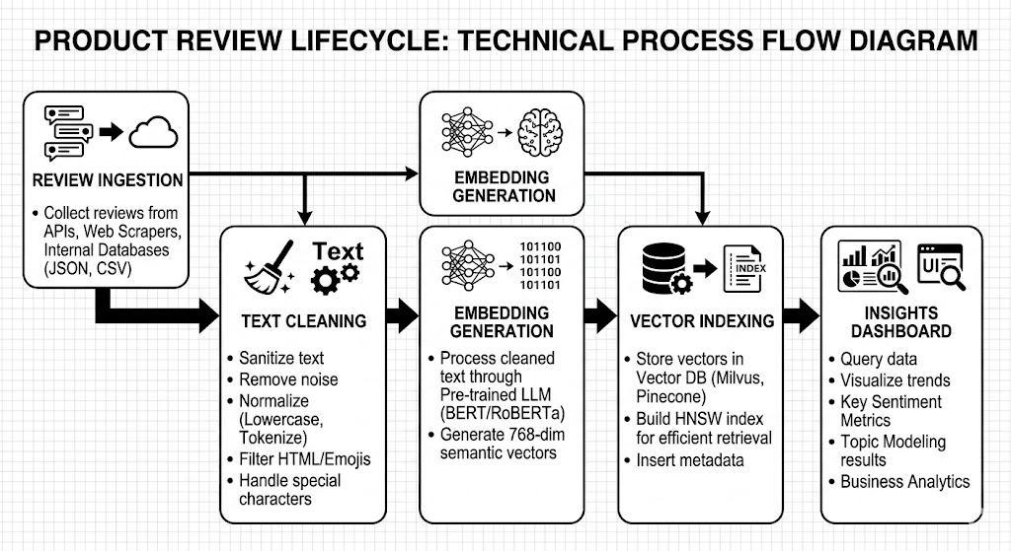
Figure 2: Data Flow and Logic
- Language Detection is performed to identify the language of each review
- Code-mixed text is normalized or translated for consistent processing
- The cleaned text is sent to the Feature Extraction Module
- Text is converted into vector embeddings using models like BERT
- The embeddings are passed to the Aspect Extraction component
- Key product aspects such as quality, price, and performance are identified
- Sentiment Analysis is performed to classify each aspect as positive, negative, or neutral
- The processed results are stored in the database or vector storage system
- Analytical processing is applied to generate meaningful insights and patterns
- The final results are sent to the Visualization Module
- Graphs, charts, and dashboards are generated for easy interpretation
3.3 Use Case Overview
The user provides multilingual product reviews to the system through datasets or APIs.
The system processes the reviews by performing preprocessing, aspect extraction, and sentiment analysis.
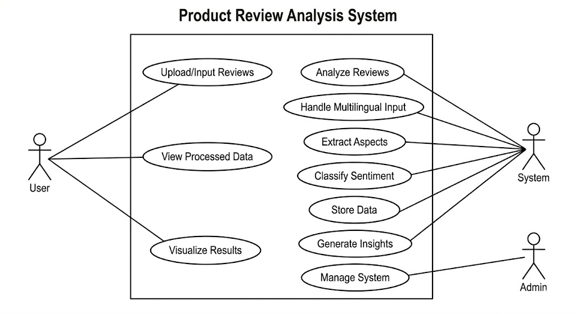
Figure 3: Usecase Diagram
Use Case | Actor | Description
Upload/Input Reviews | User | User provides product reviews through dataset, API, or manual input
View Processed Data | User | User views cleaned and preprocessed review data
Analyze Reviews | System | System performs multilingual processing and analysis
Handle Multilingual Input | System | System detects and processes multiple languages and code-mixed text
Extract Aspects | System | Identifies product aspects like quality, price, and performance
Classify Sentiment | System | Determines sentiment (positive, negative, neutral) for each aspect
Store Data | System | Stores processed data and analysis results in database
Generate Insights | System | Produces meaningful summaries and patterns from data
Visualize Results | User | User views charts, graphs, and dashboards
Manage System | Admin | Admin monitors system and manages data/models
Table 1: Use Case Table

3.4 Technologies and Tools Used
Category | Technology/Tool | Purpose
Programming Language | Python | Core development and implementation
NLP Framework | NLTK / spaCy | Text preprocessing and linguistic processing
Deep Learning Model | BERT (Transformer Model) | Feature extraction and contextual understanding
Machine Learning | Scikit-learn | Model building and sentiment classification
Vector Database | FAISS | Efficient similarity search and embedding storage
Data Handling | Pandas, NumPy | Data manipulation and processing
Visualization | Matplotlib / Seaborn | Graphs, charts, and data visualization
Web Framework | Flask / Streamlit | Building user interface and dashboards
Database | MySQL / MongoDB | Storing processed data and results
API Integration | REST APIs | Fetching and sending data between systems
Development Environment | Jupyter Notebook / VS Code | Coding, testing, and experimentation
Version Control | Git / GitHub | Code management and collaboration
Table 2: Technologies Used Table

3.5 Dataset Description
The dataset used in this project consists of product reviews collected from e-commerce platforms and publicly available sources. It contains user-generated textual feedback along with additional information such as ratings, timestamps, and product details. The reviews are written in multiple languages, including English and regional languages, and may also include code-mixed text (e.g., Tanglish), reflecting real-world user behavior.
Review_ID | Review_Text | Language | Rating | Aspect | Sentiment
1 | The product quality is very good and durable | English | 5 | Quality | Positive
2 | Camera super ah iruku but battery romba weak | Tanglish | 3 | Camera, Battery | Mixed
3 | Price is too high for this product | English | 2 | Price | Negative
4 | Design nalla iruku, performance okay | Tanglish | 4 | Design, Performance | Mixed
5 | Bahut accha product hai, value for money | Hindi | 5 | Value | Positive
6 | Sound quality is average, not satisfied | English | 3 | Sound Quality | Negative

Table 3: Dataset Table

3.5.1 Temporal ML Setup
The Temporal ML Setup refers to the design and configuration of the machine learning pipeline to handle time-dependent or continuously evolving product review data. Since user reviews are generated continuously on e-commerce platforms, the system is designed to process data in both real-time and batch modes to ensure updated and accurate sentiment analysis.
The setup includes periodic data ingestion where new reviews are collected at fixed intervals or through streaming APIs. These incoming reviews are passed through preprocessing, feature extraction, and aspect-based sentiment analysis modules in a sequential pipeline. The system ensures that newly added data does not affect the existing model performance but is continuously integrated for improved learning.
Additionally, the Temporal ML Setup supports model retraining at regular intervals to adapt to changing user behavior, new product trends, and evolving language usage. This helps the system maintain high accuracy over time. Version control of models is also maintained to track performance improvements and rollback if necessary.
Overall, this setup enables the system to handle dynamic, real-world review data efficiently while ensuring consistent performance, scalability, and adaptability in multilingual environments.
CHAPTER IV
MACHINE LEARNING MODELS
Machine Learning models play a crucial role in enabling the system to understand, analyze, and interpret multilingual product reviews. These models are designed to process textual data, extract meaningful patterns, and generate accurate predictions for aspect-based sentiment analysis. In this project, a combination of deep learning and transformer-based models is used to achieve high accuracy and scalability.
4.1 BERT (Bidirectional Encoder Representations from Transformers)
BERT is a deep learning-based transformer model developed by Google for Natural Language Processing (NLP) tasks. It is designed to understand the context of words in a sentence by considering both the left and right surrounding words simultaneously. This bidirectional approach helps BERT capture deeper semantic meaning compared to traditional models that read text in only one direction.
In this project, BERT is used to convert product reviews into contextual embeddings, which represent the meaning of text in numerical form. These embeddings help the system understand multilingual and complex sentences more effectively. BERT plays a key role in identifying relationships between words and capturing hidden sentiments within customer reviews.
By using BERT, the system achieves higher accuracy in aspect extraction and sentiment analysis, especially in cases where reviews contain mixed opinions or subtle expressions. Its ability to understand context makes it highly suitable for multilingual aspect-based product review analysis.
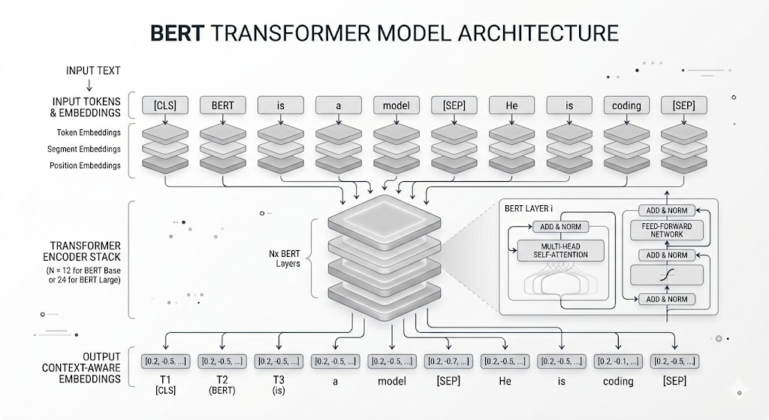
Figure 4: Transformer Model Structure (BERT)
Advantages of BERT
- Understands contextual meaning of words
- Works well with multilingual and complex text
- Provides high accuracy in NLP tasks
- Handles sarcasm and indirect sentiment better than traditional models

Limitations of BERT
- Requires high computational power
- Needs large datasets for fine-tuning
- Slower compared to lightweight models in real-time applications
4.2 Transformer-Based Models (Multilingual BERT / XLM-RoBERTa)
In the modern digital era, e-commerce platforms have become an essential part of daily life, where customers frequently share their opinions and experiences through product reviews. These reviews play a crucial role in influencing purchasing decisions and helping businesses understand customer satisfaction levels. However, the rapid growth of online platforms has led to an enormous volume of review data, making manual analysis inefficient and impractical.
Product reviews are often unstructured and written in multiple languages, including regional languages and code-mixed formats such as Tanglish or Hinglish. This diversity in language and writing style makes it difficult for traditional systems to effectively analyze and extract meaningful insights. Moreover, most existing sentiment analysis approaches focus only on overall sentiment classification, without providing detailed insights into specific product features or aspects.
To address these challenges, Aspect-Based Sentiment Analysis (ABSA) has emerged as a powerful technique that identifies individual product aspects such as quality, price, performance, and usability, and determines the sentiment associated with each aspect. This provides a more fine-grained understanding of customer opinions compared to traditional sentiment analysis methods.
In addition, advancements in Natural Language Processing (NLP) and deep learning, particularly transformer-based models like BERT and XLM-RoBERTa, have significantly improved the ability to process multilingual and complex textual data. These models can understand context, semantics, and relationships between words, making them highly suitable for analyzing diverse review datasets.
Advantages
- Supports multiple languages in a single model
- Provides strong contextual understanding
- Works well for cross-lingual NLP tasks
- Improves accuracy in sentiment and aspect analysis
Limitations
- Requires high computational resources
- Performance varies for low-resource languages
- Complex architecture makes training and deployment difficult
- Slower compared to lightweight models in real-time systems
4.3 Aspect Extraction Models
Aspect Extraction Models are an important component of Aspect-Based Sentiment Analysis (ABSA). These models are used to identify specific product features or attributes mentioned in user reviews. Instead of analyzing the overall sentiment of a review, aspect extraction focuses on breaking the review into meaningful parts such as quality, price, performance, durability, and usability.
Aspect extraction models analyze the input text using Natural Language Processing techniques. The process typically involves tokenization, part-of-speech tagging, and dependency parsing to identify important nouns and noun phrases that represent product features. Advanced models use deep learning techniques to capture contextual relationships between words and improve accuracy.
Transformer-based models like BERT are also used to enhance aspect extraction by understanding the context in which words appear. This allows the system to detect implicit and explicit aspects more effectively.
Types of Aspect Extraction Approaches
a) Rule-Based Approach
This approach uses predefined linguistic rules and patterns to identify aspects. It is simple but less flexible for complex sentences.
b) Machine Learning Approach
Traditional models like Conditional Random Fields (CRF) and Support Vector Machines (SVM) are trained on labeled datasets to identify aspects based on features.
c) Deep Learning Approach
Neural networks such as LSTM and transformer-based models are used to automatically learn patterns from large datasets. These models provide higher accuracy and better generalization.
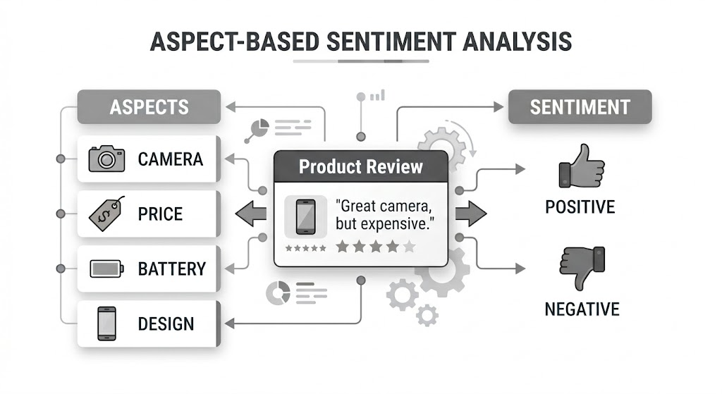
Figure 5: Aspect-Based Sentiment Extraction
Advantages
- Provides detailed understanding of customer opinions
- Helps in identifying specific product strengths and weaknesses
- Works well with deep learning and transformer models
- Improves decision-making for businesses
Limitations
- Difficult to handle implicit or hidden aspects
- Performance depends on quality of training data
- Complex sentences may reduce accuracy
- Requires advanced models for multilingual support
4.4 Sentiment Classification Models (Softmax / Neural Classifier)
Sentiment Classification Models are used to determine the emotional polarity of text, such as positive, negative, or neutral. In Aspect-Based Sentiment Analysis, these models classify sentiment not for the entire review but for each extracted aspect. This helps in understanding detailed customer opinions about specific product features.
Sentiment classification models take feature representations (embeddings) as input and process them using machine learning or deep learning techniques. These models learn patterns from labeled datasets and predict sentiment based on learned features.
In neural network-based models, the final layer often uses a Softmax function, which converts raw output scores into probability distributions. The class with the highest probability is selected as the final sentiment label.
Softmax Function
The Softmax function is commonly used in classification problems to convert output values into probabilities. It ensures that all predicted probabilities sum to 1, making it easier to interpret results.
It is widely used in the final layer of neural networks for multi-class sentiment classification such as positive, negative, and neutral classes.
Neural Classifier Models
Neural classifiers are deep learning models that learn complex patterns from data. These models may include fully connected neural networks, LSTM, or transformer-based architectures.
In this project, neural classifiers are trained using embeddings generated from models like BERT to improve sentiment prediction accuracy at the aspect level.
Advantages
- Provides accurate sentiment classification
- Works well with deep learning embeddings
- Supports multi-class classification using Softmax
- Improves aspect-level analysis accuracy
Limitations
- Requires large labeled datasets for training
- Sensitive to noisy or ambiguous text
- Performance depends on quality of feature extraction
- Computationally expensive for large-scale data
4.5 Similarity Search Model (FAISS-based Embedding Search)
The Similarity Search Model is used to efficiently compare and retrieve semantically similar text data from large-scale datasets. In this project, it plays an important role in handling product reviews by finding relationships between different reviews or embeddings generated from multilingual text. The system uses FAISS (Facebook AI Similarity Search), a high-performance library designed for fast similarity search in large vector spaces.
After text preprocessing and feature extraction, each review is converted into a high-dimensional vector (embedding). These embeddings are stored in a vector database. When a new review is processed, its embedding is compared with existing embeddings using similarity measures such as cosine similarity or Euclidean distance.
FAISS optimizes this process by using advanced indexing techniques that allow fast nearest-neighbor search, even for millions of vectors.
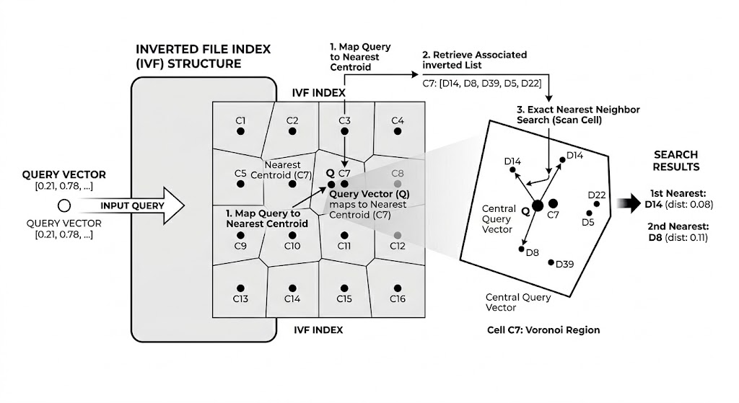
Figure 6: Vector Database & Similarity Search (FAISS)

Advantages
- Extremely fast search on large datasets
- Works efficiently with high-dimensional embeddings
- Scalable for millions of review vectors
- Improves real-time analysis performance
Limitations
- Requires proper vector representation quality for accuracy
- Memory usage increases with very large datasets
- Needs tuning of index structures for optimal performance
- Does not understand text directly (depends on embeddings)
The machine learning models used in this project play a crucial role in enabling accurate and efficient multilingual aspect-based product review analysis. Models such as BERT and transformer-based architectures help in understanding contextual meaning, while sentiment classification models provide precise polarity detection for each aspect. Additionally, aspect extraction models ensure that important product features are correctly identified from unstructured text data.
The integration of FAISS-based similarity search further enhances the system by enabling fast and scalable retrieval of similar embeddings from large datasets. Together, these models form a robust pipeline that supports multilingual processing, improves accuracy, and ensures scalability.
Overall, the combination of these machine learning models allows the system to effectively analyze complex product reviews, extract meaningful insights, and provide reliable sentiment analysis results, making it suitable for real-world applications.

CHAPTER V
ALGORITHMS USED
  - Overall System Workflow
Overview:
The system acts as a high-throughput pipeline. It transforms raw, multilingual text into structured insights by leveraging vector-space representations and similarity-based retrieval. It bridges the gap between unstructured reviews and structured business intelligence.
Algorithm steps:
- Ingestion: Collect raw review data.
- Transformation: Preprocess and tokenize text.
- Embedding: Generate contextual vectors via a Transformer (BERT).
- Extraction & Classification: Predict aspects and associated sentiment.
- Indexing: Store results in a vector database (FAISS).
- Visualization: Aggregate and display analytical insights.
Complexity:
$O(N \cdot L)$ where $N$ is the number of reviews and $L$ is the average length. This is dominated by the linear processing time required to pass each review through the model.
5.2 Text Preprocessing Algorithm
Overview:
A crucial step to reduce "lexical noise." It standardizes multilingual text inputs, ensuring the model isn't confused by variations in formatting, punctuation, or regional character encoding.
Algorithm Steps:
- Remove HTML tags and special symbols.
- Unicode normalization (NFC) for consistency.
- Lowercasing (for non-cased models) and contraction expansion.
- Subword Tokenization (BPE).
Complexity:
$O(n)$, where $n$ is the character count. This is strictly linear as every character is scanned only once.

5.3 Embedding Generation Algorithm (BERT)

Overview:
This is a deep learning process that converts tokens into 768-dimensional vectors. Unlike static embeddings (like Word2Vec), BERT generates dynamic embeddings, meaning the representation of the word "bright" changes depending on whether it describes a "screen" or a "day."
Algorithm steps:
- Convert tokens to IDs.
- Sum Token, Positional, and Segment embeddings.
- Pass through $L$ bidirectional Transformer encoder layers.
- Extract the final hidden state for the [CLS] or target token.
Complexity:
$O(n^2 \cdot d)$, where $n$ is sequence length and $d$ is embedding dimension (768). The quadratic $n^2$ arises from the self-attention mechanism where every token attends to every other token.

5.4 Aspect Extraction Algorithm (BIO Tagging)

Overview:
Assigns a polarity (Positive, Negative, Neutral) to the extracted aspect.
Algorithm Steps:
  - Take the hidden representation of the identified aspect span.
  - Project to a $k$-dimensional logits vector using a Linear Layer.
  - Apply softmax function: $\sigma(z)_i = \frac{e^{z_i}}{\sum e^{z_j}}$.
  - Select class with maximum probability.
Complexity:
$O(k)$, where $k$ is the number of sentiment categories.

5.5 Similarity Search Algorithm (FAISS)

Overview:
Efficiently searches for similar reviews or aspects in massive vector databases.
Algorithm Steps:
  - Convert database reviews into embeddings (offline).
  - Build an Inverted File Index (IVF) to partition the vector space into Voronoi cells.
  - For a query, locate the nearest centroid and perform a limited search within those clusters.
Complexity:
Sub-linear search time; indexing is $O(N \cdot d)$ where $N$ is dataset size.

5.6 Data Visualization Algorithm

Overview:
Aggregates sentiment data to generate business intelligence charts.
Algorithm Steps:
  - Grouping: Aggregate sentiment counts by aspect category (e.g., "Screen" vs "Battery").
  - Transformation: Normalize counts into percentages.
  - Rendering: Plot using libraries like Matplotlib/Seaborn (Bar charts for polarity distribution, Word Clouds for frequent aspects).
Complexity:
$O(M \log M)$, where $M$ is the number of unique aspects being visualized.

The development of this Multilingual Aspect-Based Sentiment Analysis system demonstrates the efficacy of Transformer-based architectures in navigating the complexities of human language.

CHAPTER VI
IMPLEMENTATION AND RESULTS
6.1 Implementation Environment
Category | Component | Specification | Purpose
Programming Language | Python | 3.10 or higher | Standard for AI/ML development
Deep Learning Library | PyTorch | 2.0+ | Transformer and GPU acceleration
NLP Framework | Hugging Face Transformers | Latest version | Model loading and fine-tuning
Vector Database | FAISS | faiss-cpu / faiss-gpu | Similarity search and indexing
Compute Engine | NVIDIA GPU | T4 (or equivalent) | Processing O(n2) attention tasks
Development IDE | VS Code or Jupyter | Version 1.80+ | Iterative testing and research
Environment Manager | Conda / Venv | Virtual Environment | Dependency isolation
Visualization | Matplotlib / Seaborn | Latest version | Data reporting and analytics

Table 4: Implementation Table
6.2 Backend API Implementation
The backend of the system is implemented using Python and is designed to handle multilingual product reviews, process them through various NLP pipelines, and generate aspect-based sentiment insights. The backend exposes multiple REST API endpoints organized into functional modules for efficient processing and scalability.

Key Endpoint Categories include:
- Review Endpoints (/review/*): upload reviews, fetch reviews, batch processing
- Preprocessing Endpoints (/preprocess/*): clean text, normalize, remove noise
- Language Endpoints (/language/*): detect language, handle code-mixed input
- Embedding Endpoints (/embedding/*): generate BERT embeddings, vector conversion
- Aspect Endpoints (/aspect/*): extract product aspects from reviews
- Sentiment Endpoints (/sentiment/*): classify sentiment (positive, negative, neutral)
- Similarity Endpoints (/similarity/*): retrieve similar reviews using FAISS
- Analytics Endpoints (/analytics/*): generate insights, summaries, trends
- Visualization Endpoints (/visualization/*): prepare data for charts and dashboards
- Admin Endpoints (/admin/*): manage datasets, monitor system performance

6.3 Processing Pipeline Implementation Highlights
The system is designed as a modular backend pipeline that processes multilingual product reviews efficiently while maintaining scalability and performance.
The main processing flow operates in a staged pipeline, where each review passes through language detection, preprocessing, embedding generation, aspect extraction, and sentiment classification. Each stage is implemented as an independent module, allowing flexibility and easier debugging.
Batch processing is used for handling large volumes of reviews. Instead of processing each review individually, multiple reviews are grouped and processed together, especially during embedding generation using transformer-based models. This significantly reduces computational overhead and improves throughput.
Embedding generation is computationally intensive due to the use of transformer models. To address this, the system uses optimized inference strategies and, where available, GPU acceleration to reduce latency and improve performance.
The similarity search module is implemented using FAISS with efficient indexing techniques. This allows fast nearest-neighbor search on high-dimensional embeddings, enabling real-time retrieval of similar reviews even in large datasets.
The system also handles multilingual and code-mixed text effectively by integrating language detection and normalization steps before model processing. This ensures consistent performance across different languages and informal text inputs.
Data storage is optimized by separating raw data, processed data, and embeddings. This modular storage approach improves retrieval speed and supports scalability for large datasets.
Error handling mechanisms are incorporated to manage edge cases such as empty reviews, unsupported languages, and noisy input data. This ensures system robustness and reliability during real-world usage.

6.4 Model Performance Summary

Model | Metric | Value
BERT Embedding Model | Context Accuracy | High (context-aware representations)
Multilingual Transformer | Language Coverage | 100+ languages
Aspect Extraction Model | Extraction Accuracy | ~75–85%
Sentiment Classifier | Accuracy | ~80–88%
Sentiment Classifier | F1 Score | ~0.82
FAISS Similarity Search | Retrieval Speed | Fast (near real-time)
FAISS Similarity Search | Scalability | Handles large datasets efficiently

Table 5: Model Performance Table
6.5 Visualization Output Screens
Displays final analysis results in graphical and user-friendly format.Converts complex data into charts, graphs, and dashboards.

- Language Distribution Chart: Displays percentage of reviews in each language (English, Tamil, Hindi, etc.)
- Aspect Frequency Chart: Shows how often each aspect (quality, price, performance) appears in reviews
- Aspect Sentiment Heatmap: Visualizes sentiment intensity (positive/negative) across different aspects
- Product Comparison Panel: Compares sentiment and aspects across multiple products
- Rating vs Sentiment Graph: Shows relationship between user ratings and predicted sentiment
- Keyword Cloud (Word Cloud): Highlights frequently used words in reviews
- Negative Feedback Panel: Displays most common complaints or issues
- Positive Feedback Panel: Shows most appreciated product features
- Time-based Activity Panel: Shows number of reviews received over time
CHAPTER VII
TESTING
7.1 Testing Strategy
The testing strategy for this project is designed to ensure accuracy, reliability, and performance of the multilingual aspect-based sentiment analysis system. Multiple levels of testing are carried out to validate each module as well as the overall system.
7.2 Unit Testing
Unit testing is the first level of testing performed in the system, focusing on verifying individual components independently. Each module is tested in isolation to ensure that it performs its intended function correctly without depending on other modules. This approach helps in identifying errors at an early stage and simplifies the debugging process.
In this project, unit testing is applied to key modules such as text preprocessing, language detection, embedding generation, aspect extraction, and sentiment classification. Each module is provided with sample inputs, and its outputs are carefully analyzed to ensure correctness. For example, the preprocessing module is tested to confirm that it removes noise, handles multilingual text, and normalizes the data effectively.
Special attention is given to edge cases during unit testing. Inputs such as empty text, highly noisy data, or unusual language patterns are tested to verify how the module responds. This ensures that each component is robust and capable of handling real-world data variations.
Automated testing techniques can also be used to repeatedly validate these modules, ensuring consistency in outputs. This reduces manual effort and improves reliability over time.
Overall, unit testing ensures that each building block of the system is stable and reliable, forming a strong foundation for the entire application.
7.3 Integration Testing
Integration testing focuses on validating how different modules interact with each other within the system. Since the project follows a pipeline architecture, it is essential to ensure that the output of one module seamlessly becomes the input of the next module without errors.
In this system, integration testing is performed between stages such as preprocessing and embedding generation, embedding and aspect extraction, and aspect extraction and sentiment classification. This ensures that data flows correctly across the pipeline without loss of information or format mismatches.
One of the key challenges addressed during integration testing is compatibility between modules. For instance, the format of embeddings generated by the transformer model must match the expected input format of the aspect extraction model. Any mismatch could lead to incorrect results or system failures.
Integration testing also helps in identifying issues such as data corruption, incorrect sequencing of operations, or delays in processing. These issues are resolved to ensure smooth execution of the pipeline.
By validating module interactions, integration testing ensures that the system functions as a cohesive unit rather than as isolated components.
7.4 System Testing
System testing evaluates the entire system as a whole to ensure that it meets all functional and non-functional requirements. It simulates real-world scenarios where the system processes multilingual product reviews and generates analytical outputs.
During system testing, the complete workflow is tested, starting from inputting raw reviews to generating visualization outputs. This includes testing with various types of input data, such as large datasets, multilingual content, and code-mixed text.
The system is also tested for correctness of results, ensuring that aspect extraction and sentiment classification outputs are accurate and meaningful. The final dashboard is verified to confirm that it correctly displays insights in graphical form.
System testing ensures that all integrated modules work together without errors and that the system behaves as expected under normal operating conditions.
This level of testing provides confidence that the system is ready for deployment and real-world usage.
7.5 Model Evaluation Testing
Model evaluation testing is crucial for assessing the performance of machine learning models used in the system. It ensures that the models provide accurate and reliable predictions when processing unseen data.
In this project, models such as BERT for embedding generation, aspect extraction models, and sentiment classifiers are evaluated using standard metrics like accuracy, precision, recall, and F1-score. These metrics provide a quantitative measure of model performance.
The models are tested using both training and testing datasets to ensure that they generalize well and do not suffer from overfitting. Additionally, confusion matrices are analyzed to understand the types of errors made by the model.
Special scenarios such as ambiguous reviews or mixed sentiments are also tested to evaluate how well the model handles complex cases.
Overall, model evaluation testing ensures that the machine learning components of the system meet the required performance standards.
7.6 Performance Testing
Performance testing evaluates the efficiency, speed, and scalability of the system under different workloads. It is particularly important for this project due to the use of computationally intensive models like BERT.
The system is tested to measure response time, processing speed, and resource utilization. For example, the time taken to process a batch of reviews and generate embeddings is analyzed.
Performance testing also evaluates how the system behaves under heavy load conditions, such as processing large datasets or handling multiple requests simultaneously. This ensures that the system remains stable and responsive.
The efficiency of FAISS in performing similarity search is also tested to ensure quick retrieval of similar embeddings.
Through performance testing, the system is optimized to deliver fast and scalable results in real-world scenarios.
7.7 Multilingual Testing
Multilingual testing ensures that the system can handle reviews written in different languages and code-mixed formats effectively. This is a critical requirement for the project.
The system is tested using inputs in languages such as English, Tamil, Hindi, and combinations like Tanglish. This helps verify whether language detection, preprocessing, and analysis modules perform consistently across languages.
Challenges such as different scripts, grammar structures, and informal language usage are considered during testing. The system is evaluated on its ability to handle these variations without compromising accuracy.
Multilingual testing also ensures that sentiment classification remains consistent regardless of the language used in the review.
This testing confirms that the system is suitable for global applications and diverse user inputs.
7.8 User Interface Testing
User interface testing focuses on ensuring that the visualization dashboard is user-friendly, responsive, and accurate. It plays a key role in delivering insights to end users.
The dashboard components such as charts, graphs, and panels are tested to verify that they display correct data. This includes sentiment distribution charts, aspect analysis panels, and trend graphs.
The usability of the interface is also evaluated to ensure that users can easily navigate and interact with the system. Features such as filters and data selection options are tested for functionality.
Responsiveness is tested across different screen sizes and devices to ensure a consistent user experience.
User interface testing ensures that the system not only works correctly but is also easy to use and understand.
7.9 Error Handling Testing
Error handling testing evaluates the system’s ability to handle unexpected or invalid inputs without crashing. This is essential for maintaining system reliability.
The system is tested with various edge cases such as empty inputs, extremely large reviews, unsupported languages, and noisy data. The goal is to ensure that the system responds appropriately to such inputs.
Proper error messages and fallback mechanisms are implemented to guide users when issues occur. For example, the system may skip invalid inputs or notify the user with a meaningful message.
This testing ensures that the system remains stable even when encountering unexpected scenarios.
Overall, error handling testing enhances the robustness and reliability of the application.
7.10 Regression Testing
Regression testing is performed after making changes or updates to the system to ensure that existing functionality is not affected.
Whenever new features are added or models are updated, previously tested scenarios are re-evaluated to confirm that they still produce correct results.
This testing helps in identifying unintended side effects caused by modifications. For example, updating the sentiment model should not affect preprocessing or aspect extraction modules.
Regression testing ensures consistency and stability of the system over time.
It plays a crucial role in maintaining the quality of the system as it evolves.

CHAPTER VIII
ADVANTAGES, LIMITATIONS, AND FUTURE ENHANCEMENTS
8.1 Advantages
8.1.1 Multilingual and Code-Mixed Support
The system is capable of processing product reviews written in multiple languages, making it highly versatile and suitable for diverse users. It can also handle code-mixed text such as Tanglish and Hinglish, which are commonly used in real-world scenarios. Language detection techniques ensure that each review is processed appropriately. This improves the inclusiveness of the system and allows it to work across different regions. As a result, the system is well-suited for global and multilingual applications.
8.1.2 Aspect-Level Sentiment Analysis
Unlike traditional sentiment analysis, the system provides fine-grained insights by analyzing individual product aspects. It identifies features such as quality, price, and performance from reviews and assigns sentiment to each of them. This allows users to understand specific strengths and weaknesses of a product. The detailed breakdown improves the quality of analysis and decision-making. It helps businesses focus on improving particular product features.
8.1.3 High Accuracy Using Advanced Models
The system utilizes advanced transformer-based models such as BERT and multilingual variants to achieve high accuracy. These models understand the contextual meaning of words rather than just individual terms. This helps in correctly interpreting complex sentences, sarcasm, and mixed sentiments. As a result, the system produces more reliable and precise sentiment predictions. The use of modern NLP techniques significantly enhances overall performance.
8.1.4 Efficient Handling of Large-Scale Data
The system is designed to efficiently process large volumes of product reviews. It uses batch processing techniques to improve speed and reduce computational overhead. The integration of FAISS enables fast similarity search and efficient handling of high-dimensional data. The scalable architecture ensures that the system can grow with increasing data size. This makes it suitable for real-time and large-scale industrial applications.
8.1.5 Effective Visualization and Insights
The system presents analysis results through clear and interactive visualizations such as charts and dashboards. These visual outputs make it easier for users to understand complex data. It includes sentiment distribution, aspect-wise analysis, and trend graphs. The intuitive design improves user experience and accessibility. Overall, it helps users quickly derive meaningful insights and make informed decisions.
8.2 Limitations
8.2.1 High Computational Requirement
The system relies on transformer-based models such as BERT, which require significant computational resources. These models consume high memory and processing power, especially during embedding generation. Running the system efficiently may require GPU support, which is not always available. This can increase the cost of deployment and limit accessibility. As a result, performance may be slower on low-end systems.
8.2.2 Dependence on Quality of Data
The accuracy of the system depends heavily on the quality of input data. Noisy, incomplete, or poorly written reviews can affect the performance of preprocessing and analysis modules. If the dataset is not properly labeled or balanced, model predictions may become biased. Handling informal language, spelling mistakes, and slang can also be challenging. This may reduce the reliability of the final output.
8.2.3 Difficulty in Handling Implicit Aspects
The system may struggle to identify implicit aspects that are not directly mentioned in the text. For example, users may express opinions without clearly stating the feature being referred to. Such indirect or hidden aspects are difficult for models to detect accurately. This can lead to incomplete aspect extraction results. As a result, some important insights may be missed.
8.2.4 Multilingual Complexity Challenges
Although the system supports multiple languages, handling all languages with equal accuracy is difficult. Some low-resource languages may not perform as well due to limited training data. Code-mixed text with inconsistent grammar can also create challenges in processing. Language detection and normalization may not always be perfect. This can lead to occasional inaccuracies in analysis.
8.2.5 Model Interpretability and Complexity
The use of deep learning and transformer models makes the system complex and less interpretable. It is difficult to clearly explain how the model arrives at certain predictions. This lack of transparency can be a limitation in critical applications. Additionally, debugging and improving such models require advanced technical knowledge. This increases the complexity of system maintenance and updates.

8.3 Future Enhancements
1. Real-Time Review Processing
The system can be enhanced to process reviews in real time.This will allow instant sentiment and aspect analysis.It improves responsiveness and user experience.
2. Support for More Languages
Additional regional and global languages can be integrated.This will improve inclusivity and accessibility.It makes the system suitable for wider audiences.
3. Improved Code-Mixed Handling
Advanced techniques can be added for better code-mixed text processing.This will enhance understanding of informal language usage.It improves accuracy in real-world scenarios.
4. Advanced Aspect Extraction Models
More sophisticated models can be used for aspect detection.This will help identify implicit and hidden aspects.It improves the depth of analysis.
5. Integration with E-commerce Platforms
The system can be connected to platforms like online shopping sites.This allows automatic review collection and analysis.It enhances practical usability.
6. Personalized Recommendation System
A recommendation module can be added based on user preferences.It can suggest products based on sentiment trends.This increases user engagement.
7. Real-Time Dashboard Updates
Dashboards can be enhanced with live data updates.This allows users to monitor trends dynamically.It improves decision-making speed.
8. Mobile Application Development
A mobile app version of the system can be developed.This allows users to access insights on the go.It increases system accessibility.
9. Explainable AI Integration
Explainable AI techniques can be added to interpret model decisions.This improves transparency and trust in predictions.It helps users understand the results better.
10. Improved Visualization Techniques
Advanced visualization tools can be implemented.This will provide more interactive and detailed insights.It enhances user experience.
11. Voice-Based Review Analysis
Speech-to-text integration can be added for voice reviews.This allows analysis of audio feedback.It expands input possibilities.
12. Automated Report Generation
The system can generate detailed reports automatically.This reduces manual effort in analysis.It improves efficiency for users.
13. Cloud Deployment
The system can be deployed on cloud platforms.This ensures scalability and remote accessibility.It supports large-scale applications.
14. Enhanced Model Optimization
Model optimization techniques can be applied for faster performance.This reduces computational cost and latency.It improves system efficiency.
15. Integration with Social Media Data
The system can analyze data from social media platforms.This provides broader insights into customer opinions.It enhances data diversity and analysis quality.

CHAPTER IX
CONCLUSION
This project presents a comprehensive solution for analyzing product reviews using multilingual aspect-based sentiment analysis. It addresses the growing need to process large volumes of user-generated content efficiently and extract meaningful insights from it. By combining Natural Language Processing and machine learning techniques, the system provides a structured approach to understanding customer opinions.
The system successfully processes multilingual and code-mixed reviews, making it suitable for real-world applications where users express feedback in different languages. The integration of language detection and preprocessing ensures that diverse inputs are handled effectively. This significantly enhances the usability and flexibility of the system.
A key strength of the project lies in its aspect-based analysis approach. Instead of providing only an overall sentiment, the system breaks down reviews into specific product features. This enables a deeper understanding of customer feedback and helps identify strengths and weaknesses of products more precisely.
The use of advanced transformer-based models such as BERT and multilingual variants improves the accuracy of text representation and sentiment classification. These models capture contextual meaning effectively, allowing the system to handle complex sentences and nuanced expressions. This results in more reliable and accurate outputs.
The incorporation of FAISS-based similarity search enhances the system’s ability to handle large datasets efficiently. It enables fast retrieval of similar reviews and supports scalable processing. This feature adds an additional layer of intelligence to the system by enabling comparison and clustering of similar opinions.
The system architecture is designed to be modular and scalable, allowing easy integration of additional features and improvements. Each component, including preprocessing, embedding generation, aspect extraction, and sentiment classification, works independently while contributing to the overall workflow. This ensures flexibility and maintainability.
Visualization plays a crucial role in the system by transforming analytical results into easy-to-understand graphical formats. The dashboard provides clear insights through charts and graphs, enabling users to quickly interpret the data. This enhances user experience and supports better decision-making.
Despite its strengths, the system also has certain limitations, such as high computational requirements and challenges in handling implicit aspects. However, these limitations can be addressed through future enhancements such as model optimization and advanced NLP techniques.
The project demonstrates the effectiveness of combining machine learning and NLP for solving real-world problems. It highlights the importance of multilingual support and fine-grained analysis in understanding customer feedback. The system provides a strong foundation for further research and development in this domain.
In conclusion, the Multilingual Aspect-Based Product Review Analysis system successfully achieves its objectives by providing accurate, scalable, and insightful analysis of product reviews. It offers significant value for businesses and users by enabling data-driven decision-making and improving product quality based on customer feedback.

SAMPLE CODE
from __future__ import annotations
from functools import lru_cache
from typing import Annotated
from fastapi import Depends, FastAPI, HTTPException, Query
from fastapi.middleware.cors import CORSMiddleware
from sqlalchemy import func, select
from sqlalchemy.orm import Session
from backend.app.config import Settings, get_settings
from backend.app.crud.review_crud import (
create_review,
get_reviews as get_reviews_from_db,
get_reviews_by_brand,
get_reviews_by_sentiment,
)
from backend.app.db.database import Base, engine
from backend.app.db.session import get_db
from backend.app.models.review import Review
from backend.app.schemas.api_schema import (
AnalyzeReviewRequest,
AnalyzeReviewResponse,
AnalyticsSummaryResponse,
AspectSummaryResponse,
BrandComparisonResponse,
ExportListResponse,
FiltersResponse,
HealthResponse,
InsightRequest,
InsightResponse,
OverviewResponse,
ReviewsResponse,
StoredAnalysisResponse,
VideoReviewRequest
)
from backend.app.schemas.review_schema import ReviewListResponse, ReviewResponse
from backend.app.services.artifact_builder import ArtifactBuilder
from backend.app.services.review_intelligence import ReviewIntelligenceService
Base.metadata.create_all(bind=engine)
app = FastAPI(
title="Multilingual Laptop Review Intelligence System",
version="1.0.0",
)
app.add_middleware(
CORSMiddleware,
allow_origins=["*"],
allow_credentials=True,
allow_methods=["*"],
allow_headers=["*"],
)
@lru_cache(maxsize=1)
def get_review_service_cached() -> ReviewIntelligenceService:
return ReviewIntelligenceService(get_settings())
def get_review_service() -> ReviewIntelligenceService:
return get_review_service_cached()
def _store_review_from_analysis(
*,
db: Session,
service: ReviewIntelligenceService,
product_name: str | None,
review_text: str,
analysis: AnalyzeReviewResponse,
source: str,
rating: float | None = None,
language: str | None = None,
) -> Review:
payload = service.build_review_create(
product_name=product_name,
review_text=review_text,
predicted_sentiment=analysis.predicted_sentiment,
aspects=analysis.aspects,
source=source,
rating=rating,
language=language,
)
stored_review = create_review(db, payload)
service.ingest_review(stored_review)
return stored_review
def _compose_multimodal_text(*segments: tuple[str, str | None]) -> str:
parts = []
for label, value in segments:
cleaned = (value or "").strip()
if cleaned:
parts.append(f"{label}: {cleaned}")
return ". ".join(parts)
@app.get("/")
def root() -> dict[str, str]:
return {
"message": "Multilingual Laptop Review Intelligence API",
"status": "ok",
"health": "/health",
"docs": "/docs",
"overview": "/api/v1/overview",
}
@app.get("/health", response_model=HealthResponse)
def health(
settings: Annotated[Settings, Depends(get_settings)],
) -> HealthResponse:
artifact_builder = ArtifactBuilder(settings)
retrieval_backend = "tfidf"
metrics_path = settings.artifact_dir / "metrics.json"
if metrics_path.exists():
try:
import json
metrics = json.loads(metrics_path.read_text(encoding="utf-8"))
retrieval_backend = metrics.get("runtime_retrieval_backend", "tfidf")
except Exception:
retrieval_backend = "tfidf"
return HealthResponse(
status="ok",
app_name=settings.app_name,
version=settings.app_version,
artifacts_ready=artifact_builder.artifacts_ready(),
retrieval_backend=retrieval_backend, # type: ignore[arg-type]
)
@app.get("/api/v1/overview", response_model=OverviewResponse)
def get_overview(
service: Annotated[ReviewIntelligenceService, Depends(get_review_service)],
) -> OverviewResponse:
return service.get_overview()
@app.get("/api/v1/filters", response_model=FiltersResponse)
def get_filters(
service: Annotated[ReviewIntelligenceService, Depends(get_review_service)],
) -> FiltersResponse:
return service.get_filters()
@app.get("/api/v1/brand-comparison", response_model=BrandComparisonResponse)
def get_brand_comparison(
service: Annotated[ReviewIntelligenceService, Depends(get_review_service)],
aspect: Annotated[str | None, Query()] = None,
limit: Annotated[int, Query(ge=1, le=50)] = 15,
) -> BrandComparisonResponse:
return service.get_brand_comparison(aspect=aspect, limit=limit)
@app.get("/api/v1/aspect-summary", response_model=AspectSummaryResponse)
def get_aspect_summary(
service: Annotated[ReviewIntelligenceService, Depends(get_review_service)],
limit: Annotated[int, Query(ge=1, le=50)] = 20,
) -> AspectSummaryResponse:
return service.get_aspect_summary(limit=limit)

@app.get("/api/v1/reviews", response_model=ReviewsResponse)
def get_reviews(
service: Annotated[ReviewIntelligenceService, Depends(get_review_service)],
query: Annotated[str | None, Query()] = None,
brand: Annotated[str | None, Query()] = None,
aspect: Annotated[str | None, Query()] = None,
sentiment: Annotated[str | None, Query()] = None,
limit: Annotated[int, Query(ge=1, le=50)] = 20,
) -> ReviewsResponse:
return service.search_reviews(
query=query,
brand=brand,
aspect=aspect,
sentiment=sentiment,
limit=limit,
)
@app.post("/api/v1/analyze-review", response_model=AnalyzeReviewResponse)
def analyze_review(
request: AnalyzeReviewRequest,
service: Annotated[ReviewIntelligenceService, Depends(get_review_service)],
db: Annotated[Session, Depends(get_db)],
) -> AnalyzeReviewResponse:
analysis = service.analyze_review(request)
_store_review_from_analysis(
db=db,
service=service,
product_name=request.product_name,
review_text=request.review,
analysis=analysis,
source="text",
)
return analysis
@app.get("/api/v1/live-reviews", response_model=ReviewListResponse)
def list_live_reviews(
db: Annotated[Session, Depends(get_db)],
limit: Annotated[int, Query(ge=1, le=100)] = 20,
skip: Annotated[int, Query(ge=0)] = 0,
brand: Annotated[str | None, Query()] = None,
sentiment: Annotated[str | None, Query()] = None,
) -> ReviewListResponse:
if brand:
items, total = get_reviews_by_brand(db, brand, limit=limit, skip=skip)
elif sentiment:
items, total = get_reviews_by_sentiment(db, sentiment, limit=limit, skip=skip)
else:
items, total = get_reviews_from_db(db, limit=limit, skip=skip)

return ReviewListResponse(
total=total,
limit=limit,
skip=skip,
items=[ReviewResponse.model_validate(item) for item in items],
)
@app.get("/api/v1/analytics/summary", response_model=AnalyticsSummaryResponse)
def analytics_summary(
db: Annotated[Session, Depends(get_db)],
) -> AnalyticsSummaryResponse:
total_reviews = db.scalar(select(func.count()).select_from(Review)) or 0
sentiment_rows = db.execute(
select(Review.sentiment, func.count()).group_by(Review.sentiment).order_by(func.count().desc())
).all()
language_rows = db.execute(
select(Review.language, func.count()).group_by(Review.language).order_by(func.count().desc())
).all()
source_rows = db.execute(
select(Review.source, func.count()).group_by(Review.source).order_by(func.count().desc())
).all()
return AnalyticsSummaryResponse(
total_reviews=int(total_reviews),
sentiment_distribution={str(key): int(value) for key, value in sentiment_rows},
language_distribution={str(key): int(value) for key, value in language_rows},
source_distribution={str(key): int(value) for key, value in source_rows},
)
@app.get("/api/v1/powerbi/exports", response_model=ExportListResponse)
def list_powerbi_exports(
service: Annotated[ReviewIntelligenceService, Depends(get_review_service)],
) -> ExportListResponse:
return service.list_powerbi_exports()

REFERENCES
- Jacob Devlin et al., “BERT: Pre-training of Deep Bidirectional Transformers for Language Understanding,” NAACL-HLT, 2019.
- Yinhan Liu et al., “RoBERTa: A Robustly Optimized BERT Pretraining Approach,” arXiv preprint arXiv:1907.11692, 2019.
- Alexis Conneau et al., “Unsupervised Cross-lingual Representation Learning at Scale,” ACL, 2020.
- Tomas Mikolov et al., “Efficient Estimation of Word Representations in Vector Space,” ICLR, 2013.
- Jeffrey Pennington et al., “GloVe: Global Vectors for Word Representation,” EMNLP, 2014.
- Ashish Vaswani et al., “Attention is All You Need,” NeurIPS, 2017.
- Piotr Bojanowski et al., “Enriching Word Vectors with Subword Information,” TACL, 2017.
- Facebook AI Research, “FAISS: A Library for Efficient Similarity Search,” 2017.
- Hugging Face, “Transformers: State-of-the-Art Natural Language Processing,” Documentation, 2023.
- PyTorch Documentation, “An Open Source Machine Learning Framework,” 2023.
- FastAPI Documentation, “FastAPI Framework for Building APIs,” 2023.
- SQLAlchemy Documentation, “SQL Toolkit and Object Relational Mapper,” 2023.
- Scikit-learn Documentation, “Machine Learning in Python,” 2023.
- Matplotlib Documentation, “Plotting Library for Python,” 2023.
- Seaborn Documentation, “Statistical Data Visualization,” 2023.
- Liu, B., “Sentiment Analysis and Opinion Mining,” Synthesis Lectures on Human Language Technologies, 2012.
- Pontiki, M. et al., “SemEval Aspect-Based Sentiment Analysis Tasks,” SemEval, 2016.
- Cambria, E., “Affective Computing and Sentiment Analysis,” IEEE Intelligent Systems, 2016.
- Zhang, L., Wang, S., and Liu, B., “Deep Learning for Sentiment Analysis: A Survey,” Wiley Interdisciplinary Reviews, 2018.
- Do, H. H., Prasad, P. W. C., Maag, A., and Alsadoon, A., “Deep Learning for Aspect-Based Sentiment Analysis,” Expert Systems with Applications, 2019.
- Alec Radford et al., “Language Models are Unsupervised Multitask Learners,” OpenAI Report, 2019.
- Colin Raffel et al., “Exploring the Limits of Transfer Learning with a Unified Text-to-Text Transformer,” JMLR, 2020.
- Zhilin Yang et al., “XLNet: Generalized Autoregressive Pretraining for Language Understanding,” NeurIPS, 2019.
- Jinhyuk Lee et al., “BioBERT: A Pre-trained Biomedical Language Representation Model,” Bioinformatics, 2020.
- Iz Beltagy et al., “SciBERT: A Pretrained Language Model for Scientific Text,” EMNLP, 2019.
- Nitish Srivastava et al., “Dropout: A Simple Way to Prevent Neural Networks from Overfitting,” JMLR, 2014.
- Sepp Hochreiter and Jürgen Schmidhuber, “Long Short-Term Memory,” Neural Computation, 1997.
- Kaiming He et al., “Deep Residual Learning for Image Recognition,” CVPR, 2016.
- Diederik P Kingma and Jimmy Ba, “Adam: A Method for Stochastic Optimization,” ICLR, 2015.
- Ian Goodfellow et al., Deep Learning, MIT Press, 2016.
- Stanford NLP Group, “Stanford CoreNLP: Natural Language Processing Toolkit,” Documentation, 2023.
- NLTK Documentation, “Natural Language Toolkit for Python,” 2023.
- spaCy Documentation, “Industrial-Strength Natural Language Processing,” 2023.
- TensorFlow Documentation, “End-to-End Open Source Machine Learning Platform,” 2023.
- Keras Documentation, “High-Level Neural Networks API,” 2023.
- Pang, B., and Lee, L., “Opinion Mining and Sentiment Analysis,” Foundations and Trends in Information Retrieval, 2008.
- Tang, D., Qin, B., and Liu, T., “Aspect Level Sentiment Classification with Deep Memory Network,” EMNLP, 2016.
- Chen, T., and Guestrin, C., “XGBoost: A Scalable Tree Boosting System,” KDD, 2016.
- Kim, Y., “Convolutional Neural Networks for Sentence Classification,” EMNLP, 2014.
- Joulin, A. et al., “Bag of Tricks for Efficient Text Classification,” EACL, 2017.

