PROGRAM TO IMPLEMENT CIRCULAR QUEUE(Vaishnavi Kamath 1BM21CS235)

#include<stdio.h>

#include<conio.h>

#define size 3

int q[size],r=-1,f=-1;

void insert();

void delete();

void display();

void main()

{

int choice;

while(1)

{

printf("\n 1.INSERT \n 2.DELETE \n 3.DISPLAY \n 4.EXIT");

printf(" \n Enter your choice");

scanf("%d",&choice);

printf("\n");

switch(choice)

{

case 1:

insert();

break;

case 2:

delete();

break;

case 3:

display();

break;

case 4:

exit(0);

break;

default:

printf("Wrong choice");

}

}

getch();

}

void insert()

{ int item;

if(((f==0)&&(r==size-1))||(f==r+1))

{

printf("Circular Queue is full \n");

}

else

{ printf("Enter an element to insert \n");

scanf("%d",&item);

if((f==-1)&&(r==-1))

{

f=0;r=0; q[r]=item;

}

else

{

r=(r+1)%size ; q[r]=item;

}

}

}

void delete()

{

int item;

if((f==-1)&&(r==-1))

{

printf("\n Queue is empty \n");

}

else

{

item=q[f];

printf("\n Deleted element %d \n",item);

if(f==r)

{

f=-1;r=-1;

}

else

{

f=(f+1)%size;

}

}

}

void display()

{

if((f==-1)&&(r==-1))

printf("Queue is empty \n");

else

{

int i;

if(f<=r)

{

for(i=f;i<=r;i++)

printf("%d \n",q[i]);

}

else

{

for(i=f;i<=size-1;i++)

printf("%d \n",q[i]);

for(i=0;i<=r;i++)

printf("%d \n",q[i]);

}

}

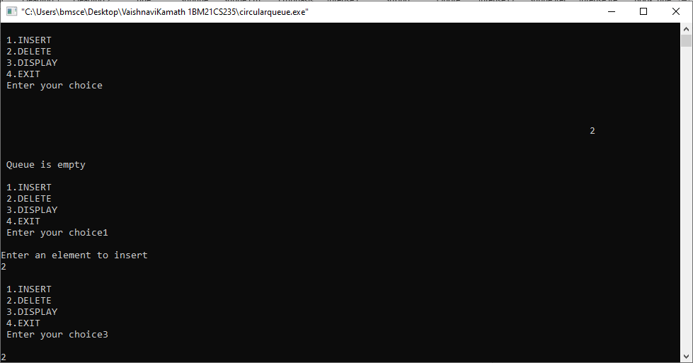}

SAMPLE OUTPUT

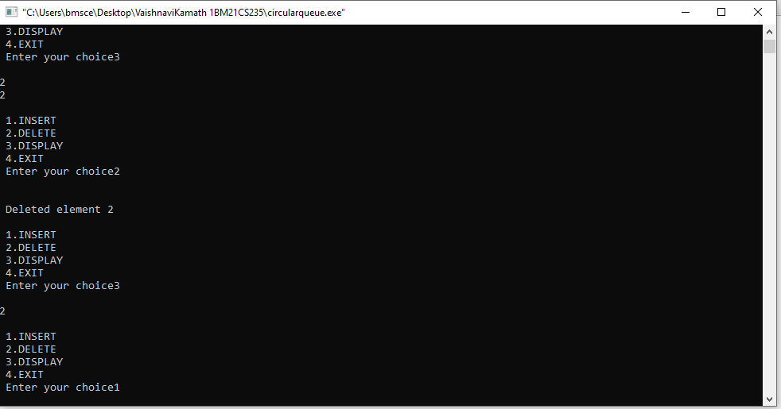

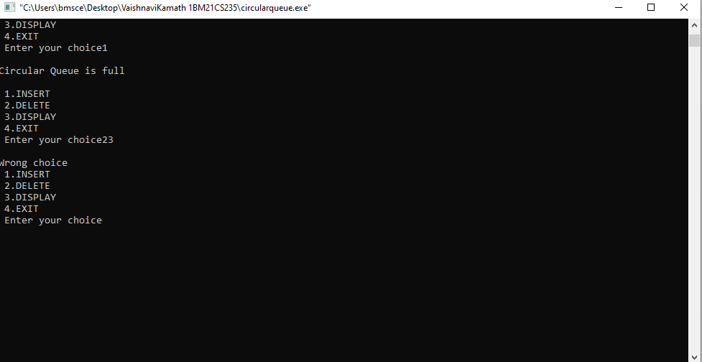

Circular queue condition

