TO DEMONSTRATE QUEUES USING ARRAYS

(VAISHNAVI KAMATH 3D BATCH)

#include<stdio.h>

#include<conio.h>

#define size 3

int queue[size],rear=-1,front=0,item;

void push();

void pop();

void display();

void main()

{

int choice;

while(1)

{

printf("\n 1.PUSH \n 2.POP \n 3.DISPLAY \n 4.EXIT");

printf(" \n Enter your choice");

scanf("%d",&choice);

printf("\n");

switch(choice)

{

case 1:

push();

break;

case 2:

pop();

break;

case 3:

display();

break;

case 4:

exit(0);

break;

default:

printf("Wrong choice");

}

}

getch();

}

void push()

{

if(rear==size-1){

printf("Queue is full");

}

else

{

printf("Enter an element");

scanf("%d",&item);

++rear;

queue[rear]=item;

}

}

void pop()

{

int x;

if(rear==-1)

printf("Queue underflow");

else{

x=queue[front];

front++;

if(front==size)

{

front=0;rear=-1;

}

}

}

void display()

{

int i;

if(rear==-1)

{

printf("Queue is empty");

}

else

{

for(i=front;i<=rear;i++)

printf("%d",i);

}

}

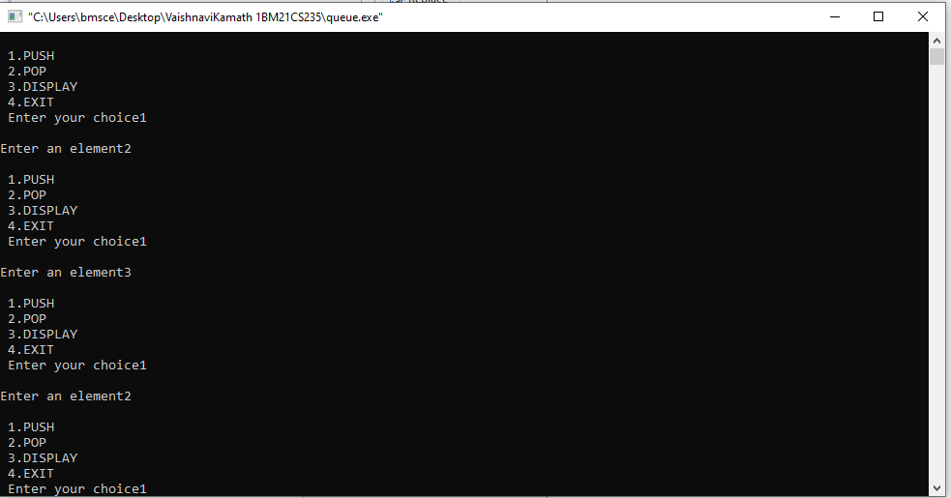SAMPLE OUTPUT

