ARP

Topology

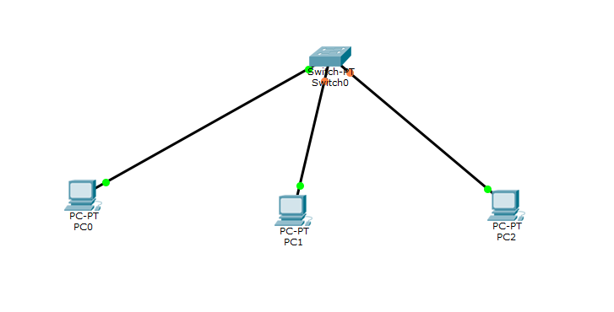

Configure ip address for pc. No default gateway for switches.

Go to any pc cmd prompt and type as below

