DNS

Topology:

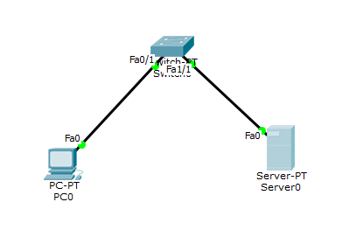

Configure ip address of PC-10.0.0.1

Server-10.0.0.2

Go to services in server select dns and add a new name as Vaishnavi Kamath and address as 10.0.0.2 address of your server.

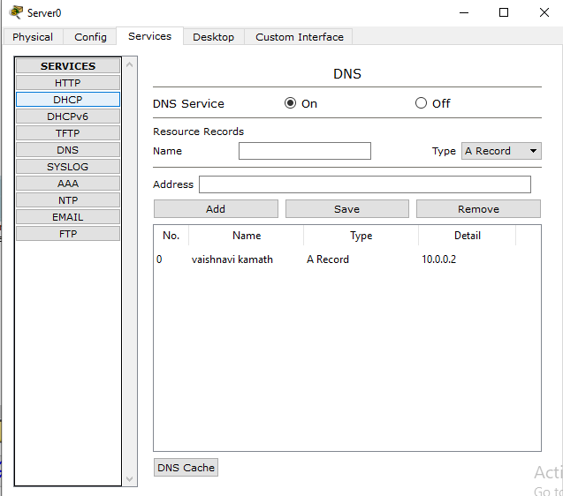

Go to http index.html and edit index page as shown below.

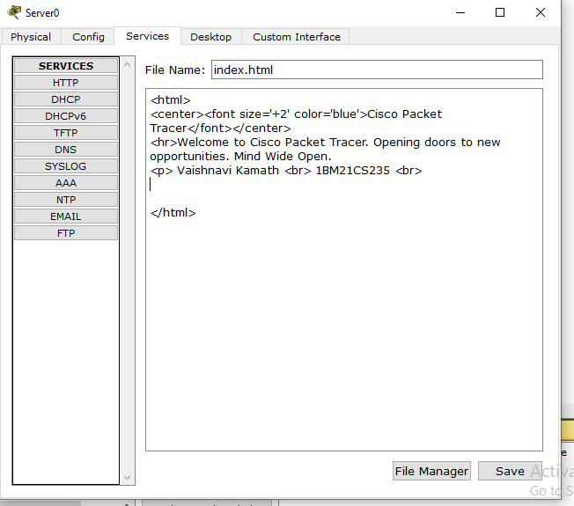

In PC go to desktop - Web browser and try to connect to server using server ip address. Output is shown (type 10.0.0.2)

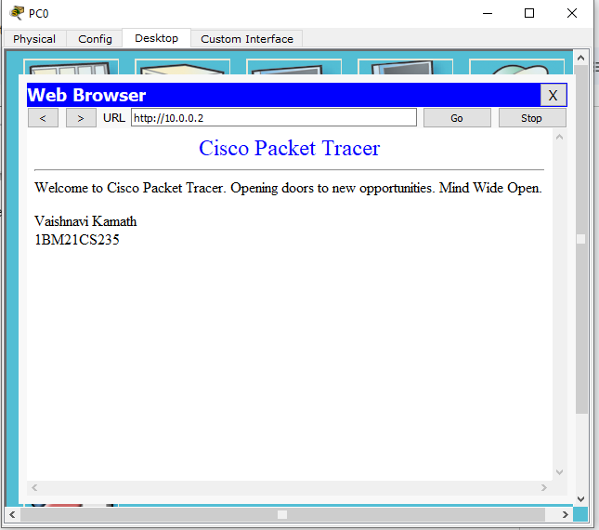

Next type name which was given in server(vaishnavi kamath) and retry to connect. Following output is obtained.

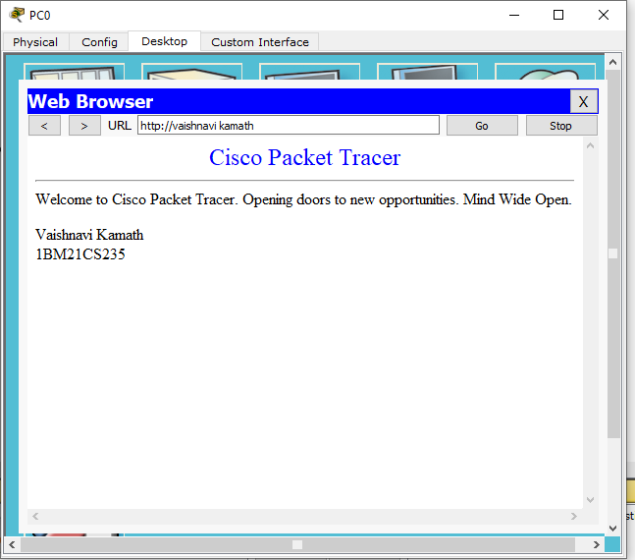

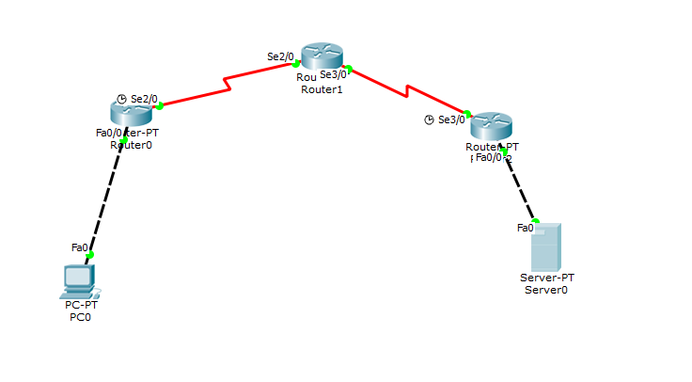

Using rip with routers

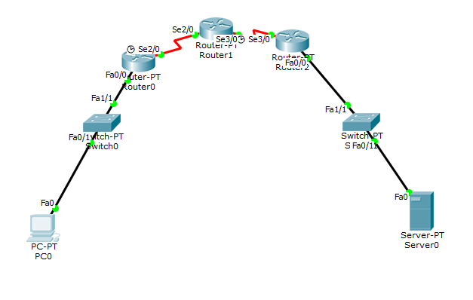

Using default routing