VLAN

TOPOLOGY

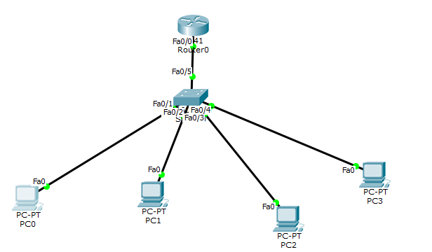

1. Connect pc’s as shown.Switch-2960 Router-1841
2. Configure IP address and gateway to pc.
3. Go to switch ->config->VLAN database set any VLAN name. But vlan number must be equal to the last but one number of the ip address (this must not be initially configured as the interface address of router) if we have 2 g/w as 192.168.1.1 and 192.168.20.1 and you have configured basically 192.168.1.1 for router interface then vlan number is 20.
4. In switch select the interface which goes to router and set dropdown to trunk

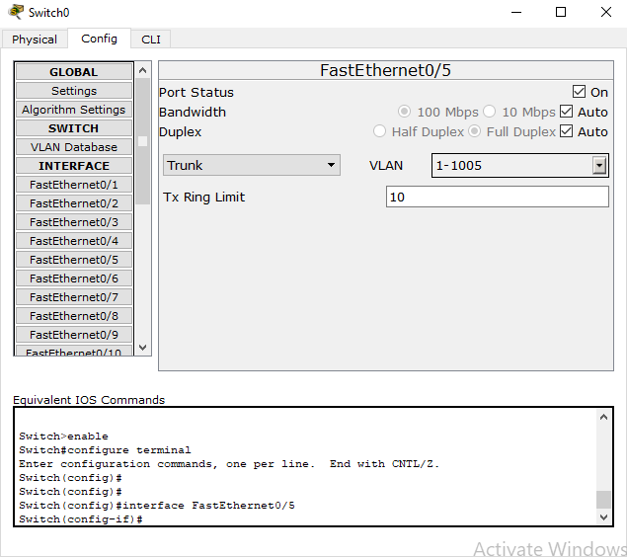

1. The right side sys conn to switch must be selected as vlan 20.

Go to router and foll commands.

