Query 1

Find all the customers who have an account at all the branches located in a city(Eg Delhi)

select customer_name,b.branch_city from Branch b inner join BankAccount ba inner join depositor d on b.branch_name=ba.branch_name and ba.accno=d.accno where b.branch_city='Delhi' group by customer_name having count(distinct branch_name)=(select count(*) from Branch where branch_city=’Delhi’);

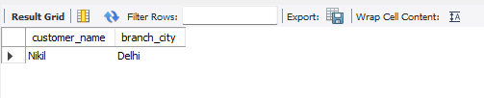

Query 2

Find all the customers who have a loan at a bank but do not have an account

Query 3

Query 4

Find the names of all branches that have greater assets tghan all branches located in Bangalore

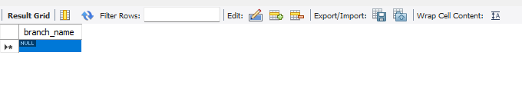

Query 5

Demonstrate how you delete all acct tuples at every branch located in a specific city.

delete from BankAccount b where b.branch_name in (select branch_name from Branch where branch_city='Bombay');

select * from BankAccount;

