

Vishwakarma Institute Of Technology, Pune

Department Name: Computer Engineering
Subject: Operating System (CS2307)

ASSIGNEMENT NO. 2
“Write shell script covering – basic arithmetic, control structures, loops, execution of Linux command in shell, command line arguments, functions and arrays. ”

Student Name: Aditya Subhash Kamble
Roll no.: 10
Division: CS SEDA A

- Find Largest Number Amoung 3 Numbers
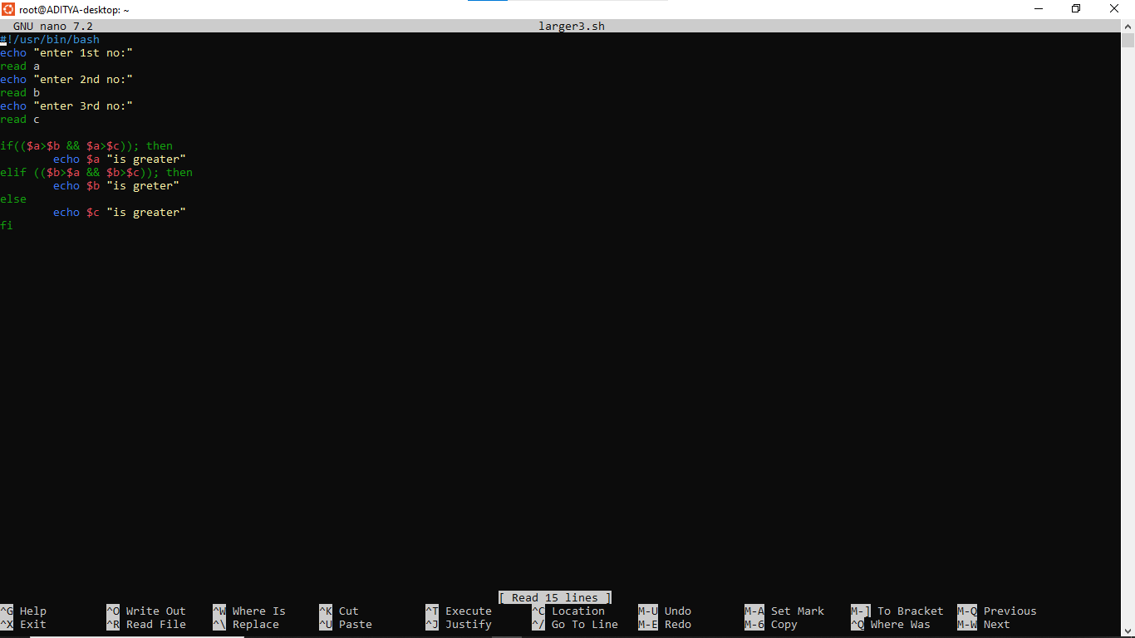
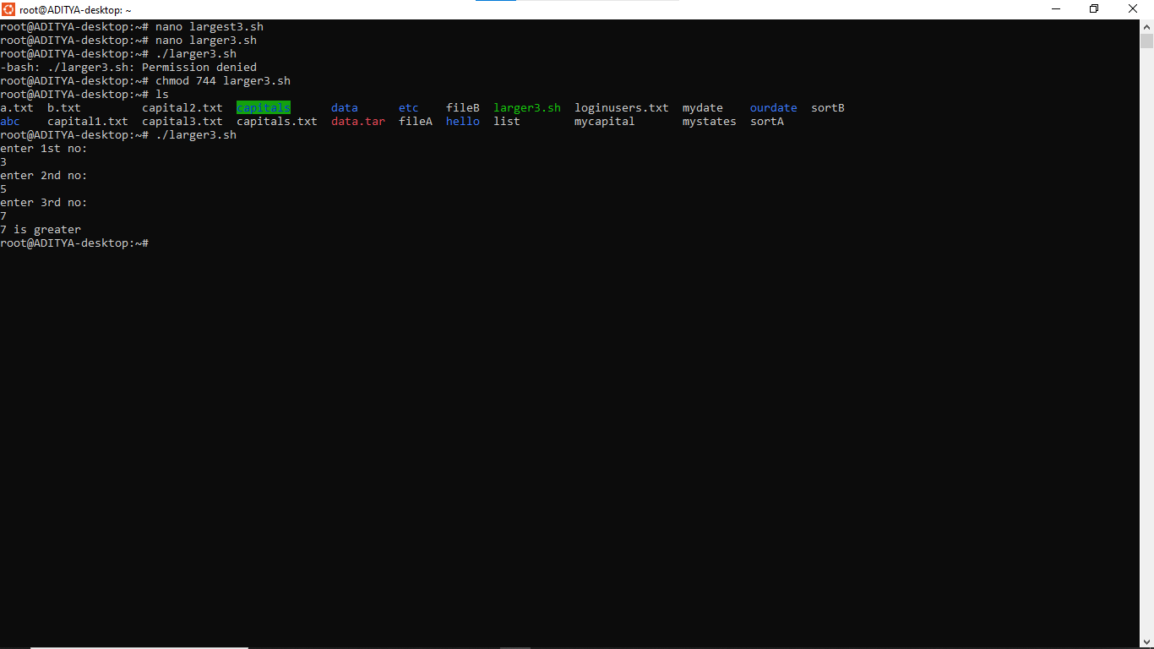
- Menu Driven Program for Arithmatic +, -, *, /
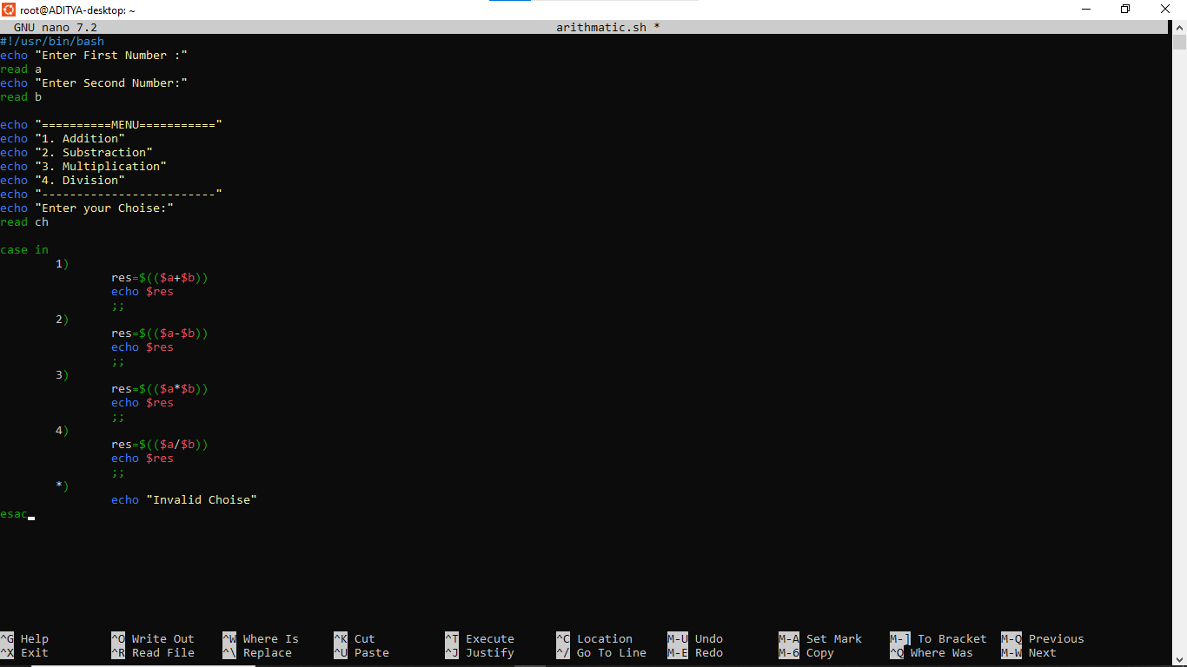
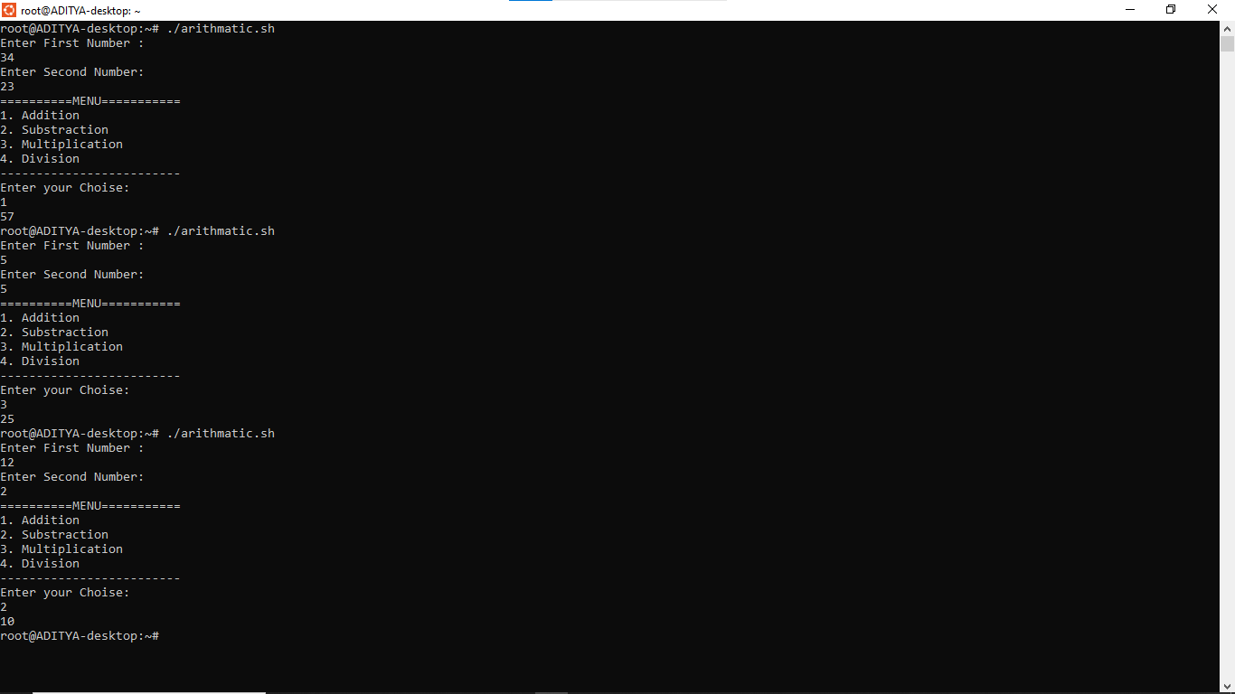

- Menu Driven Program for file
- System Date
- Disk usages
- Count no. Of lines from given file name
- Count no. Of lines from collegedate.txt file where VIT is present
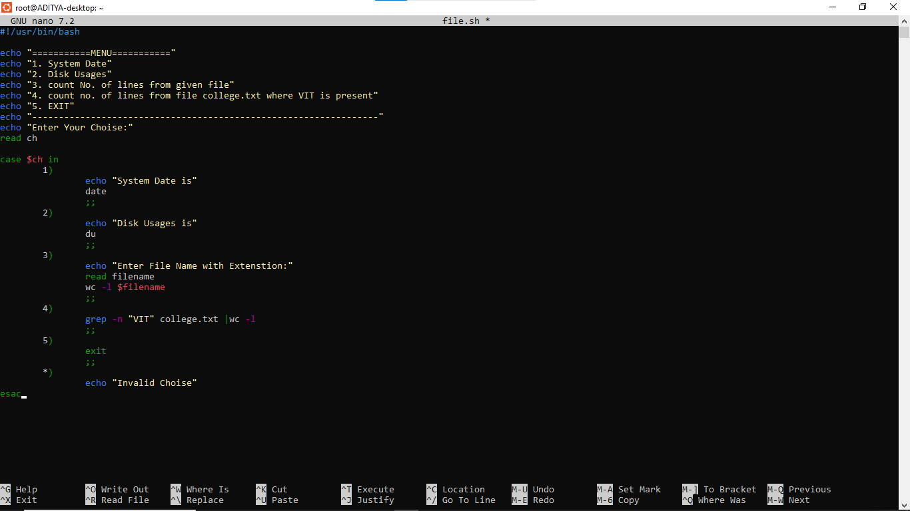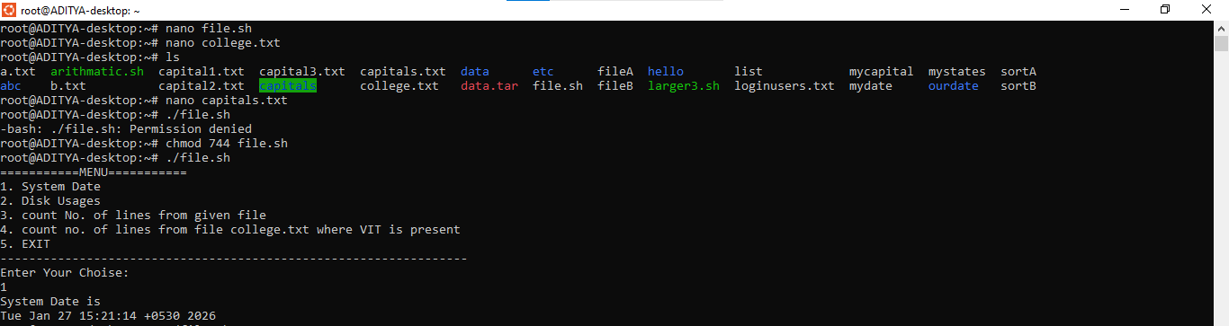
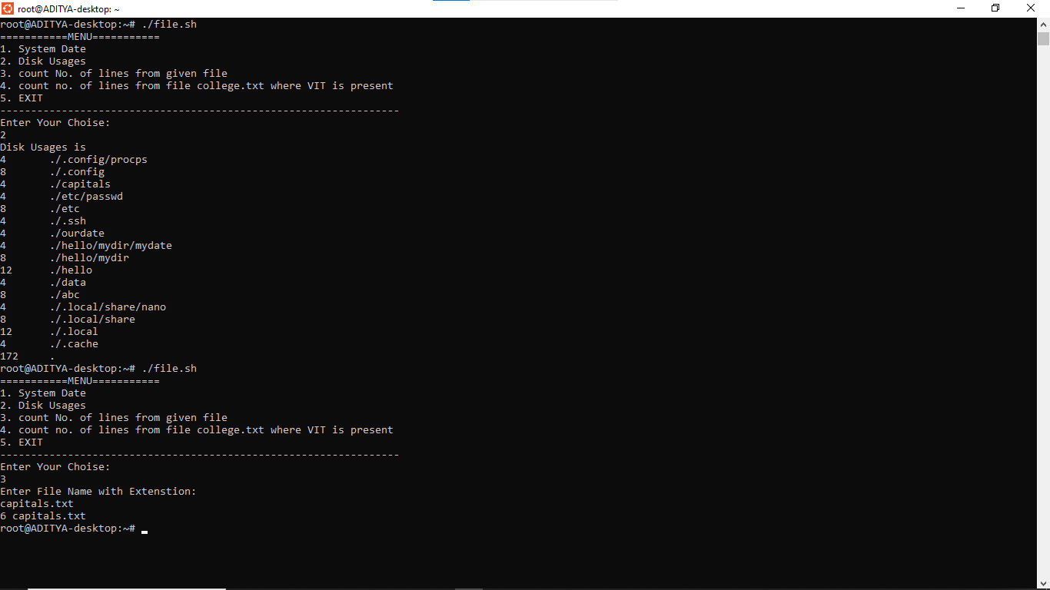
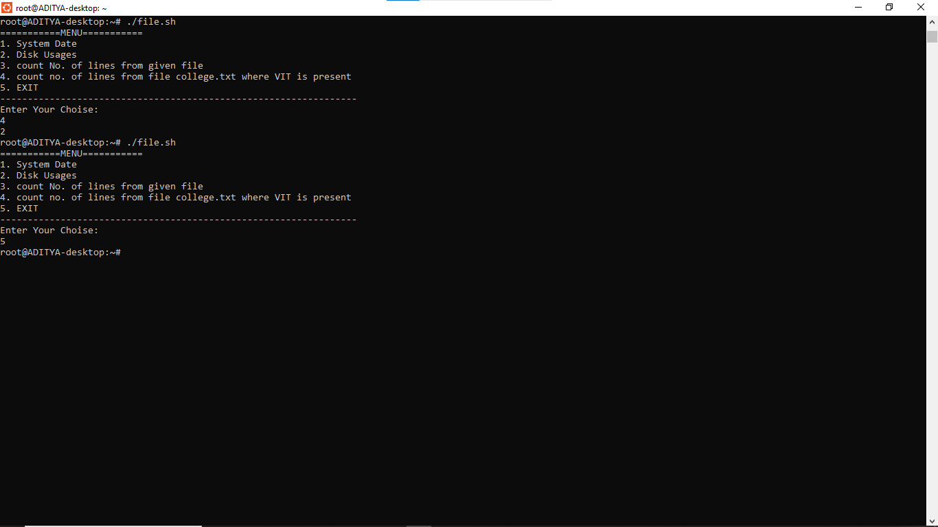

4.Searching of Element in array
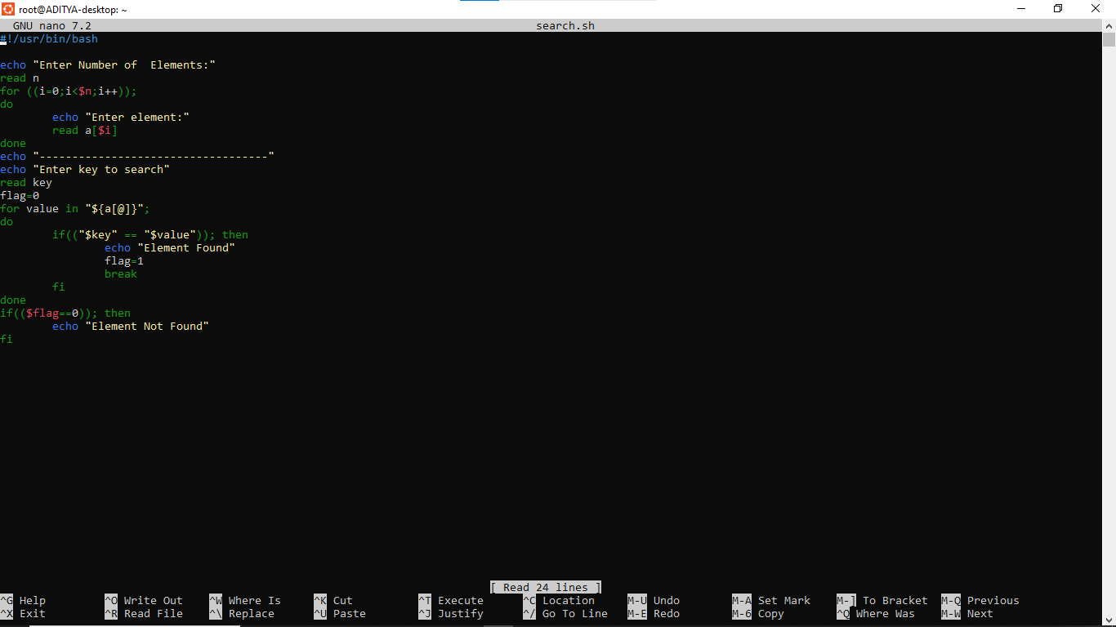
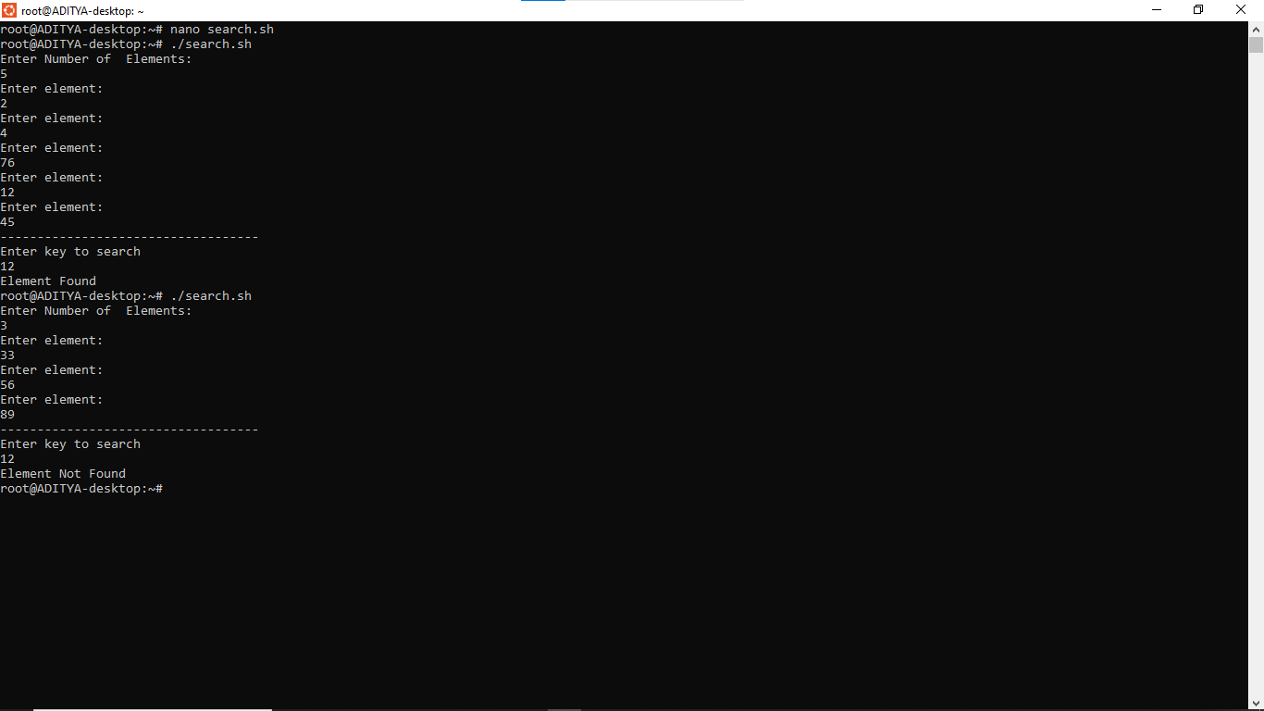

5.using command line argument find factorial of given number
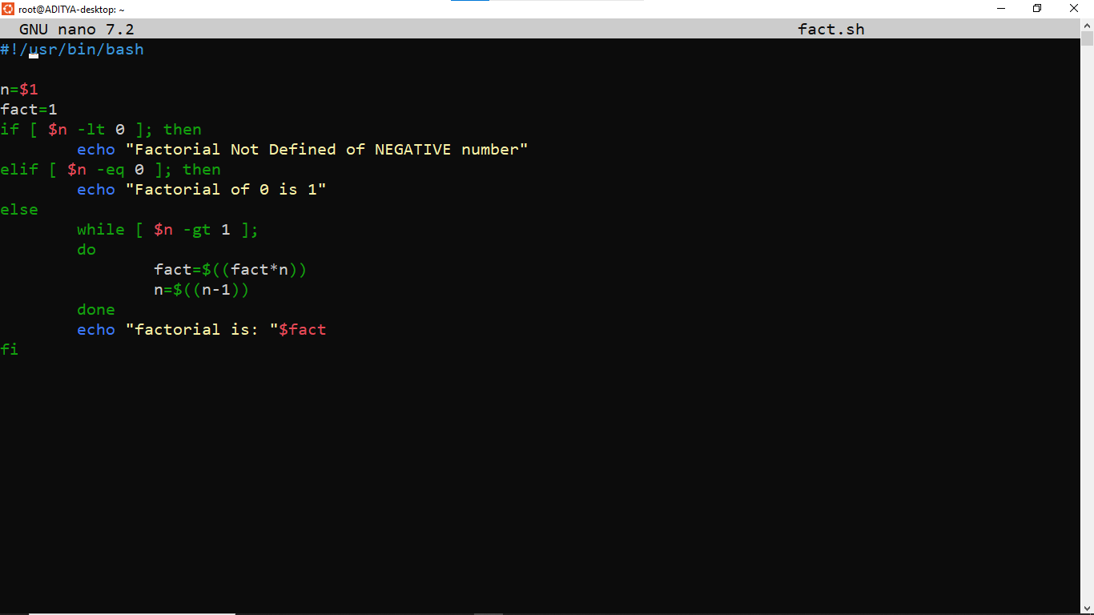
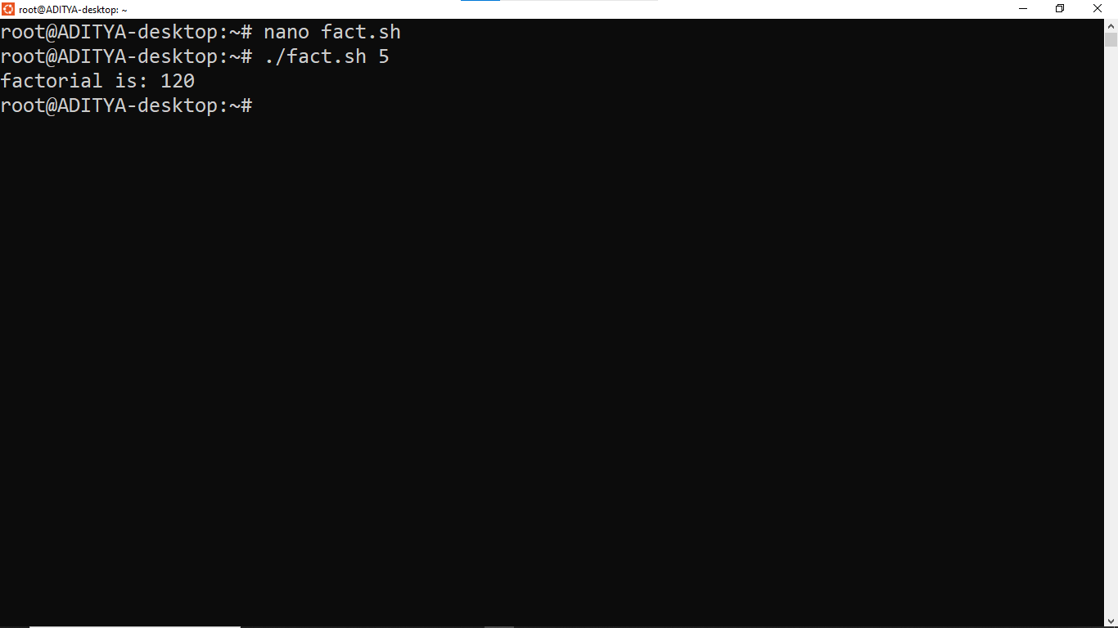

6. Automatic Backup with Date- Create a compressed backup with today’s date in the filename.
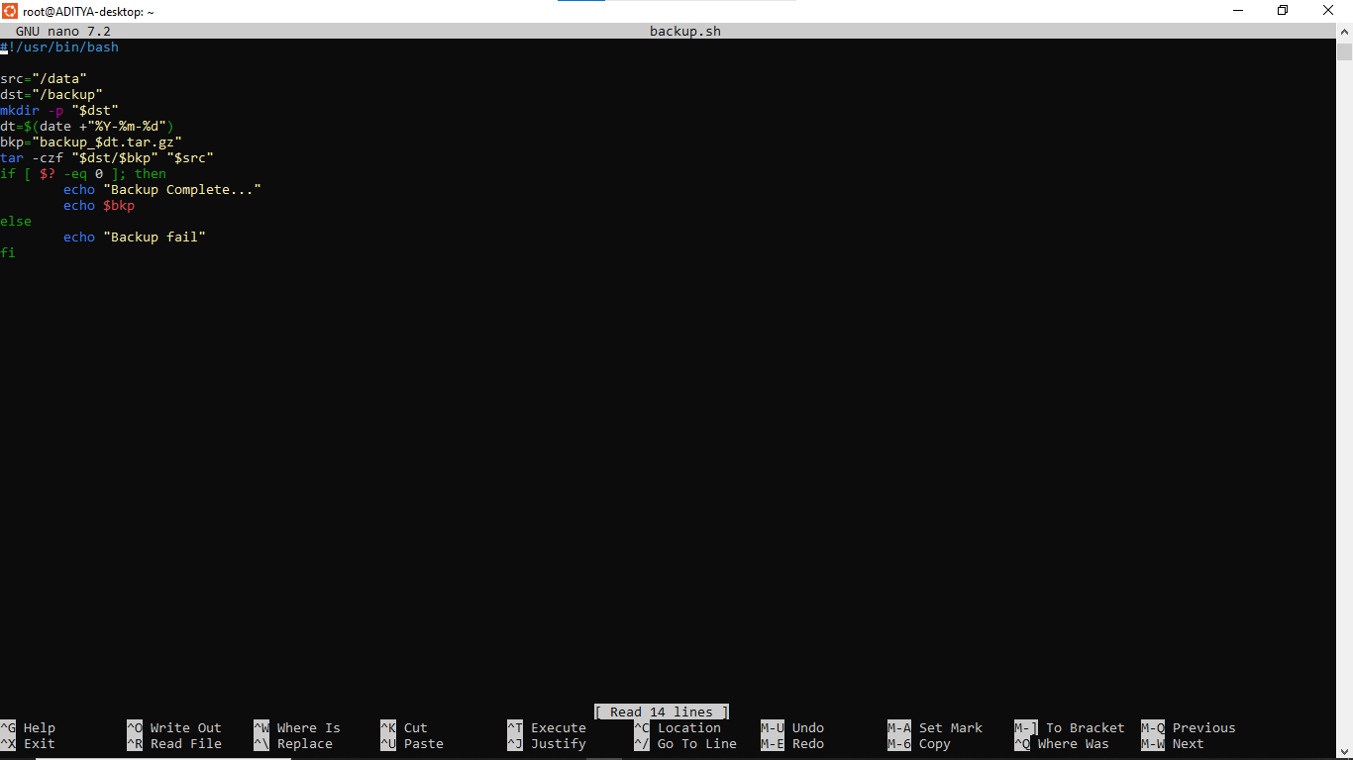
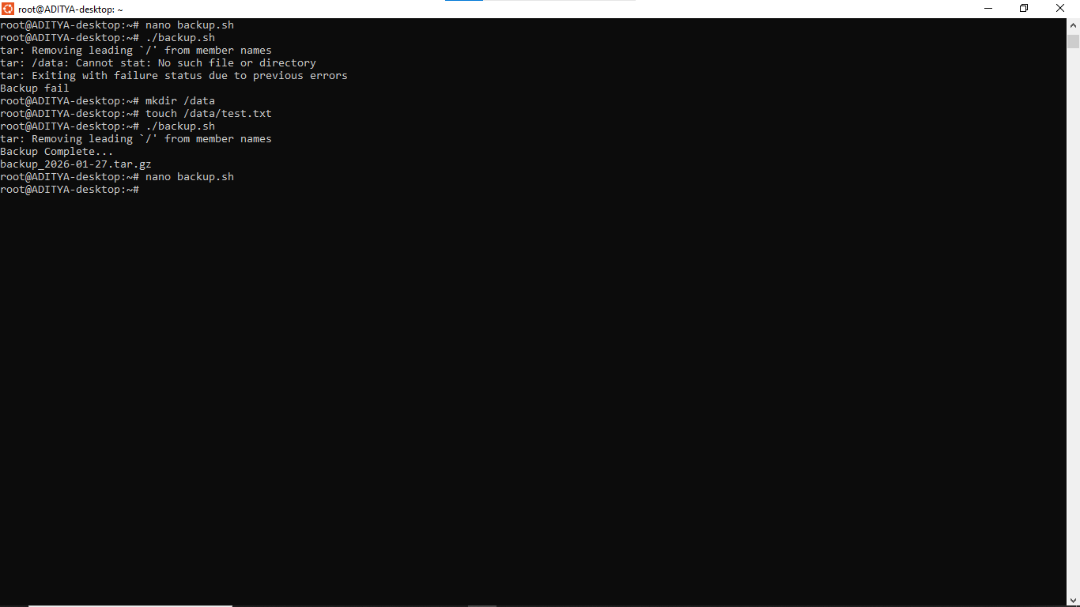

7. Using command line arguments remove all files older than n days. Give folder path & n days as command line input to program.
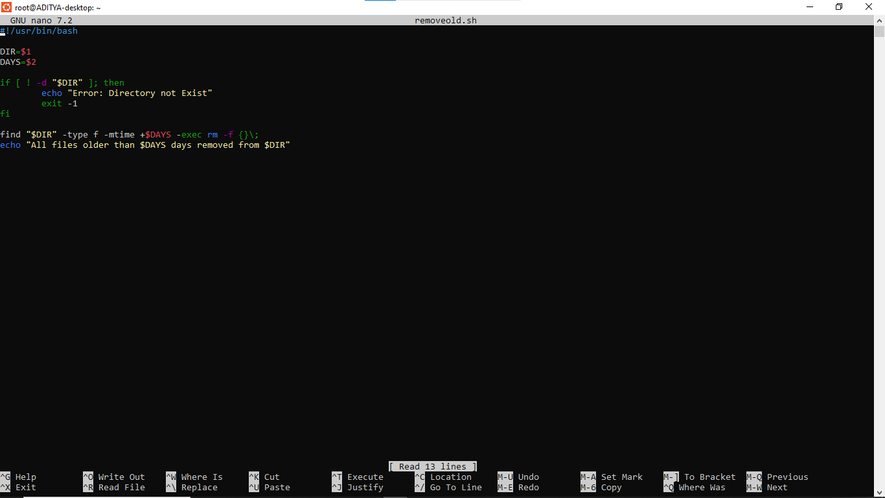
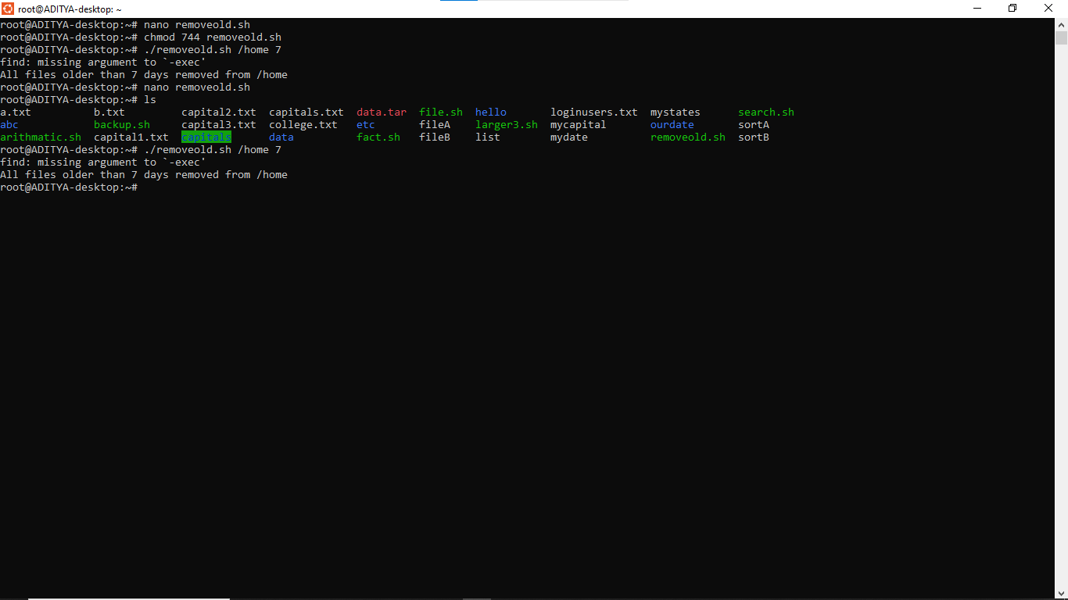

- Write a shell script that redirects all the even numbers to a file called "even" and odd numbers to a file called "odd" from a list of n numbers given as input through file.
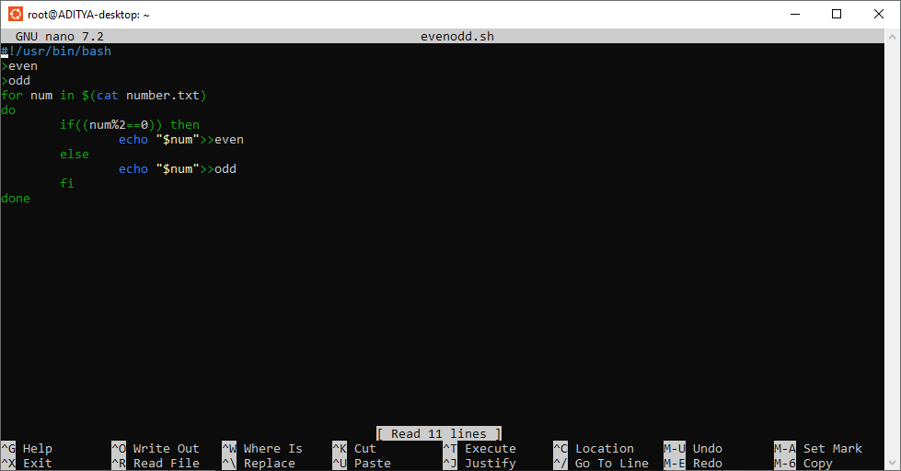
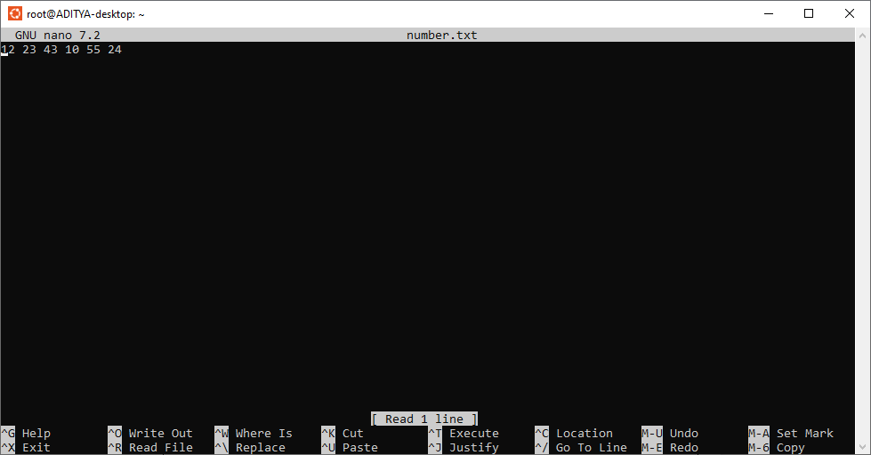
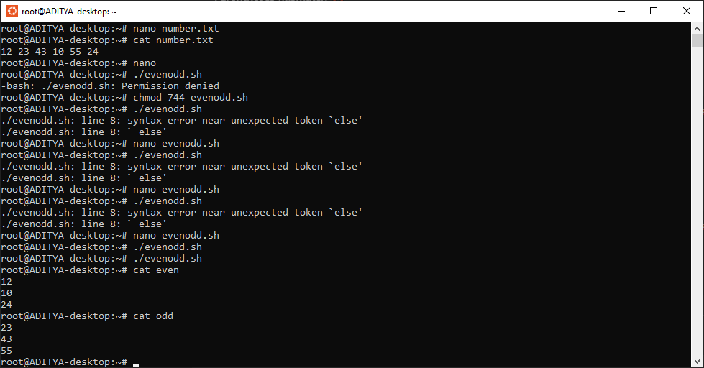
- Write a shell script to display the smallest file name(in respect of the string length) among the list of files available in the current directory.
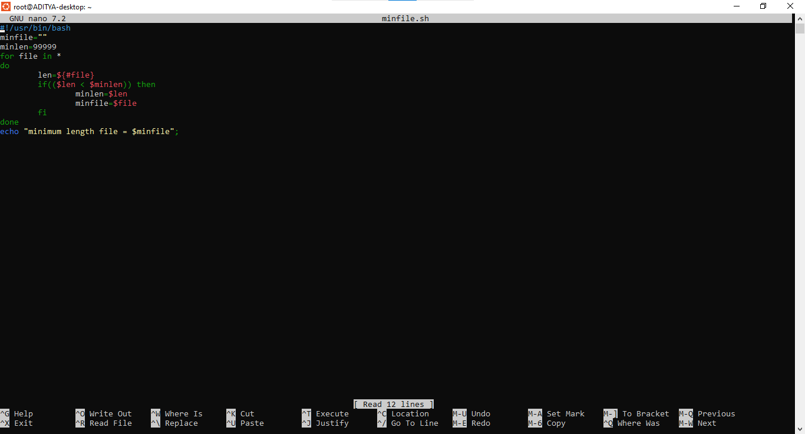
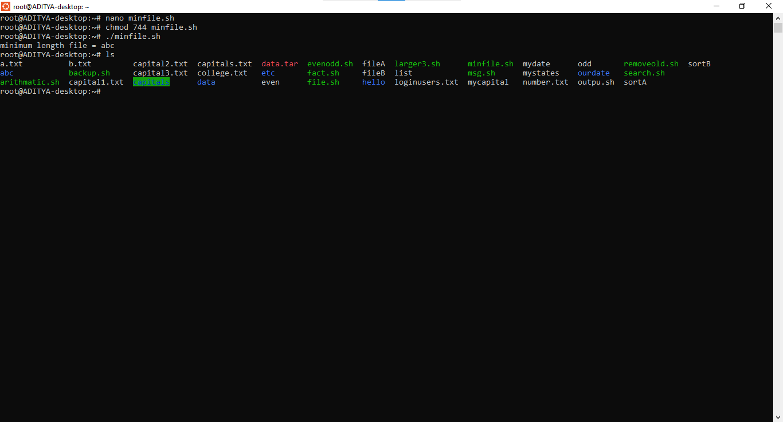
- Write a shell program to sort an array of numbers using any sort method. 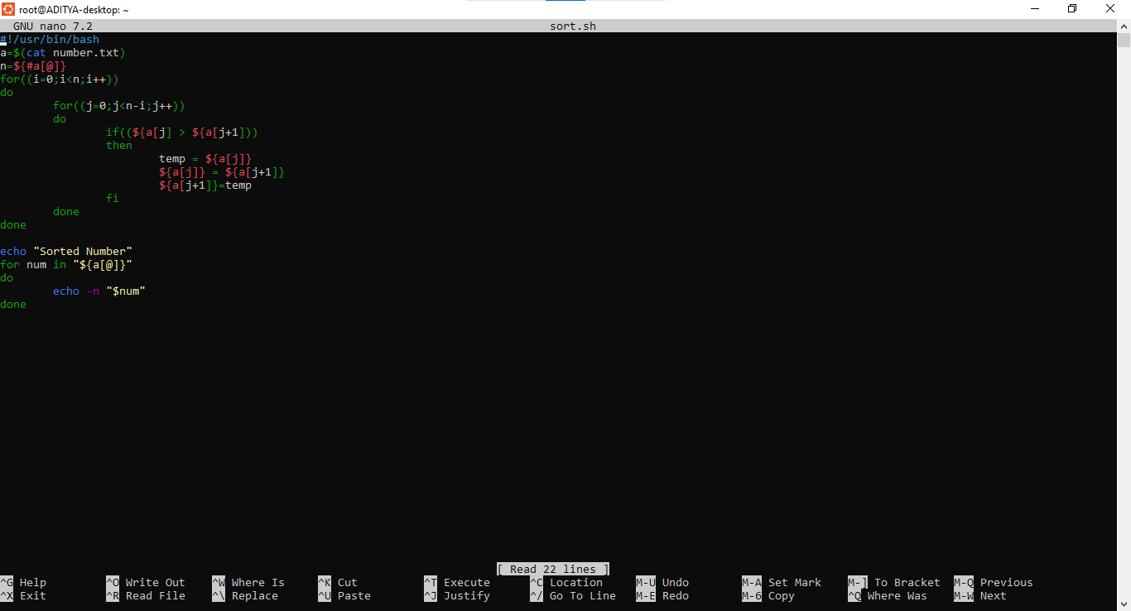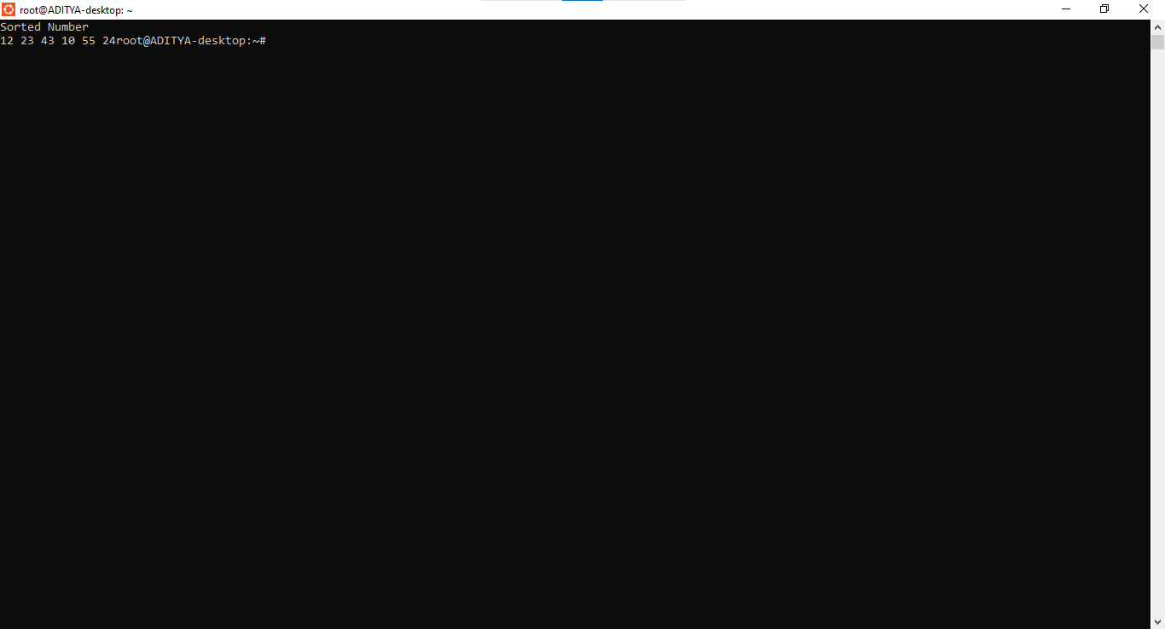

- Shell program to check whether given number is prime or not. Also print the reverse of the given number.
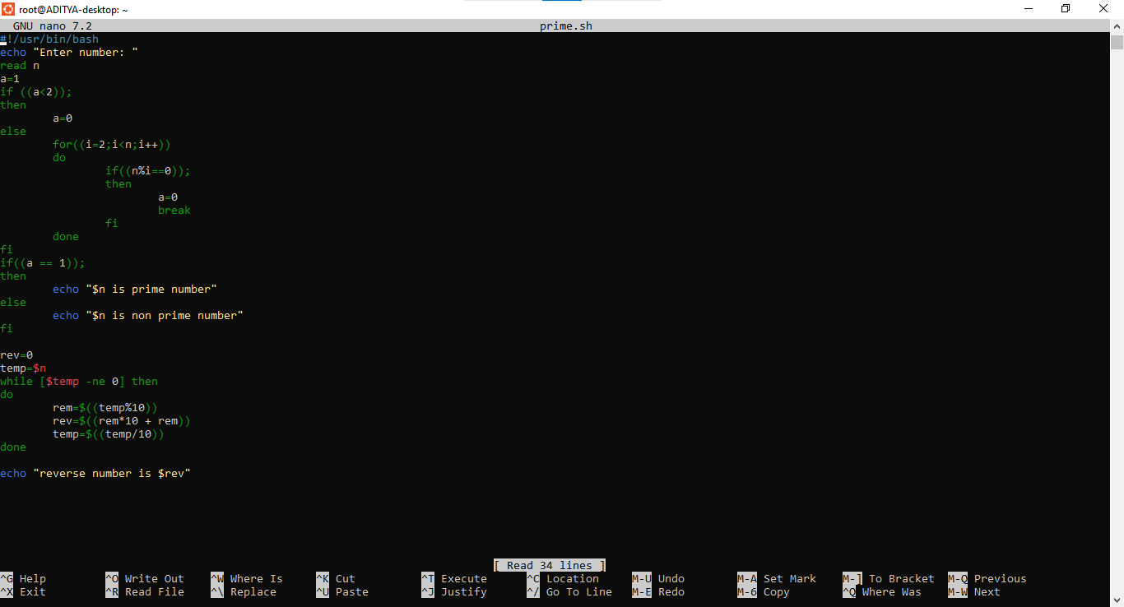
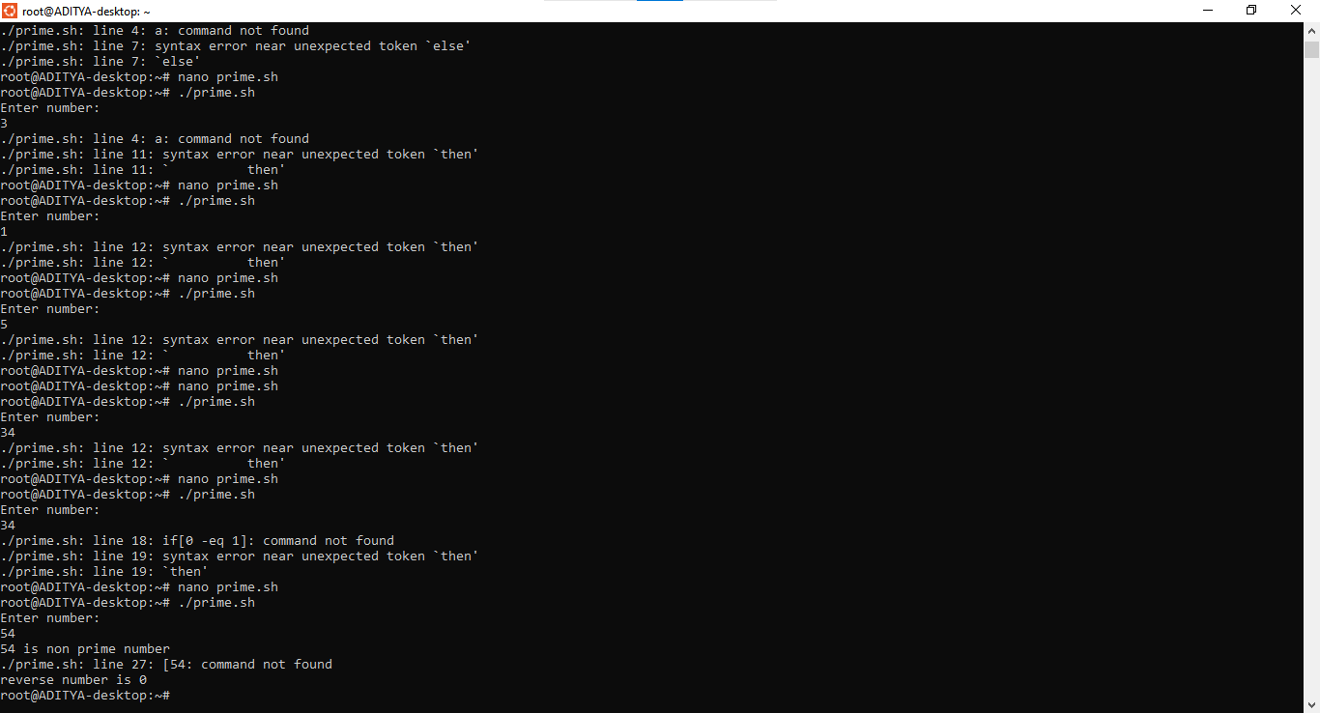

- Write a shell script to check and count occurrence of a substring in the given string using command line arguments.
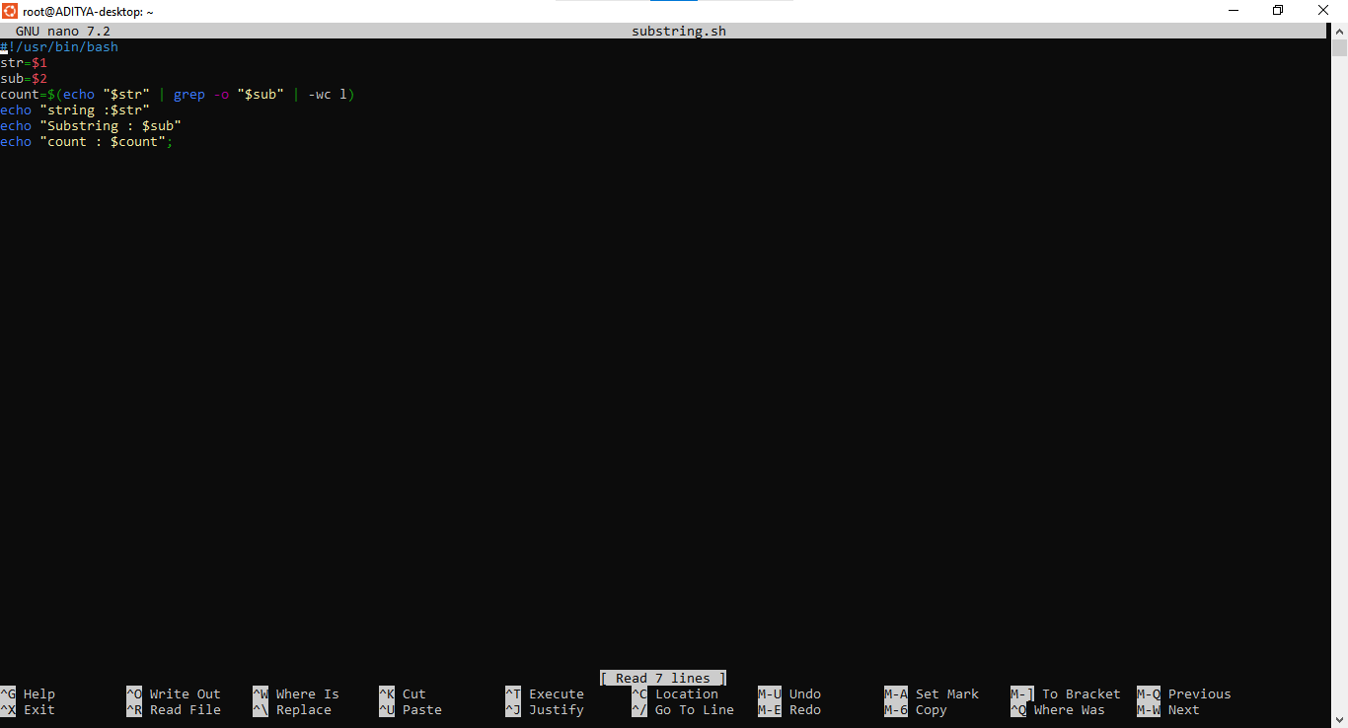
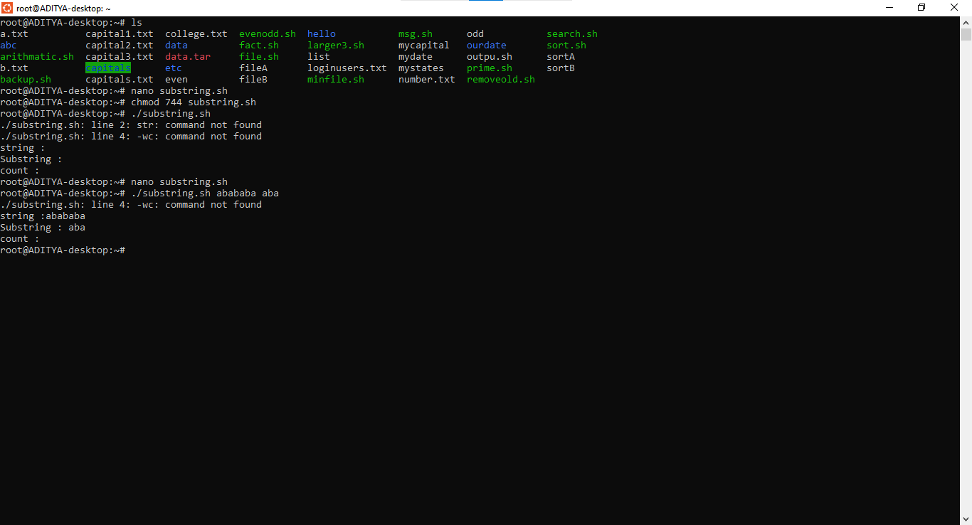

- Shell program to convert given number from decimal to binary and binary to decimal.
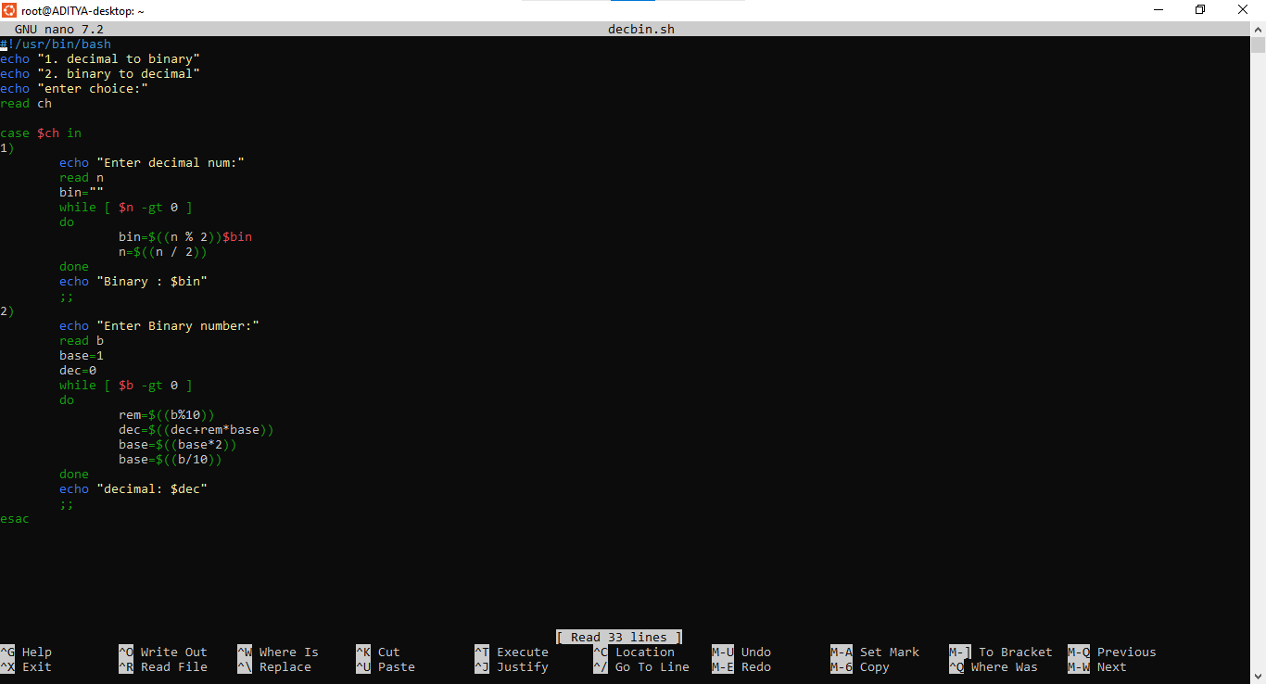
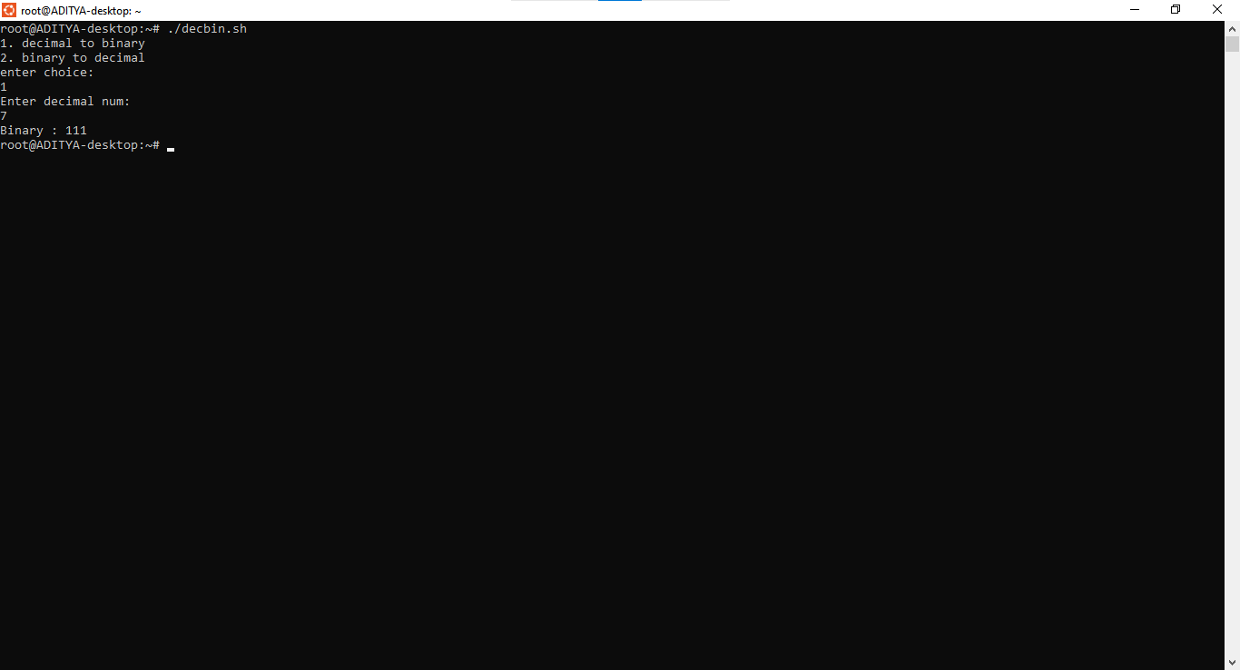

- Write a shell script to enter a name & 3 subject marks of a student & calculate total & percentage & print First class, second class, pass class & fail.
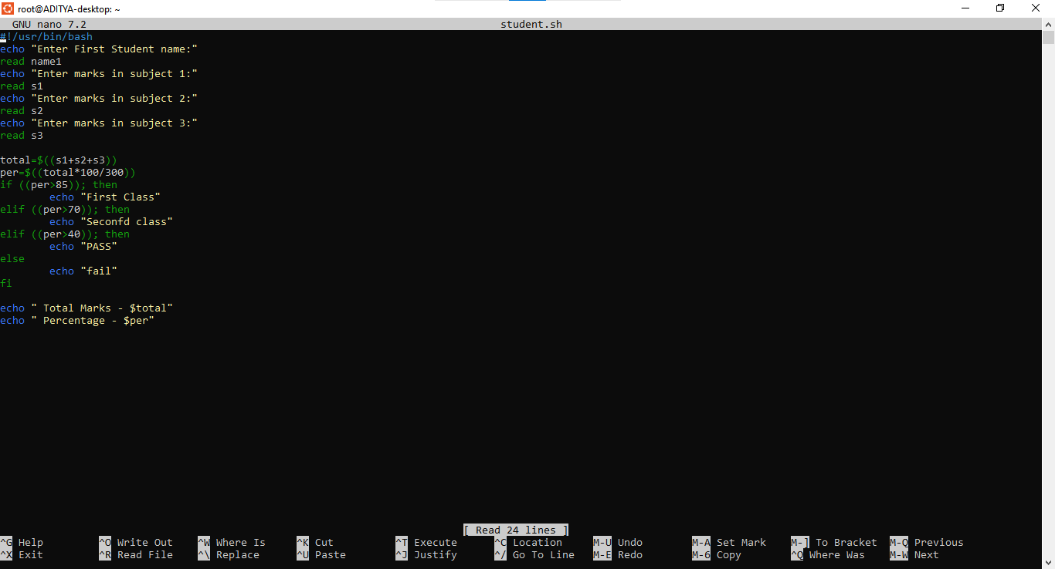
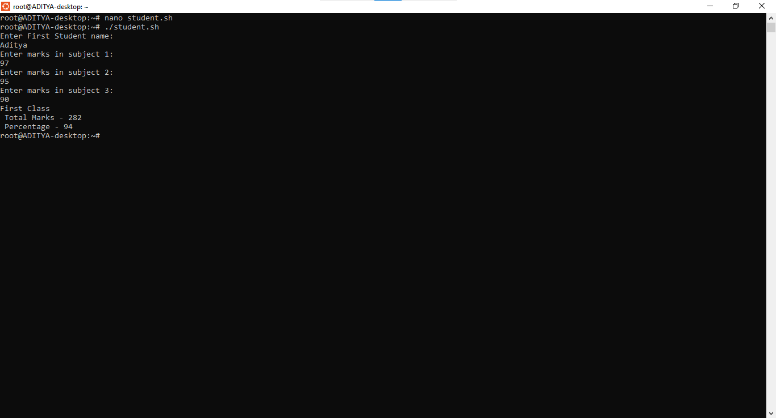

- Write a shell script that prints the sum of n even numbers. The limit is entered through the command line arguments (using functions)
