

Vishwakarma Institute Of Technology, Pune

Department Name: Computer Engineering
Subject: Operating System (CS2307)

ASSIGNEMENT NO. 1
“Execution of Basic and Advanced
Commands of Linux”

Student Name: Aditya Subhash Kamble
Roll no.: 10
Division: CS SEDA A

- Architecture of Linux Operating System.

Linux is an open-source UNIX-based operating system. The main component of the Linux operating system is Linux kernel. It is developed to provide low-cost or free operating system service to personal system users, which includes an X-window system, Emacs editor, IP/TCP GUI, etc.
Like any operating system, Linux consists of software, computer programs, documentation, and hardware.
The main components of Linux operating system are: Application, Shell, Kernel, Hardware, Utilities
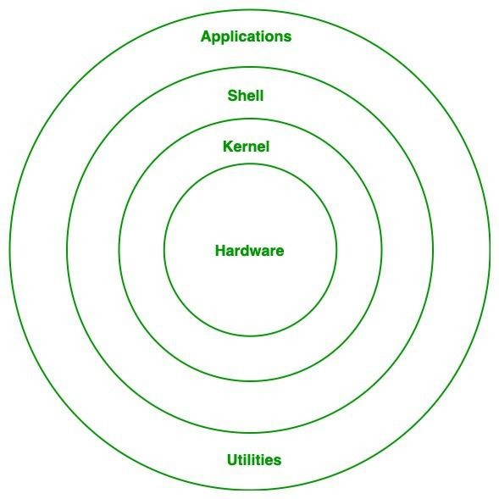

Linux Operating System Architecture

- Hardware
Hardware is the physical part of the computer system that we can touch and see. It includes devices like the CPU, RAM, hard disk, keyboard, mouse, monitor, printer, and network devices. Hardware alone cannot perform tasks properly without an operating system. In Linux OS architecture, hardware is the lowest layer and all other layers depend on it to run programs and store data.
- Kernel
Kernel is the core (main) part of the Linux operating system. It acts as a bridge between the hardware and the software. The kernel controls and manages the system resources such as CPU, memory, disk storage, and connected devices. Whenever any program wants to use hardware, it cannot directly access it, so the kernel provides permission and manages the process. That is why kernel is called the heart of Linux because it handles important operations like process management, memory management, file management, and device control.
- Shell
Shell is an interface between the user and the kernel. It works like a command interpreter because it takes commands from the user and passes them to the kernel for execution. Shell helps the user to interact with the Linux system using the terminal. When you type any command like ls, pwd, or mkdir, the shell reads that command, understands it, and sends it to the kernel. After the kernel completes the task, the shell shows the output on the screen.
- Applications / Utilities
Applications and utilities are the top layer in Linux OS architecture and they are the programs that users directly use for different tasks. Applications include software like web browsers, media players, editors, and office tools. Utilities are small system programs that help in performing basic tasks such as file handling, searching, compression, and user management. These programs work with the help of the shell and kernel to complete tasks. Basically, applications and utilities make Linux useful for daily work.

- Explain what is Kernel and Shell.

- Kernel
Kernel is the core (main) part of the Linux operating system. It acts as a bridge between the hardware and the software. The kernel controls and manages the system resources such as CPU, memory, disk storage, and connected devices. Whenever any program wants to use hardware, it cannot directly access it, so the kernel provides permission and manages the process. That is why kernel is called the heart of Linux because it handles important operations like process management, memory management, file management, and device control.
- Shell
Shell is an interface between the user and the kernel. It works like a command interpreter because it takes commands from the user and passes them to the kernel for execution. Shell helps the user to interact with the Linux system using the terminal. When you type any command like ls, pwd, or mkdir, the shell reads that command, understands it, and sends it to the kernel. After the kernel completes the task, the shell shows the output on the screen.

- Explain Linux File System.

The Linux File System is a structured method of storing and organizing data on a Linux machine. It arranges files in a hierarchical directory format starting from the root directory /.
- All files and directories in Linux originate from a single root directory /.
- It follows a hierarchical tree structure, making navigation simple and logical.
- Different directories like /home, /etc, /bin, and /var serve specific system purposes.
- Linux supports multiple file system types like ext4, XFS, Btrfs, each offering different features.
The Linux file system architecture is organized into three important layers, each responsible for different functionalities. These layers work together to provide smooth file access, storage, and management.

1. Logical File System
- Acts as the interface between user applications and the file system.
- Handles key operations like open, read, write, and close.
- Provides security checks, such as permissions and file access control.
- Ensures applications interact with files in a simple and consistent way, without worrying about storage details.

2. Virtual File System (VFS)
- Provides a common interface for different file systems (ext4, XFS, FAT32, NTFS, etc.).
- Allows Linux to use multiple file system types at the same time.
- Acts as an abstraction layer, hiding the internal complexities of each file system.
- Makes file operations uniform and compatible, regardless of the underlying file system format.

3. Physical File System
- Directly interacts with the hardware and disk storage.
- Manages data blocks, inodes, and physical memory allocation.
- Responsible for writing data to the disk and retrieving it efficiently.
- Ensures reliable storage, error handling, and low-level data management.
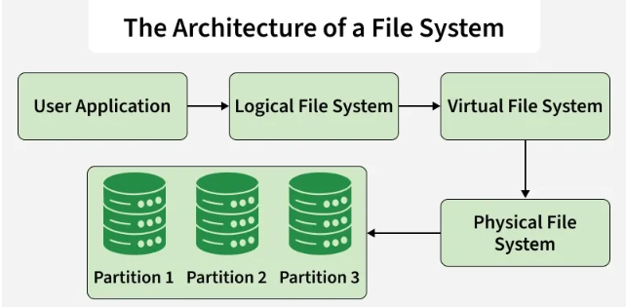

- Explain what is WSL? How to set up it on Windows.

WSL stands for Windows Subsystem for Linux. It is a feature provided by Microsoft that allows users to run a Linux operating system environment directly on a Windows computer. With the help of WSL, we can use Linux commands and tools on Windows without installing Linux separately using dual boot or a virtual machine. WSL is mainly useful for students and developers who want to learn Linux commands, use Linux terminals, and run Linux-based applications while still using Windows as their main operating system.
WSL provides many benefits to Windows users. Some important features of WSL are given below:
- Runs Linux Terminal on Windows: It provides a Linux command line interface inside Windows.
- No Need of Virtual Machine: Linux can run without using VM software like VirtualBox.
- Fast Installation and Easy Setup: WSL can be installed in a few minutes.
- Supports Multiple Linux Distributions: We can install Ubuntu, Debian, Kali Linux, etc.
- Useful for Learning and Development: It helps to learn Linux, run programming tools, and use open-source software easily.

How to Setup WSL on Windows (Step-by-Step):
To install and set up WSL on Windows, follow the steps below:

Step 1: Open PowerShell as Administrator
First, we need to open PowerShell with administrator access.
- Click on the Start menu
- Search for Windows PowerShell
- Right click on it and select Run as Administrator

Step 2: Install WSL using Command
After opening PowerShell, type the following command and press Enter:
wsl --install
This command automatically installs WSL and also installs a Linux distribution (usually Ubuntu).

Step 3: Restart the Computer
After installation, restart your system to apply all changes properly.

Step 4: Open Ubuntu and Create Username & Password
After restarting the computer:
- Open Ubuntu from the Start menu
- It will ask to create a username
- Then it will ask to create a password
After completing this, the Linux terminal will start successfully.

Step 5: Check WSL Installation
To confirm that WSL is installed properly, open PowerShell and type:
wsl --list –verbose

This command shows the installed Linux distribution and its WSL version.
WSL (Windows Subsystem for Linux) is a useful feature that helps Windows users to run Linux commands and tools within Windows. It is very helpful for students and programmers who want to learn Linux or use Linux software without leaving Windows. Installing WSL is simple and can be done easily using a few steps. Therefore, WSL is a good option for learning and working with Linux on Windows systems.

- Linux Commands

- File and Directory Operations Commands
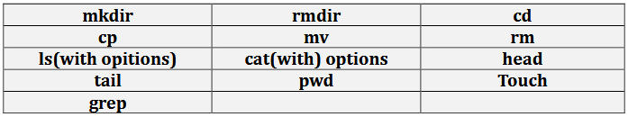
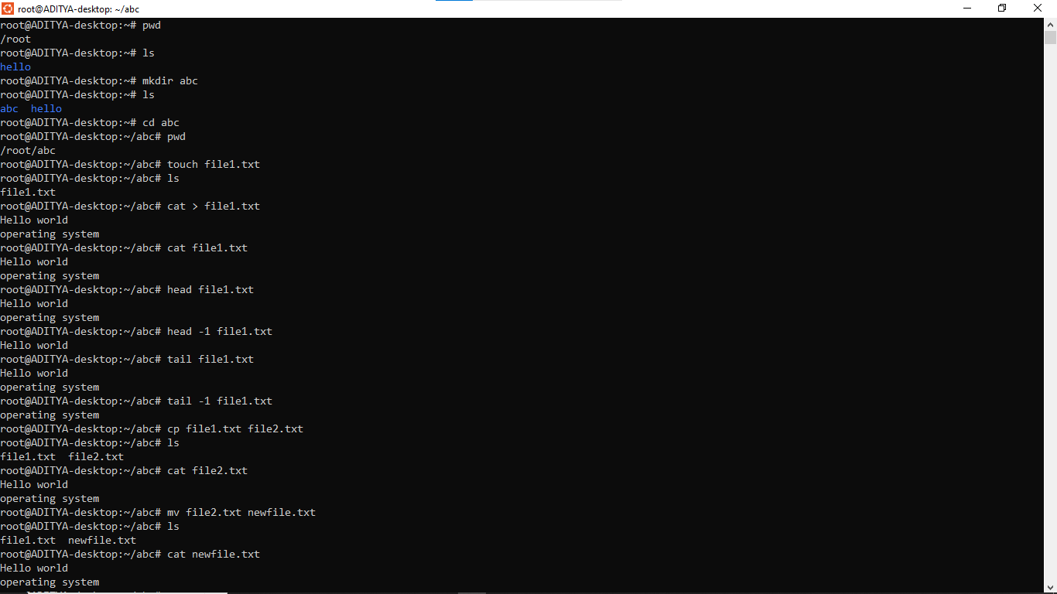
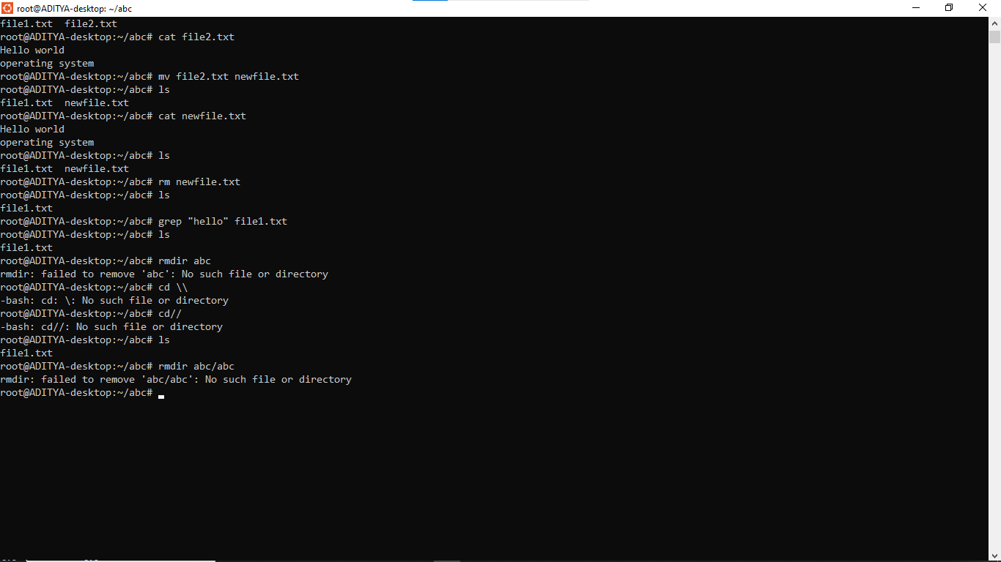

- File Compression and Archiving Commands
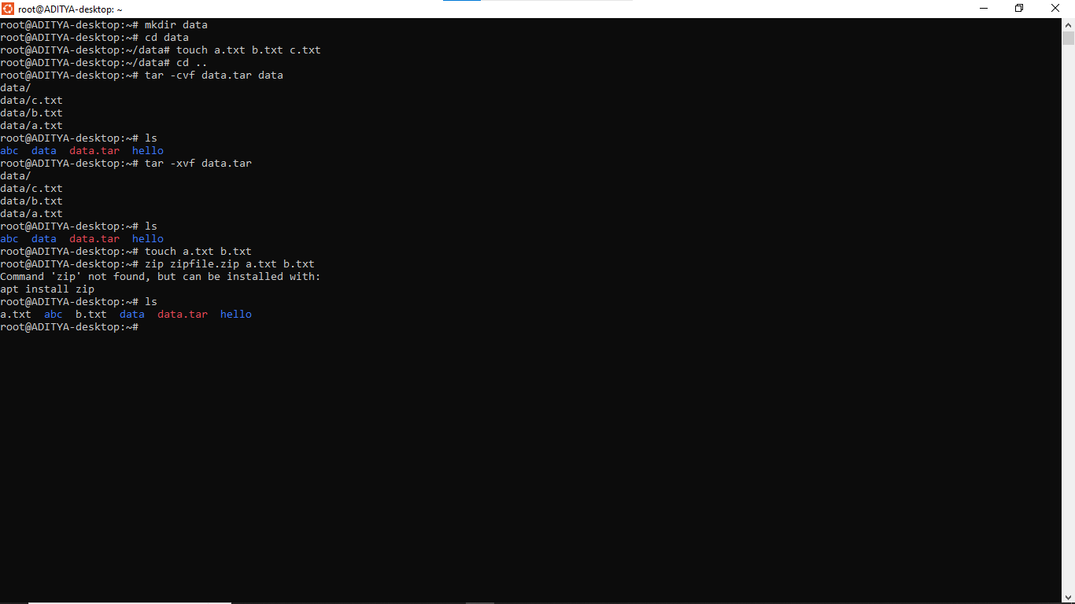

- File Permission Commands
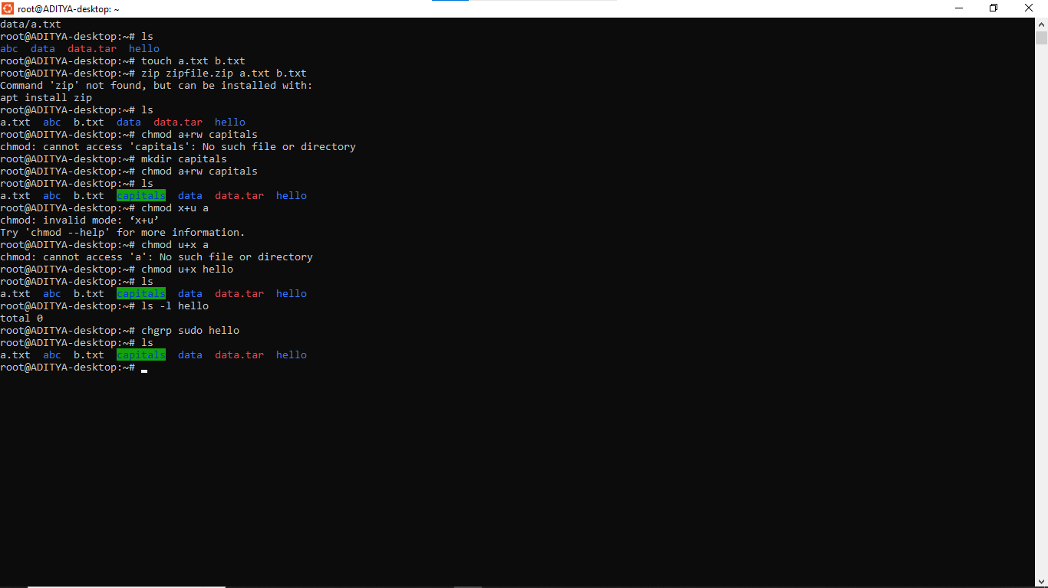
- Process Management Commands
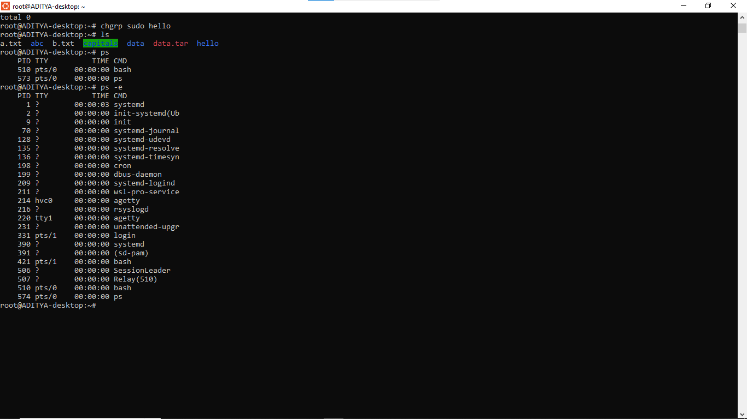
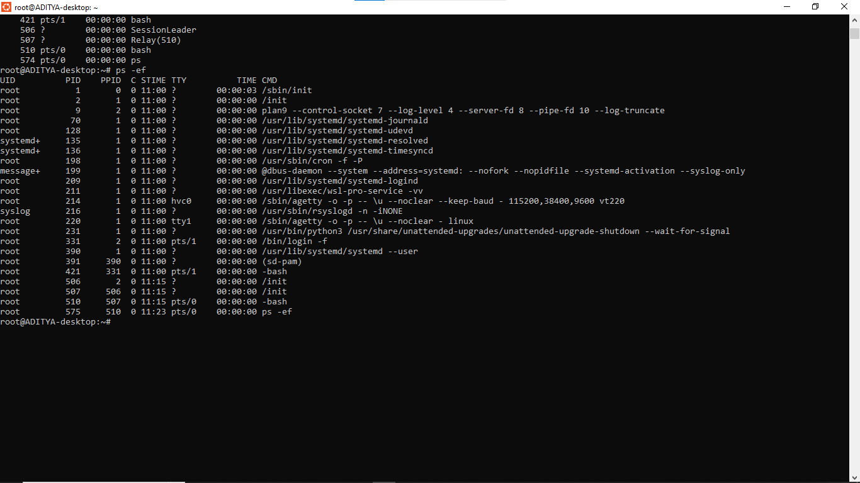
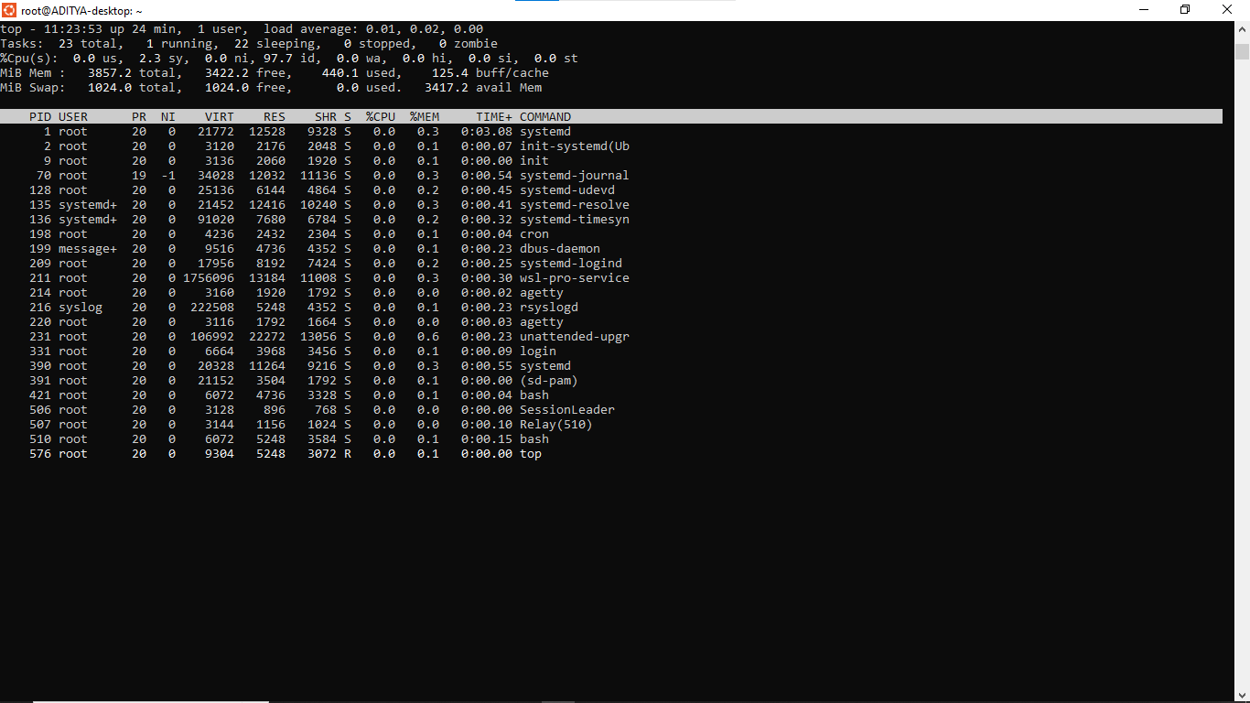

- System Information Commands
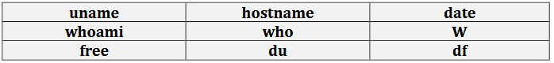
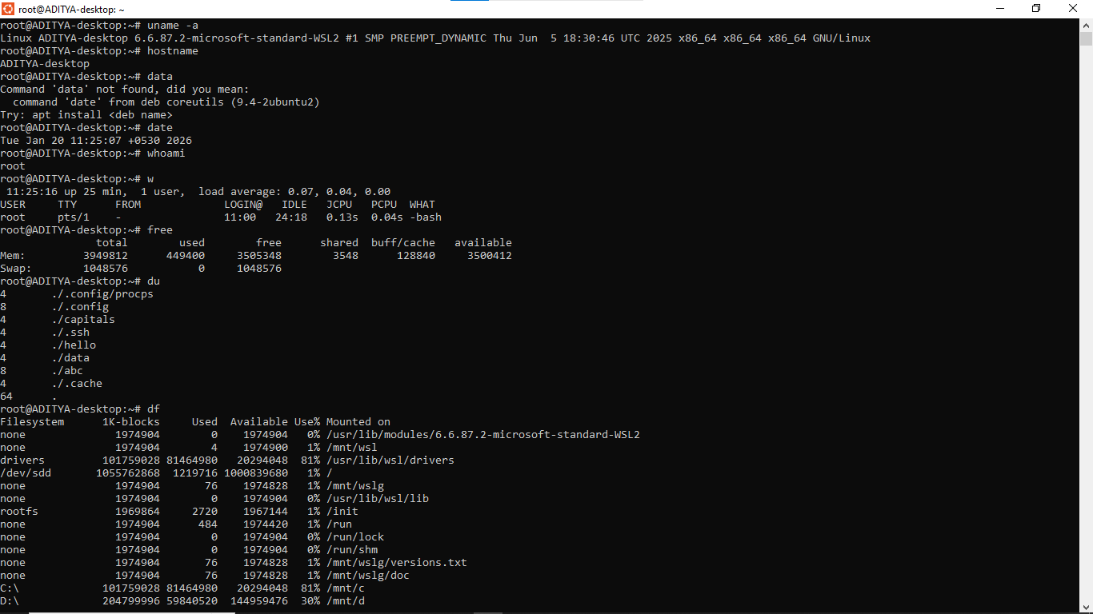

- Networking Commands
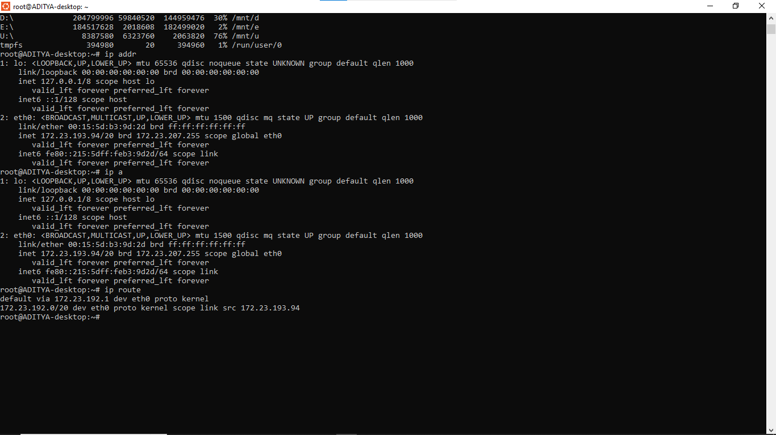

- I/O Direction Commands
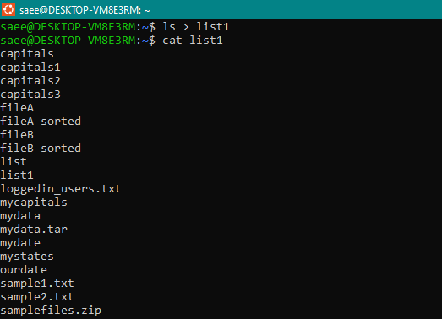

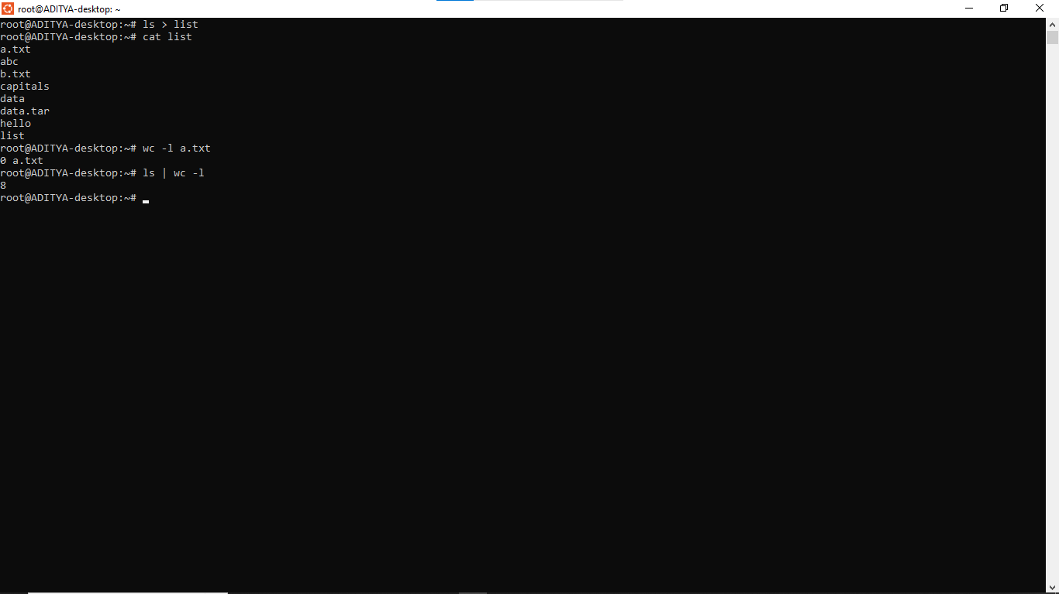

- User Management Commands

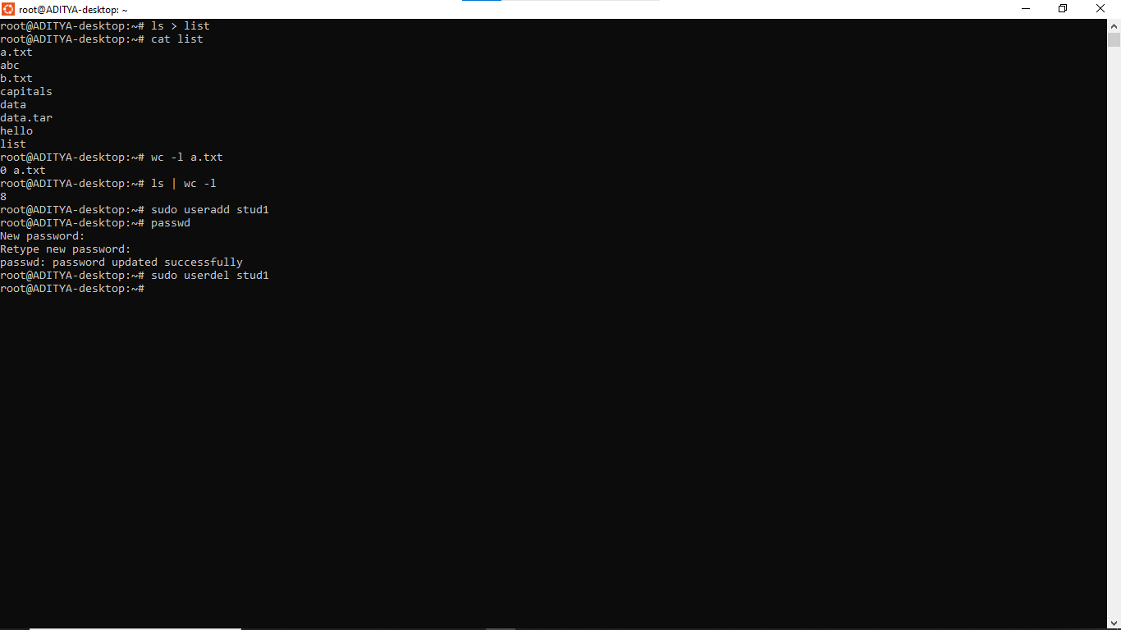
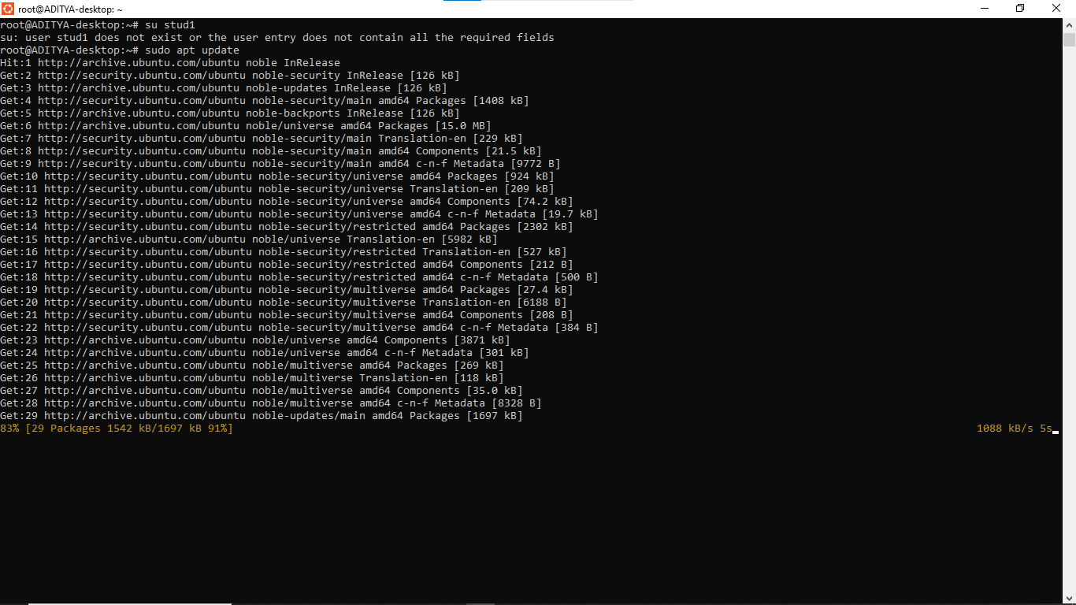

- Problems
1. Change your password to a password you would like to use for the remainder of the
semester.
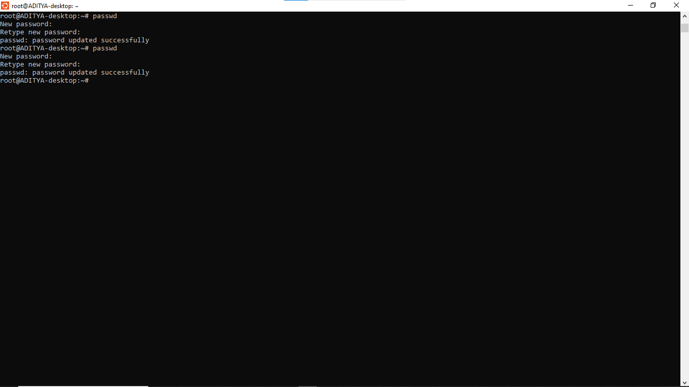

2. Display the system’s date.
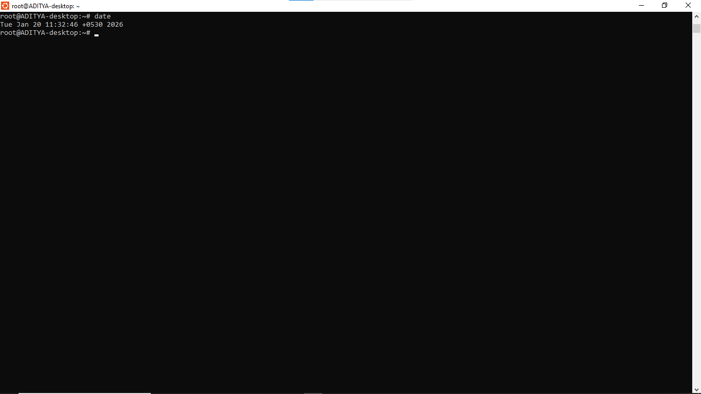

3. Count the number of lines in the /etc/passwd file.
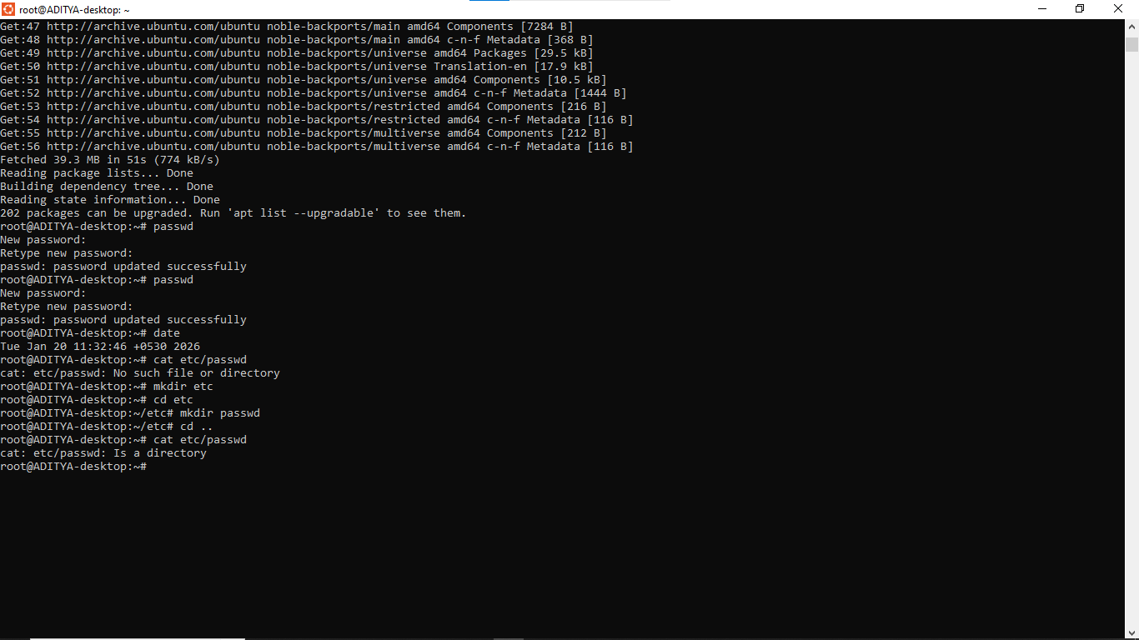
4. Find out who else is on the system.
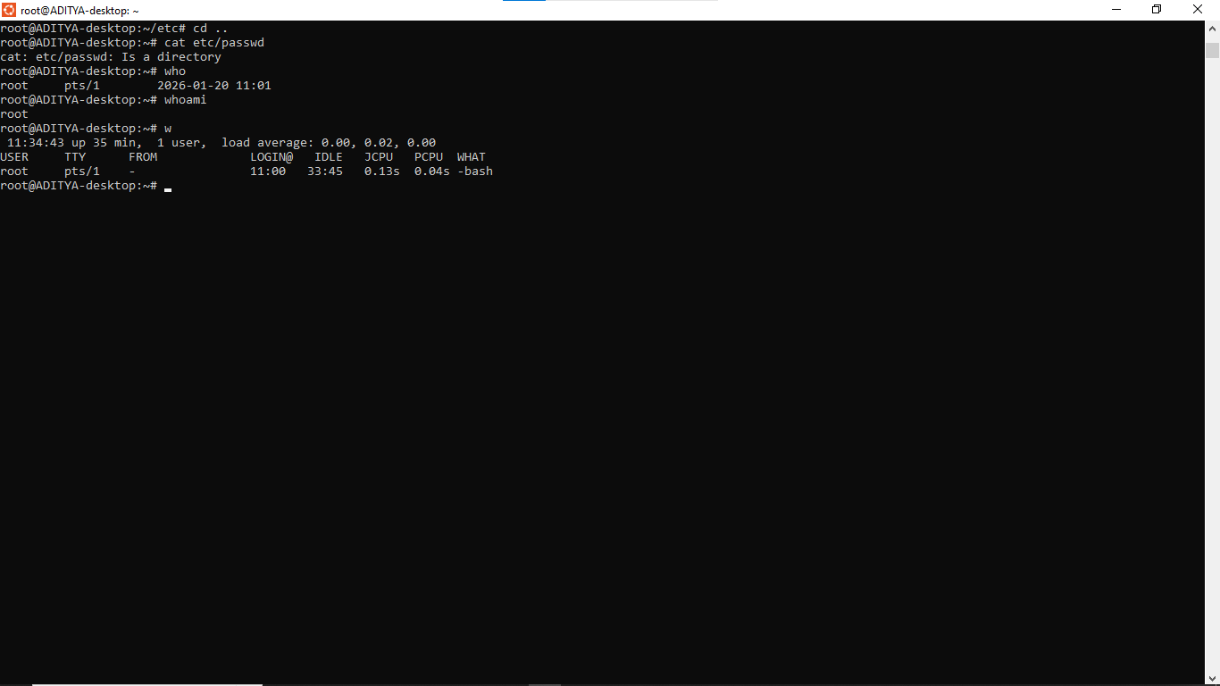

5. Direct the output of the man pages for the date command to a file named mydate.
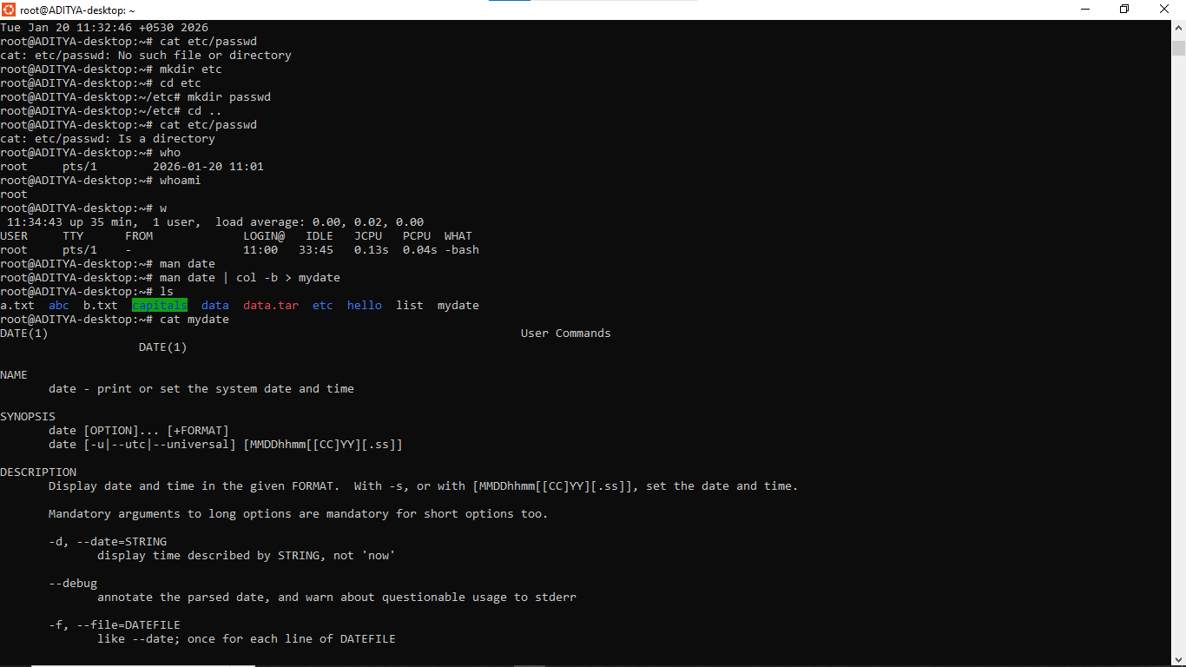

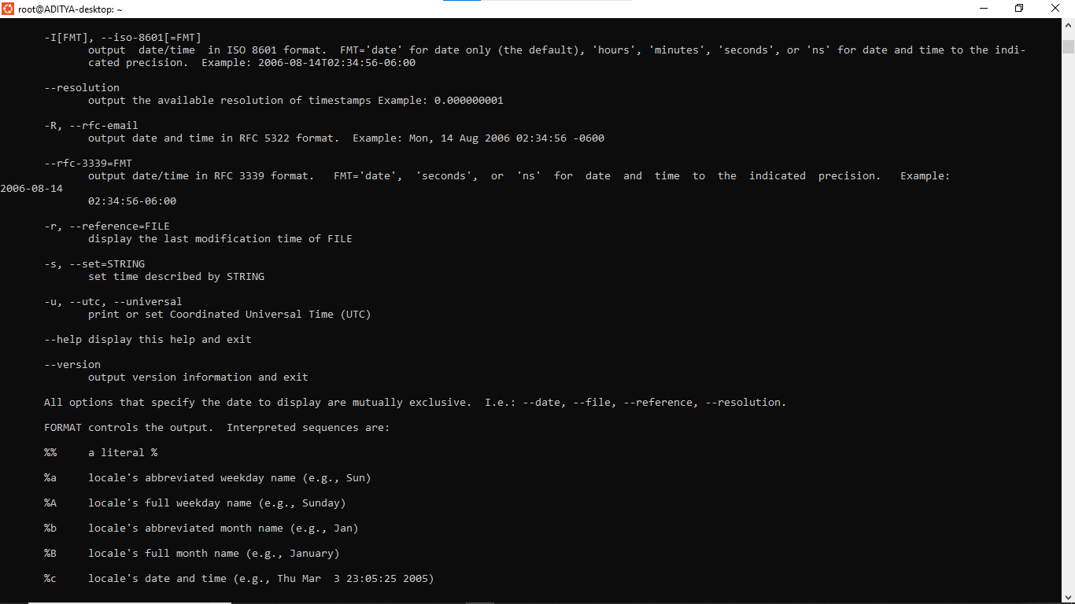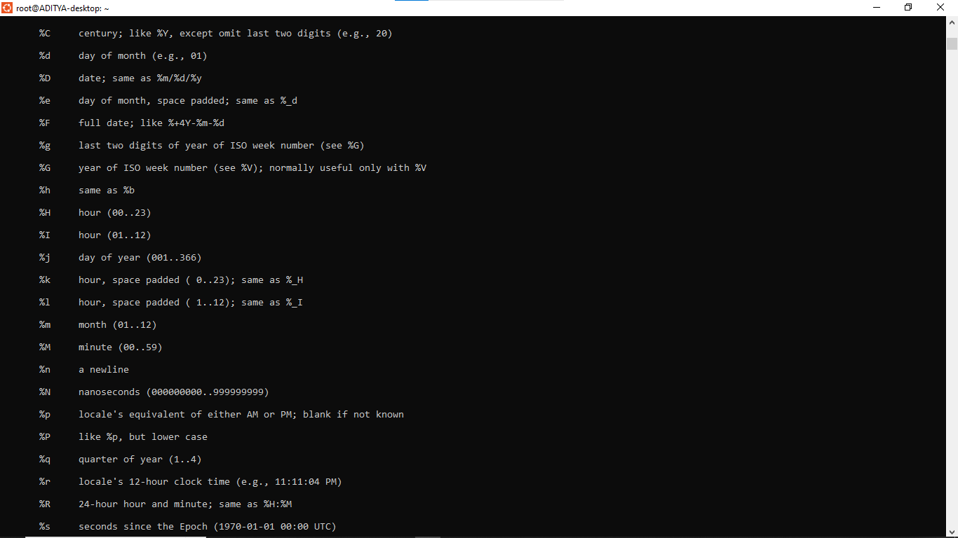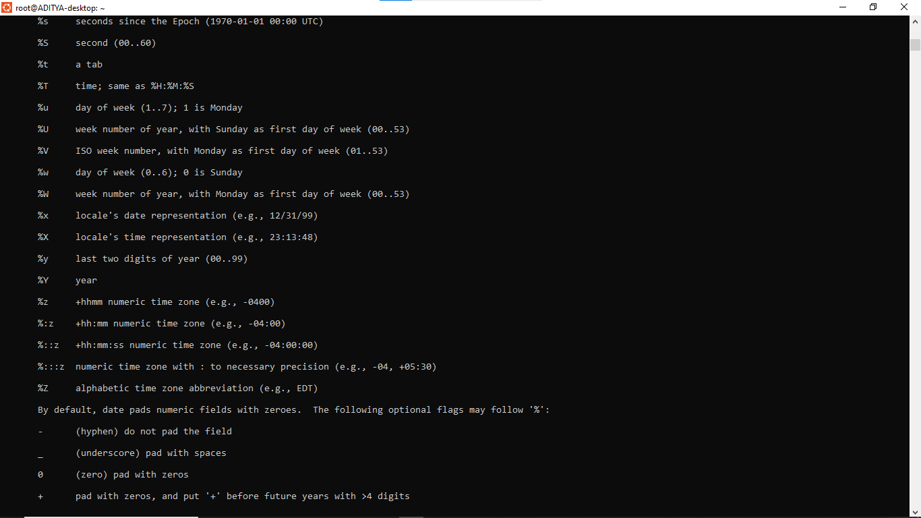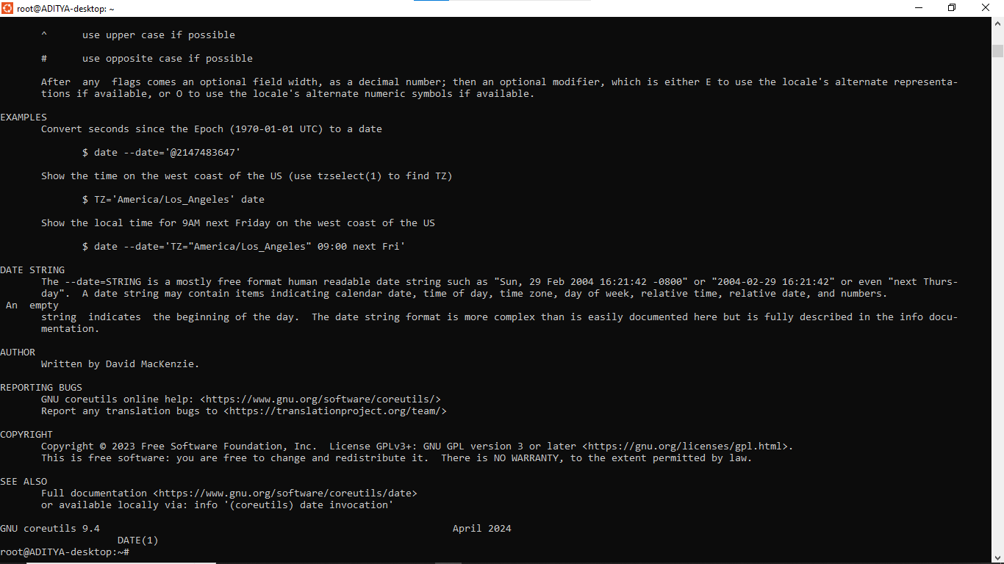

6. Create a subdirectory called mydir.
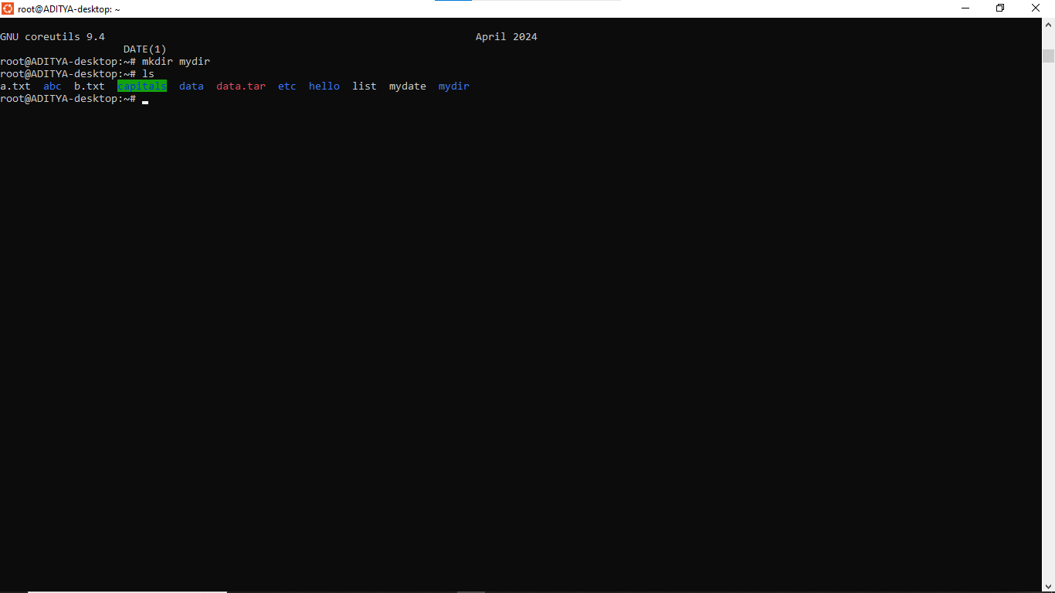

7. Move the file mydate into the new subdirectory.
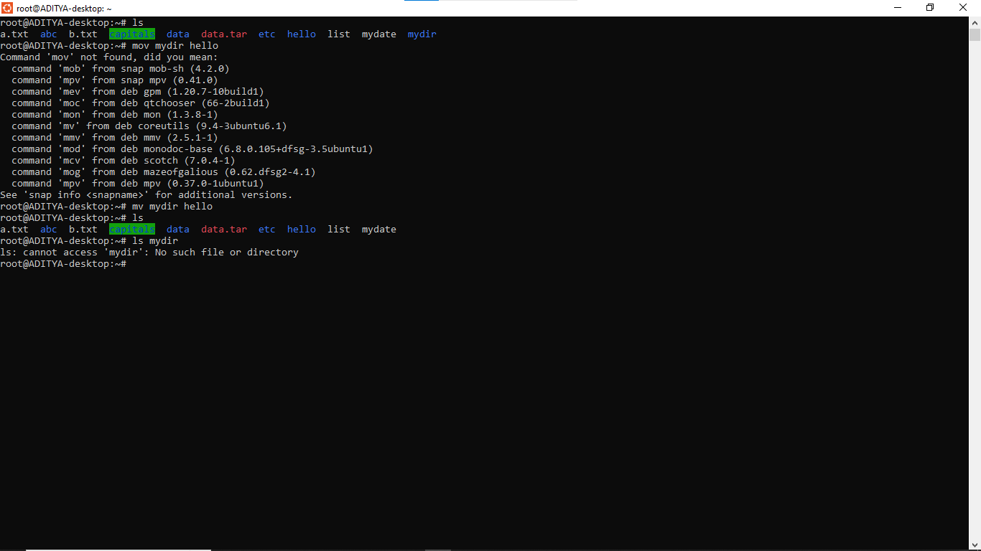

8. Go to the subdirectory mydir and copy the file mydate to a new file called ourdate
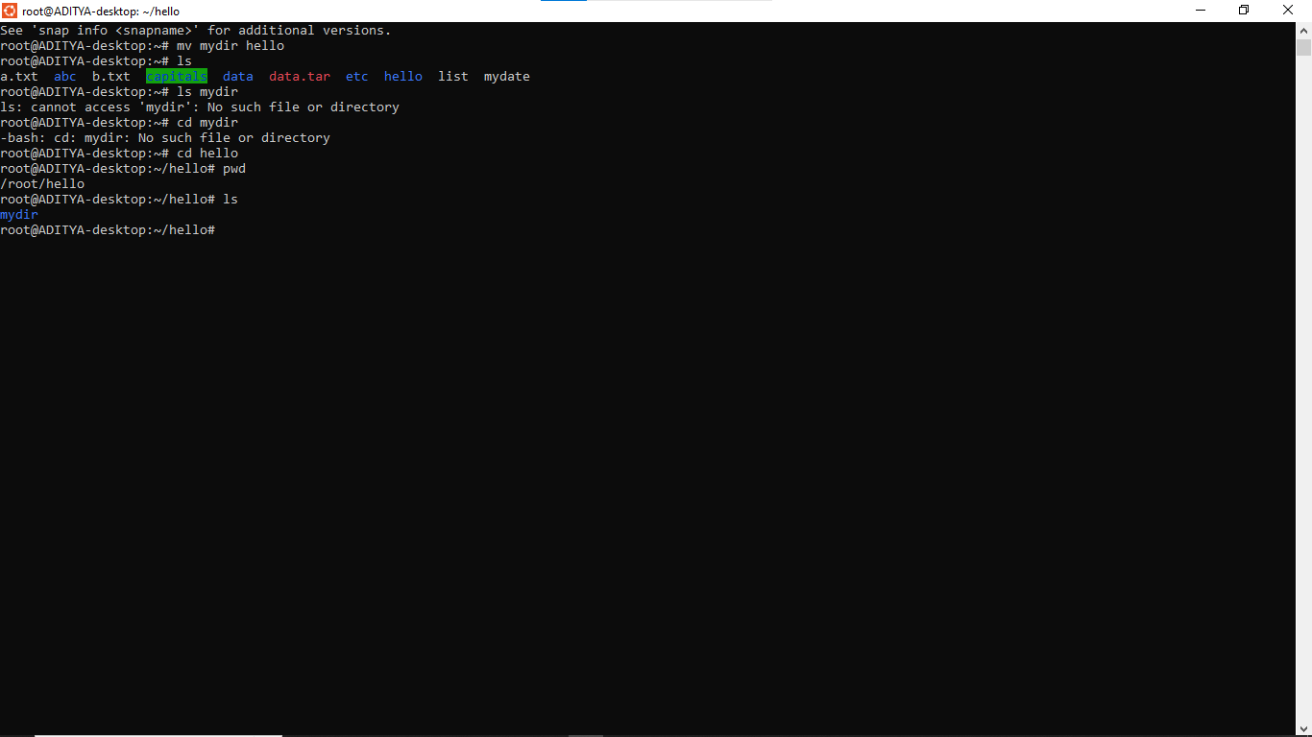

9. List the contents of mydir.
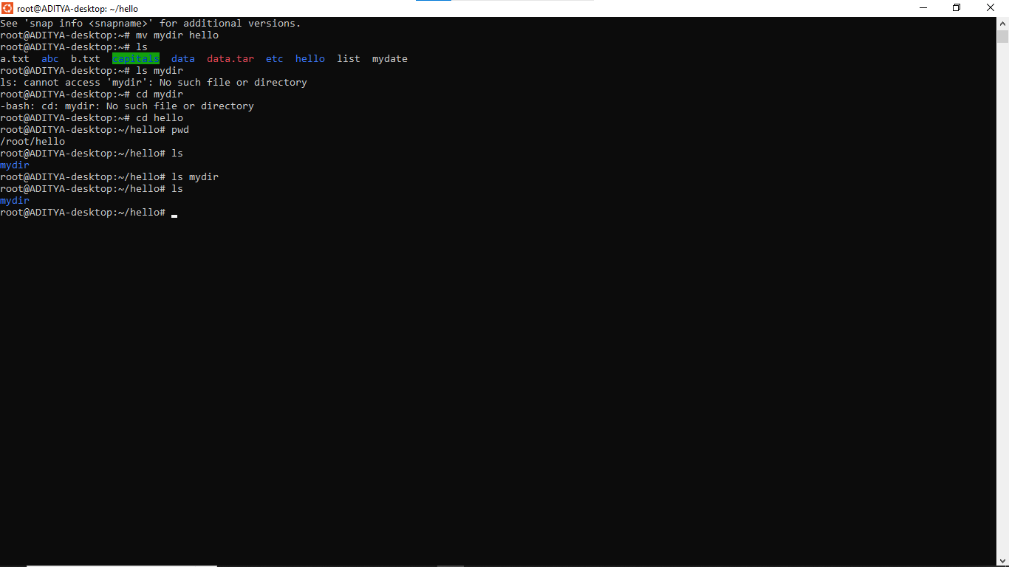

10. Do a long listing on the file ourdate and note the permissions.
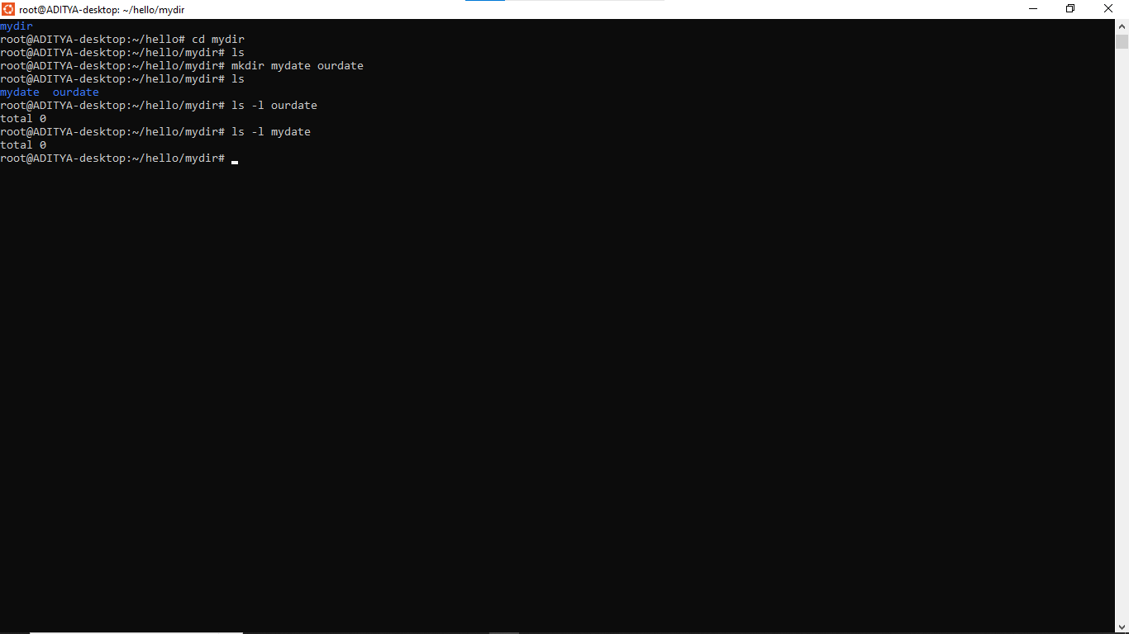

11. Display the name of the current directory starting from the root.
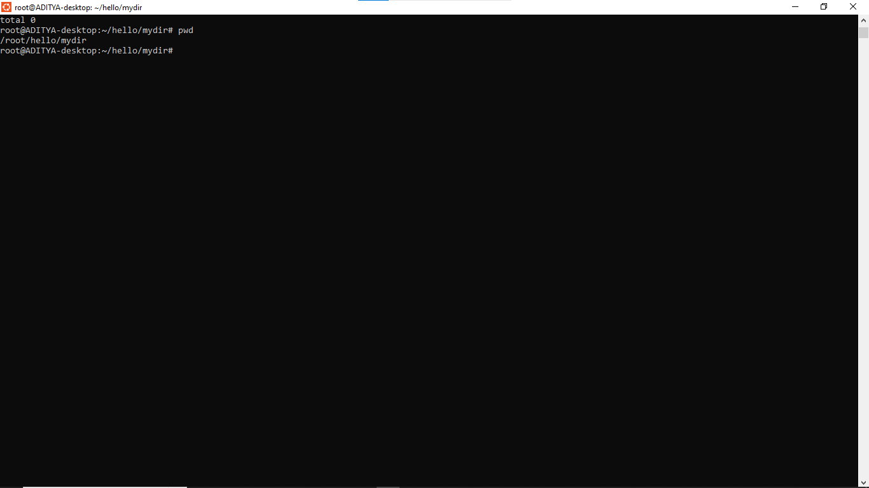

12. Move the files in the directory mydir back to your home directory.
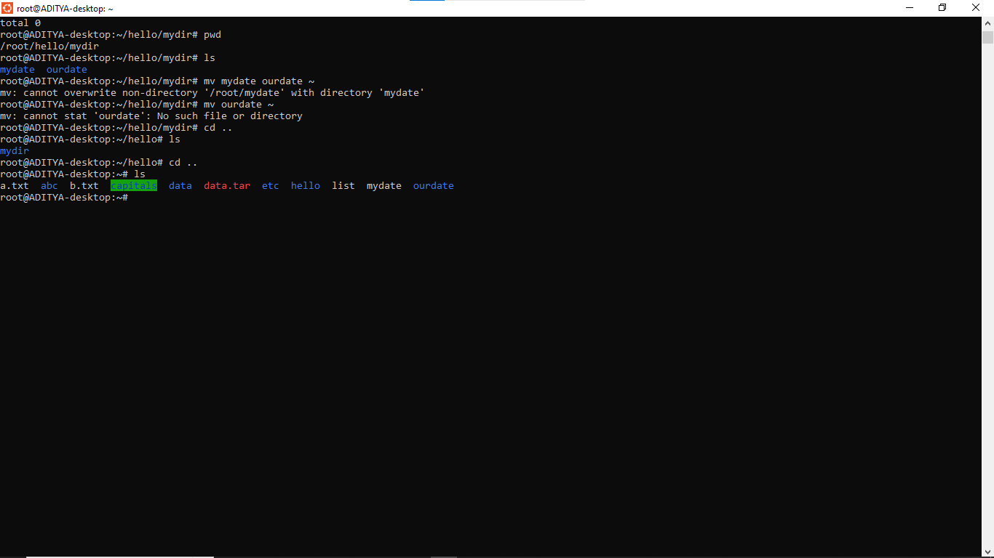

13. Display the first 5 lines of mydate.
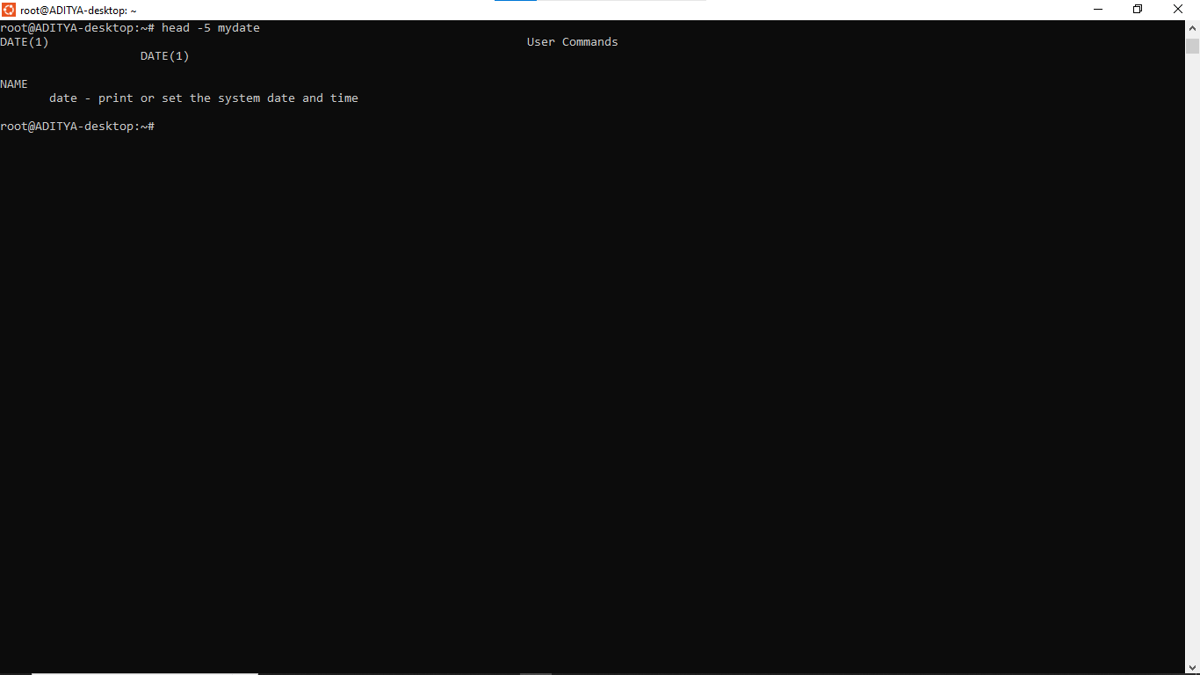

14. Display the last 8 lines of mydate.
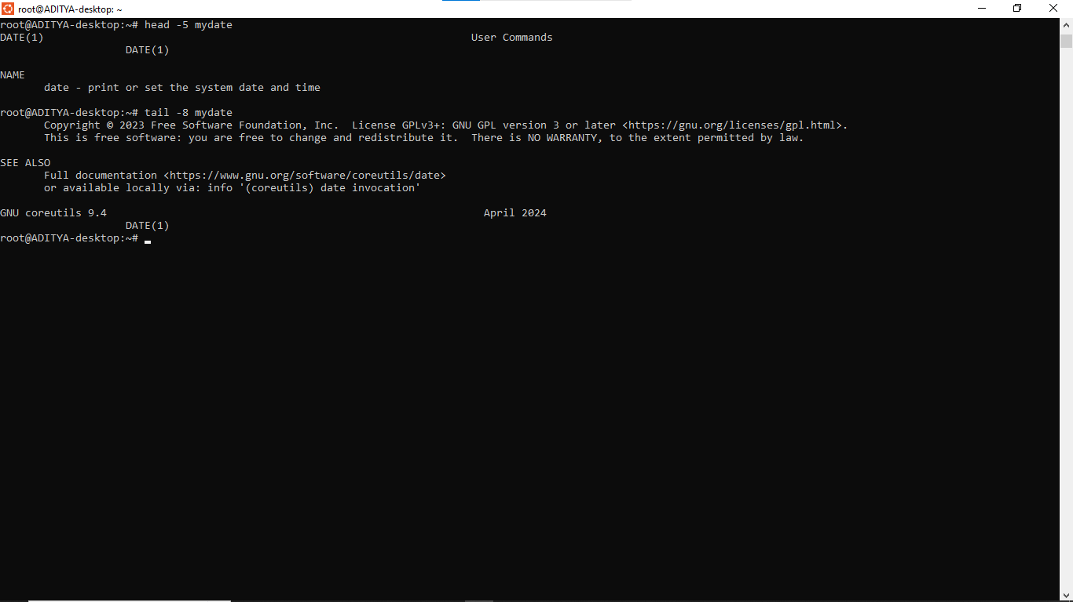

15. Remove the directory mydir.
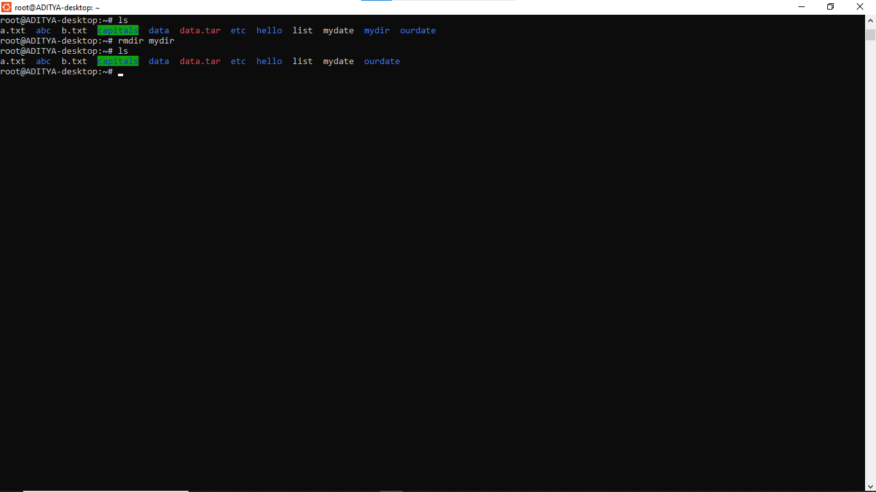

16. Redirect the output of the long listing of files to a file named list.
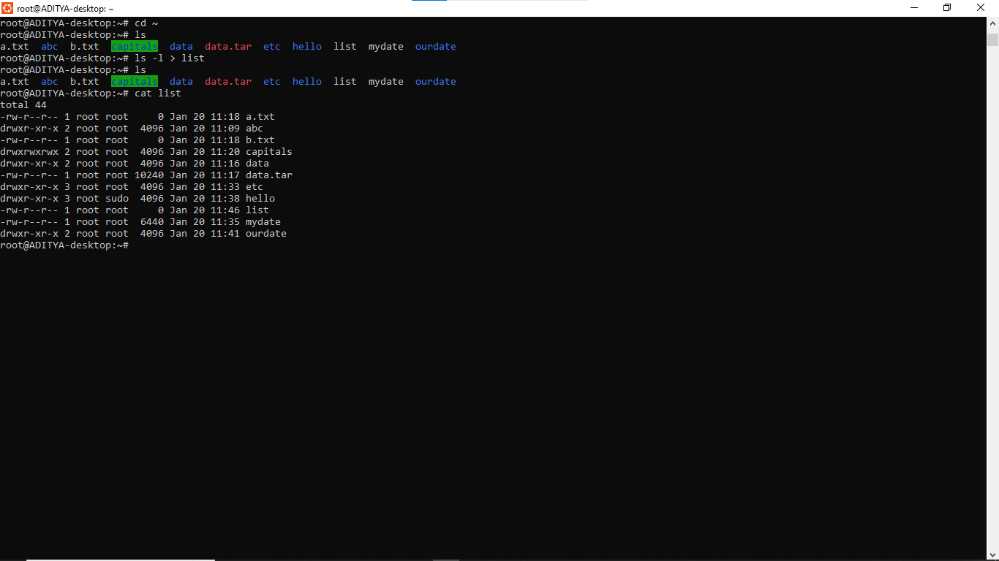

17. Select any 5 capitals of states in India and enter them in a file named capitals1. Choose 5
more capitals and enter them in a file named capitals2. Choose 5 more capitals and enter
them in a file named capitals3. Concatenate all 3 files and redirect the output to a file
named capitals.
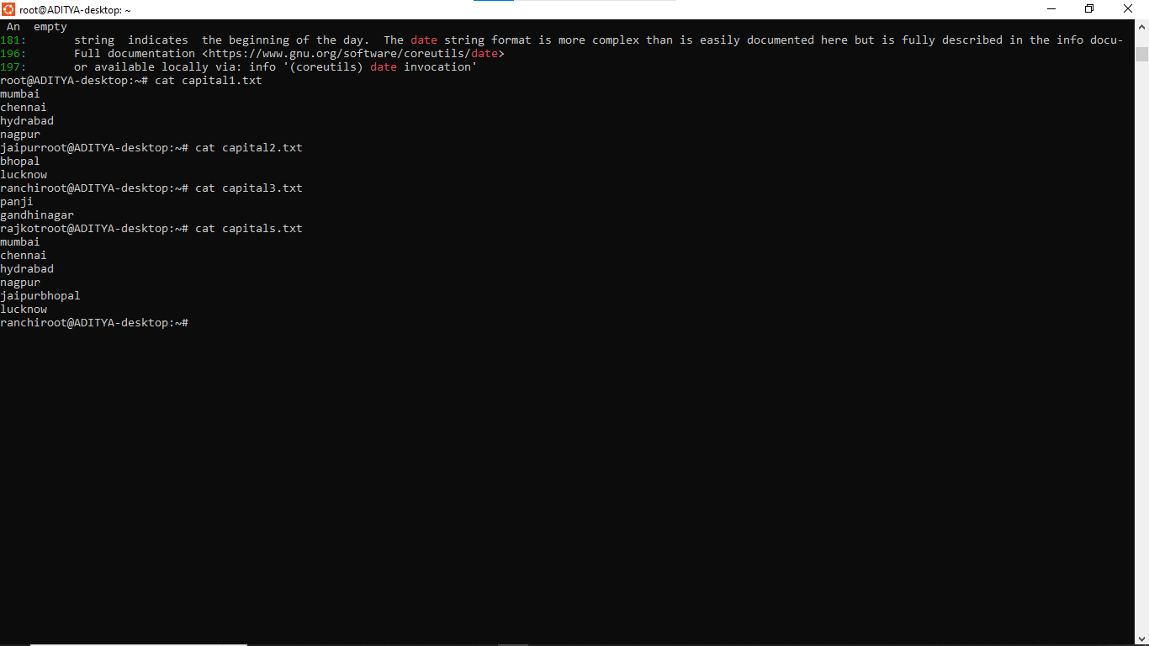

18. Concatenate the file capitals2 at the end of file capitals.
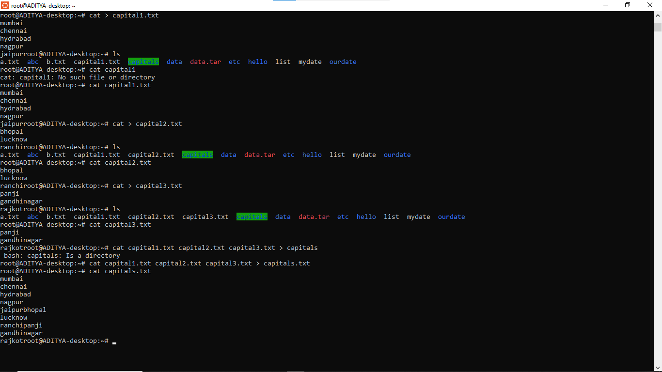

19. Give read and write permissions to all users for the file capitals.
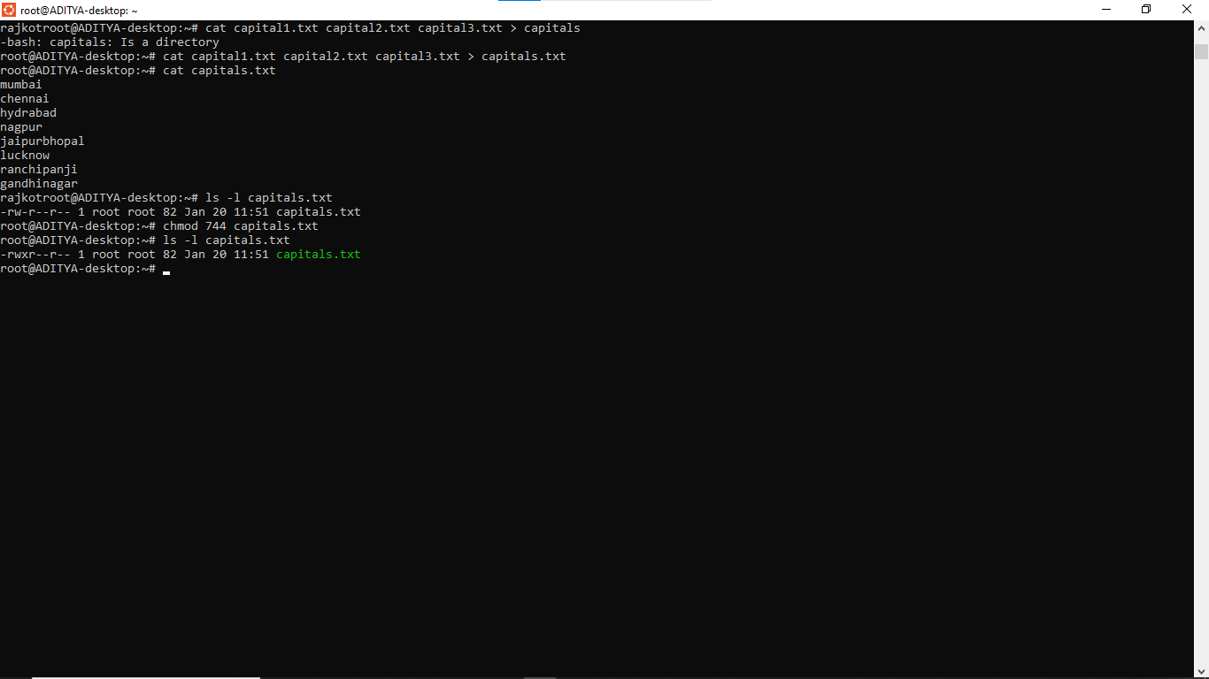

20. Give read permissions only to the owner of the file capitals. Open the file, make some
changes and try to save it. What happens ?
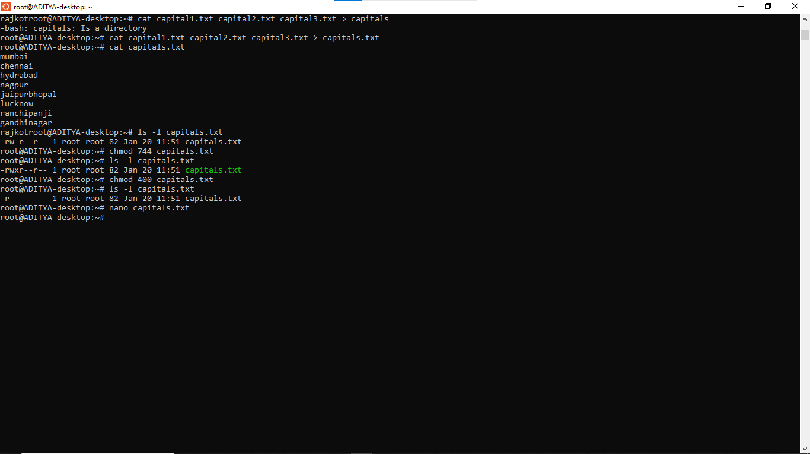
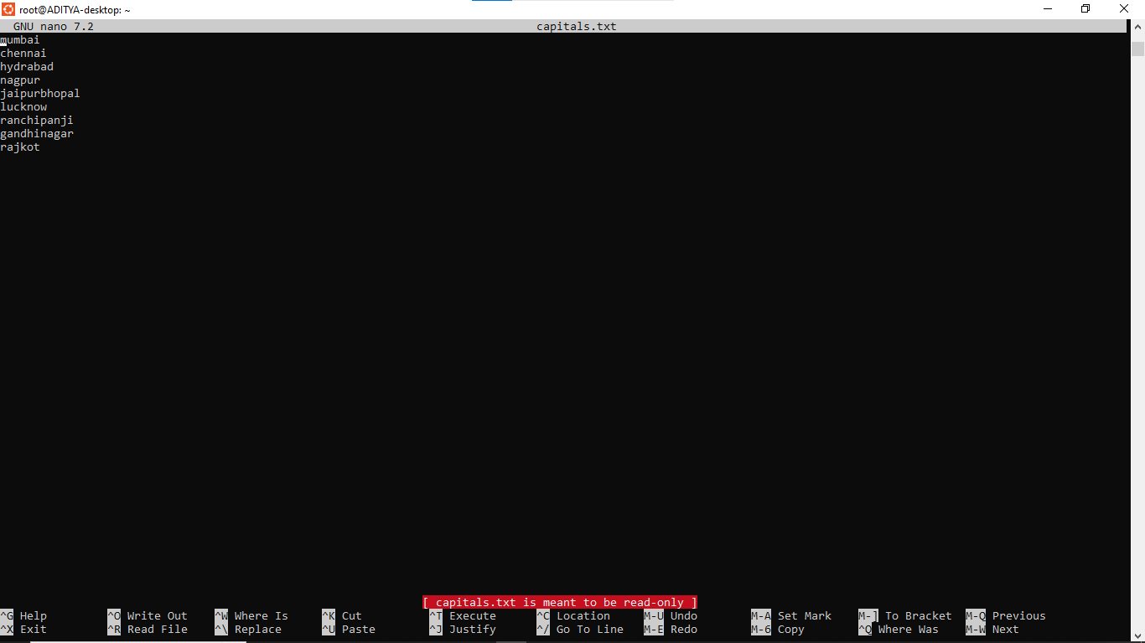

21. Create an alias to concatenate the 3 files capitals1, capitals2, capitals3 and redirect the
output to a file named capitals. Activate the alias and make it run.
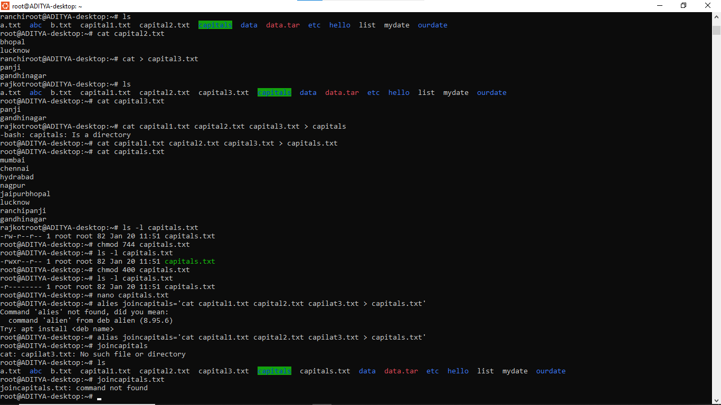

22. Find out the number of times the string “the” appears in the file mydate.
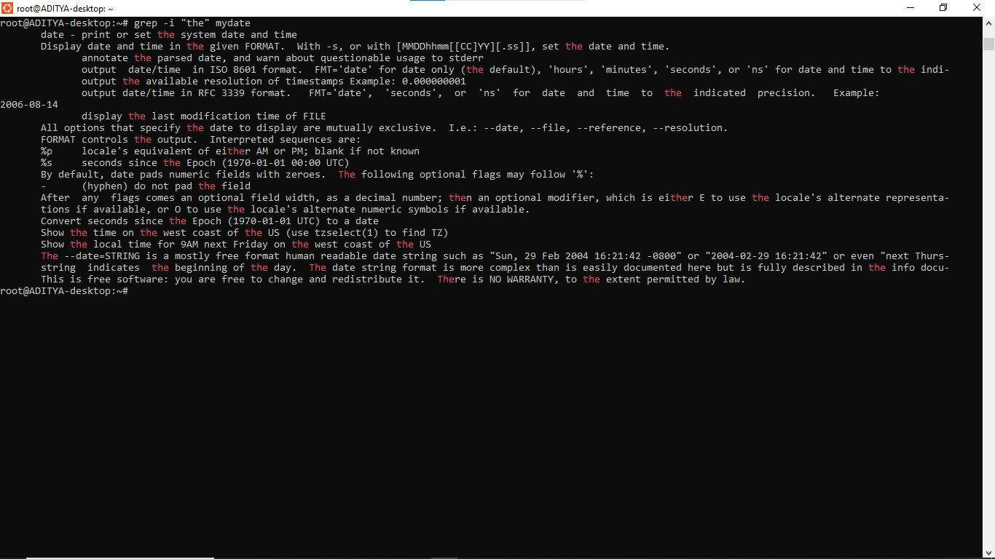
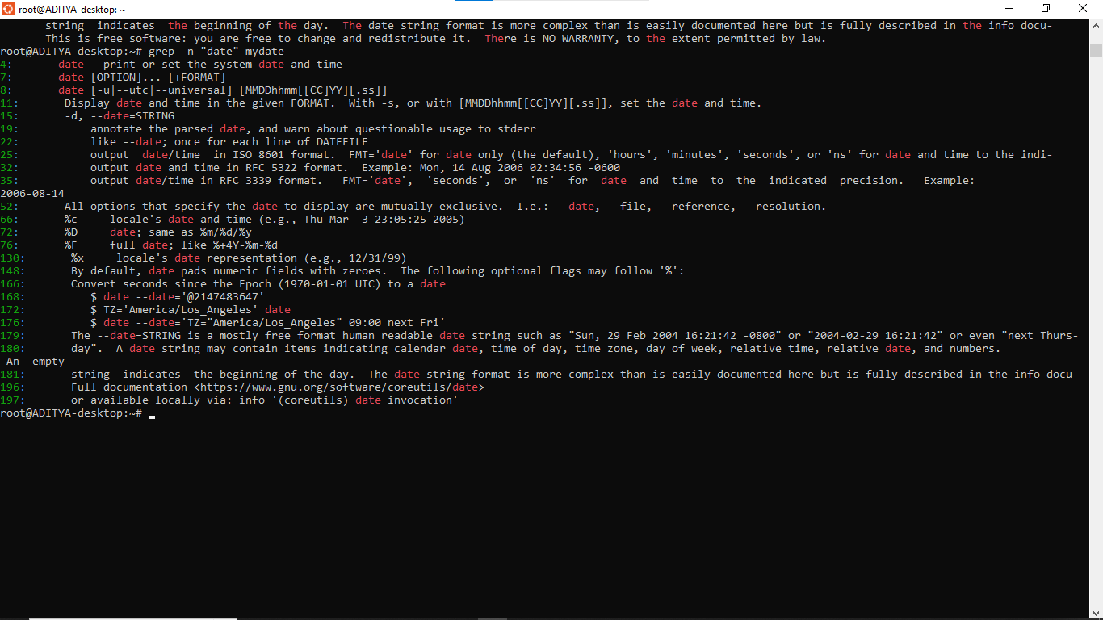

23. Find out the line numbers on which the string “date” exists in mydate.


24. Print all lines of mydate except those that have the letter “i” in them.
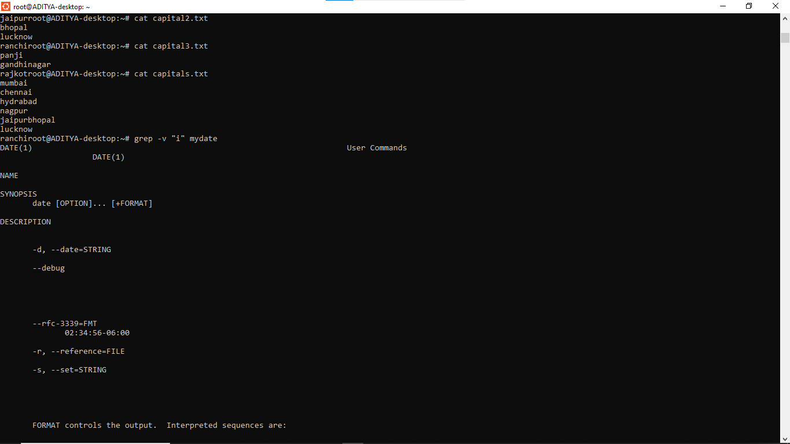
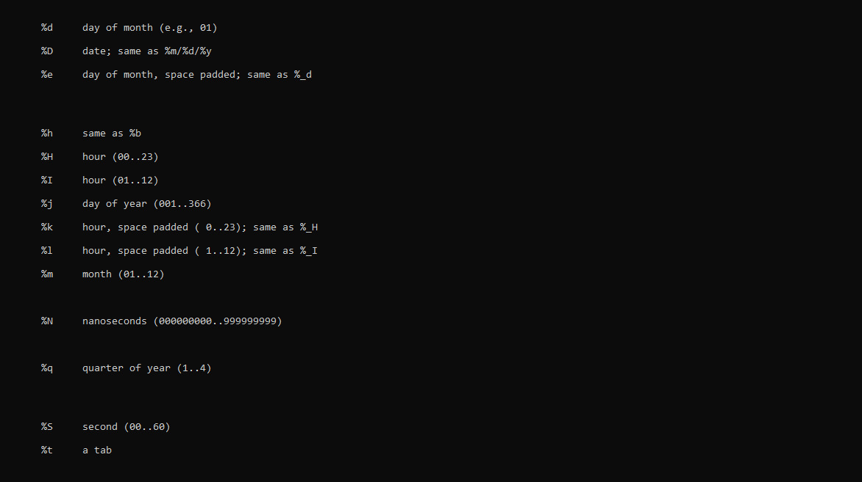
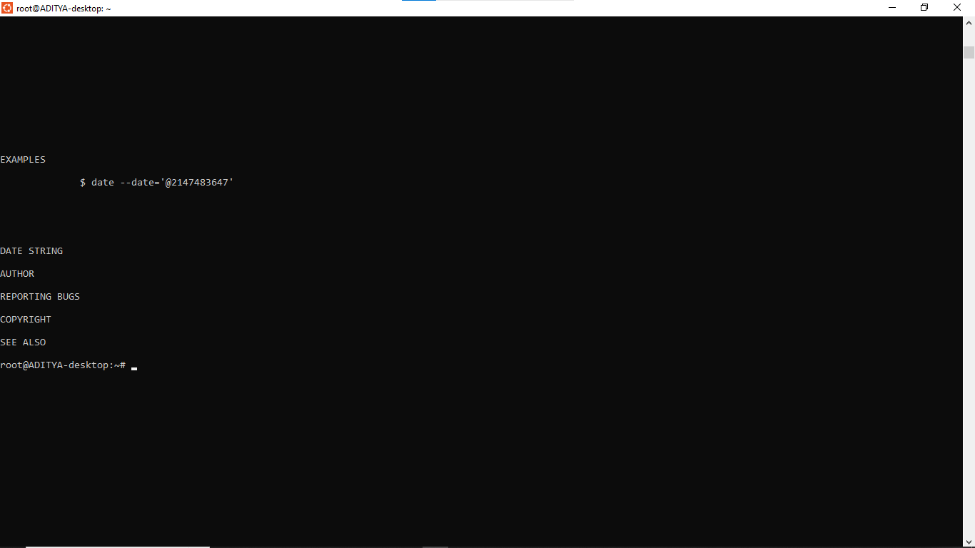

25. List the words of 4 letters from the file mydate.
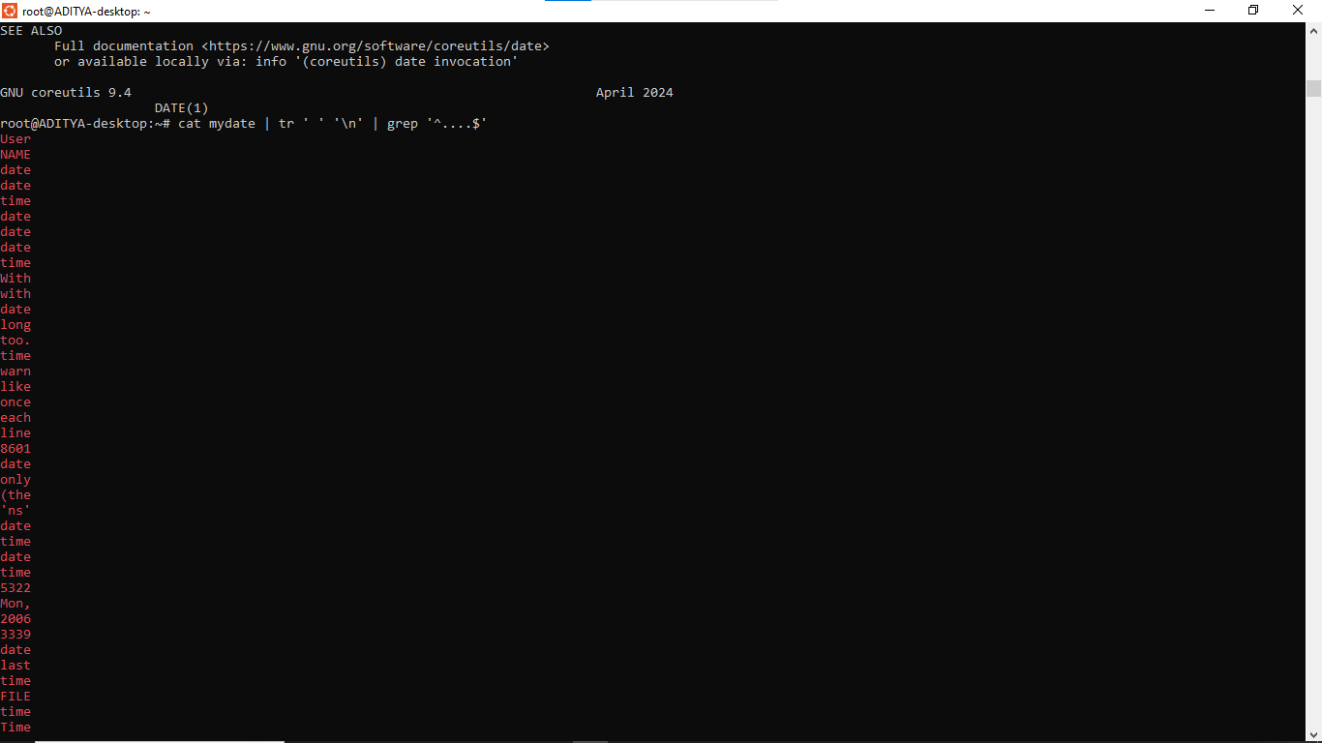
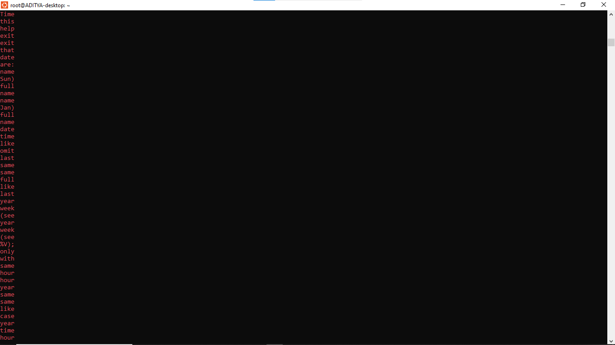
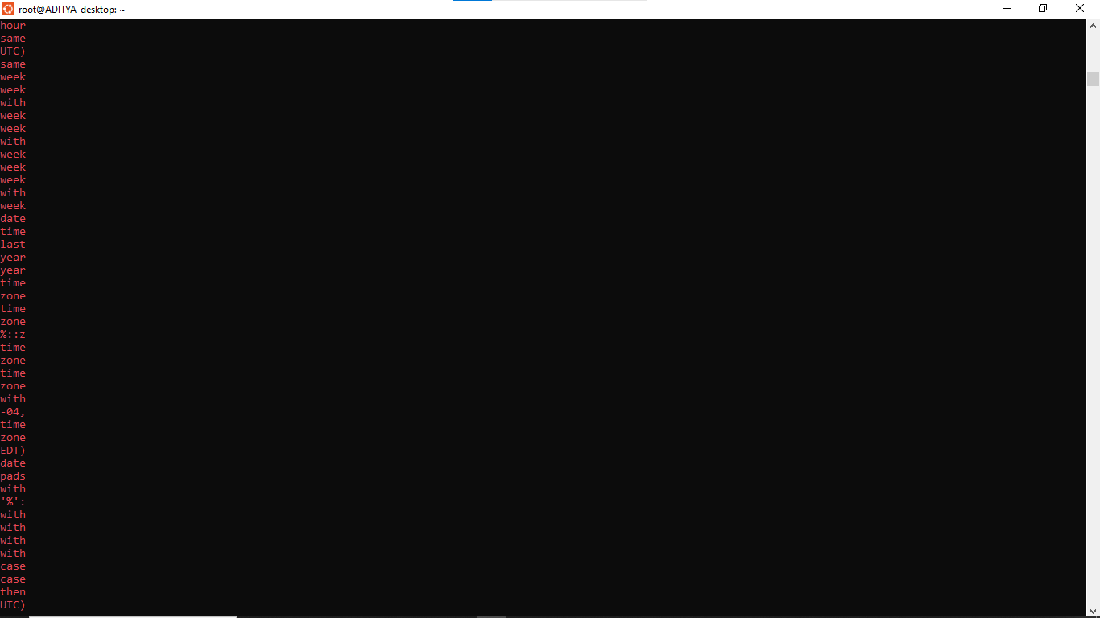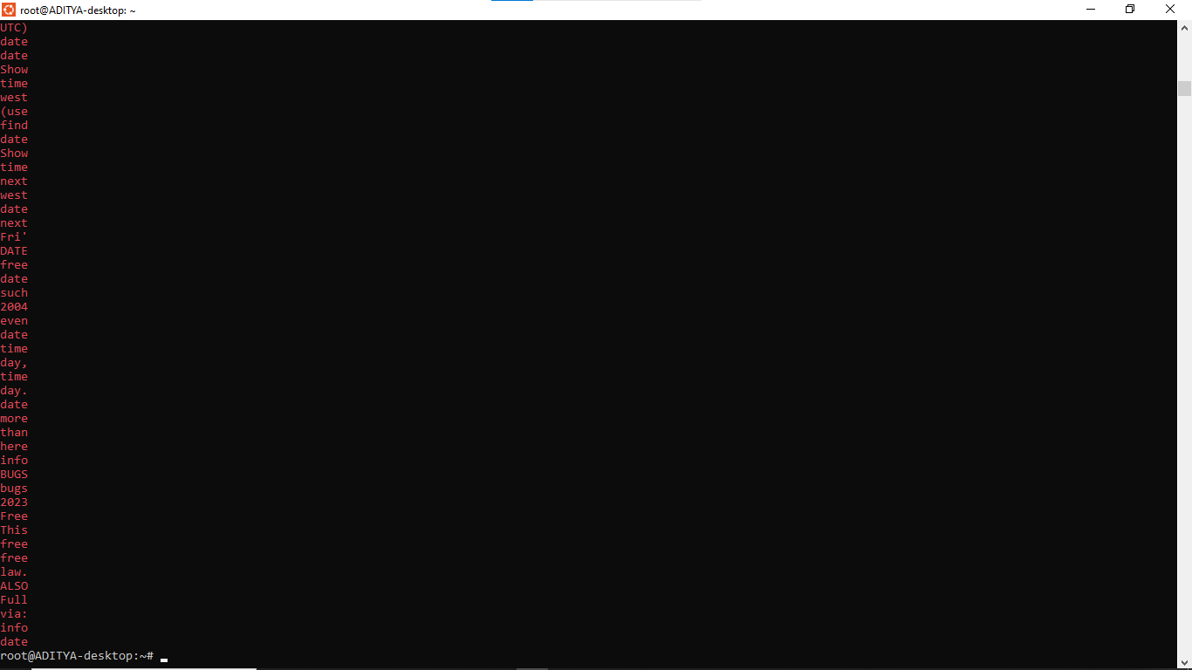

26. List 5 states in north east India in a file mystates. List their corresponding capitals in a file
mycapitals. Use the paste command to join the 2 files.
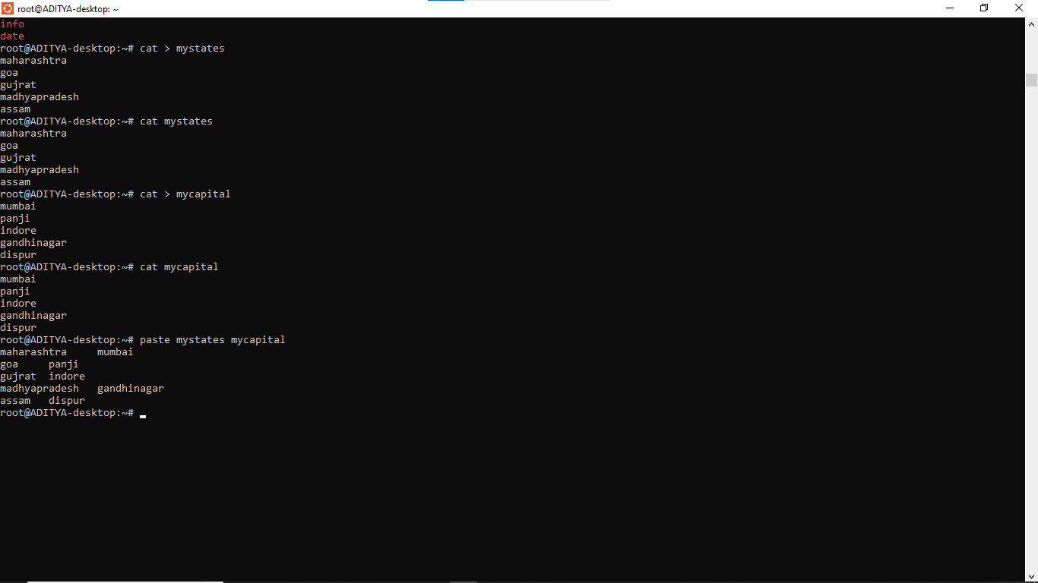
27. Use the cut command to print the 1 st and 3 rd columns of the /etc/passwd file for all
students in this class.
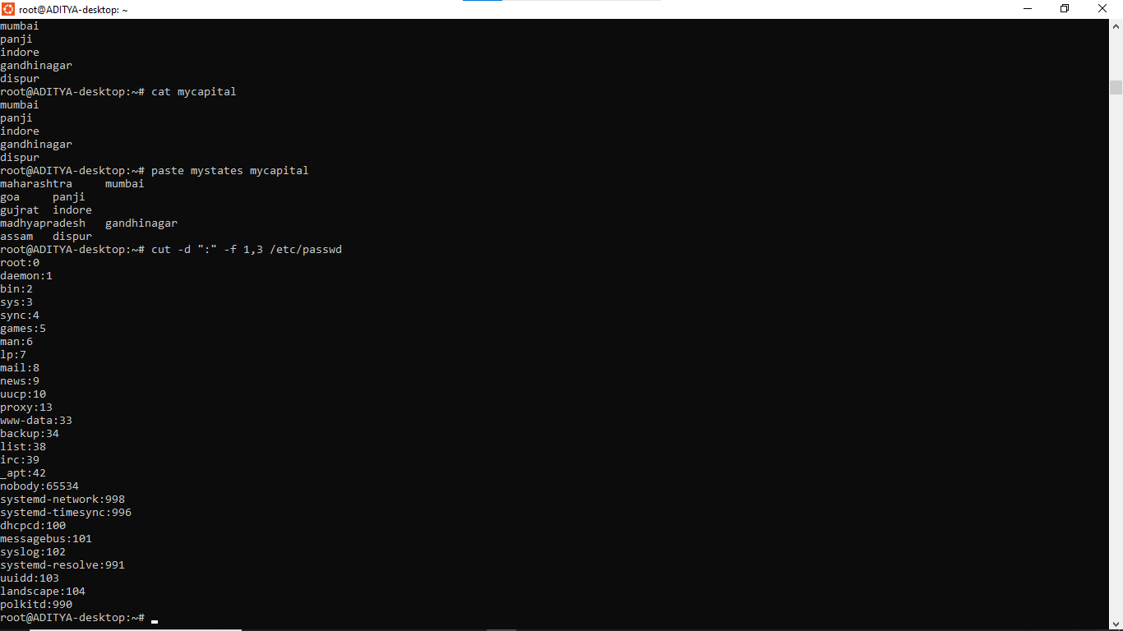

28. Count the number of people logged in and also trap the users in a file using the tee
command.
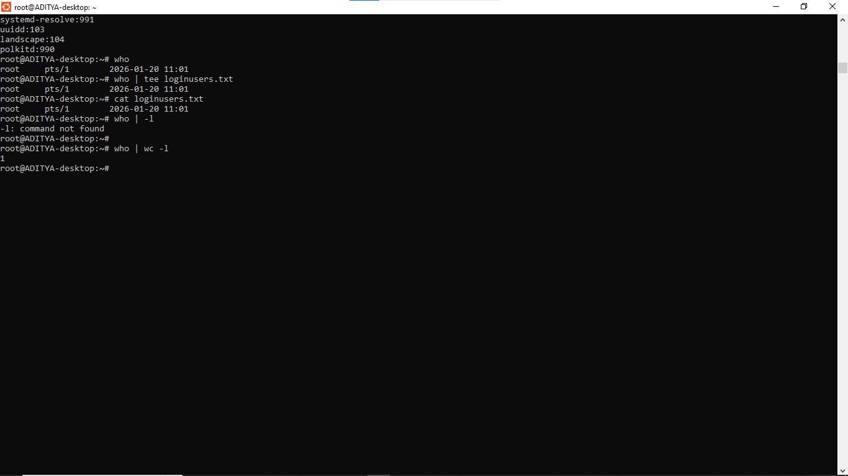
29. Convert the contents of mystates into uppercase.
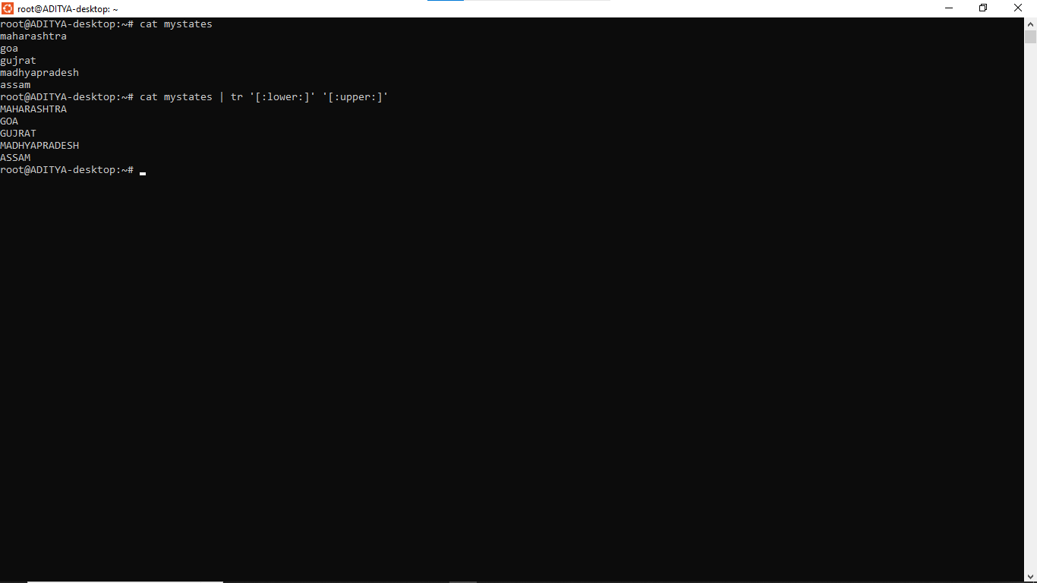

30. Create any two files & display the common values between them.
