COLLEGE DAA COURSE PROJECT · TECHNICAL SPECIFICATION & ALGORITHM AUDIT
RescueGrid: Disaster Relief Optimization System
Design and Analysis of Algorithms (DAA) Interactive Simulation & Verification Platform
Course: Design & Analysis of Algorithms | Project Type: Disaster Response Simulation | Graph Topology: 13 Nodes · 19 Roads | Payload Limit: 15 Units (Configurable)
Primary Stack: React 18 · TypeScript · Vite | Algorithms: MergeSort · Bellman-Ford · Knapsack · Backtrack | Execution Engine: Discrete-Event Team Reuse | Verification: 28 Vitest Tests Passed

1. Project Overview
RescueGrid is an interactive disaster management simulation platform engineered to solve critical bottlenecks in emergency relief coordination. During humanitarian crises (such as flash floods, earthquakes, and urban fires), decision-makers face three high-stakes logistical challenges: triaging life-threatening casualty incidents under extreme time pressure, navigating heavily damaged town transit networks containing hazardous road collapses, and packing limited-capacity rescue transports with the most beneficial mixture of medical and relief supplies. RescueGrid addresses these challenges by integrating four classical Design and Analysis of Algorithms (DAA) paradigms into an end-to-end discrete-event simulation engine.
System Architecture & Operation: The application models an urban emergency zone as an undirected, weighted graph of 13 strategic infrastructure nodes (Operations Headquarters, Hospitals, River Banks, Shelters, Bridges) connected by 19 primary road segments. The system operates in two core operational modes:
• Option A (User Input Scenario Builder): A clean starting canvas allowing operators to define custom incidents with specific casualty counts, urgency ratings, and specialized capability demands; configure rescue teams with medical, flood, and general skills; manage relief supplies; and dynamically toggle road hazards directly on the interactive town map.
• Option B (Predefined Emergency Scenarios): Curated emergency scenarios (Normal Rescue, Critical Emergency, Resource Shortage, No Route Available) engineered to test boundary conditions, road closures, supply deficits, and isolated zones.

2. Four Algorithms Implemented in RescueGrid
All algorithms in RescueGrid have been verified directly from the source code (src/algorithms.ts). Each algorithm addresses a distinct phase of disaster response:

2.1 Merge Sort — Multi-Criterion Casualty Incident Triage
• How It Works: Merge Sort is a divide-and-conquer algorithm that recursively splits an unsorted list of incident requests into singletons (arrays of length ≤ 1), and then systematically merges adjacent sublists in priority order using a custom comparator function.
• Multi-Criterion Priority Hierarchy: Triage order is evaluated strictly through a 5-tier policy: (1) Urgency Tier (Critical > High > Medium > Low), (2) Medical Emergency Flag (medical incidents prioritize over non-medical), (3) Affected Population (descending casualty counts), (4) Waiting Time (longer elapsed waiting time prioritized), and (5) Deterministic Incident ID tie-break.
• Where & Why Used in RescueGrid: Located in src/algorithms.ts (mergeSort and mergeSortWithTrace). It sorts the operational incident queue so rescue teams are dispatched to the most severe and time-sensitive disasters first, ensuring life-critical medical emergencies are never delayed.
• Time Complexity: O(R log R) across best, worst, and average cases, where R is the number of incidents. Space Complexity: O(R) auxiliary space.

2.2 Bellman-Ford — Shortest Safe Transit Path Under Road Hazards
• How It Works: Bellman-Ford is a dynamic programming graph traversal algorithm. It initializes distance estimates from Headquarters (HQ) to all vertices as ∞ (with dist[HQ] = 0). It systematically performs |V| - 1 passes over all active directed edges, relaxing any edge (u, v) where dist[u] + cost(u, v) < dist[v]. A final verification pass checks for negative-weight cycles.
• Where & Why Used in RescueGrid: Located in src/algorithms.ts (bellmanFord). In disaster zones, collapsed roads, flood debris, and damaged bridges render road segments impassable. Bellman-Ford filters out all blocked roads and calculates the optimal minimum-travel-cost route from HQ to every incident destination, verifying reachability and providing alternative detours.
• Time Complexity: O(V · E), where V is the number of town locations (13 nodes) and E is the number of road segments (19 bidirectional edges = 38 directed edges). Space Complexity: O(V) for predecessor and distance tables.

2.3 0/1 Knapsack (Dynamic Programming) — Optimal Relief Supply Allocation
• How It Works: The 0/1 Knapsack algorithm constructs an (N + 1) × (W + 1) dynamic programming table where dp[i][w] represents the maximum humanitarian relief value attainable using a subset of the first i package items within weight capacity w. The recurrence relation is:
dp[i][w] = dp[i - 1][w] if weight[i] > w, else max(dp[i - 1][w], value[i] + dp[i - 1][w - weight[i]])
Following table generation, the algorithm backtracks from dp[N][W] to determine the exact subset of packages packed onto the vehicle.
• Where & Why Used in RescueGrid: Located in src/algorithms.ts (knapsack). Emergency transport vehicles have rigid physical payload limits (default 15 capacity units). The algorithm optimizes cargo manifests (Trauma Kits, Mobile Clinics, Water Purification Units, Food Rations) to maximize total casualty support value without exceeding payload limits. It also computes a greedy fractional comparison to demonstrate DP optimality.
• Time Complexity: O(N · W) pseudo-polynomial time and space, where N is total relief items and W is vehicle payload capacity.

2.4 Backtracking with State Space Tree — Specialized Rescue Team Assignment
• How It Works: Backtracking systematically explores the combinatorial assignment space using depth-first search over a state space tree. At each node, it evaluates candidate team assignments against strict feasibility constraints: (1) Team Availability (team must not be active elsewhere), and (2) Capability Compatibility (team skills must match incident demands, e.g., 'medical' for trauma clinics, 'flood' for river rescues, or 'general'). Infeasible assignments are immediately pruned (bounding step), causing the algorithm to backtrack up the tree and test alternative branches.
• Where & Why Used in RescueGrid: Located in src/algorithms.ts (assignTeams). It prevents fatal dispatch mismatches (e.g., dispatching general volunteers to critical surgical trauma sites) and eliminates double-booking of emergency units.
• Time Complexity: O(M^N) worst-case combinatorial complexity, where N is incident tasks and M is available rescue teams; significantly pruned in practice by capability and availability bounding constraints.
Algorithm | Design Paradigm | Time Complexity | Space Complexity | Operational Role in RescueGrid
Merge Sort | Divide & Conquer | O(R log R) | O(R) | Multi-criterion triage ranking of emergency incidents
Bellman-Ford | Dynamic Programming | O(V · E) | O(V) | Shortest safe transit routing bypassing blocked road hazards
0/1 Knapsack | Dynamic Programming | O(N · W) | O(N · W) | Relief cargo optimization under rigid vehicle payload limits
Backtracking | State Space Search | O(M^N) worst (pruned) | O(N) recursion | Constraint-satisfaction assignment of specialized rescue teams

3. Application Screenshots & Interface Walkthrough
Below are genuine high-resolution screenshots captured directly from the live running RescueGrid application. Each screen demonstrates an integral functional module of the system.

Figure 1: Platform Mode Selection (Option A Custom Builder vs Option B Predefined Demos)
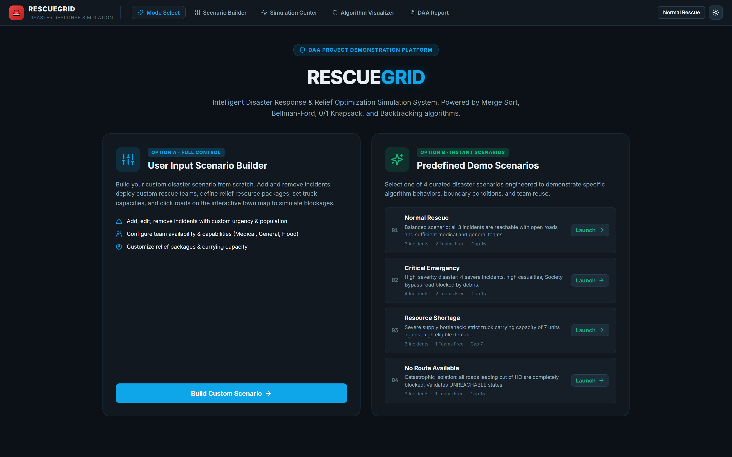
The landing view provides operators with two pathways: Option A for full granular control via the Scenario Builder, and Option B for one-click launching of 4 pre-engineered disaster scenarios that test critical conditions like severe debris blockages and supply bottlenecks.

Figure 2: Clean Scenario Builder Canvas (Option A User Input Starting State)
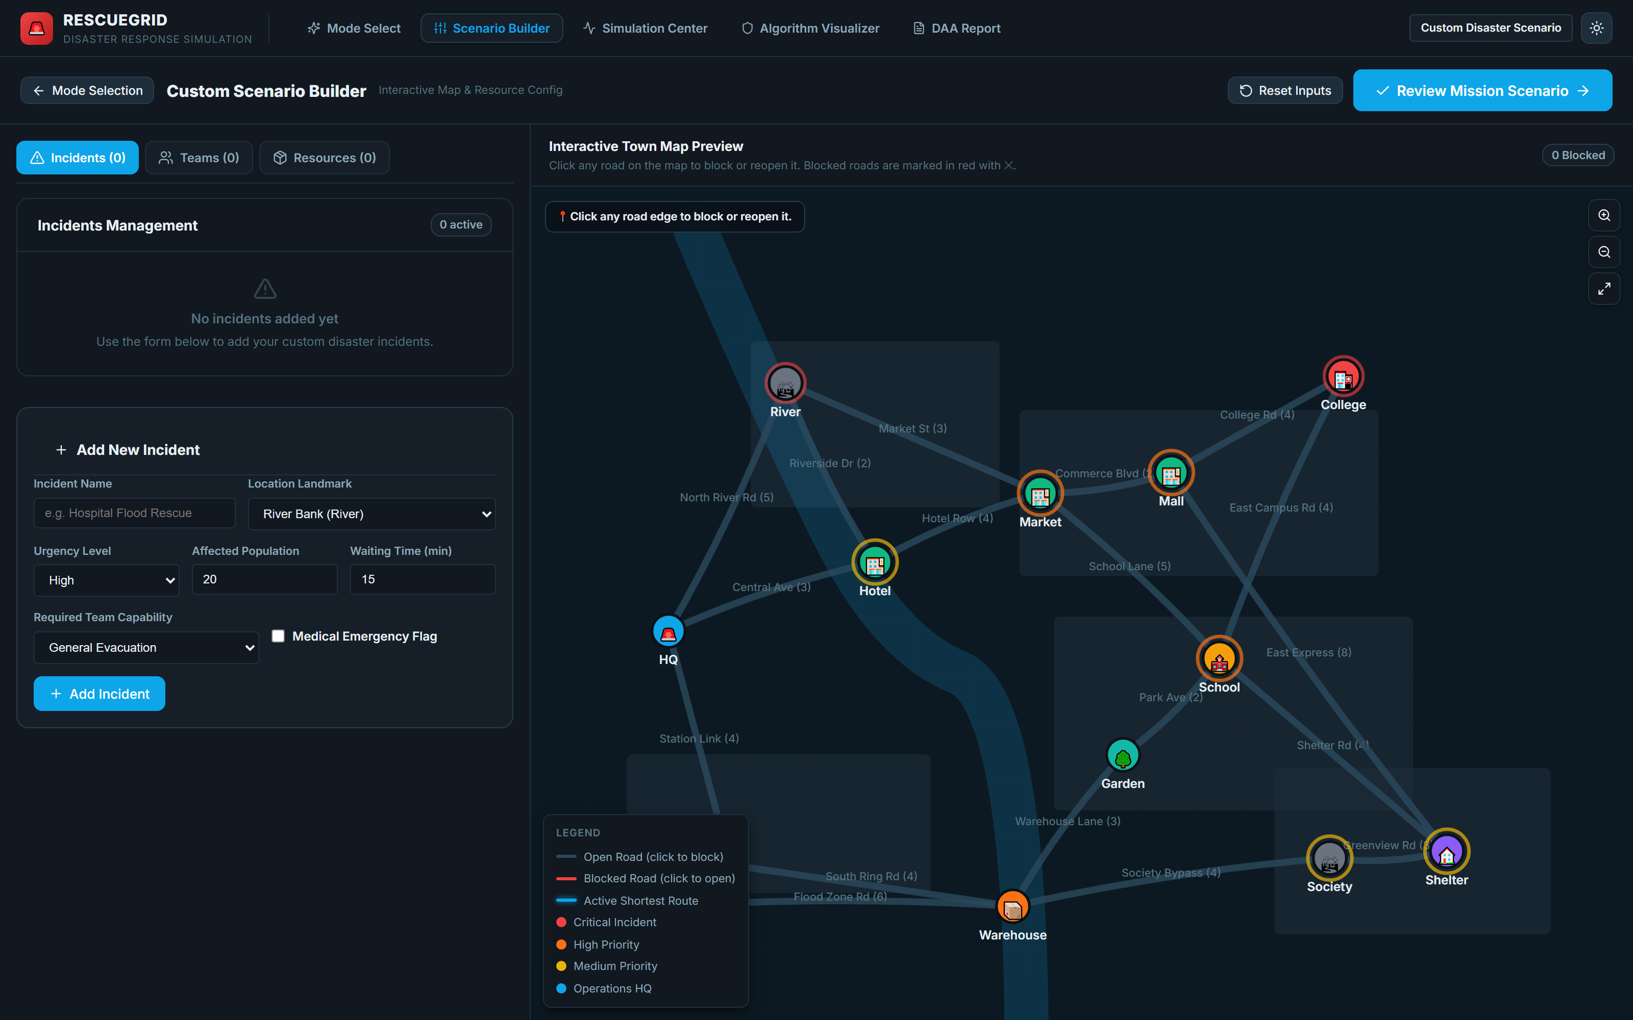
Upon selecting Option A, the system initializes a clean canvas with 0 incidents, 0 teams, and 0 relief packages. The interactive town road network is fully loaded, allowing users to toggle road blockages and enter custom emergency parameters from scratch.

Figure 3: Configured Disaster Scenario with Custom Incidents, Teams, and Road Hazards
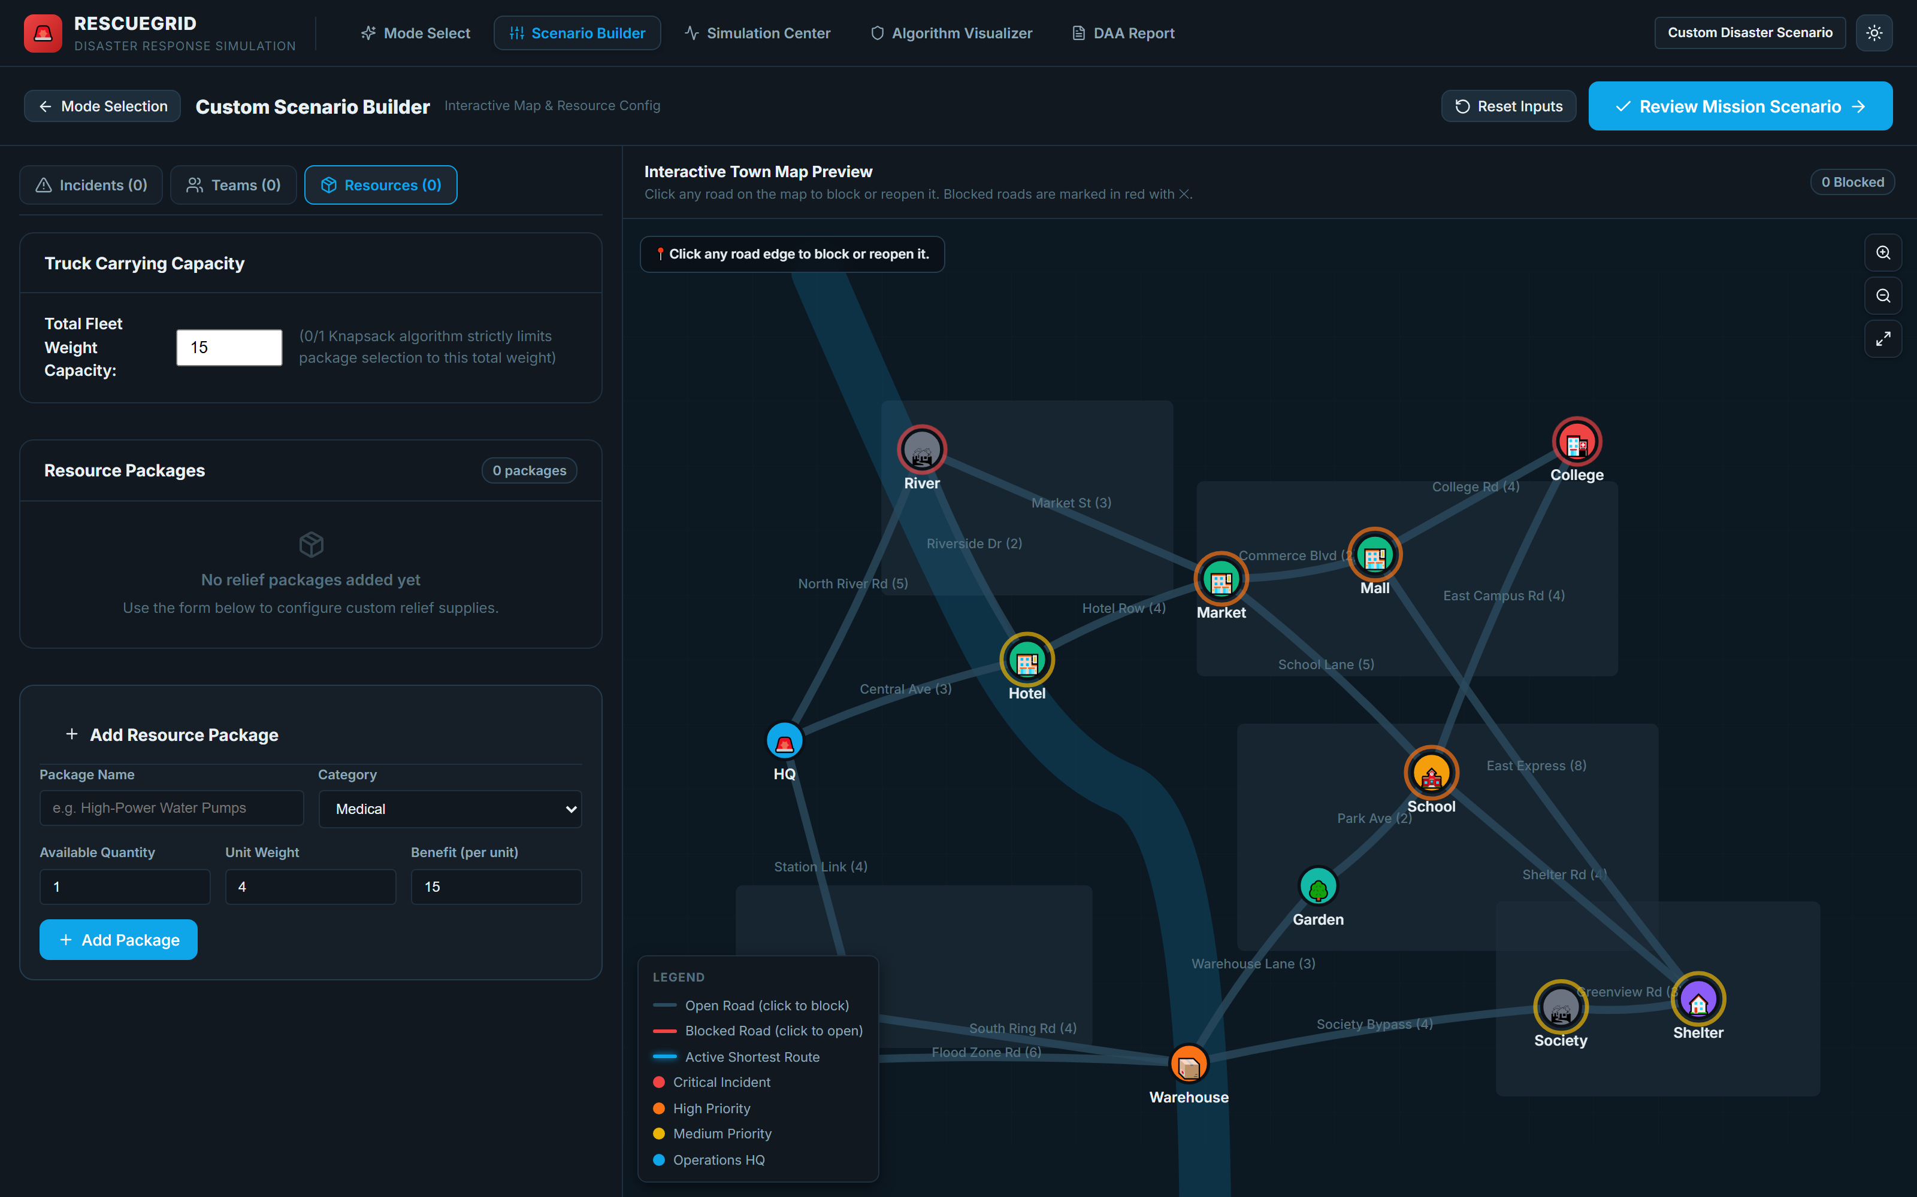
Operators can input custom incident parameters (location, casualty count, urgency rating, medical flags), register specialized rescue squads (paramedic, flood, general), allocate relief packages, and block roads by clicking road segments directly on the SVG map.

Figure 4: Pre-Flight Mission Verification & Resource Review Modal
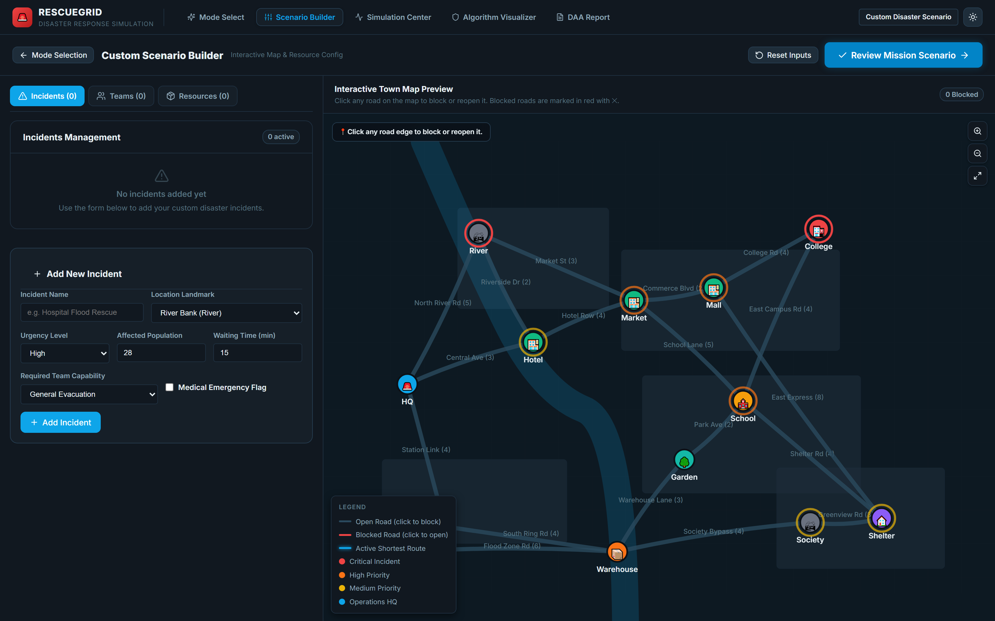
Before initiating algorithms, the mission review screen validates system parameters: verifying at least 1 incident and 1 team exist, auditing road connectivity, and calculating total affected casualties and aggregate relief weight.

Figure 5: Operations Command Dashboard & Active Simulation Center
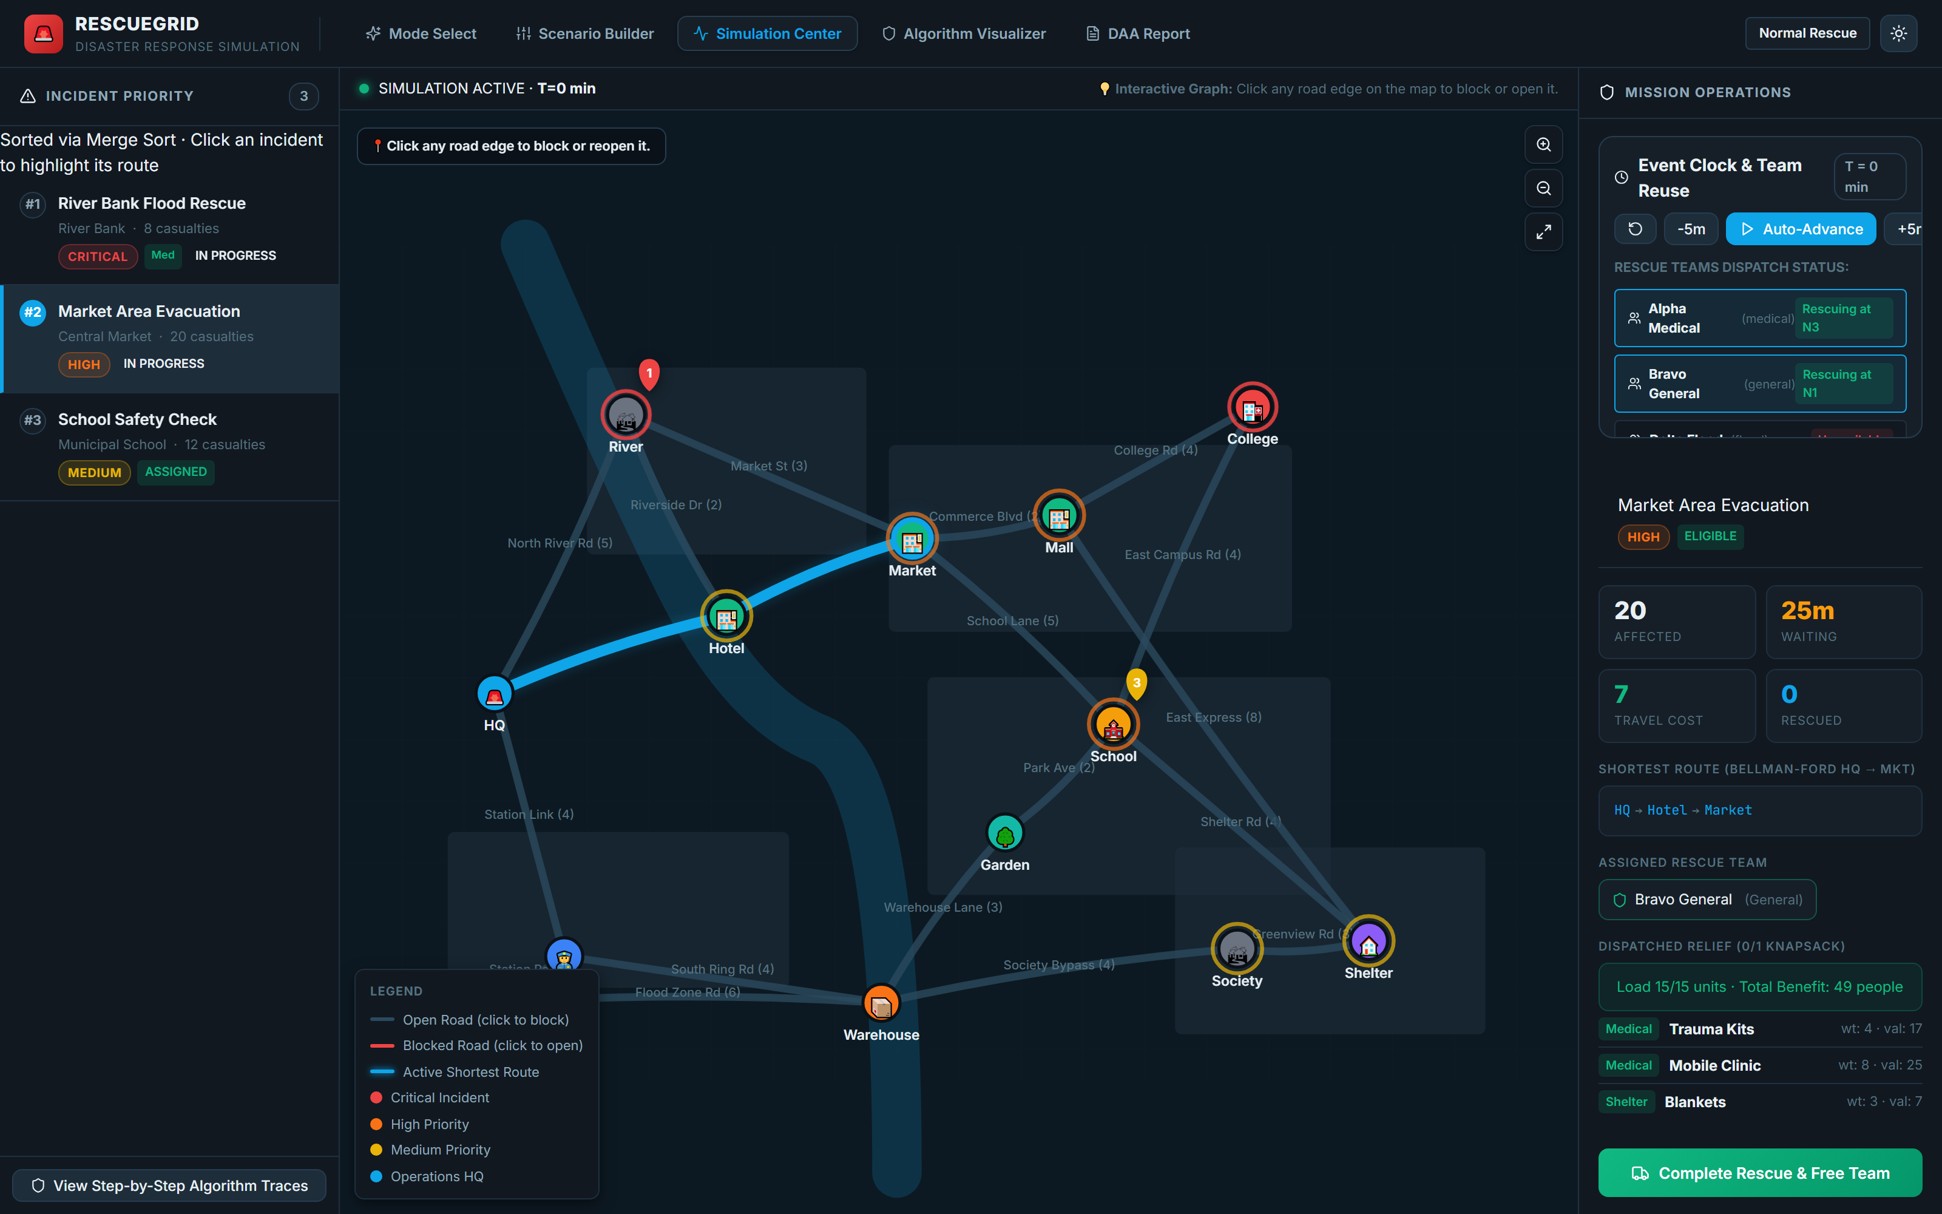
The primary command center integrates the SVG town map, the Merge-Sort-ordered priority queue on the left, and the live status panel on the right. Operators can monitor live incident triage, dispatched teams, active shortest paths in neon cyan, and knapsack cargo allocations.

Figure 6: Interactive Town Map & Road Network Topological Graph
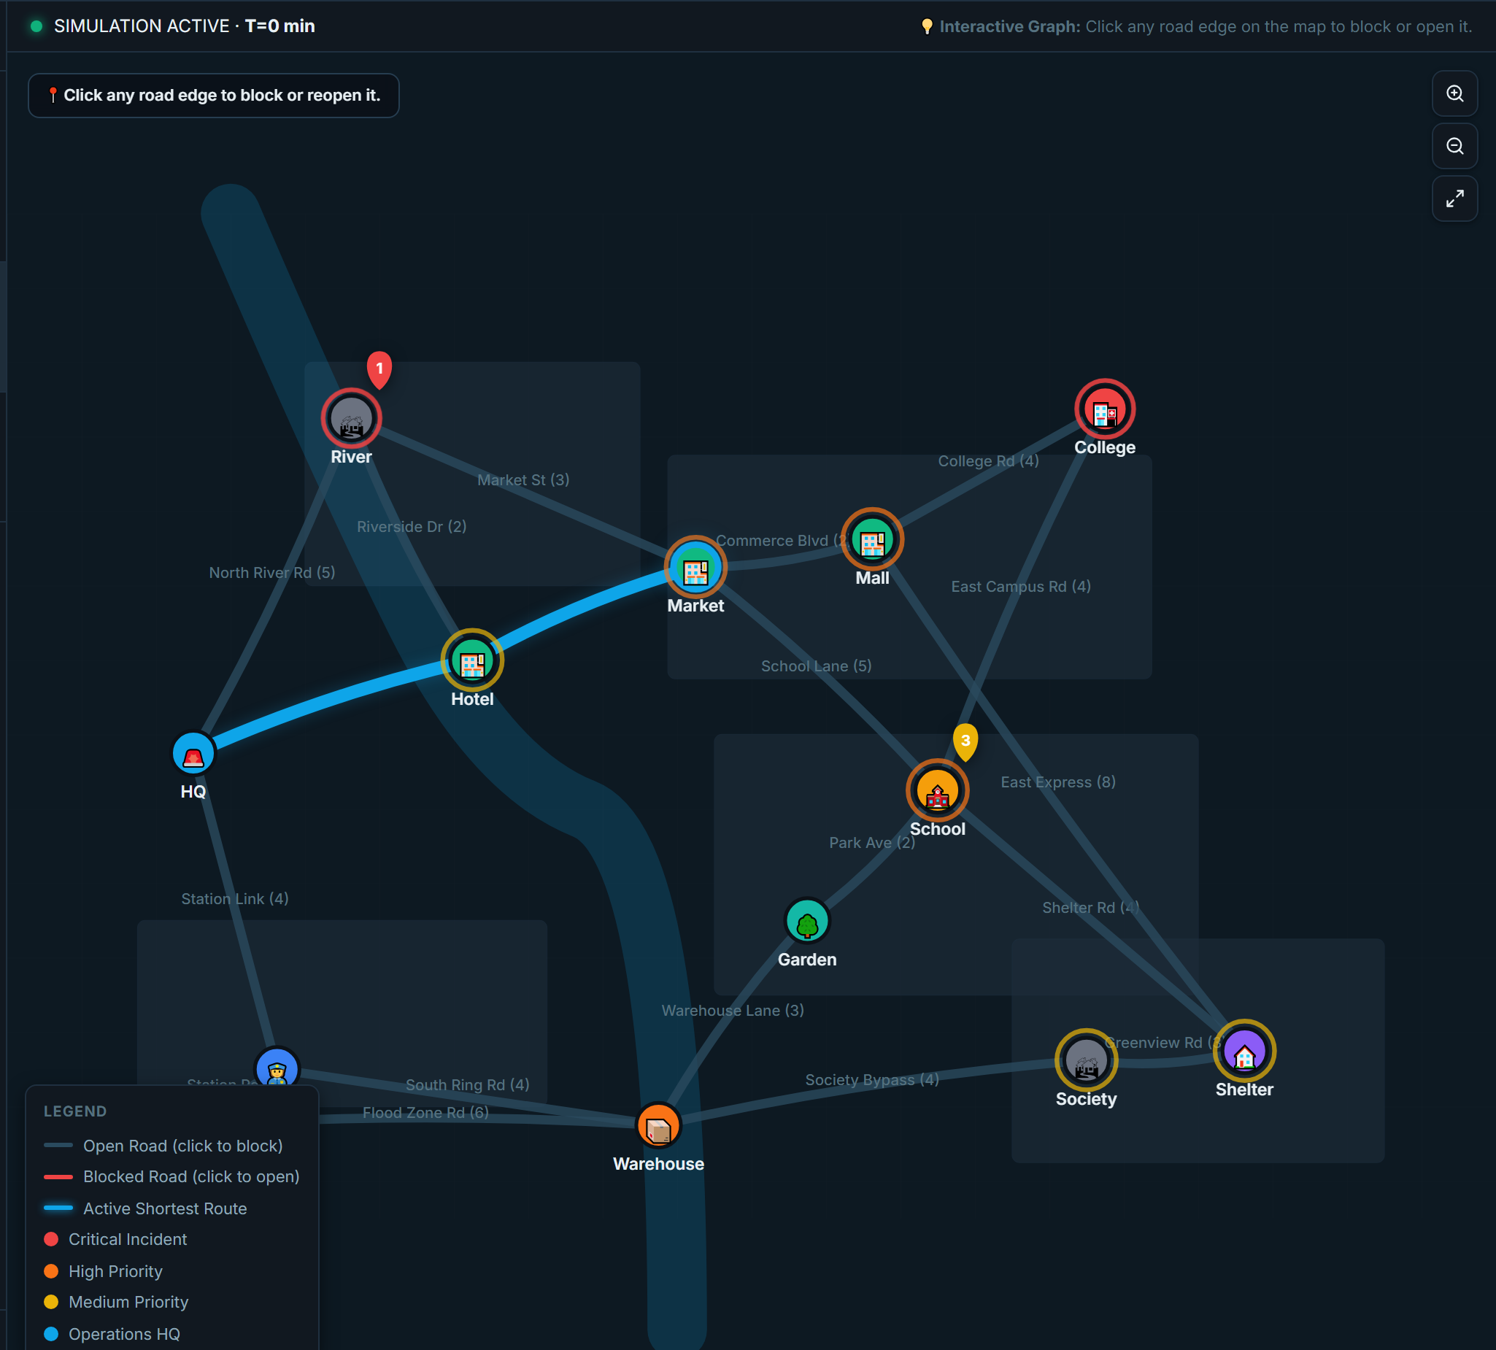
The SVG graph engine renders 13 municipal nodes and 19 road segments with transit costs in minutes. Blocked roads are rendered in bright red with hazard icons, while the active optimal transit route from HQ to the selected emergency is highlighted in dynamic cyan.

Figure 7: Incident Priority Queue (Multi-Criterion Merge Sort Triage)
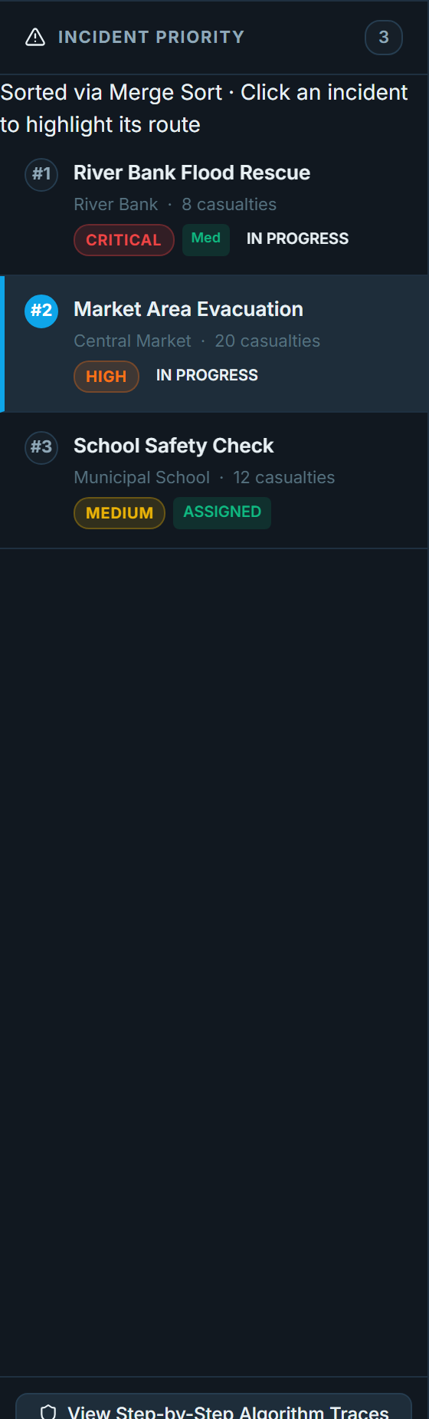
The left sidebar displays emergencies sorted strictly by the 5-tier Merge Sort comparator. Each incident card indicates rank (#1, #2, #3), urgency badges (Critical, High, Medium), medical status chips, casualty figures, and live fulfillment state (Waiting, In Progress, Completed).

Figure 8: Relief Cargo Allocation (0/1 Knapsack) & Dynamic Team Dispatch
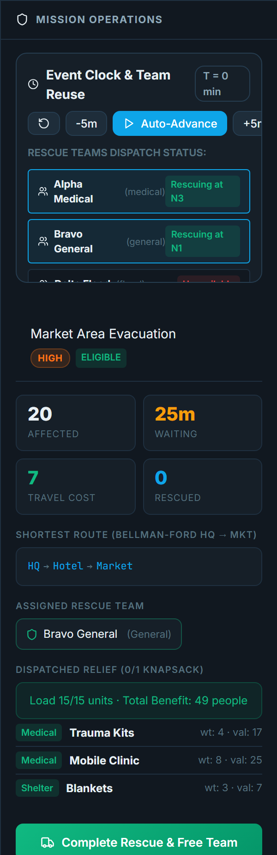
The right operations panel details the selected incident's Bellman-Ford shortest path (HQ → Hotel → Market, cost: 7 min), assigned team (Bravo General), and optimal 0/1 Knapsack payload (15/15 units packed, delivering 49 total casualty support points).

Figure 9: Step-by-Step Algorithm Visualizer — Merge Sort Divide & Conquer Tree
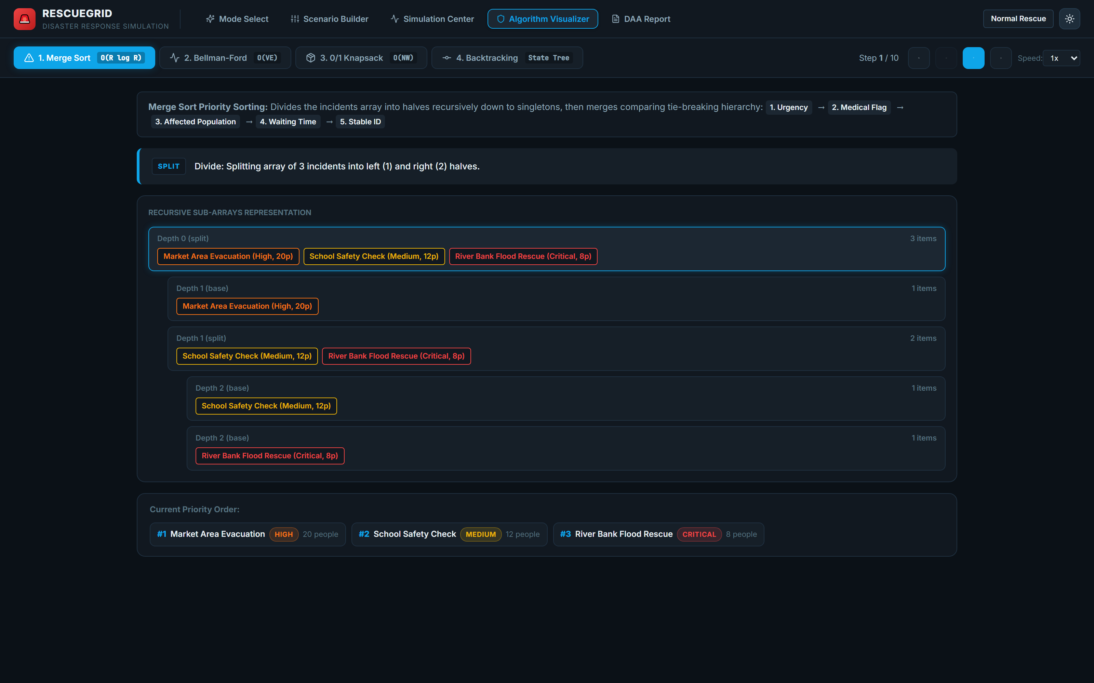
The interactive visualizer illustrates the recursive decomposition of incidents into tree subproblems, followed by pairwise merge steps with human-readable comparison reasoning justifying why each incident was prioritized.

Figure 10: Step-by-Step Algorithm Visualizer — Bellman-Ford Edge Relaxation Table
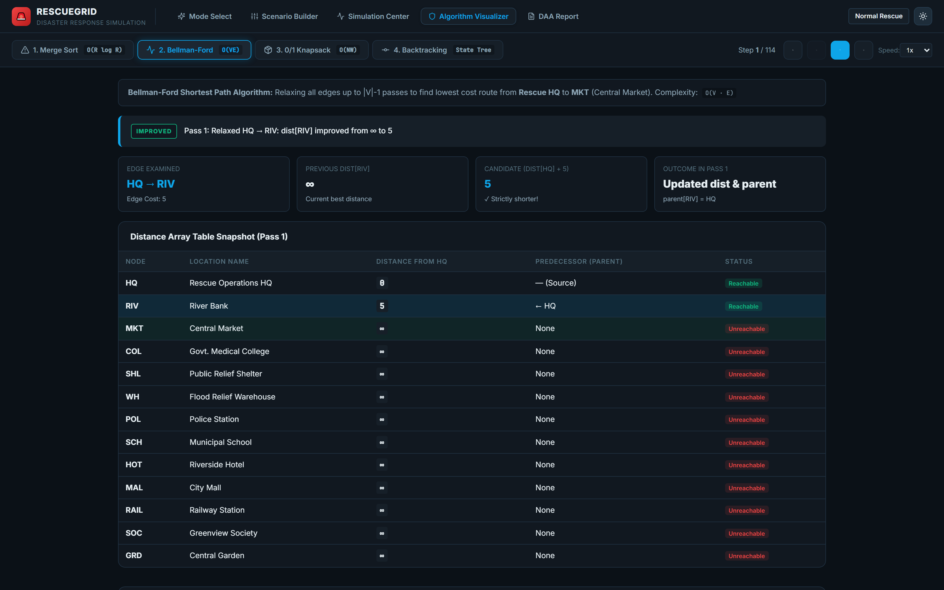
An interactive edge relaxation inspector demonstrating dynamic programming passes over the graph. It highlights relaxed edges, compares candidate distances against current bests, and updates the distance array table snapshot in real time.

Figure 11: Step-by-Step Algorithm Visualizer — 0/1 Knapsack Dynamic Programming Matrix
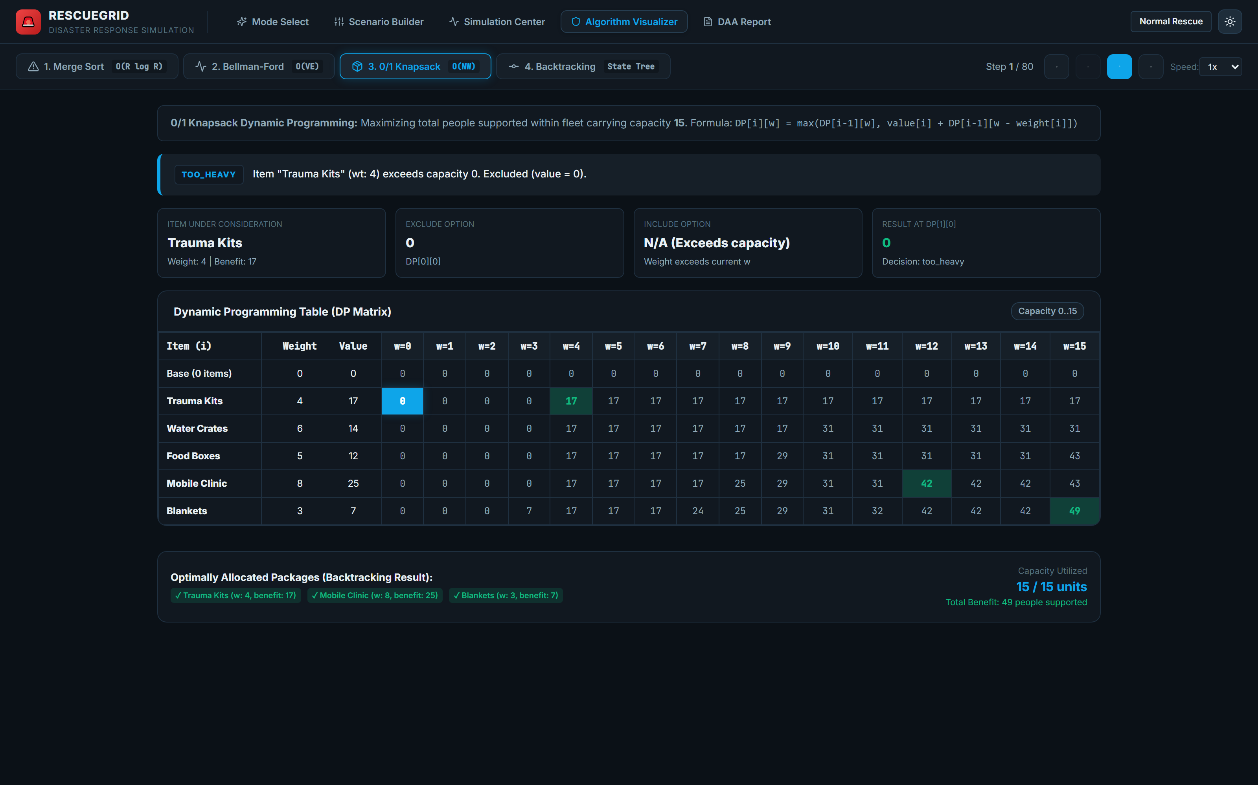
Renders the complete (N + 1) × (W + 1) DP state matrix. Cells are highlighted as the algorithm computes include-versus-exclude decisions, followed by yellow backtrack markers tracing the exact optimal cargo subset.

Figure 12: Step-by-Step Algorithm Visualizer — Team Assignment State Space Tree
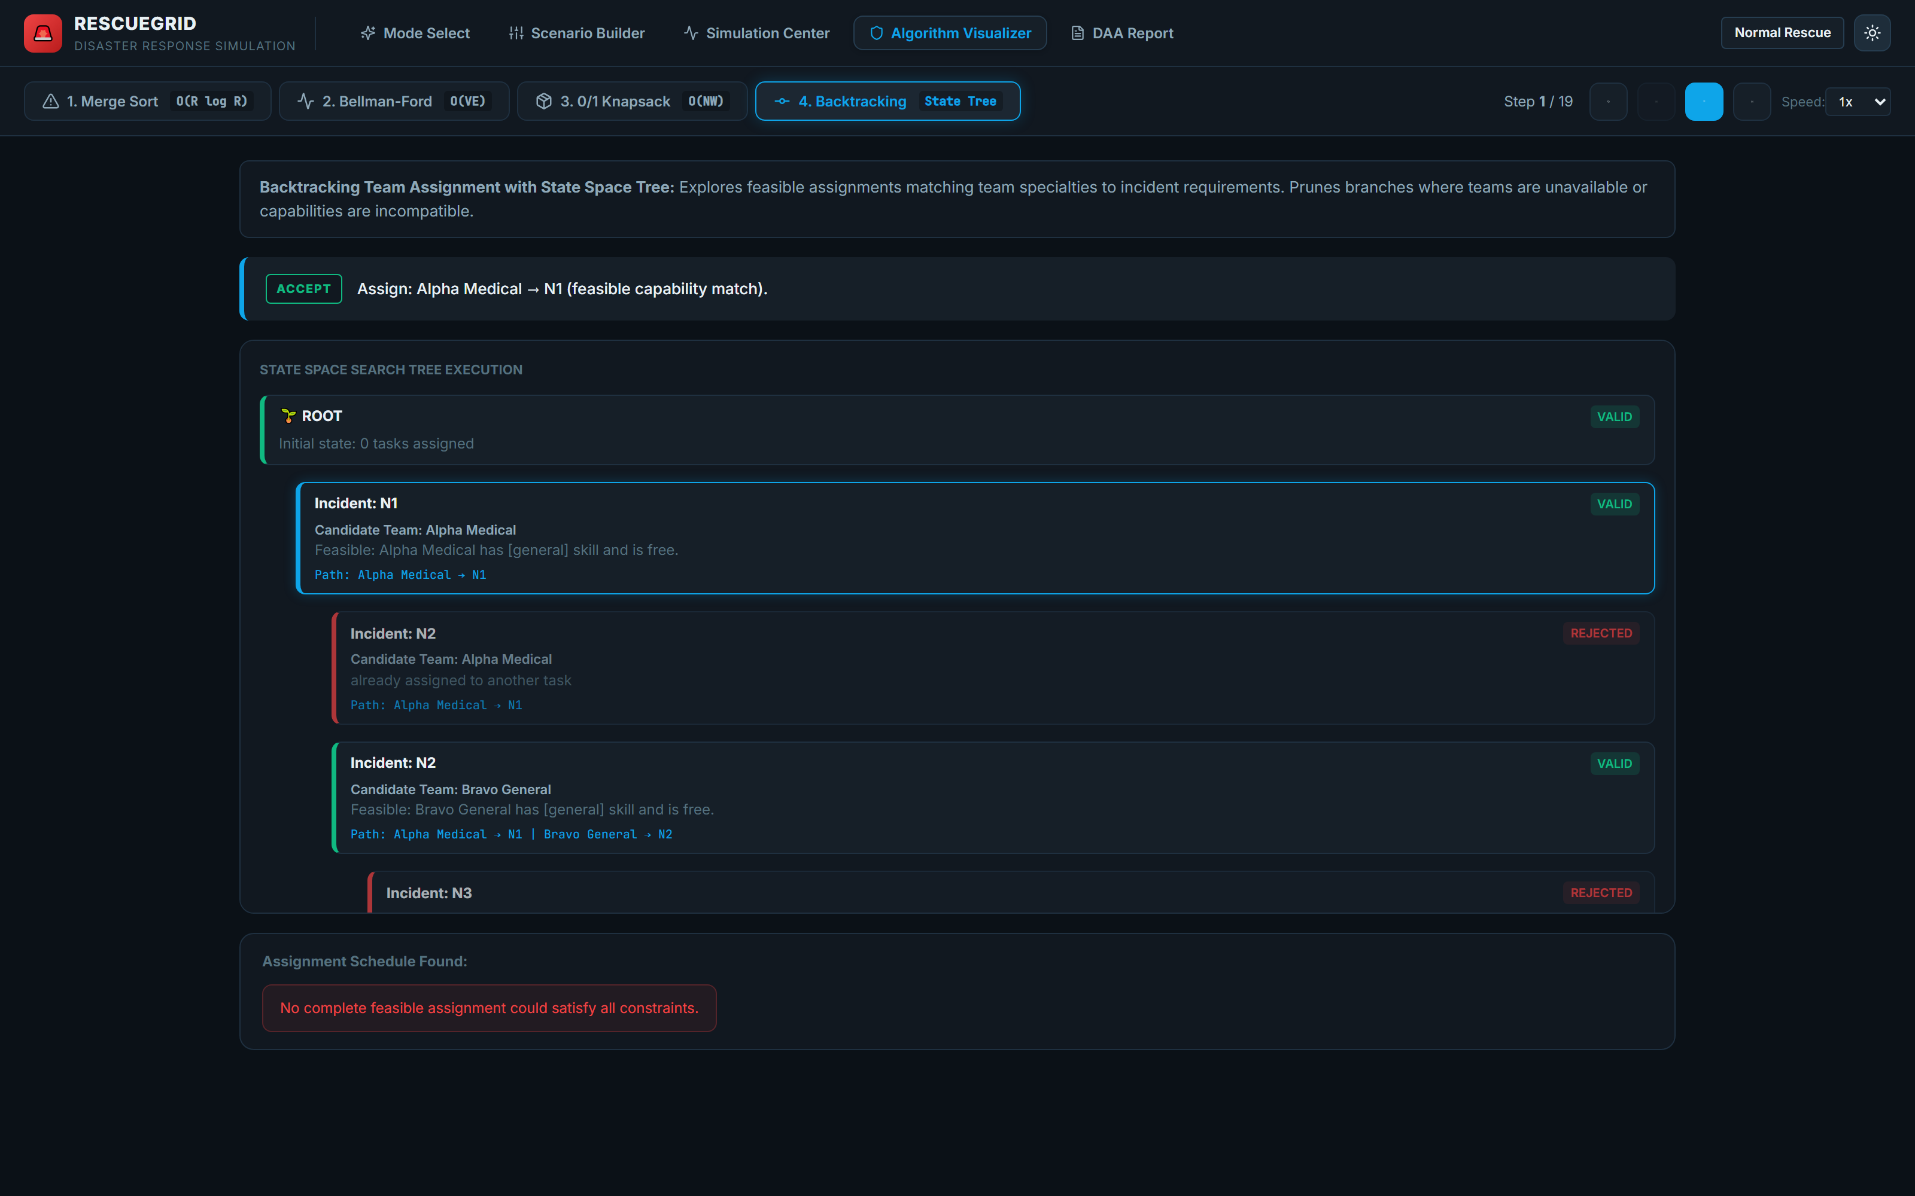
Visualizes the combinatorial backtracking tree. Green branches indicate valid skill matches, red branches depict constraint violations (unavailable or lacking skills) pruned immediately to prevent invalid dispatches, and final goal nodes indicate complete feasible assignments.

Figure 13: Comprehensive DAA Execution Audit & Engineering Report
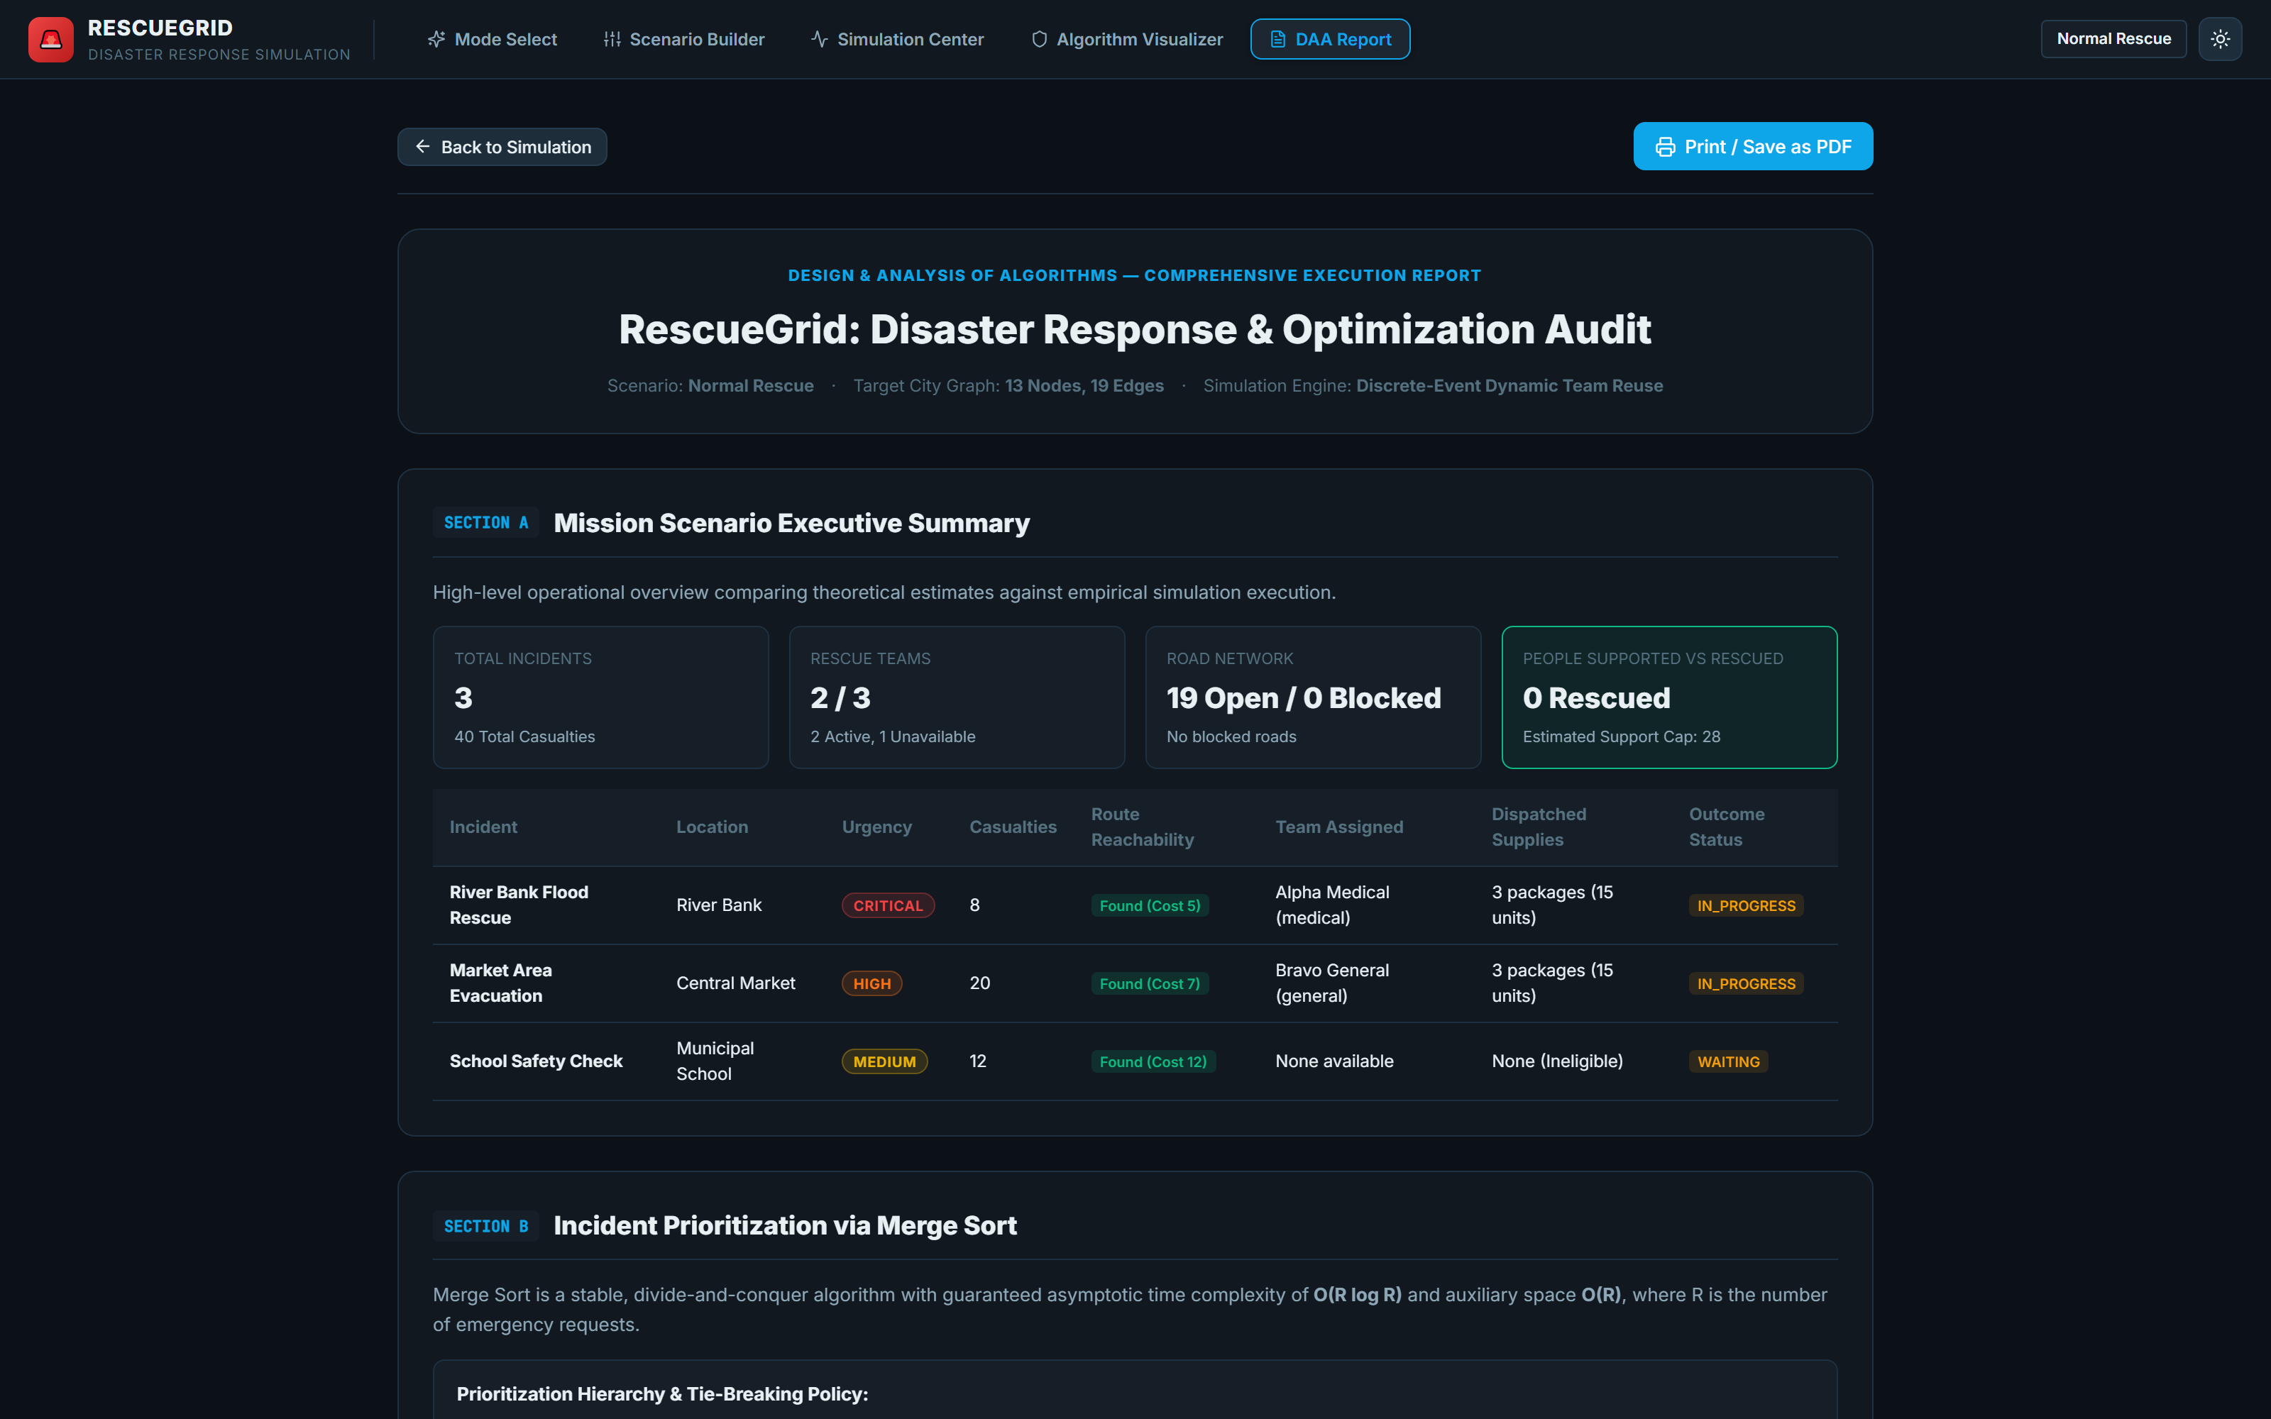
A formal printable engineering audit screen displaying high-level mission KPIs, incident outcome matrices (reachability, dispatched cargo, team assigned), road network audit logs, and theoretical-versus-empirical algorithm performance analyses.

4. Conclusion
RescueGrid successfully demonstrates how classical algorithms taught in computer science form the core foundation of modern, life-saving disaster relief logistics. By combining Merge Sort for deterministic multi-criterion casualty triage, Bellman-Ford for resilient shortest-path routing around physical road hazards, 0/1 Knapsack Dynamic Programming for payload-constrained cargo maximization, and Backtracking for capability-matched team dispatch, the system transforms chaotic emergency response into an optimized, data-driven operation.
The project bridges theoretical algorithm design and practical software engineering by offering both a clean, customizable user scenario builder and rich step-by-step visualizers. Automated test suites (28/28 tests passing) confirm deterministic correctness across all boundary conditions. RescueGrid provides an extensible blueprint for emergency management systems where every second and every kilogram of relief cargo directly impacts human lives.

